Worksheet No. 2

Student Name: Ashi Gupta UID: 25MCA20160
Branch: MCA Gen Section/Group: MCA-1_A
Semester: II Date of Performance: 19/01/2026
Subject Name: Technical Training Subject Code: 25CAP-652

1.Aim/Overview of the practical:
To implement and analyze SQL SELECT queries using filtering, sorting, grouping, and aggregation concepts in PostgreSQL for efficient data retrieval and analytical reporting.

2. Objectives:
● To retrieve specific data using filtering conditions
● To sort query results using single and multiple attributes
● To perform aggregation using grouping techniques
● To apply conditions on aggregated data
● To understand real-world analytical queries commonly asked in placement interviews

S/W Requirement: Oracle Database Express Edition and pgAdmin

Practical:

Step 1: Database and Table Preparation
create table orders (
order_id serial primary key,
customer_name varchar(50),
product varchar(50),
quantity int,
price numeric(10,2),
order_date date
);
insert into orders (customer_name, product, quantity, price, order_date) values
('amit', 'laptop', 1, 65000, '2024-01-10'),
('neha', 'mobile', 2, 40000, '2024-01-12'),
('rohan', 'tablet', 1, 25000, '2024-01-15'),
('simran', 'laptop', 1, 70000, '2024-01-18'),
('ankit', 'mobile', 3, 60000, '2024-01-20'),
('pooja', 'headphones', 2, 5000, '2024-01-22'),
('rahul', 'tablet', 2, 48000, '2024-01-25');

Step 2: Filtering Data Using Conditions
select * from orders where price > 50000;
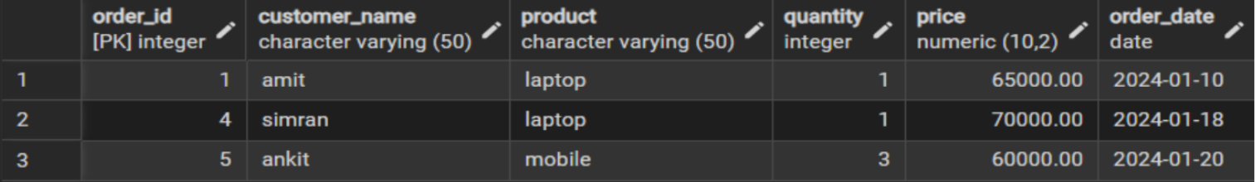

select customer_name, product, price from orders where price > 30000 and quantity >= 2;
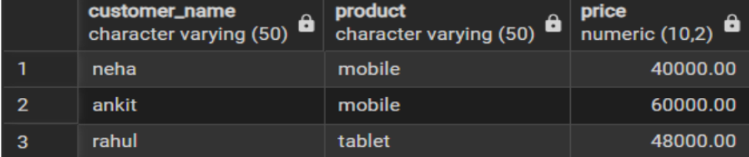

Step 3: Sorting Query Results
select customer_name, product, price from orders order by price asc;
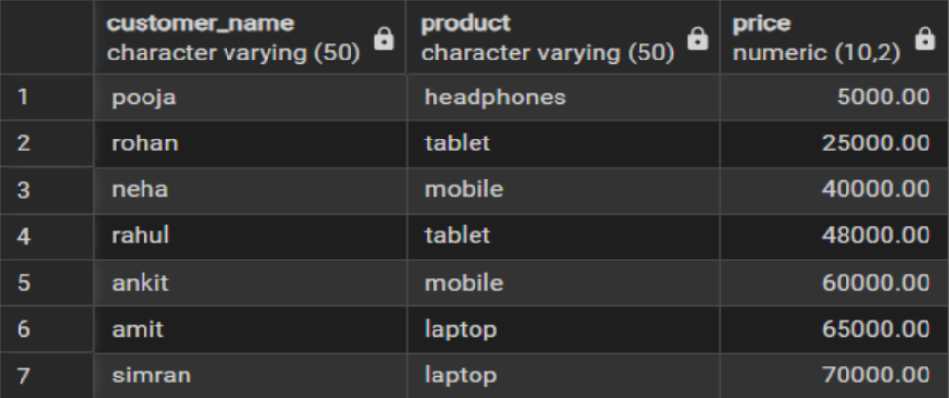
select customer_name, product, price from orders order by price desc;
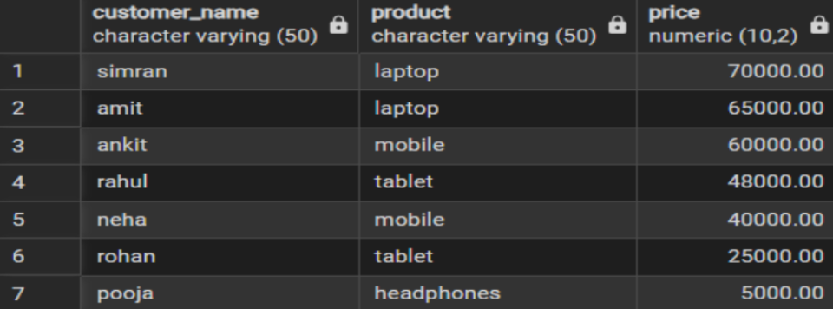

select customer_name, product, price, quantity from orders order by product asc, price desc;
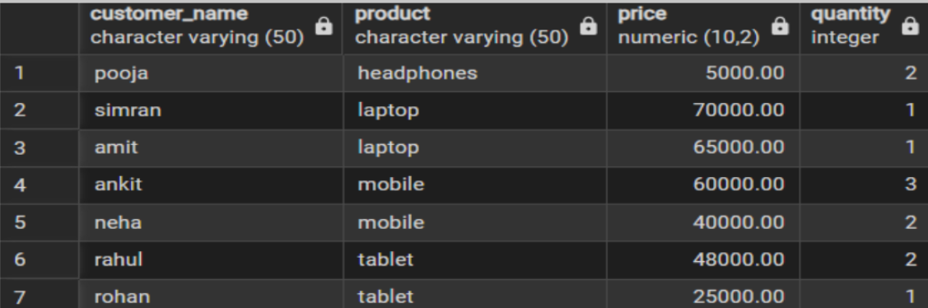

Step 4: Grouping Data for Aggregation
select product, sum(price) as total_sales from orders group by product;
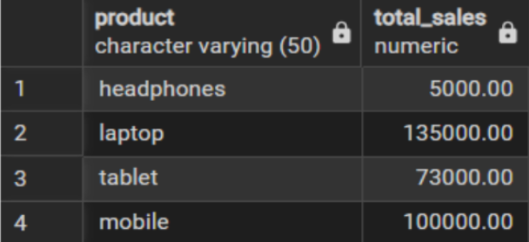

select product, sum(quantity) as total_quantity from orders group by product;
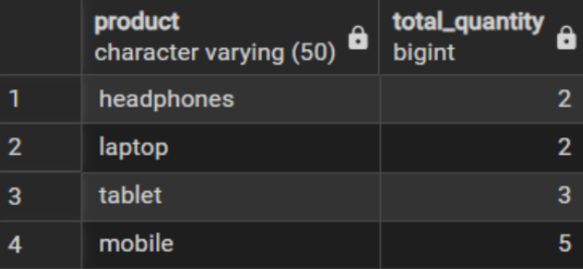

Step 5: Applying Conditions on Aggregated Data
select product, sum(price) as total_sales from orders group by product having sum(price) > 50000;
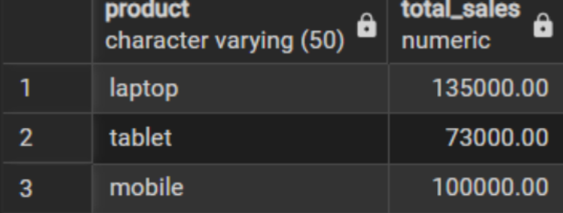
Step 6: Conceptual Understanding of Filtering vs Aggregation Conditions
select product, sum(price) from orders where sum(price) > 50000 group by product;

select product, sum(price) from orders group by product having sum(price) > 50000;
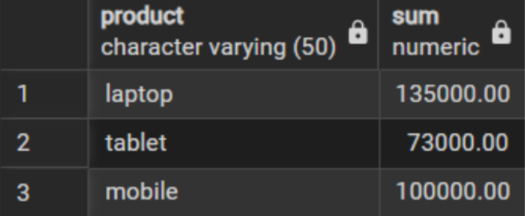

Learning Outcomes
● Understand how conditional filtering is used to retrieve only relevant records from a database.
● Explain how sorting enhances the readability and usefulness of query results in reports.
● Apply grouping techniques to organize data for analytical and summary purposes.
● Distinguish clearly between row-level conditions and group-level conditions using appropriate sql clauses.
● Develop confidence in writing analytical sql queries applicable to real-world database scenarios.
● Demonstrate improved readiness for placement and interview questions related to filtering, grouping, and aggregation concepts.

