PROJECT

**BookNJoy**

2023F CSD 2206 4-Database Design & SQL



PREPARED BY

Aashika Salieshbhai Vachhani – C0903269

Amisha Nareshbhai Nakrani –C0903272

Jay Rajeshbhai Vara-C0908305

Vohra Saifil Sikandarbhai -C0911452

PROFESSOR

**Name: Rachida Amjoun**

**Company Overview**

BookNJoy is a leading online ticket booking platform that allows users to purchase tickets for a wide range of events, including concerts, sports events, theater performances, festivals, and more. We provide a convenient and user-friendly platform that connects event organizers and promoters with eager attendees, making it easy for people to discover, book, and attend their favorite events. Our user-friendly platform prioritizes secure booking, with various ticket delivery options and interactive seat selection.

Our company differentiates itself in the market by connecting enthusiasts with the events customer love and enhancing the vibrancy of the entertainment sector by utilizing technology and a customer-centric approach. The organization has established a reputation for providing hassle-free access to a wide variety of entertainment events and is dedicated to both innovation and customer satisfaction.

**Product**

Event Ticket

**Product Attributes**

|  |  |
| --- | --- |
| Attributes | Sample Data |
| Event Ticket ID | 01 |
| Name | Child Admission |
| Description | Harbor Lights Jazz Festival-celebration of smooth tunes and rhythmic beats |
| Price | $250 |
| Begin Sale | 2023-12-09 |
| End Sale | 2023-12-30 |
| Issued Tickets | 1000 |
| Sold Tickets | 600 |

**Customer Sales Invoice**

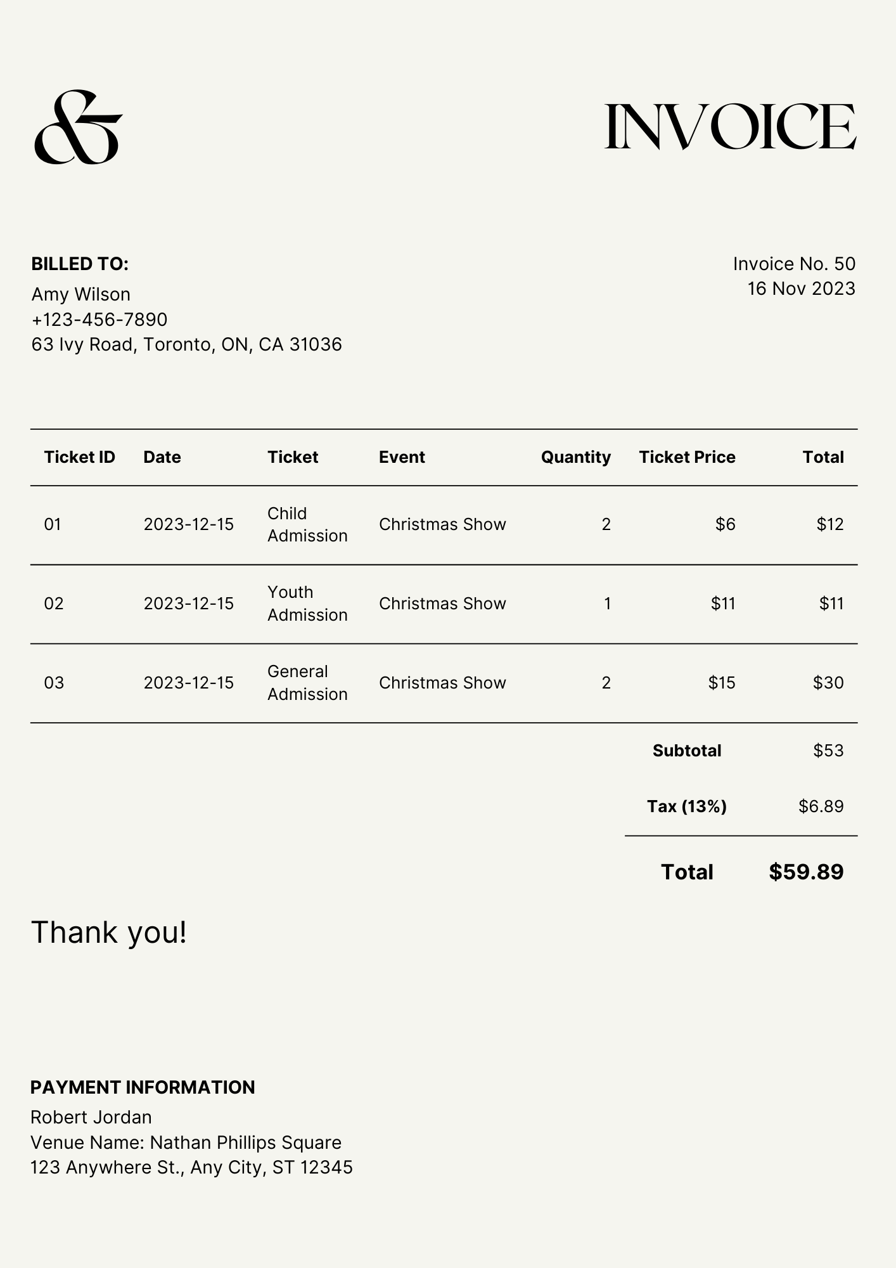

**Entity Relationship Diagrams**

ER Diagram including M:M Relationships

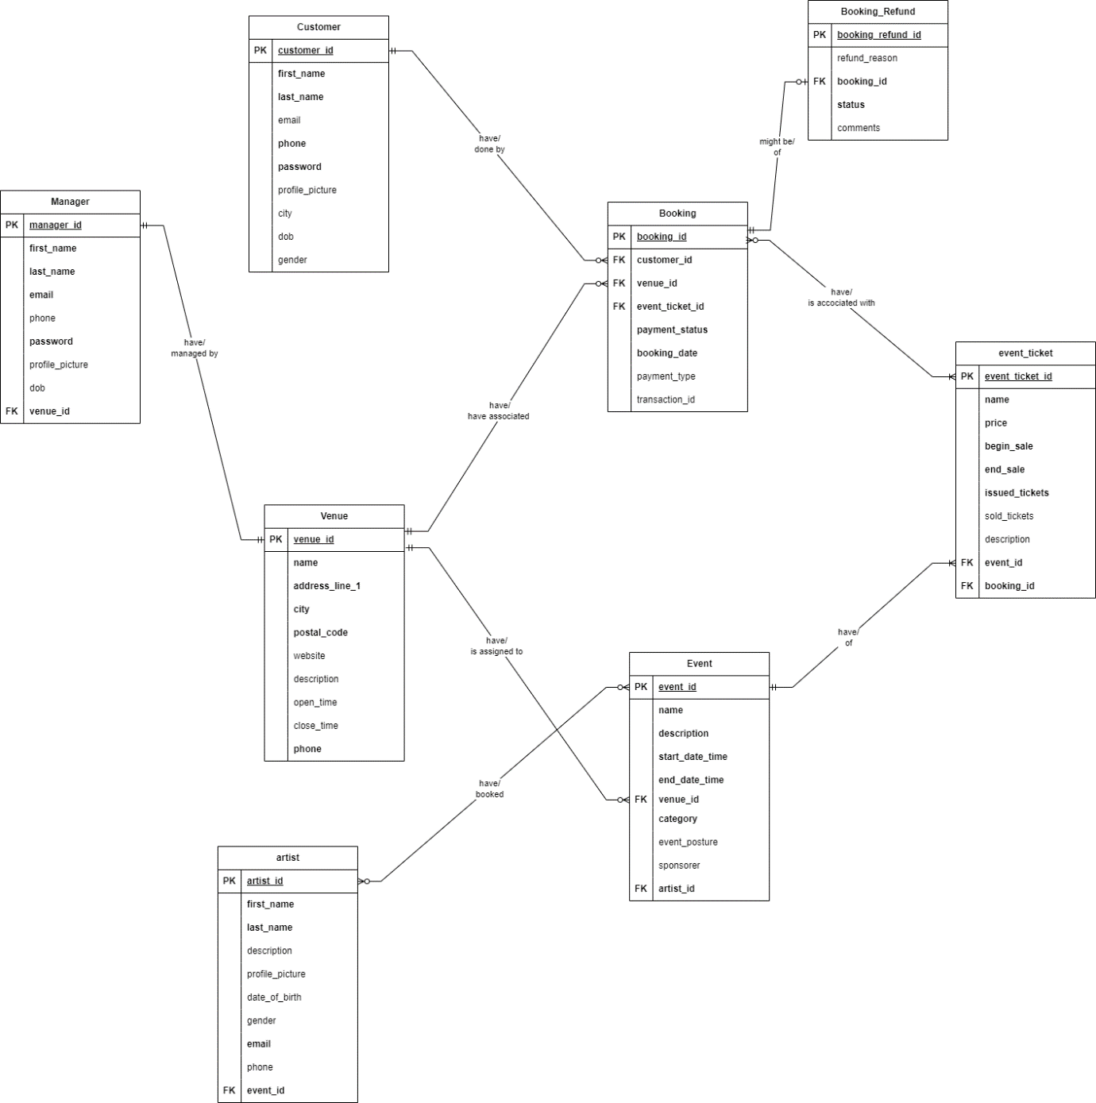

ER Diagram including M:M Relationships Resolved

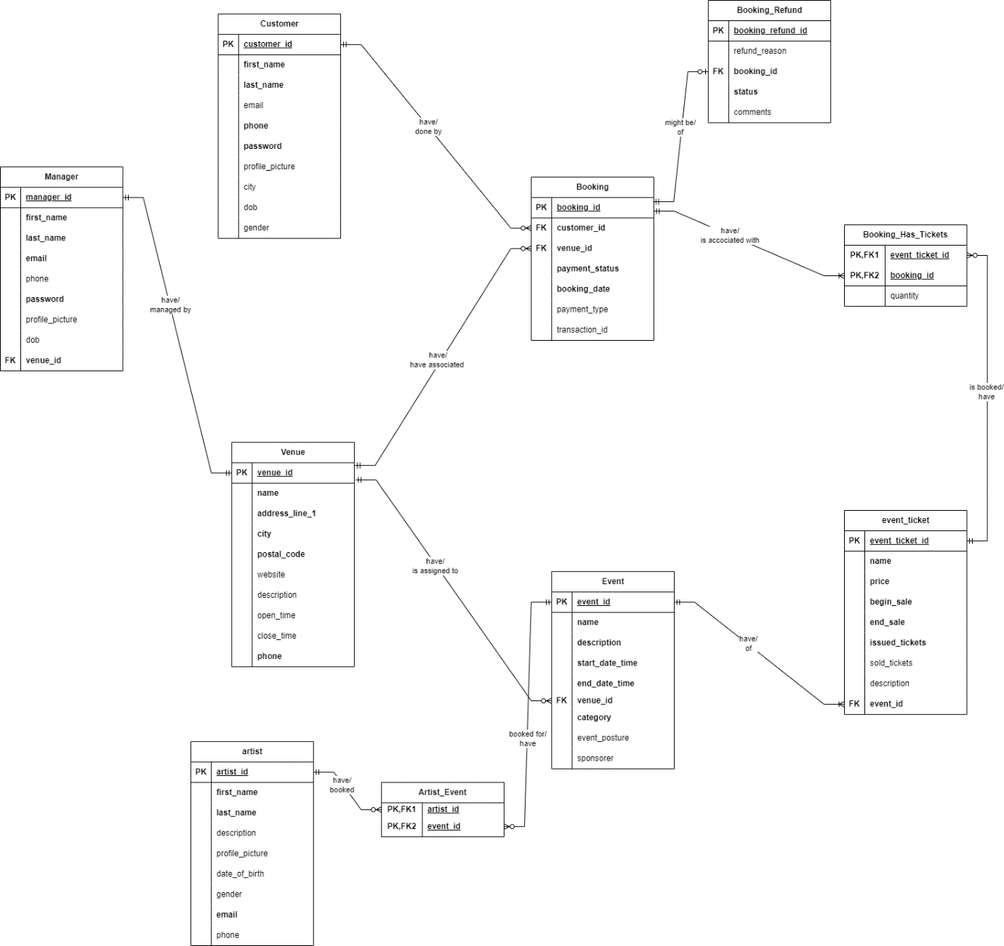

# Business Rules

1. Artist

|  |  |  |  |  |
| --- | --- | --- | --- | --- |
| **Column Name** | **Data Type** | **Length** | **Null Capable** | **Constraints** |
| artist_id | Integer |  | N | PK |
| first_name | Varchar | 25 | N |  |
| last_name | Varchar | 25 | N |  |
| description | Varchar | Max | Y |  |
| profile_picture | Varchar | 500 | Y |  |
| date_of_birth | Date |  | Y | Must be lesser than current date |
| gender | Varchar | 10 | Y | Must be ‘Male’ or ‘Female’ |
| email | Varchar | 50 | N | Unique Identifier |
| phone | Numeric | (12,0) | Y | Unique Identifier |

1. Artist_Event

|  |  |  |  |  |
| --- | --- | --- | --- | --- |
| **Column Name** | **Data Type** | **Length** | **Null Capable** | **Constraints** |
| artist_id | Integer |  | N | PK, FK to Artist |
| event_id | Integer |  | N | PK, FK to Event |

`

1. Booking

|  |  |  |  |  |
| --- | --- | --- | --- | --- |
| **Column Name** | **Data Type** | **Length** | **Null Capable** | **Constraints** |
| booking_id | Integer |  | N | PK |
| customer_id | Integer |  | N | FK to Customer |
| venue_id | Integer |  | N | FK to Venue |
| payment_status | Varchar | 10 | N | Must be ‘Pending’ or ‘Completed’ |
| booking_date | Date |  | N | Must be greater than or equal to current date |
| payment_type | Varchar | 10 | Y | Must be ‘Debit’ or ‘Credit’ |
| transaction_id | Varchar | 50 | Y | Transaction_id and payment type must be null or both should be not null |

1. Booking_Has_Tickets

|  |  |  |  |  |
| --- | --- | --- | --- | --- |
| **Column Name** | **Data Type** | **Length** | **Null Capable** | **Constraints** |
| booking_id | Integer |  | N | PK, FK to Booking |
| event_ticket_id | Integer |  | N | PK, FK to Event_Ticket |
| quantity | Integer |  | N | Must have quantity and it should be greater then 0 |

1. Booking_Refund

|  |  |  |  |  |
| --- | --- | --- | --- | --- |
| **Column Name** | **Data Type** | **Length** | **Null Capable** | **Constraints** |
| booking_refund_id | Integer |  | N | PK |
| refund_reason | Varchar | 100 | Y |  |
| booking_id | Integer |  | N | FK to Booking |
| status | Varchar | 10 | N | Must be ‘Pending’ or ‘Refunded’ |
| comments | Varchar | Max | Y |  |

1. Customer

|  |  |  |  |  |
| --- | --- | --- | --- | --- |
| **Column Name** | **Data Type** | **Length** | **Null Capable** | **Constraints** |
| customer_id | Integer |  | N | PK |
| first_name | Varchar | 25 | N |  |
| last_name | Varchar | 25 | N |  |
| email | Varchar | 50 | Y | Unique Identifier |
| phone | Numeric | (12, 0) | N | Unique Identifier |
| password | Varchar | 16 | N |  |
| profile_picture | Varchar | 500 | Y |  |
| city | Varchar | 25 | Y |  |
| dob | Date |  | Y | Must be lesser than current date |
| gender | Varchar | 10 | Y | Must be ‘Male’ or ‘Female’ |

1. Event

|  |  |  |  |  |
| --- | --- | --- | --- | --- |
| **Column Name** | **Data Type** | **Length** | **Null Capable** | **Constraints** |
| event_id | Integer |  | N | PK |
| name | Varchar | 25 | N |  |
| description | Varchar | Max | N |  |
| start_date_time | Datetime |  | N | Must be lesser than the end date time and start date time must be greater than current date time |
| end_date_time | Datetime |  | N |  |
| venue_id | Integer |  | N | FK to Venue |
| category | Varchar | 25 | N | Must be ‘Music’ ,’Laugh’ or ‘Mime Show’ |
| event_posture | Varchar | 25 | Y |  |
| sponsorer | Varchar | 25 | Y |  |

1. Event_Ticket

|  |  |  |  |  |
| --- | --- | --- | --- | --- |
| **Column Name** | **Data Type** | **Length** | **Null Capable** | **Constraints** |
| event_ticket_id | Integer |  | N | PK |
| name | Varchar | 25 | N |  |
| price | Numeric |  | N | Must be greater than 0 |
| begin_sale | Datetime |  | N | Must be lesser than or equal to end sell date time and begin sell must be greater than or equal to current date time |
| end_sale | Datetime |  | N |  |
| issued_tickets | Integer |  | N |  |
| sold_tickets | Integer |  | Y | Must be lesser than or equal to issued tickets |
| description | Varchar | Max | Y |  |
| event_id | Integer |  | N | FK to Event |

1. Manager

|  |  |  |  |  |
| --- | --- | --- | --- | --- |
| **Column Name** | **Data Type** | **Length** | **Null Capable** | **Constraints** |
| manager_id | Integer |  | N | PK |
| first_name | Varchar (25) | 25 | N |  |
| last_name | Varchar (25) | 25 | N |  |
| email | Varchar |  | Y | Unique Identifier |
| phone | Numeric | (12,0) | N | Unique Identifier |
| password | Varchar | 16 | N |  |
| profile_picture | Varchar | 500 | Y |  |
| dob | Date |  | Y | Must be lesser than current date |
| venue_id | Integer |  | N | FK to Venue, Unique Identifier |

1. Venue

|  |  |  |  |  |
| --- | --- | --- | --- | --- |
| **Column Name** | **Data Type** | **Length** | **Null Capable** | **Constraints** |
| venue_id | Integer |  | N | PK |
| name | Varchar | 25 | N |  |
| address_line_1 | Varchar | 100 | N |  |
| city | Varchar | 25 | N |  |
| postal_code | Varchar | 25 | N |  |
| website | Varchar | 50 | Y |  |
| description | Varchar | Max | Y |  |
| open_time | Time | 7 | Y |  |
| close_time | Time | 7 | Y |  |
| phone | Numeric | (12,0) | N | Unique Identifier |