PROJECT REPORT
on
SMART PARKING MANAGEMENT SYSTEM
(Console-based application in C++ using Object-Oriented Programming)
Submitted by
Aashika

DECLARATION
I, Aashika, hereby declare that the project report entitled “Smart Parking Management System” is an original piece of work carried out by me. The program was written in C++ using the concepts of Object-Oriented Programming, and the outputs shown in this report were obtained by compiling and running the program on a Windows system.
This work has not been submitted to any other institution for the award of any degree, diploma or certificate.

Aashika

ACKNOWLEDGEMENT
I would like to express my sincere gratitude to my teachers and mentors for their guidance, encouragement and valuable suggestions throughout the development of this project. Their support helped me understand the practical use of classes, objects and encapsulation in solving a real-life problem.
I also thank my family and friends for their constant motivation and for helping me test the program with different inputs.

ABSTRACT
Managing a parking area manually using registers is slow, error-prone and makes it hard to know which slots are free. The Smart Parking Management System is a simple console-based application developed in C++ that automates the basic operations of a small parking area.
The system has 10 parking slots: 4 for bikes, 4 for cars and 2 for trucks. When a vehicle arrives, the operator enters the owner’s name, the vehicle number and the vehicle type, and the system automatically allocates the first free slot of the matching type. The system also prevents the same vehicle from being parked twice, shows all booked and available slots, searches for a vehicle by its number, frees the slot when a vehicle exits, and displays a parking summary after every action.
The project is built with two classes, Vehicle and ParkingSystem, and demonstrates classes and objects, encapsulation, constructors and composition. It deliberately avoids advanced features such as inheritance, file handling and databases so that the program remains easy to understand and explain.
Keywords: Parking management, C++, OOP, Encapsulation, Slot allocation, Console application

TABLE OF CONTENTS
1. Introduction 6
1.1 Background 6
1.2 Problem Statement 6
1.3 Proposed Solution 6
1.4 Scope of the Project 6
2. Objectives 7
3. System Requirements 7
3.1 Hardware Requirements 7
3.2 Software Requirements 7
3.3 Compile and Run Commands 7
4. System Design 8
4.1 Parking Capacity 8
4.2 Menu Options 8
4.3 Class Design 8
4.4 OOP Concepts Used 9
4.5 Algorithms 9
5. Implementation 11
5.1 Overview of the Program 11
5.2 Important Logic 11
5.3 Complete Source Code 11
6. Testing and Output 18
6.1 Initial State – All Slots Available 18
6.2 New Vehicle Entry 19
6.3 View Booked Slots 20
6.4 View Available Slots 20
6.5 Search Vehicle 21
6.6 Parking Summary 21
6.7 Vehicle Exit 21
6.8 Test Cases 21
7. Limitations 23
8. Future Scope 23
9. Conclusion 23
10. References 23

1. Introduction

1.1 Background
With the rapid increase in the number of vehicles, finding and managing parking space has become a common problem in colleges, offices, markets and residential societies. When parking is handled manually, the attendant has to write vehicle details in a register, remember which slots are occupied and search through pages to find a vehicle. This wastes time and often leads to mistakes.

1.2 Problem Statement
A small parking area needs a simple way to record which vehicle is parked in which slot, to guarantee that a vehicle gets a slot suitable for its size, to avoid duplicate entries, and to know instantly how many slots are free. A manual register cannot provide this information quickly or reliably.

1.3 Proposed Solution
The Smart Parking Management System is a menu-driven C++ program that stores vehicle and owner details in memory, assigns slots automatically by vehicle type, and presents the current parking status on request. All operations are performed through a simple text menu, so the operator needs no special training.

1.4 Scope of the Project
- Suitable for a small parking area with a fixed number of slots (10 in this version).
- Supports three vehicle categories: Bike, Car and Truck.
- Designed as a learning project to demonstrate Object-Oriented Programming in C++.
- Data is held in memory while the program runs; it does not use files or a database.

2. Objectives
The main objectives of the project are:
- To design a simple parking management system using Object-Oriented Programming in C++.
- To register a vehicle using the owner name, vehicle number and vehicle type.
- To automatically assign an available slot that matches the vehicle type.
- To prevent a vehicle that is already parked from being entered again.
- To display booked slots together with owner and vehicle details.
- To display all available slots.
- To search for a vehicle using its vehicle number.
- To free a slot when a vehicle leaves the parking area.
- To show the total, booked and available slot counts after each menu action.

3. System Requirements

3.1 Hardware Requirements
Component | Requirement
Processor | Any modern processor (Intel / AMD)
RAM | 2 GB or more
Storage | Less than 10 MB free space
Display | Standard monitor with console / terminal

3.2 Software Requirements
Component | Requirement
Operating System | Windows 10 / 11 (also works on Linux and macOS)
Language | C++ (C++11 standard)
Compiler | g++ (MinGW) or any standard C++ compiler
Editor / IDE | VS Code, Code::Blocks, Dev-C++ or any text editor
Interface | Command Prompt / Terminal

3.3 Compile and Run Commands
g++ -std=c++11 main.cpp -o parking
.\parking.exe

4. System Design

4.1 Parking Capacity
The parking area has a total of 10 slots. Each slot is reserved for one type of vehicle, as shown below.
Slot Numbers | Vehicle Type | Number of Slots
1 – 4 | Bike | 4
5 – 8 | Car | 4
9 – 10 | Truck | 2
Total |  | 10

4.2 Menu Options
Choice | Option | Purpose
1 | New Vehicle Entry | Register a vehicle and allocate a slot
2 | Vehicle Exit | Remove a vehicle and free its slot
3 | View Booked Slots (Owner Details) | List all occupied slots with details
4 | View Available Slots | List all free slots with their type
5 | Search Vehicle Details | Find a vehicle using its number
6 | Parking Summary | Show slot counts
0 | Exit | Close the program

4.3 Class Design
The program uses two classes. The Vehicle class stores the data of one parked vehicle, and the ParkingSystem class manages all slots and contains an array of Vehicle objects.
Class: Vehicle
Member | Description
ownerName (private string) | Name of the vehicle owner
vehicleNumber (private string) | Registration number of the vehicle
vehicleType (private string) | Bike, Car or Truck
slotNumber (private int) | Slot allotted to the vehicle (0 when empty)
Vehicle() | Constructor that sets all fields to empty values
setDetails() | Stores owner, number, type and slot
getOwnerName(), getVehicleNumber(), getVehicleType(), getSlotNumber() | Getter methods to read the private data
clearDetails() | Resets the record when a vehicle exits
displayDetails() | Prints the vehicle details on screen

Class: ParkingSystem
Member | Description
TOTAL_SLOTS (private static const int) | Total number of slots (10)
vehicles[TOTAL_SLOTS] (private) | Array of Vehicle objects, one per slot
occupied[TOTAL_SLOTS] (private bool) | Whether each slot is booked
slotTypes[TOTAL_SLOTS] (private string) | Type of vehicle each slot is meant for
ParkingSystem() | Constructor that marks all slots free and assigns slot types
newEntry() | Reads details, validates and allocates a slot
vehicleExit() | Finds the vehicle and frees its slot
viewBookedSlots() | Displays all booked slots
viewAvailableSlots() | Displays all free slots
searchVehicle() | Searches a vehicle by number
showSummary() | Displays total, booked and available counts

4.4 OOP Concepts Used
Concept | Where it is used
Classes and Objects | Vehicle and ParkingSystem classes; the object “parking” is created in main()
Encapsulation | Vehicle data members are private and are accessed only through public methods
Constructors | Vehicle() initialises an empty record; ParkingSystem() initialises slots and slot types
Composition | ParkingSystem contains an array of Vehicle objects (“has-a” relationship)

4.5 Algorithms
New Vehicle Entry
- Read owner name and vehicle number.
- Ask for vehicle type (1 = Bike, 2 = Car, 3 = Truck). If the choice is invalid, display a message and stop.
- If the name or number is empty, display a message and stop.
- Check all booked slots; if the vehicle number already exists, display “This vehicle is already parked” and stop.
- Scan the slots from 1 to 10 and pick the first free slot whose type matches the vehicle.
- Mark the slot as occupied, store the details and display them. If no slot is free, display “No slot is available”.
Vehicle Exit
- Read the vehicle number.
- Search the booked slots for a matching number.
- If found, display the details, mark the slot free, clear the record and show that the slot is available.
- If not found, display “Vehicle not found in the parking area”.

5. Implementation

5.1 Overview of the Program
The whole program is written in a single file, main.cpp, of about 336 lines. The main() function creates a ParkingSystem object and runs a do-while loop that displays the menu, reads the user’s choice and uses a switch statement to call the matching method. After every action (except Exit) the parking summary is displayed so that the operator always sees the current status.

5.2 Important Logic
Slot allocation by vehicle type. The constructor assigns slot types to the array positions: positions 0–3 are Bike, 4–7 are Car and 8–9 are Truck. During entry, the program loops through the slots and chooses the first one that is not occupied and whose type equals the vehicle type. The slot number shown to the user is the array index plus one.
Duplicate prevention. Before allocating a slot, the program compares the entered vehicle number with the number of every occupied slot. If a match is found, the entry is rejected.
Summary calculation. showSummary() counts booked and available slots and also counts booked slots separately for bikes, cars and trucks. Available slots per type are calculated by subtracting the booked count from the capacity of that type (4, 4 and 2).
Input validation. The program rejects an invalid vehicle type, empty name or number, duplicate vehicle numbers, and invalid menu choices.

5.3 Complete Source Code
The complete source code of main.cpp is given below.
#include <iostream>
#include <string>
using namespace std;

// Stores the details of one vehicle and its owner.
class Vehicle {
private:
string ownerName;
string vehicleNumber;
string vehicleType;
int slotNumber;

public:
Vehicle() {
ownerName = "";
vehicleNumber = "";
vehicleType = "";
slotNumber = 0;
}

void setDetails(string name, string number, string type, int slot) {
ownerName = name;
vehicleNumber = number;
vehicleType = type;
slotNumber = slot;
}

string getOwnerName() {
return ownerName;
}

string getVehicleNumber() {
return vehicleNumber;
}

string getVehicleType() {
return vehicleType;
}

int getSlotNumber() {
return slotNumber;
}

void clearDetails() {
ownerName = "";
vehicleNumber = "";
vehicleType = "";
slotNumber = 0;
}

void displayDetails() {
cout << "Owner Name : " << ownerName << endl;
cout << "Vehicle Number : " << vehicleNumber << endl;
cout << "Vehicle Type : " << vehicleType << endl;
cout << "Slot Number : " << slotNumber << endl;
}
};

// Manages all parking slots and vehicle records.
class ParkingSystem {
private:
static const int TOTAL_SLOTS = 10;

Vehicle vehicles[TOTAL_SLOTS];
bool occupied[TOTAL_SLOTS];
string slotTypes[TOTAL_SLOTS];

public:
ParkingSystem() {
for (int i = 0; i < TOTAL_SLOTS; i++) {
occupied[i] = false;
}

// Slots 1-4 are for bikes, 5-8 for cars, 9-10 for trucks.
for (int i = 0; i < 4; i++) {
slotTypes[i] = "Bike";
}

for (int i = 4; i < 8; i++) {
slotTypes[i] = "Car";
}

for (int i = 8; i < 10; i++) {
slotTypes[i] = "Truck";
}
}

void newEntry() {
string name, number, type;

cout << "\n========== NEW VEHICLE ENTRY ==========\n";

cout << "Enter owner name: ";
cin.ignore();
getline(cin, name);

cout << "Enter vehicle number: ";
getline(cin, number);

cout << "\nSelect vehicle type:\n";
cout << "1. Bike\n";
cout << "2. Car\n";
cout << "3. Truck\n";
cout << "Enter choice: ";

int choice;
cin >> choice;

if (choice == 1) {
type = "Bike";
} else if (choice == 2) {
type = "Car";
} else if (choice == 3) {
type = "Truck";
} else {
cout << "Invalid vehicle type!\n";
return;
}

if (name.empty() || number.empty()) {
cout << "Name and vehicle number cannot be empty.\n";
return;
}

// Do not allow the same vehicle to be entered twice.
for (int i = 0; i < TOTAL_SLOTS; i++) {
if (occupied[i] &&
vehicles[i].getVehicleNumber() == number) {
cout << "This vehicle is already parked.\n";
return;
}
}

// Find the first empty slot suitable for this vehicle.
for (int i = 0; i < TOTAL_SLOTS; i++) {
if (!occupied[i] && slotTypes[i] == type) {
occupied[i] = true;
vehicles[i].setDetails(name, number, type, i + 1);

cout << "\nVehicle entry successful!\n";
cout << "Your parking details:\n";
vehicles[i].displayDetails();
return;
}
}

cout << "Sorry! No " << type << " slot is available.\n";
}

void vehicleExit() {
string number;

cout << "\n========== VEHICLE EXIT ==========\n";
cout << "Enter vehicle number: ";
cin >> ws;
getline(cin, number);

for (int i = 0; i < TOTAL_SLOTS; i++) {
if (occupied[i] &&
vehicles[i].getVehicleNumber() == number) {

cout << "\nVehicle found. Parking details:\n";
vehicles[i].displayDetails();

occupied[i] = false;
vehicles[i].clearDetails();

cout << "\nVehicle exited successfully.\n";
cout << "Slot " << i + 1 << " is now available.\n";
return;
}
}

cout << "Vehicle not found in the parking area.\n";
}

void viewBookedSlots() {
cout << "\n========== BOOKED PARKING SLOTS ==========\n";

bool found = false;

for (int i = 0; i < TOTAL_SLOTS; i++) {
if (occupied[i]) {
found = true;
cout << "\n-----------------------------\n";
vehicles[i].displayDetails();
}
}

if (!found) {
cout << "No parking slots are currently booked.\n";
}
}

void viewAvailableSlots() {
cout << "\n========== AVAILABLE PARKING SLOTS ==========\n";

bool found = false;

for (int i = 0; i < TOTAL_SLOTS; i++) {
if (!occupied[i]) {
found = true;
cout << "Slot " << i + 1
<< " - " << slotTypes[i] << " - Available\n";
}
}

if (!found) {
cout << "No parking slots are available.\n";
}
}

void searchVehicle() {
string number;

cout << "\n========== SEARCH VEHICLE ==========\n";
cout << "Enter vehicle number: ";
cin >> ws;
getline(cin, number);

for (int i = 0; i < TOTAL_SLOTS; i++) {
if (occupied[i] &&
vehicles[i].getVehicleNumber() == number) {
cout << "\nVehicle record found:\n";
vehicles[i].displayDetails();
return;
}
}

cout << "No record found for this vehicle number.\n";
}

void showSummary() {
int booked = 0;
int available = 0;
int bikeBooked = 0;
int carBooked = 0;
int truckBooked = 0;

for (int i = 0; i < TOTAL_SLOTS; i++) {
if (occupied[i]) {
booked++;

if (slotTypes[i] == "Bike") {
bikeBooked++;
} else if (slotTypes[i] == "Car") {
carBooked++;
} else if (slotTypes[i] == "Truck") {
truckBooked++;
}
} else {
available++;
}
}

cout << "\n========== PARKING SUMMARY ==========\n";
cout << "Total Slots : " << TOTAL_SLOTS << endl;
cout << "Slots Booked : " << booked << endl;
cout << "Slots Available : " << available << endl;

cout << "\nBike Slots : " << bikeBooked << " booked, "
<< 4 - bikeBooked << " available (out of 4)\n";

cout << "Car Slots : " << carBooked << " booked, "
<< 4 - carBooked << " available (out of 4)\n";

cout << "Truck Slots : " << truckBooked << " booked, "
<< 2 - truckBooked << " available (out of 2)\n";

cout << "=====================================\n";
}
};

int main() {
ParkingSystem parking;
int choice;

do {
cout << "\n";
cout << "============================================\n";
cout << " SMART PARKING MANAGEMENT SYSTEM\n";
cout << "============================================\n";
cout << "1. New Vehicle Entry\n";
cout << "2. Vehicle Exit\n";
cout << "3. View Booked Slots (Owner Details)\n";
cout << "4. View Available Slots\n";
cout << "5. Search Vehicle Details\n";
cout << "6. Parking Summary\n";
cout << "0. Exit\n";
cout << "============================================\n";
cout << "Enter your choice: ";
cin >> choice;

switch (choice) {
case 1:
parking.newEntry();
parking.showSummary();
break;

case 2:
parking.vehicleExit();
parking.showSummary();
break;

case 3:
parking.viewBookedSlots();
parking.showSummary();
break;

case 4:
parking.viewAvailableSlots();
parking.showSummary();
break;

case 5:
parking.searchVehicle();
parking.showSummary();
break;

case 6:
parking.showSummary();
break;

case 0:
cout << "\nThank you for using Smart Parking System!\n";
break;

default:
cout << "\nInvalid choice. Please try again.\n";
parking.showSummary();
}

} while (choice != 0);

return 0;
}

6. Testing and Output
The program was compiled with g++ and run in the Windows Command Prompt. The following screenshots show the working of each menu option.

6.1 Initial State – All Slots Available
When no vehicle is parked, option 4 lists all 10 slots as available and the summary shows 0 booked and 10 available. This output was captured after the test vehicle had exited, which also confirms that the slot was released correctly.
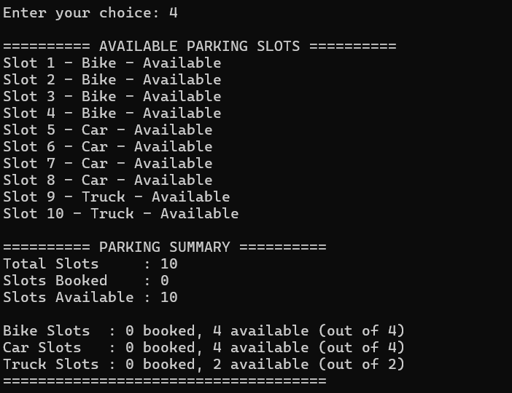
Figure 1: Available slots when the parking area is empty (Option 4)

6.2 New Vehicle Entry
Option 1 was used to park a bike for the owner Aashika with vehicle number NP8023. The system allotted slot 1, the first free bike slot, and the summary updated to 1 booked and 9 available.
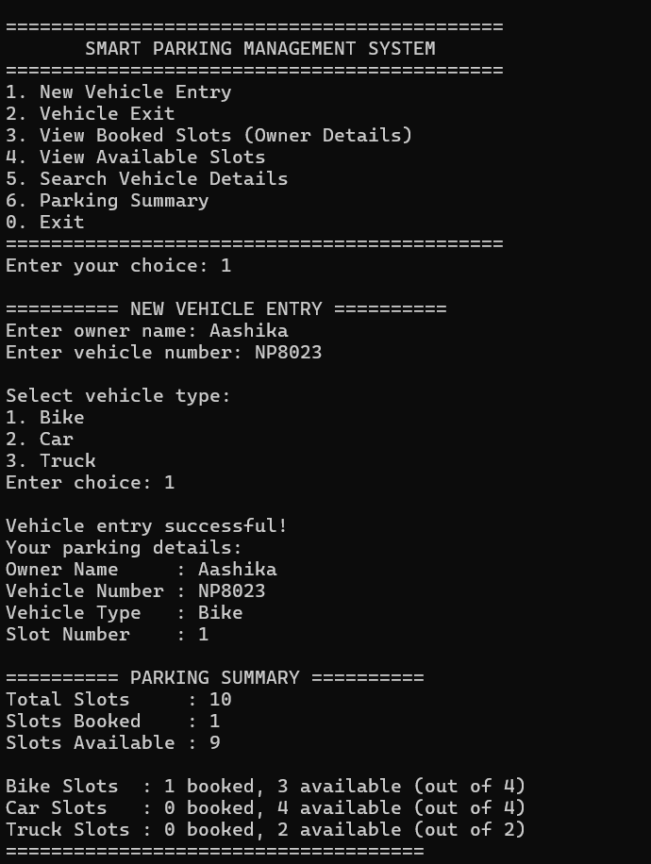
Figure 2: New vehicle entry and parking summary (Option 1)

6.3 View Booked Slots
Option 3 displays the owner name, vehicle number, vehicle type and slot number of every booked slot.
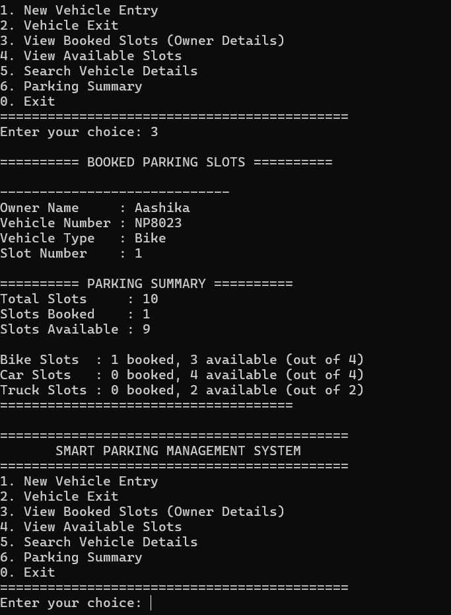
Figure 3: Booked slots with owner details (Option 3)

6.4 View Available Slots
After the entry, slot 1 no longer appears in the list of available slots. Only slots 2 to 10 are shown.
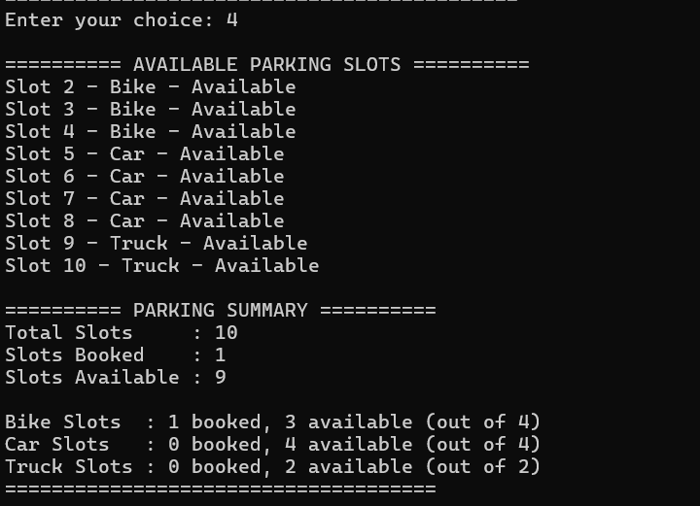
Figure 4: Available slots after one bike is parked (Option 4)

6.5 Search Vehicle
Option 5 searches by vehicle number. Searching for NP8023 returned the correct owner and slot details.
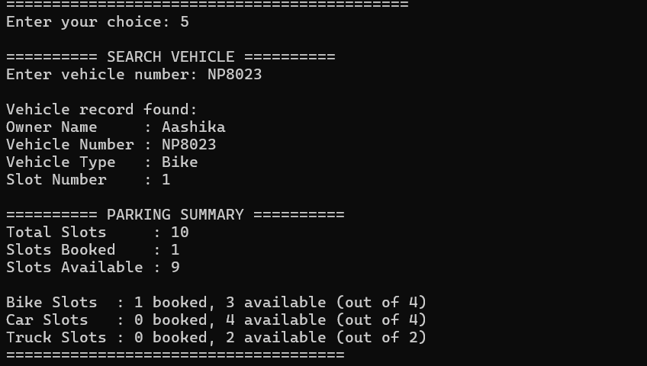
Figure 5: Search vehicle details (Option 5)

6.6 Parking Summary
Option 6 shows the total, booked and available slots, along with the booking status of each vehicle category.
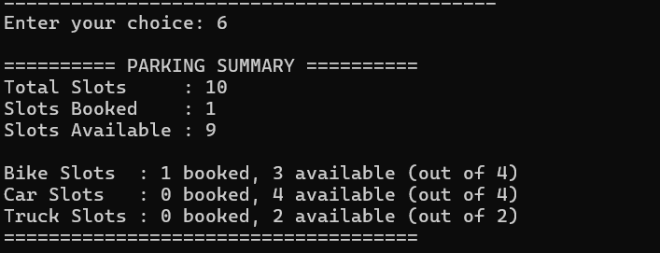
Figure 6: Parking summary (Option 6)

6.7 Vehicle Exit
Option 2 finds the vehicle by number, shows its details, and releases the slot. The message confirms that slot 1 is available again.
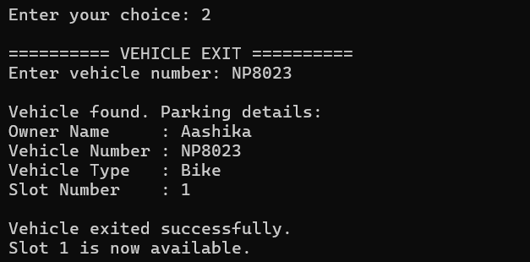
Figure 7: Vehicle exit (Option 2)

6.8 Test Cases
The table below lists the test cases. Cases 1–6 were run and are shown in the screenshots; cases 7–10 describe the behaviour defined in the source code.
No. | Test Case | Expected Result | Result | Evidence
1 | Park a bike (NP8023, Aashika) | Slot 1 allotted | Pass | Fig. 2
2 | View booked slots | Vehicle details displayed | Pass | Fig. 3
3 | View available slots after entry | Slot 1 not listed | Pass | Fig. 4
4 | Search NP8023 | Record found | Pass | Fig. 5
5 | Show summary | 1 booked, 9 available | Pass | Fig. 6
6 | Exit NP8023 | Slot 1 freed | Pass | Fig. 7, 1
7 | Park the same vehicle number twice | Entry rejected as already parked | By code logic | main.cpp
8 | Enter an invalid vehicle type (e.g. 5) | “Invalid vehicle type!” | By code logic | main.cpp
9 | Park a 5th bike when all bike slots are full | “No Bike slot is available” | By code logic | main.cpp
10 | Exit or search a number that is not parked | “Not found” message | By code logic | main.cpp

7. Limitations
- Data is stored in memory only; all records are lost when the program is closed.
- The number of slots and their types are fixed in the code.
- There is no parking fee, time-in/time-out or payment calculation.
- The interface is text-based; there is no graphical interface.
- Entering a non-numeric value where a number is expected (for example, a letter in the menu) is not handled and may cause the program to behave incorrectly.
- Vehicle numbers are compared exactly as typed, so “NP8023” and “np8023” are treated as different vehicles.

8. Future Scope
- Add file handling or a database so that records are saved permanently.
- Record entry and exit time and calculate the parking charges.
- Add inheritance and polymorphism with separate classes for Bike, Car and Truck.
- Allow the administrator to configure the number of slots of each type.
- Add stronger input validation, including case-insensitive vehicle numbers.
- Develop a graphical or web-based interface, with login for the operator.
- Integrate sensors or a number-plate recognition camera for automatic slot detection.

9. Conclusion
The Smart Parking Management System successfully performs the main tasks of a small parking area: registering vehicles, allocating slots by vehicle type, preventing duplicate entries, searching vehicles, releasing slots on exit and showing the current slot status. The program was tested through all its menu options and produced the expected outputs.
The project helped in understanding how classes, encapsulation, constructors and composition can be used to model a real-world problem in C++. Although the current version is simple, it provides a strong base that can be extended with file storage, billing and a graphical interface in the future.

10. References
- Bjarne Stroustrup, The C++ Programming Language, Addison-Wesley.
- E. Balagurusamy, Object-Oriented Programming with C++, McGraw Hill Education.
- cppreference.com – C++ language and standard library reference. https://en.cppreference.com
- GeeksforGeeks – Classes and Objects in C++. https://www.geeksforgeeks.org

