STUDENT ATTENDANCE RECORD SYSTEM
Design & Documentation Requirements
Console-Based Python Application
Document Type: Software Design Specification (SDS)
Version: 1.0
Language / Platform: Python 3 (Standard Library Only)

1. Problem Statement
Educational institutions and individual teachers frequently need a lightweight way to record and monitor student attendance without depending on paid software, spreadsheets that are easy to corrupt, or a full client-server information system that needs installation, a database server, and network connectivity.
Manual, register-based attendance tracking is slow, error-prone, and makes it difficult to answer simple analytical questions quickly, such as “which students are below 75% attendance this term?” or “how many students were present today?” Computing these figures by hand across many students and many days is tedious and inconsistent.
The Student Attendance Record System addresses this gap with a single-file, menu-driven console application built using only the Python standard library. It lets a teacher or administrator register students, mark day-to-day attendance, and instantly retrieve attendance statistics and low-attendance alerts, all within one interactive session, with a plain-text export of the final records for record-keeping.

2. Objectives
- Provide a simple, dependency-free console interface for registering and managing student records identified by a unique roll number.
- Allow attendance to be marked as Present or Present/Absent for any registered student in a given session.
- Automatically compute per-student attendance percentage and flag students below a teacher-defined threshold.
- Summarize attendance activity for the current session (present/absent counts and percentage).
- Persist the final state of all student records to a human-readable text file (students.txt) at the end of a session.
- Validate user input defensively (roll numbers, menu choices, thresholds) so that invalid entries do not crash the program.
- Keep the codebase small, readable, and easy to extend by students or maintainers with basic Python knowledge.

3. Functional Requirements
The functional requirements below map directly to the numbered options in the program's main menu.
ID | Requirement | Description
FR-1 | Add Student | System shall allow a new student to be registered with a unique numeric roll number and a non-empty name. Duplicate roll numbers must be rejected.
FR-2 | View All Students | System shall display a tabular list of all registered students with their cumulative present/absent counts.
FR-3 | Mark Attendance | System shall allow attendance (Present/Absent) to be recorded for an existing student by roll number, updating both the student's totals and the session-level counters.
FR-4 | View Attendance Records | System shall display, for every student, the present count, absent count, and computed attendance percentage (or N/A if no attendance has been recorded).
FR-5 | Search Student | System shall retrieve and display the full record of a single student given a valid roll number.
FR-6 | Calculate Attendance Percentage | System shall compute and display the attendance percentage of a specific student on demand.
FR-7 | Low Attendance Report | System shall accept a numeric threshold from the user and list every student whose attendance percentage falls below it.
FR-8 | Today's Summary | System shall report the total number of registered students, present/absent counts, and attendance percentage for the current session.
FR-9 | Save & Exit | On exit, the system shall write all student records to students.txt and terminate the program gracefully.
FR-10 | Input Validation | System shall reject non-numeric roll numbers, empty names, invalid menu choices, and non-numeric thresholds with a clear message, without crashing.

4. Non-Functional Requirements
Category | Requirement
Usability | The menu must be self-explanatory, numbered 1–9, and re-displayed after every operation so a first-time user needs no manual.
Portability | The application must run on any platform with a standard Python 3 interpreter, with no third-party libraries, databases, or internet access required.
Reliability | Invalid input (letters where numbers are expected, blank names, out-of-range menu choices) must be handled without raising unhandled exceptions.
Performance | All operations must complete in effectively constant/linear time for the expected scale (a single classroom, tens to low hundreds of students); no operation should notice­ably delay the console.
Maintainability | Code shall be organised into small, single-purpose functions with clear naming and inline comments, enabling easy extension (e.g., adding new reports).
Data Integrity | Roll numbers must remain unique; attendance counters must never be decremented incorrectly or double-counted.
Persistence | Session data must be saved to a plain-text file on exit so that records are not silently lost when the program closes.
Auditability | The exported students.txt must be human-readable, so a teacher can inspect it without special tools.
Note on the current implementation: students.txt is overwritten on every exit and is not re-read on startup, so records currently persist only within a single run for computation, and are exported (not re-imported) at the end. This is documented as a known limitation and a candidate enhancement (see Section 9).

5. System Architecture Diagram
The system follows a simple layered architecture appropriate for a single-file console application: a presentation layer (menu I/O), a business logic layer (the eight feature functions plus two shared helpers), a volatile in-memory data layer (the students list and session counters), and a persistence layer (the students.txt export).
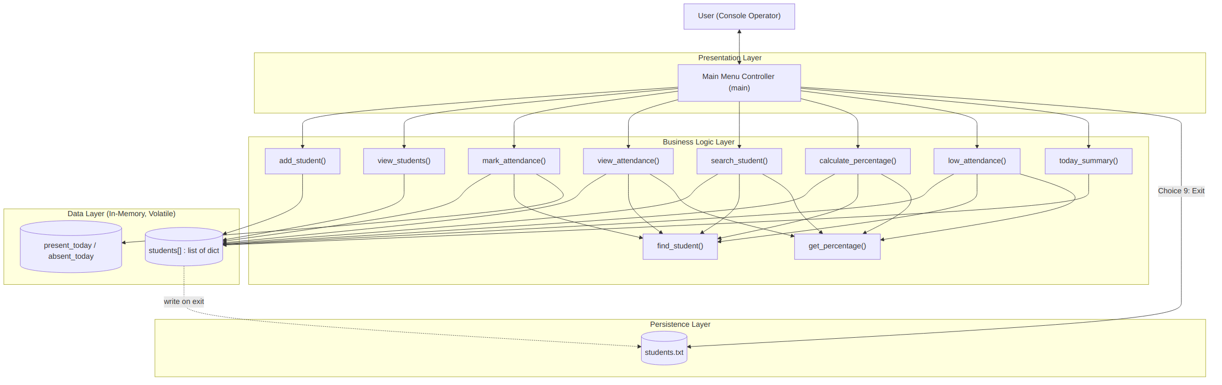
Figure 1: Layered system architecture of the Student Attendance Record System.

6. Process Flow / Workflow Diagram
The workflow below models the application's main control loop: the menu is displayed repeatedly, a choice is validated, the corresponding feature function executes, and control returns to the menu until the user selects Exit, which triggers the file save and program termination.
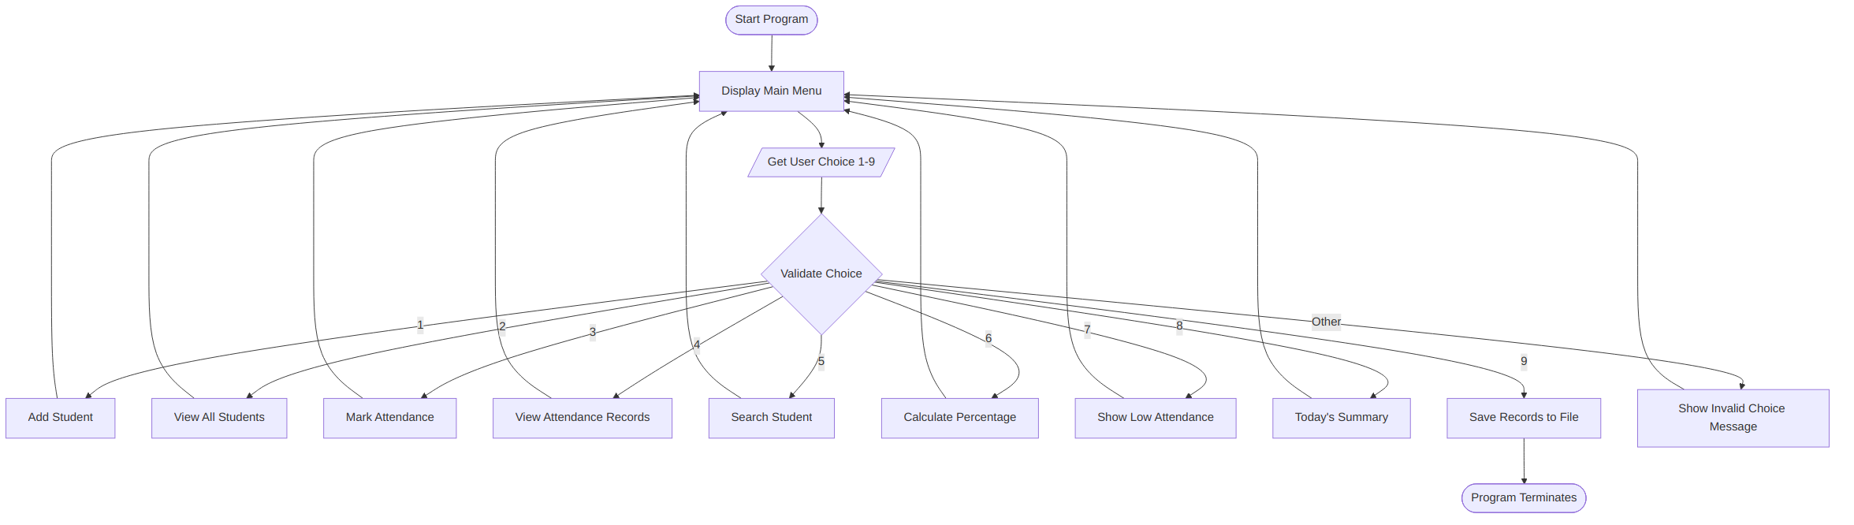
Figure 2: Main menu control-flow / workflow diagram.

7. UML Diagrams

7.1 Use Case Diagram
The single actor (User / Class Teacher) interacts with nine use cases corresponding to the main menu options. “Calculate Attendance Percentage” and “View Low Attendance Students” both reuse the percentage-computation logic that underlies “View Attendance Records,” modelled here as an include relationship.
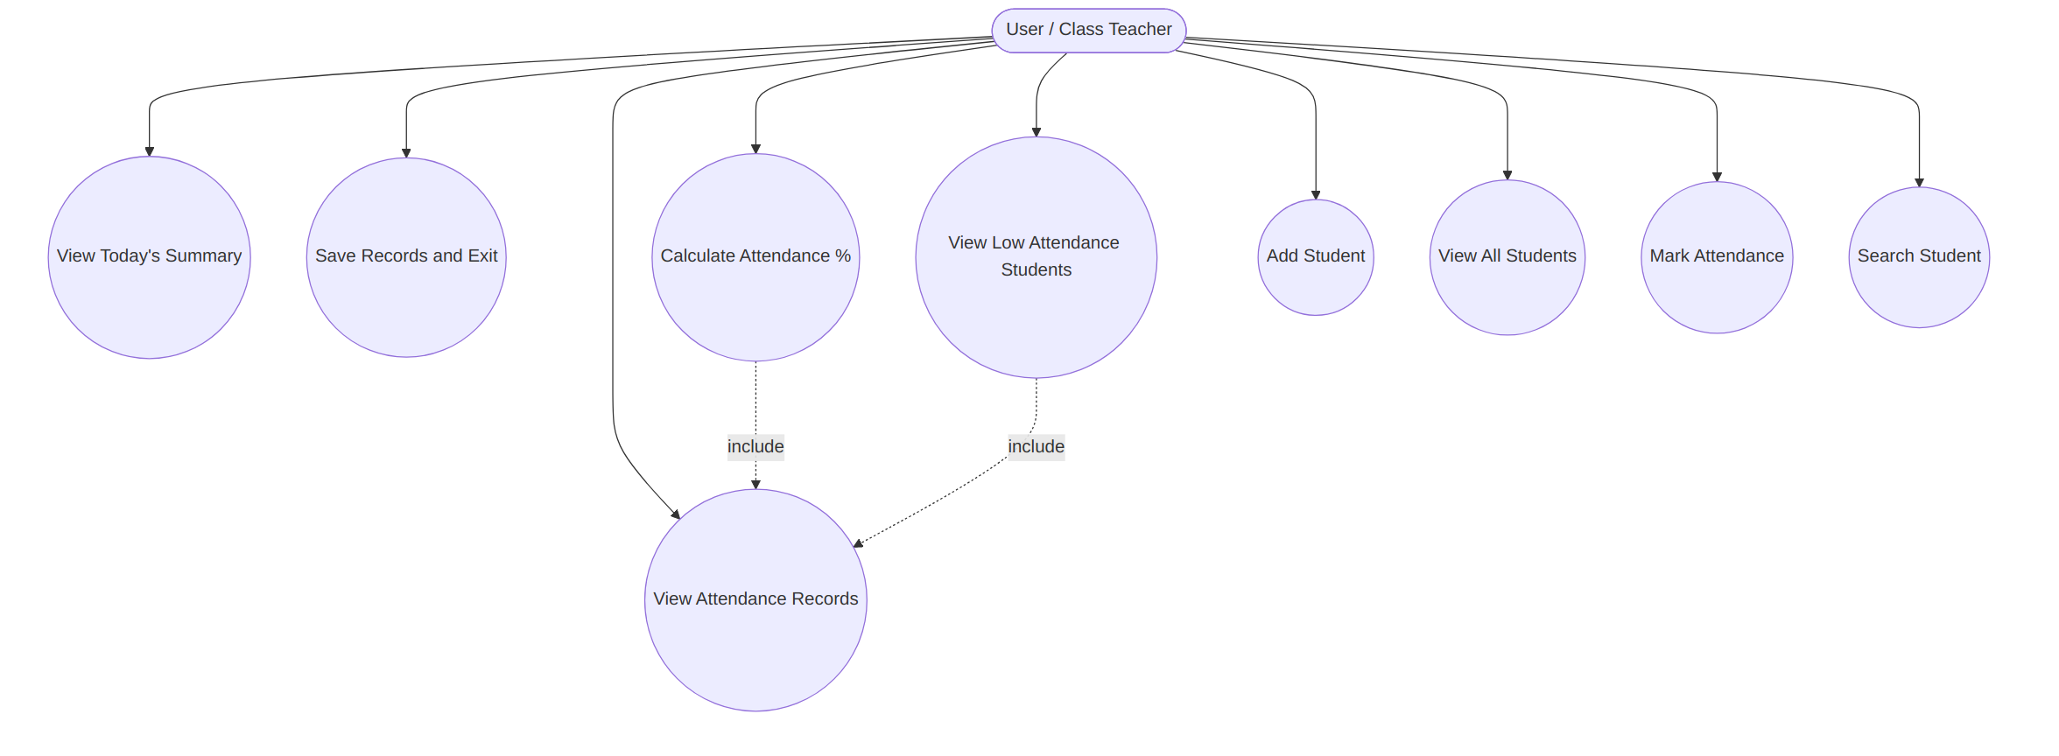
Figure 3: Use case diagram for the Student Attendance Record System.

7.2 Class Diagram
The current program is written procedurally with a global list of dictionaries rather than classes. The diagram below presents the equivalent object-oriented design — a conceptual mapping useful for documentation, extension, or refactor — in which Student models one record, AttendanceSystem encapsulates the menu operations and holds the collection of students, and FileManager encapsulates persistence.
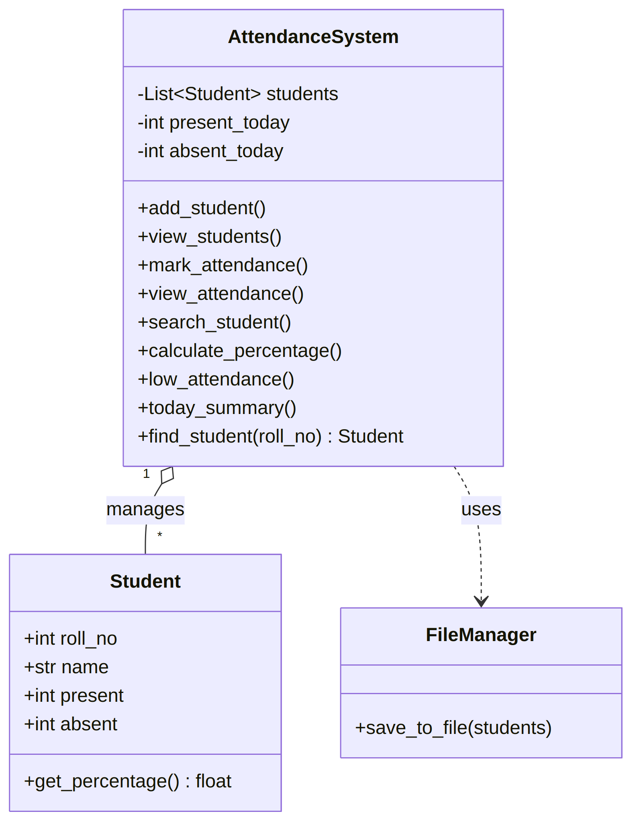
Figure 4: Conceptual class diagram (logical OOP mapping of the procedural code).

7.3 Sequence Diagram
The sequence diagram traces the Mark Attendance use case (menu option 3), the most representative interaction: it looks up a student, branches on whether the student exists, and on a further branch for Present vs. Absent, updating both the student's own counters and the session-wide counters.
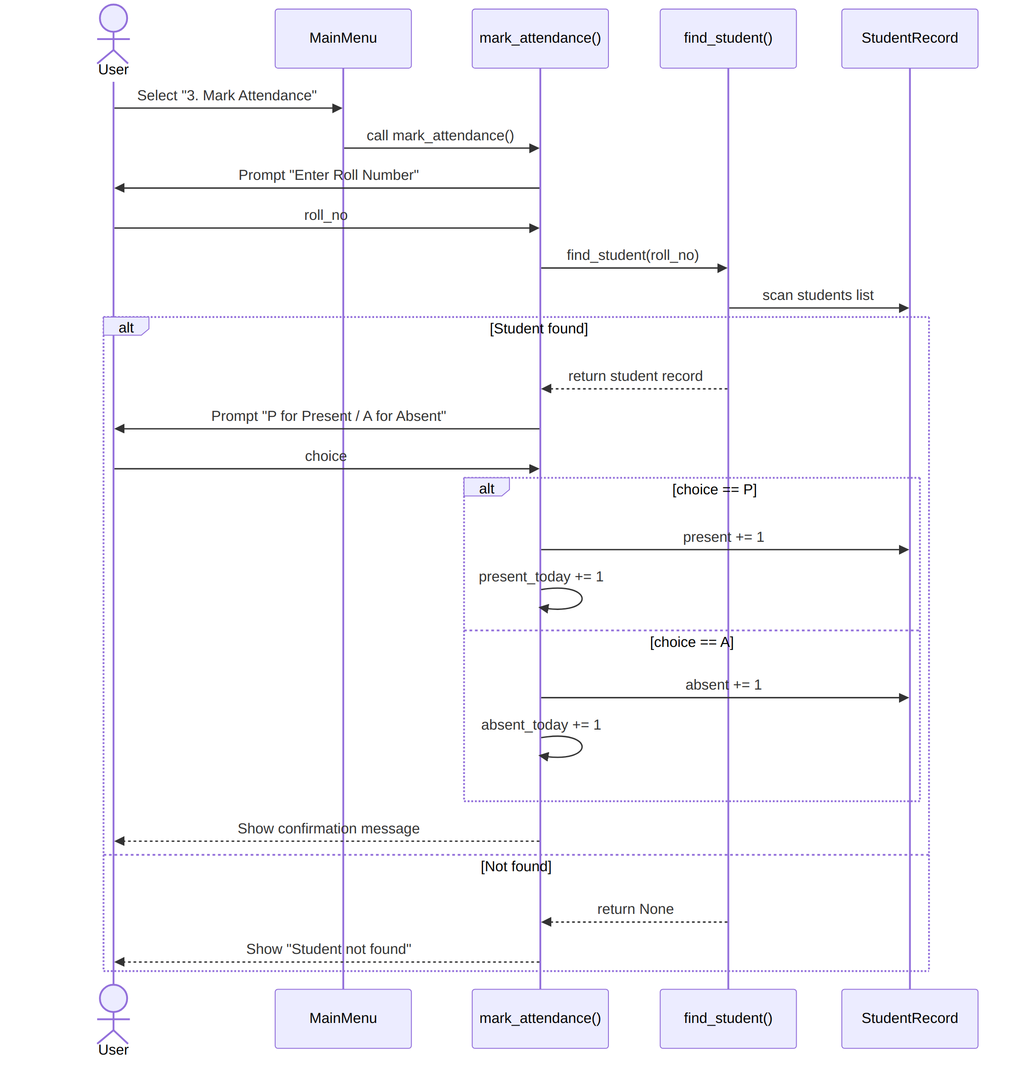
Figure 5: Sequence diagram for the Mark Attendance use case.

8. Database / Storage Design
The application does not use a relational database; the runtime “database” is the in-memory students list, and the persisted artefact is a plain-text file. The ER diagram and schema below describe (a) the data currently modelled, and (b) a proposed ATTENDANCE_LOG entity that would let the system persist day-by-day history instead of only cumulative counters — a natural next step if the system is upgraded to use a real database (e.g., SQLite).

8.1 ER Diagram
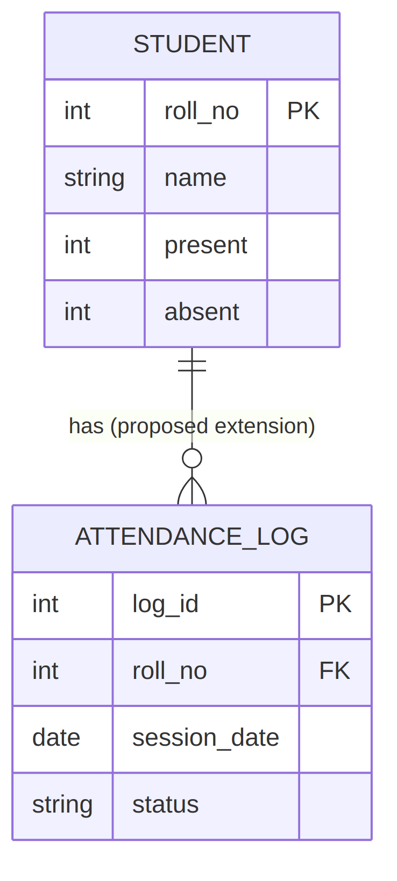
Figure 6: Entity-Relationship diagram: current STUDENT entity and proposed ATTENDANCE_LOG extension.

8.2 Schema Design
Current in-memory record (one Python dict per student):
Field | Type | Constraints | Description
roll_no | int | Unique, required | Primary identifier entered by the user; validated as numeric.
name | str | Required, non-empty | Student's display name.
present | int | Default 0 | Cumulative count of Present markings.
absent | int | Default 0 | Cumulative count of Absent markings.
Exported flat-file schema (students.txt), written on exit, one block per student:
Roll No: <int>
Name: <str>
Present: <int>
Absent: <int>
(blank line separator)
Proposed relational schema for a future upgrade (e.g., SQLite), enabling date-wise history rather than cumulative-only counts:
Table | Column | Type | Constraints
STUDENT | roll_no | INTEGER | PRIMARY KEY
STUDENT | name | TEXT | NOT NULL
ATTENDANCE_LOG | log_id | INTEGER | PRIMARY KEY, AUTOINCREMENT
ATTENDANCE_LOG | roll_no | INTEGER | FOREIGN KEY → STUDENT.roll_no
ATTENDANCE_LOG | session_date | DATE | NOT NULL
ATTENDANCE_LOG | status | TEXT | CHECK (status IN ('P','A'))

9. Known Limitations & Future Enhancements
- Data is not re-loaded from students.txt on startup, so records do not survive across separate runs of the program — only within one session, exported at the end.
- Attendance is stored only as cumulative present/absent totals, not per-date records, so historical trends (e.g., “attendance in March”) cannot currently be reconstructed.
- There is no authentication; any user of the console can add, modify, or view all records.
- The proposed relational schema (Section 8.2) and a load-on-start / append-on-write persistence model are recommended as the primary next iteration.

10. Requirements Traceability Summary
Each functional requirement traces to a concrete function in the source code, confirming that the documentation and implementation are aligned:
Requirement | Implementing Function(s)
FR-1 Add Student | add_student()
FR-2 View All Students | view_students()
FR-3 Mark Attendance | mark_attendance(), find_student()
FR-4 View Attendance Records | view_attendance(), get_percentage()
FR-5 Search Student | search_student(), find_student()
FR-6 Calculate Attendance % | calculate_percentage(), get_percentage()
FR-7 Low Attendance Report | low_attendance(), get_percentage()
FR-8 Today's Summary | today_summary()
FR-9 Save & Exit | save_to_file(), main()
FR-10 Input Validation | All feature functions (roll_input.isdigit(), name checks, try/except on threshold)

