Project Proposal

On

**Book Keeping System**

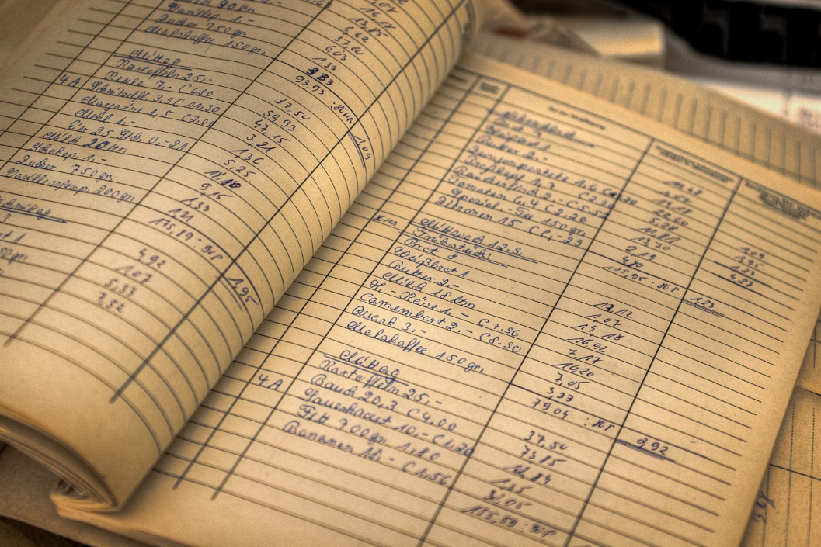

Aashik Majhi

00158350

Computing Project

Level 5 Diploma in Computing

Softwarica College of IT and E-Commerce

Kathmandu, Nepal

June 2019

Submitted to:

Table of Contents

1. Introduction 3

1.1 Project Introduction 3

1.2 Justification for project 3

1.2.1 Background of the project 3

1.2.2 Problem Statement 3

1.3 Description of the project 3

1.3.1 Features 3

2. Project Scope 4

2.1 Scope and Limitation of project 4

2.2 Aims and Objectives 4

3. Development Methodology 4

3.1 Methodology used 4

3.2 Design Pattern 5

3.3 System Architecture 6

4. Work Breakdown Structure (WBS) / Scheduling 7

4.1 Work Breakdown Structure 7

4.2 Milestones 7

4.3 Scheduling / Gantt Chart 9

5. Risk Management 10

6. Configuration Management 11

7. Conclusion of the project 13

8. References 14

# 1. Introduction

## 1.1 Project Introduction

Book Keeping System is a basic project that handles the simple books of account of a small business organization. This system can be approached by any small business organization. The system also helps the users to digitalize the data that they have been recording in the papers for ages. The system mainly focuses in minimized the use of paper for bookkeeping and the retrieval of data smooth and efficient.

## 1.2 Justification for project

### 1.2.1 Background of the project

The project, Book Keeping System can be used for general bookkeeping. The system allows to maintain the books of accounts in a digital way. This system will minimize paper work and increase efficiency of the business organization.

**Primary focus**

The main purpose of the project is to reduce paper work and develop digital market among the business organizations. Digitalization of the books of accounts maintained in the organization.

### 1.2.2 Problem Statement

At the present time period the books of records are maintained clerkly in papers and notebooks. The current state of the process is messed up. It takes much longer time to get information about the past transactions made by the organization.

The project is not being approached for any specific organization even though it can be approached by any small organizations. The project is the alternative to the paper work and getting digitalized. The project aims to minimize the use of paper work.

## 1.3 Description of the project

### 1.3.1 Features

The features of the project are as follows:

* Maintain books for liabilities, assets and capital.
* Maintain book for Clients and Dealers.
* Keeps record of the purchase and sales.
* Reduce irrelevant accounts.
* Consistent records and details.

# 2. Project Scope

## 2.1 Scope and Limitation of project

**Scope**

It is a good system that can be adopted by small organization where transactions are frequent and bookkeeping is must. Data can be retrieved in small time and no pages needs to be turned. Bulky books are long gone with the use of the system.

**Limitation**

The system can only be approached by small business organizations. The system does not generate any reports in its initial version. Only the paper work is digitalized and basic arithmetic logics are added. Proper knowledge about computer is must to use the system.

## 2.2 Aims and Objectives

**Aim**:

The primary aim is to make bookkeeping easy and smooth, with user satisfaction.

Minimization of paper documentation as the records are to be digital. This will help in building a digital record keeping and less use of paper. Get rid of bulky books and ledgers.

**Objective**

* + - The system allows user to keep detail information about the customers.
    - It also lets the user to keep detailed record of the products available.
    - It also keeps the record of daily expenses and incomes made.
    - The system enables the user to maintain ledger that keeps the information about the creditors and the debtors.
    - Simple UI with user-friendly setup environment.
    - The system maintains reliability and security of the data.

# 3. Development Methodology

## 3.1 Methodology used

Waterfall method has been approached in this project as the project is small and the requirements do not need to be altered during the developing phase. The Waterfall approach is very easy to manage because each phase is defined clearly. It is easy and simple to understand. The phases are completed one by one. Initial phase completion leads to next consecutive phase and so until the last phase is completed.

The methodology approached has the following merits:

* Simple and easy to follow up.
* Limited phases and rules to complete the tasks and the phases of development.
* Maintenance is far simpler and easier.
* Progress can be tracked and reviewed over time.
* The documentation brings the easiness in approaching the methodology.

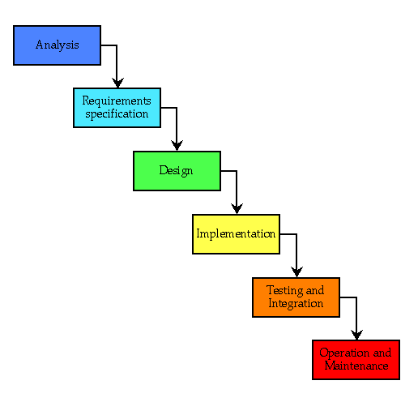

Fig1.Waterfall

This methodology is inappropriate for the projects that have dynamic variation of requirements. Measuring the progress is difficult hence not suitable for large ongoing projects.

## 3.2 Design Pattern

Design pattern are the solution to those problems occurring in the software design phase. These patterns are the blue-prints explaining the solution in detail. MVC- Model-View-Control design pattern is selected for the development of the project.

The different parts of the MVC design pattern are:

* Model:
* Independent from the UI
* Central part of the system
* Management of logics, data and rule of the system
* View:
* The basic idea of the view is to handle the interface of the system
* All the UIs are handled here
* Controller:
  + Main objective is to take in inputs and send either to Model or the View as a command, where and where necessary

The reasons for using the pattern are:

* Its facility to multiple view for model.
* Coupling the system architecture is low
* Due to simultaneous development, it has high cohesion in the code structure.

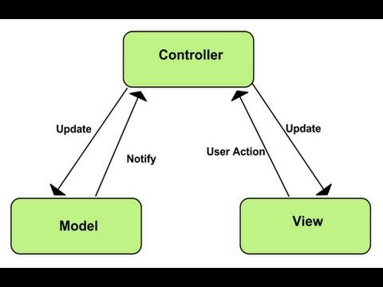

Fig2.MVC diagram

## 3.3 System Architecture

The architecture followed in this project is 3-tier architecture. It has three functional process, logic, data access and the data storage. The three functional process and the user interface module are independent of each other so that they can be developed and maintained on separate platforms. The 3-tiers are as follows:

* Presentation Tier that communicates with other tiers.
* Application Tier that controls the functions and logics of the application.
* Data Tier that stores the data for retrieval, it is independent of the other two tiers.

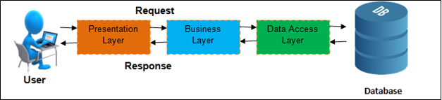

Since data availability is very important in present technology, 3-tier architecture

Fig3.3-Tier architecture

provides the scalability and data security, it is approached in the system. It also provides with extra layer of security to the data.

# 4. Work Breakdown Structure (WBS) / Scheduling

## 4.1 Work Breakdown Structure

WBS stands for Work Breakdown Structure. It helps in success of a project by dividing the huge chunk ok problem into small pieces. The work is divided into small simple parts so that it can be completed without facing any complexities. WBS assures us the completion of the project with maximum performance and good quality within the provided time. It also plays a vital role in smoothness and continuous development of the project.

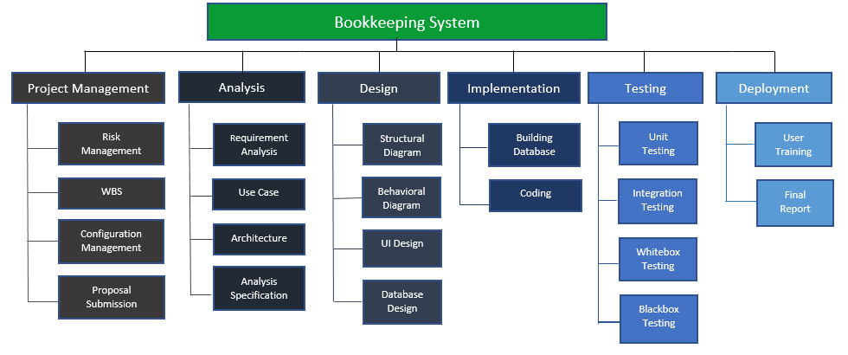

Fig4.Work Breakdown Structure

## 

## 4.2 Milestones

|  |  |
| --- | --- |
| **Milestones** | **Date** |
| **Project Management**  Risk Management  WBS  Configuration Management  Proposal Submission | 21st Dec 2018-4th Jan 2019  21st Dec 2018-24th Dec 2018  24th Dec 2018-28th Dec 2018  28th Dec 2018-2nd Jan 2019  2nd Jan 2019-4th Jan 2019 |
| **Analysis**  Requirement analysis  Use Case  Architecture (Initial Class Diagram)  Analysis Specification | 4th Jan 2019-29th Jan 2019  4th Jan 2019-10th Jan 2019  10th Jan 2019-14th Jan 2019  14th Jan 2019-21st Jan 2019  21st Jan 2019-29th Jan 2019 |
| **Design**  Structural Diagram  Behavioral Diagram  UI Design  Database Design (ER, Data Dictionary) | 29th Jan 2019-26th Feb 2019  29th Jan 2019-4th Feb 2019  4th Feb 2019-10th Feb 2019  10th Feb 2019-20th Feb 2019  20th Feb 2019-26th Feb 2019 |
| **Implementation**  Building Database  Coding | 26th Feb 2019-29th Mar 2019  26th Feb 2019-29th Feb 2019  29th Feb 2019-29th Mar 2019 |
| **Testing**  Unit Testing  Integration Testing  Whitebox Testing  Blackbox Testing | 29th Mar 2019-9th Mar 2019  29th Mar 2019-1st April 2019  1st April 2019-4th April 2019  4th April 2019-6th April 2019  6th April 2019-9th April 2019 |
| **Deployment**  User Training  Final Report | 9th April 2019-19th April 2019  9th April 2019-13th April2019  13th April 2019-19th April 2019 |

**Description of Milestones:**

* **Project Management (14 days)**
  + Risk Management (2 days)
  + WBS (4 days)
  + Configuration Management (5 days)
  + Proposal Submission (3 days)
* **Analysis (25 days)**
  + Requirement (7 days)
  + Use Case (3 days)
  + Architecture (7 days)
  + Analysis Specification (7 days)
* **Design (30 days)**
  + Structural Model (7 days)
  + Behavioral Model (6 days)
  + UI Design (10 days)
  + Database Design (6 days)
* **Implementation (32 days)**
  + Build Database (3 days)
  + Coding (29 days)
* **Testing (10 days)**
  + Unit Testing (3 days)
  + Integration Testing (3 days)
  + White Box Testing (2 days)
  + Black Box Testing (2 days)
* **Deployment (10 days)**
  + User Training (4 days)
  + Final Report (6 days)

## 4.3 Scheduling / Gantt Chart

Scheduling in the way of allocating time or duration to achieve a specific milestone. Scheduling enables us to get a specific task done in short time range. It is one of the key points that makes our project successful. Proper scheduling enhances the chances of completing the project in time.

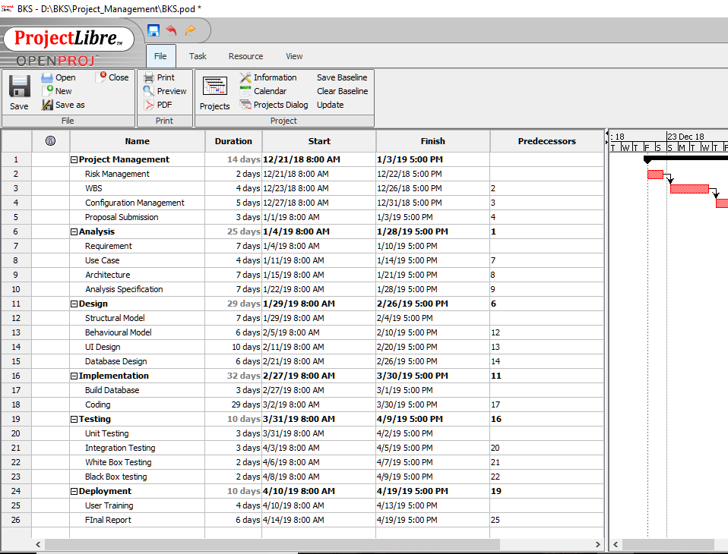Fig5.Gantt Chart

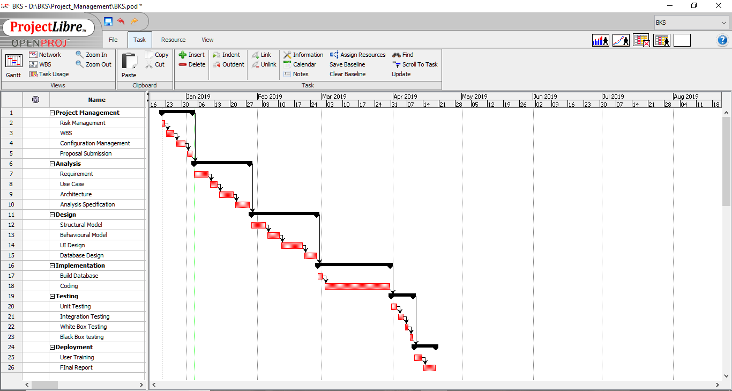

Fig6.Gantt Chart

# 5. Risk Management

Risk Management can be defined as the procedure approached for identifying the drawbacks in the project which can be analyzed and simplified after taking proper approach to the likely solutions. Risk Management avoids the possibly likely obstacles that leads to the failure of the project. The risks can be minimized by taking measure steps to minimize the risk.

The procedure shown below can be followed to get the impact that are possibly to be the risks in our project.

Impact = Likelihood * Consequence

Risk Likelihood values are shown as follows

|  |  |
| --- | --- |
| Likelihood | Value |
| Low | 1 |
| Medium | 2 |
| High | 3 |

Risk Consequence values are shown below

|  |  |
| --- | --- |
| Consequence | Value |
| Very low | 1 |
| Low | 2 |
| Medium | 3 |
| High | 4 |
| Very High | 5 |

**Risk Management Table**

|  |  |  |  |  |  |
| --- | --- | --- | --- | --- | --- |
| S. No | Risks | Likelihood | Consequences | Impact | Solution |
| 1 | Incomplete information | 2 | 4 | 8 | Researches must be done thoroughly before initializing the project. |
| 2 | Hard Disk Failure | 1 | 5 | 5 | Data should be backed up into the cloud servers and other means of storage |
| 3 | Failure to meet the requirements | 2 | 5 | 10 | Proper planning is necessary to meet the requirement. |
| 4 | Health Issues | 1 | 4 | 4 | Precautions are to be taken to avoid any injuries or illness. |
| 5 | Hardware Incompatibility | 1 | 2 | 2 | Hardware components should be upgraded and maintained as per the requirement. |
| 6 | Time | 2 | 4 | 8 | Proper planning should be done and tasks should be completed in given time. |
| 7 | Natural Disaster | 1 | 5 | 5 | Best alternatives are be approached for minimum effects. |
| 8 | Bugs and Errors | 1 | 5 | 5 | Program must be tested and checked before deployment. |
| 9 | Alien User Interface | 2 | 3 | 6 | User-friendly UI should be designed. |
| 10 | Viruses and Malwares | 2 | 3 | 6 | Installation of antivirus and avoidance of unsecure sites for download. |

The risk factors scoring above 6 are listed below along their suitable solutions:

1. Time: Time is the most important factor that plays an important role in completion of the project in the provided due time. Proper planning and scheduling of the task is vital. Measures to be followed are:
2. Proper time management.
3. Completion of the task must be punctual.
4. Failure to meet the requirements: The requirements are to be noted carefully in an orderly manner. If the requirements are failed to bring up in the project, the project is not worth done. The measures to be taken are:
5. The requirements noted down should be verified with the owner.
6. The requirements are to be tested and presented to the owner once the task is completed.

# 6. Configuration Management

It is the way of keeping the record about the change and modification in our project. It helps in tracking the key changes and other minor changes being made in our project. Generally, configuration management lets us to control the version of the project. It keeps the record of the change logs with detailed information regarding the date, time and what changes has been brought in the project. It controls all the attributes (performance, functional and physical) of the project.

Version control is a system that records changes to a file or set of files over time so that you can recall specific versions later. It allows you to revert selected files back to a previous state, revert the entire project back to a previous state, compare changes over time, see who last modified something that might be causing a problem, who introduced an issue and when, and more.

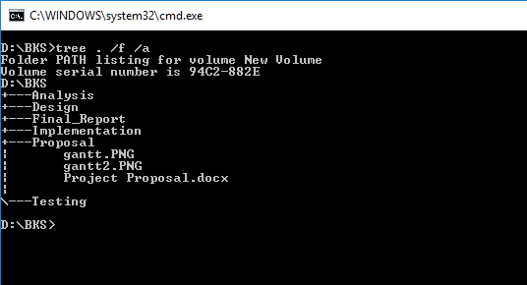

Fig7.Local File Directory

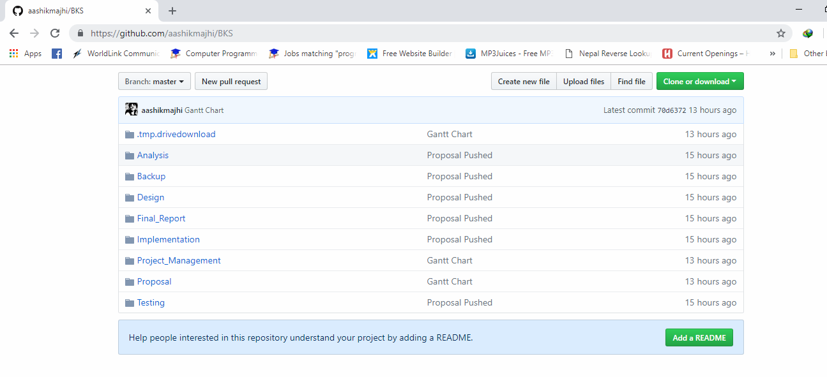

Fig8.GitHub Repository

# 7. Conclusion of the project

The project is targeting to minimize the use of paper and convert the written data into digital data in the business organization. The project helps in building digital market. The project uplifts the standard of the business. It encourages the business to enhance efficiency, integrity, tidy and smooth. The business organization is assured to achieve the efficiency and relevant data. The data recorded will bring up redundancy and digital data can even pursue benefit to the organization.

# 8. References