**User Manual for Futsal Management System**

This User Manual contains all essential information for the user to make full use of the information system. This manual includes a description of the system functions operation, and step-by-step procedures for system access and use.

**Some System Compatibilities that FMS requires in order to operates are follows:**

1. **Operating system**

Windows 7 or MAC OS X 10.0: Cheetah or higher.

1. **XAMPP Server should be installed**

As, this project is not officially at world wide network we need local host to run this website.

1. **Web Browser**

Chrome, Firefox, Safari or MS Edge.

**Feature of FMS are:**

1. Login/Registration System
2. Profile Updating Facility
3. Search Available Timeslots
4. Easy Booking Form
5. Removing Bookings

**Following are steps to follow if you are new to FMS:**

**Step 1. Home Page**



* This is our home page where you can know basic information about our organization.
* Now, Click “Book Now” for your Booking process.

**Step 2. Login Page**

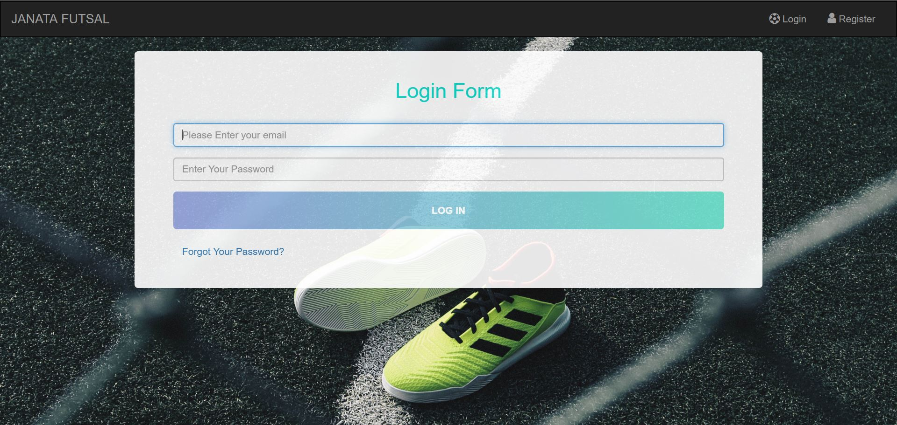

* Now, enter your email and password in order to access our client dashboard.
* If you are new here then click on “Register” text which is presented at top right of navigation bar.

**Step 3. Registration Page**

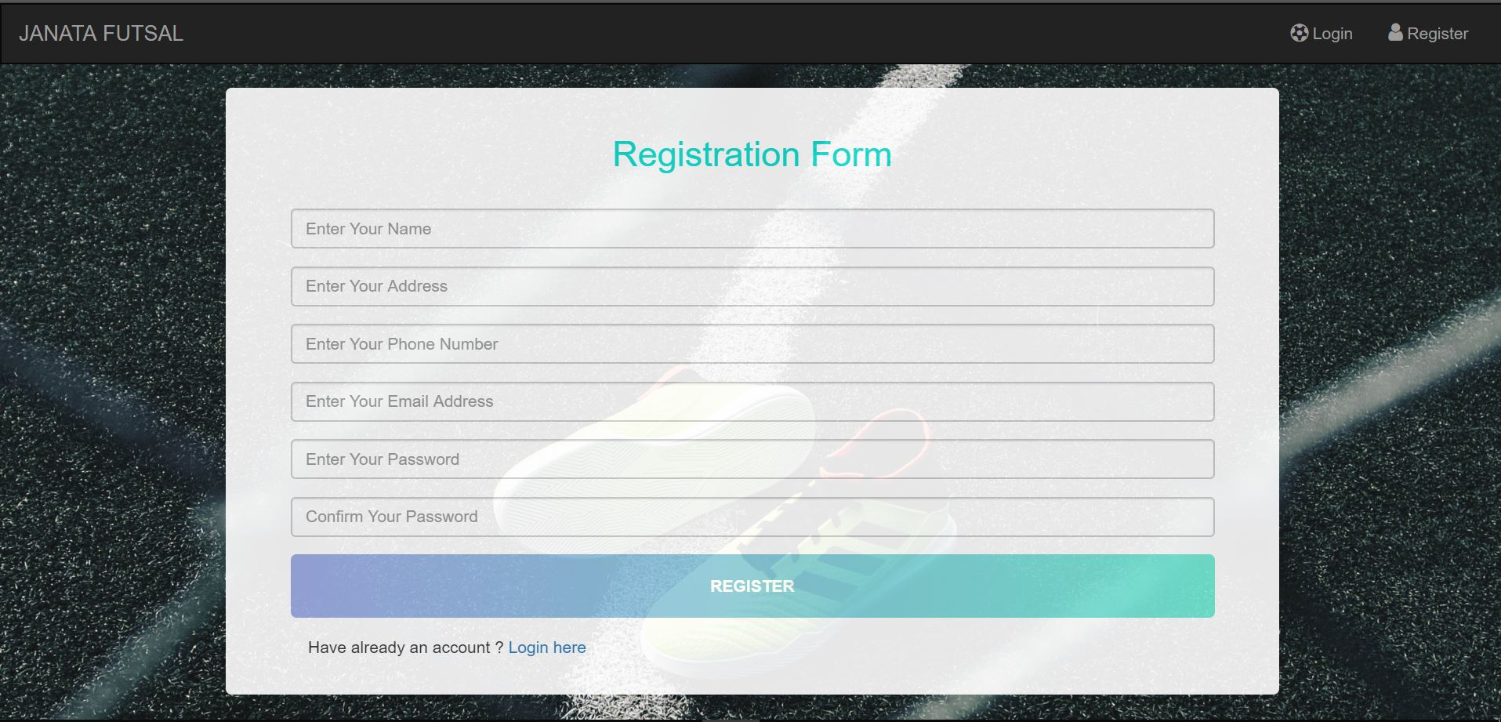

* This is our registration form of our project.
* Fill your information and click “REGISTER” button as in next image.

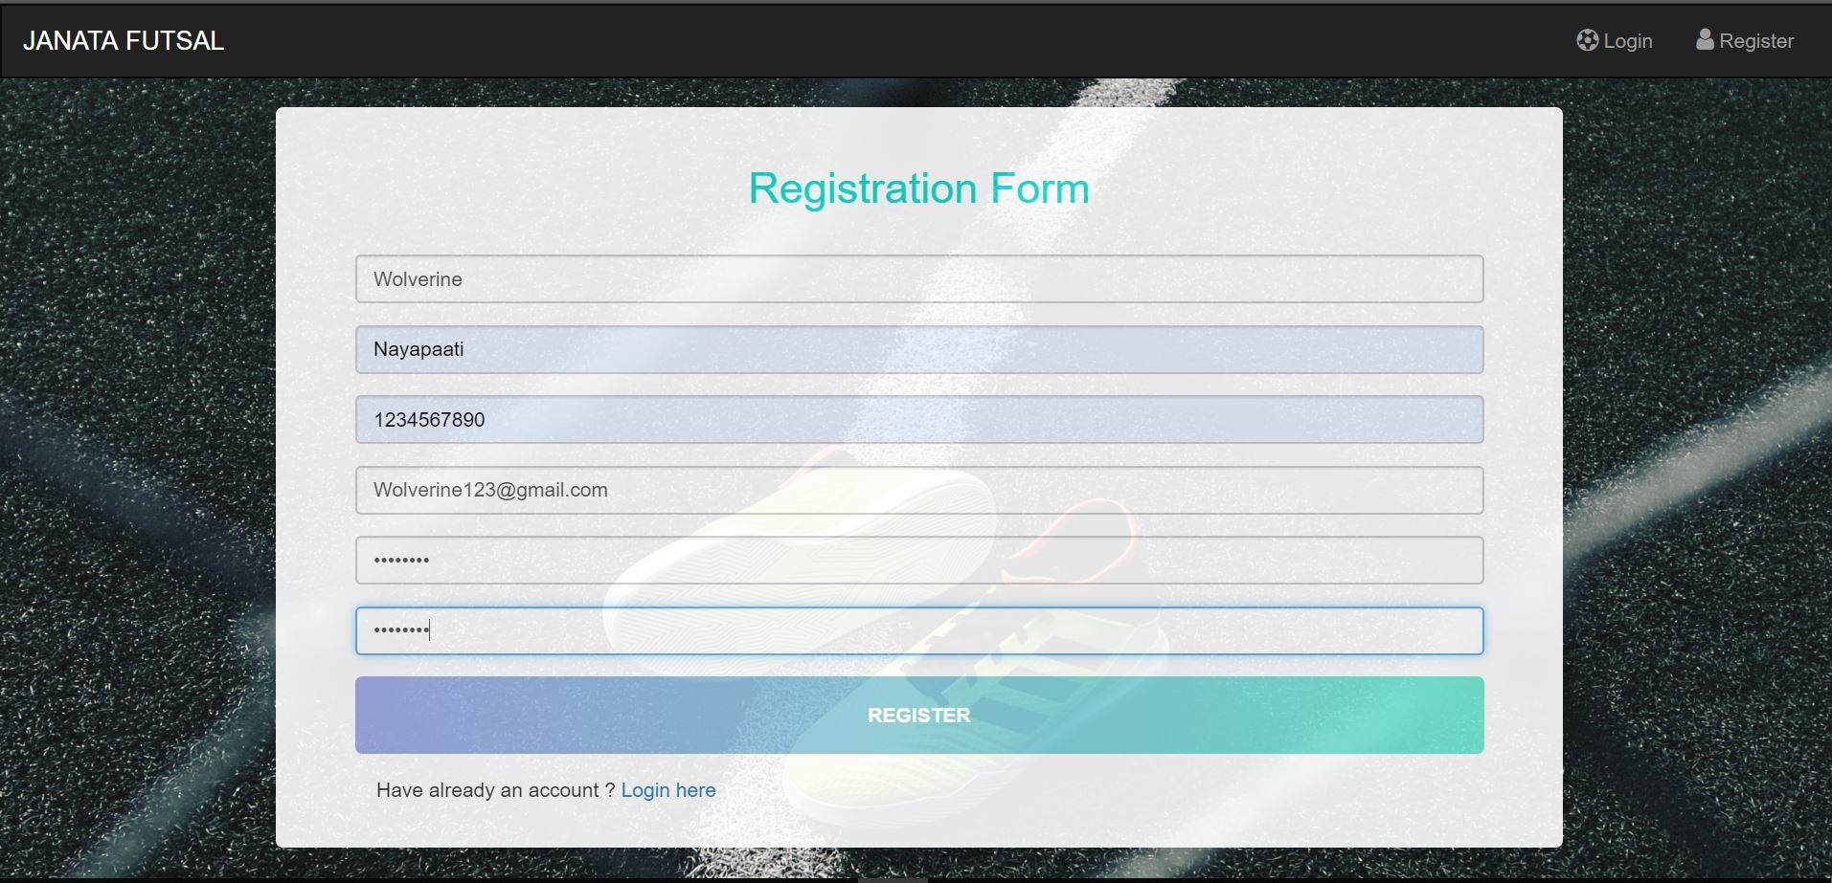

**Step 4. Welcome to Your Dashboard**

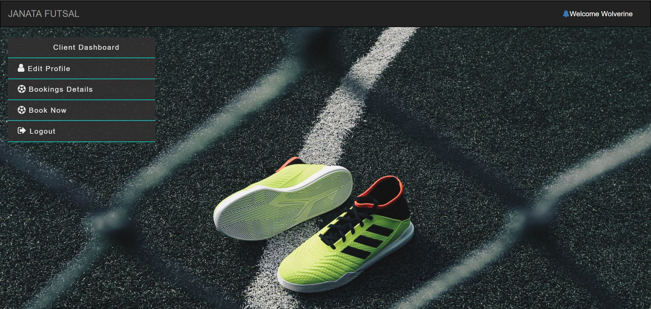

* This is your dashboard where you are permit to add your bookings in our ground.

**Step 5. Click “Book Now” Button**

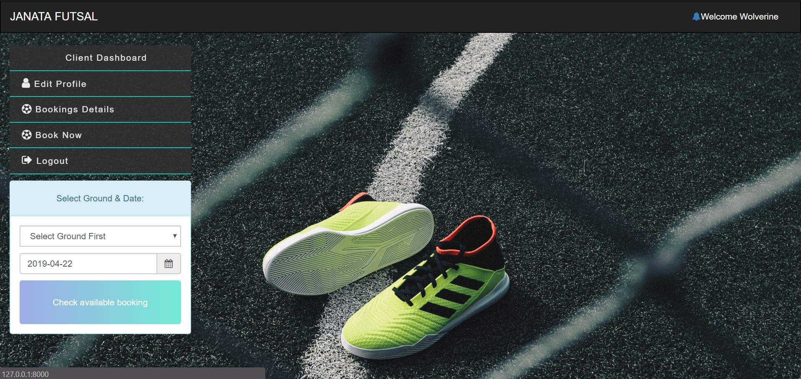

* Select Ground of your choice and date you want for your booking and Search its Available Timeslots.

**Step 6. List of Timeslots**

Note: Red button characterized as booked timeslot and blue represent available for bookings.

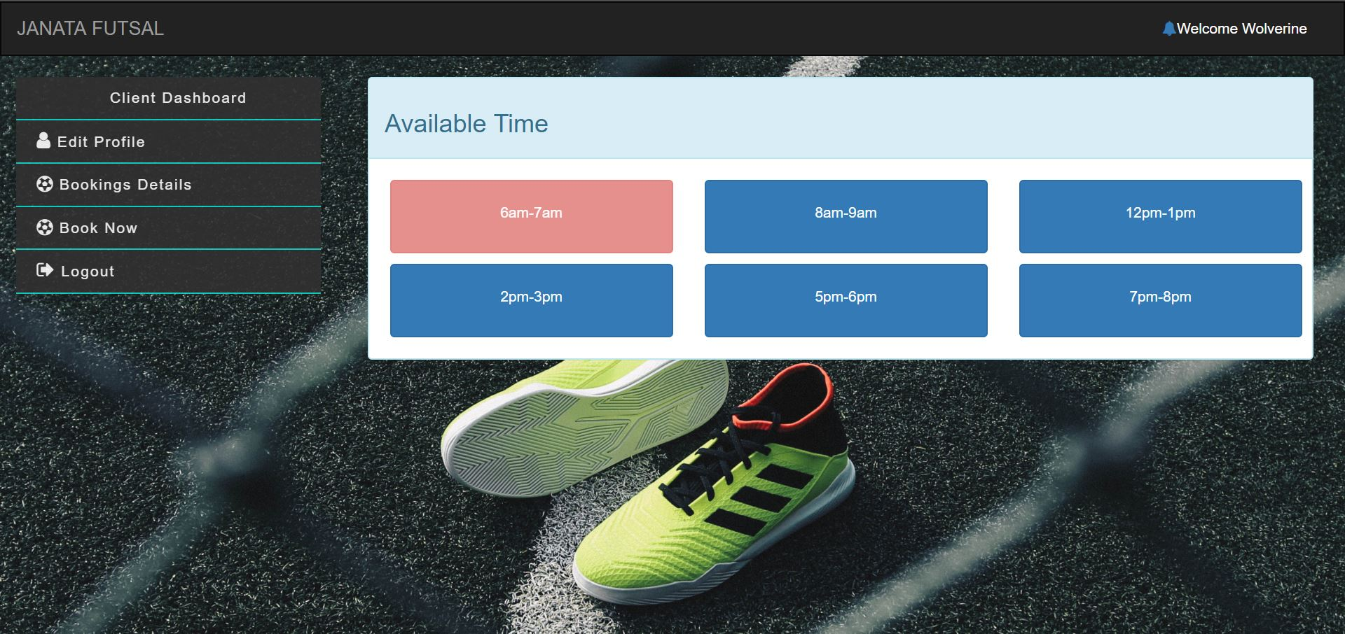

* Select Timeslot of your choice and click on it.

**Step 7. Booking Form**

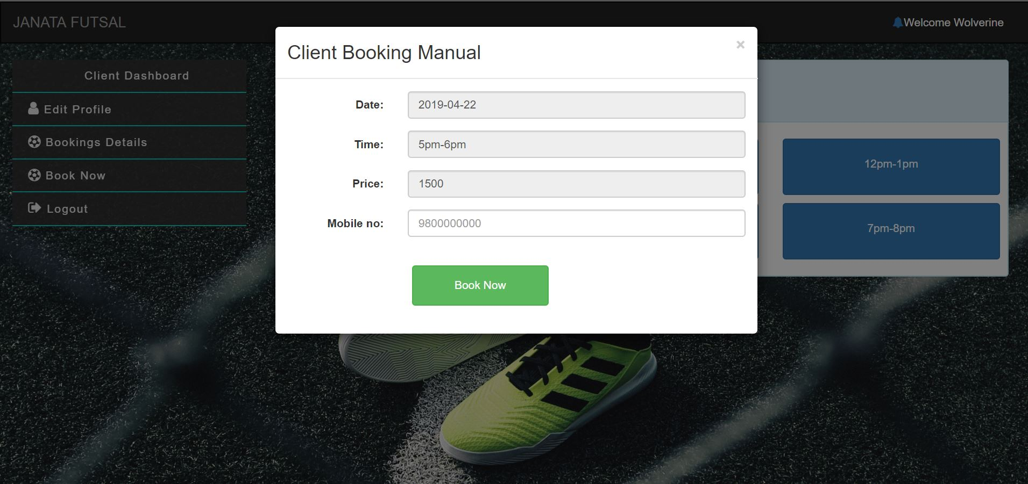

* Now this booking form will be available as you click your intended timeslot with information about date, time. Price and asking your contact number.
* Enter your contact number and click Book Now.

**Step 8. Booking list**

Note: If your booking date and you haven’t paid your booking cost then it will restrict from deleting your bookings and payment status as Booked.

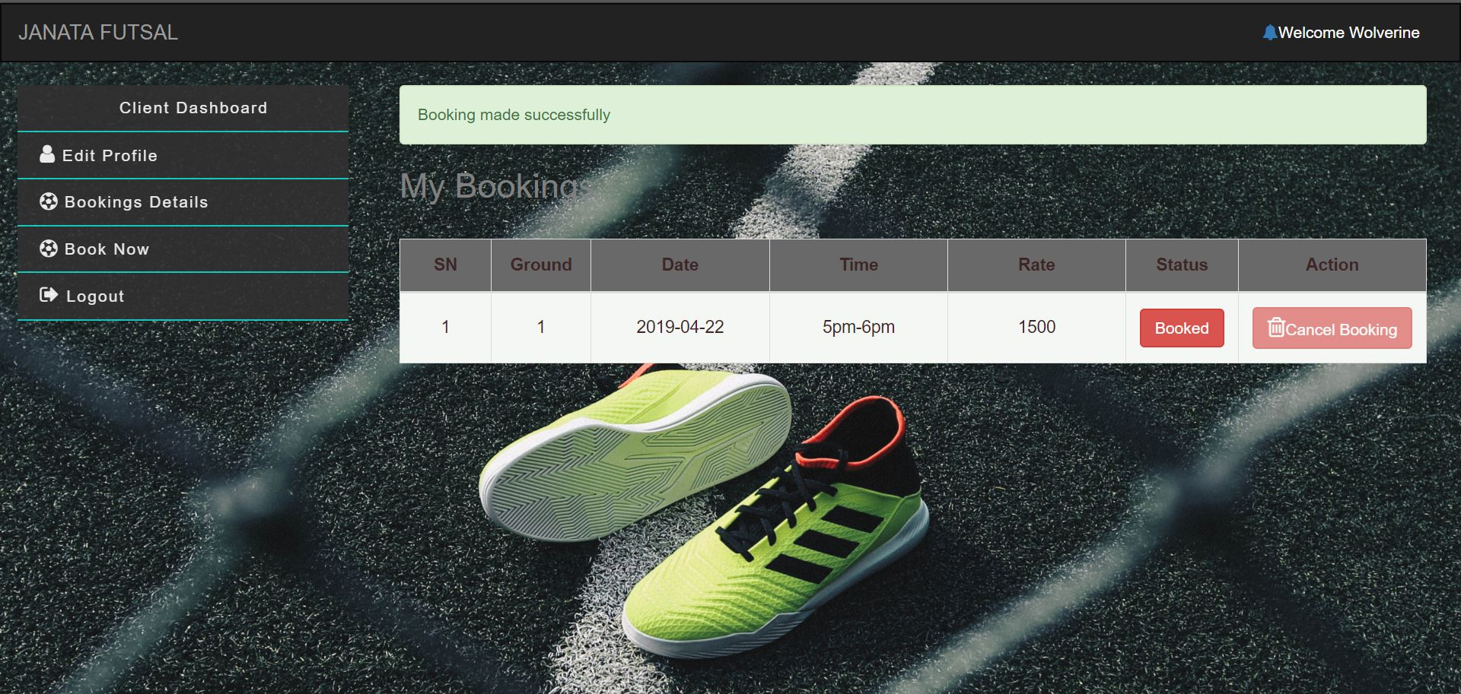

* Now, as you booked you will be redirected to your booking detail page with success where you can look, manage your bookings.