# Abstract

Bookkeeping System is a web-based application which is developed to keep record of the stock items available in the store, the daily sales and purchase data and to know the available quantity in the store. The application enables to maintain the record of the creditors and the debtors, for easiness to make new orders of previously purchased items and sales item.

The sole objective for the development of the application is helping the organization of all range, no matter small or big or even extremely large. It helps to maintain the books of accounts in an orderly manner and systematic form. The data to be recorded are all digital that makes extremely less use of paper and bulky books. Hence, it solves the problem of managing spaces for huge racks to maintain the bulky books and ledgers. It also saves time for turning the pages when any specific data is to be retrieved. Retrieval, update and query of data will be easy to get access with and in a minimal time, this can make positive influence in the way of making business. It would definitely uplift the business standard and would be able to run the business in easy and orderly smooth manner.

The users of this application are the sole owner or the authorized personal to use the application for the business purpose. They have full authority to use the application to its fullest. One can be able to use it even from hundred miles away from any internet connected device.

# Chapter 1

# Introduction

The project developed is for the Module Computing in project. The respective module is based on Level 5 Diploma in Computing (L5DC). The outcome of the learning for three semesters of study can be projected, out of the three semesters, two includes L4DC and one includes L5DC. The project aims to prepare learners for the real-life projects of their interest.

In the era of technology, it is still found, organizations, small and big, recording their business in paper. In today’s digital world, it is not convenient to record data in a clerical manner. It is very risky to maintain document papers and other valuable data in papers and files. Even though we are able to manage that, it is difficult and troublesome to keep up maintenance.

The Bookkeeping System is a web-based application, developed to overcome the problems of maintaining huge bulky books and racks to manage those ledgers and other accounts which also cover huge area. Moreover, the application will be helpful to reduce paper work and transform the hand-written paper data to digital data and will make a step closer to the digital market, which is in a hype in today’s period.

## Problem Background to the System

Keeping records of any particular data in paper and trying to retrieve the same data has been a complete headache to many organizations. Maintaining and managing the books of accounts that include ledger and all the data of the inventory is a real pain. And again, maintaining the data for years and years is a complete pain. Retrieving the data from few years back could be near to impossible. Over the time the books of accounts keep on increasing, resulting in more space coverage and we run out of space.

It can be very difficult to check out the financial status in such cases, tracking the business status is completely nuisance and incorrect. A single person is not enough to keep the records and huge space is required, which can cost more than the business is making.

Hence, the project aims to grow a digital market among the organizations and making the process of book keeping digital and simple, so, even a normal person can approach the application for their use.

## Justification

This is the era of science of technology, which means people might be enjoying the creation of the science and technology. In this era, it is a little old fashion to use pen and paper more frequently. In spite of using modern tools and technologies of the technology period, it is rather old school stuff to write and make notes in paper or notebooks. To overcome all these old stuff issues and hedges this project was completed, in order, to make the proper uses of technologies. The project has also been designed to grow the digital data among current markets and other business organizations.

Keeping the records and maintaining other books of account will be easier, convenient and simple. This will ease the problem of large space for data storing and other expenses to maintain those huge bulky books, to keep them safe from several external factors that might damage the books and other ledger stuffs stored for future reference and other uses.

## Overview of the project design

The application developed on basis of the project proposal is very simple and user friendly. The application is developed with a simple and easily adaptable user interface, keeping in mind that many users may not have any knowledge about such relevant application and may take time to get used to with the system. The application is developed so that the users feel reliable, easiness and comfortable while using the system. This will bring out positive changes in maintaining the books of account for any scale business organization.

## Aims and Objectives

## Aim

* Easy data management
* Smooth business operation
* Maintaining books of account
* Promote digital business and digital market

### Objectives

* Reduce the likely occurring risks of data loss, redundancy and availability
* Minimize the use of paper and general books for bookkeeping
* Secure system to record relevant and related data more reliably and risk freely
* Keeping record of various data regarding business, that will be valuable in future and can be referenced
* Providence of proper application for data management and reliable service.

## Feature of the Project

### Features included:

User registration and login

* Users can be registered with relevant information before access to the system
* Users are the only authorized persons to access the data and make changes.

Retrieve data when needed

* One can retrieve old data for reference purpose from any where
* Users do not have to turn huge bulky books to check any information

Check products available

* Users can easily know the status of the product available with them
* Since the product items will be recorded accordingly, it is also possible to view the quality of the products

Manage Ledgers

* Users can easily know who their customers are
* Users can easily know who their suppliers are

# Chapter 2

# Analysis

Analysis is the most important of the software development life cycle (SDLC). It is the earliest and very important part in software development. All the requirements of the systems are analyzed. Every possible and relevant requirements of the project are noted down and then further analyzed which requirements to be implemented while development phase. This makes crystal clear which features to be prioritized and implemented at the initial phase of development.

Analysis can also be called as the process of identifying the requirements that are very critical to the system, meaning without those functions our application cannot be operated or is non-functional. Analysis also defines the working principle of the system and provides a guideline during development phase. It plays a vital role in software development as it also helps us to meet our requirements for the system in an orderly and appropriate manner. It can also provide a guideline to skip the incoming risk factors that can cause effect in the software development life cycle process. (Anon., 2019)

## Object Oriented Analysis

The process of analysis that defines our requirement along the relationship between the objects and classes involved in each requirement is called as object-oriented analysis. It demonstrates the functional requirement of the system having independent relation with other potential implementation for the requirements.

Advantages and Disadvantages of Bookkeeping System

The advantages of the system:

* Since, it is a web-based application, it can be accessed from anywhere at any time
* Clean user interface for easy adaptability
* Authenticity for secure data storing and comprehending

The drawbacks of the project:

* No customer care service
* Limited account related features

## Requirement Analysis

The requirements are categorized into two types. They are:

1. Functional Requirements

These requirements consist of those requirements that actually describes the behavior of certain features of our application. It also describes the action of the system when a particular condition is satisfied. The functional requirements are the base of the application that helps to accomplish the requirement specification of the program that also meets the client expectations.

1. Non-function Requirements

These requirements are related to the quality of the system developed for the project. The quality attributes like security, performance, compatibility, usability and scalability fall under this categoric requirements. It also describes the functions working principle in the application, that is, how is the application going function.

## Prioritization of the Requirements

Prioritization, itself makes it clear that it is related to priority. Hence, prioritization of requirements can be said the process of prioritizing the features that are to be included in the developing system. The features and functions are prioritized on the basis of their importance to the system. It makes clear to the developers in understanding the requirements of the project. It makes approach of orderly steps of features development to accomplish the objectives. For the process of prioritization Moscow rule has been approached to make prior features and functions for the Bookkeeping System. It’s simplicity and easy to understand feature convinced me to approach this methodology. The methodology MoSCoW stands for Must have, Should have, Could have and Will not have requirements of the project. (Anon., 2019)

Must Have

* Covers about the 60% of the requirements list
* Only critical functions any features lie under this part

Should have

* Covers the 20% of the requirements list
* Features that hold important functions but not as critical as that of must have features

Could Have

* Covers 20% of the total requirements list
* Involves the essential but not critical features that can fail the operation of the system. They are the supporting features that could be beneficial to the client, if added.

Won’t Have

* Involves features that do not have any value to the system but can be helpful to operate the system without and hinderance.

## Natural Language Analysis (NLA)

Natural Language Analysis is a process of identification of the requirements using the common language and identifying the candidate classes and their relationship with help of nouns, verbs and adjectives. A descriptive text is used for the identification of the attributes of the classes and process that can be created in our system. The potential methods could also be identified with the help of NLA.

## Use Case Diagram

A use case diagram is a diagrammatic representation of the interactions of the elements in our system. The interaction among the different functions and methods is shown or presented in a diagram form and the relation is shown using straight lines. The lines show relationship with the functions, what the user can do in the system. It provides a clear view of the system, how the system will function after the launch.

The features of the class diagram:

* The use case diagram defines the boundary of the system that is to be developed.
* The roles of the individual actors those who may take part in using the system is defined.
* It represents the relation between and among the actors and the use cases of the developing system within the project.
* The use cases are defined. Actors play specific roles within and around the system.

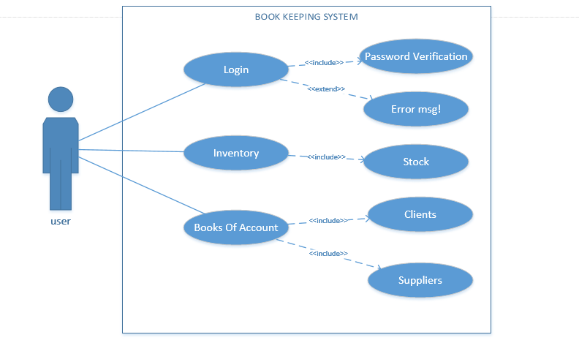

## Architecture Diagram

### Initial Class Diagram

Class

It is the blue print of the system that is to be developed in the project. Objects with same attributes and operations are explained in the class.

* Attributes for structural features
* The state of the class object can be defined by the attributes
* Structural and static features of the class can be described.
* Operations for Behavioral features
* Defines the functionality of the objects
* The dynamic features of the class are described

Class Notation

* Class Name
* Class name at the center in the topmost layer.
* Attributes
* Variables along their data type is contained in the second layer.
* Methods
* Methods listed in the class are listed in the last layer
* Parameters and returning values are mentioned
* Colon is used for the separation of the Method and the return type of the passing parameters

Class Diagram

Class diagram is such type of figurative structure that is used for the illustration of the classes and functions and methods present in each classes of the system. It also contrasts the relationship of the classes. Getting information of the functions and objects of the methods is easy from this diagram.

It provides the developer a static view of the purposed project. This diagram can be easily mapped with the object-oriented programming, hence, used as a skeleton of the system during code implementation phase. This diagram is very essential and appropriate before implementing the code structure to the system.

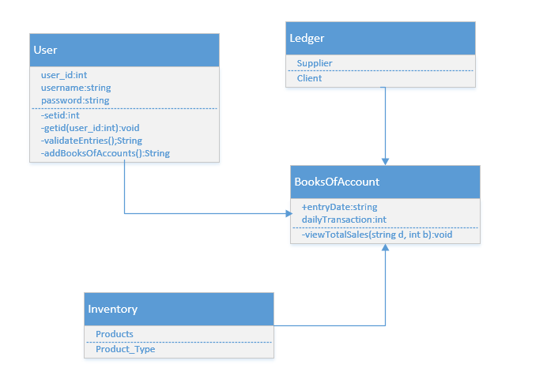

Fig Initial Class diagram

## System Architecture

The architecture followed in this project is 3-tier architecture. It has three functional process, logic, data access and the data storage. The three functional process and the user interface module are independent of each other so that they can be developed and maintained on separate platforms. The 3-tiers are as follows:

* Presentation Tier that communicates with other tiers.
* Application Tier that controls the functions and logics of the application.
* Data Tier that stores the data for retrieval, it is independent of the other two tiers.

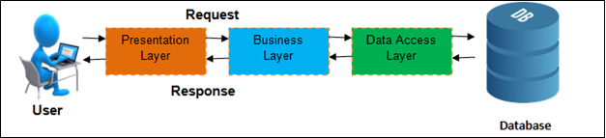

Fig3.3-Tier architecture

Since data availability is very important in present technology, 3-tier architecture provides the scalability and data security, it is approached in the system. It also provides with extra layer of security to the data.

# Chapter 3

# Design

After the analysis of the requirements for the development of the system, the requirements are to be implemented into a functioning system. All the analysis and other documents are changed into logical structures being ready to implement in the system at the time of code implementation. The design phase consists of the data flow diagram, activity diagram, sequence diagram, class diagram. These diagrams provide logic for the development of the project. It is also a critical phase in the software development life cycle. It gives a clear view for the use of function along their usability in the system. With the help of the design the processes can be traced and their activity or actions can be recorded to check if the system is functioning as it is designed for.

## Structural Modeling

The data and the entities are presented in structural modeling. The relationship between the entities is described and then presented diagrammatically. All the functions are transformed to structures and finally measures for development phase is decided to be carried out. This modeling provides a clear blue print of the system about the database design. It keeps track of the entities and the attributes to be recorded or stored by the system in the database designed for the system.

## Data Flow Diagram

DFD is created for the vision of data flow in our system from the system to the database where the data is stored. The data flow diagram provides a vision of the data flow from and to the system. Simply the path of the data to be travelled in the system. The flow of the data in the system can be traced, which is very useful in discovering the bugs and maintenance of the system is simplified. It can give us a clear path of the data travel in the system from and to the various functions.

## Behavioral Modelling

One of the UML diagram used for the representation of the behavior of the system developed. It can be used to explain the proper behavior of the application. The work flow of the system can be generated systematically that enhances the development of a robust system. It provides us the wide view of the behaviors of the functions and process at the run time. It enables us to track where a specific process is called for what purpose.

## Activity Diagram

It is a structured version of the flowchart diagram. It is more likely a workflow diagram, used to describe the active and the changing factors in the system. Flow of the activity or process is demonstrated to define the functions and logic in the system. It can be helpful in tracing the functions and to ensure that the respective functions and processes are being executed when and where required or called by the system.

## Sequence Diagram

This diagram is generated to make the relation of the objects in the system visible and manageable. It provides us a visionary graph about the interactions and actions of the objects. It provides us information about the sequence of the processes, which function executes at first, and then which function is to be executed sequentially for any particular action.

## Database Design

Database design involves the data dictionary that contains all the details about the entities and attributes created in the system. The data types and constraints are implemented in this design. Database design is made simple and minimum numbers of columns are created for each entity because it is said that, “Too Many Column Too Many Work”. It is made simple so no data are duplicated and data base is not flooded.

## ER Modelling

Entity-relationship diagram is a diagrammatical representation of the entities or classes created in our system. It shows a clear relationship between the classes, their attributes and dependencies along the multiplicity. It is very helpful for the process of designing a database for the system to hold the values and data.

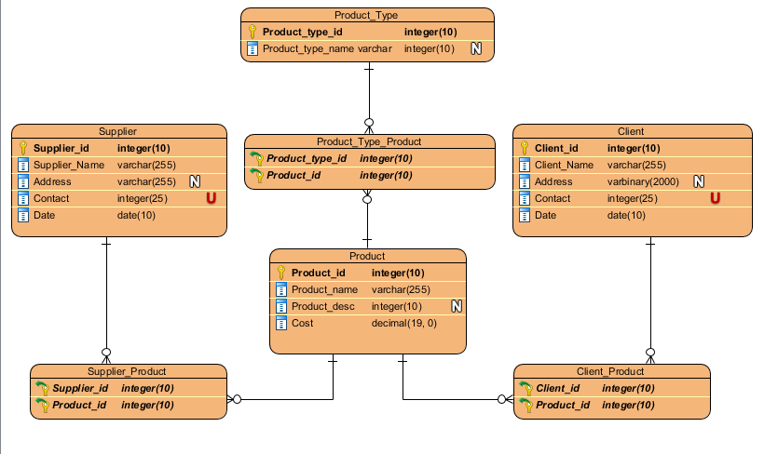

Justification

The entity relationship (ER) diagram has been constructed. It shows the tuples and the attributes in the tuples along with their data type and constraints implemented for the data base of the system. The entities are associated with their relationship to each other. Constraints like primary key and foreign key have been implemented.

## Data Dictionary

Data dictionary holds the data and data types of the entities that the data base holds. The data about the information in the meta data is presented normally in the data dictionary. Other database related contents and information are contained in the data dictionary.

The data dictionary for the purposed system is presented down below, along their key values applying constraints where required.

## UI Modelling (Prototype)

User Interface is the most critical part is presenting the system. It ensures how comfortable the user can be while using the system. It must be simple and easy. Furthermore, the UI of any system must be user-friendly so that the users can easily adapt to the working principle of the system and feels easy to communicate with the system.

# Chapter 4

# Implementation

## Language (Java)

Java is the language designed for programming. It is based on classes, objects and designs. According to technopedia ([www.technopedia.com/definition/3927/java),”Java](http://www.technopedia.com/definition/3927/java),) is a programming language that produces software for multiple platforms.” Designed in mid-190’s by James A. Gosling.

It is improvised version of version C language but the compiled used by jdk is designed from that of C++. The tool used for development of the project is Spring Tool Suite (STS) which is a free development ide provided for Java. Advantages of using java for application development are:

* More secure than any other programming languages.
* It is an object-oriented programming language.
* Java is usable in various ide.

## Framework (Spring Boot)

Framework approached for the development of the project is Spring Boot. It is one of the mostly used java framework developed by Pivotal Team. Bean is automatically configured in Spring Boot whereas it had to configured manually for spring framework. It is suitable to develop a robust free applications and systems as it is simple and easy to work with. Spring Boot allows to adapt MVC pattern for application development.

## Development Methodology

Waterfall method has been approached in this project as the project is small and the requirements do not need to be altered during the developing phase. The Waterfall approach is very easy to manage because each phase is defined clearly. It is easy and simple to understand. The phases are completed one by one. Initial phase completion leads to next consecutive phase and so until the last phase is completed.

The methodology approached has the following merits:

* Simple and easy to follow up.
* Limited phases and rules to complete the tasks and the phases of development.
* Maintenance is far simpler and easier.
* Progress can be tracked and reviewed over time.

The documentation brings the easiness in approaching the methodology.

This methodology is inappropriate for the projects that have dynamic variation of requirements. Measuring the progress is difficult hence not suitable for large ongoing projects.

## Design Pattern

Design pattern are the solution to those problems occurring in the software design phase. These patterns are the blue-prints explaining the solution in detail. MVC- Model-View-Control design pattern is selected for the development of the project.

The different parts of the MVC design pattern are:

* Model:
* Independent from the UI
* Central part of the system
* Management of logics, data and rule of the system
* View:
* The basic idea of the view is to handle the interface of the system
* All the UIs are handled here
* Controller:

Main objective is to take in inputs and send either to Model or the View as a command, where and where necessary.

The reasons for using the pattern are:

* Its facility to multiple view for model.
* Coupling the system architecture is low
* Due to simultaneous development, it has high cohesion in the code structure.

# Chapter 5

# Testing

Testing is the process of uncovering the bugs and errors present in our system. Sometimes a bug in a system can cause a huge damage and loss, therefore a testing is important. Some software bugs can even be more dangerous and could result in expensive solution. Testing is done to make our program robust and functional. Testing also defines the drawbacks present in our system. It also assures the quality of our application. General way of testing is to define how well something works and it also checks if any functional requirement is met or not.

A test is performed to deliver a bug free application, that runs smoothly and ensures that the requirements has been met and the quality is as promised to be delivered. There are different types of testing, white box testing, black box testing, accessibility testing, compatibility testing, acceptance testing and many more. The testing performed in this project are listed below:

1. White Box testing

White box testing has various names. It can be known by clear box testing, code-based testing. But in general, it is a function testing of our system. It is performed to check the internal structure, design architecture and the implementation done in our system. All the test modules are known to the tester, the tester knows the working principle of the system and has knowledge about all the modules and functions present in our system.

* Unit Testing

The term unit makes clear about the unit testing. Unit is the basic part of our system, that is to be tested. All the modules created in our program are tested individually. The individual units of our system are assured with functionality. In general unit testing has few inputs and a single output.

1. Black Box Testing

Here the tester is completely blank, with no idea about how the system works. The tester is completely unknown to the modules and functions. The tester is not from the development team. Black box testing is performed to check the compatibility of the user. The application is executed and the tester provides the input and commonly the outcome of the input is the test result of the test. According to www.guru99.com, “Black box testing is defined as a testing technique in which functionality of the Application Under Test (AUT) is tested without looking at the internal code structure, implementation details and knowledge of internal paths of the software”.

Black box testing is generally input and output focused.

# Chapter 6

# Other Project Issues

Alike the pros and cons of all the other projects, this project also has its own cons. The major issues of this project are listed down:

1. The application is slower as it takes several minutes to load the details about the debtors and creditors. This is caused as the data to be retrieved are to be extracted from the database through queries.
2. Some mobile devices might not be able to load the application. It is designed in a very limited time without testing it in any mobile devices.

## Limitations of the Project

* Supports in very limited browsers:
* Limited to data keeping, no any further reports can be generated.
* Not applicable for service-oriented business organizations.

## Risk Management

Risk Management can be defined as the procedure approached for identifying the drawbacks in the project which can be analyzed and simplified after taking proper approach to the likely solutions. Risk Management avoids the possibly likely obstacles that leads to the failure of the project. The risks can be minimized by taking measure steps to minimize the risk.

## Problem faced during development

### Incomplete resources

During the proposal of the project, case study had to be performed, but due to limited access to the resources and other components, study was not deep and thorough. The project also needed access to the various organizations and business transaction related data, due to security and privacy reason that could not be provided to us hence the requirements could be out of the relevant topic. Due to time boundary only few stores and business organizations were surveyed, that were not sufficient to generate the analysis requirement.

### Static Requirements

The approached methodology for the system development was water cycle process, where the initial requirements were to be completed before dealing with the other consecutive modules. But our requirements were static that kept on changing. It was very difficult o meet the requirements and complete the project in the provided time limit. This was the main problem faced during the development of this project as time was limited but the requirements had no boundary.

### Failure of servers

The servers crash was a big deal while implementing the database to our system. The local host would keep on crashing due to some incompatibility with the OS version of the development environment. Ended up with the time lacking, it was fixed the development was continued.

### Health Issues

Due to some changing weather conditions of the nature. The natural climate in the locality, some extreme weather conditions were a blockade in the process of software development. The extreme weather conditions directly influenced with the personal health and was a hinderance.

## Configuration Management

It is the way of keeping the record about the change and modification in our project. It helps in tracking the key changes and other minor changes being made in our project. Generally, configuration management lets us to control the version of the project. It keeps the record of the change logs with detailed information regarding the date, time and what changes has been brought in the project. It controls all the attributes (performance, functional and physical) of the project.

Version control is a system that records changes to a file or set of files over time so that you can recall specific versions later. It allows you to revert selected files back to a previous state, revert the entire project back to a previous state, compare changes over time, see who last modified something that might be causing a problem, who introduced an issue and when, and more.

## Scheduling

Scheduling in the way of allocating time or duration to achieve a specific milestone. Scheduling enables us to get a specific task done in short time range. It is one of the key points that makes our project successful. Proper scheduling enhances the chances of completing the project in time.

WBS stands for Work Breakdown Structure. It helps in success of a project by dividing the huge chunk ok problem into small pieces. The work is divided into small simple parts so that it can be completed without facing any complexities. WBS assures us the completion of the project with maximum performance and good quality within the provided time. It also plays a vital role in smoothness and continuous development of the project.

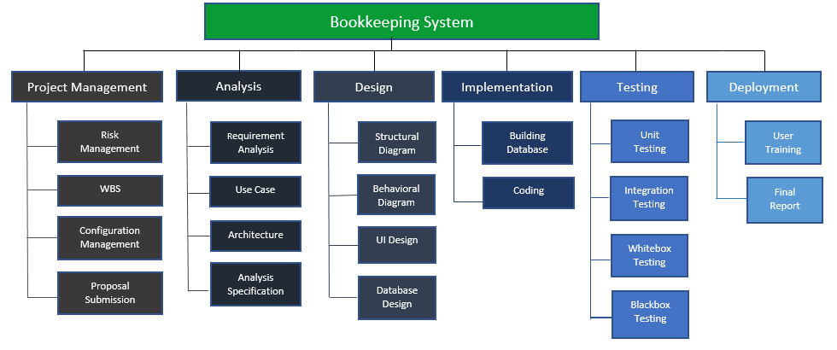

Fig Work Break Down Structure (WTS)

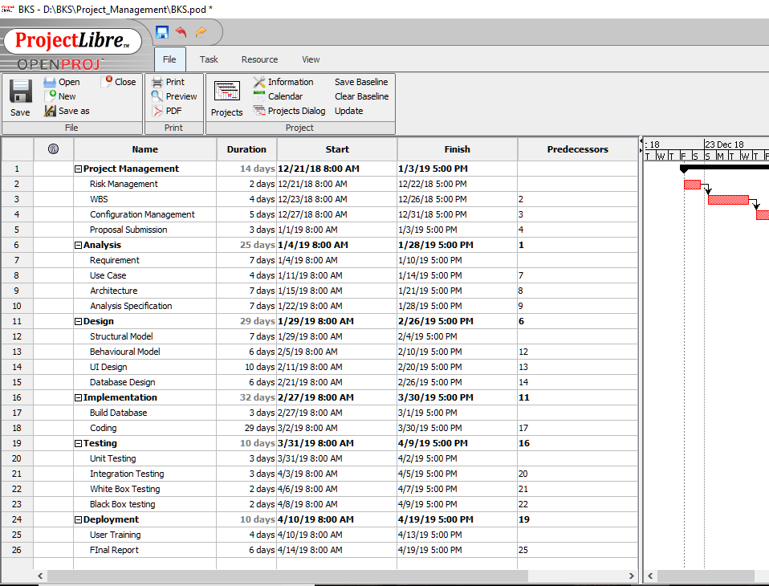

Fig project planning

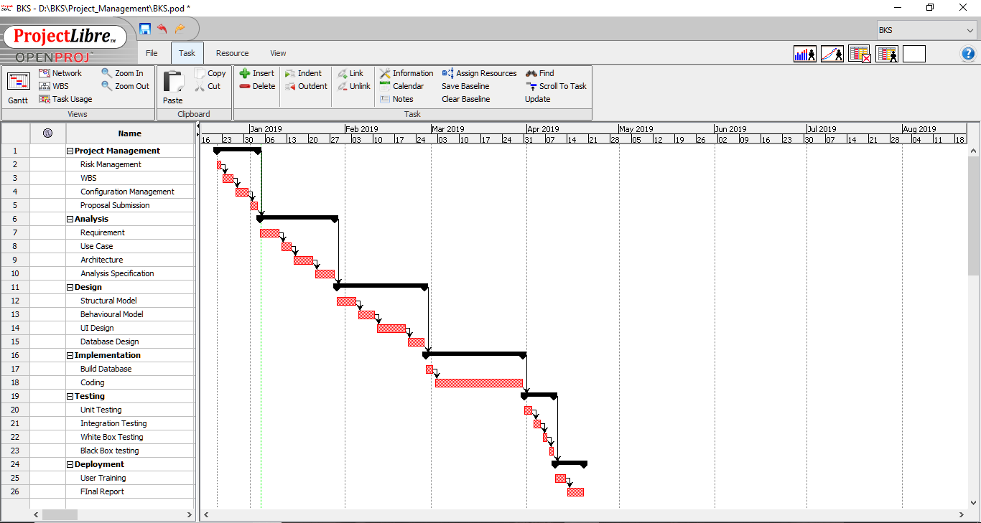

Fig Project Cycle Dependencies

## Future Work

No project is perfect, everything lacks something that ranks them below perfect. Since, only basic functions were added in the system, that covered up the sixty percent of the total requirements. More compatible relevant features need to be added in the system that can ease other account related problems to its users. Other features that could be added to the system in future are listed here:

* Business Transaction- Monetary and non- monetary transactions
* Account details of the suppliers and customers- Debit and Credit balance
* Low on Stock alert

# Chapter 7

# Conclusion

The project is targeting to minimize the use of paper and convert the written data into digital data in the business organization. The project helps in building digital market. The project uplifts the standard of the business. It encourages the business to enhance efficiency, integrity, tidy and smooth. The business organization is assured to achieve the efficiency and relevant data. The data recorded will bring up redundancy and digital data can even pursue benefit to the organization.

Finally, the project was successful and functional. The report for the project was completed that included all the steps followed for the completion. The success was only achievable with the help of following measures and actions:

* Analysis: Analysis was conducted in order to check the feasibility of the project.
* Requirement Specification: The analysis process was followed by requirement specification. It had the use cases diagrams that explained the actions of the users in the system.
* NLA: NLA was performed to determine the classes and functions in the system. It was very helpful in constructing final class and the initial class.
* Design: After the determination of initial and final classes, functions and the basic requirement of the system, design had to be generated. The design part consisted of the diagrams like; Structural Diagram, Behavioral Diagram, UI design were generated for the visualization of the system. The design also included the database modeling, ER-diagram, class diagram, activity diagram, sequence diagram and data-flow-diagram to use the logics in our system. The data dictionary was constructed that included the metadata of the columns in the table.
* Coding: Design made the concept clear on how to implement the above measures and then the coding phase was conducted. Because of the above solutions and guidelines, it was simpler and more relevant to implement the coding structure for the development.
* Testing: The completion of the coding phase was led by testing process.

Completion of the above process led to the successful launch of the project “BOOKKEEPING SYSTEM”. A proper documentation for the processes involved while building the system and the reason behind all those processes are stated.

# Chapter 8

# References