**MCS**

**Assignment 1**

**Y. Sai Dheeraj**

**IS201501056**

**UG3 C.S.E**

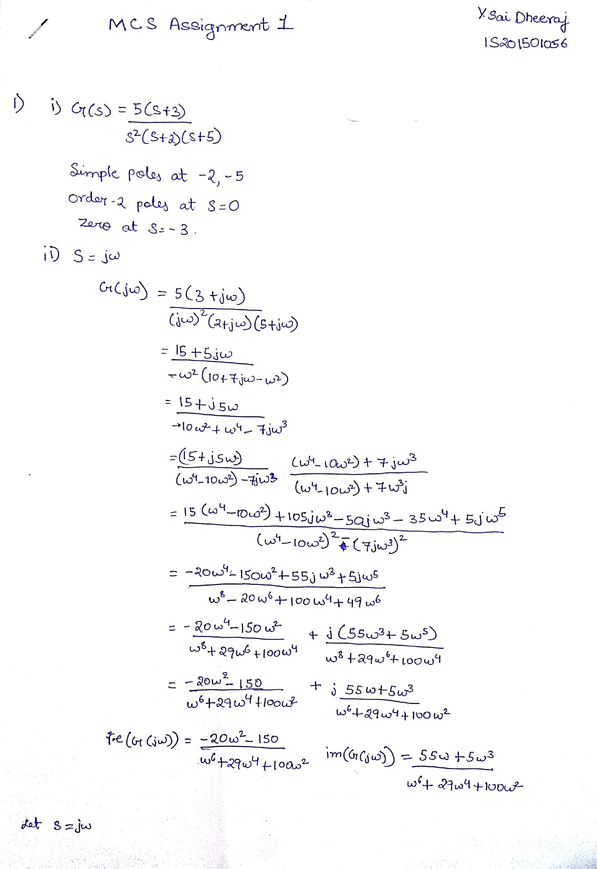

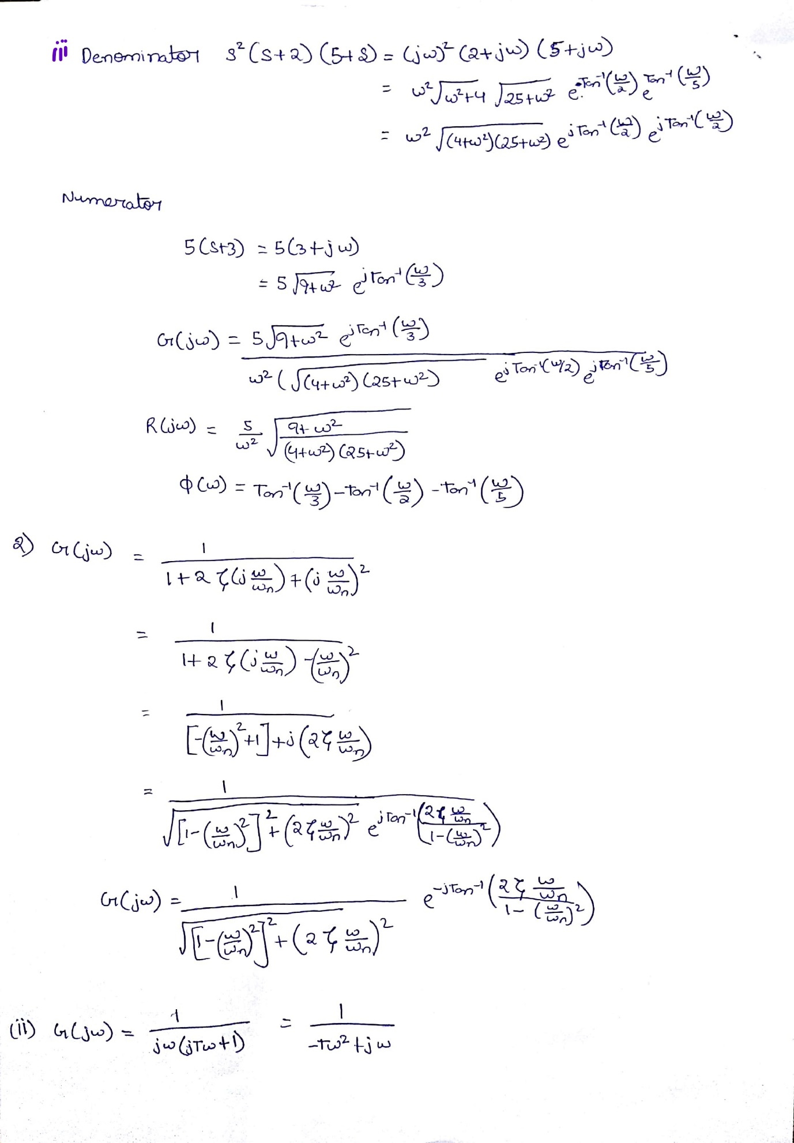

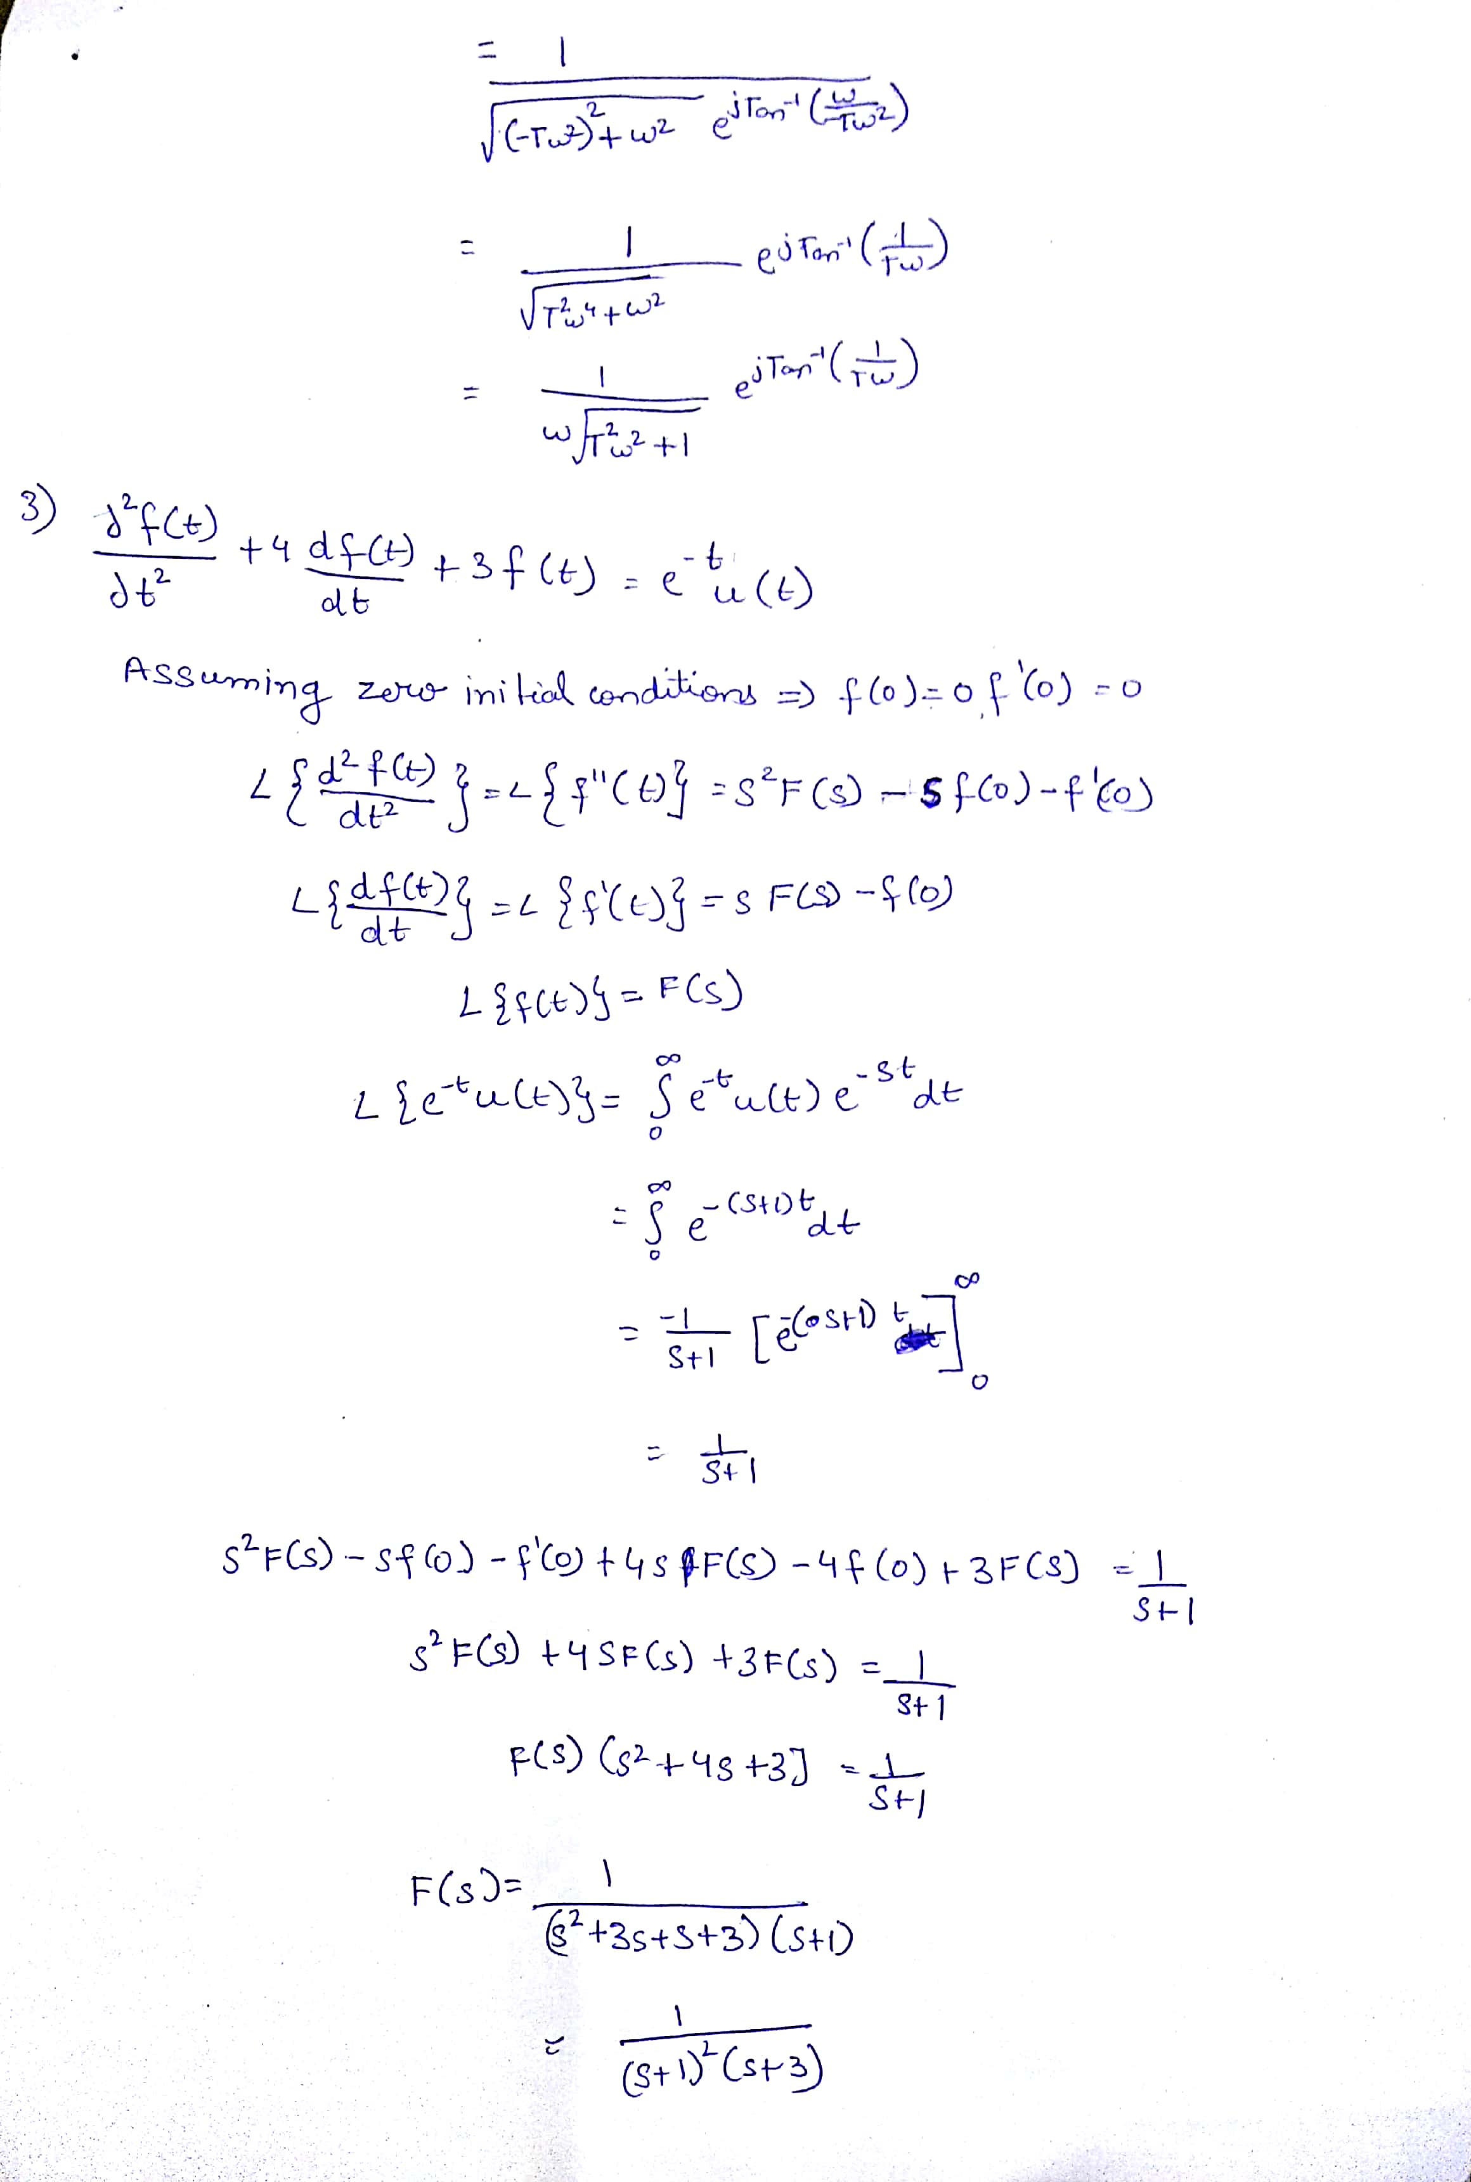

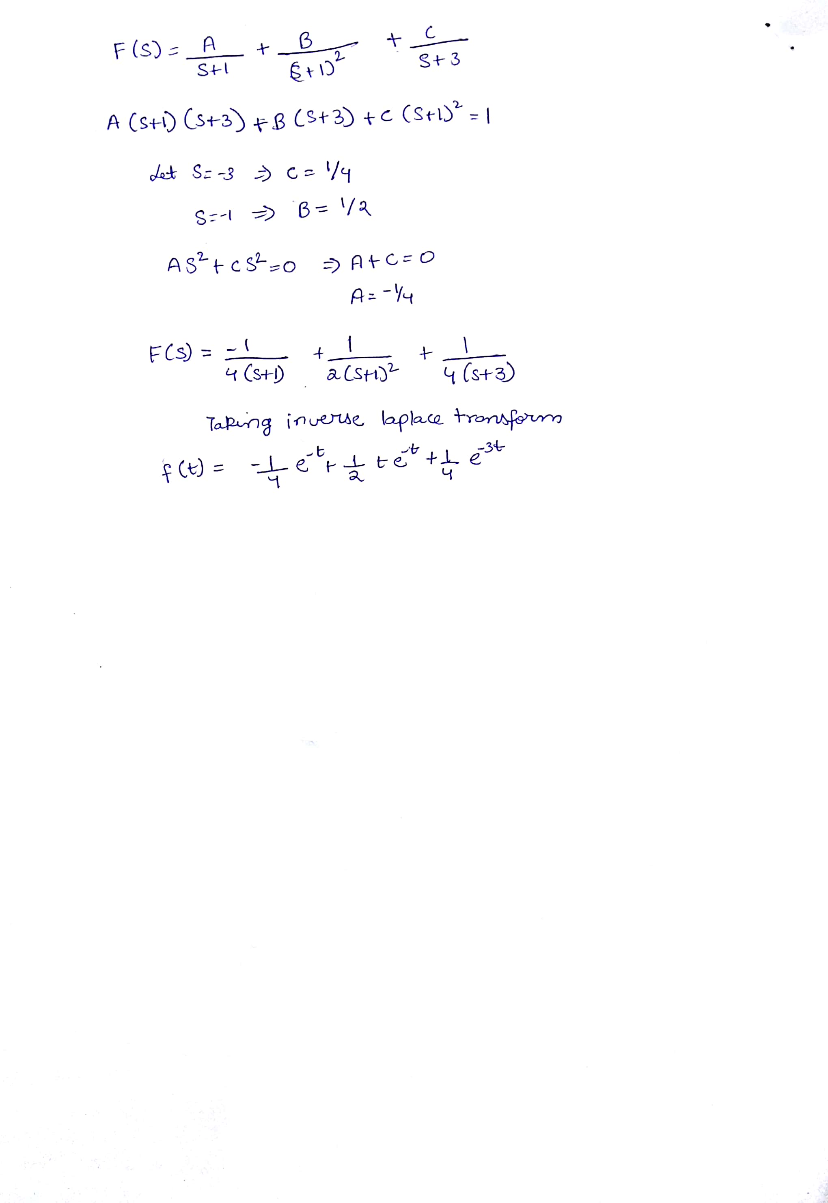

**MATLAB Codes and Results**

Q1. Part1: poles and zeroes

Code:

syms s;

Z=5*(s+3);

P=(s^2)*(s+2)*(s+5);

p=roots(sym2poly(P));

z=roots(sym2poly(Z));

zplane(z,p);

Result:

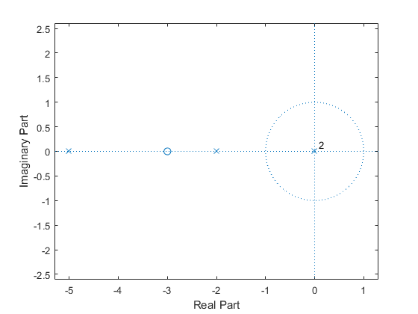

Part2: Rectangular coordinates i.e., **re{G(jω)} vs. im{G(jω)}**

Code:

omega=0:0.01:2*pi;

Real=(-20.*(omega.^2)-150)./((omega.^6)+29.*(omega.^4)+100.*(omega.^2));

Imaginary=(5.*(omega.^2)+55)./((omega.^5)+29.*(omega.^3)+100.*omega);

plot(Real,Imaginary,'x');

Result:

**re{G(jω)} vs. im{G(jω)}**

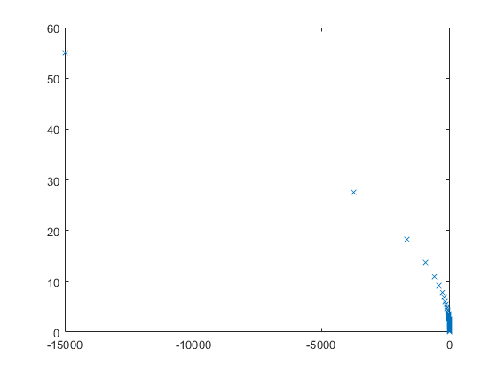

Part3: Polar representation of **G(jω) plot between R and Phi**

Code:

omega=0:0.01:2*pi;

R=5.*sqrt(9+omega.^2)./((omega.^2).*sqrt((4+omega.^2).*(25+omega.^2)));

p=atan(omega./3)-atan(omega./2)-atan(omega./5);

polarplot(R,p,'x');

Result:

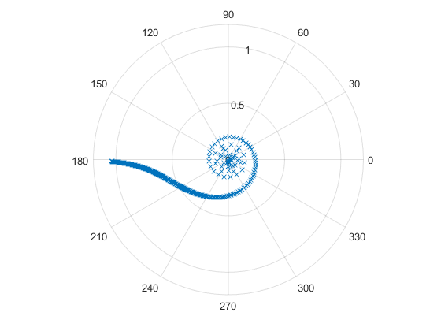

Q2. Part1: **Polar form G(jω):**

Code:

omega=linspace(0,2*pi,500);

psi=linspace(0,1,500);

wn=1e9;

R=sqrt( ((1-(omega./wn).^2).^2)+(2.*(psi).*(omega./wn)).^2 );

p=atan((2.*(psi).*(omega./wn))./(1-(omega./wn).^2));

polarplot(R,p,'x');

Result:

For wn=109

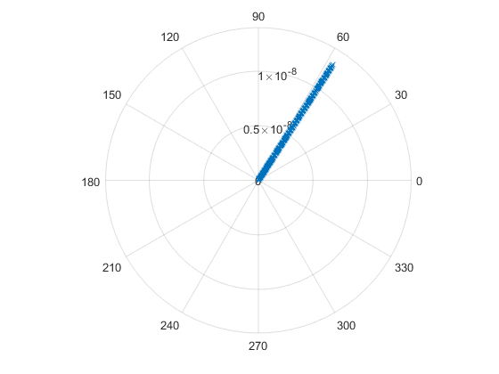

Part2:

Code:

omega=linspace(0,2*pi,100);

T=linspace(1,100,100);

R=1./(sqrt((T.^2).*(omega.^4)+(omega.^2)));

p=-1*atan(-1./(T.*omega));

G=R.*exp(1i.*p);

polarplot(R,p);

Result:

For 100 T values

