AI23531 – DEEP LEARNING
EX 2 MULTI-LAYER PERCEPTRON (MLP) FOR CLASSIFICATION (IRIS DATASET)

AIM
To develop a Multi-Layer Perceptron for a classification task, experiment with different numbers of hidden layers and activation functions, and evaluate performance using accuracy and loss.

PROCEDURE
- Import the required libraries (NumPy, Matplotlib, scikit-learn, Keras).
- Load the Iris dataset, one-hot encode the labels and standardise the features.
- Split the data into 80% training and 20% test sets.
- Define a function that builds an MLP for a given list of hidden layers and activation.
- Train nine models: hidden layers [8], [16, 8], [32, 16, 8] with ReLU, tanh and sigmoid activations (50 epochs, batch size 5).
- Record the test accuracy and loss of each model.
- Plot the accuracy and loss curves of the last model and predict the species for user-entered measurements.

ALGORITHM
- Start.
- Load Iris data; apply one-hot encoding to the labels and StandardScaler to the features.
- Split into training and test sets (test size 0.2).
- For each hidden-layer configuration and each activation function: build the MLP (hidden Dense layers + Softmax output), compile with Adam and categorical cross-entropy.
- Train the model for 50 epochs with 10% validation split.
- Evaluate on the test set and print accuracy and loss.
- Plot training/validation accuracy and loss.
- Read the four flower measurements from the user, scale them, predict the class with the model and print the species.
- Stop.

PROGRAM
import numpy as np
import matplotlib.pyplot as plt
from sklearn.datasets import load_iris
from sklearn.model_selection import train_test_split
from sklearn.preprocessing import StandardScaler, OneHotEncoder
from tensorflow.keras.models import Sequential
from tensorflow.keras.layers import Dense

iris = load_iris()
X = iris.data
y = iris.target.reshape(-1, 1)
classes = iris.target_names

encoder = OneHotEncoder(sparse_output=False)
y_encoded = encoder.fit_transform(y)

scaler = StandardScaler()
X_scaled = scaler.fit_transform(X)

X_train, X_test, y_train, y_test = train_test_split(
X_scaled, y_encoded, test_size=0.2, random_state=42
)

def create_mlp(input_dim, output_dim, hidden_layers, activation='relu'):
model = Sequential()
model.add(Dense(hidden_layers[0], input_dim=input_dim, activation=activation))

for units in hidden_layers[1:]:
model.add(Dense(units, activation=activation))

model.add(Dense(output_dim, activation='softmax'))

model.compile(
optimizer='adam',
loss='categorical_crossentropy',
metrics=['accuracy']
)
return model

hidden_layer_configs = [[8], [16, 8], [32, 16, 8]]
activations = ['relu', 'tanh', 'sigmoid']

for hidden_layers in hidden_layer_configs:
for activation in activations:
print(f"\nTesting MLP with hidden_layers={hidden_layers}, activation={activation}")

model = create_mlp(
input_dim=4,
output_dim=3,
hidden_layers=hidden_layers,
activation=activation
)

history = model.fit(
X_train,
y_train,
epochs=50,
batch_size=5,
verbose=0,
validation_split=0.1
)

test_loss, test_acc = model.evaluate(X_test, y_test, verbose=0)

print(f"Test Accuracy: {test_acc:.4f}")
print(f"Test Loss: {test_loss:.4f}")

plt.figure(figsize=(10, 4))

plt.subplot(1, 2, 1)
plt.plot(history.history['accuracy'], label='Train Accuracy')
plt.plot(history.history['val_accuracy'], label='Validation Accuracy')
plt.xlabel('Epoch')
plt.ylabel('Accuracy')
plt.title('Model Accuracy')
plt.legend()

plt.subplot(1, 2, 2)
plt.plot(history.history['loss'], label='Train Loss')
plt.plot(history.history['val_loss'], label='Validation Loss')
plt.xlabel('Epoch')
plt.ylabel('Loss')
plt.title('Model Loss')
plt.legend()

plt.tight_layout()
plt.show()

sepal_length = float(input("Sepal length (cm): "))
sepal_width = float(input("Sepal width (cm): "))
petal_length = float(input("Petal length (cm): "))
petal_width = float(input("Petal width (cm): "))

user_input = np.array([[
sepal_length,
sepal_width,
petal_length,
petal_width
]])

user_input_scaled = scaler.transform(user_input)

prediction = model.predict(user_input_scaled, verbose=0)
predicted_class_index = np.argmax(prediction)
predicted_class_name = classes[predicted_class_index]

print("\nPredicted Iris Species:", predicted_class_name)

OUTPUT
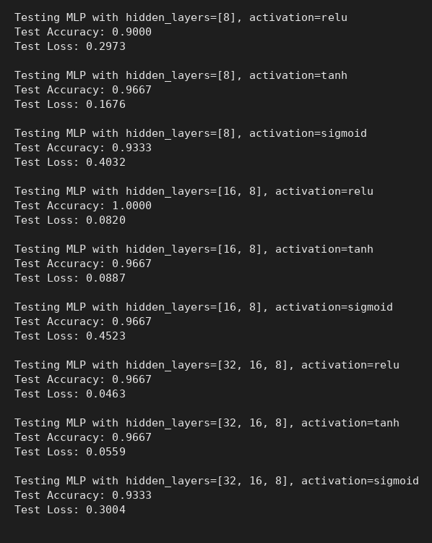
Console output
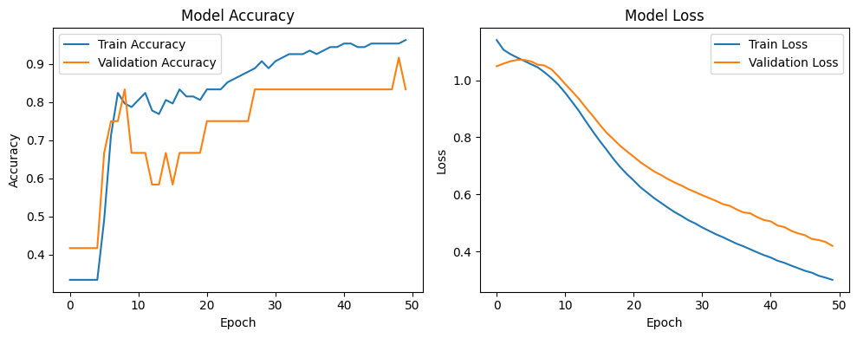
Accuracy and loss curves of the MLP

RESULT
The best accuracy (100%) was obtained with hidden layers [16, 8] and ReLU, while the lowest test loss (0.0463) came from [32, 16, 8] with ReLU. Sigmoid gave the highest losses overall.

