AI23531 – DEEP LEARNING
EX 3 COMPARISON OF SGD WITH MOMENTUM AND ADAM OPTIMIZER (CIFAR-10)

AIM
To implement a training algorithm using stochastic gradient descent (SGD) with momentum, compare it with the Adam optimizer on the same model and dataset, and compare their convergence rate and performance.

PROCEDURE
- Import PyTorch, torchvision and Matplotlib; select CPU/GPU.
- Load the CIFAR-10 training set, normalise it and create a DataLoader (batch size 128).
- Define an MLP: Flatten → Linear(3072, 256) → ReLU → Linear(256, 10).
- Write a training function that records average loss and accuracy per epoch.
- Train one MLP with SGD (lr = 0.01, momentum = 0.9) for 10 epochs.
- Train an identical MLP with Adam (lr = 0.001) for 10 epochs.
- Plot the loss and accuracy of both optimizers for comparison.

ALGORITHM
- Start.
- Load and normalise CIFAR-10; create mini-batches.
- Create two identical MLP models.
- For each optimizer (SGD + Momentum, Adam) and each epoch: forward pass, compute cross-entropy loss, zero gradients, backpropagate, update weights.
- Accumulate the epoch loss and number of correct predictions; store the average loss and accuracy.
- Plot loss and accuracy curves of both optimizers.
- Compare convergence speed and final accuracy.
- Stop.

PROGRAM
# Step 1: Import Necessary Libraries
import torch
import torch.nn as nn
import torch.optim as optim
import torchvision
import torchvision.transforms as transforms
import matplotlib.pyplot as plt

# Step 2: Set Device and Load Dataset
device = torch.device("cuda" if torch.cuda.is_available() else "cpu")

print("Using device:", device)

transform = transforms.Compose([
transforms.ToTensor(),
transforms.Normalize((0.5,), (0.5,))
])

trainset = torchvision.datasets.CIFAR10(
root='./data',
train=True,
transform=transform,
download=True
)

trainloader = torch.utils.data.DataLoader(
trainset,
batch_size=128,
shuffle=True
)

# Step 3: Define MLP Model
class MLP(nn.Module):
def __init__(self):
super().__init__()

self.flatten = nn.Flatten()

self.net = nn.Sequential(
nn.Linear(3 * 32 * 32, 256),
nn.ReLU(),
nn.Linear(256, 10)
)

def forward(self, x):
x = self.flatten(x)
return self.net(x)

# Step 4: Define Training Function
def train(model, optimizer, epochs=10):
model.to(device)

loss_fn = nn.CrossEntropyLoss()

losses = []
accuracies = []

for epoch in range(epochs):

total_loss = 0
correct = 0
total = 0

model.train()

for imgs, labels in trainloader:

imgs, labels = imgs.to(device), labels.to(device)

# Forward pass
outputs = model(imgs)

# Calculate loss
loss = loss_fn(outputs, labels)

# Backpropagation
optimizer.zero_grad()
loss.backward()
optimizer.step()

# Calculate loss and accuracy
total_loss += loss.item()

_, predicted = outputs.max(1)

total += labels.size(0)
correct += (predicted == labels).sum().item()

# Average loss and accuracy
avg_loss = total_loss / len(trainloader)
accuracy = 100.0 * correct / total

losses.append(avg_loss)
accuracies.append(accuracy)

print(
f"Epoch {epoch + 1}: "
f"Loss = {avg_loss:.4f}, "
f"Accuracy = {accuracy:.2f}%"
)

return losses, accuracies

# Step 5: Train with SGD + Momentum
model_sgd = MLP()

sgd = optim.SGD(
model_sgd.parameters(),
lr=0.01,
momentum=0.9
)

losses_sgd, acc_sgd = train(
model_sgd,
sgd
)

# Step 5: Train with Adam
model_adam = MLP()

adam = optim.Adam(
model_adam.parameters(),
lr=0.001
)

losses_adam, acc_adam = train(
model_adam,
adam
)

# Step 6: Visualize Loss and Accuracy Comparison
plt.figure(figsize=(12, 5))

# Loss Comparison
plt.subplot(1, 2, 1)

plt.plot(
losses_sgd,
label="SGD + Momentum"
)

plt.plot(
losses_adam,
label="Adam"
)

plt.xlabel("Epoch")
plt.ylabel("Loss")
plt.title("Loss Comparison on CIFAR-10 (MLP)")
plt.legend()

# Accuracy Comparison
plt.subplot(1, 2, 2)

plt.plot(
acc_sgd,
label="SGD + Momentum"
)

plt.plot(
acc_adam,
label="Adam"
)

plt.xlabel("Epoch")
plt.ylabel("Accuracy (%)")
plt.title("Accuracy Comparison on CIFAR-10 (MLP)")
plt.legend()

plt.tight_layout()
plt.show()

OUTPUT
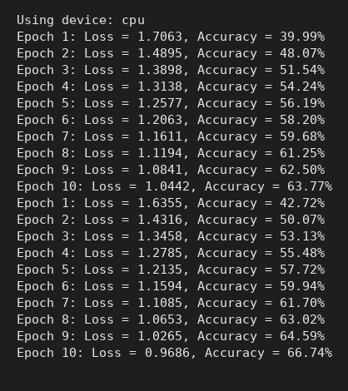
Console output
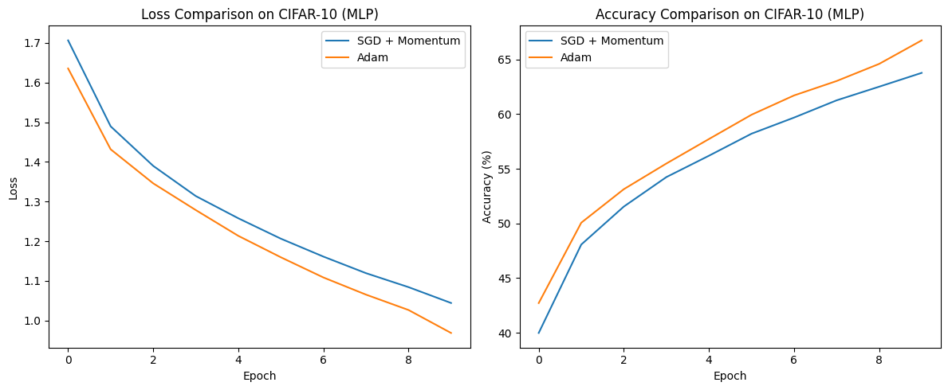
Loss and accuracy comparison: SGD + Momentum vs Adam

RESULT
Both optimizers reduced the loss steadily over 10 epochs; the training accuracy of the SGD + Momentum model reached 63.77% after epoch 10. Adam started faster (42.72% accuracy in epoch 1 versus 39.99%), as seen in the plots.

