AI23531 – DEEP LEARNING
EX 4 CONVOLUTIONAL NEURAL NETWORK (CNN) FROM SCRATCH AND FILTER VISUALISATION (CIFAR-10)

AIM
To implement a Convolutional Neural Network from scratch to classify images, train it on labelled images, evaluate its performance and visualise the learned filters of the convolution layer.

PROCEDURE
- Import PyTorch, torchvision and Matplotlib.
- Load CIFAR-10 train and test sets, convert to tensors and normalise.
- Define SimpleCNN with two convolution layers (16 and 32 filters, 3×3), max-pooling and two fully connected layers.
- Train with Adam (lr = 0.001) and cross-entropy loss for 10 epochs.
- Evaluate the accuracy on the test set.
- Normalise and plot the first eight filters of the first convolution layer.

ALGORITHM
- Start.
- Load CIFAR-10 and create train/test DataLoaders (batch size 64).
- Define the CNN: Conv(3→16) → ReLU → MaxPool → Conv(16→32) → ReLU → MaxPool → Flatten → FC(2048→128) → ReLU → FC(128→10).
- For each epoch and mini-batch: forward pass, compute loss, backpropagate, update weights; print the average loss.
- Run the model on the test set without gradients and calculate accuracy.
- Take the weights of conv1, scale each filter to 0–1 and display it as an image.
- Stop.

PROGRAM
import torch
import torch.nn as nn
import torch.optim as optim
import torchvision
import torchvision.transforms as transforms
import matplotlib.pyplot as plt

# Step 1: Load and preprocess CIFAR-10
transform = transforms.Compose([
transforms.ToTensor(),
transforms.Normalize((0.5, 0.5, 0.5),
(0.5, 0.5, 0.5))
])

trainset = torchvision.datasets.CIFAR10(
root='./data', train=True, download=True, transform=transform)

trainloader = torch.utils.data.DataLoader(
trainset, batch_size=64, shuffle=True)

testset = torchvision.datasets.CIFAR10(
root='./data', train=False, download=True, transform=transform)

testloader = torch.utils.data.DataLoader(
testset, batch_size=64, shuffle=False)

classes = trainset.classes

# Step 2: Define CNN
class SimpleCNN(nn.Module):
def __init__(self):
super(SimpleCNN, self).__init__()

self.conv1 = nn.Conv2d(3, 16, 3, padding=1)
self.conv2 = nn.Conv2d(16, 32, 3, padding=1)
self.pool = nn.MaxPool2d(2, 2)

self.fc1 = nn.Linear(32 * 8 * 8, 128)
self.fc2 = nn.Linear(128, 10)
self.relu = nn.ReLU()

def forward(self, x):
x = self.pool(self.relu(self.conv1(x)))
x = self.pool(self.relu(self.conv2(x)))

x = x.view(-1, 32 * 8 * 8)

x = self.relu(self.fc1(x))
x = self.fc2(x)

return x

# Step 3: Train CNN
device = torch.device("cuda" if torch.cuda.is_available() else "cpu")

model = SimpleCNN().to(device)

lossfn = nn.CrossEntropyLoss()
optimizer = optim.Adam(model.parameters(), lr=0.001)

for epoch in range(10):
running_loss = 0.0

for inputs, labels in trainloader:
inputs, labels = inputs.to(device), labels.to(device)

optimizer.zero_grad()

outputs = model(inputs)
loss = lossfn(outputs, labels)

loss.backward()
optimizer.step()

running_loss += loss.item()

print(f"Epoch {epoch+1}, Loss: "
f"{running_loss / len(trainloader):.4f}")

# Step 4: Evaluate model
correct = 0
total = 0

with torch.no_grad():
for images, labels in testloader:
images, labels = images.to(device), labels.to(device)

outputs = model(images)
_, predicted = outputs.max(1)

total += labels.size(0)
correct += (predicted == labels).sum().item()

print(f"Accuracy on test data: "
f"{100 * correct / total:.2f}%")

# Step 5: Visualize learned filters
def visualize_filters(layer, n_filters=8):
filters = layer.weight.data.cpu()

fig, axs = plt.subplots(1, n_filters, figsize=(15, 4))

for i in range(n_filters):
f = filters[i]
f = (f - f.min()) / (f.max() - f.min())

axs[i].imshow(f.permute(1, 2, 0))
axs[i].axis('off')
axs[i].set_title(f'Filter {i+1}')

plt.tight_layout()
plt.show()

visualize_filters(model.conv1)

OUTPUT
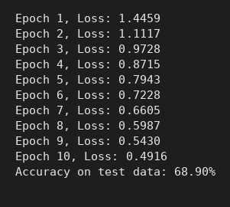
Console output
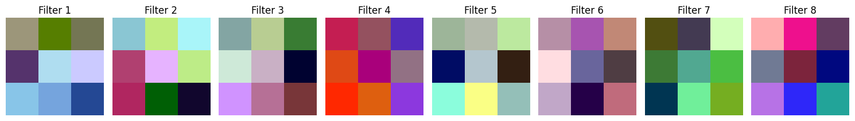
Learned filters of the first convolution layer

RESULT
The training loss fell from 1.4459 to 0.4916 over 10 epochs and the CNN achieved 68.90% accuracy on the CIFAR-10 test data. The learned filters were visualised.

