AI23531 – DEEP LEARNING
EX 5 COMPARATIVE ANALYSIS OF VGG, RESNET AND GOOGLENET

AIM
To implement and compare the performance of three popular CNN architectures — VGG16, ResNet18 and GoogLeNet — for image classification using transfer learning.

PROCEDURE
- Import PyTorch, torchvision, Matplotlib and PIL.
- Load CIFAR-10, resize images to 224×224 and use the first 500 images split 80/20 into training and validation sets.
- Load each pre-trained model and replace its final layer with a 10-class layer.
- Train each model with Adam (lr = 1e-4) for 5 epochs, recording training and validation accuracy.
- Plot the validation accuracy of the models and predict the class of a custom image.

ALGORITHM
- Start.
- Load and preprocess the dataset; create training and validation loaders.
- For each model in {VGG16, ResNet18, GoogLeNet}: load ImageNet weights and replace the final fully connected layer with a 10-output layer.
- Train for 5 epochs: forward pass, cross-entropy loss, backpropagation, Adam update; compute training accuracy.
- Evaluate on the validation set after every epoch and store the accuracies.
- Plot the validation accuracy of all models for comparison.
- Predict the class of a given image with every trained model.
- Stop.

PROGRAM
import torch
import torch.nn as nn
import torch.optim as optim
from torchvision import datasets, models, transforms
from torch.utils.data import DataLoader, random_split, Subset
import matplotlib.pyplot as plt
from PIL import Image
import os

device = torch.device("cuda" if torch.cuda.is_available() else "cpu")
class_names = ['airplane', 'automobile', 'bird', 'cat', 'deer',
'dog', 'frog', 'horse', 'ship', 'truck']

transform = transforms.Compose([
transforms.Resize((224, 224)),
transforms.ToTensor(),
transforms.Normalize((0.5, 0.5, 0.5), (0.5, 0.5, 0.5))
])
dataset = datasets.CIFAR10(root='./data', train=True, download=True, transform=transform)
test_dataset = datasets.CIFAR10(root='./data', train=False, download=True, transform=transform)
dataset = Subset(dataset, range(500))
train_size = int(0.8 * len(dataset))
val_size = len(dataset) - train_size
train_dataset, val_dataset = random_split(dataset, [train_size, val_size])
train_loader = DataLoader(train_dataset, batch_size=64, shuffle=True)
val_loader = DataLoader(val_dataset, batch_size=64, shuffle=False)

def train_and_evaluate(model, name, num_epochs=5):
model = model.to(device)
criterion = nn.CrossEntropyLoss()
optimizer = optim.Adam(model.parameters(), lr=1e-4)
train_accs, val_accs = [], []
for epoch in range(num_epochs):
model.train()
correct, total = 0, 0
for inputs, labels in train_loader:
inputs, labels = inputs.to(device), labels.to(device)
optimizer.zero_grad()
outputs = model(inputs)
loss = criterion(outputs, labels)
loss.backward()
optimizer.step()
_, predicted = torch.max(outputs, 1)
correct += (predicted == labels).sum().item()
total += labels.size(0)
train_accs.append(100 * correct / total)
model.eval()
correct, total = 0, 0
with torch.no_grad():
for inputs, labels in val_loader:
inputs, labels = inputs.to(device), labels.to(device)
outputs = model(inputs)
_, predicted = outputs.max(1)
correct += (predicted == labels).sum().item()
total += labels.size(0)
val_accs.append(100 * correct / total)
print(f"{name} Epoch {epoch+1}/{num_epochs} - Train Acc: {train_accs[-1]:.2f}%, Val Acc: {val_accs[-1]:.2f}%")
return model, train_accs, val_accs

def get_model(name):
if name == "vgg":
model = models.vgg16(pretrained=True)
model.classifier[6] = nn.Linear(4096, 10)
elif name == "resnet":
model = models.resnet18(pretrained=True)
model.fc = nn.Linear(model.fc.in_features, 10)
elif name == "googlenet":
model = models.googlenet(pretrained=True, aux_logits=True)
model.fc = nn.Linear(model.fc.in_features, 10)
else:
raise ValueError("Unknown model")
return model

results = {}
trained_models = {}
for model_name in ["vgg", "resnet", "googlenet"]:
print(f"\nTraining {model_name.upper()} on CIFAR-10...")
model = get_model(model_name)
trained_model, train_acc, val_acc = train_and_evaluate(model, model_name.upper(), num_epochs=5)
results[model_name] = (train_acc, val_acc)
trained_models[model_name] = trained_model

plt.figure(figsize=(10, 6))
for name, (train_acc, val_acc) in results.items():
plt.plot(val_acc, label=f'{name.upper()} Val Acc')
plt.title('Validation Accuracy Comparison on CIFAR-10')
plt.xlabel('Epoch'); plt.ylabel('Accuracy (%)'); plt.legend(); plt.grid(True)
plt.show()

def predict_image(image_path, models_dict):
image = Image.open(image_path).convert('RGB')
image = transform(image).unsqueeze(0).to(device)
print(f"\nPrediction results for image: {image_path}")
for model_name, model in models_dict.items():
model.eval()
with torch.no_grad():
outputs = model(image)
_, predicted = outputs.max(1)
pred_class = class_names[predicted.item()]
print(f"{model_name.upper():<10} => {pred_class}")

custom_image_path = "download.jpeg"
if os.path.exists(custom_image_path):
predict_image(custom_image_path, trained_models)
else:
print(f"\nImage not found: {custom_image_path}. Please add an image to test.")

OUTPUT
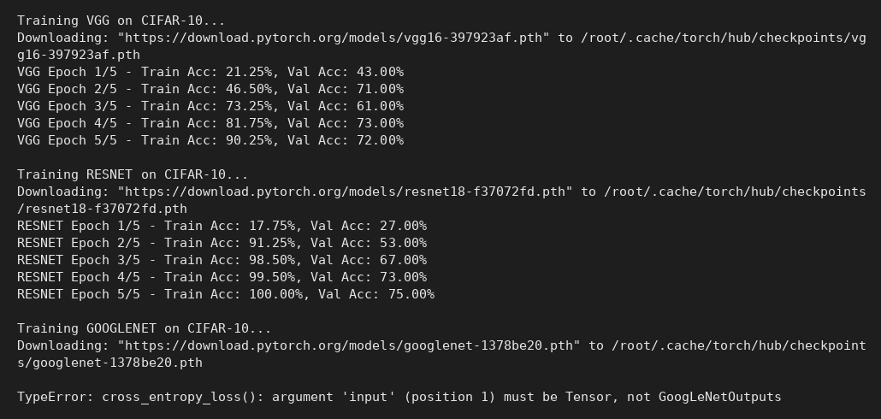
Console output

RESULT
VGG16 reached 72% and ResNet18 reached 75% validation accuracy after 5 epochs (ResNet18 fitted the training data fastest, 100%). The GoogLeNet run stopped with a TypeError because its training-mode output (GoogLeNetOutputs, with auxiliary heads) was passed directly to the loss function; the comparison plot was therefore not produced.

