AI23531 – DEEP LEARNING
EX 6 BIDIRECTIONAL RNN VS FEED-FORWARD NETWORK FOR TIME-SERIES PREDICTION

AIM
To implement a bidirectional recurrent neural network (BiRNN) to predict sequences in time-series data, train it, and compare its performance with a traditional feed-forward neural network (Airline Passenger dataset).

PROCEDURE
- Load the monthly airline passenger data and scale it to 0–1 with MinMaxScaler.
- Create input sequences of 10 past values with the next value as the target.
- Split the sequences into 80% training and 20% test sets and create PyTorch DataLoaders.
- Define a BiRNN (bidirectional RNN with 64 hidden units + linear layer) and a feed-forward network (10 → 64 → 1).
- Train both with Adam (lr = 0.01) and MSE loss for 100 epochs.
- Predict on the test data, inverse-scale the predictions and plot them against the actual values.
- Compare the models using Mean Squared Error (MSE).

ALGORITHM
- Start.
- Read the dataset and normalise it.
- Generate sliding-window sequences (length 10) and targets; split into train and test sets.
- Build the BiRNN and the feed-forward model.
- For each model, for 100 epochs: forward pass, compute MSE loss, backpropagate, update weights with Adam.
- Predict the test sequences, convert back to the original scale.
- Plot actual vs predicted values and compute the MSE of each model.
- Stop.

PROGRAM
import pandas as pd
import numpy as np
from sklearn.preprocessing import MinMaxScaler

url = 'https://raw.githubusercontent.com/jbrownlee/Datasets/refs/heads/master/monthly-airline-passengers.csv'
df = pd.read_csv(url, usecols=[1])
data = df.values.astype('float32')
scaler = MinMaxScaler(feature_range=(0, 1))
data_scaled = scaler.fit_transform(data)

SEQ_LENGTH = 10
X = np.array([data_scaled[i:i+SEQ_LENGTH] for i in range(len(data_scaled) - SEQ_LENGTH)])
y = np.array([data_scaled[i + SEQ_LENGTH] for i in range(len(data_scaled) - SEQ_LENGTH)])
train_size = int(len(X) * 0.8)
X_train, X_test = X[:train_size], X[train_size:]
y_train, y_test = y[:train_size], y[train_size:]

import torch
from torch.utils.data import TensorDataset, DataLoader

X_train_tensor = torch.tensor(X_train)
y_train_tensor = torch.tensor(y_train)
X_test_tensor = torch.tensor(X_test)
y_test_tensor = torch.tensor(y_test)
train_loader = DataLoader(TensorDataset(X_train_tensor, y_train_tensor), batch_size=16, shuffle=True)
test_loader = DataLoader(TensorDataset(X_test_tensor, y_test_tensor), batch_size=1)

import torch.nn as nn

class BiRNN(nn.Module):
def __init__(self, input_size=1, hidden_size=64, num_layers=1):
super(BiRNN, self).__init__()
self.rnn = nn.RNN(input_size, hidden_size, num_layers, batch_first=True, bidirectional=True)
self.fc = nn.Linear(hidden_size * 2, 1)
def forward(self, x):
out, _ = self.rnn(x)
return self.fc(out[:, -1, :])

class FeedforwardNN(nn.Module):
def __init__(self, input_size):
super(FeedforwardNN, self).__init__()
self.fc1 = nn.Linear(input_size, 64)
self.relu = nn.ReLU()
self.fc2 = nn.Linear(64, 1)
def forward(self, x):
x = x.view(x.size(0), -1)
return self.fc2(self.relu(self.fc1(x)))

def train_model(model, loader, epochs=100):
criterion = nn.MSELoss()
optimizer = torch.optim.Adam(model.parameters(), lr=0.01)
model.train()
for epoch in range(epochs):
loss_epoch = 0
for seqs, targets in loader:
optimizer.zero_grad()
outputs = model(seqs)
loss = criterion(outputs, targets)
loss.backward()
optimizer.step()
loss_epoch += loss.item()
if (epoch + 1) % 20 == 0:
print(f"Epoch {epoch+1}/{epochs}, Loss: {loss_epoch / len(loader):.5f}")

def evaluate_model(model, X):
model.eval()
with torch.no_grad():
return model(X).numpy()

birnn = BiRNN()
train_model(birnn, train_loader)
ffnn = FeedforwardNN(input_size=SEQ_LENGTH)
train_model(ffnn, train_loader)
pred_birnn = evaluate_model(birnn, X_test_tensor)
pred_ffnn = evaluate_model(ffnn, X_test_tensor)

from sklearn.metrics import mean_squared_error
import matplotlib.pyplot as plt

pred_birnn_inv = scaler.inverse_transform(pred_birnn)
pred_ffnn_inv = scaler.inverse_transform(pred_ffnn)
y_test_inv = scaler.inverse_transform(y_test)

plt.figure(figsize=(12, 5))
plt.plot(y_test_inv, label='Actual')
plt.plot(pred_birnn_inv, label='BiRNN Prediction')
plt.plot(pred_ffnn_inv, label='FFNN Prediction')
plt.legend()
plt.title('BiRNN vs Feedforward NN on Airline Passenger Data')
plt.xlabel('Time Step'); plt.ylabel('Passengers')
plt.show()

mse_birnn = mean_squared_error(y_test_inv, pred_birnn_inv)
mse_ffnn = mean_squared_error(y_test_inv, pred_ffnn_inv)
print(f"BiRNN MSE: {mse_birnn:.3f}")
print(f"FFNN MSE: {mse_ffnn:.3f}")

OUTPUT
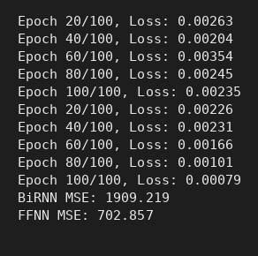
Console output
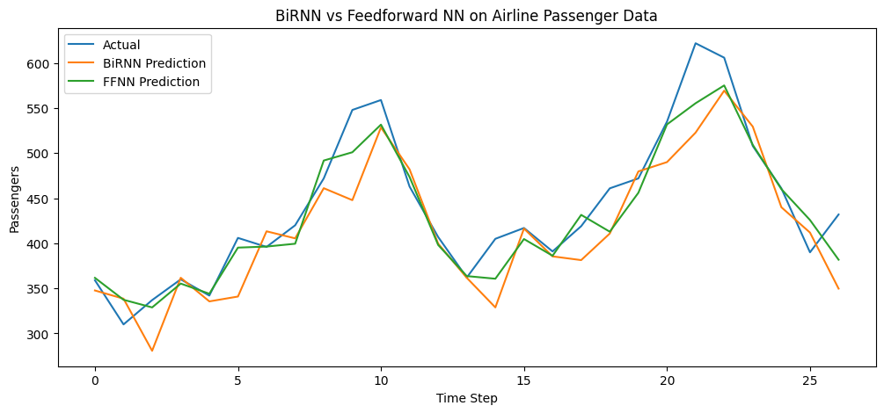
BiRNN vs Feed-forward NN on the Airline Passenger data

RESULT
In this run the feed-forward network gave a lower test error (MSE 702.857) than the BiRNN (MSE 1909.219), so the BiRNN did not outperform it on this small dataset.

