AI23531 – DEEP LEARNING
EX 8 IMAGE GENERATION USING A VARIATIONAL AUTOENCODER (VAE)

AIM
To implement a Variational Autoencoder that learns the latent representation of face images (CelebA) and generates new images from the learned distribution.

PROCEDURE
- Import PyTorch and torchvision; set image size 64, latent dimension 100, 5 epochs.
- Load a 500-image subset of CelebA, centre-crop, resize and normalise it.
- Define the Encoder (4 convolution layers producing mean and log-variance), the Decoder (4 transposed-convolution layers) and the VAE with the reparameterisation trick.
- Define the loss as reconstruction (MSE) loss plus KL divergence.
- Train with Adam (lr = 1e-3) and print the loss each epoch.
- After every epoch, sample random latent vectors, decode them and display a grid of generated faces.

ALGORITHM
- Start.
- Load and preprocess the CelebA images.
- Encode each image to μ and log σ².
- Sample z = μ + ε·σ with ε ~ N(0, I) (reparameterisation).
- Decode z to reconstruct the image.
- Compute loss = MSE(reconstruction, input) + KL divergence; backpropagate and update with Adam.
- After each epoch, sample z ~ N(0, I), decode it and display a 64-image grid.
- Repeat for all epochs.
- Stop.

PROGRAM
import torch
import torch.nn as nn
import torch.nn.functional as F
import torchvision
from torchvision import datasets, transforms
from torch.utils.data import DataLoader, Subset
import matplotlib.pyplot as plt

device = torch.device('cuda' if torch.cuda.is_available() else 'cpu')
image_size = 64
batch_size = 128
latent_dim = 100
num_epochs = 5
learning_rate = 1e-3

transform = transforms.Compose([
transforms.CenterCrop(178),
transforms.Resize(image_size),
transforms.ToTensor(),
transforms.Normalize((0.5, 0.5, 0.5), (0.5, 0.5, 0.5))
])
dataset = datasets.CelebA(root='data', split='train', download=True, transform=transform)
dataset = Subset(dataset, range(500))
dataloader = DataLoader(dataset, batch_size=batch_size, shuffle=True)

class Encoder(nn.Module):
def __init__(self, latent_dim):
super(Encoder, self).__init__()
self.conv = nn.Sequential(
nn.Conv2d(3, 64, 4, 2, 1), nn.ReLU(),
nn.Conv2d(64, 128, 4, 2, 1), nn.BatchNorm2d(128), nn.ReLU(),
nn.Conv2d(128, 256, 4, 2, 1), nn.BatchNorm2d(256), nn.ReLU(),
nn.Conv2d(256, 512, 4, 2, 1), nn.BatchNorm2d(512), nn.ReLU()
)
self.fc_mu = nn.Linear(512*4*4, latent_dim)
self.fc_logvar = nn.Linear(512*4*4, latent_dim)
def forward(self, x):
x = self.conv(x)
x = x.view(x.size(0), -1)
return self.fc_mu(x), self.fc_logvar(x)

class Decoder(nn.Module):
def __init__(self, latent_dim):
super(Decoder, self).__init__()
self.fc = nn.Linear(latent_dim, 512*4*4)
self.deconv = nn.Sequential(
nn.ConvTranspose2d(512, 256, 4, 2, 1), nn.BatchNorm2d(256), nn.ReLU(),
nn.ConvTranspose2d(256, 128, 4, 2, 1), nn.BatchNorm2d(128), nn.ReLU(),
nn.ConvTranspose2d(128, 64, 4, 2, 1), nn.BatchNorm2d(64), nn.ReLU(),
nn.ConvTranspose2d(64, 3, 4, 2, 1), nn.Tanh()
)
def forward(self, z):
x = self.fc(z)
x = x.view(x.size(0), 512, 4, 4)
return self.deconv(x)

class VAE(nn.Module):
def __init__(self, latent_dim):
super(VAE, self).__init__()
self.encoder = Encoder(latent_dim)
self.decoder = Decoder(latent_dim)
def reparameterize(self, mu, logvar):
std = torch.exp(0.5 * logvar)
eps = torch.randn_like(std)
return mu + eps * std
def forward(self, x):
mu, logvar = self.encoder(x)
z = self.reparameterize(mu, logvar)
return self.decoder(z), mu, logvar

def vae_loss(recon_x, x, mu, logvar):
recon_loss = F.mse_loss(recon_x, x, reduction='sum')
kl_div = -0.5 * torch.sum(1 + logvar - mu.pow(2) - logvar.exp())
return recon_loss + kl_div

model = VAE(latent_dim).to(device)
optimizer = torch.optim.Adam(model.parameters(), lr=learning_rate)

for epoch in range(num_epochs):
model.train()
total_loss = 0
for images, _ in dataloader:
images = images.to(device)
recon, mu, logvar = model(images)
loss = vae_loss(recon, images, mu, logvar)
optimizer.zero_grad()
loss.backward()
optimizer.step()
total_loss += loss.item()
print(f"Epoch [{epoch+1}/{num_epochs}], Loss: {total_loss/len(dataloader.dataset):.4f}")

model.eval()
with torch.no_grad():
z = torch.randn(64, latent_dim).to(device)
sample_images = model.decoder(z).cpu() * 0.5 + 0.5
grid = torchvision.utils.make_grid(sample_images, nrow=8)
plt.imshow(grid.permute(1, 2, 0))
plt.axis('off')
plt.title(f"Generated Faces - Epoch {epoch+1}")
plt.show()

OUTPUT
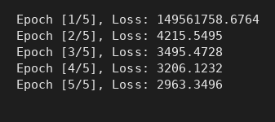
Console output
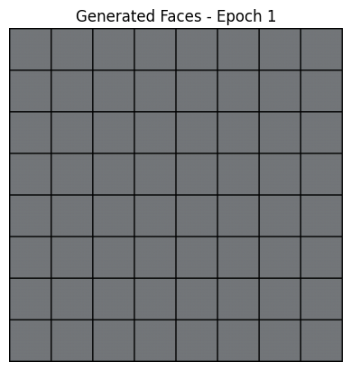
Generated faces – Epoch 1
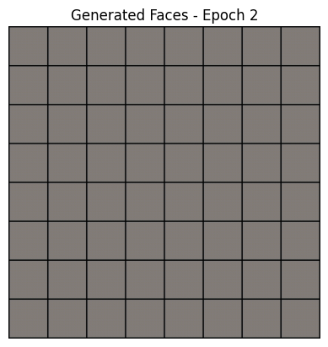
Generated faces – Epoch 2
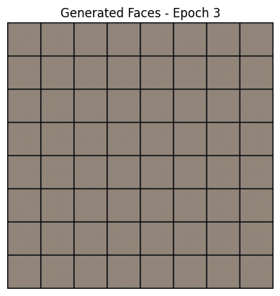
Generated faces – Epoch 3
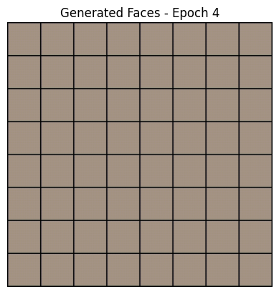
Generated faces – Epoch 4
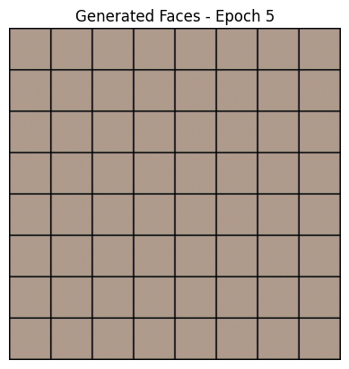
Generated faces – Epoch 5

RESULT
The loss dropped from 149,561,758.68 in epoch 1 to 2,963.35 in epoch 5, and the generated face grids became progressively more structured, although they remain blurry because only 500 images were used.

