AI23531 – DEEP LEARNING
EX 9 TEXT GENERATION USING LSTM NETWORKS

AIM
To build a text-generation model using Long Short-Term Memory (LSTM) networks, train it on a text corpus (Shakespeare) and generate new text sequences.

PROCEDURE
- Download the Tiny Shakespeare corpus and convert it to lower case.
- Build character-to-index and index-to-character dictionaries.
- Create input sequences of 40 characters with the following character as the target.
- Build the model: Embedding(64) → LSTM(128) → Dense(softmax over characters).
- Compile with sparse categorical cross-entropy and the Adam optimizer; train for 1 epoch (batch size 128).
- Define a generation function that predicts one character at a time by sampling from the output probabilities.
- Generate 300 characters from the seed "shall i compare thee to a summer's day?".

ALGORITHM
- Start.
- Load the text and create the character vocabulary.
- Slice the text into overlapping sequences of length 40 and their next characters; encode them as integers.
- Train the Embedding–LSTM–Dense model to predict the next character.
- Take the seed text and convert it to indices.
- Repeat 300 times: feed the last 40 characters to the model, obtain the probability distribution, sample the next character and append it.
- Convert the indices back to text and print the result.
- Stop.

PROGRAM
# Step 1: Load and Preprocess the Dataset
import tensorflow as tf
import numpy as np

text = tf.keras.utils.get_file('shakespeare.txt',
'https://raw.githubusercontent.com/karpathy/char-rnn/master/data/tinyshakespeare/input.txt')
text = open(text, 'r').read().lower()
chars = sorted(set(text))
c2i = {c: i for i, c in enumerate(chars)}
i2c = {i: c for i, c in enumerate(chars)}

# Step 2: Create Input and Output Sequences
seq_len = 40
X = []
y = []
for i in range(len(text) - seq_len):
input_seq = text[i:i + seq_len]
target_char = text[i + seq_len]
X.append([c2i[c] for c in input_seq])
y.append(c2i[target_char])

X = np.array(X)
y = np.array(y)

# Step 3: Build the LSTM Model
model = tf.keras.Sequential([
tf.keras.layers.Embedding(len(chars), 64, input_length=seq_len),
tf.keras.layers.LSTM(128),
tf.keras.layers.Dense(len(chars), activation='softmax')
])
model.compile(loss='sparse_categorical_crossentropy', optimizer='adam')
model.fit(X, y, batch_size=128, epochs=1)

# Step 4: Define the Text Generation Function
def generate(seed, length=300):
seq = [c2i[c] for c in seed.lower()]
for _ in range(length):
inp = np.array(seq[-seq_len:]).reshape(1, -1)
pred = model.predict(inp, verbose=0)[0]
next_idx = np.random.choice(len(pred), p=pred)
seq.append(next_idx)
return seed + ''.join(i2c[i] for i in seq[len(seed):])

# Step 5: Generate and Display Text
print("\nGenerated Text:\n")
print(generate("shall i compare thee to a summer's day?\n"))

OUTPUT
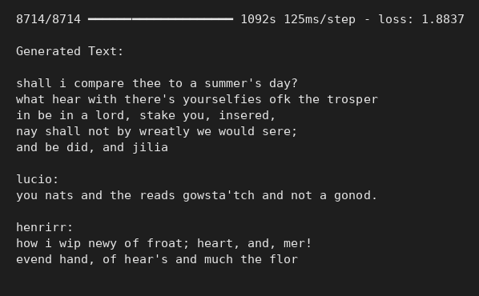
Console output

RESULT
After one epoch (loss 1.8837) the model produced Shakespeare-style text with correct line and speaker-name structure, but many words were invented; more epochs would improve fluency and coherence.

