AI23531 – DEEP LEARNING
EX 10 IMAGE GENERATION USING A GENERATIVE ADVERSARIAL NETWORK (GAN)

AIM
To use a Generative Adversarial Network (StyleGAN2-ADA) to generate new images and evaluate their quality by visual inspection and a quantitative metric, the Fréchet Inception Distance (FID).

PROCEDURE
- Clone the StyleGAN2-ADA repository and install the required packages.
- Download the pre-trained FFHQ StyleGAN2 model and load the generator (G_ema).
- Generate 20 images from random latent vectors using truncation ψ = 0.7 and save them.
- Display the generated images in a grid for visual inspection.
- Prepare 20 real images (CIFAR-10 resized to 64×64) as the reference set.
- Compute the FID between the real and generated image folders using pytorch-fid.

ALGORITHM
- Start.
- Load the pre-trained StyleGAN2 generator.
- Repeat 20 times: sample z ~ N(0, I), pass it with an empty label through the generator (truncation 0.7), rescale the output to 0–1 and save it.
- Display the generated images.
- Save 20 real reference images.
- Pass both sets through InceptionV3, compute feature mean and covariance, and calculate FID = ‖μ₁−μ₂‖² + Tr(Σ₁+Σ₂−2(Σ₁Σ₂)^½).
- Print the FID score.
- Stop.

PROGRAM
# ============================================
# EX 10 - IMAGE GENERATION USING GAN
# Fast Colab Version
# ============================================

# 1. Install StyleGAN2-ADA
!git clone -q https://github.com/NVlabs/stylegan2-ada-pytorch.git
!pip -q install ninja torchmetrics[image] pytorch-fid

# 2. Imports
import os
import sys
import urllib.request
import torch
import matplotlib.pyplot as plt

from torchvision.utils import save_image
from torchvision.io import read_image

sys.path.append("/content/stylegan2-ada-pytorch")

import legacy

# GPU
device = torch.device("cuda" if torch.cuda.is_available() else "cpu")
print("Device:", device)

# ============================================

# 3. Download pretrained StyleGAN2 model
# ============================================

url = "https://nvlabs-fi-cdn.nvidia.com/stylegan2-ada-pytorch/pretrained/ffhq.pkl"
model_path = "/content/ffhq.pkl"

if not os.path.exists(model_path):
print("Downloading model...")
urllib.request.urlretrieve(url, model_path)

print("Model ready!")

# ============================================
# 4. Load Generator
# ============================================

G = legacy.load_network_pkl(
open(model_path, "rb")
)["G_ema"].to(device)

# ============================================
# 5. Generate Images
# ============================================

NUM_IMAGES = 20

os.makedirs("/content/fake", exist_ok=True)

for i in range(NUM_IMAGES):

z = torch.randn(
[1, G.z_dim],
device=device
)

label = torch.zeros(
[1, G.c_dim],
device=device
)

with torch.no_grad():
img = G(
z,
label,
truncation_psi=0.7,
noise_mode="const"
)

img = (img + 1) / 2
img = img.clamp(0, 1)

save_image(
img,
f"/content/fake/fake_{i}.png"
)

print("Generated", NUM_IMAGES, "images!")

# ============================================
# 6. Display Generated Images
# ============================================

fig, axes = plt.subplots(2, 5, figsize=(15, 6))

for i, ax in enumerate(axes.flat):

img = read_image(
f"/content/fake/fake_{i}.png"
).permute(1, 2, 0)

ax.imshow(img)
ax.axis("off")

plt.show()

# ============================================
# 7. Create Real Images
# ============================================
# Instead of downloading huge CelebA,
# use CIFAR-10 for a quick demonstration.

import torchvision
from torchvision import datasets, transforms

transform = transforms.Compose([
transforms.Resize((64, 64)),
transforms.ToTensor()
])

real_dataset = datasets.CIFAR10(
root="/content/data",
train=True,
download=True,
transform=transform
)

os.makedirs("/content/real", exist_ok=True)

for i in range(NUM_IMAGES):

img, label = real_dataset[i]

save_image(
img,
f"/content/real/real_{i}.png"
)

print("Real images prepared!")

# ============================================
# 8. Calculate FID
# ============================================

!python -m pytorch_fid /content/real /content/fake

OUTPUT
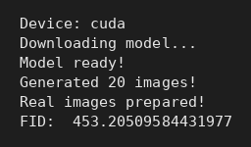
Console output
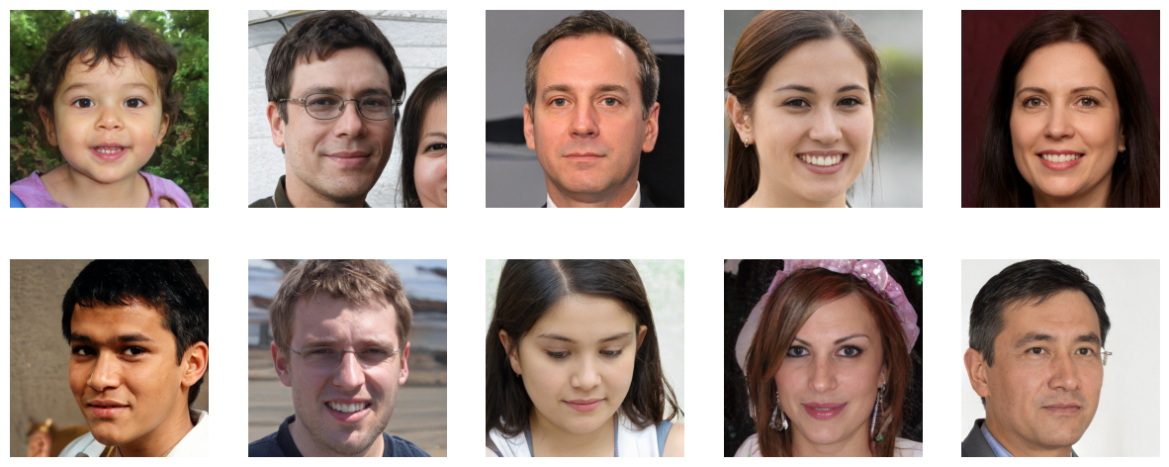
Images generated by StyleGAN2

RESULT
Twenty face images were generated. The measured FID was 453.21; this is high because only 20 images were compared and the real set was CIFAR-10 (not faces), so the score should be read as a demonstration of the metric rather than a quality verdict.

