Healthcare Data Analytics
Exploratory Data Analysis of the Pima Indians Diabetes Dataset

1. Dataset Explanation
The dataset contains medical measurements for 768 female patients and records whether each patient has diabetes. The uploaded CSV has 768 rows and 9 columns.
Column | Meaning
Pregnancies | Number of pregnancies
Glucose | Plasma glucose level (mg/dL)
BloodPressure | Diastolic blood pressure (mm Hg)
SkinThickness | Triceps skin-fold thickness (mm)
Insulin | 2-hour serum insulin level
BMI | Body mass index
DiabetesPedigreeFunction | Family-history-related diabetes score
Age | Age in years
Outcome | 0 = no diabetes; 1 = diabetes
Data preparation: zero values in Glucose, BloodPressure, SkinThickness, Insulin, and BMI were treated as missing because they are not realistic measurements for these fields. Their missing values were filled with each column's median; 0 duplicate rows were found.

2. Python Visualizations
Chart 1. Missing-value analysis
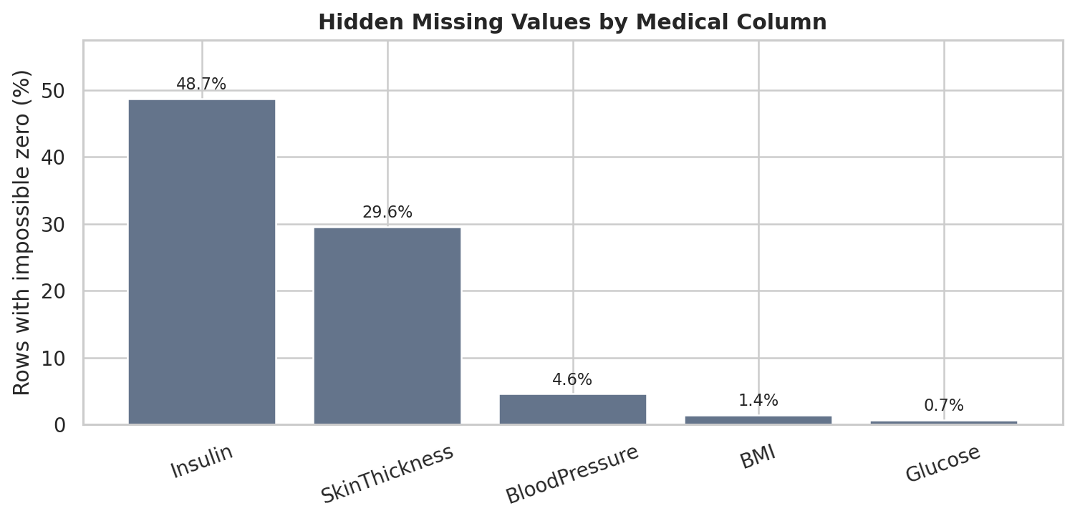
Insulin has the most zero-coded missing values: 374 rows (48.7%). These zeros were treated as missing values and filled with the median for the cleaned dataset.
Chart 2. Glucose histogram
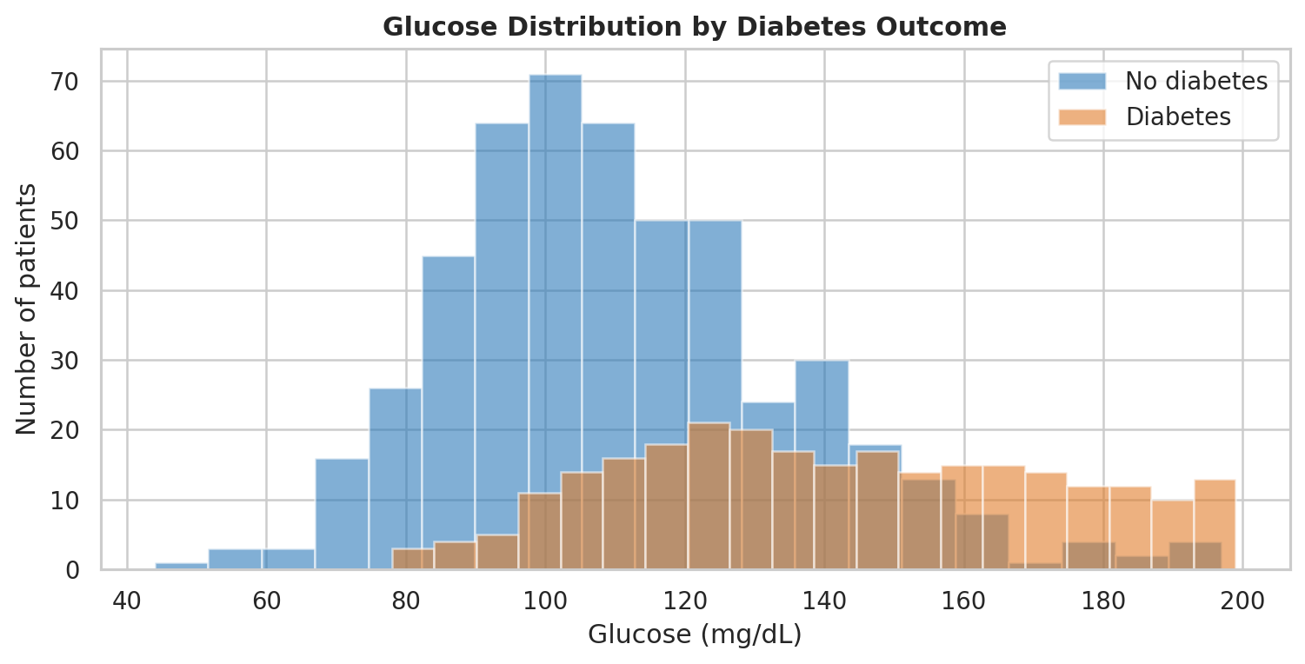
The chart compares glucose readings for patients with and without diabetes. The diabetes group is more concentrated at higher glucose values, so glucose is a useful variable to examine.

Chart 3. Box plots of key measurements
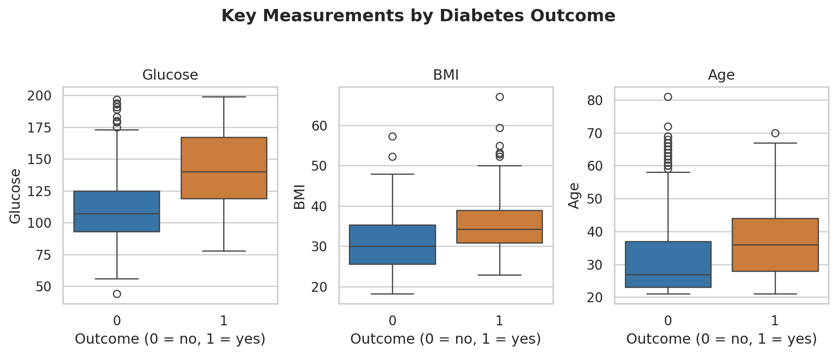
The box plots compare Glucose, BMI, and Age for both outcome groups. The median glucose is 107 mg/dL for patients without diabetes and 140 mg/dL for patients with diabetes.
Chart 4. Diabetes outcome counts
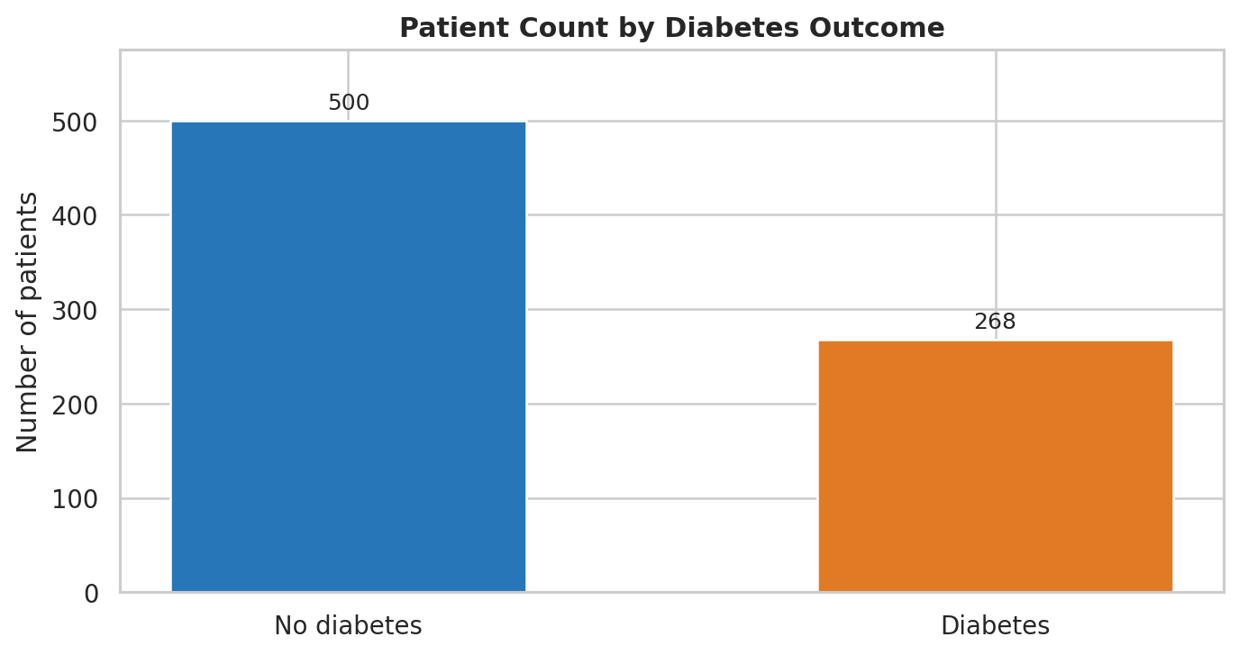
There are 500 patients with Outcome 0 and 268 with Outcome 1. This means 34.9% of the records are in the diabetes group.

Chart 5. Correlation heatmap
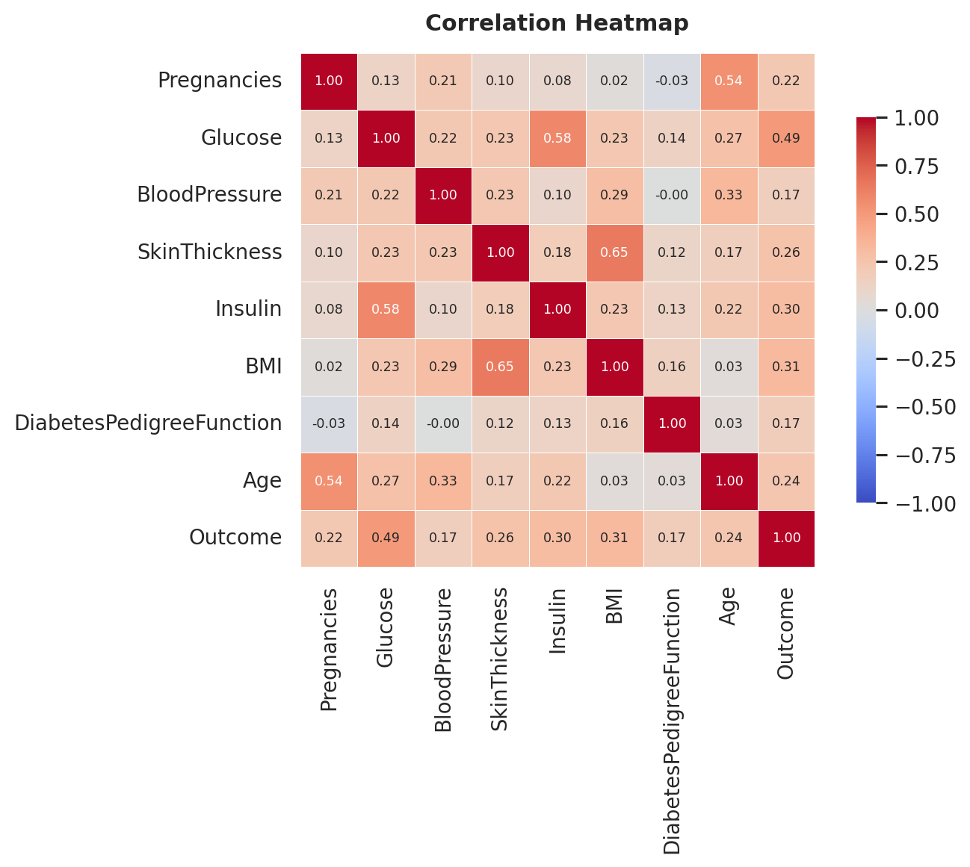
The heatmap shows how the numeric columns move together. Glucose has the strongest positive correlation with Outcome (r = 0.49); correlation does not prove that one variable causes another.
Chart 6. Glucose vs BMI
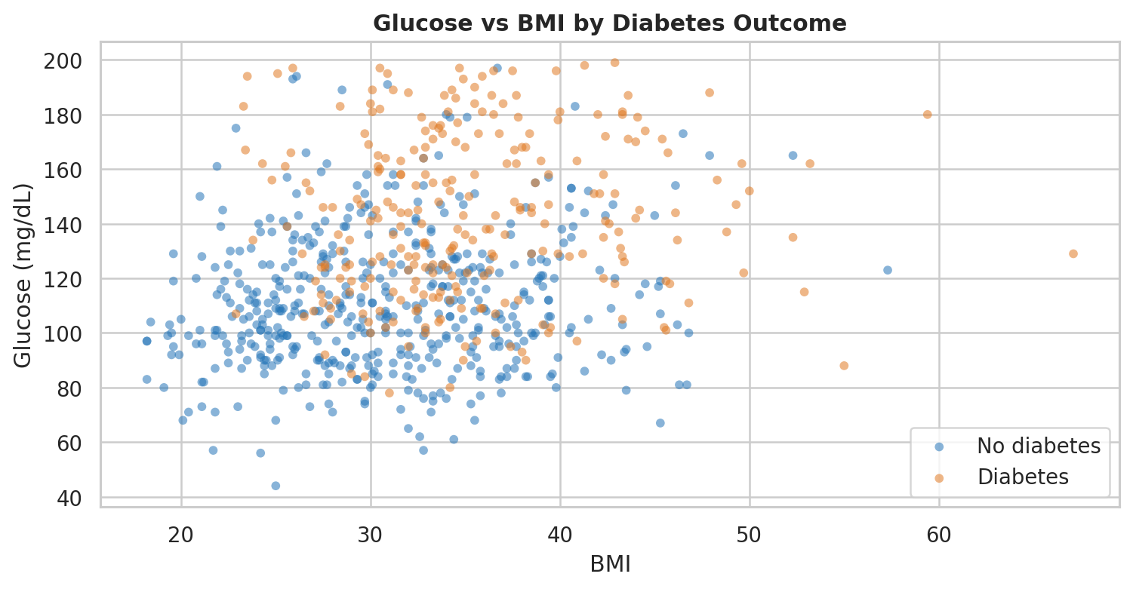
Each point represents a patient, coloured by diabetes outcome. The groups overlap, but many diabetes cases appear at higher glucose levels across a range of BMI values.

3. Power BI Dashboard
The dashboard image uses values calculated from the uploaded CSV. The filter controls are shown as a visual mock-up; they are not interactive in this image.
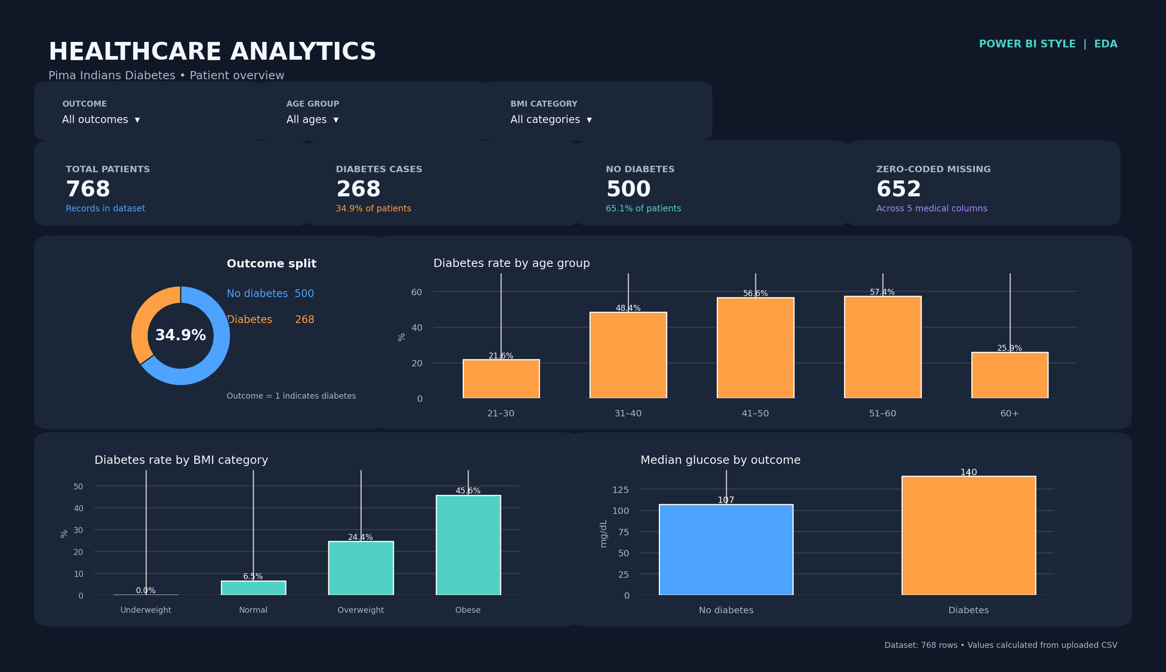

What the dashboard shows
The KPI cards show 768 patients, 268 diabetes cases (34.9%), 500 patients without diabetes, and 652 zero-coded missing entries across the five medical columns.
The charts compare outcome share, diabetes rate by age group and BMI category, and median glucose by outcome. The slicers are intended to filter by outcome, age group, and BMI category; the highest BMI-category rate is Obese at 45.6%.

4. Tableau Dashboard
This Tableau-style image presents the same dataset and verified calculations in a lighter dashboard layout. The filter controls are visual examples only and do not change the image.
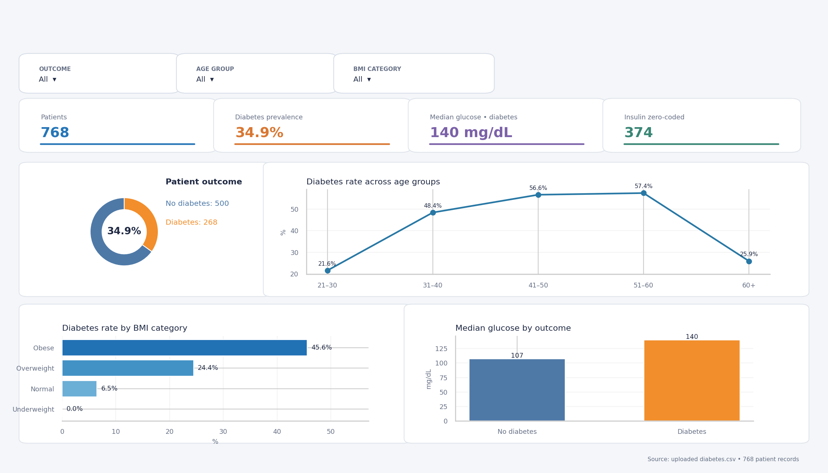

What the dashboard shows
The KPI cards show the total patient count, diabetes prevalence, median glucose for patients with diabetes (140 mg/dL), and zero-coded insulin entries (374).
The charts show patient outcome share, diabetes rate by age group and BMI category, and median glucose by outcome. The filters are labelled for outcome, age group, and BMI category; the overall data shows higher median glucose among patients with diabetes.

