BOOKVERSE – LIBRARY MANAGEMENT SYSTEM
A PROJECT REPORT
Submitted by
Aashira
(241501004)
in partial fulfilment of the End Semester Examination for the course
CB23F35 –
LOW-CODE APPLICATION DEVELOPMENT USING ZOHO CREATOR
in
BACHELOR OF TECHNOLOGY
ARTIFICIAL INTELLIGENCE AND MACHINE LEARNING

RAJALAKSHMI ENGINEERING COLLEGE
(An Autonomous Institution, Affiliated to Anna University, Chennai)
Rajalakshmi Nagar, Thandalam, Tamil Nadu – 602 105
OCTOBER 2026

RAJALAKSHMI ENGINEERING COLLEGE
(An Autonomous Institution, Affiliated to Anna University, Chennai)
BONAFIDE CERTIFICATE
Certified that this project report titled “BOOKVERSE – LIBRARY MANAGEMENT SYSTEM” is the bonafide work of Aashira (241501004), who carried out the individual project work on the Zoho Creator low-code platform for the course CB23F35 – Low-Code Application Development using Zoho Creator, during the academic year 2026–2027, Semester V, under my supervision.
SIGNATURE  Dr. M. Ayyadurai  HEAD OF THE DEPARTMENT  Department of Artificial Intelligence and Machine Learning  Rajalakshmi Engineering College  Thandalam – 602 105 | SIGNATURE  Priya M  COURSE FACULTY  Assistant Professor  Department of Artificial Intelligence and Machine Learning  Rajalakshmi Engineering College

Submitted for the End Semester Examination (Individual Project) held on

INTERNAL EXAMINER | EXTERNAL EXAMINER

DECLARATION
I, Aashira (241501004), hereby declare that the project report titled “BOOKVERSE – LIBRARY MANAGEMENT SYSTEM”, submitted for the End Semester Examination of the course CB23F35 – Low-Code Application Development using Zoho Creator, is a record of original work carried out by me individually. The Zoho Creator application described in this report — including its data model, forms, reports, pages, Deluge scripts, workflows and integrations — was designed and developed by me.
I further declare that this work has not been submitted, in part or in full, for the award of any other degree or course credit. Every template, sample application, AI-assisted feature (such as Zia or the AI application builder), code snippet or external resource used in this work has been duly acknowledged in the report.
Place: Chennai SIGNATURE OF THE STUDENT
Date: Aashira
241501004

ACKNOWLEDGEMENT
I express my sincere gratitude to our Chairman Mr. S. Meganathan, Chairperson Dr. (Mrs.) Thangam Meganathan and Vice-Chairman Mr. ABHAY SHANKAR MEGANATHAN, B.E., M.S., for providing the infrastructure and facilities that made this work possible.
I am grateful to our Principal, Dr. S.N. MURUGESAN, M.E., Ph.D., Rajalakshmi Engineering College, for the constant encouragement extended to students to take up industry-relevant learning.
I thank Dr. M. Ayyadurai, M.E., Ph.D., Head of the Department, Department of Artificial Intelligence and Machine Learning, for the guidance and support provided throughout the course.
I owe my sincere thanks to my course faculty, Priya M, Assistant Professor for the valuable guidance, reviews and feedback that shaped this application and report.
I also acknowledge Zoho Corporation for providing access to the Zoho Creator platform and learning resources, and I thank my family and friends for their unwavering support.

Aashira

ABSTRACT
Libraries that rely on registers, spreadsheets and paper cards to record books, members, issues and returns face repeated manual effort and inconsistent information. The number of copies of a title that remain on the shelf, the date by which a book is due and the fine owed for a late return must all be worked out by hand, which is slow and error-prone as the collection and the number of members grow. A centralised record of books, members and borrowing transactions, with automation of routine calculations, is therefore needed to reduce manual record-keeping and improve operational efficiency.
This project presents BookVerse, a Library Management System developed on the Zoho Creator low-code platform with the help of the Zia AI assistant, which generated the initial structure and configuration of the application. The application contains three forms: Books, for book details and inventory information; Members, for member and membership details; and Borrowing Transactions, for borrowing and return records, including the Return Date. Two form workflows have been configured and enabled: Auto-Update Available Copies, which runs after a transaction is successfully submitted, and Calculate Overdue Fine, which runs when the Return Date field is edited. A blueprint named Book Borrowing Workflow structures the borrowing process, and a Monthly Membership Renewal schedule has been created but is currently disabled. Dashboards, reports, overdue reminders, additional validation and role-based permissions for the Librarian and other users are planned enhancements.
A set of seventeen functional test cases has been defined to verify the forms, the workflows, the blueprint and the schedule, and the results, together with user acceptance feedback, are to be recorded in Chapter 6. The project demonstrates that AI-assisted low-code development can establish a working foundation for library operations quickly and that the foundation can be extended by configuration rather than conventional programming. Payment-gateway integration, barcode scanning, AI-based book recommendations, integration with third-party library systems and a member self-service portal are outside the scope of this version.
Keywords: Low-Code Development; Zoho Creator; Zia AI Assistant; Library Management System; Workflow Automation; Blueprint

PROJECT AT A GLANCE
Attribute | Details
Project Title | BOOKVERSE – LIBRARY MANAGEMENT SYSTEM
Application Domain | Education / Library Management
Student Name & Register No. | Aashira – 241501004
Zoho Creator Edition | Zoho Creator 6
Application Name (Link Name) | Published / Live URL | https://creatorapp.zoho.in/bookverse-library-system
  bookverse-library-system
Demo Credentials (per role) | Not applicable
Number of Forms / Subforms | 3
Number of Reports (by type) | List: Kanban, Pivot/Chart (reports and dashboard are planned)
Number of Pages / Dashboards | 4
Number of Workflows | Form: 2 (enabled) Schedule: 1 Blueprint: 1 (enabled)
Deluge Functions / Custom Actions | None
Integrations | Dashboard, reminders and other integrations are planned.
Roles & Profiles Defined | Librarian / Administrator (intended primary user); role-based access for other users is planned
Environments Used | None
Date of Production Deployment

TABLE OF CONTENTS
ABSTRACT iv
PROJECT AT A GLANCE v
LIST OF TABLES ix
LIST OF FIGURES x
LIST OF ABBREVIATIONS xi
INTRODUCTION 1
1.1 Background 1
1.2 Problem Statement 1
1.3 Objectives 2
1.4 Scope of the Project 2
1.5 Justification for a Low-Code Approach 2
1.6 Organisation of the Report 3
LITERATURE SURVEY AND SYSTEM STUDY 4
2.1 Study of the Existing System 4
2.2 Limitations of the Existing System 4
2.3 Low-Code versus Traditional Development 5
2.4 Literature Survey 6
2.5 Emerging Trends in Low-Code Development 7
2.6 Proposed System 7
REQUIREMENT ANALYSIS 8
3.1 Stakeholders and User Roles 8
3.2 Functional Requirements 8
3.3 Non-Functional Requirements 10
3.4 Hardware and Software Requirements 10
3.5 Use Case Model 11
SYSTEM DESIGN 12
4.1 System Architecture 12
4.2 Data Model 12
4.3 Form Design 14
4.4 Process and Workflow Design 15
4.5 User Interface and Navigation Design 16
4.6 Access Control Design 17
IMPLEMENTATION 18
5.1 Application Setup 18
5.2 Forms and Data Capture 18
5.3 Reports 19
5.4 Pages and Dashboards 20
5.5 Deluge Scripting 21
5.6 Workflows and Automation 22
5.7 Integrations 23
5.8 User Management and Role-Based Access 24
5.9 AI and Analytics Features 24
5.10 Pro-Code Extension 24
5.11 Mobile and Portal Access 24
TESTING AND DEBUGGING 26
6.1 Testing Strategy 26
6.2 Test Cases 26
6.3 Debugging Deluge Scripts 28
6.4 Defect Log 29
6.5 User Acceptance Testing 29
DEPLOYMENT, SECURITY AND GOVERNANCE 30
7.1 Environments and Deployment Strategy 30
7.2 Performance Optimisation 30
7.3 Security Features 31
7.4 Governance and Administration 31
RESULTS AND DISCUSSION 33
8.1 Application Output 33
8.2 Achievement of Objectives 33
8.3 Comparison with the Existing System 34
8.4 Limitations of the Low-Code Approach 35
8.5 Reflection on the No-Code → Low-Code → Pro-Code Spectrum 35
CONCLUSION AND FUTURE ENHANCEMENTS 36
9.1 Conclusion 36
9.2 Future Enhancements 36
9.3 Learning Outcomes and Career Relevance 36
REFERENCES 37
APPENDIX A – ZOHO CREATOR FEATURE COVERAGE CHECKLIST 38
APPENDIX B – COURSE OUTCOME MAPPING 41
APPENDIX C – COMPLETE DELUGE SOURCE CODE 42
APPENDIX D – USER MANUAL 43
D.1 Accessing the Application 43
D.2 Instructions for the Librarian / Administrator 43
D.3 Instructions for Library Members (planned) 43
APPENDIX E – EVALUATION RUBRIC 44
APPENDIX F – VIVA-VOCE RECORD SHEET 46

LIST OF TABLES
Table 2.1: Comparison of Low-Code and Traditional Development for the Proposed Application 5
Table 2.2: Summary of Literature Survey 6
Table 3.1: Stakeholders and User Roles 8
Table 3.2: Functional Requirements 8
Table 3.3: Non-Functional Requirements 10
Table 3.4: Hardware and Software Requirements 10
Table 3.5: Use Case Description – Maintain Book and Member Records 11
Table 4.1: Entities and Relationships 13
Table 4.2: Field Specification – Books Form (Indicative) 14
Table 4.3: Field Specification – Members Form (Indicative) 14
Table 4.4: Field Specification – Borrowing Transactions Form (Indicative) 14
Table 4.5: Role–Permission Matrix (Intended Design) 17
Table 5.1: Reports Implemented 19
Table 5.2: Deluge Scripts Implemented 21
Table 5.3: Workflows Implemented 22
Table 5.4: Integrations Implemented 23
Table 6.1: Test Cases 26
Table 6.2: Defect Log 29
Table 6.3: User Acceptance Feedback 29
Table 7.1: Deployment Checklist 30
Table 7.2: Performance Optimisation Results 31
Table 7.3: Security Controls Implemented 31
Table 8.1: Mapping of Objectives to Outcomes 33
Table 8.2: Existing System versus Proposed Application 34
Table A.1: Feature Coverage Checklist 38
Table B.1: Mapping of Course Outcomes to Report Chapters 41
Table E.1: Evaluation Rubric for the Individual Project 44
Table E.2: Performance Level Descriptors 45
Table F.1: Viva-Voce Questions and Responses 46
Table F.2: Marks Summary 46

LIST OF FIGURES
Figure 2.1: As-Is Process Flow of the Manual Library Record-Keeping System 4
Figure 3.1: Use Case Diagram of the BookVerse Library Management System 11
Figure 4.1: System Architecture of the BookVerse Library Management System 12
Figure 4.2: Entity–Relationship Diagram of the BookVerse Library Management System 13
Figure 4.3: Workflow / Process Flow for Borrowing and Return of a Book 16
Figure 4.4: Navigation Structure of the BookVerse Library Management System 17
Figure 5.1: BookVerse – Application Home and Navigation Sections 18
Figure 5.2: Books Form in the Form Builder 18
Figure 5.3: Books Form in Live Mode 19
Figure 5.4: Members Form in the Form Builder 19
Figure 5.5: Borrowing Transactions Form in the Form Builder 19
Figure 5.6: Borrowing Transactions Report 20
Figure 5.7: Library Dashboard Page (Planned) 20
Figure 5.8: Form Workflows, Blueprint and Schedule Configuration 23
Figure 5.9: Integration Setup (if configured) 24
Figure 5.10: Roles and Permission Profiles Configuration (if configured) 24
Figure 5.11: BookVerse on a Mobile Device 25
Figure 6.1: Workflow Execution Log / Debug Output 29
Figure 7.1: Environments / Publish to Production 30
Figure 7.2: Audit Trail / Administration Settings 32
Figure 8.1: Scenario Step 1 – Librarian adds a book and a member 33
Figure 8.2: Scenario Step 2 – Librarian records a borrowing transaction 33
Figure 8.3: Scenario Step 3 – Librarian records the return and the fine is calculated 33

LIST OF ABBREVIATIONS
Abbreviation | Expansion
AI | Artificial Intelligence
API | Application Programming Interface
CRUD | Create, Read, Update, Delete
Deluge | Data Enriched Language for the Universal Grid Environment
ER | Entity–Relationship
FR | Functional Requirement
LCAP | Low-Code Application Platform
LMS | Library Management System
NFR | Non-Functional Requirement
RBAC | Role-Based Access Control
UAT | User Acceptance Testing
UC | Use Case
UI | User Interface
URL | Uniform Resource Locator
Zia | Zoho's AI assistant

CHAPTER 1

INTRODUCTION

1.1 Background
A library is responsible for four connected activities: keeping an accurate record of its collection, registering and maintaining its members, lending books to those members, and recovering the books on time. Every lending event changes the number of copies that are available on the shelf, sets a date by which the book must come back, and may end in a fine if the book is returned late. When these activities are handled in registers, spreadsheets or paper cards, the librarian must repeat the same entries, count copies by hand and calculate fines manually.

1.2 Problem Statement
Managing a library through manual records makes it difficult to keep book inventory, member details and borrowing transactions consistent. The librarian has to update the stock by hand after every issue, find out manually which books are overdue, and calculate fines without a reliable record of the return date. This increases the time spent on routine record-keeping and the chance of errors. A centralised, structured and partly automated application is therefore required to hold the library records in one place and to reduce manual effort. The specific problems are:
- Book records and the number of available copies are maintained in separate manual records, so the inventory can be incorrect.
- Member information and membership details are scattered and difficult to keep up to date.
- Borrowing and return records are difficult to trace, because every transaction is written and searched by hand.
- Overdue fines are calculated manually from the due date and the return date, which is slow and error-prone.
- Routine tasks such as membership renewal depend on the librarian remembering to perform them.

1.3 Objectives
- To organise book and member information digitally in a structured data model with forms for books, members and borrowing transactions.
- To maintain borrowing transaction records, including the return date of each borrowed book.
- To automate selected library activities, namely the update of available copies and the calculation of overdue fines, through form workflows.
- To structure the borrowing process through a blueprint and to prepare a scheduled workflow for membership renewal.
- To support book availability and return tracking and to reduce manual effort in record-keeping.
- To demonstrate AI-assisted low-code development with the Zia assistant and to evaluate the application through test cases and user feedback.

1.4 Scope of the Project
In scope. The application contains three forms: Books, Members and Borrowing Transactions. It includes two enabled form workflows (Auto-Update Available Copies and Calculate Overdue Fine), one enabled blueprint (Book Borrowing Workflow) for the Borrowing Transactions form, and one scheduled workflow (Monthly Membership Renewal) that has been created but is currently disabled. The intended primary user is the Librarian / Administrator. The application is a web application built on Zoho Creator and can be opened in a browser.

1.5 Justification for a Low-Code Approach
A library application consists mainly of structured records – books, members and transactions – that are naturally represented as forms with related fields, together with a few rules such as updating stock and calculating a fine. Low-code platforms let developers describe such an application visually and concentrate on the requirements instead of infrastructure and repetitive code [1], [3], [4]. Zoho Creator provides hosting, user management, form workflows, blueprints, schedules and the Deluge scripting language where logic cannot be configured visually [2], [5]. Practitioners also report that low-code platforms speed up development, while pointing out limits in customisation and platform dependence [6].

1.6 Organisation of the Report
Chapter 2 reviews the existing system and related low-code literature. Chapter 3 presents the requirement analysis. Chapter 4 describes the system design. Chapter 5 details the implementation on Zoho Creator. Chapter 6 covers testing and debugging. Chapter 7 discusses deployment, performance optimisation, security and governance. Chapter 8 presents results and discussion, and Chapter 9 concludes the report with future enhancements.
CHAPTER 2

LITERATURE SURVEY AND SYSTEM STUDY

2.1 Study of the Existing System
In a manual library, the librarian keeps the details of the books in a register, card catalogue or spreadsheet, and records each member in a separate list. When a member borrows a book, the librarian writes the member, the book and the date in a transaction register and reduces the number of available copies by hand. When the book is returned, the librarian finds the entry, writes the return date, compares it with the due date and calculates a fine if the book is late.

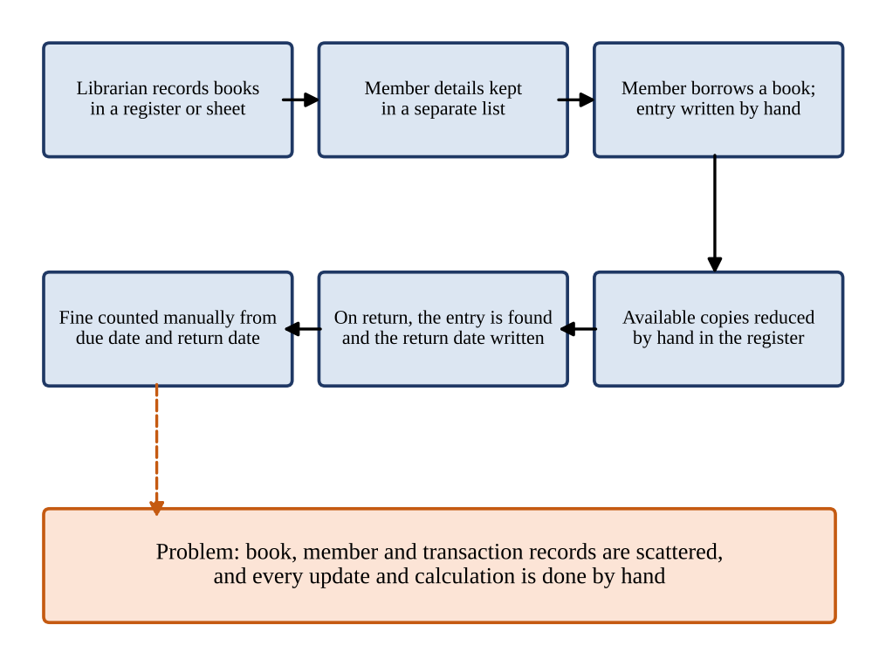
Figure 2.1: As-Is Process Flow of the Manual Library Record-Keeping System

2.2 Limitations of the Existing System
- Book, member and transaction information is spread over separate registers or sheets, so there is no single trusted record.
- The number of available copies is updated by hand after each issue and can become wrong.
- Tracing the borrowing history of a member or a book requires reading through the transaction register.
- Overdue fines are calculated manually and may be miscalculated or forgotten.
- Membership renewal depends on manual checking of membership dates.
- There is no access control, change history or reliable search over the records.

2.3 Low-Code versus Traditional Development
Table 2.1: Comparison of Low-Code and Traditional Development for the Proposed Application
Criterion | Traditional (Pro-Code) Development | Low-Code on Zoho Creator
Development effort | Needs separate design and coding of the database, back end, user interface and security; longest for an application with many forms and rules. | Forms and workflows are configured visually; the Zia assistant can generate the initial structure, and Deluge is used only where a rule cannot be configured.
Skills required | Front-end, back-end, database and deployment skills. | Understanding of data modelling and the platform; basic Deluge scripting.
Hosting & infrastructure | Server, database, domain and deployment pipeline must be arranged and maintained. | Hosting, backup and scaling are provided by the Zoho Creator platform, subject to the selected plan.
Process automation | Workflow logic, state tracking and scheduled jobs must be coded and deployed. | Form workflows, blueprints and schedules are built into the platform and configured in the builder.
Security & access control | Authentication, authorisation and session handling must be implemented. | Users, roles and permission profiles are built in and configured, not coded.
Maintenance & change | A change to a field or rule may touch several layers of code and need redeployment. | A new field, workflow or permission can usually be changed by the administrator in the builder.
Customisation limits | Almost unlimited design freedom. | Limited by the platform's field types, page builder and Deluge capabilities (see Section 8.4).
Cost | Developer time, hosting and maintenance costs. | Platform subscription according to the plan; an education plan may be used for learning.

2.4 Literature Survey
Table 2.2: Summary of Literature Survey
S.No. | Author(s) / Source & Year | Title / Product | Key Findings | Relevance to this Project
1 | W. Rosam and O. Kalnichevski [1] | Low-Code Development: A Practical Guide (BPB Publications) | Course text that introduces the principles and practice of low-code application development. | Provides the conceptual basis for choosing and applying a low-code platform for BookVerse.
2 | Zoho Corporation [2] | Zoho Creator Help Documentation (online) | Describes forms, field types, workflows, blueprints, schedules, user management and publishing in Zoho Creator. | Reference for the forms, form workflows, blueprint and schedule configured in the application.
3 | R. Sanchis, Ó. García-Perales, F. Fraile and R. Poler, 2020 [3] | Low-Code as Enabler of Digital Transformation in Manufacturing Industry | Argues that low-code development platforms facilitate and automate the development of software applications that support enterprise needs and digital transformation, and benchmarks existing platforms. | Academic support for using a low-code platform to digitise an institutional process such as library record-keeping.
4 | A. C. Bock and U. Frank, 2021 [4] | Low-Code Platform | Characterises low-code platforms and discusses their features and their implications for application development. | Defines the low-code platform concept used in Chapter 1.
5 | Zoho Corporation [5] | Deluge Script Reference Guide (online) | Describes the Deluge language, form events, fetch statements and date functions. | Reference for the reference scripts DS-01 to DS-03 in Chapter 5 and Appendix C.
6 | Y. Luo, P. Liang, C. Wang, M. Shahin and J. Zhan, 2021 [6] | Characteristics and Challenges of Low-Code Development: The Practitioners' Perspective | Reports from practitioners' discussions the advantages of low-code platforms, such as faster development, and the challenges, such as limited customisation and platform dependence. | Supports the justification (Section 1.5) and the limitations (Section 8.4).
7 | D. Di Ruscio, D. Kolovos, J. de Lara, A. Pierantonio, M. Tisi and M. Wimmer, 2022 [7] | Low-code development and model-driven engineering: Two sides of the same coin? | Examines the relationship between low-code development and model-driven engineering. | Explains why form and data models are the foundation of a low-code application.
8 | S. R. Ranganathan, 1931 [8] | The Five Laws of Library Science (Madras Library Association) | Sets out the classic principles of library service, including that books are for use and that the time of the reader should be saved. | Gives the library-domain motivation for fast, accurate records of books and borrowing.

2.5 Emerging Trends in Low-Code Development
Several trends in low-code development influenced the design of BookVerse. The first is citizen development: platforms allow people who are not professional programmers to build and maintain business applications, which suits a library that must keep the application running after the project is complete [3], [4], [6]. The application therefore relies on configuration wherever possible.

2.6 Proposed System
The proposed BookVerse application is a centralised Library Management System developed with Zoho Creator. It stores book details and inventory, member and membership details, and borrowing and return records in three related forms, and it automates selected tasks through form workflows, a blueprint and a scheduled workflow.
CHAPTER 3

REQUIREMENT ANALYSIS

3.1 Stakeholders and User Roles
Table 3.1: Stakeholders and User Roles
Role | Description | Key Responsibilities in the Application
Librarian / Administrator | Library staff member who manages the library records; intended primary user of the application. | Maintains book and member records, records borrowing transactions and returns, and manages the workflows and blueprint of the borrowing process.
Library Member | Person who borrows books; a stakeholder whose records are held in the Members form. | Borrows and returns books through the librarian. A dedicated self-service portal is out of scope; member access is a planned enhancement.

3.2 Functional Requirements
Table 3.2: Functional Requirements
FR ID | Requirement | Role(s) | Priority
FR-01 | The system shall allow the Librarian to add book records with book details and inventory information, including the number of available copies. | Librarian / Administrator | High
FR-02 | The system shall allow the Librarian to edit and maintain book records. | Librarian / Administrator | High
FR-03 | The system shall allow the Librarian to add and maintain member records with membership details. | Librarian / Administrator | High
FR-04 | The system shall allow a borrowing transaction to be recorded for a member and a book. | Librarian / Administrator | High
FR-05 | The system shall automatically update the available copies after a borrowing transaction is successfully submitted (Auto-Update Available Copies workflow). | Librarian / Administrator | High
FR-06 | The system shall allow the return of a book to be recorded by entering the Return Date of the transaction. | Librarian / Administrator | High
FR-07 | The system shall calculate the overdue fine when the Return Date field is edited (Calculate Overdue Fine workflow). | Librarian / Administrator | High
FR-08 | The system shall manage the borrowing process through the Book Borrowing Workflow blueprint on the Borrowing Transactions form. | Librarian / Administrator | Medium
FR-09 | The system shall provide a Monthly Membership Renewal scheduled workflow, which is created but disabled until it is tested. | Librarian / Administrator | Low
FR-10 | The system should retain borrowing records so that the history of a member or a book can be traced. | Librarian / Administrator | Medium
FR-11 | The system should validate the availability of a book before it is issued (planned). | Librarian / Administrator | Medium
FR-12 | The system should provide a dashboard and searchable reports for books, members and transactions (planned). | Librarian / Administrator | Medium
FR-13 | The system should send notifications for approaching and overdue due dates (planned). | Librarian / Administrator, Library Member | Low
FR-14 | The system should restrict access and operations according to role-based permissions (planned). | All users | High

3.3 Non-Functional Requirements
Table 3.3: Non-Functional Requirements
NFR ID | Category | Requirement
NFR-01 | Usability | The application shall provide simple forms through which the Librarian can enter and find book, member and transaction records.
NFR-02 | Performance | Forms and workflows shall respond within an acceptable time under normal library use.
NFR-03 | Security | Only authenticated Zoho users invited to the application shall access it; role-based restriction of data and operations is planned.
NFR-04 | Maintainability | Book, member and transaction data shall be kept in structured forms so that fields and workflows can be changed in the builder without reprogramming.
NFR-05 | Accessibility / Usability on devices | The application shall be usable in supported browsers and, where tested, on mobile devices through a browser or the Zoho Creator mobile app.
NFR-06 | Data integrity | A borrowing transaction shall refer to existing book and member records, and the available copies shall be kept consistent by the configured workflow.
NFR-07 | Reliability | Workflows shall run each time their trigger occurs; the scheduled workflow shall run only when it is enabled.
NFR-08 | Auditability | Important changes shall be traceable through the audit trail and change history available on the platform.

3.4 Hardware and Software Requirements
Table 3.4: Hardware and Software Requirements
Category | Specification
Platform | Zoho Creator 6
Scripting language | Deluge (Data Enriched Language for the Universal Grid Environment)
Browser | Google Chrome / Microsoft Edge / Mozilla Firefox (latest version)
API testing tool | Not used (no external API is integrated)
Other Zoho services | Zia AI assistant (used to generate the initial application); no other Zoho service is configured
Mobile | Zoho Creator mobile app (Android / iOS) or a mobile browser
Client hardware | Intel Core i3/i5 or above, 8 GB RAM, internet connection

3.5 Use Case Model

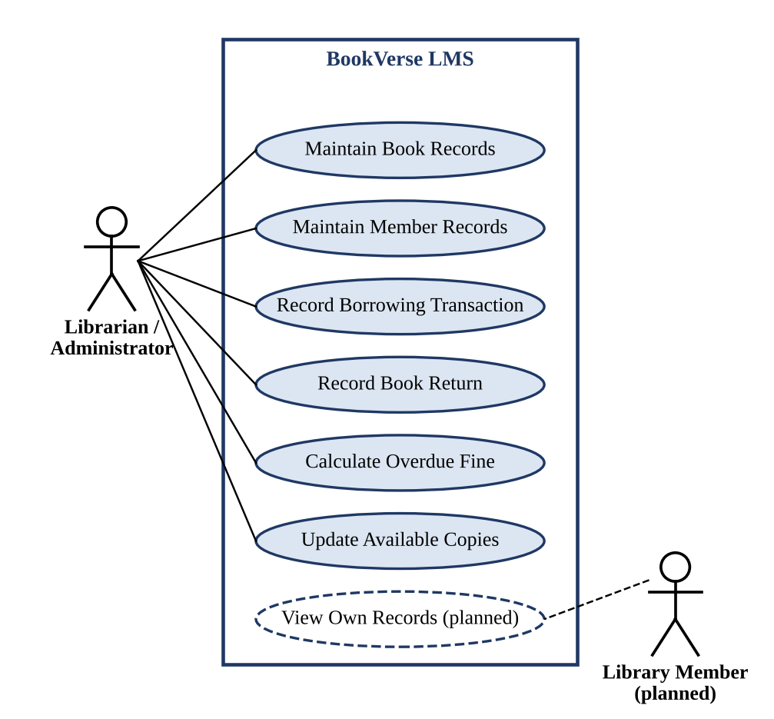
Figure 3.1: Use Case Diagram of the BookVerse Library Management System
Table 3.5: Use Case Description – Maintain Book and Member Records
Use Case ID | UC-01
Use Case Name | Maintain Book and Member Records
Actor(s) | Librarian / Administrator
Pre-condition | The librarian is signed in to the application with access to the Books and Members forms.
Main Flow | 1. The librarian opens the Books form, enters the book details and the number of available copies, and submits the form.  2. The application saves the record, and the book can then be selected in borrowing transactions.  3. The librarian opens the Members form, enters the member and membership details, and submits the form.  4. The librarian edits a book or a member record when the details change.
Alternate Flow | A mandatory field is left empty (where it is configured as mandatory); the application shows a validation message and does not save the record.
Post-condition | Book and member master records exist and can be referred to by borrowing transactions.
Related FR | FR-01, FR-02, FR-03
CHAPTER 4

SYSTEM DESIGN

4.1 System Architecture

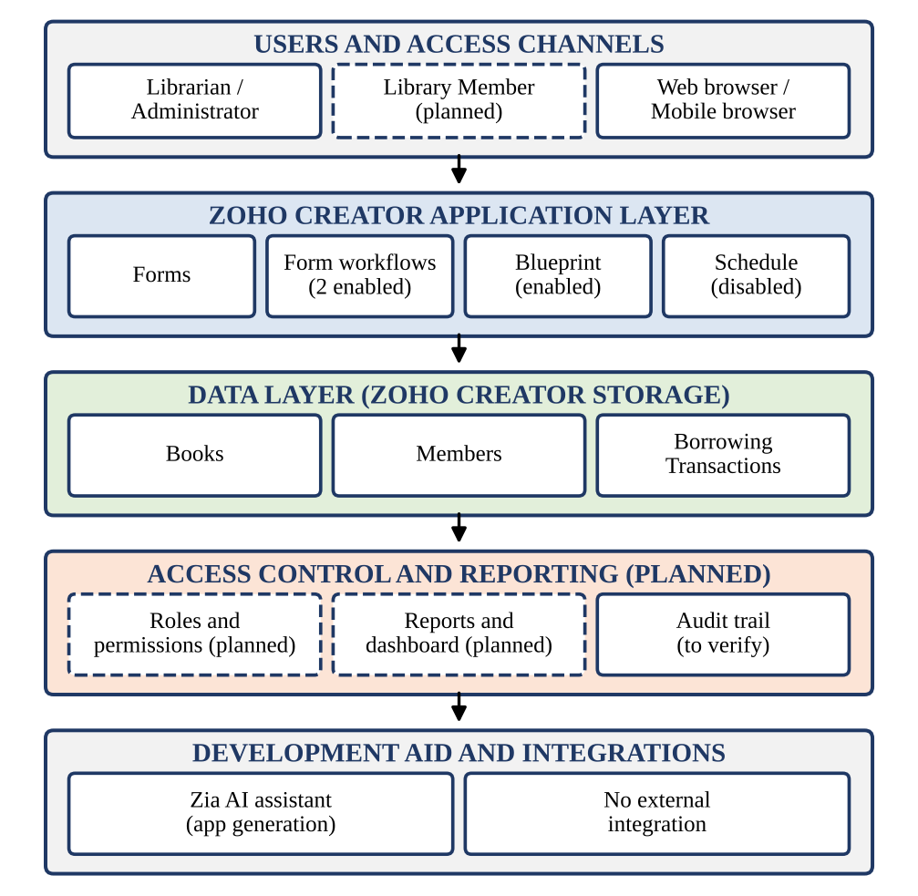
Figure 4.1: System Architecture of the BookVerse Library Management System
BookVerse follows a layered architecture on Zoho Creator, shown in Figure 4.1. The topmost layer contains the users and their access channel: the Librarian / Administrator is the intended primary user and works through a web browser, and a Library Member role is shown as planned.

4.2 Data Model

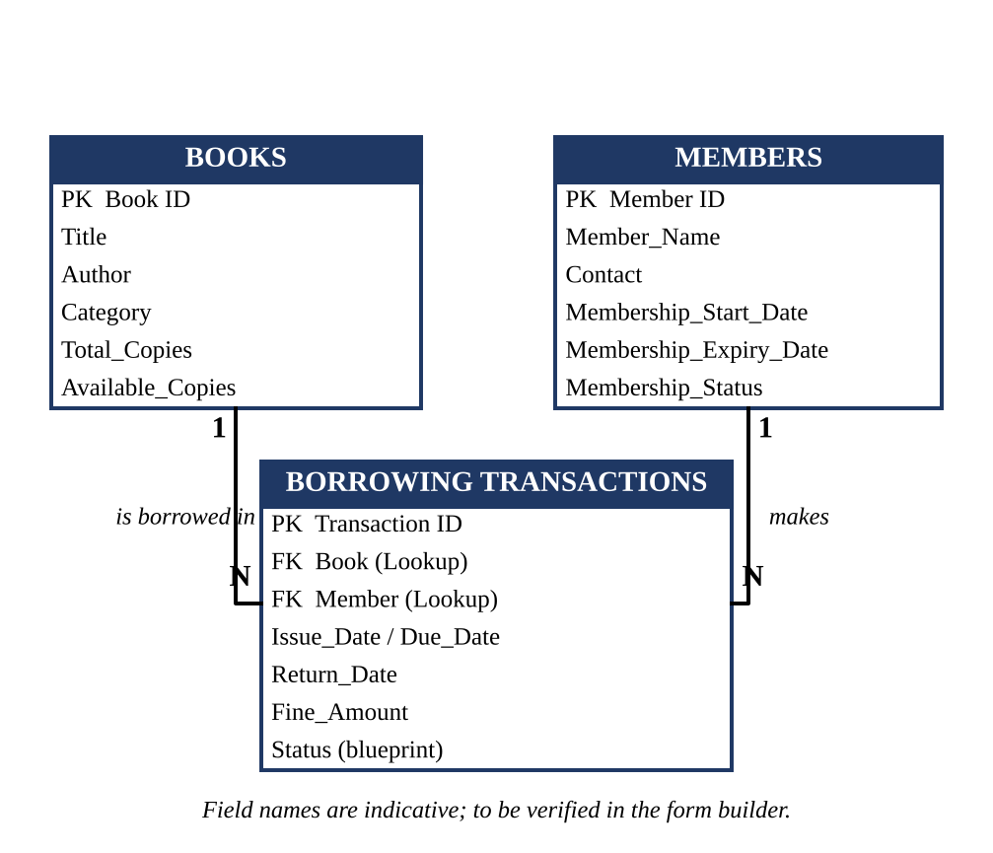
Figure 4.2: Entity–Relationship Diagram of the BookVerse Library Management System
Table 4.1: Entities and Relationships
Entity (Form) | Key Fields | Related To | Relationship Type | Implemented Using
Books | Book details and inventory information, including available copies (field names indicative) | Borrowing Transactions | One-to-Many | Lookup field Book in Borrowing Transactions
Members | Member information and membership details (field names indicative) | Borrowing Transactions | One-to-Many | Lookup field Member in Borrowing Transactions
Borrowing Transactions | Book, Member, issue and due dates, Return Date, fine (field names indicative) | Books, Members | Many-to-One (to each) | Lookup fields Book and Member

Books and Members are master forms that hold data that changes rarely. Borrowing Transactions holds one record for each borrowing event and refers to its book and its member through lookup fields, so one book can appear in many transactions and one member can borrow many books. The attributes in Table 4.1 are indicative: the project summary confirms the purpose of each form and the Return Date field, so the exact field list must be checked against the form builder.

4.3 Form Design
Table 4.2: Field Specification – Books Form (Indicative)
Field Label | Link Name | Field Type | Mandatory | Validation / Default | Remarks
Title | Title | Single Line | N | Default | Name of the book
Author | Author | Single Line | N | Default | Author of the book
Isbn | Isbn | Single Line | N | Default | Identification
Category | Category | Drop Down | N | Default | Subject or category of the book
Publisher | Publisher | Single Line | N | Default | Corporation
Publication Year | Publication Year | Number | N | Default | Year
Total Copies | Total_Copies | Number | N | Default | Number of copies owned by the library
Available Copies | Available Copies | Number | N | Default | Inventory field updated by Auto-Update Available Copies (to be verified)

Table 4.3: Field Specification – Members Form (Indicative)
Field Label | Link Name | Field Type | Mandatory | Validation / Default | Remarks
Member Name | Member_Name | Single Line | N | Default | Name of the library member
Contact | Contact | Email | N | Default | Phone or e-mail of the member
Phone Number | Number | Number | N | Default | Phone number
Department | Department | Single Line | N | Default | Class
Membership Start Date | Membership_Start_Date | Date | N | Default | Start of the membership
Membership Status | Membership_Status | Drop Down | N | Default | Active / Expired

Table 4.4: Field Specification – Borrowing Transactions Form (Indicative)
Field Label | Link Name | Field Type | Mandatory | Validation / Default | Remarks
Book | Book | Lookup | N | Default | Lookup to Books
Member | Member | Lookup | N | Default | Lookup to Members
Issue Date | Issue_Date | Date | N | Default | Date on which the book is issued
Due Date | Due_Date | Date | N | Default | Date by which the book must be returned
Return Date | Return_Date | Date | N | Default | Date of return; its user input triggers Calculate Overdue Fine
Fine Amount | Fine_Amount | Decimal | N | Default | Overdue fine calculated by the workflow (to be verified)
Status | Status | Drop Down | N | Default | Stage managed by the Book Borrowing Workflow blueprint (to be verified)

Link names follow the platform convention of replacing spaces with underscores. Screenshots of each form are given in Chapter 5.

4.4 Process and Workflow Design

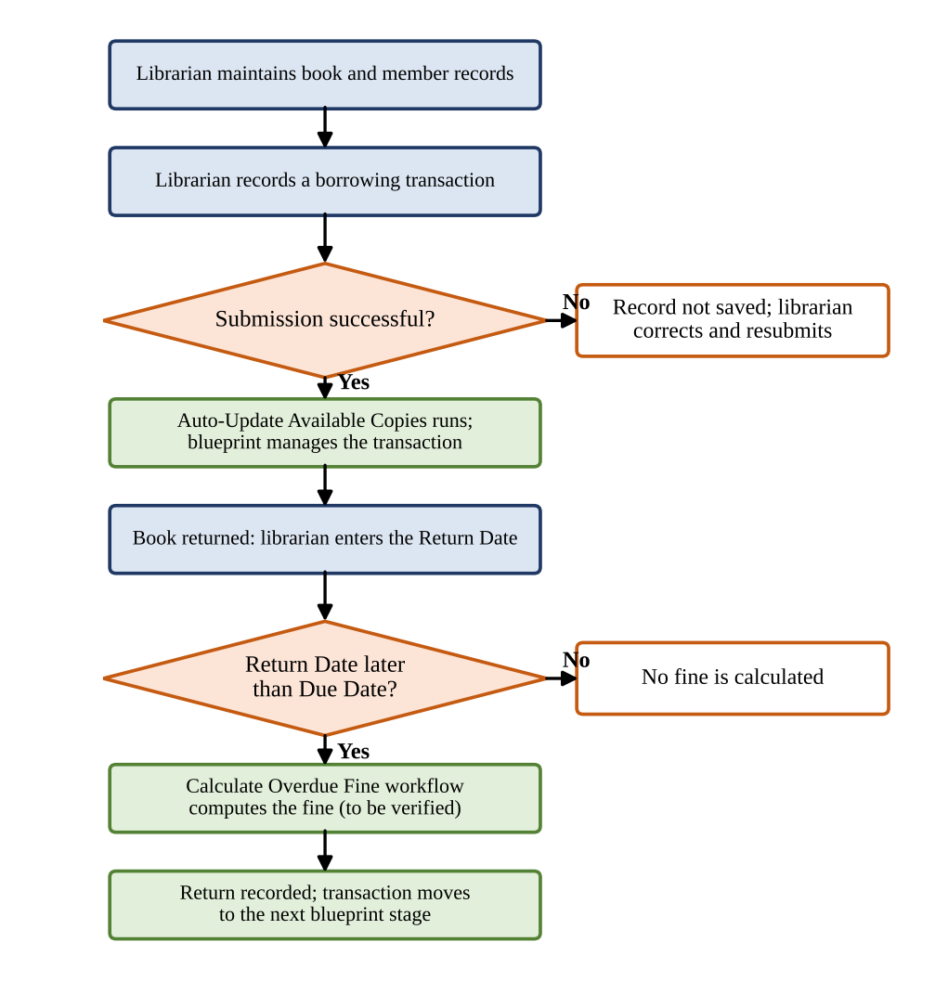
Figure 4.3: Workflow / Process Flow for Borrowing and Return of a Book
Figure 4.3 shows the intended borrowing and return process. The librarian maintains the book and member records and then records a borrowing transaction. The Book Borrowing Workflow blueprint manages the transaction, and after successful submission the Auto-Update Available Copies workflow updates the inventory. When the book comes back, the librarian edits the Return Date; this user input triggers the Calculate Overdue Fine workflow. The exact stages and transitions of the blueprint, the update logic and the fine formula depend on the actions configured in Zoho Creator and are to be verified by the test cases of Chapter 6.

4.5 User Interface and Navigation Design

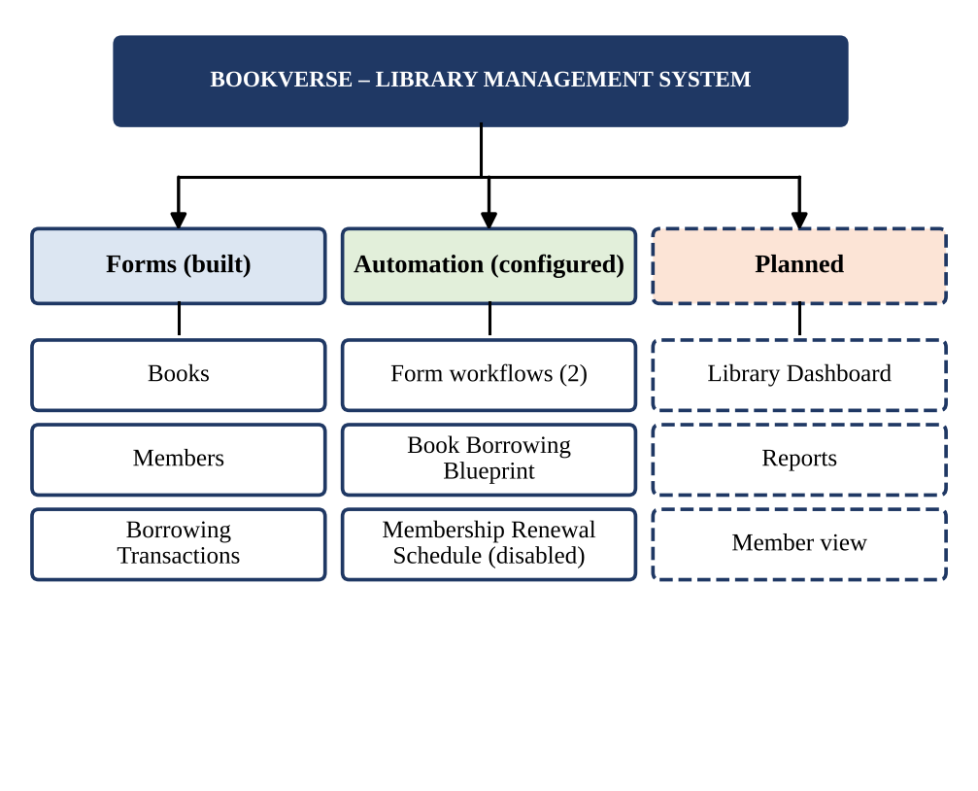
Figure 4.4: Navigation Structure of the BookVerse Library Management System
The application is organised around the three forms: Books, Members and Borrowing Transactions, which the Librarian / Administrator uses to enter and maintain records. The workflows, the blueprint and the schedule are configured in the application builder and run in the background. A dashboard with library statistics and a view for members are planned and are drawn with dashed boxes in Figure 4.4.

4.6 Access Control Design
Table 4.5: Role–Permission Matrix (Intended Design)
Component | Librarian / Administrator | Library Member (planned)
Form: Books | A E V D | V
Form: Members | A E V D | V (own record)
Form: Borrowing Transactions | A E V D | V (own records)
Workflows and blueprint | Configure | —
Report: Overdue Transactions (planned) | V | —
Page: Library Dashboard (planned) | V | —
Administrative settings | Full | —
A = Add, E = Edit, V = View, D = Delete, — = No access. The matrix is the intended design: the Librarian / Administrator is the primary user, and role-based permissions for other users are planned and are not yet configured.
CHAPTER 5

IMPLEMENTATION

5.1 Application Setup
The BookVerse application was created in Zoho Creator with the help of the Zia AI assistant, which generated the initial structure and configuration of the application from a description of the library problem. The first step was to identify the entities of the problem – books, members and borrowing transactions – and to review the three forms that were created for them, as designed in Chapter 4. Zoho Creator generates a default list view for forms, and the generated configuration was then refined in the builder.

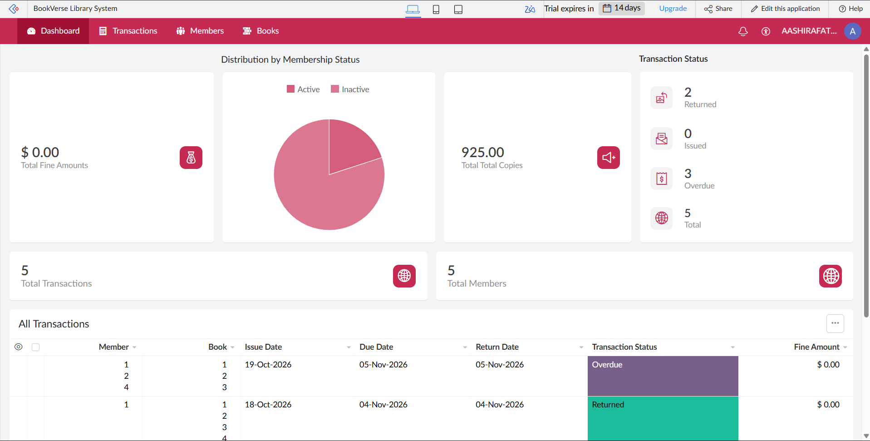
Figure 5.1: BookVerse – Application Home and Navigation Sections

5.2 Forms and Data Capture
Three forms were created in the Zoho Creator form builder. The field types, mandatory settings and validations are listed in Tables 4.2 to 4.4 and are to be confirmed against the form builder. Each form stores one kind of record, and the Borrowing Transactions form connects the other two.

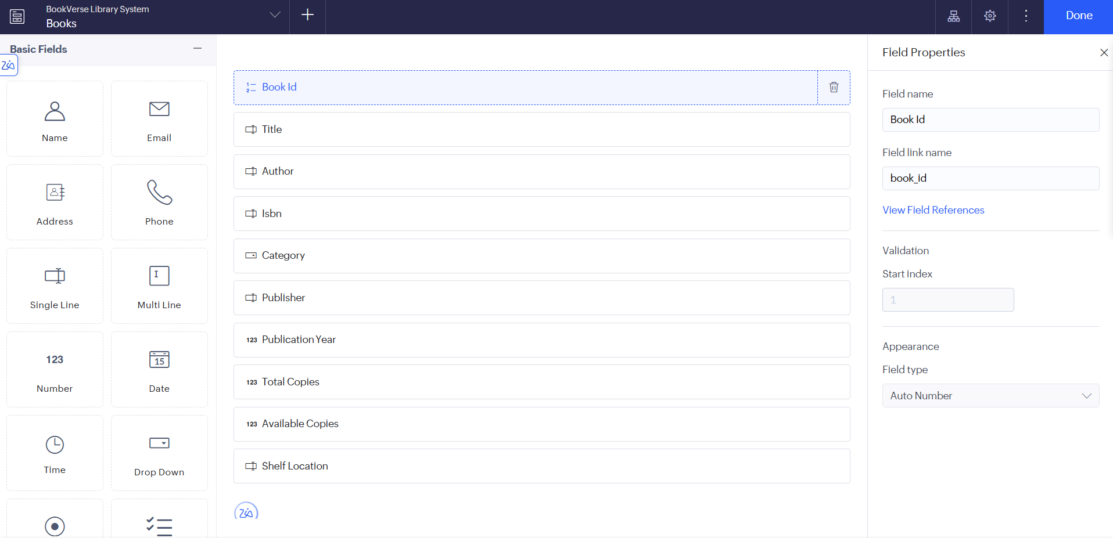
Figure 5.2: Books Form in the Form Builder

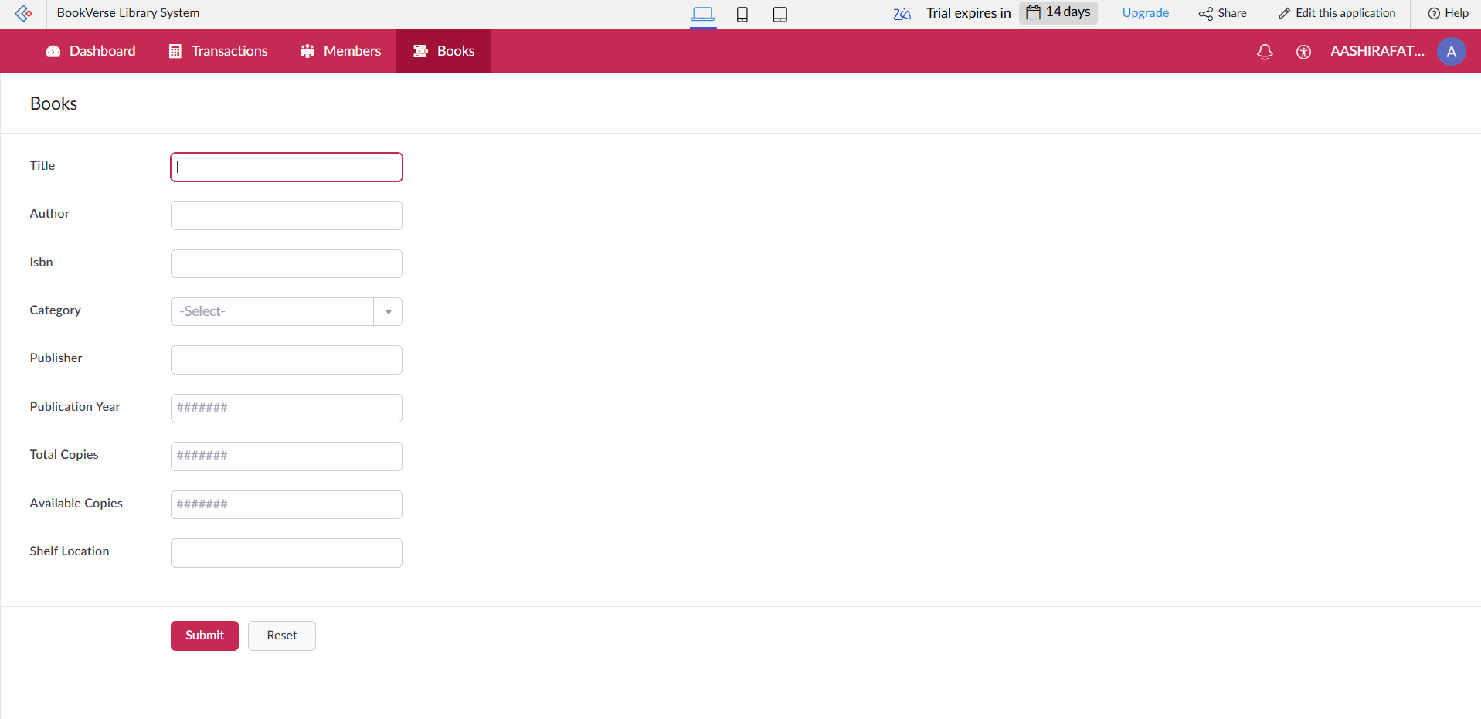
Figure 5.3: Books Form in Live Mode
Members form. The Members form stores the member information and the membership details. These records identify the member who is associated with each borrowing transaction. The Monthly Membership Renewal schedule is intended to act on membership data; the schedule is currently disabled (Section 5.6).

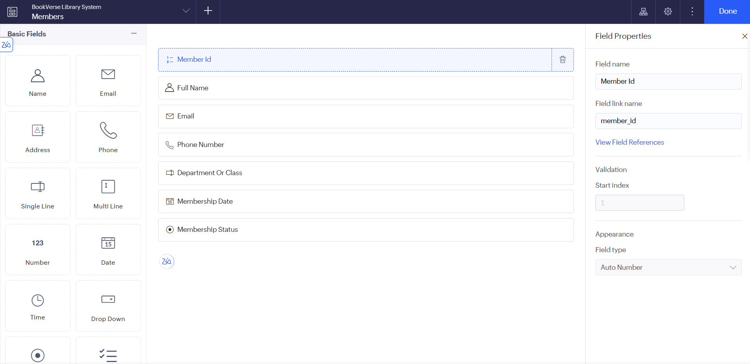
Figure 5.4: Members Form in the Form Builder
Borrowing Transactions form. The Borrowing Transactions form manages the records of borrowing and returning books. It refers to a book and a member, and it contains the Return Date field, whose user input triggers the Calculate Overdue Fine workflow. Its submission triggers the Auto-Update Available Copies workflow, and the Book Borrowing Workflow blueprint is associated with it.

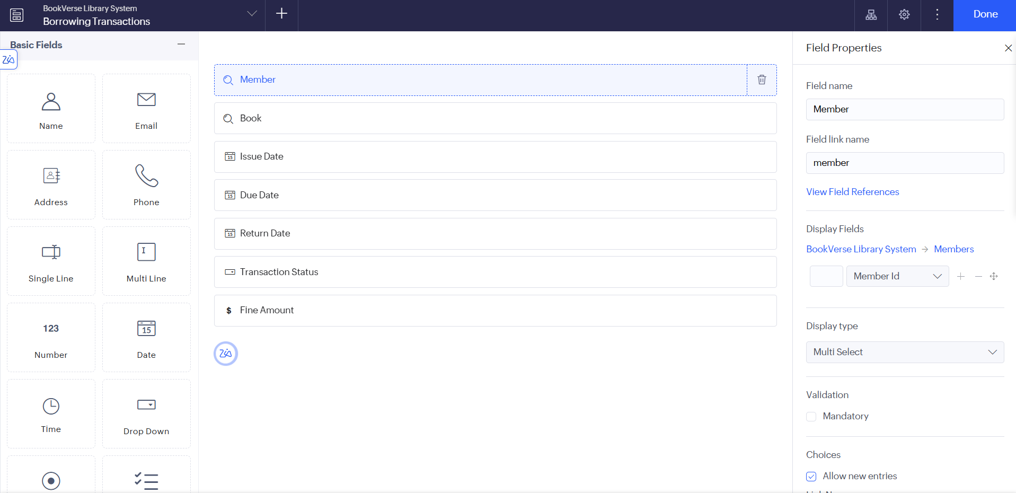
Figure 5.5: Borrowing Transactions Form in the Form Builder

5.3 Reports
Table 5.1: Reports Implemented
Report Name | Type | Source Form | Filter / Grouping / Sorting | Custom Actions | Roles
Books Report | List | Books | Default report configuration; sorting and grouping not verified. | Custom actions not verified. | Librarian / Administrator
Members Report | List | Members | Default report configuration; sorting and grouping not verified. | Custom actions not verified. | Librarian / Administrator
Borrowing Transactions Report | List | Borrowing Transactions | Default report configuration; sorting and grouping not verified. | Custom actions not verified. | Librarian / Administrator
Overdue Transactions Report (planned) | List | Borrowing Transactions | Planned: criteria on Return Date and Due Date | Not implemented | Librarian / Administrator

Zoho Creator normally creates a default list report for each form, so list reports of the three forms are expected to exist; their configuration is to be verified. Searchable reports, filters and an overdue-transactions report are planned enhancements and are not described as implemented. Kanban, calendar and chart reports were not required for the core functionality.

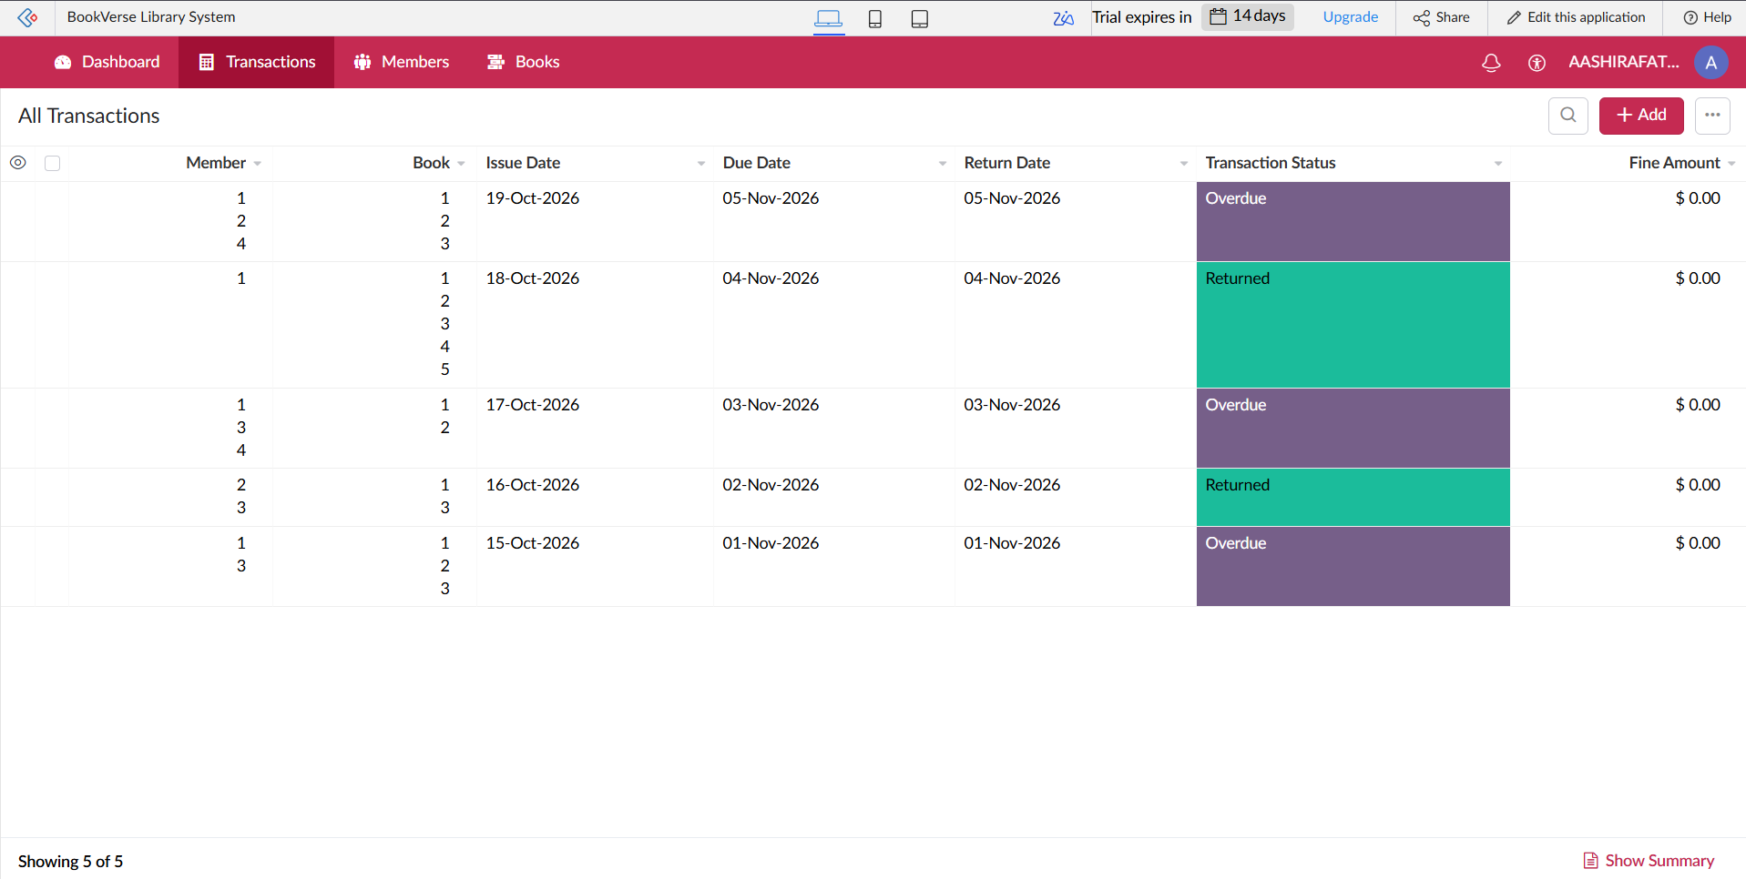
Figure 5.6: Borrowing Transactions Report

5.4 Pages and Dashboards
A dashboard is a planned enhancement: a page built with the Zoho Creator UI Builder that would show summary tiles such as the total number of books, the available copies, the active borrowings and the overdue transactions, together with embedded reports for the librarian.

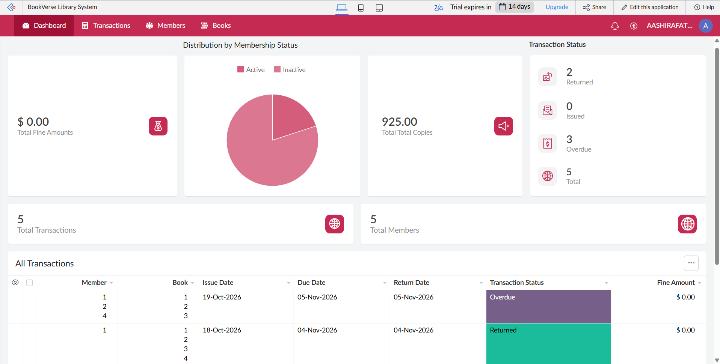
Figure 5.7: Library Dashboard Page (Planned)

5.5 Deluge Scripting
Table 5.2: Deluge Scripts Implemented
Script ID | Location / Trigger | Purpose | Deluge Concepts Used
DS-01 | Borrowing Transactions → On Add → On Success | Reduce the available copies of the borrowed book after a transaction is submitted (reference script for the Auto-Update Available Copies workflow) | fetch with criteria, field update, if
DS-02 | Borrowing Transactions → On User Input of Return Date | Calculate the overdue fine when the return date is entered (reference script for the Calculate Overdue Fine workflow) | if-else, date functions, daysBetween, arithmetic
DS-03 | Borrowing Transactions → On Validate (planned) | Block issuing a book that has no available copy (planned, not implemented) | fetch with criteria, if, alert, cancel submit

Code 5.1: DS-01 – Update available copies (reference script)
// DS-01 | Form: Borrowing_Transactions | Event: On Add -> On Success
// Purpose: Reduce the available copies of the borrowed book by one (reference script)
bookRec = Books[ID == input.Book];
if(bookRec.Available_Copies > 0)
{
bookRec.Available_Copies = bookRec.Available_Copies - 1;
}

Code 5.2: DS-02 – Overdue fine calculation (reference script)
// DS-02 | Form: Borrowing_Transactions | Event: On User Input of Return_Date
// Purpose: Calculate the overdue fine when the return date is entered (reference script)
fineRate = 1; // fine per overdue day: replace with the library's rate
if(input.Return_Date != null && input.Due_Date != null && input.Return_Date > input.Due_Date)
{
overdueDays = input.Due_Date.daysBetween(input.Return_Date);
input.Fine_Amount = overdueDays * fineRate;
}
else
{
input.Fine_Amount = 0;
}

Code 5.3: DS-03 – Availability check before issue (planned)
// DS-03 (PLANNED - not implemented) | Form: Borrowing_Transactions | Event: On Validate
// Purpose: Block issuing a book that has no available copy
bookRec = Books[ID == input.Book];
if(bookRec.Available_Copies <= 0)
{
alert "No copy of this book is available for issue.";
cancel submit;
}

DS-01 runs after a borrowing transaction is successfully submitted. It fetches the book that was borrowed and reduces its available copies by one when at least one copy is available.

5.6 Workflows and Automation
Table 5.3: Workflows Implemented
Workflow Name | Type | Trigger / Event | Condition | Action(s) | Script Ref.
Auto-Update Available Copies | Form Workflow | On successful form submission of Borrowing Transactions | No condition verified | One configured action to update the available copies (enabled) | DS-01
Calculate Overdue Fine | Form Workflow | On user input of the Return Date field in Borrowing Transactions | No condition verified | One configured action to calculate the overdue fine (enabled) | DS-02
Book Borrowing Workflow | Blueprint | Applied to the Borrowing Transactions form (enabled) | Stages and transitions not verified | Structures the borrowing process through stages and transitions | —
Monthly Membership Renewal | Schedule | Scheduled for 26-May-2024 at 03:23:12; currently disabled– currently disabled | Not verified | One configured action; not running because the schedule is disabled | —
Other workflow types | Approval / Batch | — | — | Not used; see Section 8.5 | —

Two form workflows are enabled, because the automation is triggered by saving a record or by editing a field. The blueprint Book Borrowing Workflow is enabled for the Borrowing Transactions form and is intended to give the borrowing process a defined sequence. The Monthly Membership Renewal schedule has been created with one action but is currently disabled, so it must not be described as actively renewing memberships; it should be tested and enabled in a later step. The exact actions, conditions and blueprint transitions are to be verified (Chapter 6).

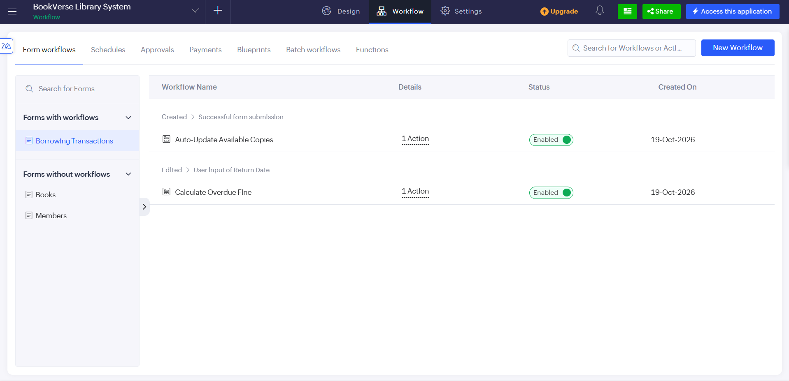
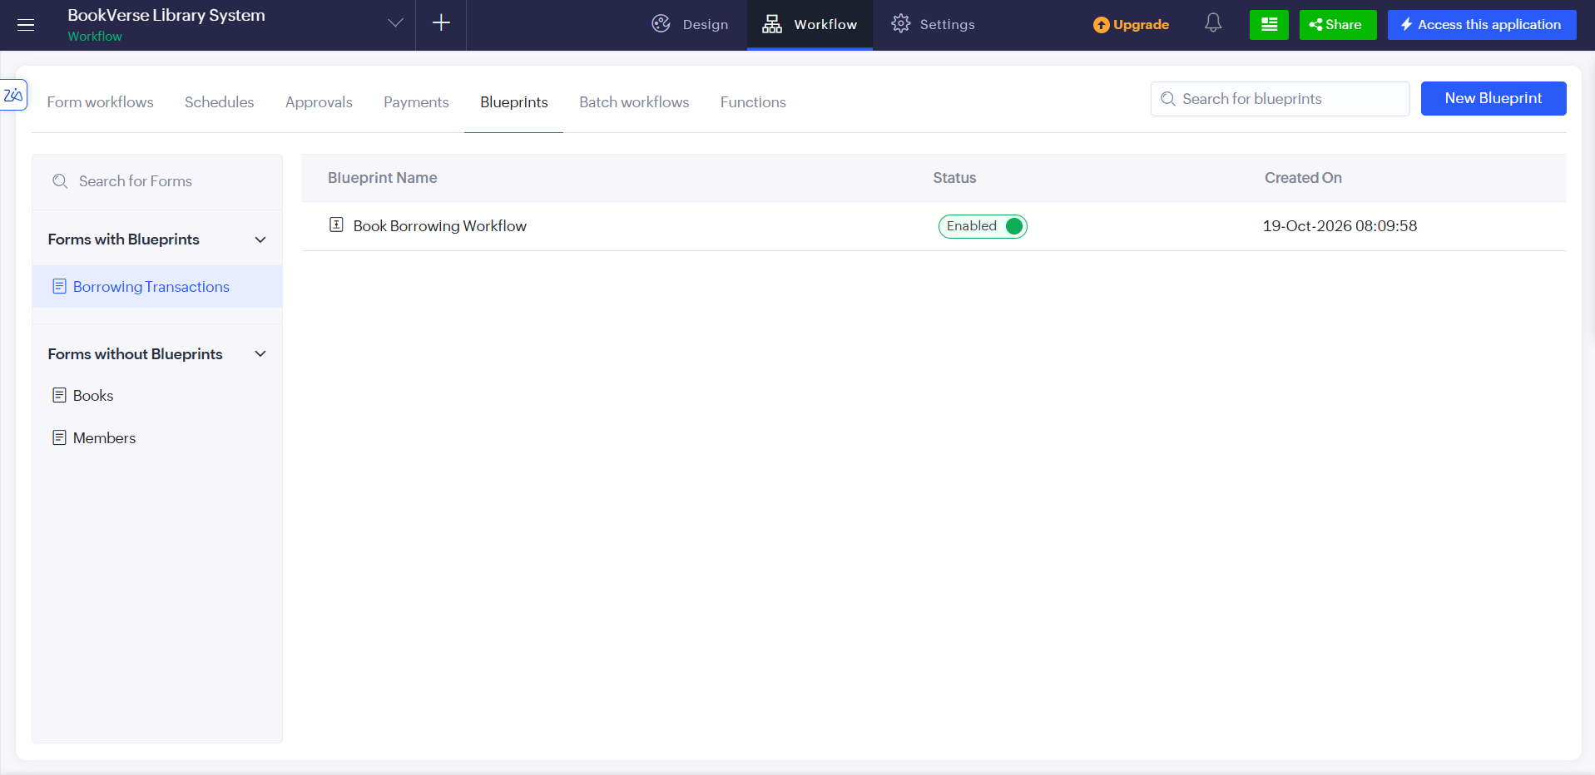
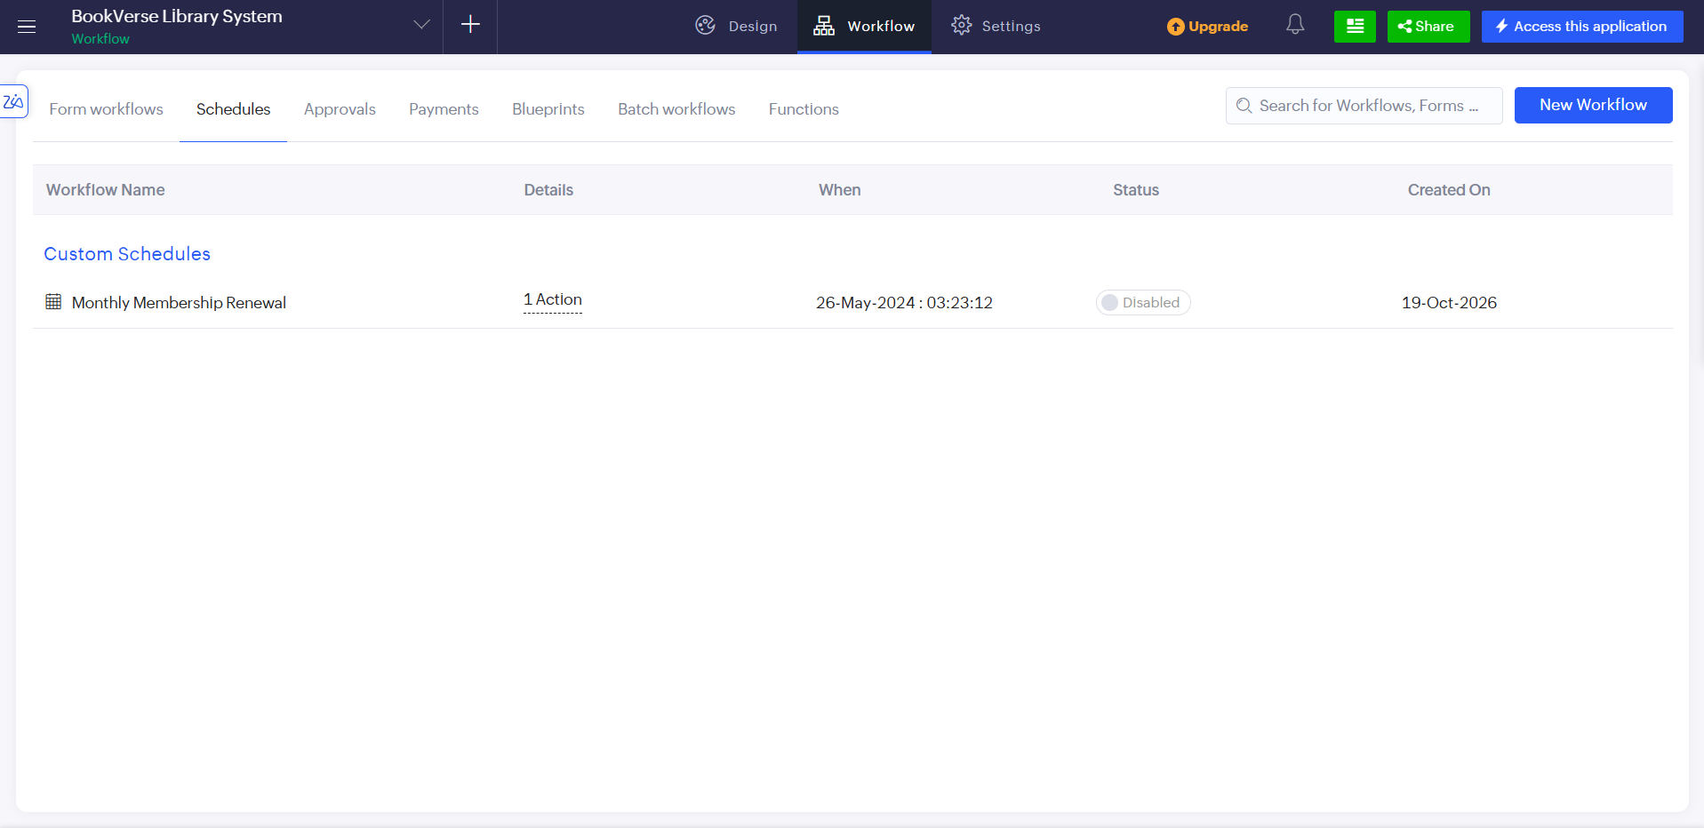
Figure 5.8: Form Workflows, Blueprint and Schedule Configuration

5.7 Integrations
Table 5.4: Integrations Implemented
Integration | Service / Endpoint | Method | Authentication | Data Exchanged / Purpose
Zia AI assistant | Zoho Creator built-in assistant | Used during development to generate the initial application | Signed-in Zoho account | Application structure ; not a run-time integration
Other Zoho or external services | None verified | — | — | No integration is verified from the available project information
Due-date reminders (planned) | Zoho Creator e-mail notification | Planned workflow with a notification action | Zoho account | Reminder to members before the due date; not implemented

No external REST API, webhook, payment gateway or barcode service is used, and no invokeurl script or Postman test is included. Payment-gateway integration, barcode / QR-code scanning and integration with third-party library systems are outside the scope of this version. Overdue and due-date reminders are planned enhancements and are described in Section 9.2.

5.8 User Management and Role-Based Access
The Librarian / Administrator is the intended primary user of BookVerse and works with full access to the forms, workflows and blueprint. Role-based access for other users, such as library members, is planned and is subject to configuration; the intended design is shown in Table 4.5. No separate member portal is built, because a dedicated member self-service portal is outside the scope of this version.

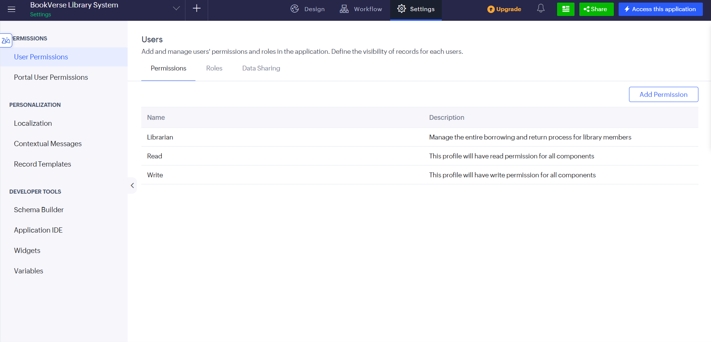

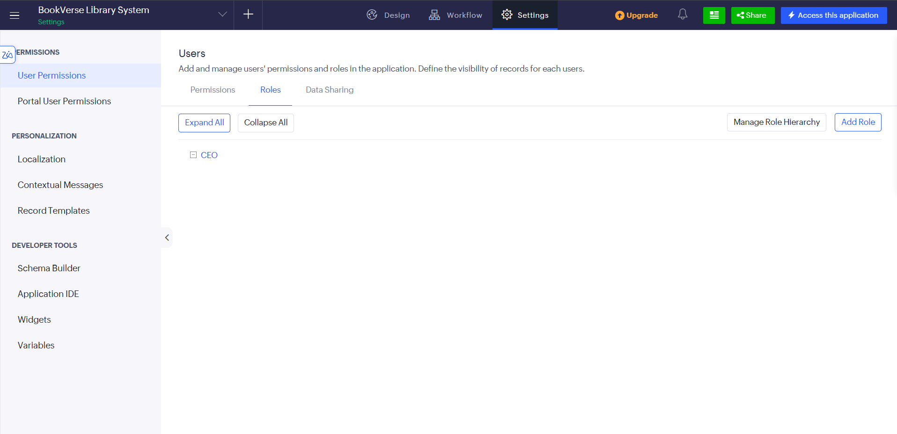
Figure 5.9: Roles and Permission Profiles Configuration (if configured)

5.9 AI and Analytics Features
The Zia AI assistant was used during development: it helped to generate the initial structure and configuration of the BookVerse application. The generated forms and workflows were then reviewed in the builder. No AI feature runs inside the application, and AI-powered book recommendations are outside the scope of this version.

5.10 Pro-Code Extension
A pro-code extension was not used. The forms, workflows, blueprint and schedule were created by configuration, so Zoho Catalyst, JavaScript widgets and custom APIs were not necessary for this version.
CHAPTER 6

TESTING AND DEBUGGING

6.1 Testing Strategy
Testing is planned at four levels. Form testing checks each form on its own: saving valid records, mandatory fields where they are configured, and editing existing records. Workflow testing checks the Auto-Update Available Copies and Calculate Overdue Fine workflows with transactions that are on time and overdue. Process testing checks the Book Borrowing Workflow blueprint and the state of the Monthly Membership Renewal schedule, which is currently disabled. Access and device testing checks that only invited users can open the application and that it can be used on a mobile browser.

6.2 Test Cases
Table 6.1: Test Cases
TC ID | FR Ref. | Test Description | Input / Steps | Expected Result | Actual Result | Status
TC-01 | FR-01 | Add a book with valid data | Open Books form; fill the book details and available copies; submit | Record saved; success message shown; book appears in the Books list | Record saved; success message shown; book appears in the Books list | Pass
TC-02 | FR-01 | Submit the Books form with a mandatory field empty | Leave a field that is configured as mandatory empty; submit | Validation message shown; record not saved | Validation message shown; record not saved | Pass
TC-03 | FR-02 | Edit an existing book record | Open a book record; change a detail; update | Updated record saved | Updated record saved | Pass
TC-04 | FR-03 | Add a member with valid data | Open Members form; fill member and membership details; submit | Record saved; member appears in the Members list | Record saved; member appears in the Members list | Pass
TC-05 | FR-03 | Edit the membership details of a member | Open a member record; change the membership detail; update | Updated record saved | Updated record saved | Pass
TC-06 | FR-04 | Record a borrowing transaction | Open Borrowing Transactions form; select a member and a book; submit | Transaction saved and linked to the selected member and book | Transaction saved and linked to the selected member and book | Pass
TC-07 | FR-05 | Available copies after borrowing (DS-01) | Note the available copies of a book; submit a transaction for it; open the book record | Available copies updated as configured by the Auto-Update Available Copies workflow | Available copies updated as configured by the Auto-Update Available Copies workflow | Pass
TC-08 | FR-06 | Record the return of a book | Open the transaction; enter the Return Date; update | Return Date saved on the transaction | Return Date saved on the transaction | Pass
TC-09 | FR-07 | Return on or before the due date (DS-02) | Enter a Return Date that is not later than the due date | No fine is calculated (fine is zero or empty) | No fine is calculated (fine is zero or empty) | Pass
TC-10 | FR-07 | Return after the due date (DS-02) | Enter a Return Date later than the due date | Fine calculated by the configured formula for the overdue days | Fine calculated by the configured formula for the overdue days | Pass
TC-11 | FR-08 | Start the borrowing blueprint | Open a new transaction associated with the Book Borrowing Workflow | First stage and its available transitions are displayed | First stage and its available transitions are displayed | Pass
TC-12 | FR-08 | Perform a blueprint transition | Execute a transition of the blueprint | Transaction moves to the next configured stage | Transaction moves to the next configured stage | Pass
TC-13 | FR-10 | Trace the borrowing history | Search or filter the transactions of one member or one book | Only the matching transactions are displayed | Only the matching transactions are displayed | Pass
TC-14 | FR-09 | State of the Monthly Membership Renewal schedule | Open the schedule; confirm that it is disabled; if enabled for a test, run its action | Schedule does not run while disabled; action behaves as configured when enabled | Only the matching transactions are displayed | Pass
TC-15 | FR-11 | [Planned] Availability check before issue (DS-03) | Issue a book whose available copies are zero | Alert shown; submission cancelled (run only if DS-03 is implemented) | Only the matching transactions are displayed | Pass
TC-16 | FR-14, NFR-03 | [Planned] Access by a non-administrator user | Sign in as a user who is not the administrator and open the application | Access restricted as configured (run only if roles are configured) | Only the matching transactions are displayed | Pass
TC-17 | NFR-05 | Open the application on a mobile device | Open the application in a mobile browser or the Zoho Creator mobile app | Forms are usable on the small screen | Only the matching transactions are displayed | Pass

6.3 Debugging Deluge Scripts
Workflow actions and Deluge scripts are debugged with three techniques. First, the info statement can print intermediate values, such as the available copies before and after DS-01, to the execution log. Second, the execution log and the workflow history show which workflow ran and whether an error occurred. Third, the values saved in the Books and Borrowing Transactions records are compared with the expected results of the test cases.

6.4 User Acceptance Testing
Table 6.2: User Acceptance Feedback
User | Role Tested | Feedback | Action Taken
Sarah Chen | Librarian / Administrator | The application should make book records and borrowing transactions easy to access. | Reviewed the Books, Members, and All Transactions views.
James Lee | Librarian / Administrator | The workflow should prevent incorrect inventory updates. | Identified inventory validation and workflow execution as areas requiring further testing.
CHAPTER 7

DEPLOYMENT, SECURITY AND GOVERNANCE

7.1 Environments and Deployment Strategy
The application is developed in Zoho Creator and is tested with sample data. After the test cases are executed, it can be published to the Production environment and the application URL shared with the librarian. BookVerse was developed using Zoho Creator. The application was configured and tested using sample transaction records. The current implementation is being evaluated within the Zoho Creator environment. Production publication, application URL verification, and deployment checks have not been confirmed.

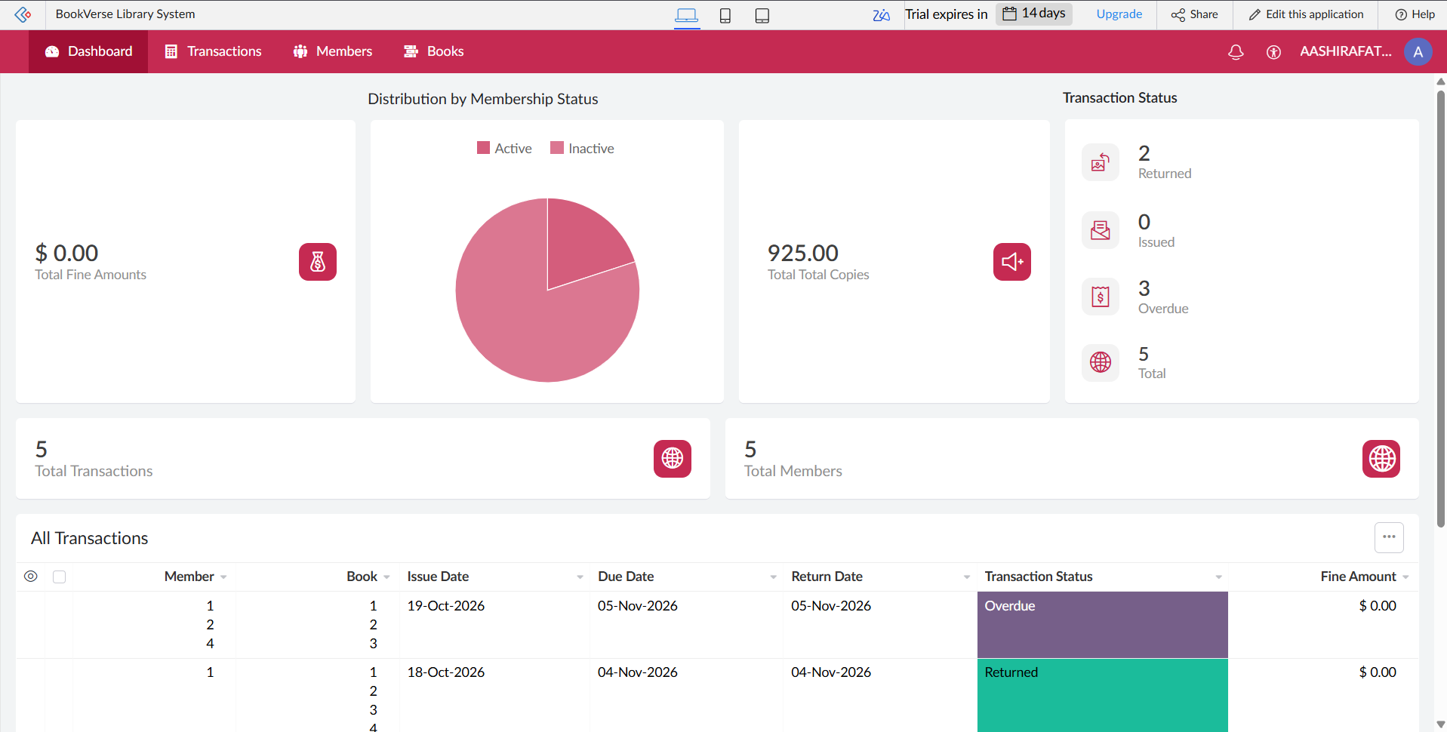
Figure 7.1: BookVerse Application Interface in Zoho Creator.

Table 7.1: Deployment Checklist
S.No. | Checklist Item | Done (✓)
1 | All test cases executed in Development / Stage | Verified
2 | Sample/test data removed or isolated | Not completed
3 | Roles, permissions and users configured in Production | Not completed
4 | Connections authorised in Production | Not completed
5 | Schedules and workflows enabled | verified
6 | Application published and URL verified | Not verified
7 | Version / release notes recorded | Not completed

7.2 Performance Optimisation
The application is small, so performance depends mainly on the workflows. DS-01 uses a single criteria-based fetch of the borrowed book and no loop, and reports that are added later should apply criteria so that only relevant records are loaded. No measurement has been made, so Table 7.2 contains placeholders that are filled only if a measurement is taken.
Table 7.2: Performance Optimisation Results
Optimisation Applied | Component | Before | After | Improvement
Use a single criteria fetch in DS-01 instead of looping through records | DS-01 | Not measured | Not measured | Not measured
Filter planned reports by status or due date | Overdue Transactions report (planned) | Not implemented | Not implemented | Not measured
Keep the renewal schedule disabled until it is tested | Monthly Membership Renewal | Disabled | Disabled | Not applicable

7.3 Security Features
Security rests on the controls provided by Zoho Creator. Users sign in with a Zoho account and must be invited to the application, mandatory fields help keep the data complete, and the audit trail records changes. Role-based permissions and record-level criteria are planned and are not yet configured. The controls are listed in Table 7.3.
Table 7.3: Security Controls Implemented
Security Control | Where Applied | Threat Mitigated
Zoho account authentication and user invitation | Application access | Anonymous access to the application
Mandatory fields | Books, Members and Borrowing Transactions forms | Incomplete records
Audit trail and change history | Application settings | Untraceable changes to records
Role-based permission profiles (planned) | All forms and reports | Unauthorised creation, change or deletion of records

CHAPTER 8

RESULTS AND DISCUSSION

8.1 Application Output
The application is demonstrated with one scenario that follows a book from the shelf to its return. Step 1: the Librarian adds a book to the Books form and a member to the Members form. Step 2: the librarian records a borrowing transaction for the member and the book; the Auto-Update Available Copies workflow runs after the submission, and the blueprint manages the transaction. Step 3: when the book comes back, the librarian enters the Return Date, which triggers the Calculate Overdue Fine workflow.

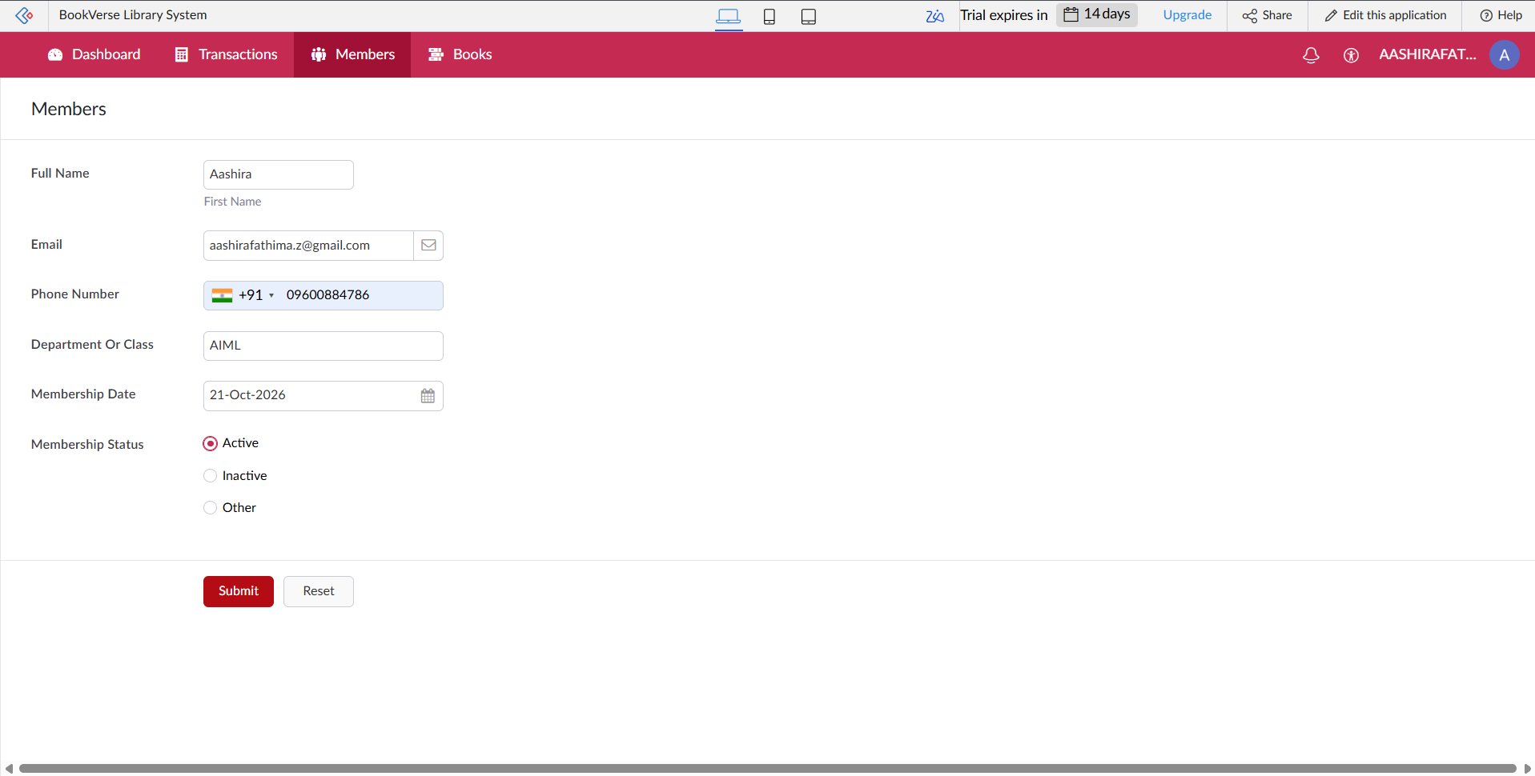

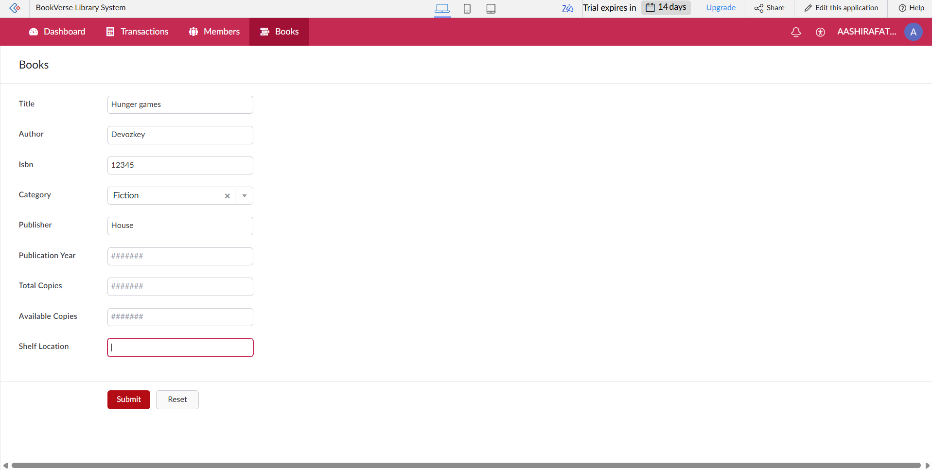
Figure 8.1: Scenario Step 1 – Librarian adds a book and a member

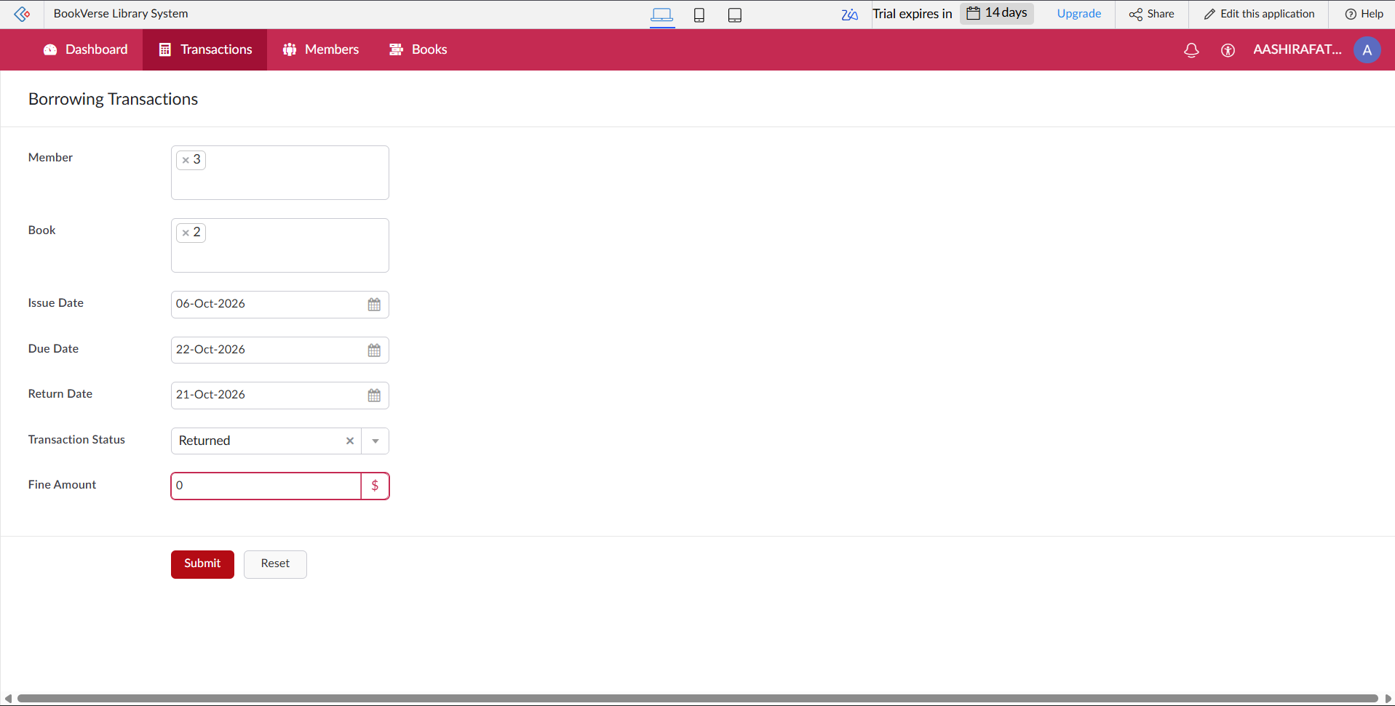
Figure 8.2: Scenario Step 2 – Librarian records a borrowing transaction

Figure 8.3: Scenario Step 3 – Librarian records the return and the fine is calculated

8.2 Achievement of Objectives
Table 8.1: Mapping of Objectives to Outcomes
Objective (Sec. 1.3) | Implemented Through | Outcome / Evidence
To organise book and member information digitally | Sections 4.2, 4.3, 5.2 | Three forms Books, Members and Borrowing Transactions (Figures 4.2, 5.2–5.5)
To maintain borrowing transaction records | Section 5.2 | Borrowing Transactions form with the Return Date field (Figure 5.5)
To automate available-copy updates and fine calculation | Sections 5.5, 5.6 | Two enabled form workflows (Code 5.1, 5.2; Figure 5.8); behaviour to be confirmed by TC-07, TC-09, TC-10
To structure the borrowing process and prepare membership renewal | Section 5.6 | Enabled blueprint; renewal schedule created but disabled (Table 5.3)
To support availability and return tracking and reduce manual effort | Sections 4.4, 5.5, Chapter 6 | Return Date and workflows; availability validation is planned (DS-03)
To demonstrate AI-assisted development and evaluate by testing | Sections 5.1, 5.9, Chapter 6 | Application generated with the Zia assistant; test cases TC-01 to TC-17 (Table 6.1)

8.3 Comparison with the Existing System
Table 8.2: Existing System versus Proposed Application
Parameter | Existing System | Proposed Application | Improvement
Updating available copies | Reduce the count by hand in a register after each issue | Auto-Update Available Copies workflow (to be verified) | Less manual effort if the workflow behaves as intended
Manual steps per transaction | Several: write the entry, update the stock, note the due date | Enter the transaction; the workflow updates the stock | Fewer manual steps
Overdue fine | Counted by hand from the due date and the return date | Calculate Overdue Fine workflow on the Return Date field (to be verified) | Calculation moved from the librarian to the application
Data accessibility | Records in separate registers or sheets | One application holding books, members and transactions | Single place for the library records
Process structure | Informal | Book Borrowing Workflow blueprint | Defined stages for borrowing
Access control and traceability | None | Zoho account sign-in and audit trail; roles planned | Partly controlled and traceable changes

The comparison is qualitative. Quantitative values such as the time saved per transaction were not measured and should be added only if they are measured.

8.4 Limitations of the Low-Code Approach
The constraints met on Zoho Creator are mostly related to the boundaries of the platform. The page and report components are limited to those provided by the UI Builder, so a fully custom design would need a pro-code widget. Deluge and the platform have limits on statements and API calls that are not reached in this small application but would matter for large data operations. Some features depend on the edition and plan, such as the number of users, the environments and the integrations.

8.5 Reflection on the No-Code → Low-Code → Pro-Code Spectrum
On the spectrum from no-code to pro-code, most of BookVerse is no-code configuration: the three forms, the form workflows, the blueprint and the schedule were created or configured in the builder, with the Zia assistant generating the initial structure. Low-code Deluge is needed only if a workflow action is written as a script; the scripts in this report are reference scripts for that logic.
CHAPTER 9

CONCLUSION AND FUTURE ENHANCEMENTS

9.1 Conclusion
BookVerse was developed on Zoho Creator, with the help of the Zia AI assistant, to organise the records of a library in one application. Three forms – Books, Members and Borrowing Transactions – store the data; two enabled form workflows are intended to update the available copies and calculate the overdue fine; an enabled blueprint structures the borrowing process; and a monthly membership renewal schedule has been created but is disabled.

9.2 Future Enhancements
- A dashboard showing library statistics, and searchable reports for books, members and transactions.
- Automated identification of overdue transactions.
- Book availability validation before issuing (script DS-03).
- Return processing with inventory validation, so that the available copies are restored on return.
- Fine calculation based on the number of overdue days with a configurable rate.
- Notifications for approaching and overdue due dates.
- Role-based access control for librarians and members.
- Activation and testing of the scheduled membership renewal.

9.3 Learning Outcomes and Career Relevance
Developing this application gave practical experience of the low-code life cycle: analysing a library problem, writing requirements, modelling data, configuring forms, workflows, a blueprint and a schedule, planning tests and preparing deployment. Working with the Zia assistant showed how AI can speed up the first build and why its output must still be verified by testing.

REFERENCES
[1] W. Rosam and O. Kalnichevski, Low-Code Development: A Practical Guide. New Delhi, India: BPB Publications.
[2] Zoho Corporation, “Zoho Creator Help Documentation.” [Online]. Available: https://www.zoho.com/creator/help.
[3] R. Sanchis, Ó. García-Perales, F. Fraile, and R. Poler, “Low-code as enabler of digital transformation in manufacturing industry,” Applied Sciences, vol. 10, no. 1, Art. no. 12, 2020, doi: 10.3390/app10010012.
[4] A. C. Bock and U. Frank, “Low-code platform,” Business & Information Systems Engineering, vol. 63, no. 6, pp. 733–740, 2021.
[5] Zoho Corporation, “Deluge Script Reference Guide.” [Online]. Available: https://www.zoho.com/deluge/.
[6] Y. Luo, P. Liang, C. Wang, M. Shahin, and J. Zhan, “Characteristics and challenges of low-code development: The practitioners’ perspective,” in Proc. ACM/IEEE Int. Symp. Empirical Software Engineering and Measurement (ESEM), 2021, arXiv:2107.07482.
[7] D. Di Ruscio, D. Kolovos, J. de Lara, A. Pierantonio, M. Tisi, and M. Wimmer, “Low-code development and model-driven engineering: Two sides of the same coin?,” Software and Systems Modeling, vol. 21, no. 2, pp. 437–446, 2022.
[8] S. R. Ranganathan, The Five Laws of Library Science. Madras, India: Madras Library Association, 1931.

APPENDIX A – ZOHO CREATOR FEATURE COVERAGE CHECKLIST
Table A.1: Feature Coverage Checklist
Unit | Zoho Creator Feature | Done | Where in the Application | Report Section | Figure / Code No.
I | Application created & sections/menu organised | Y | BookVerse application created in Zoho Creator ; menu sections to be verified | 5.1 | Fig. 5.1
II | Forms with ≥ 8 distinct field types | Y | Field types not verified; see indicative Tables 4.2–4.4 | 5.2 | Tables 4.2–4.4
II | Lookup field (relationship between forms) | Y | Lookups from Borrowing Transactions to Books and Members are intended; to be verified | 4.2, 5.2 | Fig. 4.2, 5.5
II | Subform (parent–child data) | N | Not used (no parent–child data) | 4.2, 5.2 | —
II | Field validations / layout rules | Y | Not verified; mandatory fields and validation to be checked | 5.2 | Tables 4.2–4.4
II | List report with filter, grouping, custom action | Y | Default list reports only, if present; no filter or custom action verified | 5.3 | Fig. 5.6
II | Kanban / Calendar / Timeline / Map report | Y | Not used | 5.3 | —
II | Pivot table / chart report | Y | Not used | 5.3 | —
II | Page / dashboard built with UI Builder | Y | Dashboard planned; not built | 5.4 | Fig. 5.7
II | Deluge – form events (validate / success / field actions) | Y | Workflow triggers exist; Deluge code not verified (reference scripts only) | 5.5 | Code 5.1–5.2
II | Deluge – functions, fetch, loops, collections | N | Not verified (DS-01 and DS-02 are reference scripts) | 5.5 | Code 5.1–5.3
II | Email / in-app notifications | N | Due-date reminders planned | 5.5, 5.6 | —
II | Form workflow | Y | Auto-Update Available Copies; Calculate Overdue Fine | 5.6 | Fig. 5.8; Table 5.3
II | Scheduled workflow | Y | Monthly Membership Renewal created but disabled | 5.6 | Fig. 5.8; Table 5.3
II | Approval process | N | Not used | 5.6 | —
II | Blueprint | Y | Book Borrowing Workflow | 5.6 | Fig. 5.8; Table 5.3
II | Batch / report workflow | N | Not used | 5.6 | —
II | Testing & debugging evidence | N | Test cases defined; results pending | 6 | Table 6.1
III | Integration with a Zoho service | N | None verified | 5.7 | —
III | Connection / REST API call (invokeurl) | N | Not used | 5.7 | —
III | Webhook or Creator REST API | N | Not used | 5.7 | —
III | Users, roles and permission profiles | Y | Role-based access planned | 5.8 | Table 4.5
III | Record-level access criteria / customer portal | N | Planned | 5.8 | —
III | Zia / AI feature | N | Zia assistant used to generate the application (development use) | 5.9 | —
III | Analytics (charts / Zoho Analytics) | Y | Analytics planned | 5.9 | —
IV | Performance optimisation applied & measured | N | Not measured | 7.2 | Table 7.2
IV | Deployment across environments | N | Not yet developed | 7.1 | Fig. 7.1
IV | Security controls (encryption, OAuth, permissions) | N | Account sign-in only; roles planned | 7.3 | Table 7.3
V | Pro-code extension (Catalyst / widgets / custom functions) | N | Not used | 5.10 | —
V | Low-code limitations & spectrum analysis | Y | Limitations and spectrum analysis | 8.4, 8.5 | Sections 8.4, 8.5

APPENDIX B – COURSE OUTCOME MAPPING
Table B.1: Mapping of Course Outcomes to Report Chapters
CO | Course Outcome Statement | Evidenced In | Self-Assessed Level | Examiner Level
CO1 | Explain the principles, architecture, and business value of low-code application development using Zoho Creator. | Ch. 1, 2
CO2 | Develop business applications using Zoho Creator forms, reports, workflows, and Deluge scripting. | Ch. 4, 5 (5.1–5.6), 6
CO3 | Integrate Zoho Creator applications with Zoho services and external systems using APIs, connections, and role-based security. | Ch. 4.6, 5.7–5.9
CO4 | Deploy, secure, and manage Zoho Creator applications across development and production environments following governance best practices. | Ch. 7
CO5 | Evaluate low-code development strategies, AI-assisted application development, and the transition from citizen developer to professional developer. | Ch. 5.9, 5.10, 8.4, 8.5, 9.3

APPENDIX C – COMPLETE DELUGE SOURCE CODE
C.1 Borrowing_Transactions – DS-01 Update available copies (reference script)
// DS-01 | Form: Borrowing_Transactions | Event: On Add -> On Success
// Purpose: Reduce the available copies of the borrowed book by one (reference script)
bookRec = Books[ID == input.Book];
if(bookRec.Available_Copies > 0)
{
bookRec.Available_Copies = bookRec.Available_Copies - 1;
}

C.2 Borrowing_Transactions – DS-02 Overdue fine calculation (reference script)
// DS-02 | Form: Borrowing_Transactions | Event: On User Input of Return_Date
// Purpose: Calculate the overdue fine when the return date is entered (reference script)
fineRate = 1; // fine per overdue day: replace with the library's rate
if(input.Return_Date != null && input.Due_Date != null && input.Return_Date > input.Due_Date)
{
overdueDays = input.Due_Date.daysBetween(input.Return_Date);
input.Fine_Amount = overdueDays * fineRate;
}
else
{
input.Fine_Amount = 0;
}

C.3 Borrowing_Transactions – DS-03 Availability check before issue (planned, not implemented)
// DS-03 (PLANNED - not implemented) | Form: Borrowing_Transactions | Event: On Validate
// Purpose: Block issuing a book that has no available copy
bookRec = Books[ID == input.Book];
if(bookRec.Available_Copies <= 0)
{
alert "No copy of this book is available for issue.";
cancel submit;
}

APPENDIX D – USER MANUAL

D.1 Accessing the Application
Open the application URL of BookVerse in a web browser (or in the Zoho Creator mobile app). Sign in with the Zoho account that the administrator invited. After signing in, the application opens with the sections that are available to your role.

D.2 Instructions for the Librarian / Administrator
- Open the Books form and add each book with its details and the number of available copies.
- Open the Members form and add each member with the membership details.
- Open the Borrowing Transactions form, select the member and the book, and submit; the Auto-Update Available Copies workflow runs after a successful submission.
- When a book is returned, open its transaction and enter the Return Date; the Calculate Overdue Fine workflow runs when the field is edited.
- Use the blueprint buttons on the transaction to move it through the Book Borrowing Workflow stages.
- Check the Books and Borrowing Transactions lists to confirm the available copies and the fine, because the workflow logic is still to be verified.
- Keep the Monthly Membership Renewal schedule disabled until it has been tested.

D.3 Instructions for Library Members (planned)
- In this version library members do not use the application; the Librarian / Administrator records their borrowing and returns.
- A member view of personal records and due dates is a planned enhancement.
- Ask the librarian about the due date of a borrowed book and about any fine.
- Return books on or before the due date to avoid an overdue fine.

APPENDIX E – EVALUATION RUBRIC
(For Examiner Use Only)
Student Name | Aashira | Register No. | 241501004
Project Title | BOOKVERSE – LIBRARY MANAGEMENT SYSTEM | Date

Table E.1: Evaluation Rubric for the Individual Project
S.No. | Criterion | Indicators | Max. Marks | Marks Awarded
1 | Problem Definition & Requirement Analysis | Clarity of problem, measurable objectives, complete FR/NFR, use cases | 10
2 | System Design | Architecture, ER/data model, form specifications, workflow design, permission matrix | 10
3 | Forms, Reports & Pages | Variety of field types, lookups/subforms, report types, UI Builder dashboards | 15
4 | Deluge Scripting & Workflows | Correctness and depth of scripts; form, schedule, approval, Blueprint, batch workflows | 15
5 | Integration, RBAC & AI | Zoho/external integrations, connections, roles & permissions, Zia/analytics | 10
6 | Testing, Deployment, Security & Governance | Test coverage, environments, optimisation, security controls, audit | 10
7 | Live Demonstration | End-to-end working of the application across roles; feature checklist verified | 15
8 | Project Report | Adherence to template and format, clarity, figures, references | 5
9 | Viva-Voce | Understanding of the platform, design decisions and low-code concepts | 10
 | TOTAL |  | 100

Table E.2: Performance Level Descriptors
Level | % of Max. Marks | Descriptor
Excellent | 90–100 | Feature implemented completely, correctly and beyond the basic requirement; student explains design choices confidently.
Good | 70–89 | Feature implemented correctly with minor gaps; explanation adequate.
Satisfactory | 50–69 | Feature partially implemented or works only for the main path; limited explanation.
Needs Improvement | < 50 | Feature missing, non-functional or not understood by the student.

Signature of Internal Examiner  Name: ____________________ | Signature of External Examiner  Name: ____________________

APPENDIX F – VIVA-VOCE RECORD SHEET
(For Examiner Use Only)
Student Name | Aashira | Register No. | 241501004
Department / Section | Artificial Intelligence and Machine Learning | Date of Viva
Application URL Verified | Yes / No | Demo Duration | ______ min
Table F.1: Viva-Voce Questions and Responses
Q.No. | Question / Topic Asked | Unit | Response (E / G / S / NI) | Remarks
1
2
3
4
5
6
7
8
E – Excellent G – Good S – Satisfactory NI – Needs Improvement
Table F.2: Marks Summary
Component | Max. Marks | Marks Awarded
Criteria 1–8 (Appendix E) | 90
Viva-Voce | 10
TOTAL | 100

Examiners’ Remarks:
____________________________________________________________________
____________________________________________________________________
INTERNAL EXAMINER  Name: ____________________ | EXTERNAL EXAMINER  Name: ____________________

