Name: Aashir Saroya Batch No: CCE Batch 1

Reg No:180953276

Roll No:54(CCE ‘B’)

LAB – 1

Q 1

lst1 = []

n1 = int(input('Enter the no of elements in list 1'))

for i in range(0,n1):

ele = int(input('Enter a no'))

lst1.append(ele)

lst2 = []

n2 = int(input('Enter the no of elements in list 2'))

for i in range(0,n2):

ele = int(input('Enter a no'))

lst2.append(ele)

ans = []

for i in lst1:

if i % 2 != 0:

ans.append(i)

for i in lst2:

if i % 2 == 0:

ans.append(i)

print(ans)

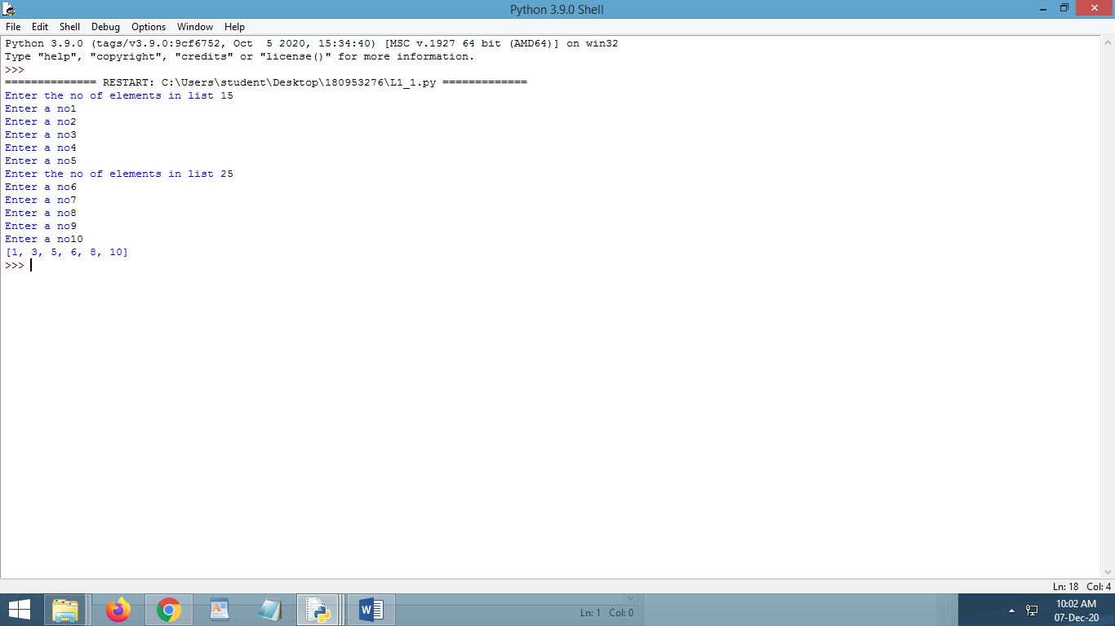

Q3

lst = []

ctr = 0

n = int(input('Enter the number of strings'))

for i in range(0,n):

str = input('Enter a string')

lst.append(str)

for st in lst:

if st[0] == st[-1] and len(st) > 1:

ctr = ctr + 1

print('No of strings with samr 1st & last letters and having len 2 or more: ',ctr)

print('Strings having odd length are as follows')

for st in lst:

if len(st)%2 !=0:

print(st)

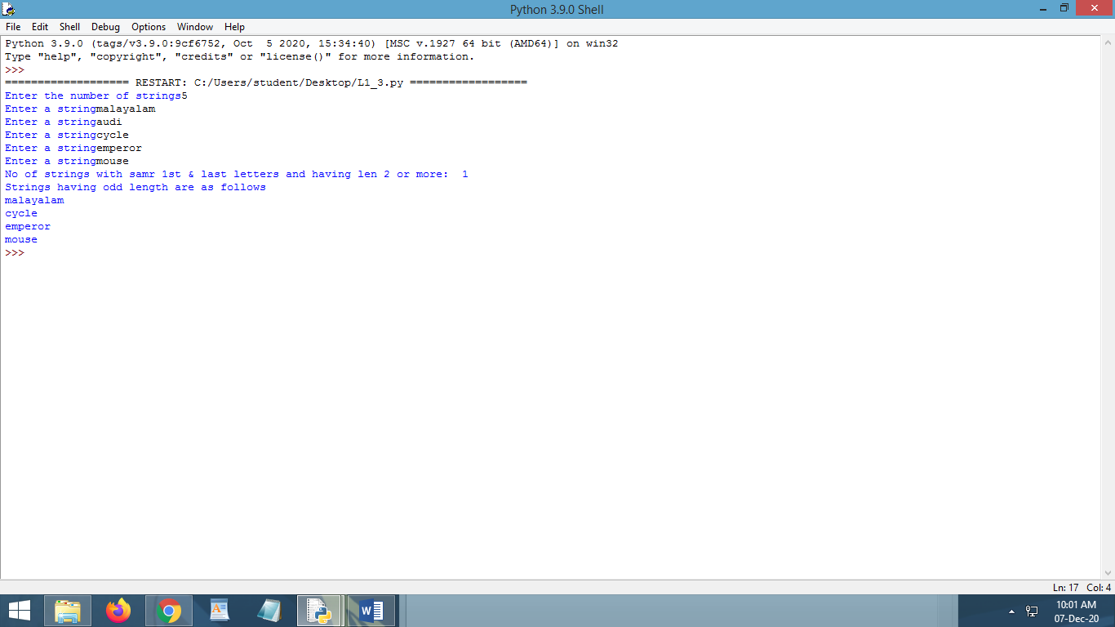

LAB-2

Q1

str = input('Enter a sentence')

words = []

words = str.split()

dct = {}

ctr = 0

for i in words:

dct[i] = words.count(i)

ctr = ctr + 1

print(dct)

print('Total words in the sentence is ',ctr)

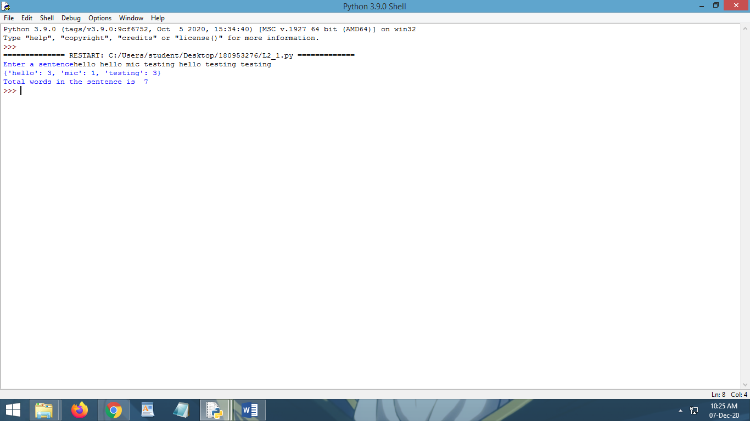

Q3

import random

dct = {}

n = int(input('Enter no of values you are entering in the dictionary'))

for i in range(0,n):

dct[random.randrange(0,100)] = input('Enter whatever you wish to')

print(dct)

avgn = 0

s = 0

st = ''

for key,value in dct.items():

if(dct[key].isdigit()):

dct[key] = int(value)

s = s + dct[key]

avgn = avgn + 1;

else:

st = st+dct[key]

avg = (float)(s/avgn)

print('Average of all the numbers are ',avg)

print('All concatenated strings are: ',st)

v = input('Enter the value to be searced')

val = None

if v.isdigit():

val = int(v)

else:

val = v

f = 0

for key, _ in dct.items():

if dct[key] == val:

print('Entered value is present and corresponding key is: ',key)

f = 1

break

if f == 0:

print('Entered value not present')

li = []

print('The strings with only special characters are as follows')

for key,value in dct.items():

li = str(value)

y = 1

for i in range(0,len(li)):

if(li[i].isalpha() or li[i].isdigit()):

y = 0

break

if y == 1:

print(value)

