Lab-3

**Aashir Saroya**

**CCE ‘B’ 54**

**CCE Batch – 1**

**180953276**

Q1)

def ques1(*lst):

ans = 1

for i in lst[0:]:

ans = ans*i

return ans

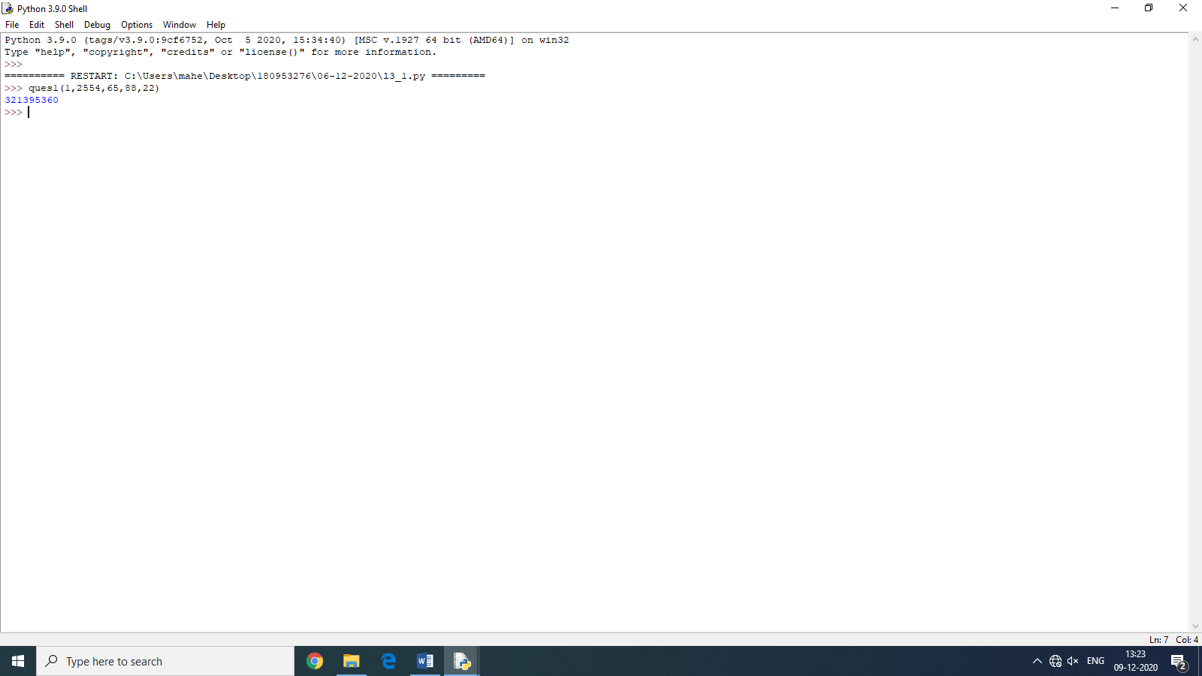

Q2)

def ques2(*numbers):

ans = set([])

for i in range(0,len(numbers)):

ans.add(numbers[i])

return ans

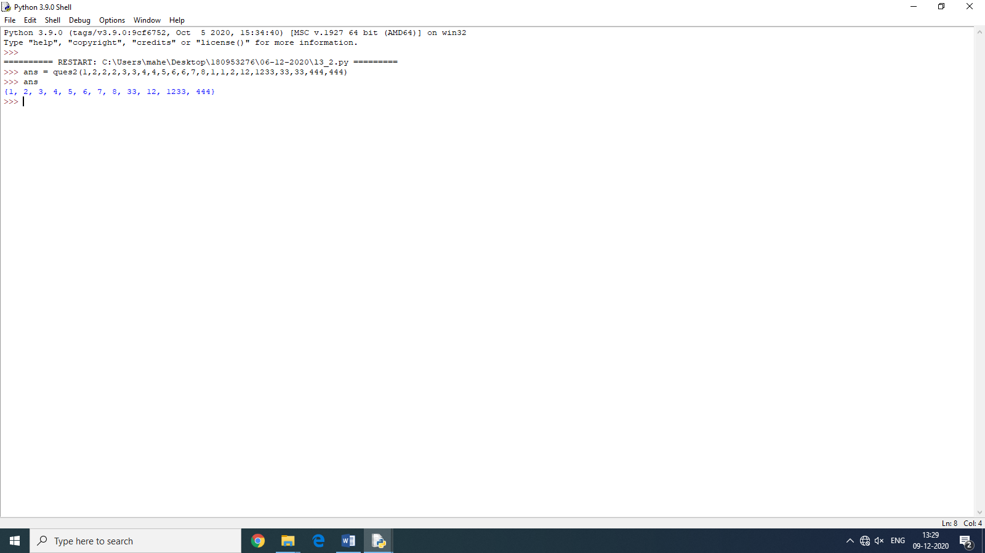

Q3)

def locvar():

global b

b = 112

a = 20

st = 'AdvancedProgrammingLab'

print('No of local variables are: ',locvar.__code__ .co_nlocals)

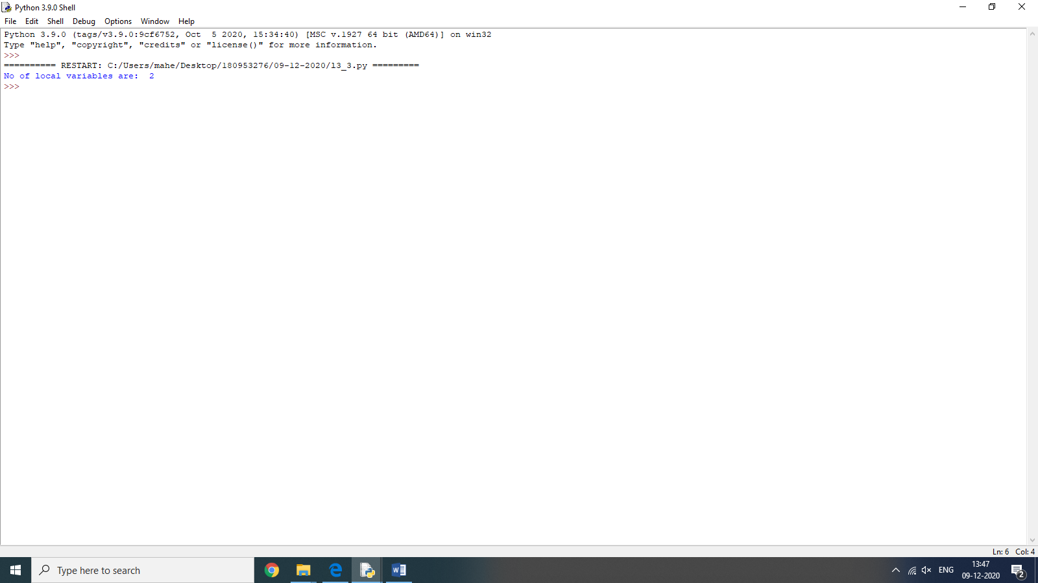

Lab-4

Q1)

import math

a = int(input('Enter a number of your choice '))

print('The Sine of ',a,' is ',math.sin(a))

print('The Square Root of ',a,' is ',math.sqrt(a))

print('The Log of ',a,' is ',math.log(a))

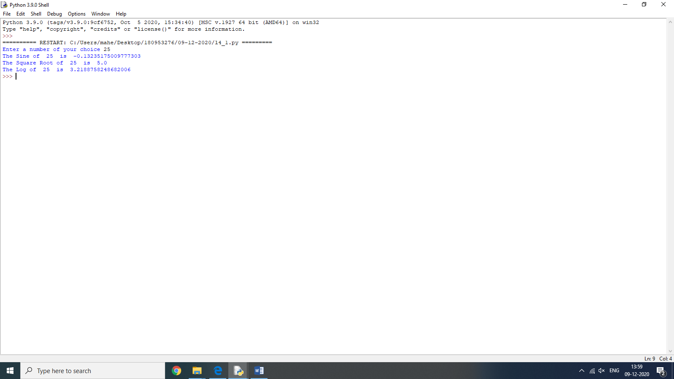

Q2)

import cmath

b = int(input('Enter real part of number '))

c = int(input('Enter complex part of number '))

a = complex(b,c)

print('The Sine of ',a,' is ',cmath.sin(a))

print('The Square Root of ',a,' is ',cmath.sqrt(a))

print('The Log of ',a,' is ',cmath.log(a))

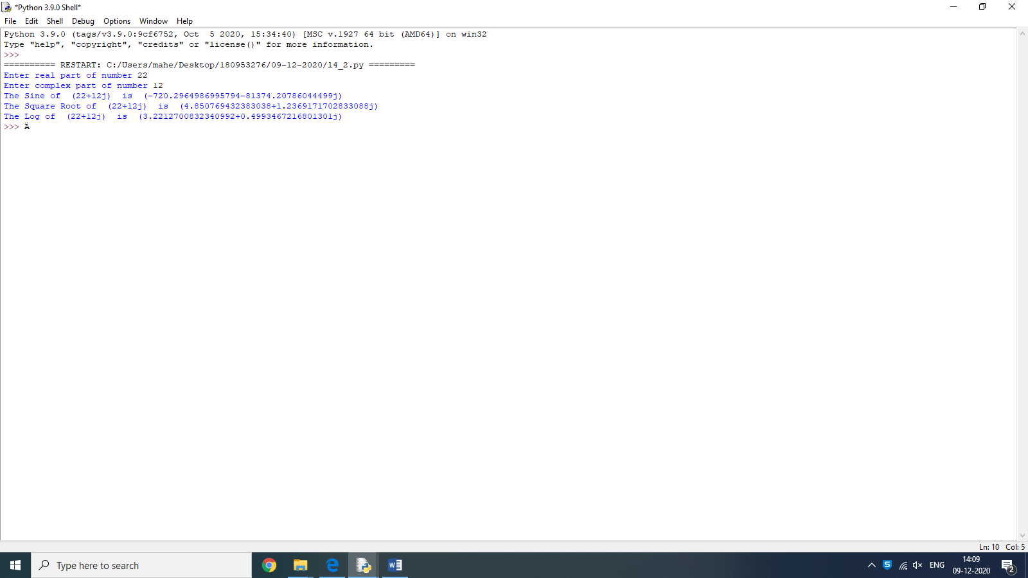

Q3)

import os

print('The list of environment variables are as follows')

print(os.environ)

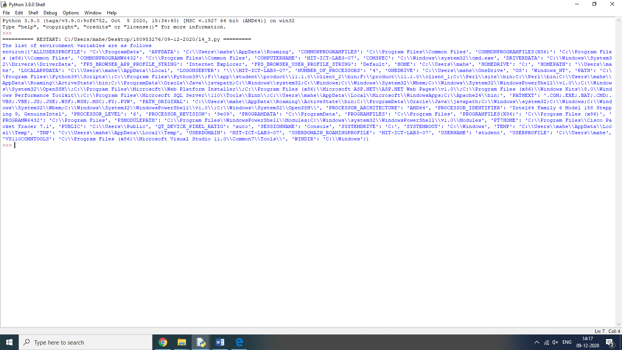

Lab-5

Q1)

print("Enter number of employees")

n = int(input())

employees = []

print('Enter the details of each employee as required')

for i in range(0,n):

id = int(input("ID : "))

name = input("Name : ")

sal = int(input("Salary : "))

dept = input("Department : ")

print()

emp = (id, name, sal, dept)

employees.append(emp)

id = int(input("Please enter ID to search for : "))

f = False

for emp in employees:

if emp[0] == id:

f = True

print("ID : ", emp[0])

print("Name : ", emp[1])

print("Salary : ", emp[2])

print("Department : ", emp[3])

break

if not f:

print("Employee does not exist")

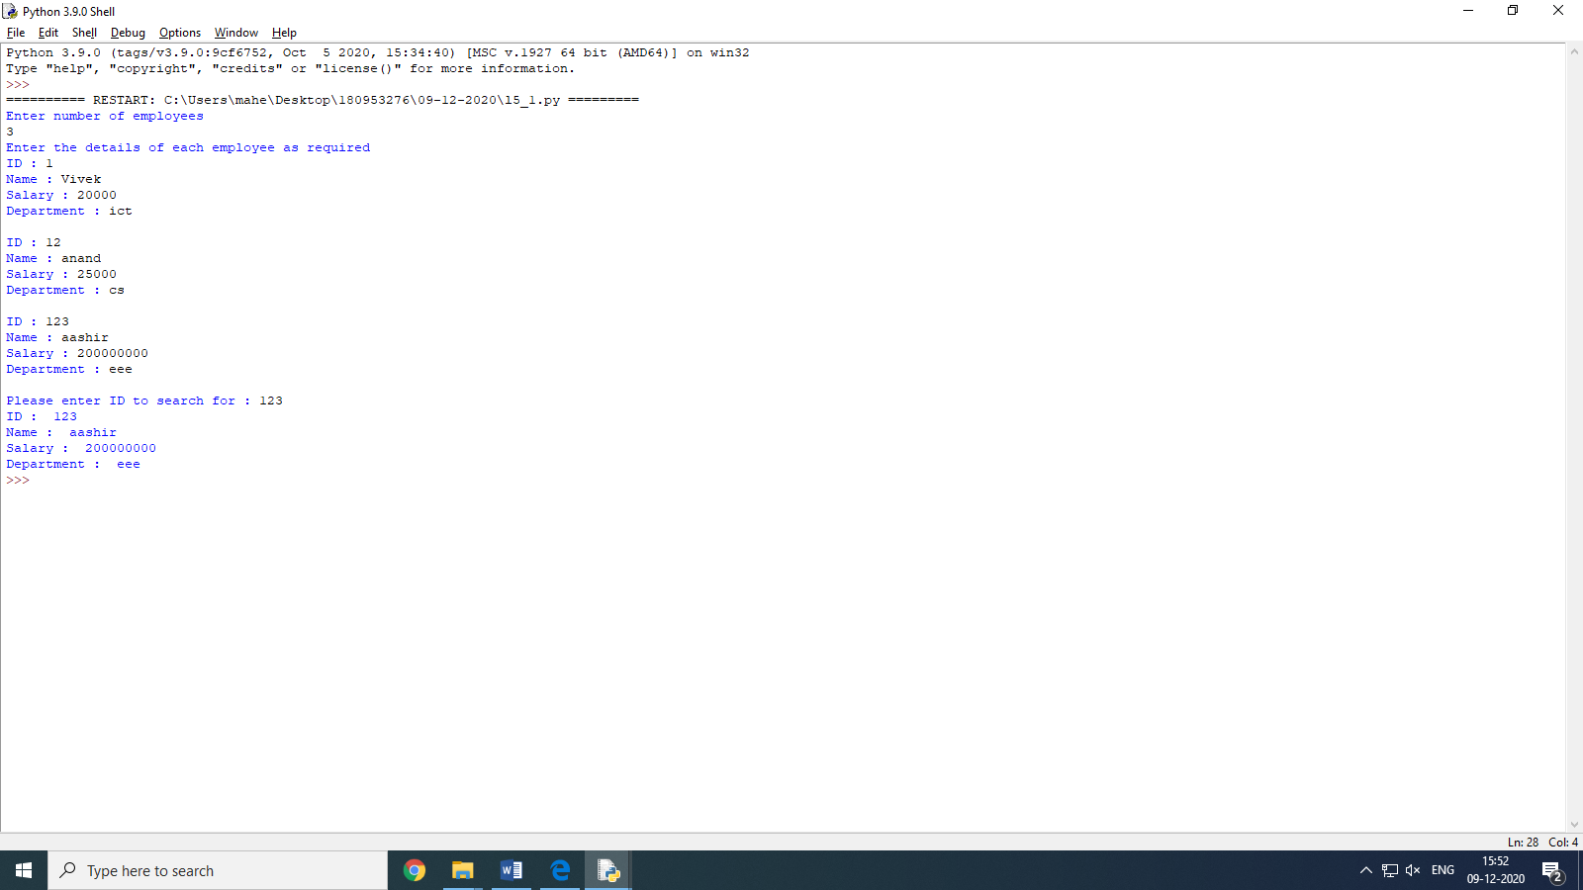

Q3)

class Subsets:

def __init__(self, nums):

self.subsets = [[]]

self.nums = nums

def Subsetfind(self):

for i in range(len(self.nums)):

orig = self.subsets[:]

new = self.nums[i]

for j in range(len(self.subsets)):

self.subsets[j] = self.subsets[j] + [new]

self.subsets = orig + self.subsets

print("Enter list of distinct numbers")

nums = list(map(int, input().split()))

subset = Subsets(nums)

subset.Subsetfind()

print("Subsets are : ", subset.subsets)

