ABES
ENGINEERING COLLEGE
ABES ENGINEERING COLLEGE
Department of Computer Science & Engineering

STOCKSMART
Retail Inventory Management System
SOFTWARE REQUIREMENTS SPECIFICATION (SRS)

Item | Detail
Project Title | StockSmart: Retail Inventory Management System
Category | Full Stack Development / Retail Inventory Management
Version | 1.0
Frontend | Angular
Backend | Java Spring Boot
Database | MySQL
Base Package | com.hcl.stocksmart

Submitted By: ______________________________
Admission No.: _____________________________
Project Guide: ______________________________
HOD: _____________________________________
Date: _____________________________________

CERTIFICATE

This is to certify that the project titled “StockSmart: Retail Inventory Management System” is a project work prepared in the Department of Computer Science & Engineering, ABES Engineering College. The work presents the requirements and design of a full-stack retail inventory application developed using Angular, Java Spring Boot and MySQL.

The project documentation describes product, supplier, category, customer, store, inventory, order and order-item management, together with dashboard reporting, low-stock monitoring and automatic inventory reduction during order-item processing.

Project Guide | Head of Department
Name: ____________________ | Name: ____________________
Signature: ________________ | Signature: ________________

ACKNOWLEDGEMENT

I would like to express sincere gratitude to the Department of Computer Science & Engineering, ABES Engineering College, for providing the academic environment and resources required for this project. I am thankful to the project guide and faculty members for their guidance, suggestions and support throughout the development and documentation of StockSmart.
I also acknowledge the contribution of all team members who participated in analysis, backend development, database design, frontend development, testing and documentation.

Student Signature: __________________________

Table of Contents
1. Introduction
1.1 Purpose
1.2 Scope
1.3 Definitions
1.4 Intended Audience
2. Overall Description
2.1 Product Perspective
2.2 Technology Stack
2.3 User Classes
2.4 Operating Environment
2.5 Assumptions and Dependencies
3. System Architecture
4. Data Requirements
4.1 Product
4.2 Supplier
4.3 Category
4.4 Customer
4.5 Store
4.6 Inventory
4.7 Order
4.8 OrderItem
4.9 User
4.10 Relationships
5. Functional Requirements
5.1 Product Management
5.2 Supplier Management
5.3 Inventory Management
5.4 Customer/Category/Store Management
5.5 Order Management
5.6 Order Item & Stock Update
5.7 Dashboard
5.8 Business Rules
6. Non-Functional Requirements
7. Future Scope
8. Observations and Recommended Improvements
9. Appendix: API Summary

1. Introduction

1.1 Purpose
This document specifies the requirements for StockSmart, a full-stack retail inventory management system. It follows the structure of the supplied HarvestHub SRS example and documents the intended complete system together with the functionality already implemented in the current project.

1.2 Scope
StockSmart centralizes retail product cataloguing, suppliers, categories, customers, stores, store-wise inventory, customer orders and order items. The system also provides low-stock monitoring and a dashboard. During order-item processing, the backend validates available stock and reduces the matching product/store inventory automatically.

1.3 Definitions
Term | Meaning
SRS | Software Requirements Specification
REST | Representational State Transfer
JPA | Jakarta Persistence API
CRUD | Create, Read, Update, Delete
API | Application Programming Interface
CORS | Cross-Origin Resource Sharing

1.4 Intended Audience
Developers, testers, faculty evaluators, project reviewers and retail/inventory stakeholders.

2. Overall Description

2.1 Product Perspective
StockSmart is a three-tier web application. Angular provides the user interface, Spring Boot exposes REST/JSON APIs, and MySQL stores persistent application data.
Angular Client > Controller > Service > Repository > MySQL Database

2.2 Technology Stack
Layer | Technology
Frontend | Angular, standalone components, routing, FormsModule, HttpClient
Language | Java
Backend Framework | Spring Boot / Spring Web
Persistence | Spring Data JPA / Hibernate
Database | MySQL
API Style | REST / JSON
Local Ports | Angular 4200; Spring Boot 8081

2.3 User Classes
User | Description
Administrator | Manages master data, products, stores, suppliers and inventory.
Inventory Staff | Maintains store-wise stock and monitors low-stock records.
Sales / Order Staff | Creates customer orders and adds products to orders.
Manager | Views dashboard summaries and inventory status.

Authentication and role-based authorization are part of future scope unless added later.

2.4 Operating Environment
Windows or another OS capable of running Java, Node.js/Angular and MySQL. A modern browser is required for the Angular frontend.

2.5 Assumptions and Dependencies
- The MySQL database 'stocksmart' is available and Spring Boot datasource credentials are configured.
- Spring Data JPA manages persistence and schema evolution.
- Angular communicates with the backend through HTTP at localhost:8081 during development.
- CORS permits requests from the Angular development origin http://localhost:4200.
- Referenced entities such as Product, Store, Customer and Order must exist before dependent records are created.

3. System Architecture
Layer | Main Components / Responsibility
Frontend | Angular Dashboard, Products, Inventory, Suppliers, Orders and related UI components
Controller | ProductController, SupplierController, InventoryController, CustomerController, CategoryController, StoreController, OrderController, OrderItemController, DashboardController
Service | Business logic for CRUD, stock validation and automatic stock reduction
Repository | Spring Data JPA repositories for database access
Model | Product, Supplier, Inventory, Customer, Category, Store, Order, OrderItem, User
Database | MySQL relational database

Request Flow
Angular Frontend
↓
Spring Boot Controller
↓
Service Layer
↓
JPA Repository
↓
MySQL
The controller receives HTTP requests, the service applies application rules, repositories perform persistence operations, and JSON responses are returned to Angular.

4. Data Requirements

4.1 Entity: Product
Field | Type | Notes
id | Long | Primary key
sku | String | Unique/product stock keeping unit
name | String | Product name
price | numeric | Selling price
quantity | int | Product-level quantity field
reorderLevel | int | Reorder threshold
barcode | value | Barcode/reference value
category | Category | Many-to-one relationship
supplier | Supplier | Many-to-one relationship

4.2 Entity: Supplier
Field | Type | Notes
id | Long | Primary key
name | String | Supplier name
email | String | Email address
phone | String | Contact number
address | String | Supplier address

4.3 Entity: Category
Field | Type | Notes
id | Long | Primary key
name | String | Category name
description | String | Category description

4.4 Entity: Customer
Field | Type | Notes
id | Long | Primary key
name | String | Customer name
email | String | Email address
phone | String | Phone number
address | String | Customer address

4.5 Entity: Store
Field | Type | Notes
id | Long | Primary key
name | String | Store name
address | String | Store address
city | String | City
phone | String | Store contact

4.6 Entity: Inventory
Field | Type | Notes
id | Long | Primary key
product | Product | Many-to-one via product_id
store | Store | Many-to-one via store_id
quantity | int | Current stock
minimumStock | int | Low-stock threshold
lastUpdated | date | Last stock update date

4.7 Entity: Order
Field | Type | Notes
id | Long | Primary key
customer | Customer | Many-to-one via customer_id
store | Store | Many-to-one via store_id
orderDate | date | Order date
totalAmount | numeric | Order total
status | String | Order status

4.8 Entity: OrderItem
Field | Type | Notes
id | Long | Primary key
order | Order | Many-to-one via order_id
product | Product | Many-to-one via product_id
quantity | int | Ordered quantity
price | numeric | Item price

4.9 Entity: User
Field | Type | Notes
id | Long | Primary key
name | String | User name
email | String | Login/contact email
password | String | Password field
role | String | User role

4.10 Relationships
Supplier 1 --- * Product Category 1 --- * Product Product 1 --- * Inventory Store 1 --- * Inventory
Customer 1 --- * Order Store 1 --- * Order Order 1 --- * OrderItem Product 1 --- * OrderItem

5. Functional Requirements

5.1 Product Management (/api/products)
ID | Requirement | Endpoint
FR-1.1 | Create a product record. | POST /api/products
FR-1.2 | List all products. | GET /api/products
FR-1.3 | Retrieve a product by ID. | GET /api/products/{id}
FR-1.4 | Delete a product by ID. | DELETE /api/products/{id}

5.2 Supplier Management (/api/suppliers)
ID | Requirement | Endpoint
FR-2.1 | Create a supplier. | POST /api/suppliers
FR-2.2 | List all suppliers. | GET /api/suppliers
FR-2.3 | Retrieve supplier by ID. | GET /api/suppliers/{id}
FR-2.4 | Delete supplier by ID. | DELETE /api/suppliers/{id}

5.3 Inventory Management (/api/inventory)
ID | Requirement | Endpoint
FR-3.1 | Create an inventory record for a product/store. | POST /api/inventory
FR-3.2 | List inventory records. | GET /api/inventory
FR-3.3 | Retrieve inventory by ID. | GET /api/inventory/{id}
FR-3.4 | Delete inventory by ID. | DELETE /api/inventory/{id}
FR-3.5 | List inventory at/below minimum stock. | GET /api/inventory/low-stock

5.4 Customer, Category and Store Management
ID | Requirement | Endpoint
FR-4.1 | Create/list/get/delete customers. | /api/customers
FR-4.2 | Create/list/get/delete categories. | /api/categories
FR-4.3 | Create/list/get/delete stores. | /api/stores

5.5 Order Management (/api/orders)
ID | Requirement | Endpoint
FR-5.1 | Create an order linked to a customer and store. | POST /api/orders
FR-5.2 | List all orders. | GET /api/orders
FR-5.3 | Retrieve an order by ID. | GET /api/orders/{id}
FR-5.4 | Delete an order by ID. | DELETE /api/orders/{id}

5.6 Order Item and Automatic Stock Update
ID | Requirement | Endpoint
FR-6.1 | Add an order item containing order, product, quantity and price. | POST /api/order-items
FR-6.2 | Resolve the order's store and selected product before saving. | Service rule
FR-6.3 | Find inventory by Product ID and Store ID. | Service rule
FR-6.4 | Reject the request when available quantity is insufficient. | Service rule
FR-6.5 | Subtract ordered quantity from inventory and save the updated stock. | Service rule
FR-6.6 | List/get/delete order-item records. | /api/order-items

5.7 Dashboard
ID | Requirement | Endpoint
FR-7.1 | Return total products, orders, customers and low-stock count. | GET /api/dashboard

5.8 Business Rules
- BR-1: Inventory is identified by the selected Product and Store combination.
- BR-2: Ordered quantity must not exceed available inventory.
- BR-3: New inventory quantity = current quantity - ordered quantity.
- BR-4: An inventory record is low stock when quantity <= minimumStock.
- BR-5: Orders require valid referenced Customer and Store records.
- BR-6: Order Items require valid referenced Order and Product records.

6. Non-Functional Requirements
Category | Requirement
Performance | Normal CRUD operations should respond quickly in a local/standard academic deployment.
Reliability | Persistent data is stored in MySQL and entity relationships should preserve referential consistency.
Security | Authentication, password protection and role-based authorization should be added before production use.
Usability | Angular pages should provide clear forms, dropdowns, tables, confirmations and readable validation messages.
Maintainability | Layered Controller-Service-Repository architecture separates responsibilities.
Portability | Backend runs on JVM-supported platforms; frontend runs in modern browsers.
Validation | Invalid IDs, insufficient stock and missing required relationships should be rejected.
Interoperability | Frontend/backend communicate using REST and JSON.

7. Future Scope
Feature | Description
Authentication & Roles | Spring Security/JWT with Admin, Manager and Staff roles.
Barcode / RFID | Scan products for faster stock movement and checkout.
Purchase / Reorder Workflow | Create purchase orders when inventory reaches reorder levels.
Analytics | Sales, stock movement and supplier performance charts.
Notifications | Email/in-app low-stock and reorder alerts.
Multi-location Enhancements | Transfers between stores and consolidated stock views.
Deployment | Deploy Angular, Spring Boot and MySQL to a cloud environment.
Audit Trail | Record who created or changed stock and order data.

8. Observations and Recommended Improvements

8.1 Current Project Notes
- The backend already contains the main retail entities and CRUD-style REST layers.
- Automatic inventory reduction has been implemented in OrderItemService and tested with a product/store inventory record.
- Low-stock and dashboard endpoints are available.
- Angular dashboard and inventory pages are connected to the backend; remaining frontend screens can be completed and refined as the project continues.
- Some older database rows may contain null relationships from earlier development and should be cleaned before final demonstration.

8.2 Design Improvements
- Prefer constructor injection over field @Autowired in a production-quality version.
- Return ResponseEntity with appropriate HTTP status codes and structured error messages.
- Add DTOs instead of exposing JPA entities directly.
- Add Bean Validation annotations and global exception handling.
- Use @Transactional for multi-step stock/order operations.
- Add unique constraints where appropriate, especially SKU/barcode and inventory product-store combinations.
- Store passwords only as secure hashes after authentication is introduced.

9. Appendix: API Summary
Resource | POST | GET All | GET by ID | DELETE | Special
/api/products | Yes | Yes | /{id} | /{id} | -
/api/suppliers | Yes | Yes | /{id} | /{id} | -
/api/inventory | Yes | Yes | /{id} | /{id} | /low-stock
/api/customers | Yes | Yes | /{id} | /{id} | -
/api/categories | Yes | Yes | /{id} | /{id} | -
/api/stores | Yes | Yes | /{id} | /{id} | -
/api/orders | Yes | Yes | /{id} | /{id} | -
/api/order-items | Yes | Yes | /{id} | /{id} | Stock reduction
/api/dashboard | - | Yes | - | - | KPI summary

ER DIAGRAM
StockSmart – Retail Inventory Management System
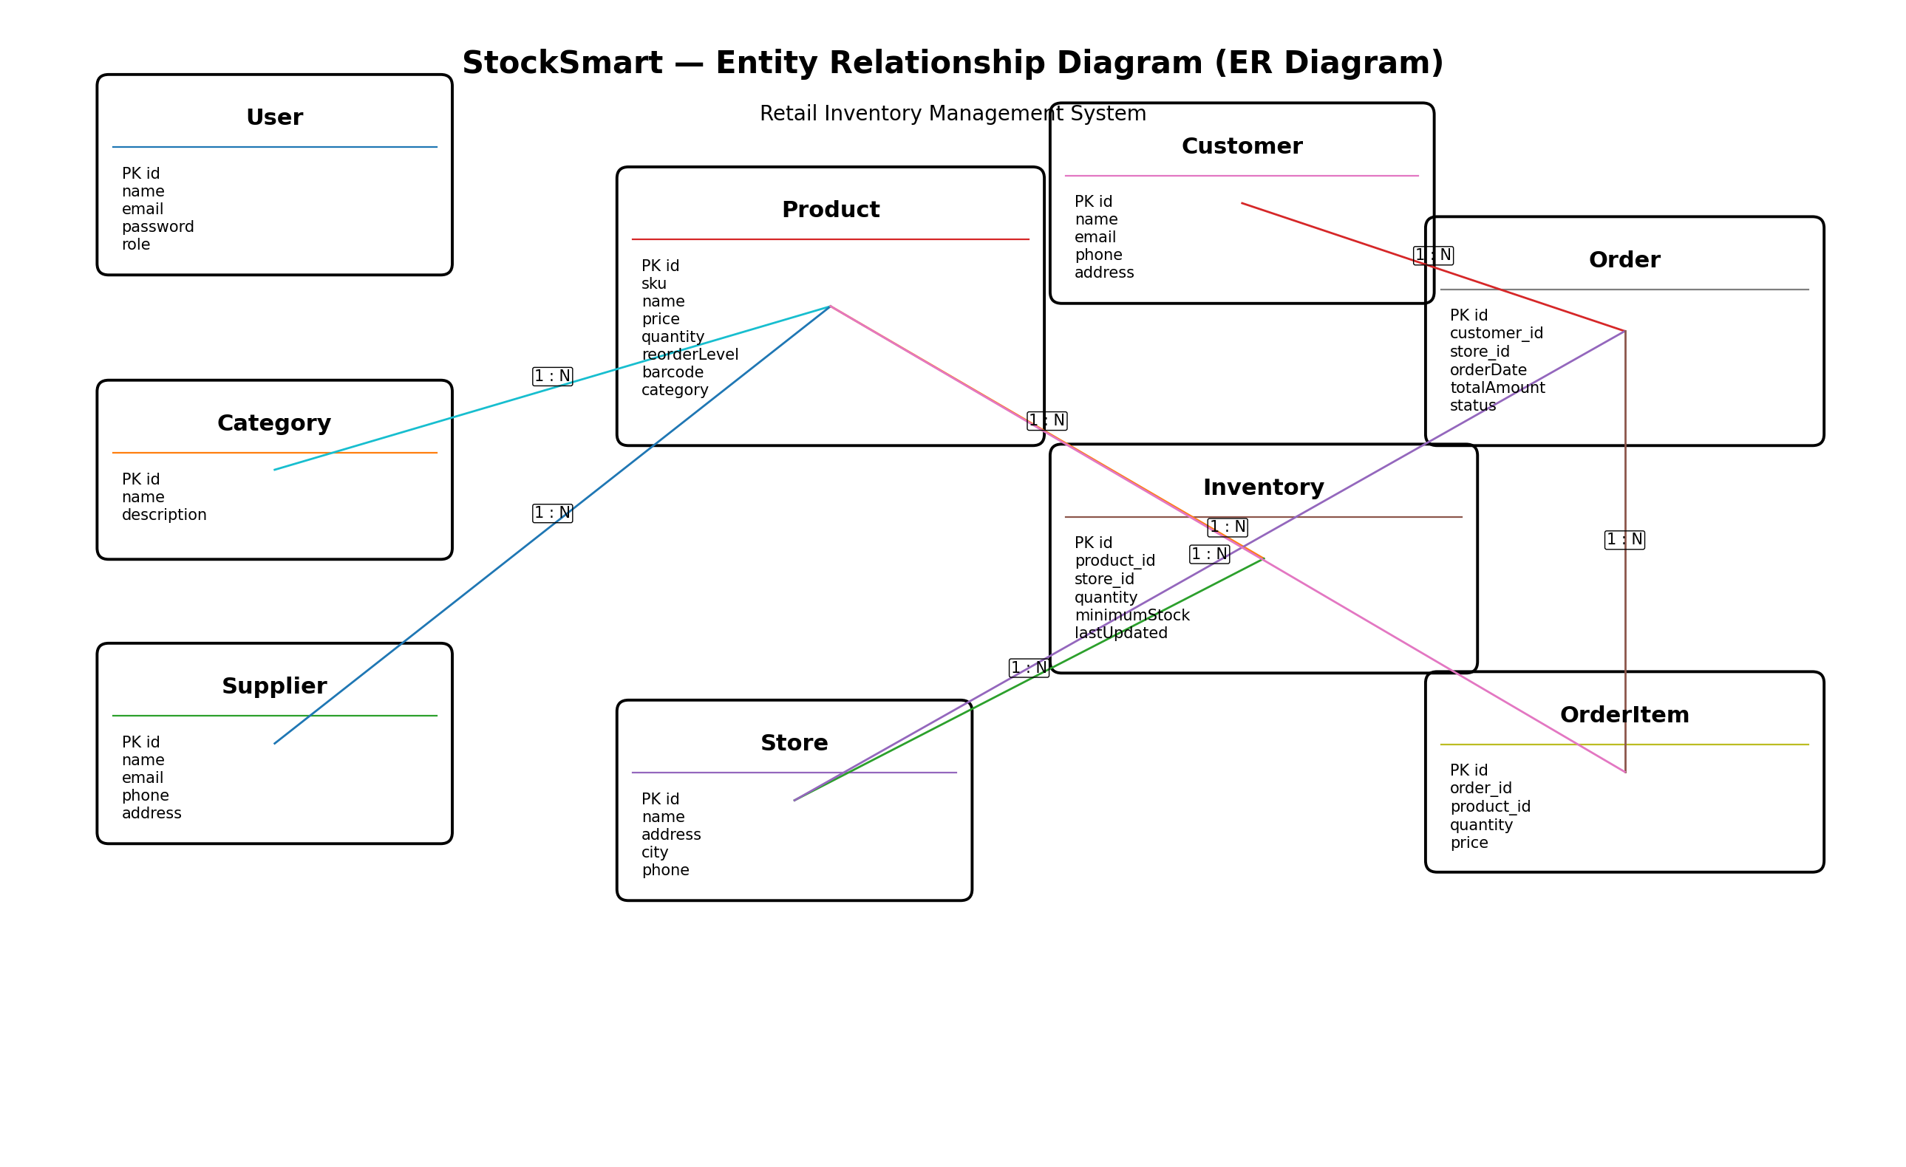
Figure: Entity Relationship Diagram of the StockSmart database.

