conceptual
1:
a)worse as if large no of n and less p overfitting might increase (wrong )
better as flexible methods require more datapoints to estimate parameters

b)worse due to overfitting as more requirements than eqations i.e flexible methods require larger datasets

c)better as flexible methods on non-linear datasets have more degress of freedom to approximate
d)worse as the noise is large overfitting by flexible methods which would try to follow noise more

2:
a)Regression as salary is continous data
it is an inference problem as we are needed to understand factors affecting salary
here n=500 , p=profit,no of employess ,industry , response = ceo salary

b)Classification as response is categorical
it is prediction n=20 , p=price for product,marketing budget,competetion price and other ten...

c)regression as change in excahnge rates is continous
it is prediction problem
n=52 weeks
p=US market percent change , British market percent change , percent change in german market

3)
a)
values for curves

irreducible error /bayes error

increasing flexibility ->

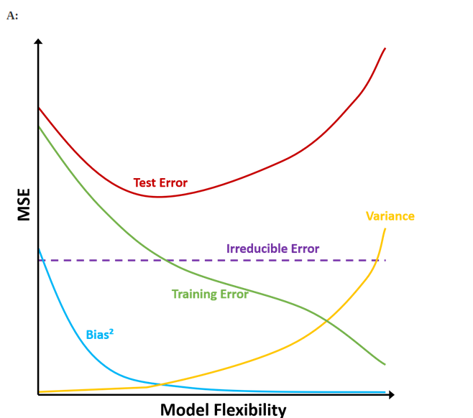

b) bias is introduced when assumptions are made about curve and model function is not flexible enough f(x)-֜f(x)
so with increasing flexibility usually bias decreases

variance is indication of spread of data points and if were weret o replace some values how much are they affected . So with increase in flexibility variance increase

test error is bias^2 + variance + irreducible error so always above var(e)
since initially bias decreases faster with flexibility than variance increases so test error decreases but after some time it starts increasing

training error with increasing flexibility the model function almost mimics the data points thus entirely reducing error

5)

advantages of flexible methods
accurate predictions
non linear relationships are captured
less assumption
disadvantages :
time taking
overfitting
computationally costly
less interpretable

flexible methods are used when prediction is important
in large datasets
cross validation over data is possible

if large no of variables are useless found by confusion matix, scatterplots then linear methods or less flexible methods are better

6)

parametric methods we assume the model function so rather than estimating the function it’s curvature and complexities entirely we only need to estimate the parameters of the assumed function
non parametric approach we do no assumption about function . The function entirely is estimated using data points using spleen splitting method.

Advantages parametric approach
complexity of estimating a function entirely is avoided
lesser observations are required
usually more interpretable

disadvantages
since we are assuming functional form the bias error will always be higher since are assuming about function its curvature and it shape and so prediction error will be automatically higher

heavily influenced by outliers ??? why

7)
a)
dist 1 = 3
dist 2 = 2
dist 3 = 10^(1/2)
dist 4 = 5^(1/2)
dist 5 = 2^(1/2)
dist 6 = 3^(1/2)

b) Green because least distance so max probablity of it to be green by estimation of bayes classifier using nearest neighbour
c)Red as 5,6,2 are three nearest neighbours and max p(y/x)= Red
d)small because with increasing k flexibility decreases hence the ability to reduce error for eastimating non linear function decreases considerably.
Larger k will have smoothing effect because takes more points in consideration

