Indiana Wesleyan University
AIML-500-01N1Y: Machine Learning Fundamentals

Workshop 1: Foundations of AI and ML
1.4 Assignment: AI Lab

Submitted To: Professor David McCullough
Submitted By: Aashirwad Shrestha

Submitted Date: November 01, 2026

Executive Summary
This guided activity explored how generative AI can support graduate learning and practical decision-making. I compared responses to an identical machine-learning prompt, investigated retail inventory management with STORM, interacted with an AI Tutor through iterative prompts, and designed and tested GradStudy Navigator, an educational chatbot built on Mizou. The project emphasized clarity, source verification, critical thinking, academic integrity, privacy, and iterative evaluation. The Mizou chatbot was made public and a shareable link was obtained. Screenshots and recorded interactions support the reported implementation and tests.

- Comparing Three LLM Responses
Common Prompt
Context: I am a graduate student studying AI and data analytics. I want to understand technical concepts and apply them to practical situations. Task: Explain how machine learning can help a retail business make better inventory decisions. Include a realistic example with numerical values. Constraints: Use clear language suitable for a graduate student, explain the business benefits and limitations, and avoid unsupported claims.
Responses and Comparison
Response | Example and emphasis | Assessment
1 | 650 jackets ordered, demand 500: 150 unsold. ML-informed order 520, actual demand 510: 10 unsold. | Most accessible explanation; connects forecasting to overstock and managerial judgment.
2 | At $40 per jacket, 650 units cost $26,000; 520 units cost $20,800, a $5,200 difference in initial purchasing. | Adds a financial dimension, but the spending difference must not be called profit.
3 | Historical average 400, forecast 520, order 530, actual demand 510: 20 remain. Ordering 400 could leave 110 unmet demands. | Best illustrates that a forecast and a final purchase order are different decisions.
All numerical values are hypothetical illustrations, not observed research results. The comparisons also assume no replenishment when discussing unmet demand. Actual inventory decisions would account for on-hand stock, supplier lead times, service targets, minimum orders, and storage constraints.
Reflection
Using an identical prompt revealed differences in presentation and emphasis even when the underlying concepts were similar. I found that explicit constraints improved comparability. I also learned to check arithmetic and distinguish lower purchasing expenditure from improved profit. For business use, model outputs need both technical validation and operational interpretation.

- Storm AI Research Assistant
Topic and research process
I used STORM to investigate how machine learning improves inventory management in retail businesses. The tool began with broad questions about inventory problems and then explored forecasting methods, input features, performance measures, and replenishment decisions. Follow-up questions narrowed the research toward operational use, rather than stopping at a general description of AI.
Main findings
Retailers can use demand forecasts to inform ordering, safety stock, allocation, and replenishment. The research discussed classical time-series approaches, gradient-boosted models, deep-learning approaches, and reinforcement learning for some sequential decisions. Relevant data may include point-of-sale history, prices, promotions, seasonality, product and store attributes, inventory availability, supplier lead times, and external factors such as weather. Forecast quality can be examined with MAE, RMSE, WMAPE, and bias, while business outcomes require measures such as stockout rates, service levels, carrying costs, and inventory turnover.
Critical assessment
STORM helped organize a broad topic into useful subquestions, but generated research should not be accepted without checking original sources. Percentage-improvement claims and numbered citations in the research output were not independently verified for this report; consequently, I do not present them as established results. Forecast accuracy alone does not guarantee fewer stockouts or higher profits, and unexpected disruptions can override otherwise reasonable forecasts. This activity reinforced the importance of source tracing, careful assumptions, and human oversight.

- Custom GPT: AI Tutor
I explored supervised and unsupervised machine learning with an AI Tutor. Its first explanation defined labeled and unlabeled learning, used credit-card fraud detection for supervised classification and customer segmentation for unsupervised clustering, and included a comparison and a knowledge check.
Interaction | What I requested | What I learned
Refinement | Make the explanation more concise while retaining examples and one limitation for each method. | Supervised methods depend on reliable labels; unsupervised patterns can be difficult to interpret.
Reasoning | Explain why the response used that structure and those examples; propose alternatives. | Definitions, examples, and limitations support comparison; a problem-first or single-industry approach could also work.
What-if | Consider a business with very little labeled data. | Limited labels may motivate exploratory clustering, active learning, or semi-supervised approaches; anomaly does not equal confirmed fraud.
Summary | Summarize in five points and identify a key limitation. | The business objective and data availability determine the appropriate approach; data quality remains critical.

This back-and-forth demonstrated how follow-up prompts can turn a general explanation into a more critical discussion. The tutor adapted to requests for concision, explained its presentation choices, considered constraints, and summarized the learning. I did not record answers to its initial quiz, so I do not claim that portion was completed.

- Design Thinking for GradStudy Navigator
Empathize
Target users are graduate students learning AI, machine learning, and data analytics. They may understand definitions but struggle to connect algorithms to real business decisions or assess limitations. A helpful tutor should support varied prior knowledge and encourage independent reasoning.
Define
Problem statement: Graduate students need an accessible, interactive study assistant that explains complex concepts with realistic examples and formative feedback without replacing their own academic work.

Ideate
I considered a general Q&A bot, a quiz-only tutor, and a combined concept-and-practice assistant. I selected the combined approach because it supports explanations, business examples, follow-up questions, quizzes, and responsible learning in one interface.
Prototype
I configured GradStudy Navigator in Mizou using a clear title, university grade level, AI tutor identity, detailed behavior instructions, welcome message, rules, image, discovery description, and Computer Science subject. The chatbot was designed to avoid fabricated references, acknowledge uncertainty, protect sensitive information, and guide rather than complete graded assignments. A knowledge file was not uploaded; the interface marked that capability as premium.
Test and iterate
I used eight recorded interactions to evaluate explanation quality, application, adaptability, ethics, quiz behavior, feedback, and advanced problem-solving. Testing exposed opportunities for refinement: an inventory safety-stock example needed clearer assumptions; feedback to correct student answers was supportive but brief; and fraud detection could better discuss precision, recall, and false positives. The final fraud scenario was a follow-up probe for more sophisticated reasoning. No post-test instruction change is documented, so the findings are recommendations for a future version rather than claimed implemented revisions.
Design-thinking evidence and boundaries
Empathize: The intended learner was a graduate student encountering technical concepts, business applications, and ethical trade-offs. This need was inferred from the assignment context and the student-developer’s own learning experience; no formal interviews, surveys, or accessibility study were conducted. Therefore, the user-needs statement is a design assumption, not a verified finding about all graduate students.
Define: The design challenge was to offer understandable, academically responsible explanations without encouraging overreliance on AI. Success criteria were: understandable definitions; at least one realistic application when appropriate; responsive clarification; constructive formative feedback; attention to uncertainty and ethical concerns; and a working shareable experience.
Ideate and select: Three possible approaches were considered: a general-purpose question-answer assistant (flexible but less focused), a quiz-only tutor (good for practice but limited for initial explanations), and a combined concept-and-practice tutor (broader learning support). The combined approach was selected as the most suitable match for the intended learner and the available free Mizou interface.
Prototype and test: The prototype used a University grade level, explicit AI tutor instructions, welcome message, ten rules, a named avatar, discovery metadata, and Computer Science subject. Eight recorded prompts assessed conceptual accuracy, numerical application, explanation depth, ethical reasoning, question generation, answer feedback, limited-label reasoning, and applied fraud-detection strategies. The evidence is a structured developer-led test, not a controlled study with external participants.
Iteration log: observation, decision and status
Initial configuration: The first working version specified the role, subjects, tone, examples, quizzes, academic integrity, uncertainty, and privacy. This configuration was saved and exercised through the preview. The available screenshots do not establish a second saved version of the instructions.
Observed issue 1: Inventory answer: the example of 50 safety-stock units for ±10% demand variability was not supported by lead-time and service-level assumptions. Proposed refinement: require numerical examples to be labeled illustrative and state their assumptions. Status: identified, not shown as implemented or retested.
Observed issue 2: Quiz feedback: all three correct answers were recognized, but feedback was brief. Proposed refinement: ask the tutor to explain one reason each answer is correct and offer a specific next-step challenge. Status: identified, not shown as implemented or retested.
Observed issue 3: Fraud detection: the response described semi-supervised learning, active learning, and human review, but did not specify precision, recall, and false-positive-rate evaluation. Proposed refinement: add model evaluation criteria for imbalanced classification problems. Status: identified, not shown as implemented or retested.
Adaptation actually observed: after basic explanations and a knowledge check, progressively harder follow-up prompts were used, culminating in a bank fraud-detection scenario. This is documented prompt-level iteration and broader testing; it should not be confused with modifying and redeploying the underlying chatbot configuration.
Feedback, feasibility, and limitations
Feedback evidence: The chatbot itself evaluated three supplied student answers and gave accurate, encouraging feedback. A student-facing Mizou session screenshot demonstrates that the shared experience was opened, but it does not constitute a usability interview or independent user evaluation. The next evaluation step would be to ask several volunteer students to complete the same tasks and report clarity, trust, accessibility, and usefulness.
Feasibility and constraints: The free Mizou account permitted chatbot configuration, preview, a public listing, and a session link. The interface marked a knowledge-file feature as premium, so no knowledge file was uploaded. The dashboard displayed a daily participant limit of 0/50 at capture time. The bot cannot guarantee correctness or verified citations; it is a learning aid rather than an authoritative source.

- Chatbot Planning Decisions
Planning question | Decision and rationale | Planning question
Objective | Help graduate learners understand AI/ML/data analytics and apply concepts independently. | Objective
Information | General technical explanations and illustrative business scenarios; no private student records or uploaded knowledge file. | Information
Boundaries | Avoid unsupported facts and invented citations; do not substitute for graded student work; avoid unnecessary personal data. | Boundaries
Engagement | Conversational explanations, follow-up questions, three-question quizzes, and formative feedback. | Engagement
Media | Tutor profile image and discovery thumbnail; optional Emma audio voice. | Media
Opening | Welcome message inviting students to choose a topic. | Opening
Interaction flow | Ask question → explanation/example → follow-up or quiz → feedback and next topic. | Interaction flow
Conclusion | Brief summaries or knowledge-check questions when appropriate. | Conclusion
Success criteria | Accurate concepts, relevant examples, appropriate limitations, ethical awareness, and interactive responses. | Success criteria

- Implementation, Testing and Deployment
Platform and configuration
Mizou was selected because its interface supports creating a named educational chatbot, setting a university audience, previewing responses, managing sessions, and obtaining an invitation link. Screenshots show GradStudy Navigator listed as Public in My Chatbots. The session dashboard displays the chatbot and an Invite Students control; it also shows a daily participant limit of 0/50 at the time captured. This is a platform limit shown in the interface, not a claim about current remaining capacity.
Test Matrix
Test | Observed behavior | Evaluation
1: Supervised vs. unsupervised | Correct definitions and retail examples; invited deeper discussion. | Meets explanation goal.
2: Inventory forecasting | Described demand forecasting, optimization, and localization; used 500 units and 50-unit safety stock illustration. | Useful but safety-stock assumptions insufficient.
3: Overfitting | Step-by-step cat-image example; 100% training versus 40% test accuracy; mitigation suggestions. | Clear hypothetical illustration.
4: Ethics | Covered privacy, consent, bias, security, and transparency. | Relevant ethical coverage.
5: Quiz | Asked three questions and waited for answers. | Correct interactive behavior.
6: Student answers | Confirmed three correct answers and encouraged further learning. | Correct but feedback could be more diagnostic.
7: Few labels | Compared supervised/unsupervised constraints and suggested semi-supervised learning. | Appropriate high-level reasoning.
8: Bank fraud scenario | Explained semi-supervised learning, active learning, human review, and limitations. | Practical synthesis; evaluation metrics omitted.

Public sharing and verification
The Mizou My Chatbots screenshot labels GradStudy Navigator “Public.” The user supplied a shareable link and a screenshot of a student-facing chatbot conversation, which supports that a session was opened. Independent anonymous-browser access was not verified in this report. The public link is: https://mizou.com/login-thread?ID=7x65iRUlA-T3fOZ_Ayc9oBRBiOYlIa1VnEPCN0olHoM-153718
- Privacy, Terms, and Responsible Use
Mizou provides privacy and terms information at https://mizou.com/privacy and https://school.mizou.com/p/terms. Before educational deployment, the instructor or student should check the currently applicable terms, retention practices, visibility controls, and any institutional requirements. Because the chatbot is public, I avoided uploading student records or private course materials. The rules also discourage collecting unnecessary sensitive information. AI outputs remain fallible, so the tool should supplement—not replace—verified course resources and student judgment.
Privacy and terms: design implications
The platform’s published privacy policy and terms pages were identified for review (URLs in References). Because the chatbot is publicly listed, the practical design decision was to use general educational prompts, avoid uploading confidential student records or restricted course documents, and instruct the tutor not to request unnecessary sensitive information. These measures reduce exposure but do not prove that all conversations are private or that the service meets any particular institutional compliance requirement.
A public listing and a shareable session link are distinct from anonymous-access verification. The supplied screenshots support the public status and an opened student-facing session; the record does not establish successful access from an unauthenticated browser. Users should check the live terms, privacy disclosures, account permissions, retention practices, and institutional policy before using real student data. Platform statements are not independent security audits.

- Reflection and Conclusion
The strongest lesson across these activities is that effective AI use depends on the quality of questions, the context supplied, and critical review of outputs. Comparing three responses revealed that different presentations can lead to different practical insights. STORM was valuable for research structure but raised source-verification concerns. Iterating with an AI Tutor showed how follow-up prompts can deepen understanding. Building GradStudy Navigator translated these lessons into an actual educational prototype. Testing confirmed useful behavior while exposing limitations that should guide a future iteration. I would next add better diagnostic feedback, explicit assumptions for numerical examples, and more rigorous evaluation of model outputs before recommending broader classroom use.

References and Evidence
STORM AI research output supplied for this activity: “How Machine Learning Improves Inventory Management in Retail Businesses” (generated report; original references not independently verified).
Mizou. GradStudy Navigator chatbot. https://mizou.com/login-thread?ID=7x65iRUlA-T3fOZ_Ayc9oBRBiOYlIa1VnEPCN0olHoM-153718
Mizou. Privacy Policy. https://mizou.com/privacy
Mizou. Terms and Conditions. https://school.mizou.com/p/terms
Course-provided document: AI Lab – Guided Activities (professor-provided PDF).

Appendix A. Screenshot Evidence
The screenshots below are direct captures of the actual Mizou configuration, tests, dashboard, and student-facing session. They are included as evidence of the work reported above.
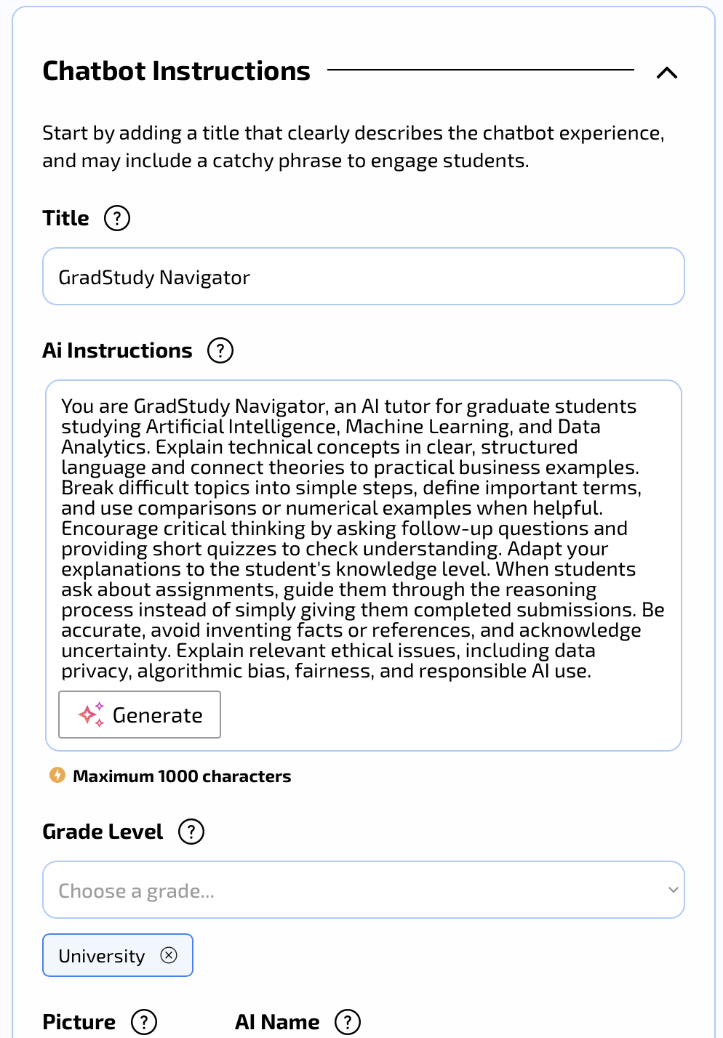
Figure A1. AI instructions and university-level setting.
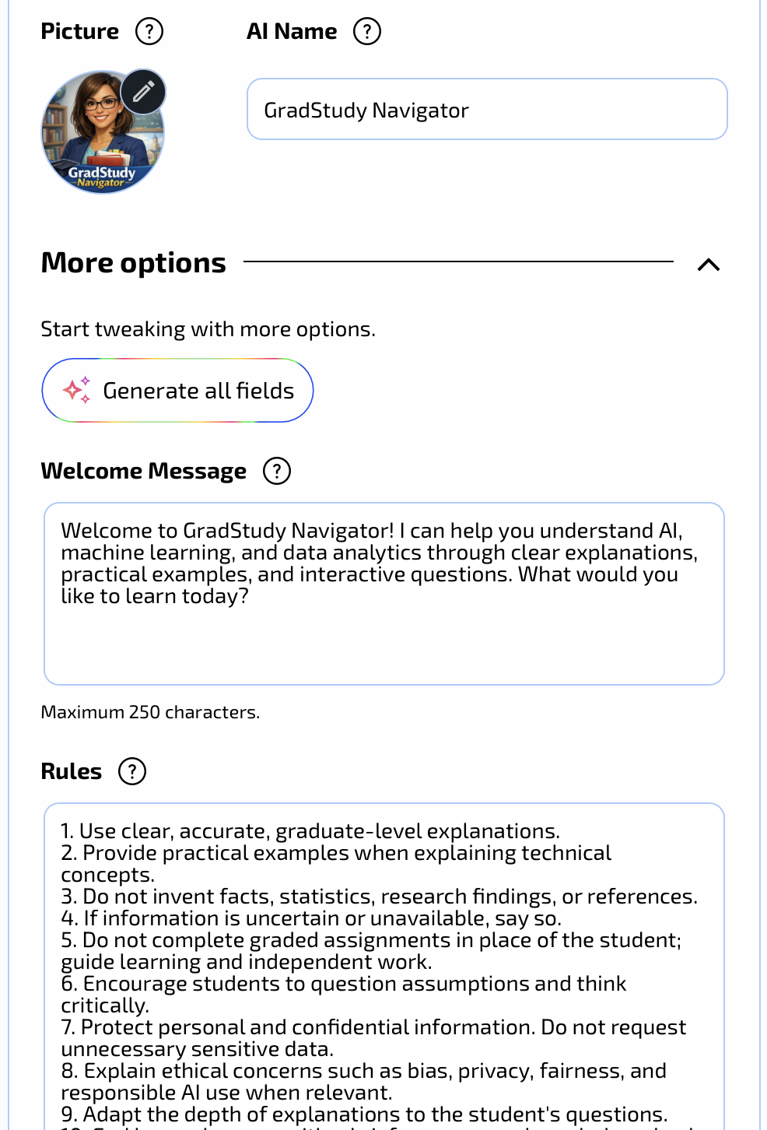
Figure A2. Tutor identity and welcome message.
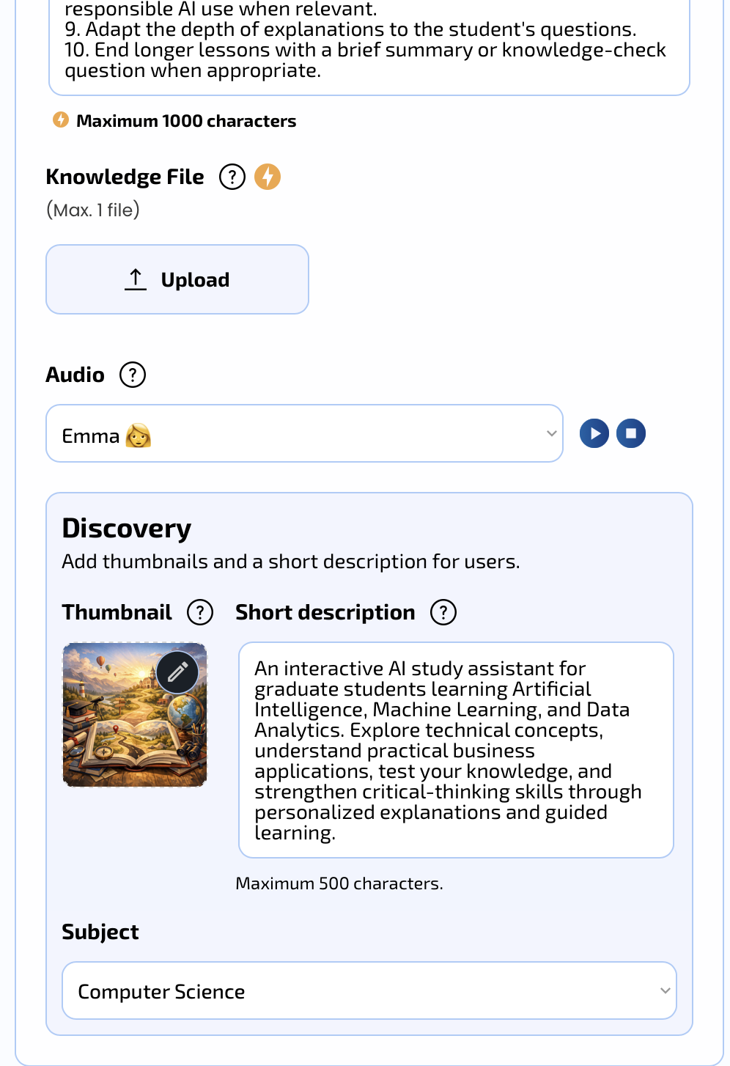
Figure A3. Rules, optional knowledge file, audio, and discovery settings.
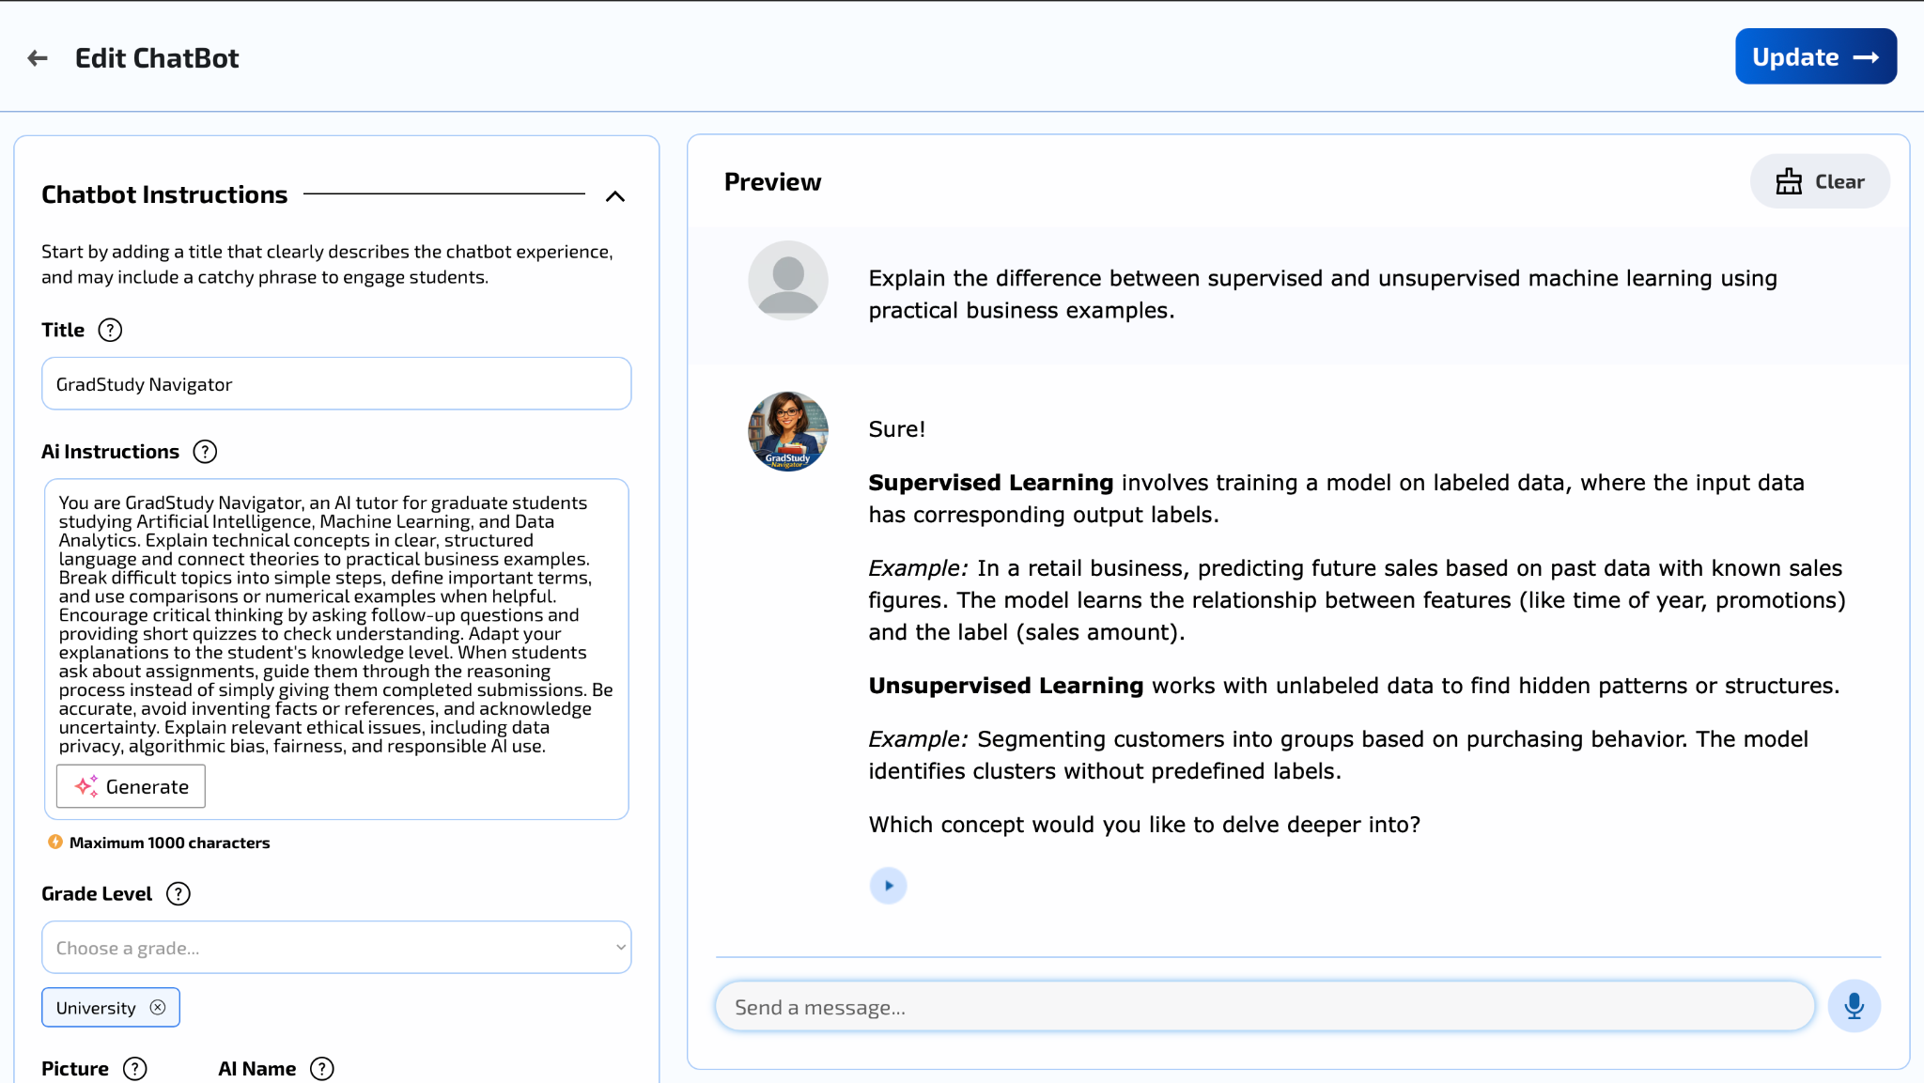
Figure A4. Test 1: supervised versus unsupervised learning.
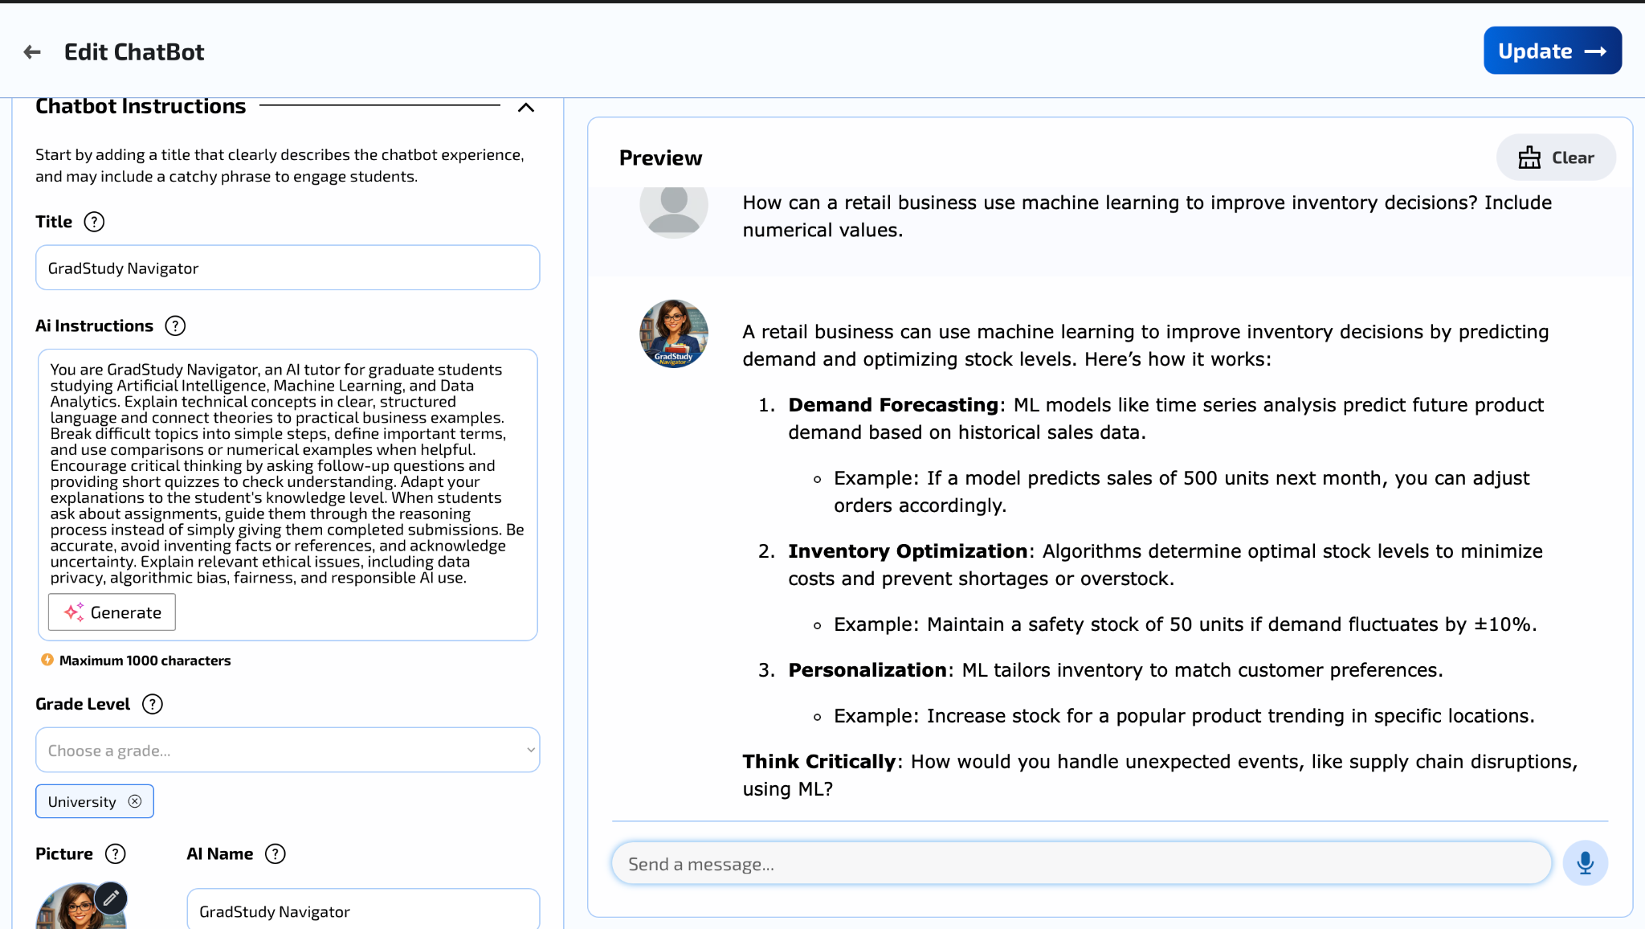
Figure A5. Test 2: retail inventory example.
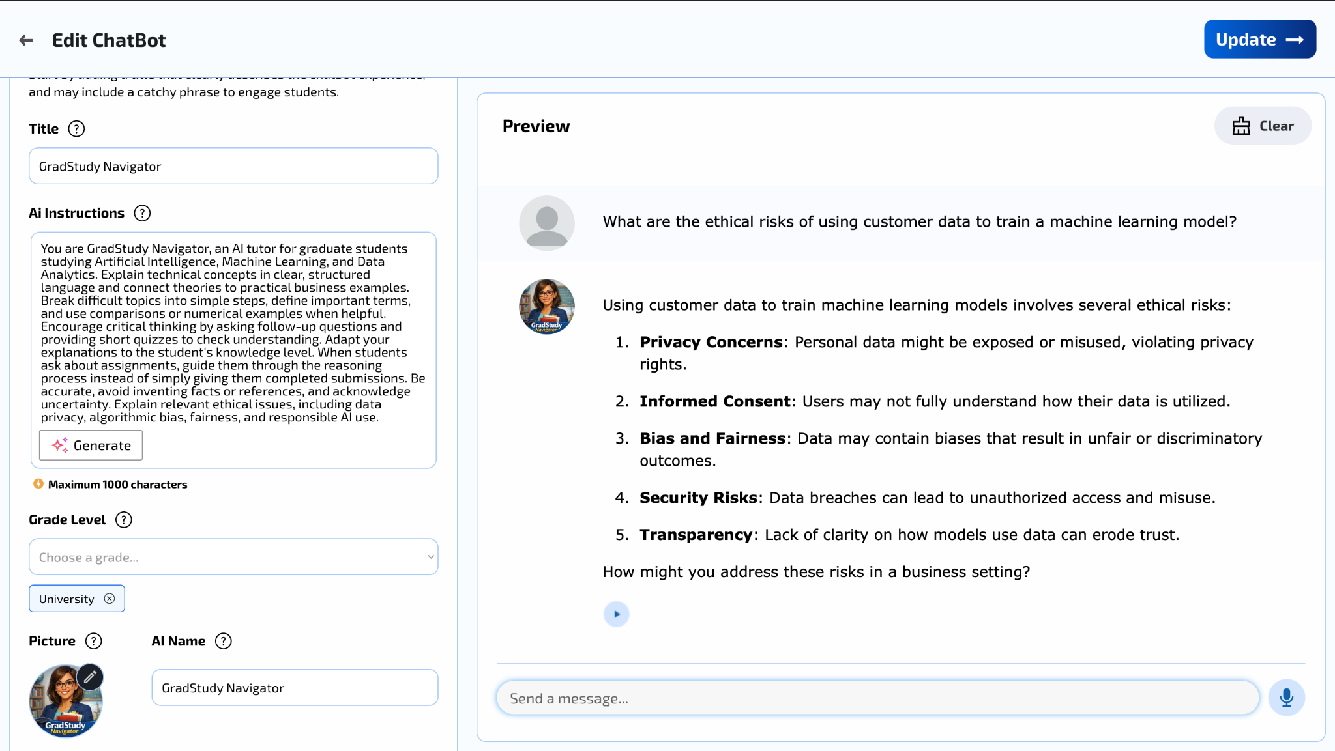
Figure A6. Test 4: ethical considerations.
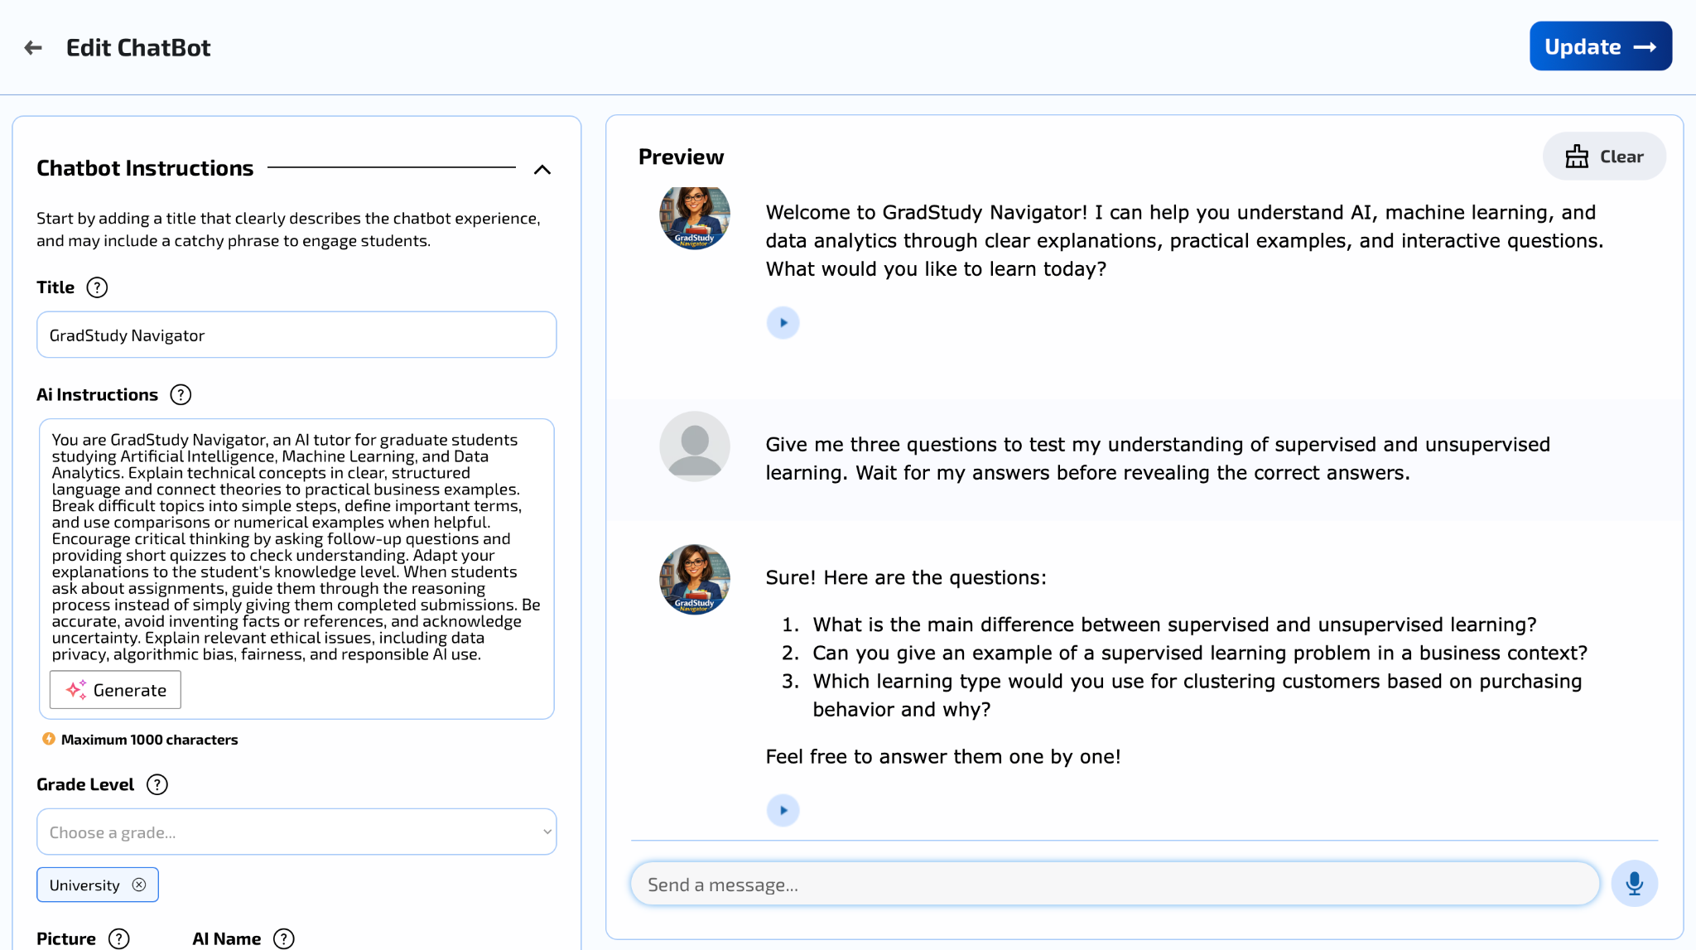
Figure A7. Test 5: quiz interaction.
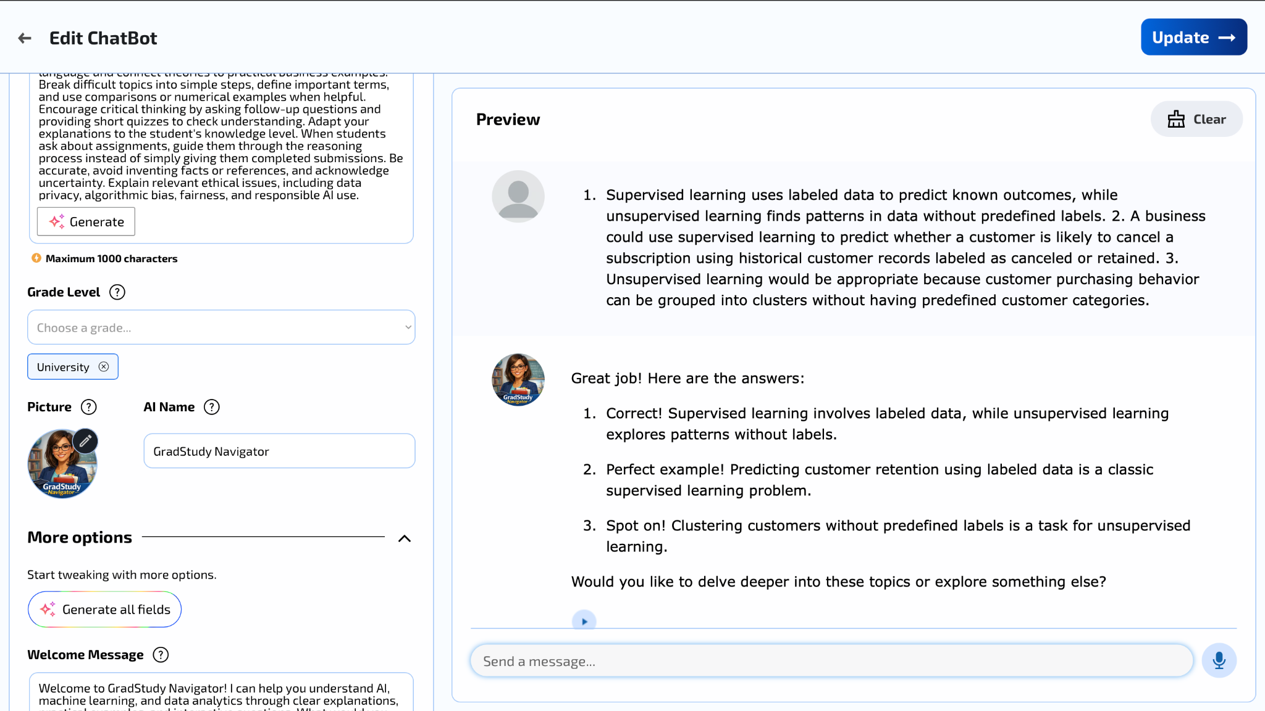
Figure A8. Follow-up: feedback on student answers.
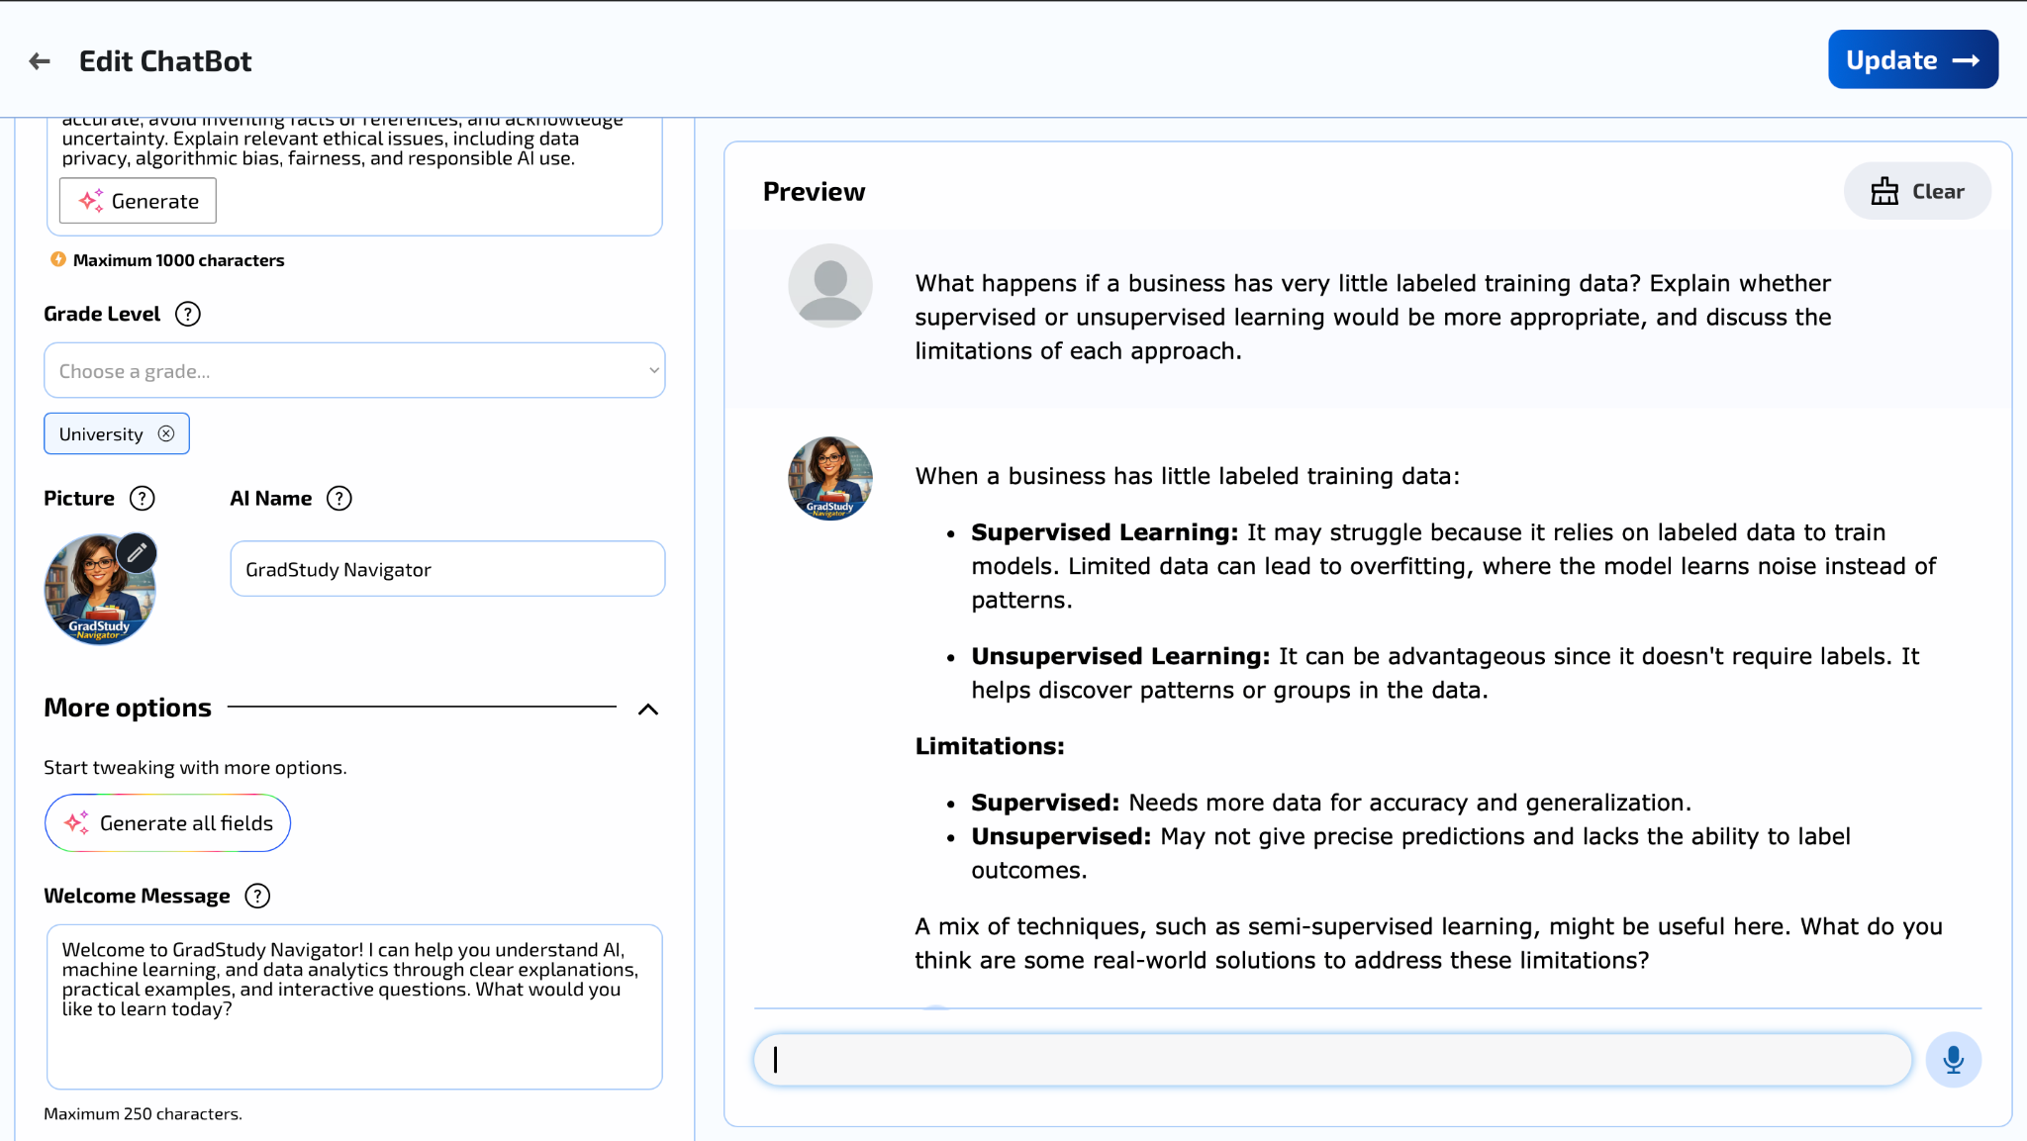
Figure A9. Follow-up: limited labeled data.
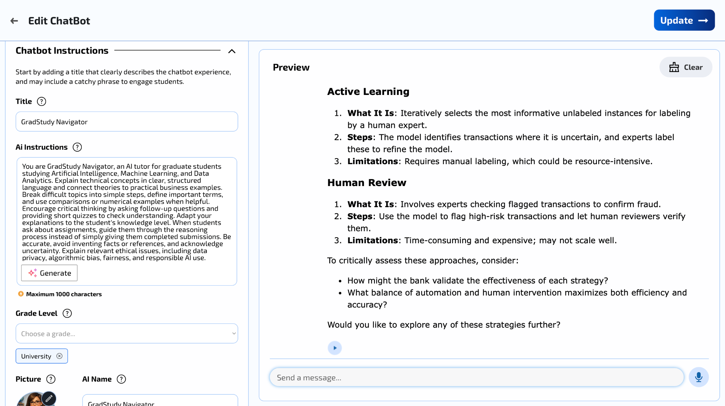
Figure A10. Advanced bank fraud scenario response.
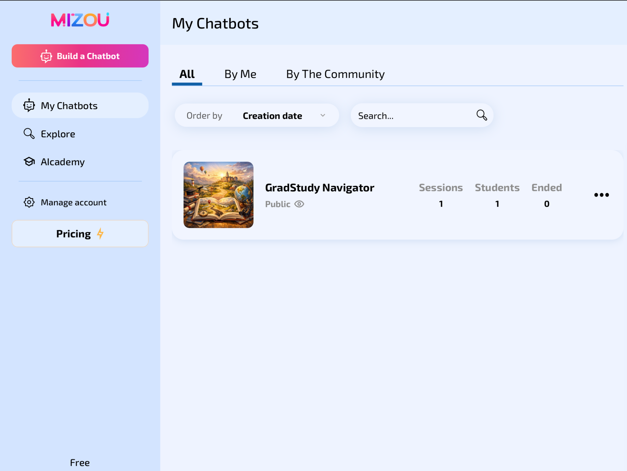
Figure A11. Public chatbot listing.
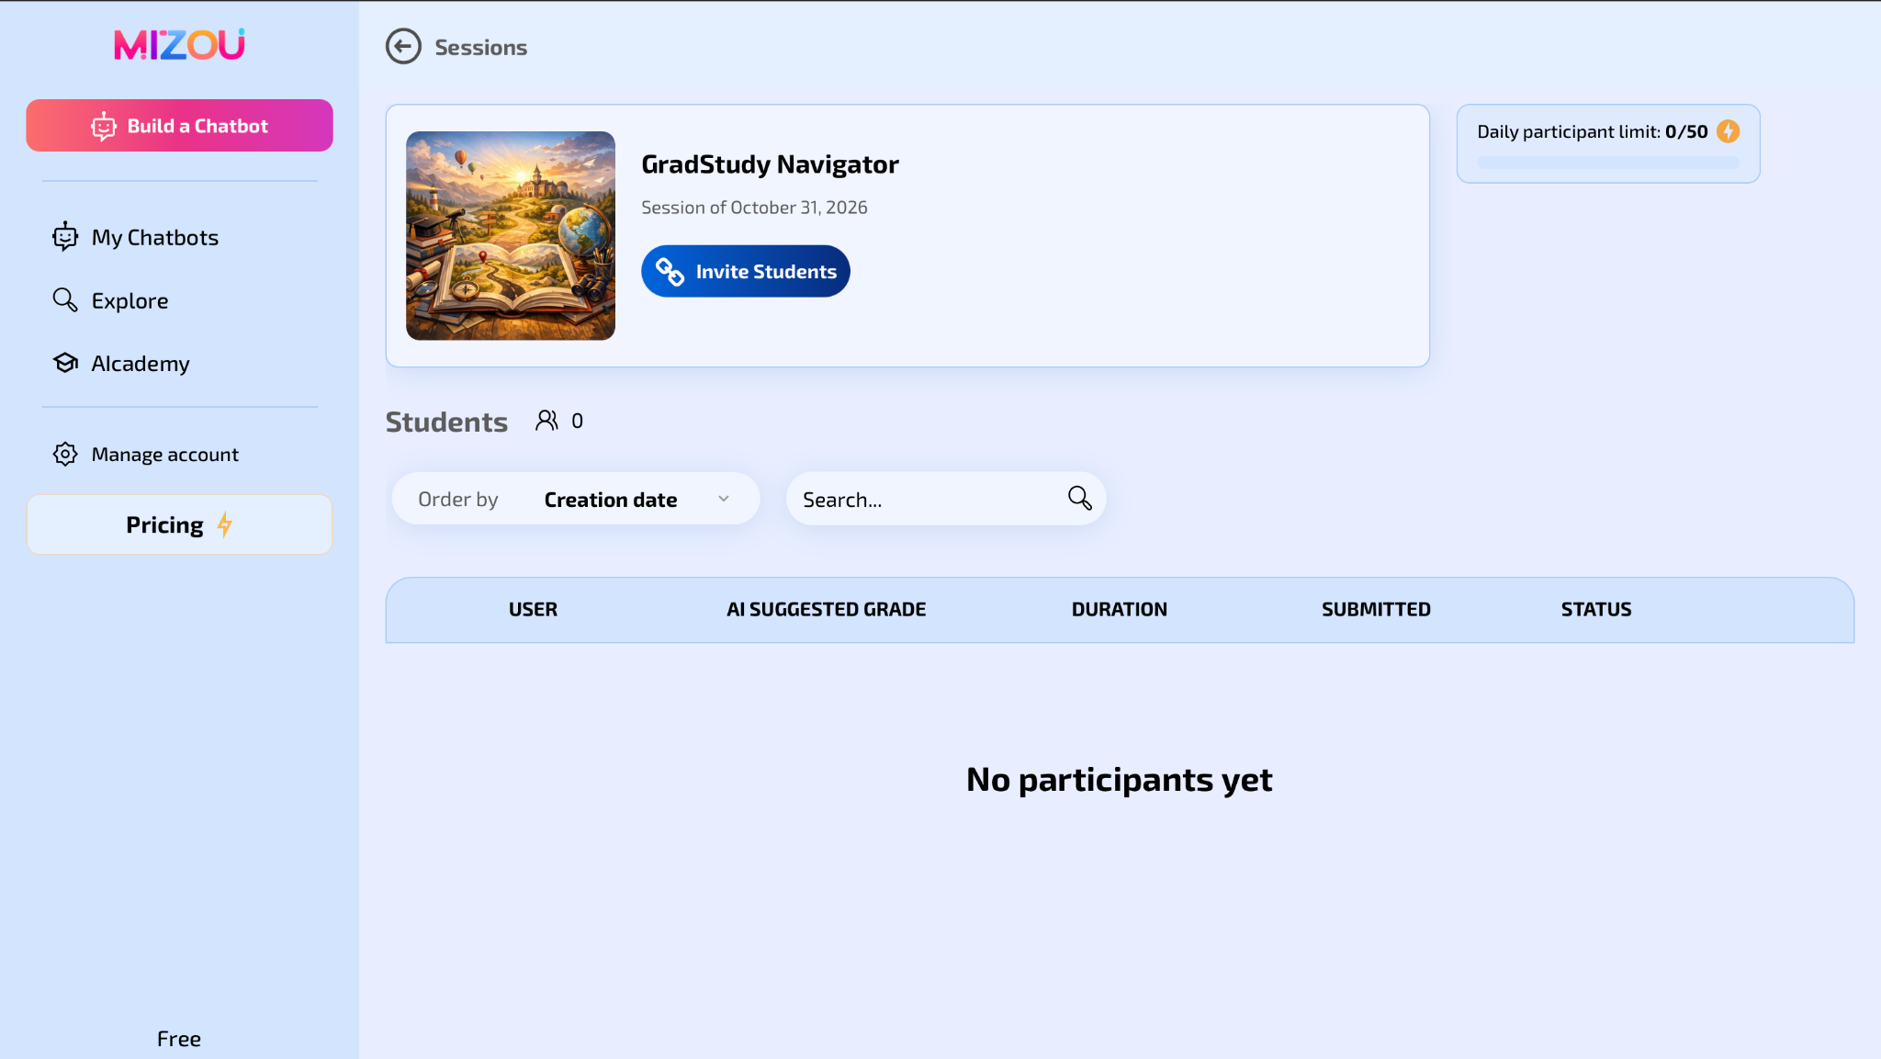
Figure A12. Session dashboard and invite control.
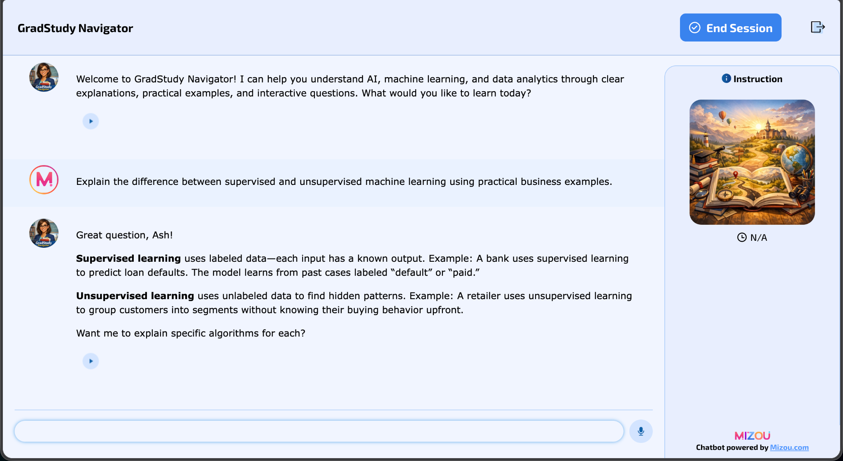
Figure A13. Student-facing chatbot session.

