Grafana

Using Loki, Promtail,

1. Ubuntu InstanceA screenshot of a computer

   Description automatically generated
2. Install Grafana, loki and promtail with the commands in Readme file
3. Loki and Grafana is working fine. 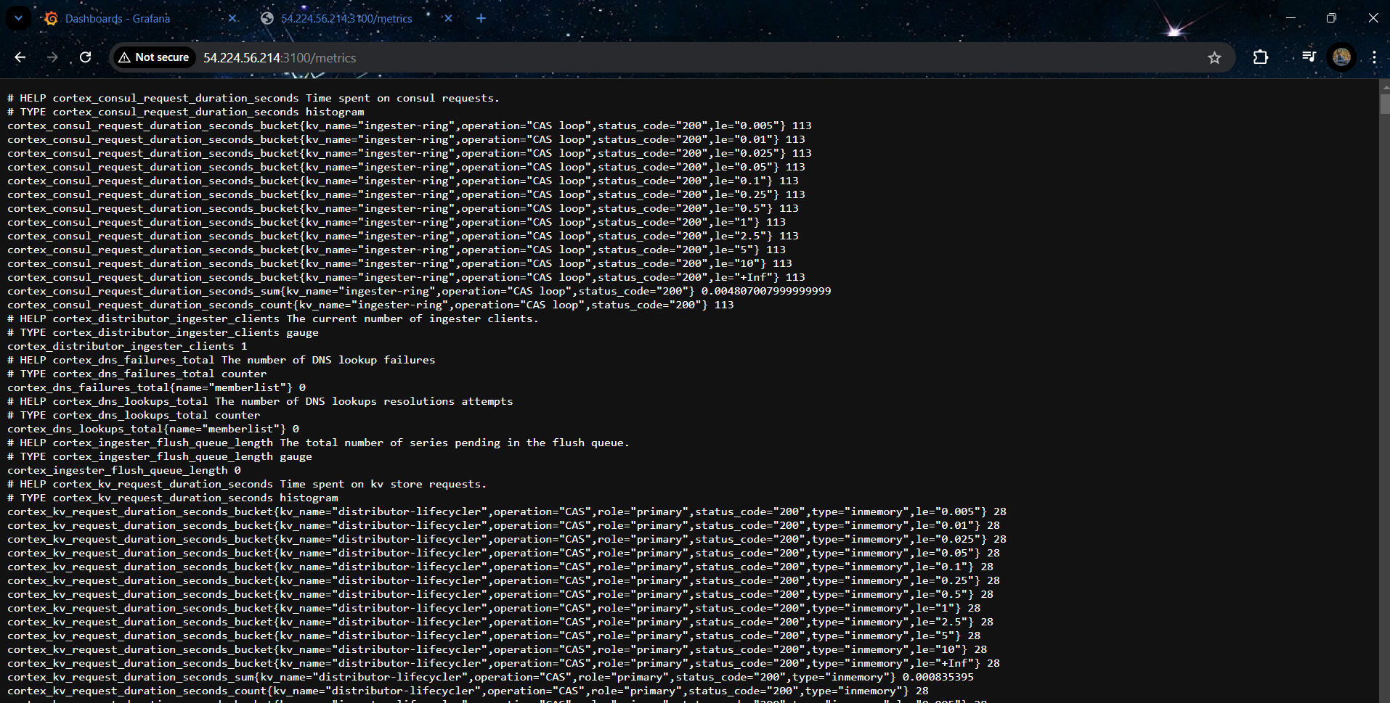
4. Grab the loki/proptail logs A screenshot of a computer

   Description automatically generated
5. Add Grafana logs in promtail yaml file A grey background with black text

   Description automatically generated
6. Grafana A screenshot of a computer

   Description automatically generated
7. Installing nginx and grabbing the logs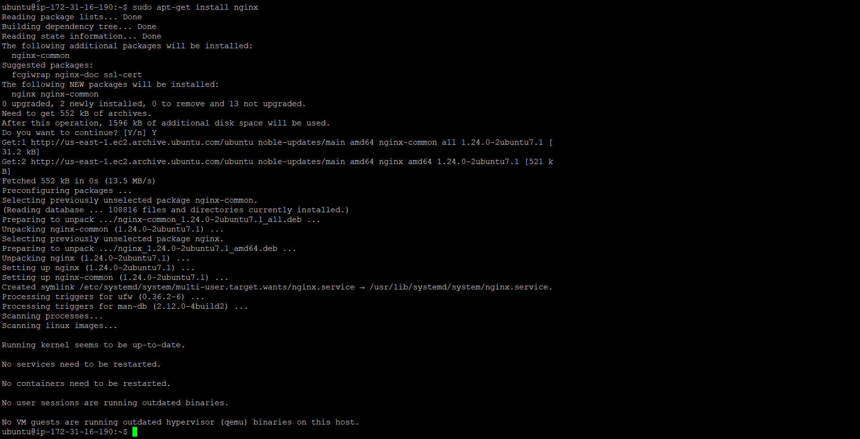
8. Operations added A screenshot of a computer

   Description automatically generated
9. Final dashboard ready

