Project 2: Scaling an E-Commerce App for High Traffic

# 1. Project Overview

|  |  |
| --- | --- |
| Client Name | ShopWave |
| Industry | E-Commerce |
| Problem Summary | Application crashes during seasonal or marketing campaigns due to load spikes |
| Current AWS Setup | EC2 + RDS |
| Business Goal | Ensure the app is highly scalable and available during traffic surges |
| Constraints | Budget-conscious: prefer Free Tier or Spot Instances. Small team: only 2 DevOps engineers, setup must remain easy to maintain. |

# 2. Discovery Phase

Key findings from the client discussion:

|  |  |
| --- | --- |
| Key Question | Answer |
| How does traffic behave? | ~10k users/day normally; spikes to 150k/day during sales. |
| Current App Hosting? | Monolithic Node.js app on a t3.medium EC2 (single AZ). |
| Database Setup? | RDS MySQL, single AZ. Read-heavy load slows it down. |
| Any caching layer? | None yet — all reads go to RDS directly. |
| CDN or S3? | S3 is used for images, but no CloudFront; EC2 serves all content. |
| Deployment Process? | Manual via SSH; PM2 restarts app with ~30s downtime. |
| Scaling Setup? | Basic CloudWatch alarm triggers 1 extra EC2 manually. |
| Monitoring? | Minimal CloudWatch, no alarms or log forwarding. |
| Pain Points? | Crashes under load, DB bottleneck, downtime during deploys. |
| Tooling Preferences? | GitHub and Terraform. No plans to adopt containers yet. |

# 3. Proposed High-Level Architecture

The architecture improves scalability and availability across four layers:

- Frontend & CDN: CloudFront distributes requests; S3 serves static assets.

- Application: ALB manages traffic across EC2 ASG. Cognito handles user auth. WAF and Shield protect traffic.

- Data Layer: Multi-AZ RDS with Read Replica and Redis for caching frequent reads.

- DevOps: GitHub Actions for CI/CD. CloudWatch, SNS for monitoring. Secrets Manager and VPC Flow Logs for security.

# 4. Service Selection & Justification

|  |  |  |
| --- | --- | --- |
| AWS Service | Purpose | Why This Service Was Chosen |
| EC2 + ASG | Host app and scale with traffic | Simpler than containers for a small team |
| ALB | Distribute traffic to EC2 | Handles spikes, supports autoscaling |
| RDS + Replica | Store relational data | Replica reduces read load, improves performance |
| S3 + CloudFront | Serve static content | Reduces EC2 load, speeds up delivery |
| IAM | Secure access control | Ensures least-privilege access |
| GitHub Actions | CI/CD | Simple, integrates well with GitHub-based workflow |
| CloudWatch + SNS | Monitoring and alerting | Tracks health and notifies DevOps |

# 5. DevOps Additions

|  |  |
| --- | --- |
| Tool | Use Case |
| Terraform | Provision infrastructure as code |
| CI/CD | Deploy app updates safely |
| CloudWatch | Set alerts and review logs |
| IAM Roles & Secrets Manager | Secure environment variables and access |

# 6. Phased Implementation Plan

|  |  |
| --- | --- |
| Phase | Description |
| Phase 1 | Migrate to ALB + ASG + CloudFront |
| Phase 2 | Add Read Replica and Redis cache |
| Phase 3 | Set up CI/CD, monitoring |
| Phase 4 | Optionally containerize the app |

# 7. Estimated Cost Plan

|  |  |  |
| --- | --- | --- |
| Resource | Tier/Type | Monthly Est. (USD) |
| EC2 | t3.medium (ASG) | ~$18–$54 |
| RDS | db.t3.micro (Multi-AZ) | ~$30–$60 |
| CloudFront | 1TB/mo | ~$0–$10 |
| ElastiCache | cache.t2.micro | ~$15 |
| CloudWatch Logs | Basic + 1 alarm | ~$2–$5 |
| Route 53 | Optional DNS | ~$1 |
| Secrets Manager | 3 secrets | ~$1.20 |
| S3 | ~5–10GB | ~$0.50–$1 |

Total Estimated Monthly Cost: ~$70–130 (depending on usage & Free Tier eligibility)

# 8. Final Deliverables

- Architecture Diagram

- Terraform Codebase

- CI/CD Script (GitHub Actions)

- Screen shots

# 9. Terraform Codebase and Screen shots

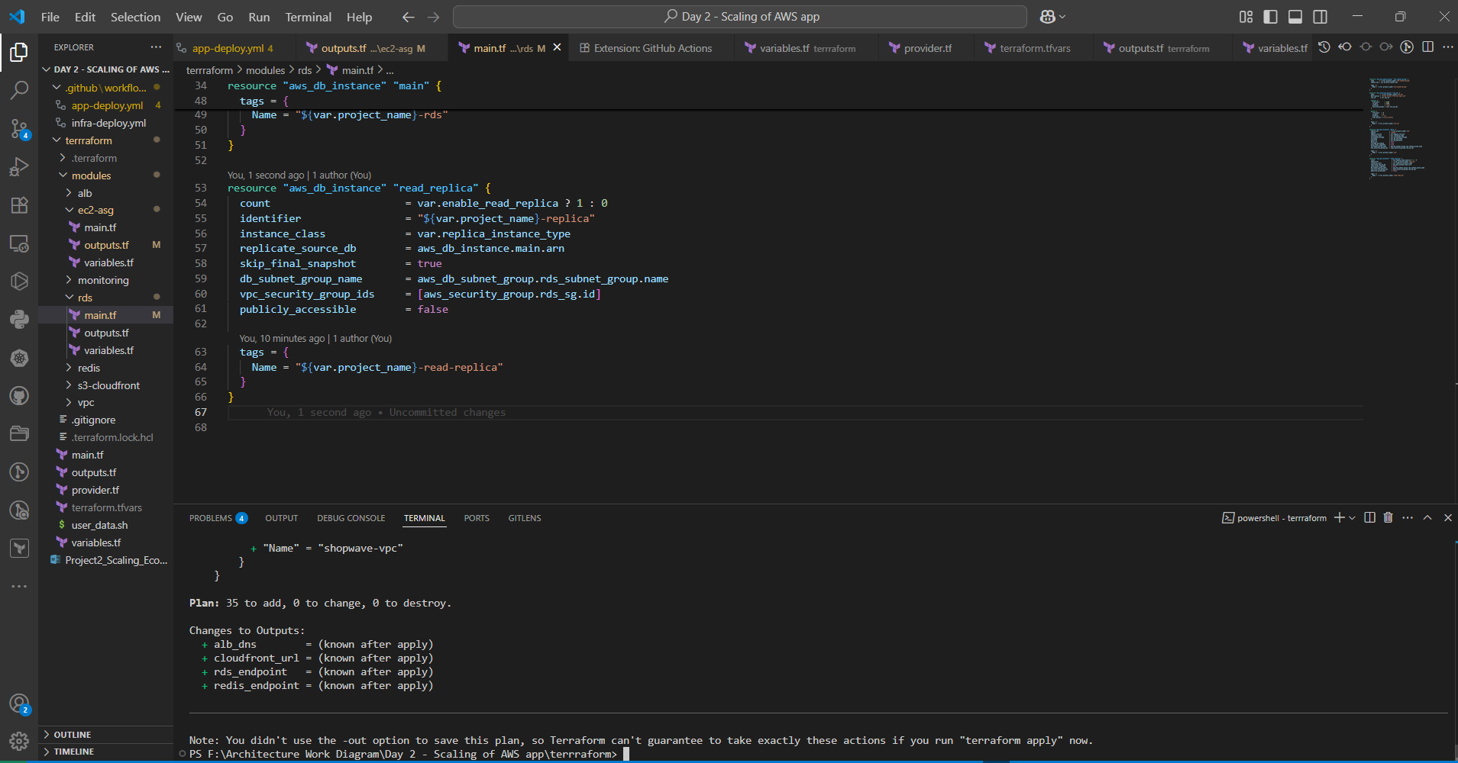

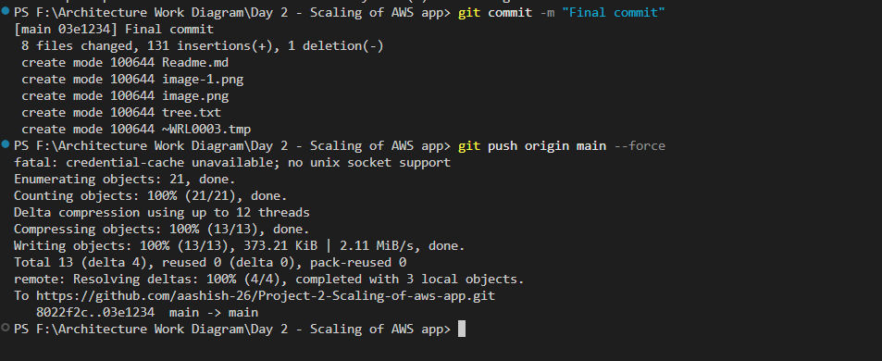

**Note:** This project includes a complete terraform plan and CI/CD setup, but terraform apply was intentionally skipped to avoid provisioning real AWS infrastructure during testing. The GitHub Actions workflow is fully functional up to the planning stage and demonstrates all required validations.