**Project Description**

Social Media platforms have widely adopted image captioning but in a manual way where the users often engage in creating their own appealing caption in order to improve the social engagement. Using artificial Intelligence and advanced machine learning one such task can be automated thus improving the user experience for the platform users. Our AI powered solution for this uses image captioning and text categorization to recommend engaging captions for the users.

**Why you selected this technology**

Using deep learning based convolutional neural networks , ML algorithms , ML libraries & available open-source datasets it is possible to train models to execute human centric tasks like the one which we have implemented here to automatically generate an engaging caption.

**Benefits-**

This project has the capability of being used by social networking platforms or other image-dependent platforms as a “Automatic Social Media Caption Generator”. Social media platforms like Instagram, Facebook, Twitter, Pinterest are highly dependent on how the image descriptions are set up with a good caption and hashtags. Our model analyzes the objects in the image and generates categories that can be used as “hashtags” and further recommend captions to the user as they upload images into the environment.

**Drawbacks-**

* Due to limited training data
* Model sometimes fails to identify the objects in the image correctly
* Model misclassified some of the categories

**Challenges-**

* Difficult to address diverse categories of the images the user can upload
* Limited Computational Power
* Limited availability of labeled data

**Describe briefly the working example your project demonstrates:**

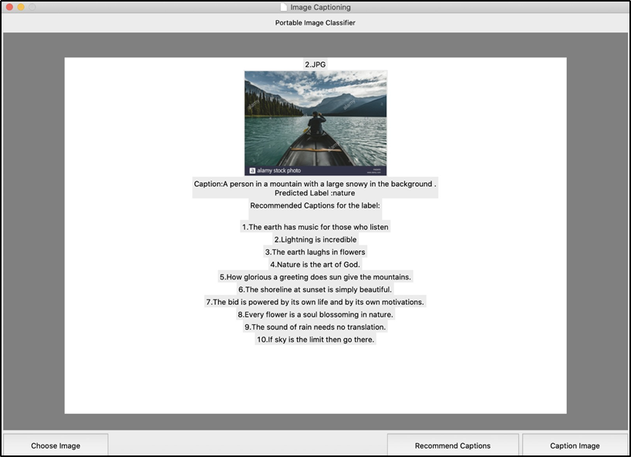

**Input:** Image file

**Output:**

1.Upon clicking the Caption Image Button an image caption would be displayed describing the image and category of the image.

Image Categories:adventure, art and music, food, history, manufacturing, nature, science and technology, sports, travel

2. Upon clicking the Recommend Captions Image Button a the user would be recommended a set of captions using the category identified for the image.