GRAPH IMPLEMENTATION :

* ADJACENCY MATRIX
* ADJACENCY LIST

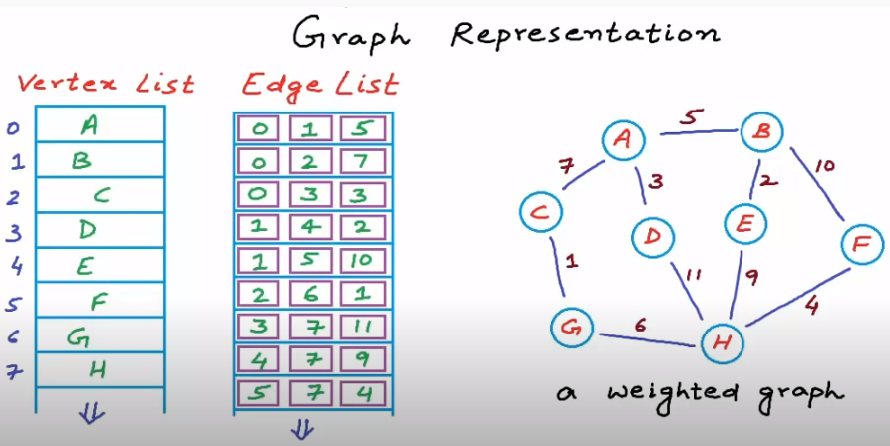

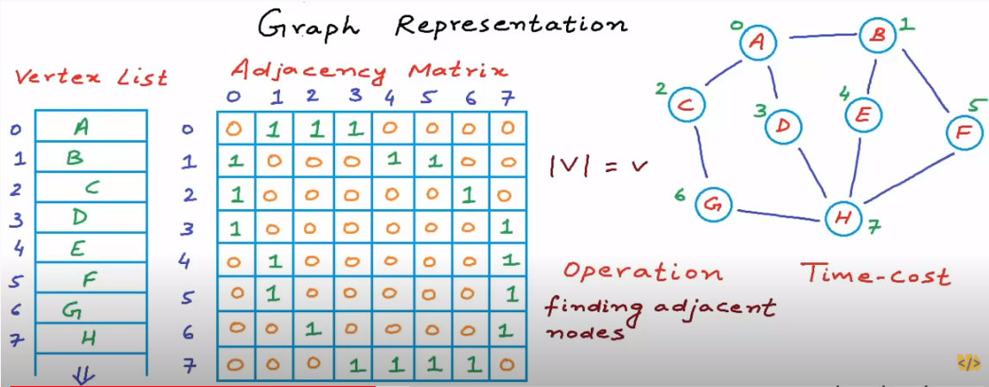

REAL WORLD GRAPHS ARE SPARSE. HENCE WE GO FOR ADJACENCY LIST IMPLEMENTATION.

SOME COMMON ALGO USED:

* Depth-First and Breadth-First Searches
* The Lightest Path: Dijkstra’s Algorithm
* The Lightest Path: Floyd’s Algorithm
* The Lightest Spanning Tree: Kruskal’s and Prim’s Algorithms
* The Lightest Hamiltonian Circuit (Travelling Salesman’s Problem)
* Maximum Matching in Bipartite Graphs:
* Maximum Flow in a Transport Network: The Ford–Fulkerson Algorithm

REFERENCES:

<https://medium.com/>

<http://math.tut.fi/>

Keijo Ruohonen

[Vaidehi Joshi](https://medium.com/@vaidehijoshi?source=follow_footer-------------------------------------)