**Project Report**

ON

**Online Electronic Store**

BCA-5th Semester

Session (2022 – 2025)



**Submitted By:**

Name**: Aashish Sharma**

College Roll No. **: 223056**

Univ. Reg. No.**: 22-MBJ-55**

Univ. Roll. No. : **220012653**

**Under Guidance Of:**

Name**: Ms. Meenakshi Sharma**

Designation**: Assistance Professor**

Department**: Computer Application**

**INDEX**

1. **Introduction** 1
2. **Overall Description** 1
3. **System Features** 3
4. **External Interface Requirements** 5
5. **System Architecture & Design** 7
6. **Non-functional Requirements** 11
7. **Testing** 12

**Software Requirements Specification (SRS)**

**For Online Electronic Store**

**1. Introduction**

**1.1 Purpose**

The purpose of this document is to provide a detailed Software Requirements Specification (SRS) for the Online Electronic Store. This document outlines the system's functional and non-functional requirements, use cases, and design constraints. It serves as a guide for developers, testers, and stakeholders to ensure that the system is built according to the defined requirements.

**1.2 Scope**

The Online Electronic Store is designed to users can easily buy electronic item at their home using internet.

**1.3 Definitions, Acronyms, and Abbreviations**

* **Node.js**: A JavaScript runtime environment that allows server-side scripting.
* **Express.js**: A web application framework for Node.js.
* **MySQL**: A relational database management system.
* **CSS**: Cascading Style Sheets, used for styling web pages.

**1.4 References**

* Node.js documentation: https://nodejs.org/en/docs/
* Express.js documentation: <https://expressjs.com/>
* MySQL documentation: <https://dev.mysql.com/doc/>

**2. Overall Description**

**The online electronic store aims to offer users a user-friendly experience while purchasing a wide range of electronic products such as laptops, mobile phones, LED TVs, and Airbuds. The website's interface is designed to be simple and intuitive, ensuring that customers of all technical abilities can easily browse and purchase products. A seamless login and registration process ensures secure access, with user authentication being a key feature to protect both user data and transaction integrity. The platform is built to ensure smooth transactions and efficient browsing.**

**2.1 Product Perspective**

This online electronic store is designed as a web-based application that provides users with the ability to browse, search, and purchase a variety of electronic devices. It stands as an independent system but is integrated with external payment gateways to handle transactions securely. The primary goal of the product is to offer a responsive, dynamic, and secure platform for users to shop online. The user journey begins with login or registration, followed by product exploration, selection, and secure payment, culminating in order confirmation and tracking.

The online store will allow users to:

* Register and log into their accounts
* Browse and search for electronic products
* View detailed product descriptions, specifications, and pricing
* Add products to a shopping cart for future purchase
* Manage a wishlist of desired items
* Complete a secure checkout process with integrated payment options
* View order history and track shipments

**2.2 Product Functions**

The core functions of the online electronic store include:

1. **User Authentication and Authorization**:
   * New users must register with a valid email address and password to create an account.
   * Existing users can log in with their credentials.
   * Forgotten passwords can be recovered using a password reset function.
   * Session management ensures that only authenticated users can access certain features (e.g., adding products to the cart, making purchases).
2. **Product Management**:
   * Users can browse through different categories of products (Laptops, Mobiles, LED TVs, Airbuds).
   * Each product will have a detailed page displaying its specifications, price, images, and user reviews.
   * Users can filter products by category, price range, and brand.

**2.3 Operating Environment**

The online electronic store will be built to function within the following operating environment:

* **Server**: The application will be hosted on a cloud-based server running **Node.js** and connected to a **MySQL** database. The server will handle all back-end functionalities including user authentication, product management, order processing, and communication with payment gateways.
* **Client**: The front-end of the system will be accessible via any modern web browser, ensuring compatibility with a wide range of devices, including desktops, laptops, tablets, and smartphones. Users will need internet access to interact with the system.
* **Database**: The **MySQL** database will store all data related to users, products, orders, and transactions. The database will be optimized to handle large datasets and ensure quick retrieval of information.

**2.4 Design and Implementation Constraints**

There are several key constraints that will guide the design and implementation of the system:

1. **Technology Stack**: The system will be developed using a strict set of technologies, including:

* + **Back-End**: Node.js with Express.js to handle server-side logic.
  + **Front-End**: HTML, CSS, and JavaScript (without the use of templating engines or external libraries such as React or Angular).
  + **Database**: MySQL will be used for persistent storage of all data.

**2.** **Security**: The system must ensure that user data, including personal information and payment details, are secure. This includes implementing SSL for secure data transmission and ensuring the back-end is protected from SQL injection and other common security threats.

**3. System Features**

**3.1 User Authentication**

**3.1.1 Login and Registration**

* **Overview:** The system shall allow users to securely authenticate themselves before accessing the full functionality of the Online Electronic Store. This ensures that only authorized users are able to make purchases, view order history, and manage their account details.
* **Feature Details:**

1. **Login Page:**
   1. The system shall provide a login page where users can enter their credentials, such as a username (or email) and password.
   2. The system shall offer a 'Forgot Password' feature, enabling users to recover their account through a secure password reset process, typically involving sending a reset link to their registered email address.

**2. Secure Authentication:**

Passwords shall be securely stored in the database using one-way hashing algorithms like bcrypt.

**3.1.2 User Registration (Sign-Up)**

* **Overview:** To engage new customers, the system shall provide an easy and secure registration process, allowing users to create an account with the Online Electronic Store.
* **Feature Details:**
  1. **Sign-Up Page:**
     + The system shall provide a sign-up form for users to create a new account. This form will collect necessary information such as name, email address, phone number, password, and optionally, shipping address and payment preferences.
     + The form shall enforce strong password policies to ensure account security. Passwords must be a minimum of 8 characters and contain a mix of upper and lower case letters, numbers, and special characters.
  2. **Email Verification:**
     + Upon successful registration, the system shall send a verification email to the user’s provided email address. The user must verify their email by clicking the link within the email to activate their account.
     + The verification link shall have an expiration period (e.g., 24 hours) to prevent unauthorized sign-ups.

**3.2 Functional Requirements**

**3.2.1 Product Search Functionality**

* **Overview:** The system shall provide a comprehensive product catalog that allows users to browse and search for electronics available in the store.
* **Feature Details (Product Listing):** The system shall display products organized by categories (e.g., Laptops, Smartphones, Accessories, etc.), featuring images, descriptions, pricing, and availability.
* **Search Bar:** The system shall provide a search bar, enabling users to perform keyword searches for specific products. The search feature shall provide auto-suggestions and support for partial matches to improve the user experience.
* **Product Details Page:** Users shall be able to view detailed product information by clicking on an item in the catalog. This page shall include product specifications, customer reviews, product comparisons, and a zoom-in feature for product images.

**3.3.2 Payment Methods**

* **Feature Details:**
  1. **Supported Payment Options:**
     + The system shall allow users to pay using a variety of methods, including credit and debit cards (Visa, Mastercard, American Express), online payment services (e.g., PayPal, Google Pay, Apple Pay), and bank transfers.
     + The system shall support alternative payment methods, such as "Buy Now, Pay Later" services like Klarna or Afterpay, to cater to a broader customer base.

**2. Stored Payment Information:**

* For returning users, the system shall allow them to store their payment details securely for faster future purchases. Sensitive payment information, such as credit card numbers, shall be tokenized or encrypted and stored following PCI-DSS (Payment Card Industry Data Security Standard) guidelines.

**3.3.3 Payment Gateway Integration**

* **Security and Compliance:**
  1. **Secure Transaction Processing:**
     + The system shall securely handle payment transactions through integrated payment gateways like Stripe, PayPal, or Braintree, ensuring that all sensitive information is encrypted during transmission.
     + The system shall support SSL certificates to ensure that all pages involving user data (e.g., checkout, login, registration) are transmitted securely.
  2. **Fraud Detection:**
     + The system shall implement fraud detection measures, such as checking for discrepancies between billing and shipping addresses, monitoring for unusual purchasing patterns, and utilizing the payment gateway’s fraud prevention tools.

**3.3.4 Payment Confirmation and Order Summary**

* **Payment Confirmation Page:**
  + - After the payment is successfully processed, the system shall display a payment confirmation page with details of the order, including the order number, itemized list of purchased products, total amount paid, and estimated delivery date.
    - A confirmation email shall be sent to the user, containing a summary of the order and a receipt of the payment.

**4. External Interface Requirements**

This section outlines the external interface requirements for the Online Electronic Store, including the interfaces that users will interact with, the hardware and software systems involved, and the communications protocols used for client-server interaction.

**4.1 User Interfaces**

* **Overview:** The Online Electronic Store will feature a user-friendly web-based interface, accessible across a wide range of devices, ensuring a consistent experience for all users. The user interface (UI) will be designed to accommodate various screen sizes, ranging from desktops to mobile devices, and will be optimized for usability and accessibility.
* **Feature Details:**
  1. **Web-Based Interface:**
     + The primary user interface will be accessible through any standard web browser. Users will be able to interact with the store by navigating to the store's URL, where they can search for products, add items to their cart, manage their account, and complete purchases.
     + The system will support all modern web browsers, including Google Chrome, Mozilla Firefox, Microsoft Edge, and Safari, ensuring compatibility across popular platforms. Users accessing the site through outdated or less common browsers will be informed about potential limitations in functionality and encouraged to upgrade to a supported browser.

**2. Responsiveness:**

* The system's UI will be fully responsive, meaning it will automatically adjust to the size and orientation of the user’s device. The website will be built using responsive design principles and front-end frameworks such as Bootstrap, ensuring that content is rendered correctly on desktop monitors, laptops, tablets, and smartphones.
* Mobile users will enjoy an optimized experience with touch-friendly controls, streamlined navigation, and quick load times. The site will support both portrait and landscape orientations, and mobile-friendly features like swipe gestures and collapsible menus will be incorporated.

**4.2 Hardware Interfaces**

* **Overview:** The Online Electronic Store will rely on standard server hardware capable of supporting the system's needs, including processing web requests, managing the database, and delivering content to users in real-time. The servers must provide reliable performance to handle a large volume of simultaneous users during peak times.
* **Feature Details:**
  1. **Server Hardware:**
     + The system will be hosted on dedicated or cloud-based server hardware. The server configuration will include sufficient CPU, memory, and disk space to handle the web traffic, database queries, and background processes.
     + Servers will include load balancing to distribute user traffic across multiple machines, preventing any single server from becoming overwhelmed. For high availability, redundant servers may be used to ensure continuous uptime in case of hardware failures.

**2. Backup and Recovery:**

* Regular backups of the server environment will be conducted to safeguard against data loss. In the event of hardware failure or data corruption, these backups will enable quick recovery of the system, minimizing downtime for users.

**4.3 Software Interfaces**

* **Overview:** The Online Electronic Store will interact with a variety of software systems to perform its core functions. This includes databases for data storage, external APIs for additional functionality, and third-party services for payments, shipping, and more.
* **Database Interface:** The system will use a MySQL relational database for storing and retrieving all essential data, including user accounts, product details, order history, and inventory management. The database will be hosted on the server, with real-time access enabled through structured queries.
* **Software Dependencies:** The system will rely on modern web technologies and software libraries, including front-end frameworks like React.js or Angular.js and back-end frameworks like Node.js or Spring Boot. These technologies will provide the necessary tools for handling user interactions, managing data flow, and rendering dynamic content.

**4.4 Communications Interfaces**

* **Overview:** The system will utilize standard communication protocols to enable interaction between the client (user’s browser) and the server. These protocols ensure that data is transmitted securely and reliably between the user's device and the server hosting the Online Electronic Store.
* **HTTP/HTTPS:**

1. The primary communication protocol between the client and server will be HTTP (Hypertext Transfer Protocol). For secure data transmission, particularly when handling sensitive information like login credentials or payment details, HTTPS (HTTP Secure) will be enforced.
2. The system will implement SSL/TLS certificates to encrypt the data exchanged between the client and the server, ensuring that user information remains private and secure. HTTPS will be mandatory on all pages involving user interaction, including login, registration, checkout, and payment processing.

**5. System Architecture and Design**

**5.1 System Architecture**

* The system will follow a client-server architecture.
* The backend will be built using Node.js and Express.js.
* The frontend will use HTML, CSS, and JavaScript for the user interface.
* MySQL will be used for data storage.

**Design**

LOGIN PAGE:

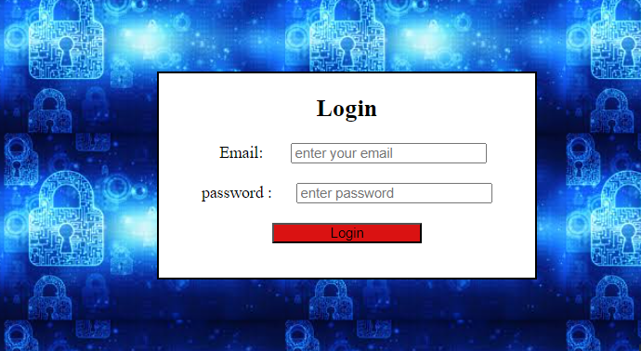

**Sign-Up PAGE:**

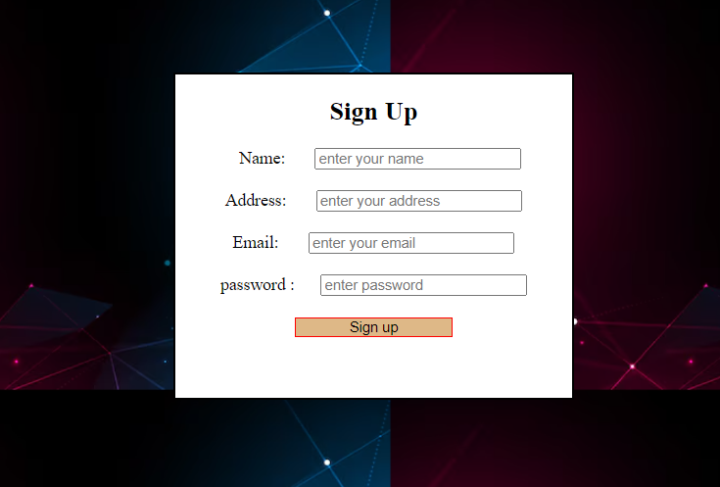

**Home PAGE:**



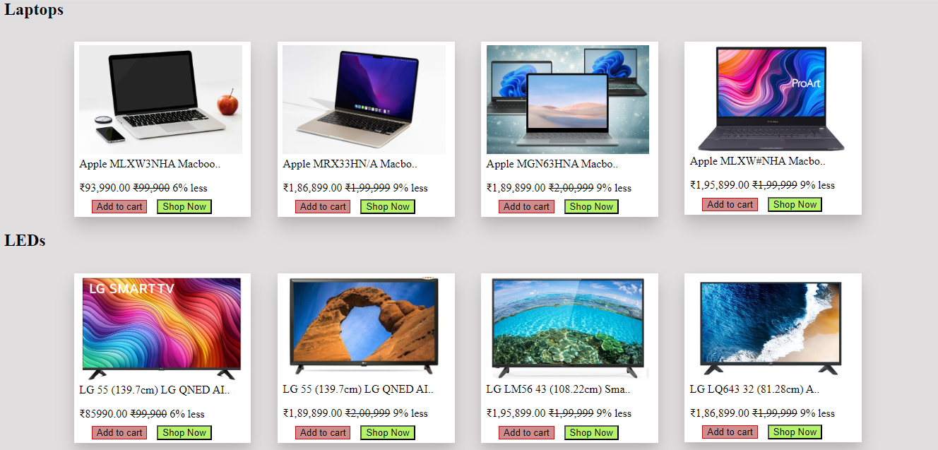



**5.2 Database Design**

**5.2.1 User login table**

* 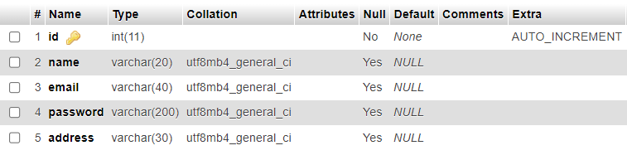The system will have several tables including users those are login into this website.

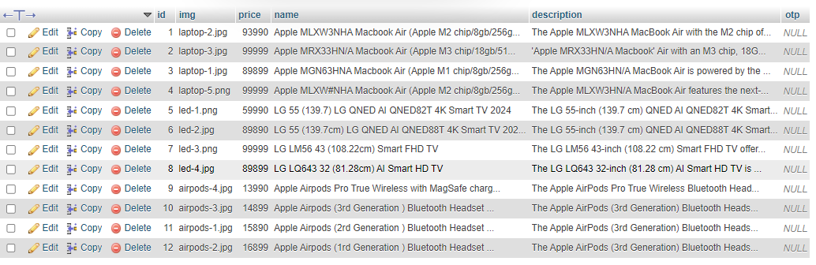**5.2.2 Images Table**

**5.3 0-DFD**

Store Management

Sales Management

Purchasing Management

Customer Management

Payment Management

Product Management

**6. Non-functional Requirements**

This section outlines the non-functional requirements of the Online Electronic Store, which focus on the performance, reliability, and other operational characteristics of the system. These requirements ensure that the system functions smoothly under various conditions and provides a satisfactory user experience.

**6.1 Performance**

* **Overview:** Performance is a critical aspect of the Online Electronic Store. It directly affects user satisfaction, conversion rates, and overall system efficiency. The system must be designed to perform well under normal and peak traffic conditions, maintaining speed and responsiveness.
* **Feature Details:**
  1. **Concurrent User Handling:**
     + The system should be able to handle up to 100 concurrent users without significant degradation in performance. This means that while 100 users are browsing the store, adding items to their cart, and making purchases simultaneously, the system should maintain optimal speed and responsiveness.
     + Performance degradation refers to situations where the system’s response time becomes noticeably slower, such as delays in page loading, product search, checkout processes, or payment confirmation. To avoid this, the system must be optimized for concurrency, with proper load balancing and resource allocation.

**2. Response Time:**

* Under normal operating conditions (i.e., with fewer than 100 concurrent users), the system should aim for a response time of under 3 seconds for page loads. This includes product catalog pages, individual product detail pages, search results, and the checkout process.
* For key operations like adding items to the cart, submitting forms, and processing payments, the response time should be even faster, ideally under 1.5 seconds. Faster response times are critical for ensuring smooth user interactions and reducing the likelihood of cart abandonment.

**6.2 Reliability**

* **Overview:** Reliability is crucial for ensuring that the Online Electronic Store is accessible and functional for customers at all times. The system’s reliability will be measured by its uptime, failure recovery mechanisms, and its ability to handle errors gracefully without affecting user experience.
* **Feature Details:**
  1. **System Uptime:**
     + The system should be available 99% of the time, which translates to a maximum allowable downtime of approximately 7 hours and 18 minutes per month. This high availability requirement ensures that users can access the store and complete transactions without unexpected interruptions.
     + To achieve this level of uptime, the system will be hosted on a robust, fault-tolerant infrastructure. This includes utilizing redundant servers, failover systems, and backup data centers. In the event of hardware failure, traffic will be rerouted to backup servers to ensure continuous service availability.

**2. Error Handling:**

* The system will implement robust error-handling mechanisms to manage both user and server-side errors. For example, if a user encounters a payment error or a page fails to load due to a temporary issue, the system will display a user-friendly error message rather than a cryptic error code.
* All errors will be logged with detailed information that can assist in diagnosing and resolving the issue. In critical situations, automated alerts will notify the system administrators to take immediate action.

**7. Testing**

This section outlines the various types of testing that will be conducted to ensure the functionality, usability, security, and overall quality of the Online Electronic Store. Testing will be performed at multiple stages of development and will cover all critical aspects of the system, including functionality, user experience, security, and performance.

**7.1 Functional Testing**

* **Overview:** Functional testing focuses on verifying that all features of the Online Electronic Store work as expected. This includes testing individual components (unit testing), their interactions (integration testing), and the system as a whole (system testing).
* **Feature Details:**
  1. **Product Search Functionality:**
     + Functional testing will verify that the product search feature works as intended. This includes ensuring that users can search for products using keywords, categories, and filters (e.g., price range, brand, availability).
     + The search results should be accurate, relevant, and sorted correctly based on user preferences or default settings (e.g., relevance, price, popularity).
     + Testing will also cover edge cases, such as searching for products that do not exist in the database, handling special characters, and dealing with misspelled search terms.

**2. Payment Gateway Integration:**

* The payment gateway will be thoroughly tested to ensure that it processes payments securely and accurately. Different payment methods (e.g., credit cards, PayPal, digital wallets) will be tested to ensure compatibility.
* Functional testing will verify that payment confirmation pages display accurate transaction details and that users receive appropriate email notifications for successful and failed transactions.

**3. User Authentication:**

* The login and registration features will be validated to ensure that users can create accounts, log in with correct credentials, and receive appropriate error messages for incorrect credentials.
* Functional testing will also ensure that password recovery, account activation, and logout features work correctly and securely.

**7.2 Usability Testing**

* **Overview:** Usability testing focuses on evaluating the user interface (UI) and user experience (UX) of the Online Electronic Store. The goal is to ensure that the system is intuitive, easy to navigate, and provides a positive experience for users across different devices and platforms.
* **Feature Details:**
  1. **User-Friendly Navigation:**
     + Usability testing will be conducted to ensure that users can easily navigate through the website. This includes testing the effectiveness of the menu structure, search functionality, product categorization, and the checkout flow.
     + Testers will assess the overall ease of use for new and returning users, ensuring that important tasks (e.g., searching for products, viewing product details, adding items to the cart, completing purchases) can be completed without confusion or unnecessary steps.

2. **Responsive Design Testing:**

* The responsiveness of the website will be tested across various devices (desktops, laptops, tablets, and smartphones) to ensure that the layout adapts correctly to different screen sizes and orientations. Usability testing will also ensure that touch-based interactions on mobile devices are intuitive and functional.
* The focus will be on ensuring that users have a seamless experience, regardless of the device they use, with no compromise in functionality or accessibility.

**7.3 Security Testing**

* **Overview:** Security testing is critical to protect the Online Electronic Store from potential threats, including data breaches, unauthorized access, and fraudulent transactions. Testing will focus on identifying and addressing vulnerabilities, ensuring that sensitive data is handled securely.
* **Feature Details:**
  1. **Secure Payment Processing:**
     + Security testing will ensure that all payment processing is conducted securely using industry-standard encryption and secure communication protocols (e.g., HTTPS). This includes validating the use of SSL/TLS certificates and ensuring that payment information is not stored or transmitted insecurely.
     + Payment gateways will be tested for compliance with the Payment Card Industry Data Security Standard (PCI DSS) to ensure that customer payment data is protected against fraud or theft.

**2. Authentication and Authorization Testing:**

* Security tests will be conducted to ensure that only authorized users can access their accounts and perform sensitive actions (e.g., making purchases, viewing order history, managing account details). This includes testing login functionality, password recovery mechanisms, and account lockout after repeated failed login attempts.
* Security testing will also ensure that user roles (e.g., customers, administrators) are correctly enforced, and that unauthorized users cannot access restricted areas of the website.

3. **Data Protection:**

* Security tests will verify that personal and sensitive information (e.g., usernames, passwords, credit card details) is encrypted both in transit and at rest. Testing will also assess the system’s ability to securely store user data, ensuring that databases and other storage systems are protected from unauthorized access.
* Penetration testing will be conducted to identify and fix vulnerabilities that could expose user data to hackers. This includes testing for common attack vectors such as SQL injection, cross-site scripting (XSS), and cross-site request forgery (CSRF).

4. **Session Management:** Security testing will ensure that user sessions are managed securely, preventing session hijacking, fixation, or other attacks. This includes testing the use of secure cookies, proper session timeout mechanisms, and ensuring that users are properly logged out after completing sensitive actions (e.g., changing passwords).