# Project Progress Report-1

# (Submission Date: 18 Feb 2019)

# **FACE RECOGNITION SYSTEM**

**BACHELOR OF ENGINEERING**

**IN**

**COMPUTER SCIENCE & ENGINEERING**



**Submitted By: Name of the Mentor: -**

**ATUL SHARMA (17BCS2268) ER. SONAM KHATTAR**

**AASHISH SIDDHARTH JHA(17BCS2270) SUBMITTED TO: ADITYA MATHUR(17BCS2275) ER. RAJKUMARER /**

**ER.HARMANPREET**

**DEPARTMENT OF COMPUTER SCIENCE & ENGINEERING**

**Chandigarh University, Gharuan**

1. **Project Goal**

Facial recognition is a biometric software application capable of uniquely identifying or verifying a person by comparing and analyzing patterns based on the person's facial contours. Facialrecognition is mostly used for security purposes, though there is increasing interest in other areas of use.

It will compare the information with a database of known faces to find a match. Facial recognition will help verify personal identity, but **it** also raises privacy issues. That's because facial recognition has all kinds of commercial applications. It can be used for everything from surveillance to marketing

1. **Project Work Done Till 18th Feb, 2019**

The team has created the basic algorithm for the project to work on .The algorithm is currently being converted into code using python compiler. We are learning the concepts of machine learning techniques especially classification machine learning techniques which based on our project.

We are learning python programming language and we are also going towards the advanced topics.

We are still finding the best data set suitable for our project.

* 1. **Working Model of the Project (Methodology Diagram)**

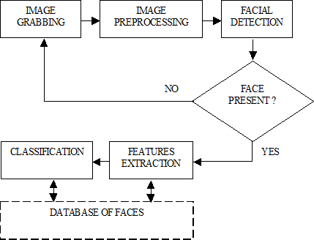

Fig 1.1-: Flow chart for facial recognition System.

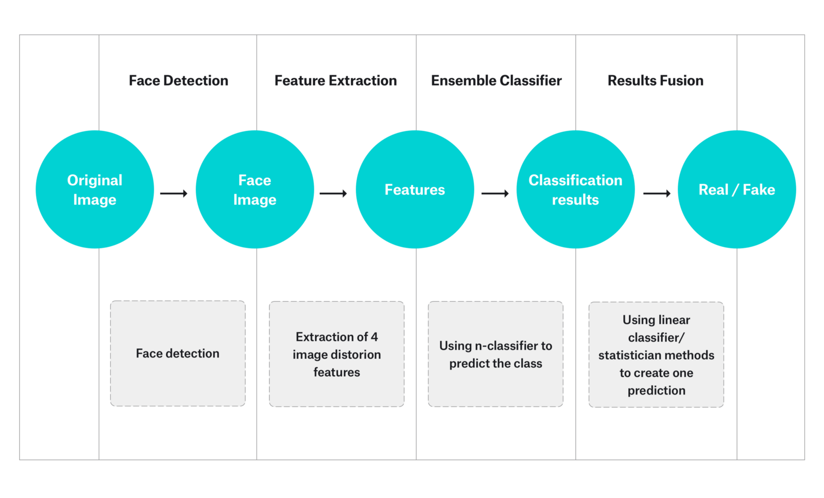

Fig 1.2-: Block diagram for facial recognition system.

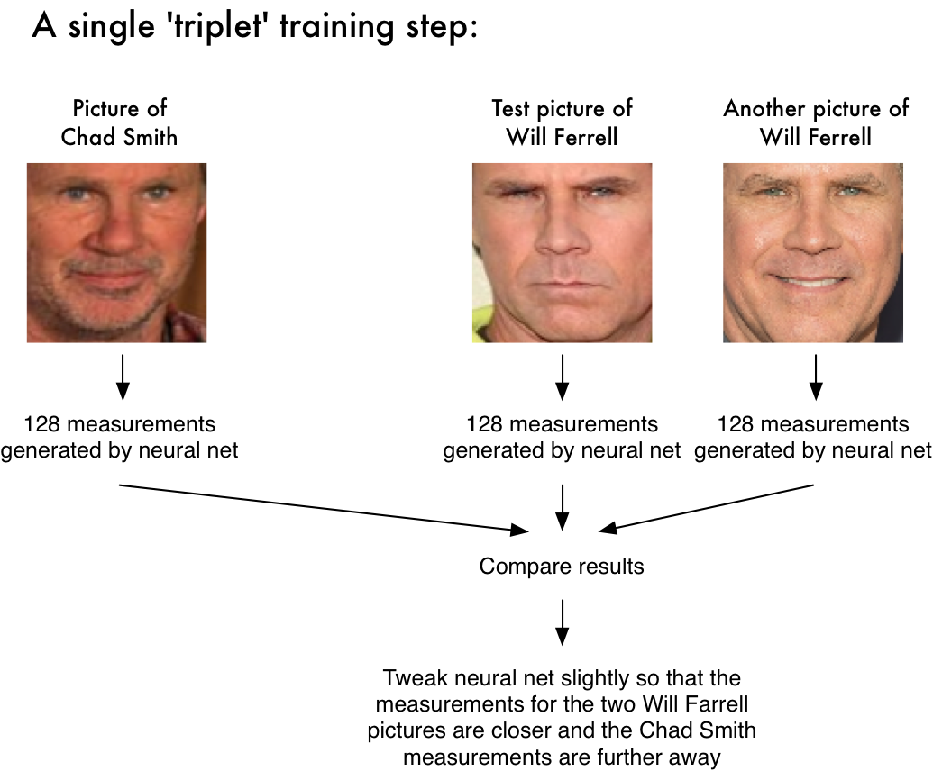

1. **Total number of phases/modules in the project**

There are 3 modules in this project. Datasets , training , face recognition

1. **Number of Modules Covered till Date**

We have Covered Two modules till 18th Feb, 2019.

The Covered Modules are the following:

1. Planning and Statically Distribution of work
2. A nearly half implementation of our work.

**5.Description of Covered Modules**

**1.Planning and Statically Distribution of work: -**

In this phase all the members of the team equally do their homework and do some research on their topics given to them.

* 17BCS2269: - Read Research papers, case study and journals on Deep learning to understand the problem briefly. To understand the algorithms based on classification which is a deep learning technique.
* 17BCS2270-: - Help in finding the correct algorithm to solve the problem of the project.

17BCS2275: - Help in finding and analysis of the problem.

**2. Designing Phase: -**

All three members will be assigned different module for coding and then finally integrating the modules to make the final product.

Website will be developed by the UID’s 17BCS2268 and 17BCS2275. Algorithm by 17BCS2270

**Screen Shots of the Working Project till 18th Feb**

