**Project Progress Report – 2**

(Submission Date: 4 March 2019)

**Face Recognition System**

BACHELOR OF ENGINEERING

IN

COMPUTER SCIENCE & ENGINEERING



Submitted by: Mentor:

Atul Sharma (17BCS2268) Er. Sonam Khattar

Aditya Mathur (17BCS2275) Submitted to:

Aashish Siddharth Jha(17BCS2270) Er.Rajkumar/Er.HARAMANPREET

**DEPARTMENT OF COMPUTER SCIENCE & ENGINEERING**

**CHANDIGARH UNIVERSITY, GHARUAN**

**1.Objectives (Covered Till 3rd March)**

* Base source code of the project has been completed and compiled.
* Two additional libraries to perform the face recognition with python and OpenCV has been installed that is “dlib” and face_recognition respectively.

**2.Status of the project**

**2.1Number of Modules Covered till 3rd March**

We have Covered 3 modules till 3rd March, 2019.

The Covered Modules are the following:

**1.Planning and Statically Distribution of work**

* In this phase all the members of the team equally do their homework and do some research on their topics given to them.
* 17BCS2275: - Read Research papers, case study and journals on deep learning to understand the problem briefly. To understand the algorithms based on classification which is a machine learning technique.
* 17BCS2270: - Help in finding the correct algorithm to solve the problem of the project and read case study and journals on OpenCV .
* 17BCS2268: - Help in finding and analysis of the problem and study about python.

**2.Designing Phase**

* All three members will be assigned different module for coding and then finally integrating the modules to make the final product.
* The base program has been developed and compiled by the UID’s 17BCS2270 and 17BCS2275.
* The installation of the libraries in the project and connection to the base program has been performed by 17BCS2268

**3.Coding Phase (Only Sanitizing of Data Set)**

* It will be more understandable in the Screenshot topic.

1. **Screenshots of running projects till 3rd March**



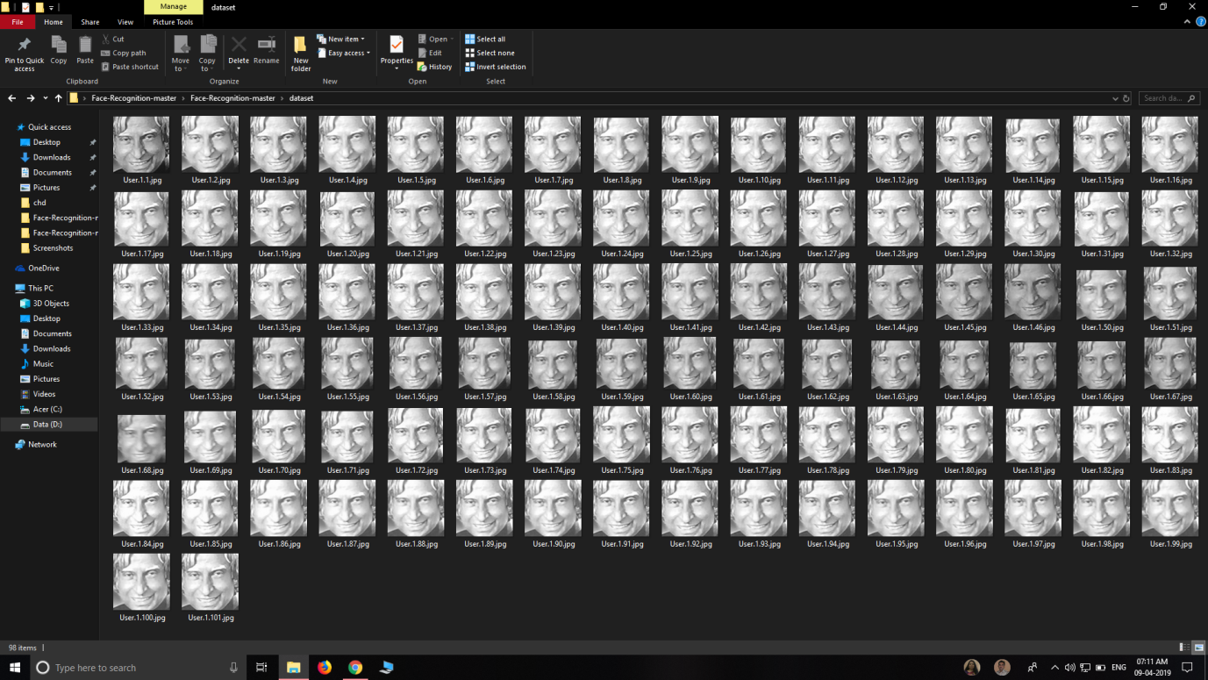

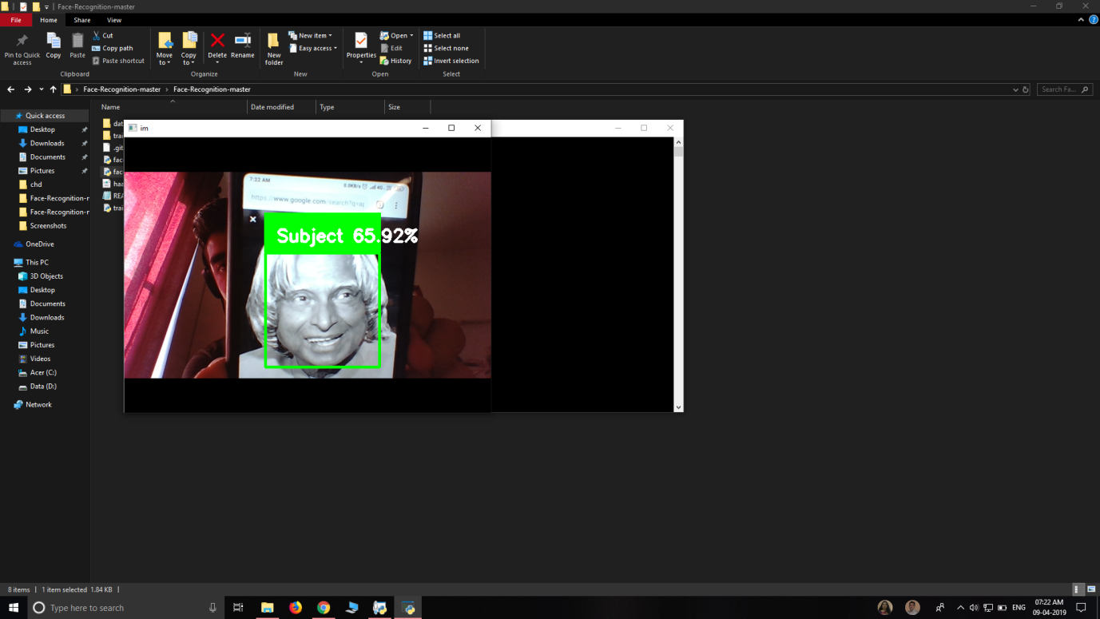

**4.Pending work details**

* Making software more interactive
* Making the dataset more effective
* Making the Coding part of the Algorithm