# Chapter 4 IMPLEMENTATION

## 4.1 Introduction

Implementation/Coding starts once the developer gets the Design document. The Software design is translated into source code. All the components of the software are implemented in this phase. After the completion of gathering of the required design, analysis we proceed further to this process.

## 4.2 Programming Language

For Tic Tac Toe, I have chosen Java as it programming language. Java is a simple and effective programming language for the development of any application.



Java is a popular general-purpose programming language and computing platform. It is fast, reliable, and secure. According to Oracle, the company that owns Java, Java runs on 3 billion devices worldwide.

## 4.3 Design and Framework

I have used Android Studio as its working framework for the development of the Tic Tac Toe application.

As for the design pattern, I have used MVC design pattern.

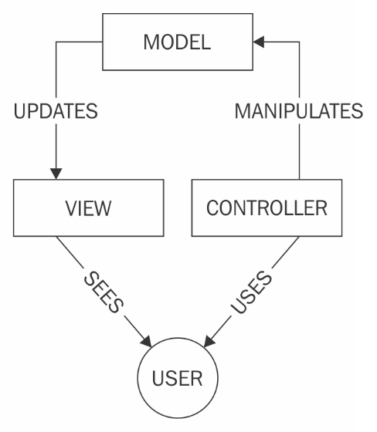

MVC Design Pattern is used to separate the logic of different layers in a program in independent units.

## 4.4 Tools used

Operating System: Windows 8.1

Tools I have used for the implementation of the system:

Android Studio

DB Browser SQLite