# 3. Design Introduction

The Design phase describes how the system fulfils the user requirements. For the achievement of user requirement, we need create both logical and physical design. In this phase the systems design functions and operations are described in detail, including storyboard and screen layouts with annotations, business rules, process diagrams and other documentation.

For Tic Tac Toe Game, I have created Structural and Behavior Modelling diagram in the following way.

# 3.1 Structural Modelling

“A structure diagram is a conceptual modeling tool used to document the different structures that make up a system such as a database or an application.”

For Tic Tac Toe Game, in the part of Structural Model, I have created Context Diagram and Class Diagram.

The context diagram of a vision document is a simple diagram that shows the source systems contributing data to a DW/BI system, as well as the major user constituents and downstream information systems that is supports.

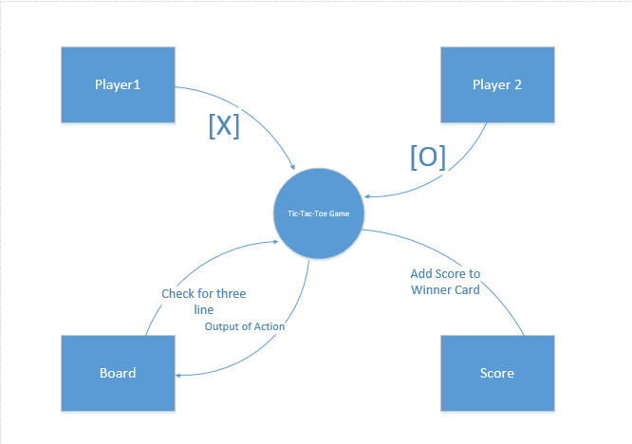

Fig: Context Diagram Tic-Tac-Toe Game

Here I have drawn Context Diagram with the help of Visio. In the context diagram I have shown the functionality of the overall system.

# 3.1.1 Class Diagram

# 3.2 Behavior Modelling

# 3.2.1 Activity Diagram

Activity Diagram is important behavioral diagram which is used to describe dynamic aspects of the system. For Tic Tac Toe Game I have created the diagrams.

Notations used in Activity Diagram

Notation Description UML Notation

|  |  |  |
| --- | --- | --- |
| **Name** | **Description** | **Diagram** |
| **Activity** | Is used to represent a set of actions | Activity Diagram Notation - Activity |
| **Action** | A task to be performed | Activity Diagram Notation - Action |
| **Control Flow** | Shows the sequence of execution | Activity Diagram Notation - Control Flow |
| **Object Flow** | Show the flow of an object from one activity (or action) to another activity (or action). | Activity Diagram Notation - Object Flow |
| **Initial Node** | Portrays the beginning of a set of actions or activities | Activity Diagram Notation - Initial Node |
| **Activity Final Node** | Stop all control flows and object flows in an activity (or action) | Activity Diagram Notation - Activity Final Node |
| **Decision Node** | Represent a test condition to ensure that the control flow or object flow only goes down one path | Activity Diagram Notation - Decision Node |
| **Swimlane and Partition** | A way to group activities performed by the same actor on an activity diagram or to group activities in a single thread | Activity Diagram Notation - Swimlane and Partition |

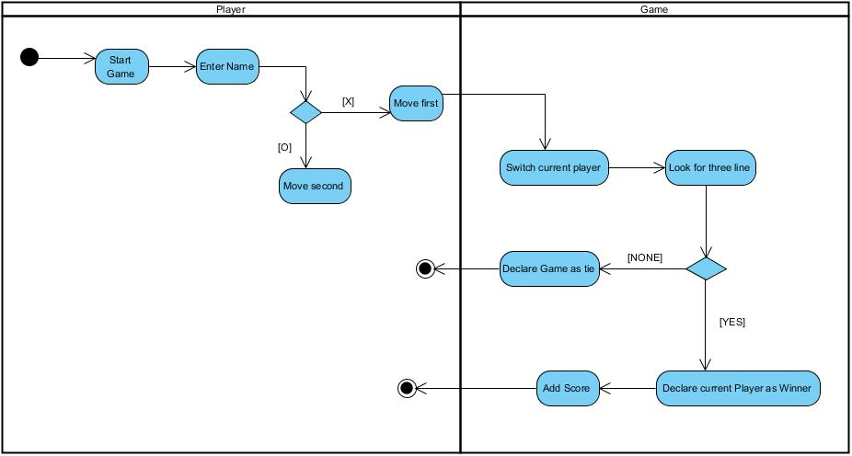

Fig: System Activity Diagram

System Activity Diagram shows the overall functions of the Tic Tac Toe Game. Starting from the player, at first where he/she enters the name then further proceeds to play the game where there are Xs and Os. The turn by turn move from the player are on the board. In the system, there is Boolean that checks whether the is three line or not. And if yes, then there is addition of the winner score and the game is in the initial phase.

# 3.2.2 Sequence Diagram

Sequence Diagrams are interaction diagrams that detail how operations are carried out. They capture the interaction between objects in the context of a collaboration.

Notations used in Sequence Diagram

|  |  |  |
| --- | --- | --- |
| **Name** | **Description** | **Diagram** |
| **Actor** | An actor does not necessarily represent a specific physical entity but merely a particular role of some entity | Actor |
| **Lifeline** | A lifeline represents an individual participant in the Interaction. | Lifeline |
| **Activations** | A thin rectangle on a lifeline) represents the period during which an element is performing an operation. | Activation |
| **Call Message** | A message defines a particular communication between Lifelines of an Interaction. | Call Message |
| **Return Message** | Call message is a kind of message that represents an invocation of operation of target lifeline. | Return Message |

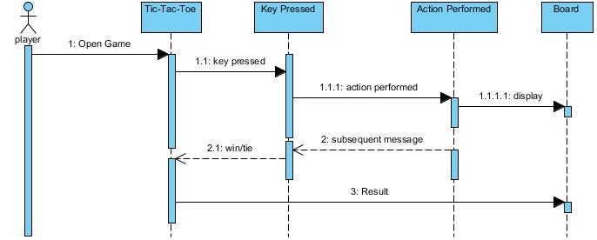

Fig: System Sequence Diagram

This the representation of the overall system sequence. This system sequence diagram shows the functionality sequence of the system. At first where player enters the name then further proceeds to play the game where there are Xs and Os. The turn by turn move from the player are on the board. In the system, there is Boolean that checks whether the is three line or not. And if yes, then there is addition of the winner score and the game is in the initial phase.

# 3.3 Database Modelling

Data modeling is the process of creating a data model for the data to be stored in a Database. This data model is a conceptual representation of

1. Data objects
2. The associations between different data objects
3. The rules.

# 3.3.1 Data Dictionary

A data dictionary is a file or a set of files that contains a database's metadata. The data dictionary contains records about other objects in the database, such as data ownership, data relationships to other objects, and other data.

Here for Tic Tac Toe Game I have created the following Data Dictionary.

**Text View**

|  |  |  |  |  |
| --- | --- | --- | --- | --- |
| **Field Name** | **Data Type** | **Field Length** | **Constraint** | **Description** |
| Id | varchar | 20 | Primary key | Id of Text view |
| layout_width | Int | 10 | Not null | Width of layout |
| layout_height | Int | 10 | Not null | height of layout |
| text | Varchar | 50 | Not null | Text field |
| textsize | Int | 10 | Not null | Size of text |

**Relative Layout**

|  |  |  |  |  |
| --- | --- | --- | --- | --- |
| **Field Name** | **Data Type** | **Field Length** | **Constraint** | **Description** |
| layout_width | Int | 10 | Not null | Width of layout |
| layout_height | Int | 10 | Not null | height of layout |

**Button**

|  |  |  |  |  |
| --- | --- | --- | --- | --- |
| **Field Name** | **Data Type** | **Field Length** | **Constraint** | **Description** |
| Id | varchar | 20 | Primary key | Id of Text view |
| layout_width | Int | 10 | Not null | Width of layout |
| layout_height | Int | 10 | Not null | height of layout |
| layout_alignparentend | Int | 10 | Not null | Layout align |
| layout_centervertical | Int | 10 | Not null | Center alignment |
| layout_marginend | Int | 10 | Not null | Layout margin end |

**Linear Layout**

|  |  |  |  |  |
| --- | --- | --- | --- | --- |
| **Field Name** | **Data Type** | **Field Length** | **Constraint** | **Description** |
| layout_width | Int | 10 | Not null | Width of layout |
| layout_height | Int | 10 | Not null | height of layout |

**User**

|  |  |  |  |  |
| --- | --- | --- | --- | --- |
| **Field Name** | **Data Type** | **Field Length** | **Constraint** | **Description** |
| Player1_name | Varchar | 20 | Not null | Player name |
| Player2_name | varchar | 20 | Not null | Player name |

# 3.3.2 ER Diagram

Here is the ER diagram I have created for Tic Tac Toe Game

fig:ER Diagram

# 3.4 Prototype

Here is the prototype I have created for Tic-Tac-Toe Game.

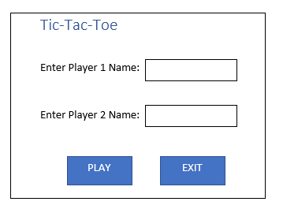

Fig: Tic-Tac-Toe Prototype-1

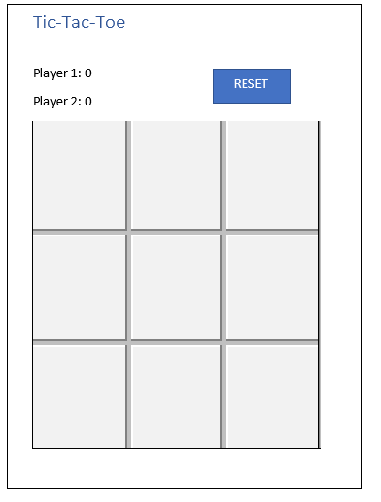

Fig: Tic-Tac-Toe Prototype-2

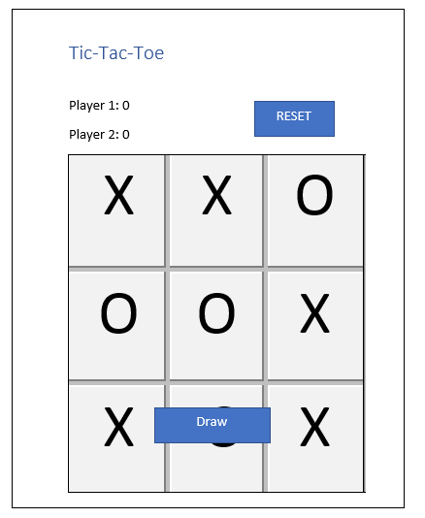

Fig: Tic-Tac-Toe Prototype-3

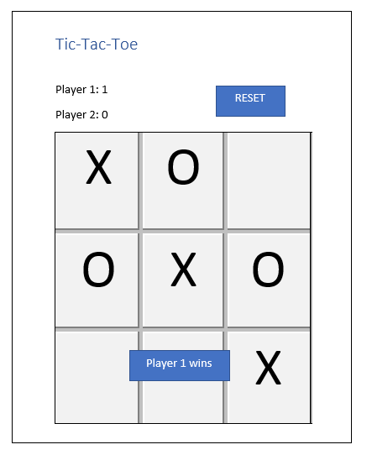

Fig: Tic-Tac-Toe Prototype-4

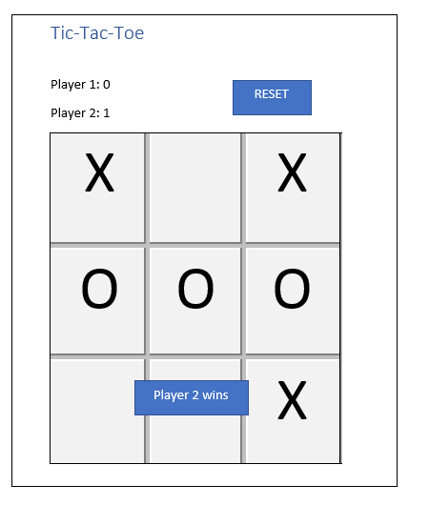

Fig: Tic-Tac-Toe Prototype-5

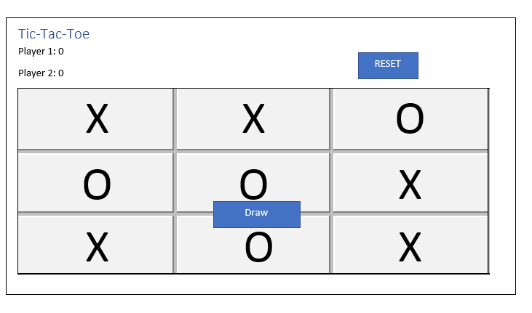

Fig: Tic-Tac-Toe Prototype-6

# CONCLUSION

In this way I have done all the necessary designing of the Tic-Tac-Toe system where it includes Sequence Diagram, Activity Diagram, Context Diagram, Data Dictionary, Prototype and the Data Dictionary.