Health and Fitness Management

System

Arnold Company

Submitted by:

Aashish Nagarkoti

NCCID:00175036

Roll num:02

Softwarica college of IT and E-commerce

Submitted to:

Mr. Sudeep Bajimaya

Module: CP

Softwarica college of IT and E- commerce

# Introduction

## Project Intro

Health and fitness play a vital part in our day to day life. In order to be healthy, one should be active and have healthy food habit. Being healthy is not an option. We need to eat healthy. We are well familiar with “Prevention Is Better Than Cure”, which means, before we are attacked by any disease, we can prevent it by being healthy.

In the current state of the world, it would be easier to get access of the need via online.so the main goal of this project is to create an online platform where people are able to access healthy lifestyle such as workout program, balanced diet chart.

## Project Background

People nowadays are more interested towards online forums and its benefices. So, with that aspect as a major factor this Health and Fitness Management System is created as online site which is easily accessible by people.

## Problem Statement-Description

Health and Fitness Management System is an online site where people are able to access stuff regarding healthy lifestyle, balanced diet, macro nutrients and micro nutrients, workout plans and fitness programs. Information on-the-go is appreciated way more and it’s efficient too. Time is valuable. Thus, an online site will save a lot of time. That’s exactly what Health and Fitness Management System does.

## Features

Health and Fitness Management System has lots of features for the interested candidates. Fitness is the key to long healthy life. Our site effectively helps people to achieve their fitness goals. There are numerous programs with respect to different people and their interest. With the help of this site people can get the required information regarding their fitness goal, healthy lifestyle, eating habits on-the-go.

## Overview

As mention above Health and Fitness Management System will be a great aid to the individual depending upon their goals. Being healthy is the main motto of this project.

# SCOPE

Health and fitness play a vital role in our day to day life activities. The aim of this project is to create site which is easily accessible by people for their own benefits. In order to be healthy, we need to eat healthy plus we need to exercise as well. Both the diet and exercise part will be focused by this project. Every individual can use this website with an ease. Many health and fitness center can use this site for their own advantages. For people who are unable to afford Personal Trainers, Health and Fitness Management System is highly recommended. People, who are looking forward to transform themselves can take huge help from this project.

## AIMS

1. To provide health related content anywhere.
2. To educate people on healthy lifestyle
3. To motivate everyone to workout
4. To prevent illness and diseases

## OBJECTIVES

1. To enable to login anywhere
2. To provides knowledge regarding nutrients
3. To provide free workout plans
4. To enable fitness forums accessible anywhere
5. To improve gymnasium skills and knowledge
6. Make unfit people fit
7. Make a transformation within people
8. To enable different effective workout plans
9. Bring awareness among the people
10. To bring the best in the people.

## Limitations

1. This project is accessible online only.
2. Only authorized personnel are able to make changes in the schedule and workout plan.

## OVERVIEW

Thus, as mentioned above, Health and Fitness Management System will help people to achieve their fitness goals, be healthy and active in day to day activities. From balanced diet to work-out plans for different fitness levels are included in Health and Fitness Management System.

# DEVELOPMENT METHODOLOGY

For the development of this project, I am going to use Waterfall Model.

Waterfall model is a traditional way of describing the development of the any software, project. This methodology explains the progress of the system in a linear flow with a specified sequence for understanding that the further level is made progressive on completion of the previous one.

## Description

Advantages of the waterfall methodology:

1. Very simple and easy to understand
2. Easily manageable due to rigidity of the model
3. Saves significant amount of time
4. This allows for easy testing and analysis

I have not chosen Waterfall methodology over other methodologies like Agile because:

1. Developers and customers agree on what will be delivered early in the development lifecycle. This makes planning and designing more straightforward while in Agile very high degree of customer involvement is required which May present problem for some customers.(**Our Project is quite simple with proper level of understanding on requirement of customer.**)
2. Progress is more easily measured, as the full scope of the work is known in advance in Waterfall while Agile focuses on time-boxed delivery and frequent reprioritization, it’s possible that some items set for delivery will not be completed within the allotted timeframe. (**this project must be completed within given timeframe which is aid by Waterfall method.**)

## Design pattern

For the development of the project I am using MVC (Model View Control)

“It is a software architectural pattern for implementing user interfaces on computers. It divides a given software application into three interconnected parts, so as to separate internal representations of information from the ways that information is presented to or accepted from the user.”

1. Model

A model is data used by a program. This May be a database, file, or a simple object.

2. View

A view is the means of displaying objects within an application.

3. Controller

A controller updates both models and views. It accepts input and performs the corresponding update.

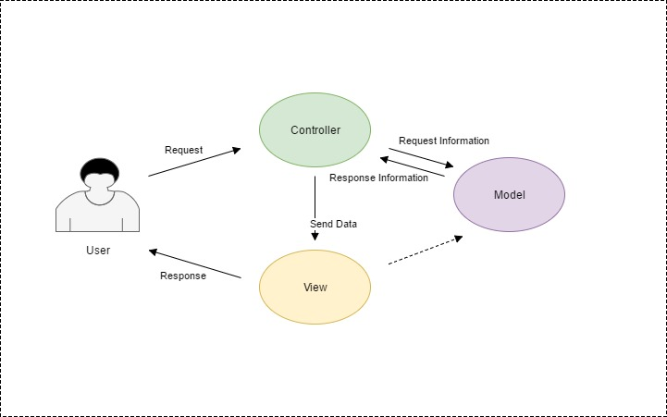

Fig: MVC Design Pattern

## Why??

I have used MVC design pattern than other design pattern since, the aim of the project is quite simple regarding Client-Server connection which is thoroughly maintained in MVC design pattern. Client-Server design pattern is the key for development of this project.

## Architecture

For the development of this project I have chosen Three-tier method.

The 3-tier architecture is a type of software architecture which is composed of three “tiers” or “layers” of logical computing. 3-tier architectures provide many benefits for production and development environments by modularizing the user interface, business logic, and data storage layers.

3-tier means:

**A Presentation Layer** that sends content to browsers in the form of HTML/JS/CSS. This might leverage frameworks like React, Angular, Ember, Aurora, etc.

**An Application Layer** that uses an application server and processes the business logic for the application. This might be written in C#, Java, C++, Python, Ruby, etc.

**A Data Layer** which is a database management system that provides access to application data. This could be MSSQL, MySQL, Oracle, or PostgreSQL, Mongo, etc.

Advantages of using 3-tier architecture:

gives us the ability to update the technology stack of one tier, without impacting other areas of the application.

Allows for different development teams to each work on their own areas of expertise

able to scale the application up and out

adds reliability and more independence of the underlying servers or services.

Provides an ease of maintenance of the code base, managing presentation code and business logic separately.

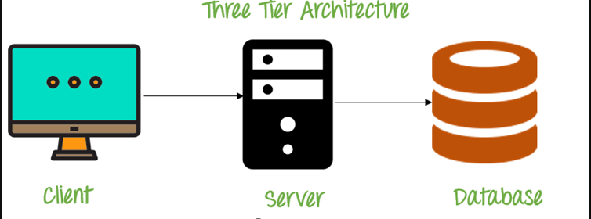

Fig: Three-tier Architecture

## Why???

Three-tier Architecture is perfect architecture required for the development of this project. I am developing this project HTML/CSS, JavaScript and MYSQL as its database. Three-tier architecture holds the perfect balance among these than other architecture for this project.

# PROJECT PLANNING

## Work Breakdown Structure

A work breakdown structure (WBS) is a key project deliverable that organizes the team's work into manageable sections. The work breakdown structure visually defines the scope into manageable chunks that a project team can understand, as each level of the work breakdown structure provides further definition and detail.

Fig: WBS (Work Breakdown Structure)

## MILESTONES

|  |  |  |  |
| --- | --- | --- | --- |
| Health and Fitness Management System | | |  |
| S.N | Project Task | Number of Days | Date |
| 1. | Proposal | 16 Days | 25th March -9th April |
|  | * Planning * Brain Storming * Risk Analysis * Config Management | 4 days  4 days  4 days  4 days | 25th March-28th March  29th March-1st April  2nd April-5th April  6th April- 9th April |
| 2. | Analysis   * Requirement Analysis * Feasibility Study * Problem Study | 29 Days  10 days  9 days  10 days | 10th April- 8th May  10th April-19th April  20th April-28th April  29th April-8th May |
| 3. | Design   * Structural Model * Design Analysis * Design Feasibility | 26 Days  9 days  9 days  8 days | 9th May-3rd June  9th May-17th May  18th May-26th May  27th May-3rd June |
|  | Implementation   * System Implementation | 21 Days  21 | 4th June-24th June  4th June-24th June |
| 5.  6. | Test   * System Testing   Other Project Requirements | 7 Days  7 days  11 Days | 25th June -1st July  25th June -1st July  2nd July-12th July |
|  | TOTAL Days |  |  |

Fig: Milestone

As mention in above table I will be completing my respective task in the designated timeframe.

For the completion of Proposal, we are given 16 days, where I have allocated task like planning, brain-storming and risk analysis.

For the completion of Analysis, we are given 29 days, where I have allocated task like requirement analysis, Feasibility study and problem study.

For the completion of Design, we are given 26 days, where I have allocated task like Structural model, design analysis and design feasibility.

For the completion of Implementation, we are given 21 days, where I have allocated task like System Implementation (coding).

For the completion of Test, we are given 7 days, where I have allocated task like System testing.

For other needs of the project we are given 1 days of time period where miscellaneous task will be done.

## Gantt Chart

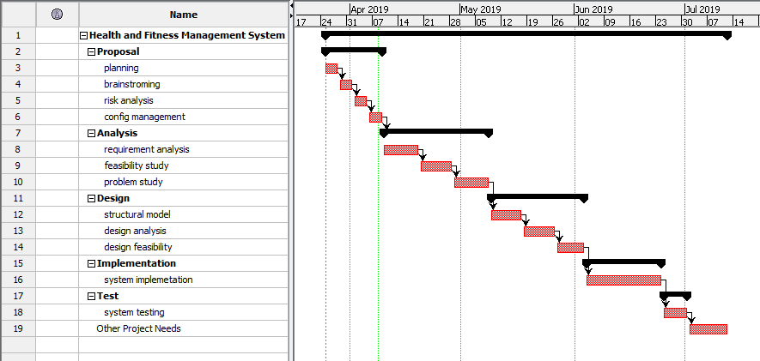

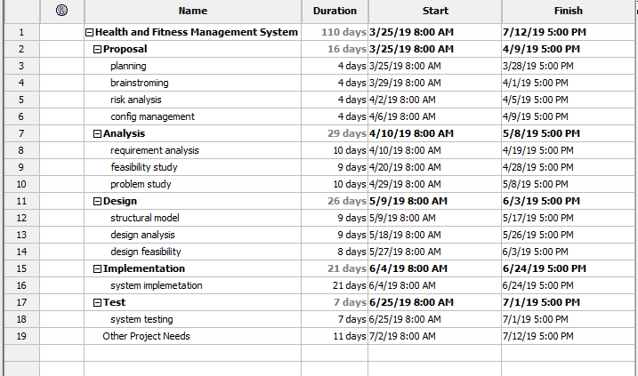

# RISK MANAGEMENT

Risk management is defined as the process of identifying, monitoring and managing potential risks in order to minimize the negative impact they may have on an organization, project, on-going development task.

Life Cycle of Risk Management

The life of Risk Management has these which are actually a cycle:

1. Establish the Context

2. Identification

3. Assessment

4. Potential Risk Treatments

5. Create the Plan

6. Implementation

7. Review and Evaluation of the Plan

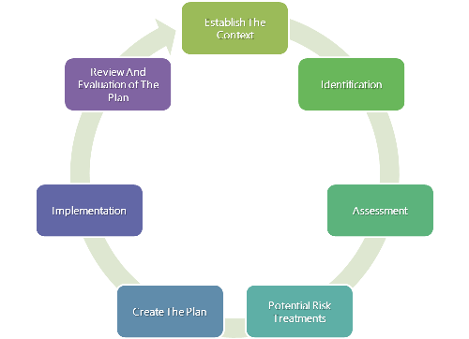

Fig: Risk Management Lifecycle

|  |  |
| --- | --- |
| LIKELIHOOD | VALUE |
| Low | 1 |
| Medium | 2 |
| High | 3 |

|  |  |
| --- | --- |
| Consequence | Value |
| Very low | 1 |
| Low | 2 |
| Medium | 3 |
| High | 4 |
| Very high | 5 |

|  |  |  |  |  |  |  |
| --- | --- | --- | --- | --- | --- | --- |
| **S. N** | **Risk** | **Likelihood** | **Consequence** | **Impact** | **Action** | **Remark** |
| 1. | Broken Authentication | 2 | 4 | 8 | Authentication should be implemented correctly. |  |
| 2. | Server crash | 1 | 2 | 2 | Established connection should be maintained. |  |
| 3. | Data security | 1 | 4 | 4 | Data Back-up should be considered on serious note. |  |
| 4. | Security Misconfiguration | 1 | 5 | 5 | Security must have a secure configuration defined and deployed for the application. |  |
| 5. | Insufficient Transport Layer Protection | 2 | 5 | 10 | Authenticate, encrypt, and protect the confidentiality and integrity of sensitive network traffic. |  |
| 6. | Malware | 1 | 3 | 3 | Anti-malware must be used in the system. |  |
| 7. | Session Hijacking | 1 | 4 | 4 | Proper training on the use of the web. |  |
| 8. | SQL Injection | 2 | 4 | 8 | Security scans should be performed from time to time. |  |

# Configuration Management

# Conclusion

In this way I have complete this proposal where I have used Waterfall as its development methodology, MVC as its design pattern and Three-tier Architecture as its development architecture.

# Reference and Bibliography

<https://acodez.in/12-best-software-development-methodologies-pros-cons/#Waterfall_Model>

<https://www.jinfonet.com/resources/bi-defined/3-tier-architecture-complete-overview/>

<https://www.izenda.com/5-benefits-3-tier-architecture/>

<https://www.workbreakdownstructure.com/>

<https://iedunote.com/risk-management>

<https://www.manageengine.com/products/asset-explorer/it-asset-life-cycle-management.html>

<https://www.interserver.net/tips/kb/mvc-advantages-disadvantages-mvc/>

<https://techterms.com/definition/mvc>

<https://www.seguetech.com/waterfall-vs-agile-methodology/>