BABU BANARASI DAS
UNIVERSITY
2026-2027
SCHOOL OF COMPUTER APPLICATIONS
NoSQL Project On
Movie Ticket Booking Management System Using MongoDB
Submitted to: Submitted by:
Mr. Harendra Singh Ashish Kumar Maurya
Department: BCA (DS & AI) Roll no:1250258143
Date: 25th September

1. CREATE DATABASE
MongoDB Query:
use CinemaDB
Explanation: Creates or switches to the CinemaDB database.
Output Screenshot:
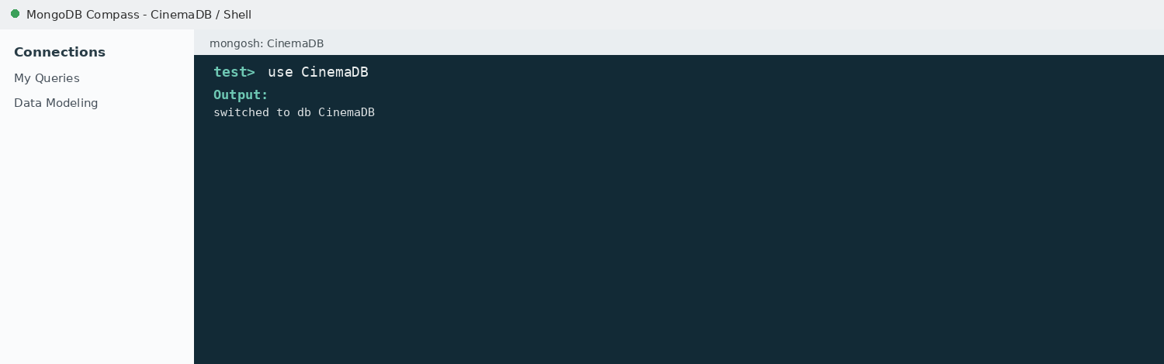

2. CREATE COLLECTION
MongoDB Query:
db.createCollection("bookings")
Explanation: Creates a collection named bookings.
Output Screenshot:
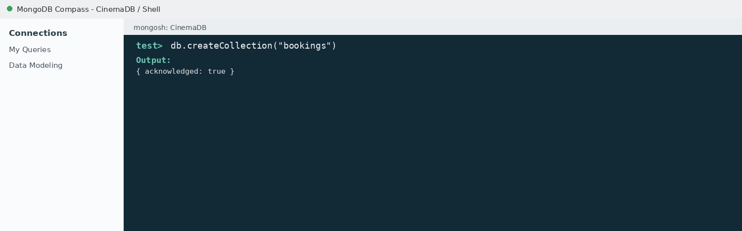

3. INSERT 50 BOOKINGS
MongoDB Query:
db.bookings.insertMany([
{bookingId:1, name:"Aman", age:24, amount:62000, theatre:"PVR Delhi"},
{bookingId:2, name:"Bhumi", age:42, amount:60000, theatre:"INOX Mumbai"},
{bookingId:3, name:"Chetan", age:55, amount:47000, theatre:"INOX Mumbai"},
{bookingId:4, name:"Damini", age:32, amount:44500, theatre:"PVR Delhi"},
{bookingId:5, name:"Eshan", age:19, amount:78000, theatre:"INOX Mumbai"},
{bookingId:6, name:"Falguni", age:33, amount:83000, theatre:"PVR Jaipur"},
{bookingId:7, name:"Gopal", age:41, amount:31000, theatre:"PVR Jaipur"},
{bookingId:8, name:"Harleen", age:50, amount:80000, theatre:"INOX Lucknow"},
{bookingId:9, name:"Ishita", age:21, amount:76000, theatre:"PVR Jaipur"},
{bookingId:10, name:"Jayesh", age:28, amount:48000, theatre:"Cinepolis Pune"},
{bookingId:11, name:"Kajal", age:29, amount:63000, theatre:"INOX Lucknow"},
{bookingId:12, name:"Lavanya", age:54, amount:49500, theatre:"Cinepolis Pune"},
{bookingId:13, name:"Mohit", age:26, amount:92000, theatre:"PVR Delhi"},
{bookingId:14, name:"Naina", age:35, amount:36000, theatre:"INOX Lucknow"},
{bookingId:15, name:"Omkar", age:41, amount:80000, theatre:"INOX Mumbai"},
{bookingId:16, name:"Palak", age:25, amount:66000, theatre:"INOX Mumbai"},
{bookingId:17, name:"Rishabh", age:53, amount:57500, theatre:"PVR Delhi"},
{bookingId:18, name:"Sakshi", age:52, amount:93000, theatre:"INOX Mumbai"},
{bookingId:19, name:"Tushar", age:50, amount:79500, theatre:"PVR Delhi"},
{bookingId:20, name:"Urvashi", age:26, amount:91000, theatre:"PVR Delhi"},
{bookingId:21, name:"Vansh", age:47, amount:56000, theatre:"PVR Jaipur"},
{bookingId:22, name:"Yamini", age:18, amount:53000, theatre:"INOX Lucknow"},
{bookingId:23, name:"Zoya", age:26, amount:94000, theatre:"INOX Mumbai"},
{bookingId:24, name:"Abhay", age:16, amount:63500, theatre:"INOX Mumbai"},
{bookingId:25, name:"Bhaskar", age:47, amount:88000, theatre:"Cinepolis Pune"},
{bookingId:26, name:"Charu", age:40, amount:70500, theatre:"PVR Delhi"},
{bookingId:27, name:"Dhruv", age:31, amount:40000, theatre:"PVR Jaipur"},
{bookingId:28, name:"Eknoor", age:46, amount:69500, theatre:"INOX Mumbai"},
{bookingId:29, name:"Farida", age:39, amount:90000, theatre:"PVR Delhi"},
{bookingId:30, name:"Girish", age:55, amount:66000, theatre:"PVR Delhi"},
{bookingId:31, name:"Heena", age:39, amount:44000, theatre:"INOX Mumbai"},
{bookingId:32, name:"Imran", age:27, amount:84000, theatre:"PVR Jaipur"},
{bookingId:33, name:"Jyoti", age:22, amount:86000, theatre:"INOX Lucknow"},
{bookingId:34, name:"Kunal", age:55, amount:47000, theatre:"INOX Lucknow"},
{bookingId:35, name:"Lakshmi", age:59, amount:47000, theatre:"PVR Delhi"},
{bookingId:36, name:"Madhav", age:58, amount:29000, theatre:"INOX Mumbai"},
{bookingId:37, name:"Nisha", age:23, amount:37000, theatre:"INOX Mumbai"},
{bookingId:38, name:"Onkar", age:47, amount:80000, theatre:"PVR Jaipur"},
{bookingId:39, name:"Prachi", age:21, amount:63500, theatre:"PVR Delhi"},
{bookingId:40, name:"Radhika", age:25, amount:55500, theatre:"INOX Lucknow"},
{bookingId:41, name:"Saurabh", age:16, amount:60000, theatre:"Cinepolis Pune"},
{bookingId:42, name:"Trisha", age:24, amount:69500, theatre:"PVR Jaipur"},
{bookingId:43, name:"Utkarsh", age:29, amount:39500, theatre:"INOX Mumbai"},
{bookingId:44, name:"Vidhi", age:45, amount:52000, theatre:"INOX Lucknow"},
{bookingId:45, name:"Wasim", age:20, amount:25000, theatre:"PVR Delhi"},
{bookingId:46, name:"Yuvraj", age:42, amount:44000, theatre:"Cinepolis Pune"},
{bookingId:47, name:"Zeenat", age:47, amount:39500, theatre:"INOX Mumbai"},
{bookingId:48, name:"Ankit", age:55, amount:84000, theatre:"INOX Mumbai"},
{bookingId:49, name:"Bhawna", age:55, amount:62500, theatre:"PVR Delhi"},
{bookingId:50, name:"Chandan", age:22, amount:43500, theatre:"INOX Mumbai"}
])
Explanation: Inserts multiple booking documents into the collection.
Output Screenshot:
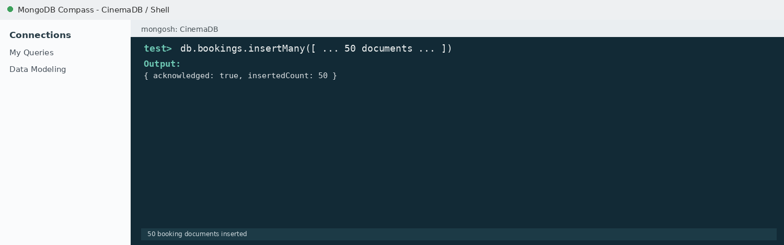

4. DISPLAY ALL BOOKINGS
MongoDB Query:
db.bookings.find()
Explanation: Retrieves all documents from the bookings collection.
Output Screenshot:
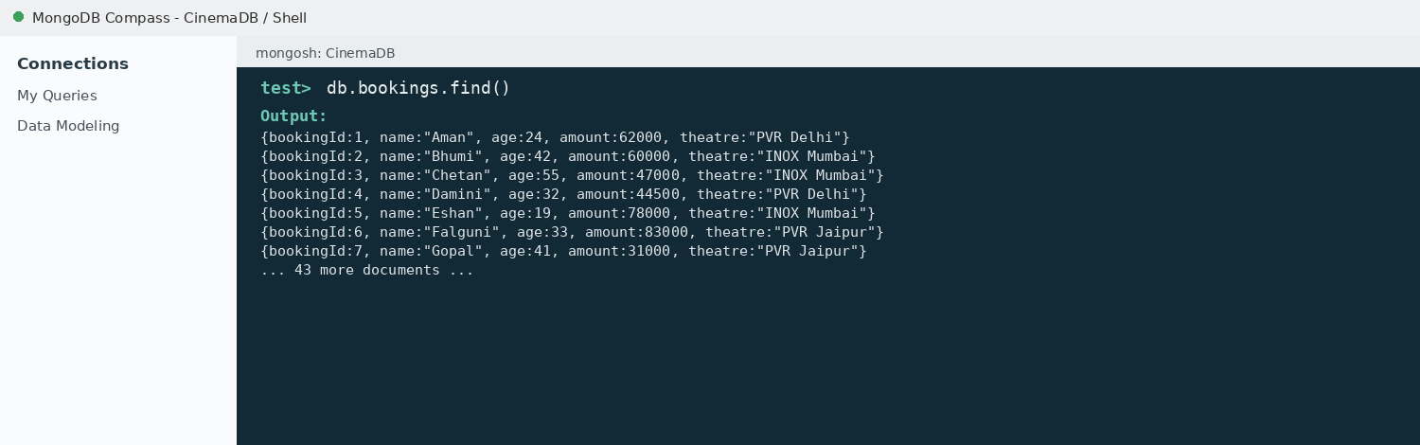

5. EQUAL TO — $eq
MongoDB Query:
db.bookings.find({amount: {$eq: 62000}})
Explanation: Finds bookings whose amount is exactly 62000.
Output Screenshot:
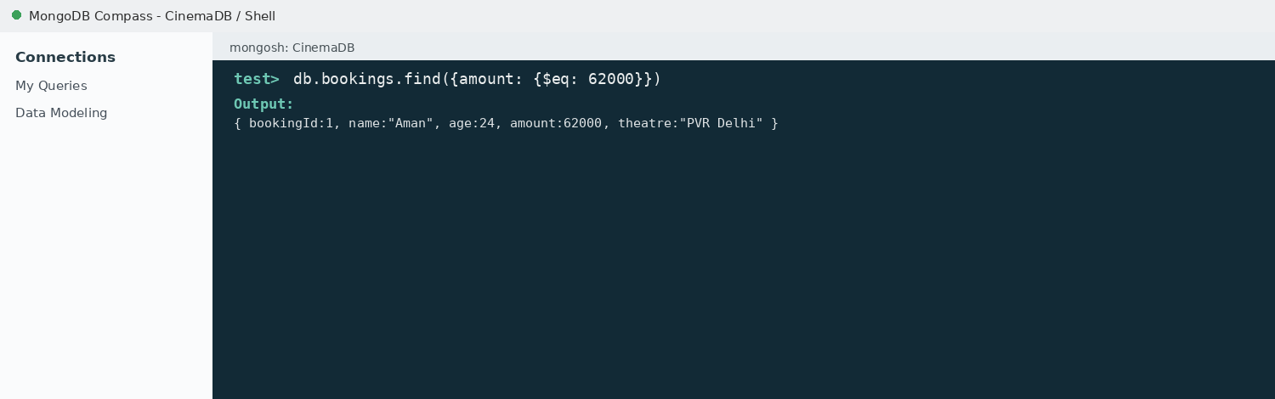

6. GREATER THAN — $gt
MongoDB Query:
db.bookings.find({amount: {$gt: 85000}})
Explanation: Finds bookings whose amount is greater than 85000.
Output Screenshot:
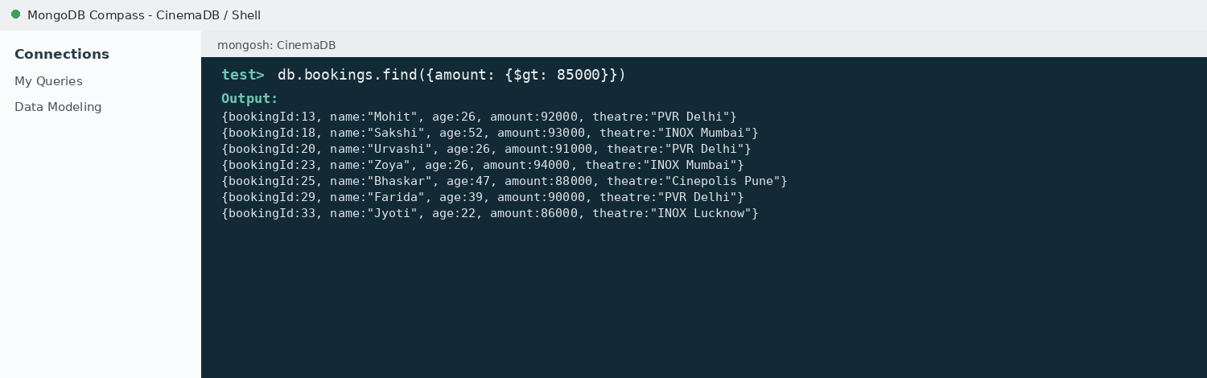

7. LESS THAN — $lt
MongoDB Query:
db.bookings.find({amount: {$lt: 35000}})
Explanation: Finds bookings whose amount is less than 35000.
Output Screenshot:
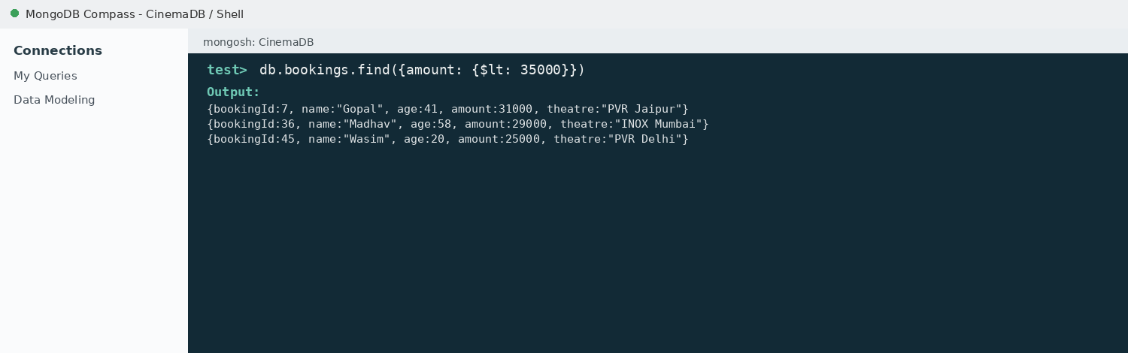

8. GREATER THAN OR EQUAL TO — $gte
MongoDB Query:
db.bookings.find({amount: {$gte: 90000}})
Explanation: Finds bookings whose amount is 90000 or above.
Output Screenshot:
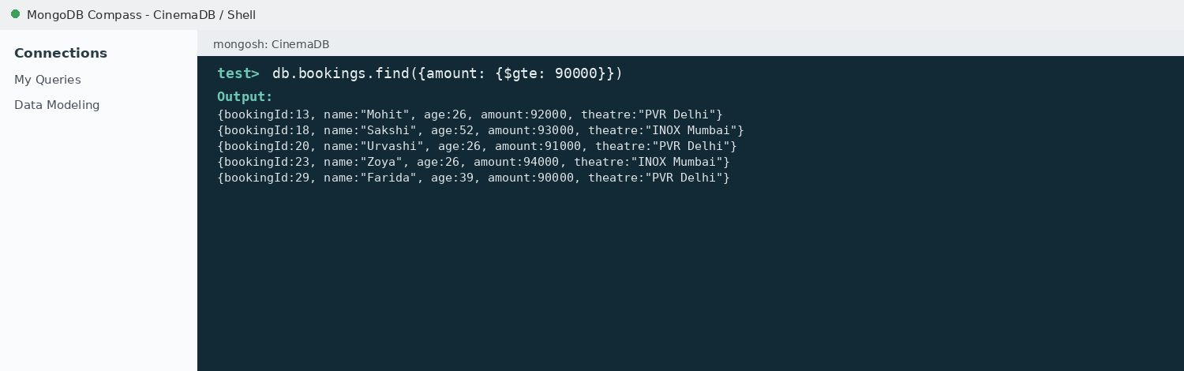

9. LESS THAN OR EQUAL TO — $lte
MongoDB Query:
db.bookings.find({amount: {$lte: 40000}})
Explanation: Finds bookings whose amount is 40000 or below.
Output Screenshot:
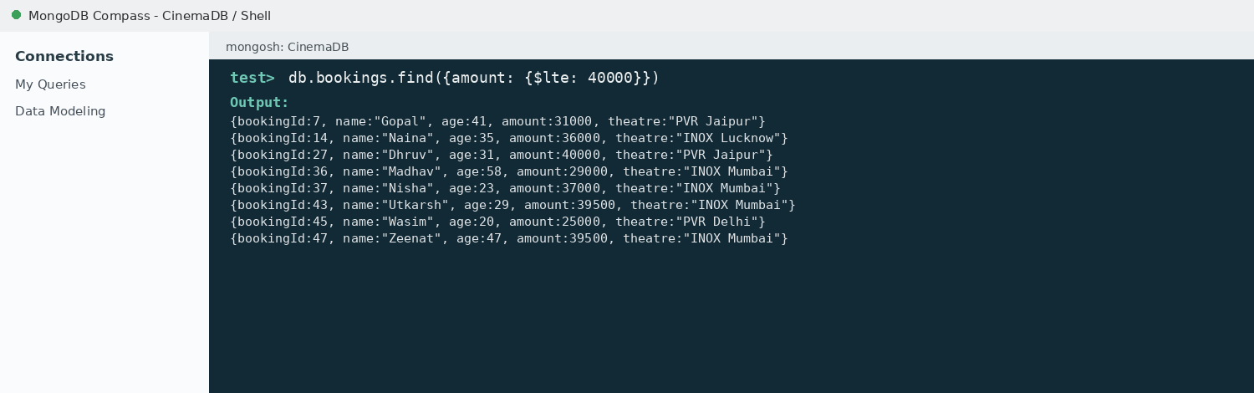

10. UPDATE OPERATION
MongoDB Query:
db.bookings.updateOne(
{bookingId:5},
{$set:{amount:95000}}
)
Explanation: Updates the amount to 95000 of the booking with bookingId 5.
Output Screenshot:
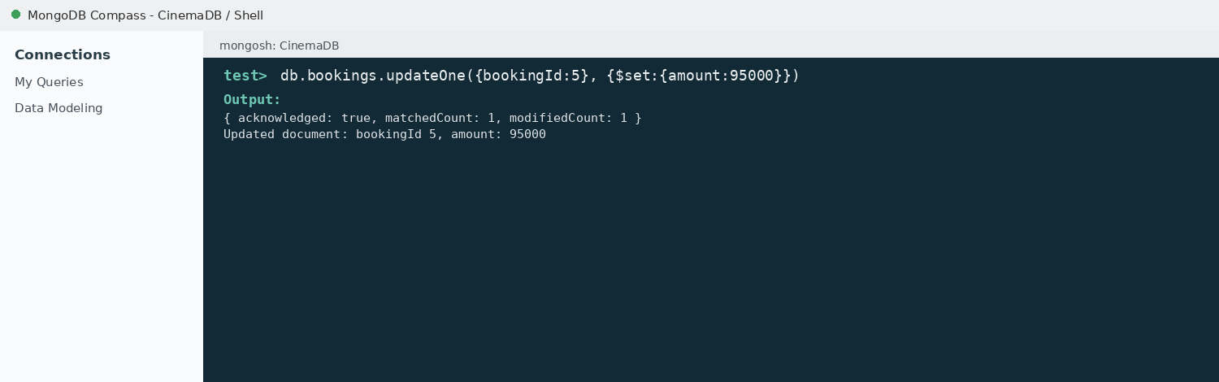

11. DELETE ONE OPERATION
MongoDB Query:
db.bookings.deleteOne({bookingId:10})
Explanation: Deletes one document matching bookingId 10.
Output Screenshot:
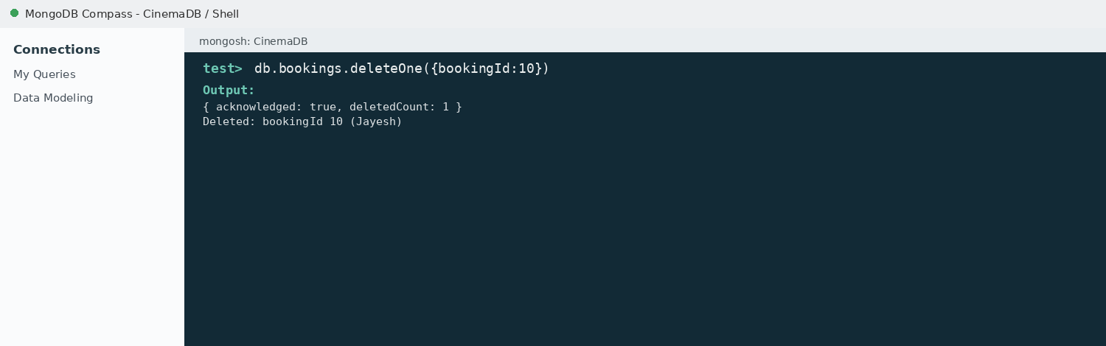

12. DELETE MANY OPERATION
MongoDB Query:
db.bookings.deleteMany({
amount: {$lt:35000}
})
Explanation: Deletes all bookings having a amount below 35000.
Output Screenshot:
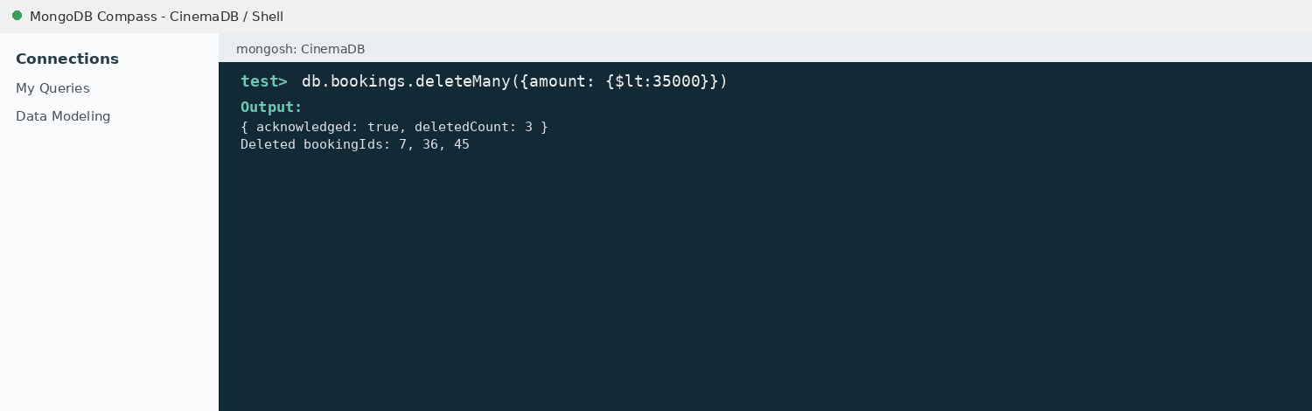

13. AND OPERATION — $and
MongoDB Query:
db.bookings.find({
$and:[
{amount:{$gt:80000}},
{age:26}
]
})
Explanation: Finds bookings satisfying both conditions.
Output Screenshot:
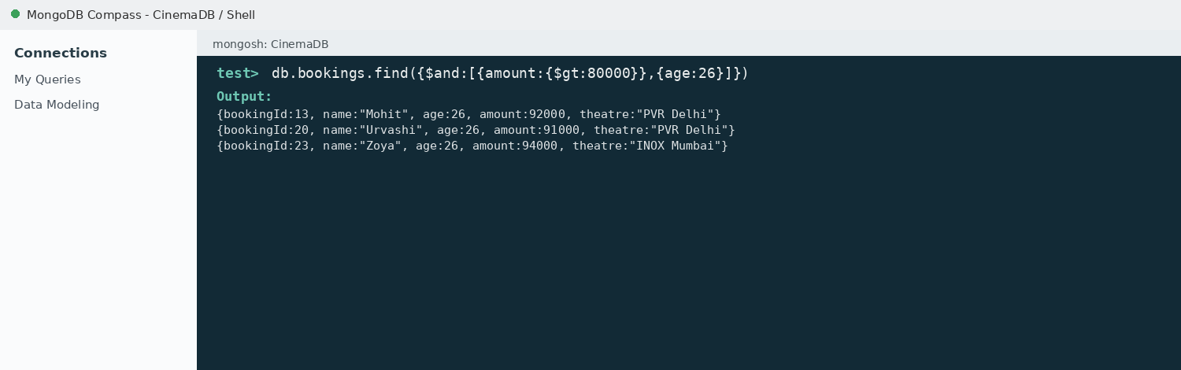

14. OR OPERATION — $or
MongoDB Query:
db.bookings.find({
$or:[
{theatre:"PVR Delhi"},
{theatre:"INOX Mumbai"}
]
})
Explanation: Finds bookings who booked tickets at PVR Delhi or INOX Mumbai.
Output Screenshot:
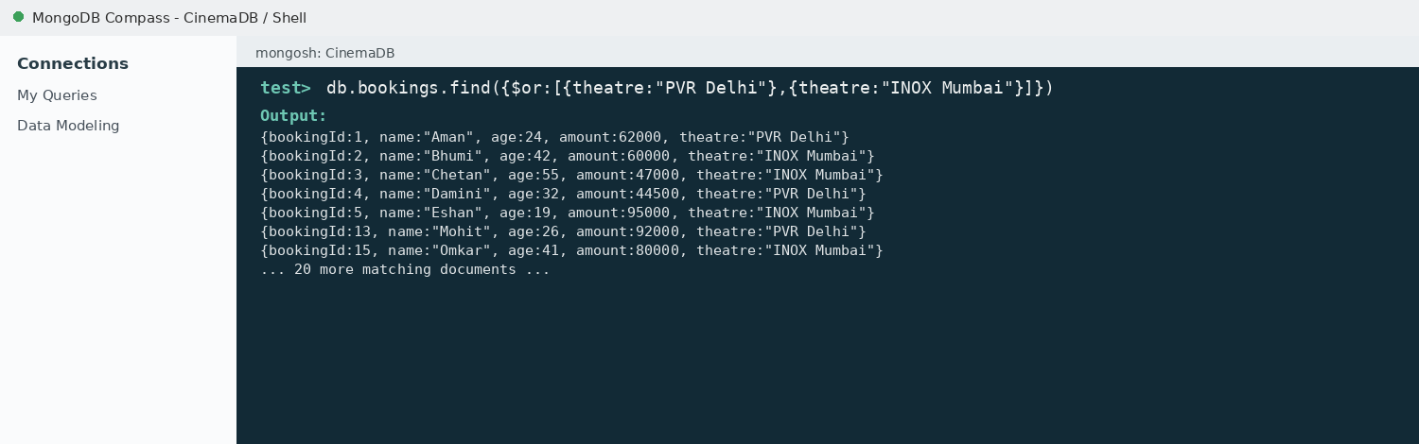

15. SORT OPERATION
A. MongoDB Query:
db.bookings.find().sort({amount: 1})
Explanation: Sorts bookings by amount from lowest to highest. Use 1 for ascending order.
Output Screenshot:
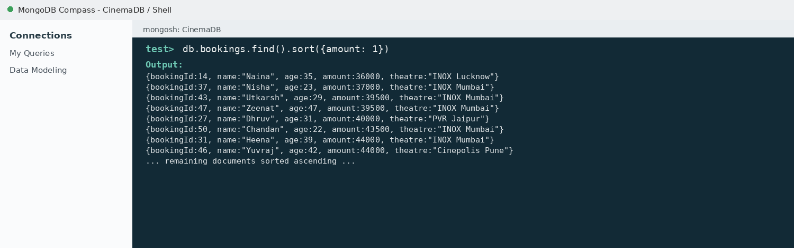
B. MongoDB Query:
db.bookings.find().sort({amount: -1})
Explanation: Sorts bookings by amount from highest to lowest. Use -1 for descending order.
Output Screenshot:
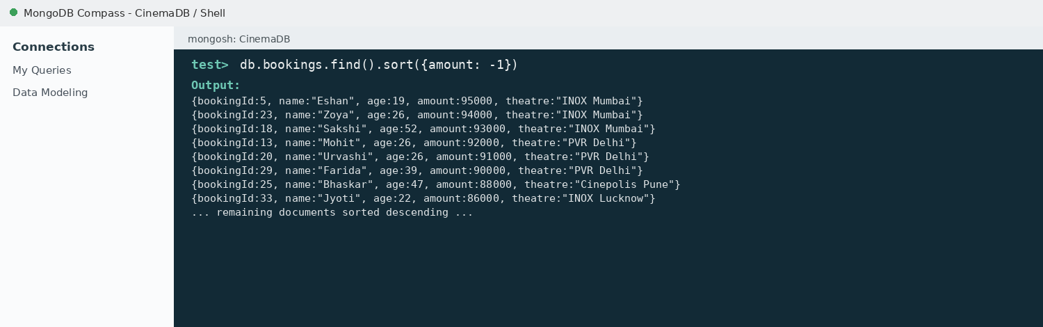

16. LIMIT OPERATION
MongoDB Query:
db.bookings.find().limit(5)
Explanation: Displays only the first five documents.
Output Screenshot:
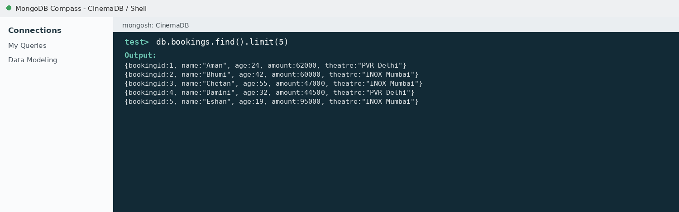

17. SEARCH BY THEATRE
MongoDB Query:
db.bookings.find({theatre:"PVR Delhi"})
Explanation: Finds all bookings who booked tickets at PVR Delhi.
Output Screenshot:
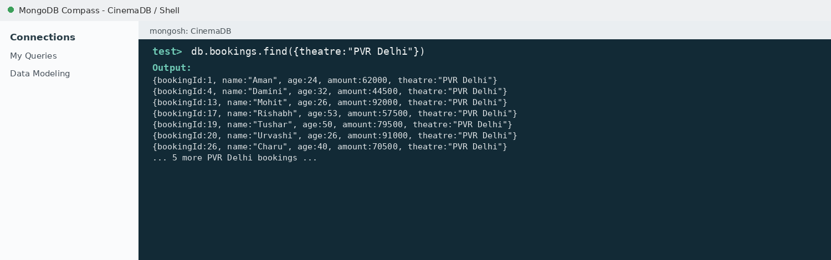

18. COUNT DOCUMENTS
MongoDB Query:
db.bookings.countDocuments()
Explanation: Counts documents currently present in the collection (performed after the delete operations).
Output Screenshot:
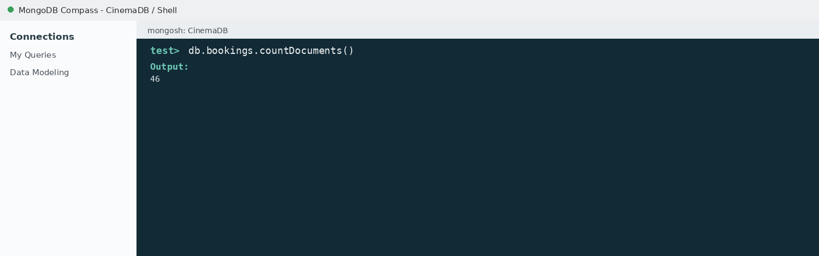

MONGODB OPERATORS USED
Operator | Meaning | Example
$eq | Equal to | amount: {$eq:62000}
$gt | Greater than | amount: {$gt:85000}
$lt | Less than | amount: {$lt:35000}
$gte | Greater than or equal to | amount: {$gte:90000}
$lte | Less than or equal to | amount: {$lte:40000}
$and | All conditions true | $and:[...]
$or | At least one condition true | $or:[...]

CONCLUSION
This project provided practical knowledge of NoSQL databases using MongoDB. A Movie Ticket Booking Management System containing booking information was created and different MongoDB operations were performed on the data.
Through this project, I learned how to insert, retrieve, update, and delete documents. I also learned how to arrange data in ascending and descending order, how comparison operators such as $eq, $gt, $lt, $gte, and $lte work, along with logical operators such as $and and $or.
Overall, this project helped me understand how MongoDB can be used to manage and query booking data efficiently.

