CS5800 Quiz-02

Aashish Awadhani

017320524

[Github Link](https://github.com/purvavj/CS5800-SWE/tree/main/Quiz2/src)

**Factory Class Diagram**

@startuml

class Character {

- character: char

- characterProperty: CharacterProperties

+ Character(character: char, characterProperty: CharacterProperties)

+ setCharacter(character: char): void

+ setCharacterProperty(characterProperty: CharacterProperties): void

+ getCharacter(): char

+ getFont(): String

+ getColor(): String

+ getSize(): int

}

class CharacterProperties {

- font: String

- color: String

- size: int

+ CharacterProperties(font: String, color: String, size: int)

+ getFont(): String

+ getColor(): String

+ getSize(): int

}

class CharacterPropertiesFactory {

- flyweights: Map<String, CharacterProperties>

+ setAndRetrieveFlyweightCharacterProperties(font: String, color: String, size: int): CharacterProperties

+ sizeOfMap(): int

}

class Document {

- characters: List<Character>

- propertiesFactory: CharacterPropertiesFactory

+ addCharacter(c: char, font: String, color: String, size: int): void

+ editCharacterProperties(index: int, font: String, color: String, size: int): void

+ saveToFile(filename: String): void

+ loadFromFile(filename: String): void

}

class Driver {

+ main(args: String[]): void

}

Character "1" *-- "1" CharacterProperties

Document "1" *-- "1" CharacterPropertiesFactory

Document "1" *-- "*" Character

Driver -- Document

@enduml

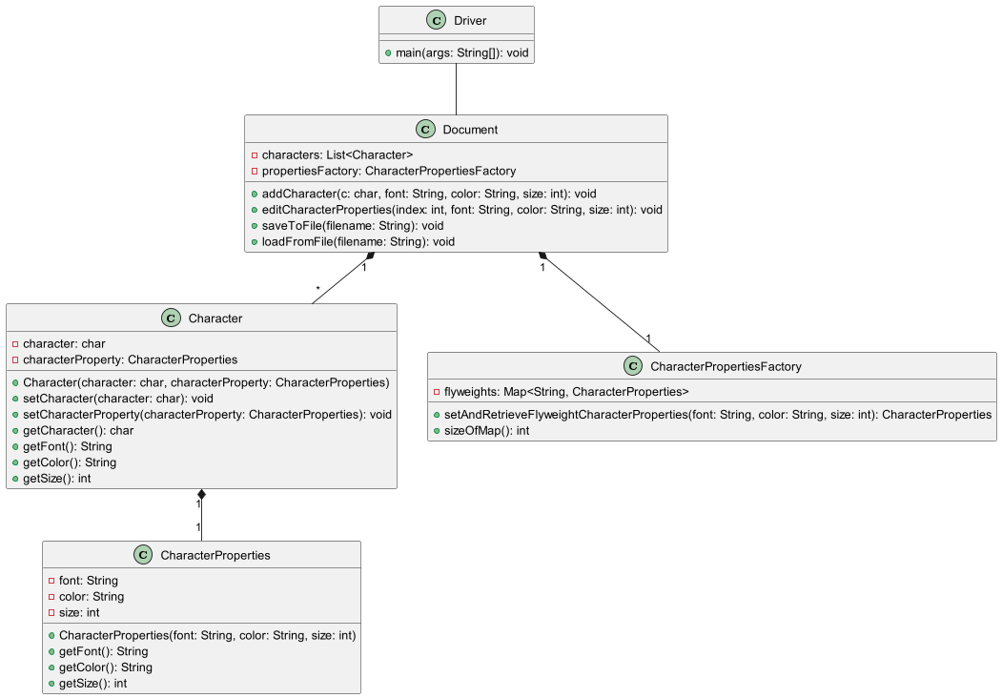

**Factory Object Diagram 1**@startuml

'https://plantuml.com/object-diagram

together {

object "<u>index0: Character</u>" as Character0{

character="H"

characterProperty=

Arial16Black

}

object "<u>index1: Character</u>" as Character1{

character="e"

characterProperty=

Arial14Black

}

object "<u>index2: Character</u>" as Character2{

character="l"

characterProperty=

Arial14Black

}

object "<u>index3: Character</u>" as Character3{

character="l"

characterProperty=

Arial14Black

}

object "<u>index4: Character</u>" as Character4{

character="o"

characterProperty=

Arial14Black

}

object "<u>index5: Character</u>" as Character5{

character="W"

characterProperty=

Arial16Black

}

object "<u>index6: Character</u>" as Character6{

character="o"

characterProperty=

Arial14Black

}

object "<u>index7: Character</u>" as Character7{

character="r"

characterProperty=

Arial14Black

}

object "<u>index8: Character</u>" as Character8{

character="l"

characterProperty=

Arial14Black

}

object "<u>index9: Character</u>" as Character9{

character="d"

characterProperty=

Arial14Black

}

object "<u>index10: Character</u>" as Character10{

character="C"

characterProperty=

Verdana18Blue

}

object "<u>index11: Character</u>" as Character11{

character="S"

characterProperty=

Verdana18Blue

}

object "<u>index12: Character</u>" as Character12{

character="5"

characterProperty=

Verdana12Red

}

object "<u>index13: Character</u>" as Character13{

character="8"

characterProperty=

Verdana12Red

}

object "<u>index14: Character</u>" as Character14{

character="0"

characterProperty=

Verdana12Red

}

object "<u>index15: Character</u>" as Character15{

character="0"

characterProperty=

Verdana12Red

}

}

object "<u>Arial16Black: CharacterProperties</u>" as Arial16Black{

font="Arial"

color="Black"

size=16

}

object "<u>Arial14Black: CharacterProperties</u>" as Arial14Black{

font="Arial"

color="Black"

size=14

}

object "<u>Verdana18Blue: CharacterProperties</u>" as Verdana18Blue{

font="Verdana"

color="Blue"

size=18

}

object "<u>Verdana12Red: CharacterProperties</u>" as Verdana12Red{

font="Verdana"

color="Red"

size=12

}

Character0 o--[#purple] Arial16Black

Character1 o--[#green] Arial14Black

Character2 o--[#green] Arial14Black

Character3 o--[#green] Arial14Black

Character4 o--[#green] Arial14Black

Character5 o--[#purple] Arial16Black

Character6 o--[#green] Arial14Black

Character7 o--[#green] Arial14Black

Character8 o--[#green] Arial14Black

Character9 o--[#green] Arial14Black

Character10 o--[#blue] Verdana18Blue

Character11 o--[#blue] Verdana18Blue

Character12 o--[#red] Verdana12Red

Character13 o--[#red] Verdana12Red

Character14 o--[#red] Verdana12Red

Character15 o--[#red] Verdana12Red

object "<u>testDocument: Document</u>" as Document{

List<Character> characters=

[('H', "Arial","Black", 16),

('e", "Arial","Black", 14),

('l", "Arial","Black", 14),

('l", "Arial","Black", 14),

('o', "Arial","Black", 14),

('W', "Arial","Black", 16),

('o', "Arial","Black", 14),

('r', "Arial","Black", 14),

('l', "Arial","Black", 14),

('d', "Arial","Black", 14),

('C', "Verdana","Blue",18),

('S', "Verdana","Blue",18),

('5', "Verdana","Red", 12),

('8', "Verdana","Red", 12),

('0', "Verdana","Red", 12),

('0', "Verdana","Red", 12)]

CharacterPropertiesFactory propertiesFactory

}

object "<u>propertiesFactory: CharacterPropertiesFactory</u>" as flyweightFactory{

Map<String,CharacterProperties> flyweights=

{"Arial16Black":Arial16Black,

"Arial14Black":Arial14Black,

"Verdana18Blue":Verdana18Blue,

"Verdana12Red";Verdana12Red}

}

Document *--flyweightFactory

flyweightFactory *--Arial16Black

flyweightFactory *--Arial14Black

flyweightFactory *--Verdana18Blue

flyweightFactory *--Verdana12Red

Document *-- Character0

Document *-- Character1

Document *-- Character2

Document *-- Character3

Document *-- Character4

Document *-- Character5

Document *-- Character6

Document *-- Character7

Document *-- Character8

Document *-- Character9

Document *-- Character10

Document *-- Character11

Document *-- Character12

Document *-- Character13

Document *-- Character14

Document *-- Character15

@enduml

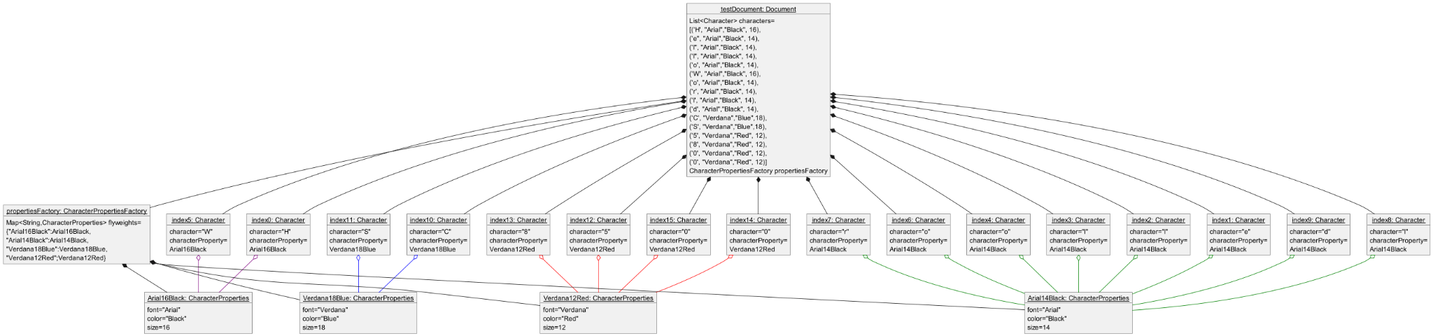

**Factory Object Diagram 2**

@startuml

'https://plantuml.com/object-diagram

together{

object "<u>index0: Character</u>" as Character0{

character="H"

characterProperty=

Calibri99Blue

}

object "<u>index1: Character</u>" as Character1{

character="e"

characterProperty=

Arial14Black

}

object "<u>index2: Character</u>" as Character2{

character="l"

characterProperty=

Arial14Black

}

object "<u>index3: Character</u>" as Character3{

character="l"

characterProperty=

Arial14Black

}

object "<u>index4: Character</u>" as Character4{

character="o"

characterProperty=

Arial14Black

}

object "<u>index5: Character</u>" as Character5{

character="W"

characterProperty=

Calibri99Blue

}

object "<u>index6: Character</u>" as Character6{

character="o"

characterProperty=

Arial14Black

}

object "<u>index7: Character</u>" as Character7{

character="r"

characterProperty=

Arial14Black

}

object "<u>index8: Character</u>" as Character8{

character="l"

characterProperty=

Arial14Black

}

object "<u>index9: Character</u>" as Character9{

character="d"

characterProperty=

Arial14Black

}

object "<u>index10: Character</u>" as Character10{

character="C"

characterProperty=

Verdana18Blue

}

object "<u>index11: Character</u>" as Character11{

character="S"

characterProperty=

Verdana18Blue

}

object "<u>index12: Character</u>" as Character12{

character="5"

characterProperty=

Verdana12Red

}

object "<u>index13: Character</u>" as Character13{

character="8"

characterProperty=

Verdana12Red

}

object "<u>index14: Character</u>" as Character14{

character="0"

characterProperty=

Verdana12Red

}

object "<u>index15: Character</u>" as Character15{

character="0"

characterProperty=

Verdana12Red

}

}

object "<u>Arial16Black: CharacterProperties</u>" as Arial16Black{

font="Arial"

color="Black"

size=16

}

object "<u>Arial14Black: CharacterProperties</u>" as Arial14Black{

font="Arial"

color="Black"

size=14

}

object "<u>Verdana18Blue: CharacterProperties</u>" as Verdana18Blue{

font="Verdana"

color="Blue"

size=18

}

object "<u>Verdana12Red: CharacterProperties</u>" as Verdana12Red{

font="Verdana"

color="Red"

size=12

}

object "<u>Calibri99Blue: CharacterProperties</u>" as Calibri99Blue{

font="Calibri"

color="Blue"

size=99

}

Character0 o--[#purple] Calibri99Blue

Character1 o--[#green] Arial14Black

Character2 o--[#green] Arial14Black

Character3 o--[#green] Arial14Black

Character4 o--[#green] Arial14Black

Character5 o--[#purple] Calibri99Blue

Character6 o--[#green] Arial14Black

Character7 o--[#green] Arial14Black

Character8 o--[#green] Arial14Black

Character9 o--[#green] Arial14Black

Character10 o--[#blue] Verdana18Blue

Character11 o--[#blue] Verdana18Blue

Character12 o--[#red] Verdana12Red

Character13 o--[#red] Verdana12Red

Character14 o--[#red] Verdana12Red

Character15 o--[#red] Verdana12Red

object "<u>testDocument: Document</u>" as Document{

List<Character> characters=

[('H', "Calibri","Blue", 99),

('e", "Arial","Black", 14),

('l", "Arial","Black", 14),

('l", "Arial","Black", 14),

('o', "Arial","Black", 14),

('W', "Calibri","Blue", 99),

('o', "Arial","Black", 14),

('r', "Arial","Black", 14),

('l', "Arial","Black", 14),

('d', "Arial","Black", 14),

('C', "Verdana","Blue",18),

('S', "Verdana","Blue",18),

('5', "Verdana","Red", 12),

('8', "Verdana","Red", 12),

('0', "Verdana","Red", 12),

('0', "Verdana","Red", 12)]

CharacterPropertiesFactory propertiesFactory

}

object "<u>propertiesFactory: CharacterPropertiesFactory</u>" as flyweightFactory{

Map<String,CharacterProperties> flyweights=

{"Arial16Black":Arial16Black,

"Arial14Black":Arial14Black,

"Verdana18Blue":Verdana18Blue,

"Verdana12Red";Verdana12Red

"Calibri99Blue":Calibri99Blue}

}

Document *--flyweightFactory

flyweightFactory *--Arial16Black

flyweightFactory *--Arial14Black

flyweightFactory *--Verdana18Blue

flyweightFactory *--Verdana12Red

flyweightFactory *--Calibri99Blue

Document *-- Character0

Document *-- Character1

Document *-- Character2

Document *-- Character3

Document *-- Character4

Document *-- Character5

Document *-- Character6

Document *-- Character7

Document *-- Character8

Document *-- Character9

Document *-- Character10

Document *-- Character11

Document *-- Character12

Document *-- Character13

Document *-- Character14

Document *-- Character15

@enduml

