RESUME 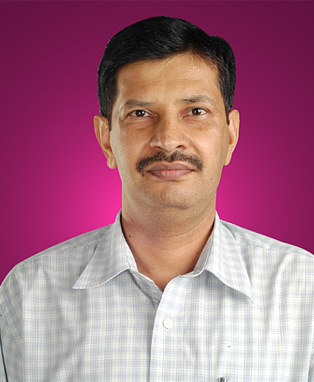
Name: Mahender Singh
Father's Name: Shri Amar Singh
Address: Janak Puri, New Delhi-110058
Date of birth: June 6, 1965
Phone No: M-9868411786, 9999268206
Email: mahender_singh11@rediffmail.com
------------------------------------------------------------------------------------------------------------------------------------------------------------
Carrier Objective:
To work in a creative and challenging environment where I can utilize my assets for the growth of the organization.

Skills:
Excellent interpersonal skills, Good Negotiation, Communication, Sourcing and Networking Skills, leadership qualities.

Education Qualification: Passed XII class with Commerce subjects in 1984
Graduation: from University of Delhi in 1987 with Industrial Relations & Personnel Management as a subject
M.A.: from Kurukshetra University in 1992
Professional Qualifications: Post Graduate Diploma in Accommodation Operation & Management from Haryana Tourism Institute of Hotel Management in 1993
Post Graduate Diploma in Human Resource Development (HRD) 1993-1994 from IGNOU.

Presently not working anywhere.
Worked with Allied Engineers as an Office Administrator Cum Executive Assistant from June 2022 to March 2023. AE renowned for pipeline integrity management services with a vision to continually innovate towards excellence in the Petroleum and Energy sectors completed 50 years. Allied Engineers formed the hallmark of specialized service and product offerings for the energy sector in India & abroad, and the company has since executed several decades of consulting services and supplied products to end-user.

Job Profile: I am involved in looking after Recruitment, Joining formalities, Offer Letter, Appointment Letter, Attendance, Salary administration, Employee Relations, New Employee profile, , Leave Management, CTC details, Overtime and late coming reports, Absenteeism reports, Pf, ESI, Full and Final Settlement, Probation extension & Confirmation Letter and other human resource related Letters, Union Relations, Casual staff supervision, House-Keeping, Maintenance, Inter-Office Coordination, Liasioning with local authorities, Monitoring Consumables purchase and their usages and other items for General use such as Supervision of stores, Warehouse, Logistic, Security, Transport, Hotel, Guest House, Ticketing, Pantry, Cafeteria, Stationery, Printing , Courier, Vendor Developments, AMC of all office utilities. Office Systems, Handle Payroll Management, Payroll Software, PMS, Movement of Assets Handling daily expenses, Besides looking the welfare work of workers & other general duties, & handling any other day to day work of the Organization, Petty Cash. Managing Appointments, diary, travel, accommodations, MOM and paperwork for meetings, Follow up. Maintain and organize files, records, and documents, Maiking Quotation, Handle confidential and sensitive information with the utmost discretion. Act as a point of contact between Executives, employees, Clients and External partners.
worked with Shiva Group of Industries Pvt Ltd as a Hr & Admin Manager cum Executive Assistant from September 2018 to May 2020. Shiva Group of Industries excels as a reputed organization engaged in the manufacturing & export of Chlorinated Paraffin, Hydrochloric Acid, Pipes and Plastigold.

Worked with Pramod Engineering Works is a sister concern of Delhi Press Group which is the largest magazine printer and publisher in India. as Hr & Administration Manager cum Executive Assistant from 1996 to 2018. Pramod Engineering Works Sahibabad is a fast-growing binding post press equipment manufacturing company. The company is presently involved in manufacturing of Printing & Binding machines. Machines installations in India and abroad.

Delhi Press Group (Masscomedia Institute, Out jobs, Binding Machines) is the publisher of the leading magazines. Magazines like, Grihshobha, Womans Era, Sarita, Champak etc. Printing 32 magazines in 12 languages. All the magazines are numero uno in their respective category.

Worked with Phoenix Overseas Ltd. as a Personnel & Administrative Officer from Sep.1994 to April 1996.

Worked temporarily at Lodhi Hotel as an Office Assistance from Nov.1993 to Sep. 1994.
Job Experience: Six Months on job training in the Samrat & Lodhi ITDC Hotels, Like. Supervision of Front Office, Housekeeping, Health Club, Public Area, Laundry, Saloon, Linen Room, Uniform Room, Attendants, Desk Plumbing, Carpentry etc.
Other Activities: Passed C Certificate of NCC & took part in Republic Day
Parade in 1986 as NCC Cadet.
Hobby: Proficient Player of Cricket, Basket Ball.
Health: Having good physique with charming personality
(Mahender Singh)

