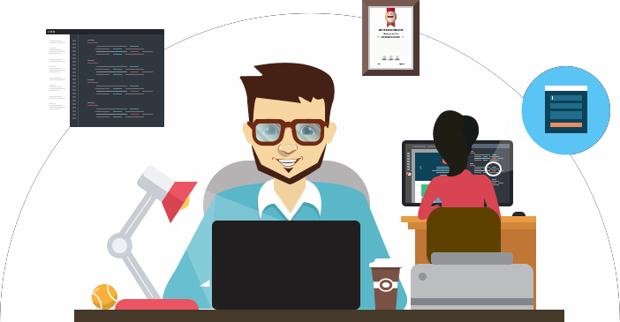

Ashish Nema

UI/UX Developer

Ashish Nema

[PrimeOne Workforce Private Limited]

***Ashish Nema*** E-mail: [aashish.nema4@gmail.com](mailto:aashish.nema4@gmail.com) Mobile No.: +91-8871491597

# Career Objective

Design efficient and intuitive user interfaces for web applications while continuing to learn and expand my knowledge of emerging web technologies, to work in a challenging environment which provides me very good opportunities for growth and development

# Work Experience

### PrimeOne Workforce Private Limited. (Deputed at Madhya Pradesh Agency for Promotion of Information)

***(UI Designer) Oct’2016- till now***

To create wireframes, designing Web UI, UX and front-end development (HTML, CSS), UI enhancement designs for better user experience, designing banners, flyers and other graphics related to Web/Mobile platform and to make the websites compatible with all browsers.

* **Responsibilities :**
  + Gather and evaluate user requirements in collaboration with managers and team members.
  + Illustrate design ideas using storyboards, process flows and sitemaps
  + Producing high-quality UX/UI design solutions through wireframes, visual and graphic designs, flow diagrams, storyboards, site maps, and prototypes.
  + Create mock-ups for proposed project pages and update them as needed.
  + Create original graphic designs (e.g. images, sketches and tables) ,identify and troubleshoot UX problems (e.g. responsiveness)
  + Conduct layout adjustments based on feedback, adhere to style standards on fonts, colors and images
  + Create wireframes, prototypes for visual layout of web pages and convert each design into HTML and CSS when required.
  + Design graphic user interface elements, like menus, tabs, and widgets, build page navigation buttons and search fields
  + Efficiently working on tools like Adobe Creative Cloud suite, Axure RP, Sketch, InVision, XD, Figma, Prototyping tools for user flow, Interaction design, Wire framing etc.
  + To design mobile friendly layout using latest methodologies such as flat UI (Bootstrap Framework design and Theme), responsive layouts, etc.
  + To follow W3C standards, table less layout cross browser compatible and bug free responsive HTML coding.

## Environment:

* + Adobe CC Suite
  + Adobe XD
  + Adobe Photoshop
  + Figma
  + Sketch
  + Axure rp
  + Adobe Dreamweaver
  + Visual Studio
  + Microsoft Office
* **Project**(s) :
  + <https://geoportal.mp.gov.in/covidmapping/>
  + http://aapdasuraksha.mp.gov.in/
  + https://geoportal.mp.gov.in/dronedata/
  + https://geoportal.mp.gov.in/igrweb/home.aspx
  + https://geoportal.mp.gov.in/mphrms/login.aspx
  + https://geoportal.mp.gov.in/ews/Default.aspx
  + https://dtcp.mp.gov.in/alpass/Web/LanduseCertificate.aspx
  + https://geoportal.mp.gov.in/mlafs/home.aspx#
  + https://geoportal.mp.gov.in/tribalweb/home.aspx
  + https://geoportal.mp.gov.in/khasraservice/uLogin.aspx
  + https://geoportal.mp.gov.in/wrd/home.aspx
  + https://geoportal.mp.gov.in/uadd/home.aspx#
  + https://geoportal.mp.gov.in/default.aspx
  + <http://geoportal.mp.gov.in/mpexcise/home.aspx>
* **Wireframe Links**
  + https://whw9xn.axshare.com/#id=f6lrjd&p=homepage&g=1
  + <https://whw9xn.axshare.com/#id=f6lrjd&p=homepage&g=1>
  + <https://inuqjs.axshare.com/#id=j11vuo&p=edit_generating_form&g=1>
  + <https://xd.adobe.com/view/30ffd055-ac31-43e3-8c97-d009c92fa529-65ac/?fullscreen>
  + <https://httfps.axshare.com/#id=gpn4io&p=homepage>
  + https://xd.adobe.com/view/8dd40119-c916-495c-b2c4-f688e64d1a7a-d887/screen/afc39ec0-c977-4c47-add8-3d44cd10001c/?fullscreen

### Confiavel Web Solutions & Consultant Pvt. Ltd. (Jr. Web Designer) May2014 – Oct 2016

Website design, front end development (HTML, CSS), design, multimedia presentations, designing banners, and other graphic designs.

* **Responsibilities :**
  + Producing sample sites
  + Writing and editing Web content
  + Meeting with clients to discuss requirements and/or project progress
  + Designing webpage layout
  + Determining technical requirements
  + Updating websites
  + Creating back up files
  + Solving code problems
  + Test the website and identify any technical problems
  + Upload the site onto a server and register it with different search engines

## Environment:

* + Adobe Dreamweaver
  + PHP/MYSQL
  + XAMP/WAMP
  + Adobe Photoshop
  + Adobe Illustrator
  + Microsoft Office
* **Project**(s):
  + htt[ps://www.loginsoftware.in/](http://www.loginsoftware.in/)
  + <http://ranabuildtech.com/>
  + <http://www.birjasoft.com/>
  + <http://solversolution.in/>
  + <http://esuvidha.co.in/>
  + htt[ps://loginsoftware.in/](http://www.loginsoftware.in/)

# Academic Qualification

Bachelor of Engineering (Computer Science) 2012, RGPV University, Bhopal, MP, India 12th – 2008, [St.Francis Convent Sr.Sec.School, Raisen,](http://stfrancisraisen.com/) MP, India

10th – 2006, [St.Francis Convent Sr.Sec.School, Raisen,](http://stfrancisraisen.com/) MP, India

# Academic Internship Project

12 months project at Confiavel Web Solutions & Consultant Pvt. Ltd.

# Extra-Curricular

* Participation in Cultural Activities
* Participation in Sports Activities at School level

# Personal Profile

Father's Name : Mohan Lal Nema

Mother’s Name : Smt. Leela Nema

Date of Birth : 5th July 1989

Sex : Male

Languages : Hindi, English

Nationality : Indian

# Declaration

I hereby declare that the information provided here is true to best of my knowledge.

Place: Bhopal

Date: Thanking you,

Aashish Nema