# Data description

We primarily worked with three datasets:

* MITgcm 2160 lat-lon-cap simulation of the ocean, of size 4PB total. Each field contains 90 levels, each level containing 13, 2160x2160 facets.
* MITgcm 4320, similar to MITgcm 2160 but double the resolution in each of the x-y dimensions.
* GEOS5 1440 cubed-sphere simulation of the atmosphere. Each field contains 52 levels, each level containing 6, 1440x1440 facets.

The original data are stored in “raw” binary formats, where each time step is stored in one file, within each file the depths are stored one after another, and within each depth, the facets are stored one after another, each as a 2D array of floating-point values.

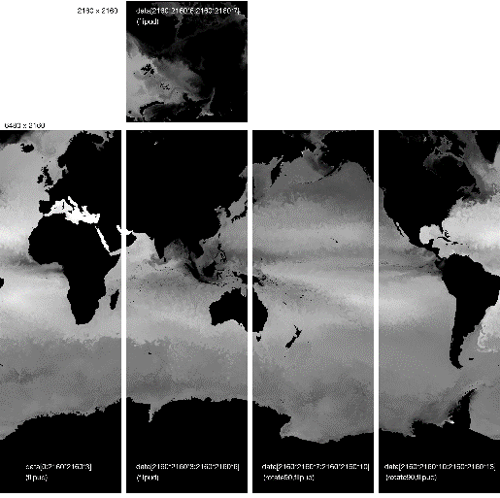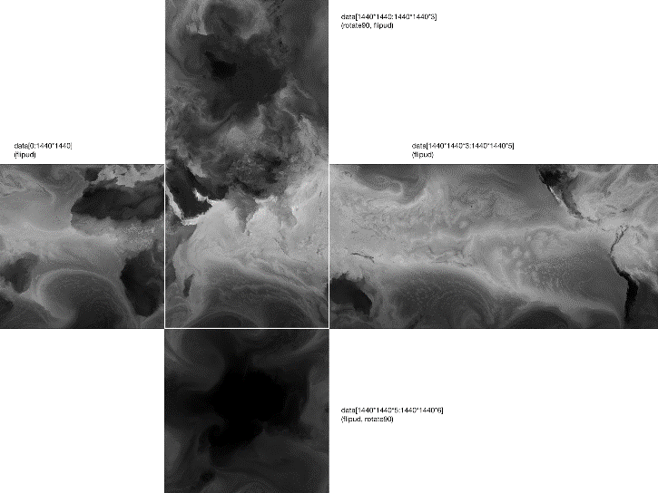

# Interactive 3D visualization

We demonstrated interactive 3D visualization of the DYAMOND LLC4320 data in OpenViSUS IDX format. Our 3D viewer allows the user to stream the data remotely from a server in SCI and visualize the data as

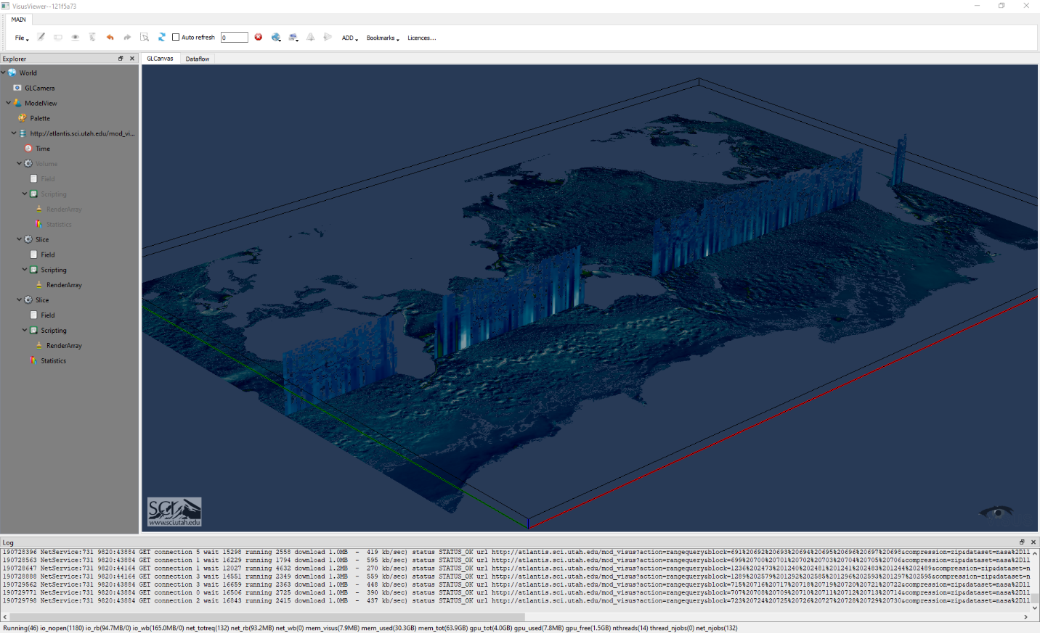

# Data encodings