

**(Affiliated to Tribhuvan University)**

**Advanced Java Programming**

|  |  |
| --- | --- |
|  |  |
|  |  |
|  |  |

**Submitted by:**

Name: Aashish Pokharel

Faculty: Bsc.CSIT,7th sem.

Roll no.: 20786/075

**Submitted to:**

Krishna Pandey

Department of CSIT , OIC

1. Case Study 1

An Amusement park company wants one application for their billing counter to enable ticket sale. Assume the Amusement park authorities approached Max to get this application developed.

This application should have ticket prize as Rs 400 per person and if a person buys more than 10 tickets then person is eligible for 10 percent discount. Calculate the total bill or amount according to the number of tickets that are sold

*package classwork;*

*import java.util.Scanner;*

*public class CS_TC {*

*public static void main(String[] args) {*

*// Entry Function*

*TicketBook tb = new TicketBook();*

*int ticket = tb.getInput();*

*double amount = tb.totalAmountCalculator();*

*System.out.println("\nNo. of Tickets:" + ticket + "\n Cost : " +amount );*

*}*

*}*

*class TicketBook{*

*int ticketCount, ticketCost = 400;*

*double totalAmount;*

*public int getInput() {*

*/* Method to get input from the user*

*\* Parameters : Void*

*\* Returns: ticketCount - no of tickets */*

*Scanner s = new Scanner(System.in);*

*System.out.println("Enter the no of ticket:");*

*this.ticketCount = s.nextInt();*

*s.close();*

*return this.ticketCount;*

*}*

*public double totalAmountCalculator() {*

*/* Method to calculate the amount*

*\* Parameters : None*

*\* Returns : Total amount*

*\* */*

*if(this.ticketCount > 10) {*

*this.totalAmount = 0.9 * (this.ticketCost * this.ticketCount);*

*}else {*

*this.totalAmount = (this.ticketCost * this.ticketCount);*

*}*

*return this.totalAmount;*

*}*

*}*

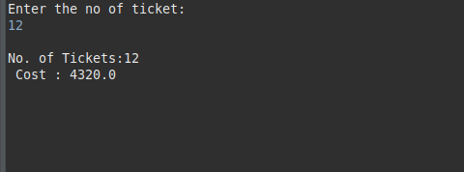

1. Case Study 2

John and Paul went to watch a movie in theatre where they need to buy two tickets.

There are two types of tickets, one Golden category and other as silver category. If

they buy tickets for silver category, then per person a ticket should cost Rs.150 and

for golden category ticket should cost them Rs.200 each.

Considering this scenario, write a program for theatre ticket booking application scenario.

*package classwork;*

*import java.util.Scanner;*

*public class CS_Ticket {*

*public static void main(String[] args) {*

*//Entry Function*

*BookTicket tb = new BookTicket();*

*tb.ticketInput();*

*tb.calculateCost();*

*tb.printResult();*

*}*

*}*

*class BookTicket{*

*int goldCount, silverCount, goldPrice = 200, silverPrice = 150;*

*double totalAmount;*

*public void ticketInput() {*

*/* Method to get input from the user*

*\* Parameters : None*

*\* Returns: None */*

*Scanner s = new Scanner(System.in);*

*System.out.println("Enter the no of gold ticket:");*

*this.goldCount = s.nextInt();*

*System.out.println("Enter the no of silver ticket:");*

*this.silverCount = s.nextInt();*

*s.close();*

*}*

*public void calculateCost() {*

*/* Method to calculate the amount*

*\* Parameters : None*

*\* Returns : None*

*\* */*

*this.totalAmount = 1.0 * ((this.goldCount * this.goldPrice) + (this.silverCount * this.silverPrice));*

*}*

*public void printResult() {*

*/* Method to print the result*

*\* Parameters : None*

*\* Returns : None*

*\* */*

*System.out.println("\nGold ticket(s):"+ this.goldCount +*

*"\nSilver Ticket(s)" + this.silverCount +*

*"\nTotal Cost:" + this.totalAmount);*

*}*

*}*

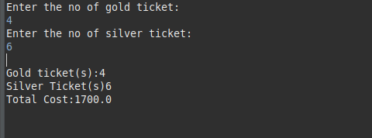

1. Write programs to use all the data types and given arithmetic operations.
2. *Java Program to Demonstrate Boolean Primitive DataType.*

*` package classwork;*

*class Boolean {*

*// Main driver method*

*public static void main(String args[])*

*{*

*boolean b1 = true, b2= false;*

*if(b1 == true) {*

*System.out.println("b1 is true");*

*}else {*

*System.out.println("B1 is false");*

*}*

*if(b1 == true && b2 == true) {*

*System.out.println("both b1 & b2 are true");*

*}else {*

*System.out.println("One of b1 and b2 is false");*

*}*

*}*

*}*

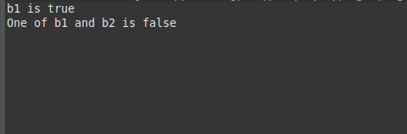

1. *Java Program to Illustrate Number Primitive Data Type.*

package classwork;

public class Numbers {

public static void main(String[] args)

{

// float

double value1 = 10.0, value2 = 9.87f;

double output = value1 + value2;

System.out.println("double sum\n"+ value1+"+"+value2+ " = "+ output);

// Integer operation

int i1 = 10, i2 = 9;

int op = i1 + i2;

System.out.println("Integer sum\n"+ i1+"+"+i2+ " = "+ op);

}

}

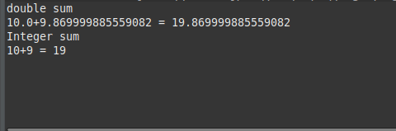

1. *Java Program to Demonstrate Char Primitive Data Type.*

class Char {

public static void main(String args[])

{

*// Creating and initializing custom character*

char a = 'G';

*// Integer data type is generally*

*// used for numeric values*

int i = 89;

*// use byte and short*

*// if memory is a constraint*

byte b = 4;

*// this will give error as number is*

*// larger than byte range*

*// byte b1 = 7888888955;*

short s = 56;

*// this will give error as number is*

*// larger than short range*

*// short s1 = 87878787878;*

*// by default fraction value*

*// is double in java*

double d = 4.355453532;

*// for float use 'f' as suffix as standard*

float f = 4.7333434f;

*//need to hold big range of numbers then we need this data type*

long l = 12121;

System.out.println("char: " + a);

System.out.println("integer: " + i);

System.out.println("byte: " + b);

System.out.println("short: " + s);

System.out.println("float: " + f);

System.out.println("double: " + d);

System.out.println("long: " + l);

}

}

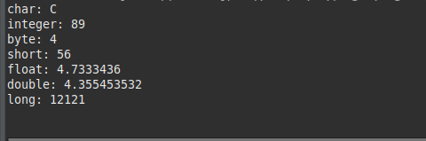

1. *Java code to illustrate Addition operator.*

package classwork;

class Addition {

public static void main(String[] args)

{

// initializing variables

int num1 = 20, num2 = 40, sum = 0;

// Displaying num1 and num2

System.out.println("num1 = " + num1);

System.out.println("num2 = " + num2);

sum = num1 + num2;

System.out.println("The sum = " + sum);

} }

Output :-

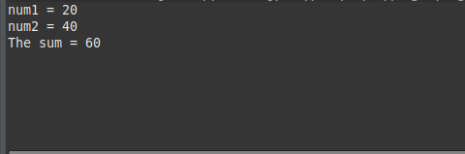

1. *Java code to illustrate Subtraction operator.*

class Subtraction {

public static void main(String[] args)

{

int num1 = 20, num2 = 10, sub = 0;

System.out.println("num1 = " + num1);

System.out.println("num2 = " + num2);

*// subtracting num1 and num2*

sub = num1 - num2;

System.out.println("Subtraction = " + sub);

} }

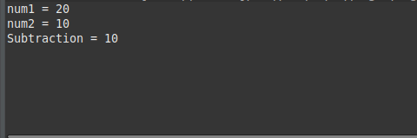

1. Java code to illustrate Multiplication operator.

package classwork;

class Multiplication {

public static void main(String[] args)

{

*// initializing variables*

int num1 = 20, num2 = 10, mult = 0;

*// Displaying num1 and num2*

System.out.println("num1 = " + num1);

System.out.println("num2 = " + num2);

mult = num1 * num2;

System.out.println("Multiplication = " + mult);

} }

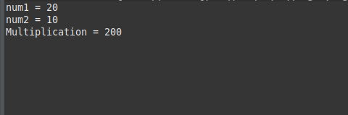

1. Java code to illustrate Division operator.

package classwork;

class Division {

public static void main(String[] args)

{

int num1 = 20, num2 = 10, div = 0;

System.out.println("num1 = " + num1);

System.out.println("num2 = " + num2);

div = num1 / num2;

System.out.println("Division = " + div);

} }

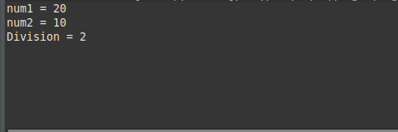

1. Java program to demonstrates the ++ and -- operators.

public class IncrementDecrement {

public static void main(String[] args)

{

int number = 50;

*// Display the value in number.*

System.out.println("Number is " + number);

number++;

*// Display the value in number.*

System.out.println("Now, number is " + number);

*// Decrement number.*

number--;

*// Display the value in number.*

System.out.println("Now, number is " + number);

} }

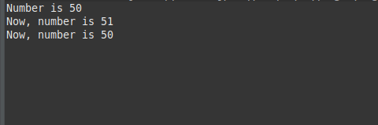

if Condition

1. Write a program to check if a candidate is eligible for voting or not. (Hint: Check age)

import java.util.Scanner;

public class Voting {

public static void main(String[] args)

{

*// Declaring variables*

int age, diff;

*// taking user input*

Scanner scan = new Scanner(System.in);

System.out.println("Please enter your age: ");

age = scan.nextInt();

*// Checking condition for voting.*

if(age>=18)

{

System.out.println("You are eligible for voting.");

}

else

{

diff = (18 - age);

System.out.println("Sorry,You can vote after: "+ diff + " years");

} } }

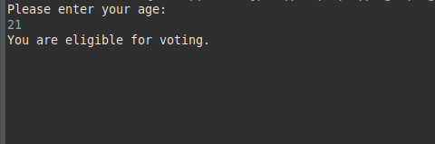

1. Write a program to check if the number is positive or negative.

import java.util.Scanner;

public class CheckPositiveOrNegativeExample2

{

public static void main(String[] args)

{

int num;

*//object of the Scanner class*

Scanner sc = new Scanner(System.in);

System.out.print("Enter a number: ");

*//reading a number from the user*

num = sc.nextInt();

*//checks the number is greater than 0 or not*

if(num>0)

{

System.out.println("The number is positive.");

}

*//checks the number is less than 0 or not*

else if(num<0)

{

System.out.println("The number is negative.");

}

*//executes when the above two conditions return false*

else

{

System.out.println("The number is zero.");

}

}

}

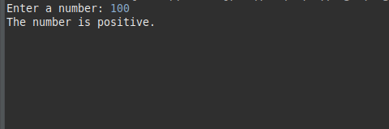

1. Write a program to find largest of two numbers.

public class Main

{

public static void main (String[]args)

{

int num1 = 50, num2 = 20;

if (num1 == num2)

System.out.println ("both are equal");

else if (num1 > num2)

System.out.println (num1 + " is greater");

else

System.out.println (num2 + " is greater");

} }

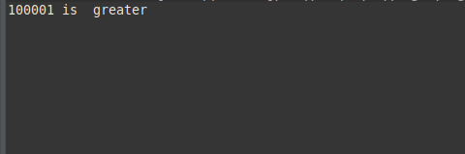

1. Write a program to check given number is even or odd. (Hint: use % operator)

import java.util.Scanner;

public class EvenOdd {

public static void main(String[] args) {

Scanner reader = new Scanner(System.in);

System.out.print("Enter a number: ");

int num = reader.nextInt();

if(num % 2 == 0)

System.out.println(num + " is even");

else

System.out.println(num + " is odd");

}

}

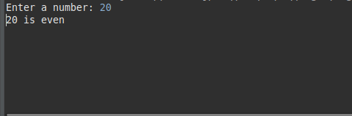

for..loop

1. Write a program to print 10 odd numbers.

public class First10OddNaturalNum1 {

public static void main(String[] args) {

System.out.println("The First 10 Odd Natural Numbers are");

for(int i = 1; i <= 10; i++)

{

System.out.println(2 * i - 1);

} } }

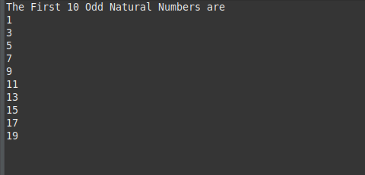

1. Write a program to print 10 even numbers.

public class First10EvenNaturalNum1 {

public static void main(String[] args) {

System.out.println("The First 10 Even Natural Numbers are");

for(int i = 1; i <= 10; i++) {

System.out.println(2 * i);

} } }

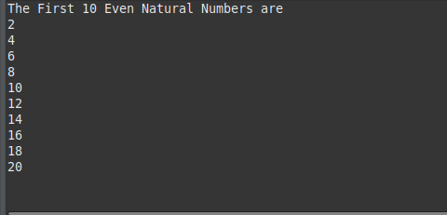

1. Write a program to find factorial of a number.

public class Factorial {

public static void main(String[] args) {

int num = 7;

long factorial = 1;

for(int i = 1; i <= num; ++i)

{

*// factorial = factorial * i;*

factorial *= i;

}

System.out.printf("Factorial of %d = %d", num, factorial);

}

}

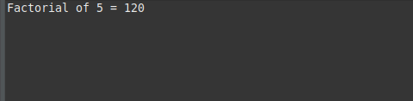

1. Write a program to generate tables of 10.

public class MultiplicationTable {

public static void main(String[] args) {

int num = 10;

for(int i = 1; i <= 10; ++i)

{

System.out.printf("%d * %d = %d \n", num, i, num * i);

}

}

}

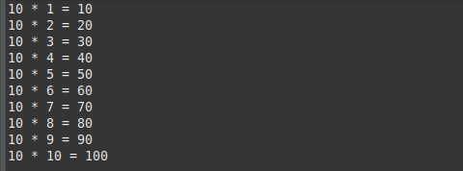

1. Write a program to add the digits of a number.

import java.io.*;

class AddNumber {

*// Function to get sum of digits*

static int getSum(int n)

{

int sum;

*// Single line that calculates sum*

for (sum = 0; n > 0; sum += n % 10, n /= 10) ;

return sum;

}

*// Driver code*

public static void main(String[] args)

{

int n = 687;

*// Function call*

System.out.println(getSum(n));

} }

1. Write a program to reverse the digits of a number.

class Main {

public static void main(String[] args) {

int num = 123456789, reversed = 0;

for(;num != 0; num /= 10) {

int digit = num % 10;

reversed = reversed * 10 + digit;

}

System.out.println("Reversed Number: " + reversed);

} }

1. Write a program to generate 10 Fibonacci numbers.

class Main {

public static void main(String[] args) {

int n = 12, firstTerm = 0, secondTerm = 1;

System.out.println("Fibonacci Series till " + n + " terms:");

for (int i = 1; i <= n; ++i) {

System.out.print(firstTerm + ", ");

*// compute the next term*

int nextTerm = firstTerm + secondTerm;

firstTerm = secondTerm;

secondTerm = nextTerm;

} } }

while..loop

1. Write a program to print 10 even numbers and 10 odd numbers.

public class First10EvenNaturalNum2 {

public static void main(String[] args) {

System.out.println("The First 10 Even Natural Numbers are");

int i = 1;

while( i <= 10)

{

System.out.println(2 * i);

i++;

} } }

public class First10OddNaturalNum2 {

public static void main(String[] args) {

System.out.println("The First 10 Odd Natural Numbers are");

int i = 1;

while( i <= 10)

{

System.out.println(2 * i - 1);

i++;

} } }

1. Write a program to find factorial of a number.

public class FactorialUsingWhileLoop {

public static void main(String[] args) {

*//declaring and intializing variables*

int num = 5;

int i = 1;

int output = 1;

*//counting the factorial using while loop*

while( i <= num ){

output = output * i;

//printing the result

System.out.println("\nFactorial of " + num + " is: " + output);

i++; //increment i by 1

}

System.out.println("\n Output : " + output);

} }

1. Write a program to generate tables of 10.

public class MultiplicationTable {

public static void main(String[] args)

{

int num = 10, i = 1;

while(i <= 10)

{

System.out.printf("%d * %d = %d \n", num, i, num * i);

i++;

} } }

1. Write a program to add the digits of a number.

import java.util.Scanner;

public class SumOfDigitsExample

{

public static void main(String args[])

{

int number, digit, sum = 0;

Scanner sc = new Scanner(System.in);

System.out.print("Enter the number: ");

number = sc.nextInt();

while(number > 0)

{

*//finds the last digit of the given number*

digit = number % 10;

*//adds last digit to the variable sum*

sum = sum + digit;

*//removes the last digit from the number*

number = number / 10;

}

System.out.println("Sum of Digits: "+sum);

} }

1. Write a program to reverse the digits of a number.

public class ReverseNumberExample1

{

public static void main(String[] args)

{

int number = 123456789, reverse = 0;

while(number != 0)

{

int remainder = number % 10;

reverse = reverse * 10 + remainder;

number = number/10;

}

System.out.println("The reverse of the given number is: " + reverse);

} }

1. Write a program to generate 10 Fibonacci numbers.

class Main {

public static void main(String[] args) {

int i = 1, n = 12, firstTerm = 0, secondTerm = 1;

System.out.println("Fibonacci Series till " + n + " terms:");

while (i <= n) {

System.out.print(firstTerm + ", ");

int nextTerm = firstTerm + secondTerm;

firstTerm = secondTerm;

secondTerm = nextTerm;

i++;

} } }

do..while loop

1. Write a program to print 10 even numbers and 10 odd numbers.

public class First10OddNaturalNum {

public static void main(String[] args) {

int i = 1;

System.out.println("The First 10 Odd Natural Numbers are");

do {

System.out.println(2 * i - 1);

}

while(++i <= 10);

}

}

public class First10EvenNaturalNum {

public static void main(String[] args) {

int i = 1;

System.out.println("The First 10 Even Natural Numbers are");

do {

System.out.println(2 * i );

}

while(++i <= 10);

}

}

1. Write a program to find factorial of a number.

*//importing Scanner class*

import java.util.Scanner;

public class FactorialUsingDoWhileLoop {

public static void main(String[] args) {

*//declaring and intializing variables*

int fact = 1;

int i = 1;

*//creating object of Scanner class*

Scanner sc = new Scanner(System.in);

*//accepting a number from the user*

System.out.println("Enter a number whose factorial is to be found: ");

int num = sc.nextInt();

*//counting the factorial using do-while loop*

do {

fact = fact * i;

i++;

} while( i <= num );

*//printing the result*

System.out.println("\nFactorial of " + num + " is: " + fact);

}

}

1. Write a program to generate tables of 10.

public class MultiplicationTable {

public static void main(String[] args)

{

int num = 10, i = 1;

do

{

System.out.printf("%d * %d = %d \n", num, i, num * i);

i++;

}

while(i <= 10);

} }

1. Write a program to add the digits of a number.

import java.util.Scanner;

public class SumOfDigitsExample

{

public static void main(String args[])

{

int number, digit, sum = 0;

Scanner sc = new Scanner(System.in);

System.out.print("Enter the number: ");

number = sc.nextInt();

do{

digit = number % 10;

sum = sum + digit;

number = number / 10;

}

while(number > 0) ;

System.out.println("Sum of Digits: "+sum);

} }

1. Write a program to reverse the digits of a number.

public class ReverseNumberExample1

{

public static void main(String[] args)

{

int number = 123456789, reverse = 0;

do

{

int remainder = number % 10;

reverse = reverse * 10 + remainder;

number = number/10;

}

while(number != 0) ;

System.out.println("The reverse of the given number is: " + reverse);

} }

1. Write a program to generate 10 Fibonacci numbers.

class Main {

public static void main(String[] args) {

int i = 1, n = 12, firstTerm = 0, secondTerm = 1;

System.out.println("Fibonacci Series till " + n + " terms:");

do

{

System.out.print(firstTerm + ", ");

int nextTerm = firstTerm + secondTerm;

firstTerm = secondTerm;

secondTerm = nextTerm;

i++;

}

while (i <= n); {

} } }