1) Design network configuration shown in Figure 5.29 for all parts. Connect all four VMs to a
single Ethernet segment via a single hub as shown in Figure 5.29. Configure the IP addresses for
the PCs as shown in Table 6.1.
Figure 5.29: Network Design
Table 5.1: IP Address of PCs
a. On PC1, view the ARP cache with show arp
b. Start Wireshark on PC1-Hub1 link with a capture filter set to the IP address of PC2.
c. Issue a ping command from PC1 to PC2:
PC1% ping 10.0.1.13 –c 3
Observe the ARP packets in the Wireshark window. Explore the MAC addresses in the
Ethernet headers of the captured packets.
Direct our attention to the following fields:
• The destination MAC address of the ARP Request packets.
• The Type Field in the Ethernet headers of ARP packets.
d. View the ARP cache again with the command arp -a. Note that ARP cache entries can get
refreshed/deleted fairly quickly (~2 minutes).
show arp
e. Save the results of Wireshark.

Ans:
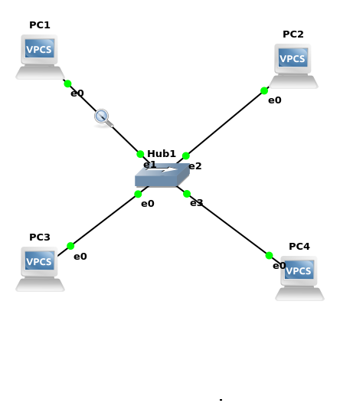
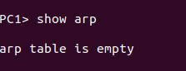
a)view the ARP cache with show arp

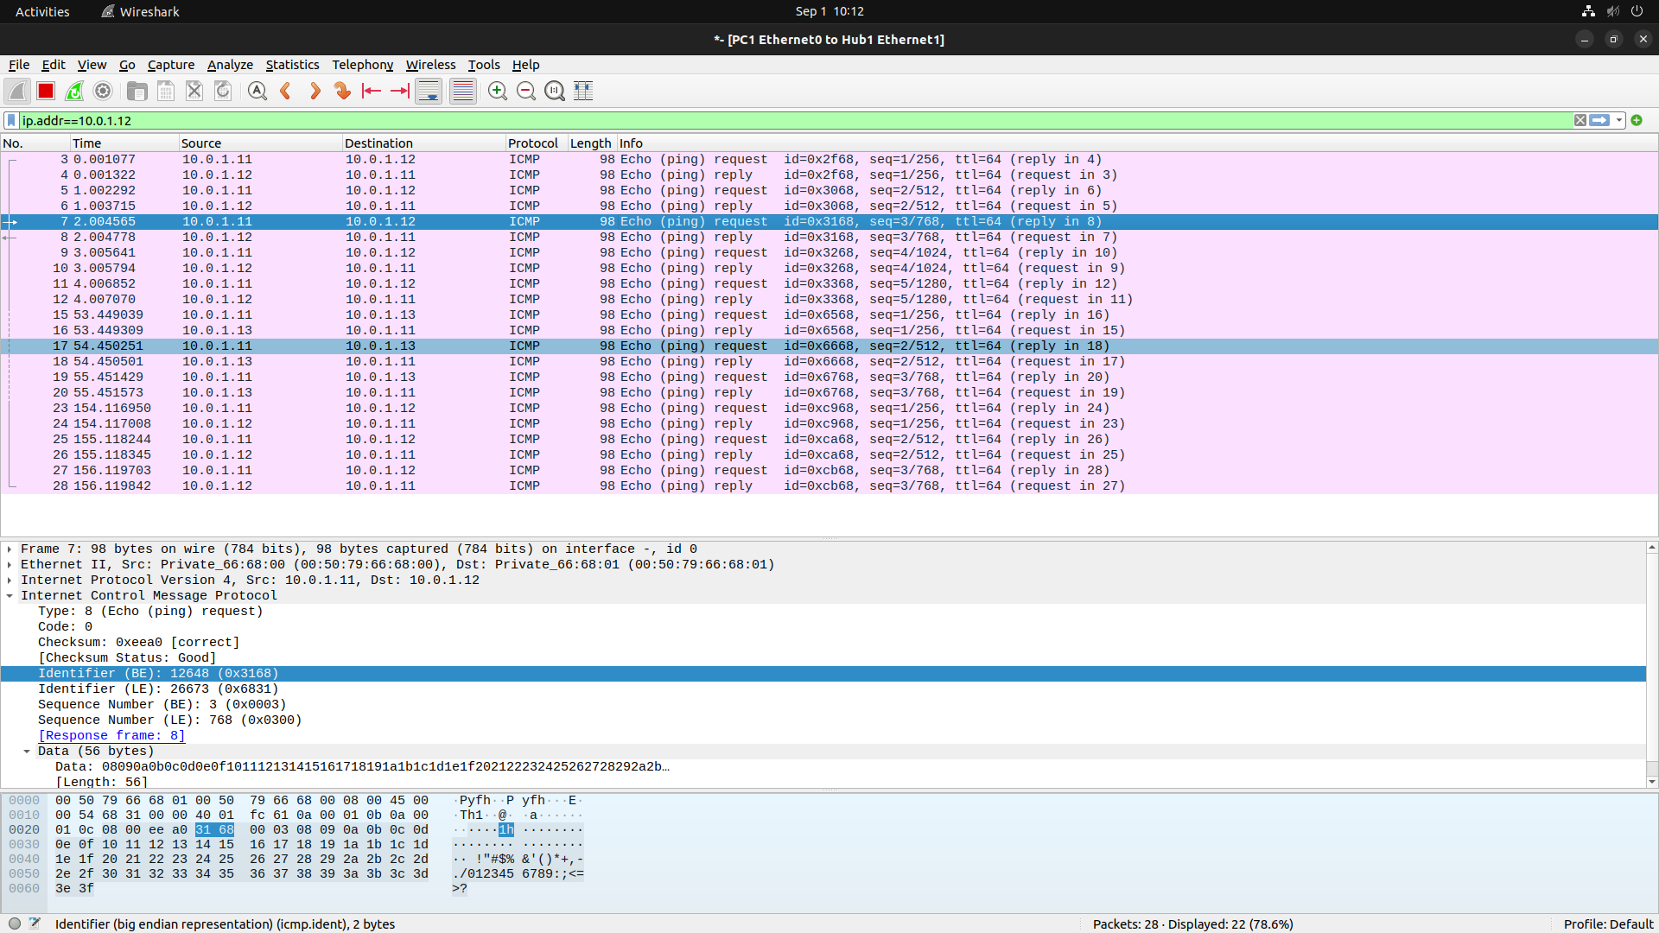
b)Start Wireshark on PC1-Hub1 link with a capture filter set to the IP address of PC2.

c)Issue a ping command from PC1 to PC2:
Observe the ARP packets in the Wireshark window. Explore the MAC addresses in the
Ethernet headers of the captured packets.
Direct our attention to the following fields:
• The destination MAC address of the ARP Request packets.
• The Type Field in the Ethernet headers of ARP packets.
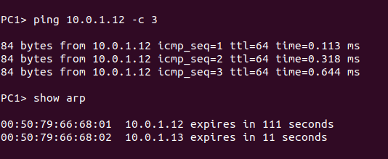
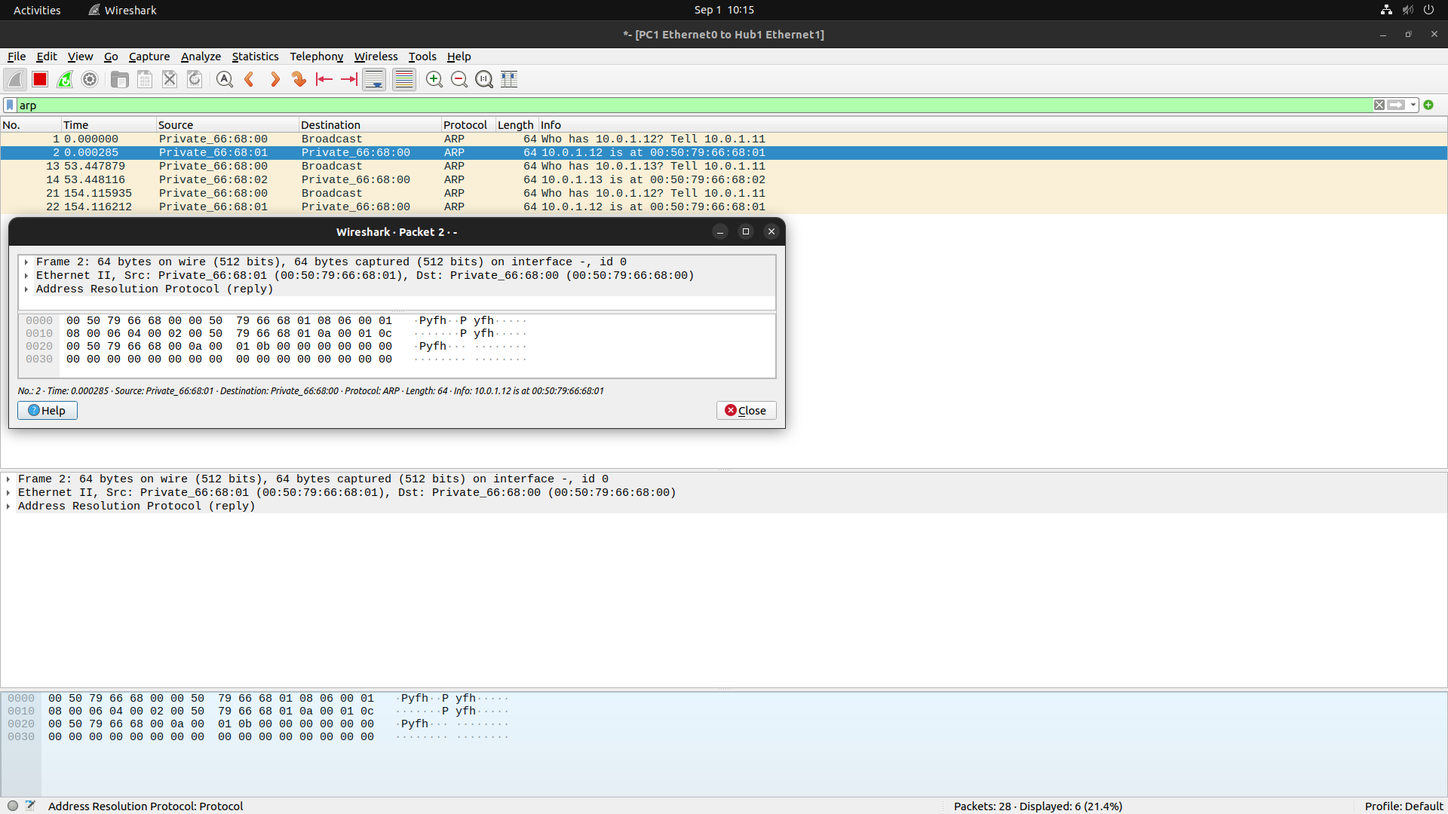

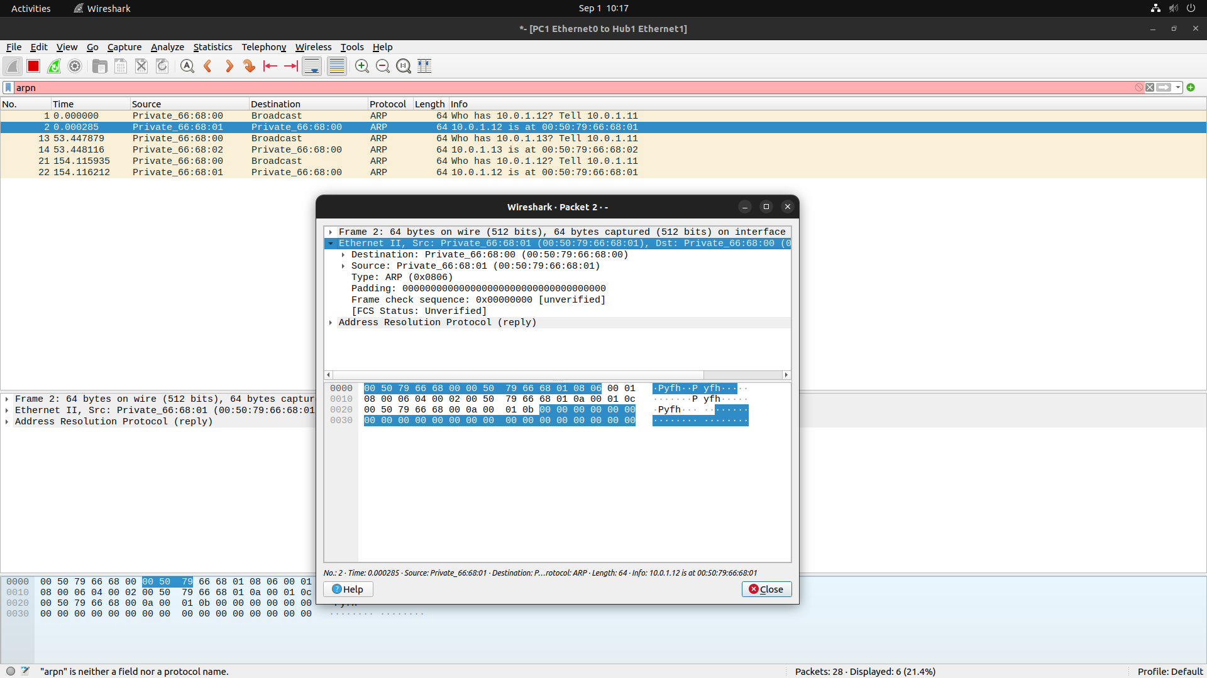

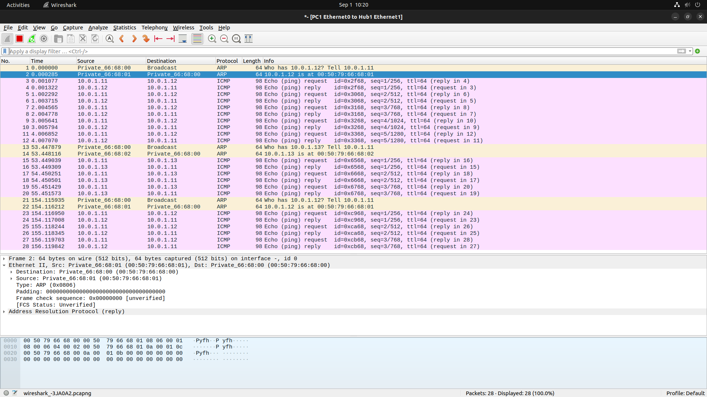
e)save results of wireshark
2) To observe the effects of having more than one host with the same (duplicate) IP address
in a network.
After completing Exercise 1, the IP addresses of the Ethernet interfaces on the four PCs are as
shown in Table 6.2 below. Note that PC1 and PC4 are assigned the same IP address.

a. Delete all entries in the ARP cache on all PCs.
b. Run Wireshark on PC3-Hub1 link and capture the network traffic to and from the duplicate IP
address 10.0.1.11.
c. From PC3, issue a ping command to the duplicate IP address, 10.0.1.11, by typing
PC3% ping 10.0.1.11 –c 5
d. Stop Wireshark, save all ARP packets and screenshot the ARP cache of PC3 using
the arp –a command:
PC3% arp – a
e. When you are done with the exercise, reset the IP address of PC4 to its original value as given
in Table 6.1.

Ans:
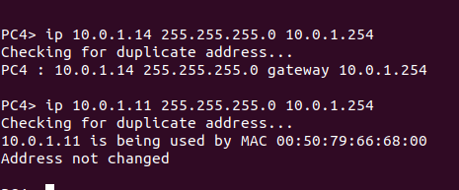

a)

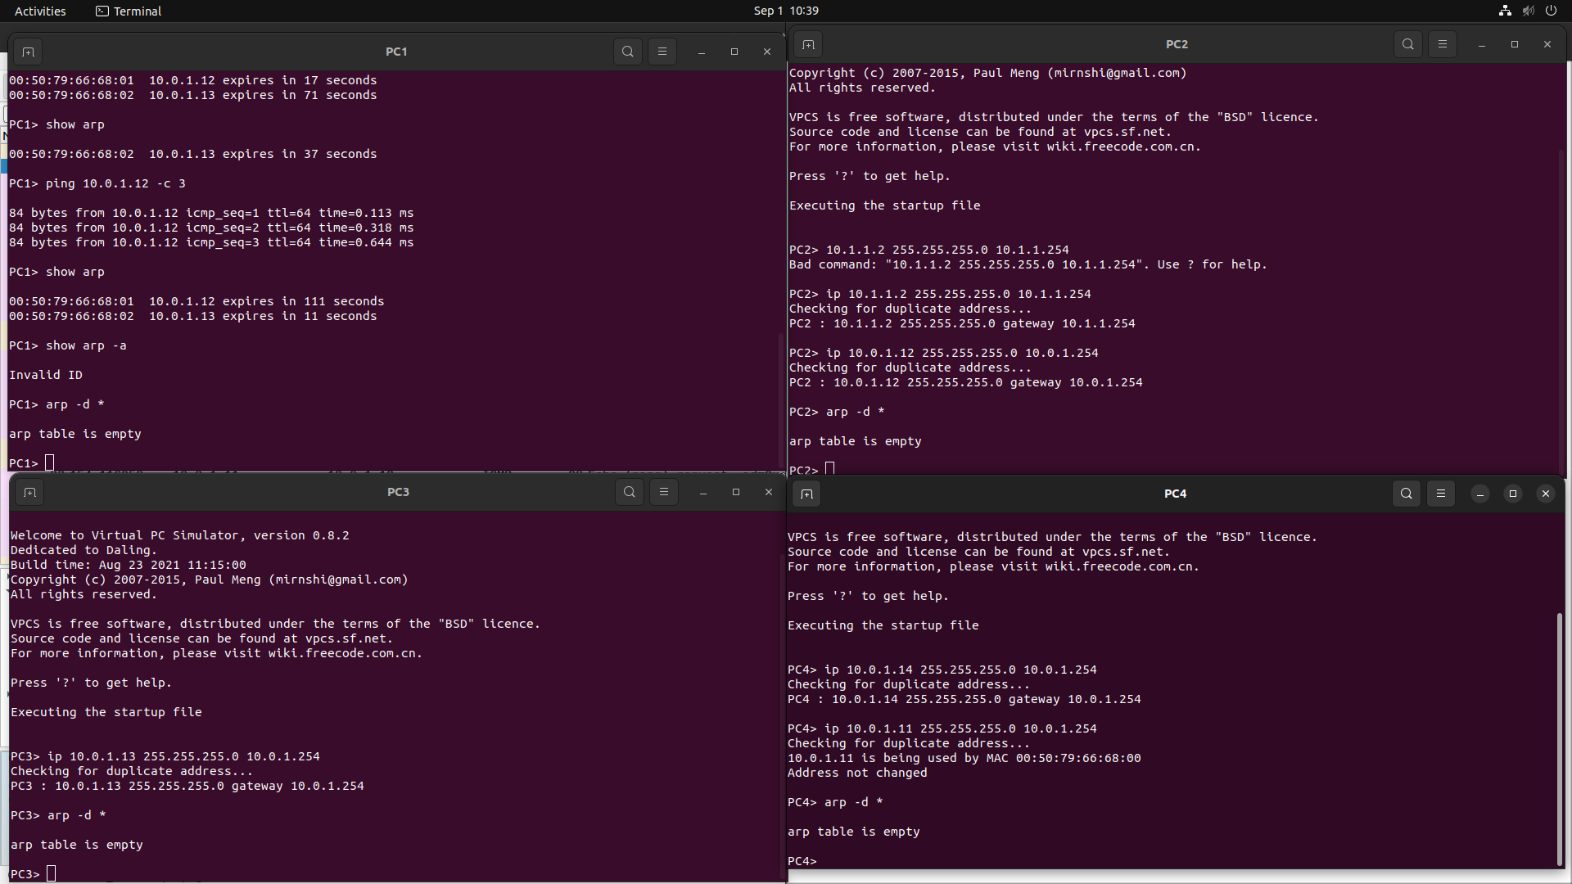
b,c,d)
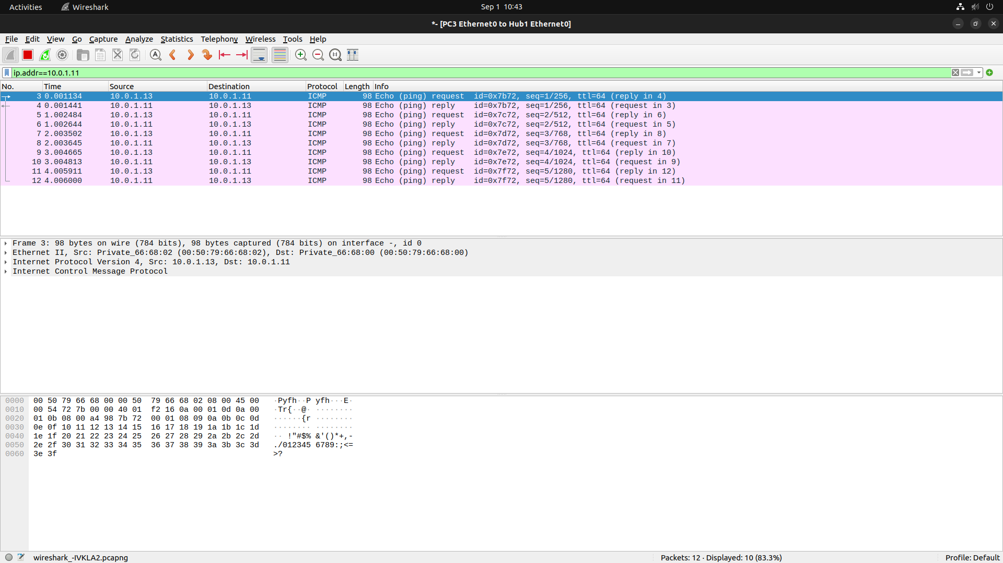
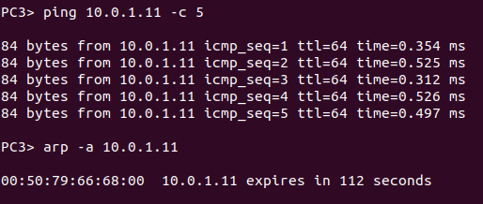
3. To test the effects of changing the netmask of a network configuration.
a. Design the configuration as Exercise 1 and replace the hub with a switch, two hosts (PC2
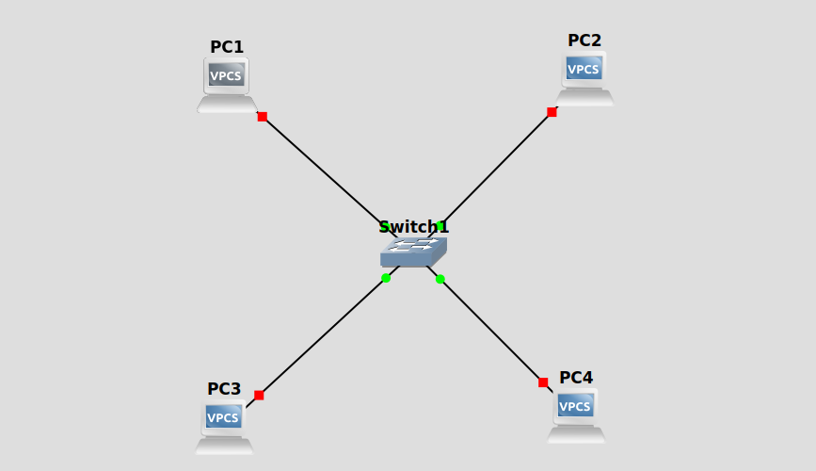
and PC4) have been assigned different network prefixes.
Setup the interfaces of the hosts as follows:
VPCS IP Address of eth0 Network Mask
PC110.0.1.100 / 24 255.255.255.0
PC210.0.1.101 / 28 255.255.255.240
PC310.0.1.120 / 24 255.255.255.0
PC410.0.1.121 / 28 255.255.255.240
b. Run Wireshark on PC1-Hub1 link and capture the packets for the following scenarios
i. From PC1 ping PC3.
PC1> ping 10.0.1.120

84 bytes from 10.0.1.120 icmp_seq=1 ttl=64 time=0.713 ms
84 bytes from 10.0.1.120 icmp_seq=2 ttl=64 time=0.904 ms
84 bytes from 10.0.1.120 icmp_seq=3 ttl=64 time=0.637 ms
84 bytes from 10.0.1.120 icmp_seq=4 ttl=64 time=0.840 ms
84 bytes from 10.0.1.120 icmp_seq=5 ttl=64 time=0.809 ms
ii. From PC1 ping PC2.
PC1> ping 10.0.1.101

84 bytes from 10.0.1.101 icmp_seq=1 ttl=64 time=0.587 ms
84 bytes from 10.0.1.101 icmp_seq=2 ttl=64 time=0.708 ms
84 bytes from 10.0.1.101 icmp_seq=3 ttl=64 time=0.641 ms
84 bytes from 10.0.1.101 icmp_seq=4 ttl=64 time=0.813 ms
84 bytes from 10.0.1.101 icmp_seq=5 ttl=64 time=0.747 ms
iii. From PC1 ping PC4.
PC1> ping 10.0.1.121

10.0.1.121 icmp_seq=1 timeout
10.0.1.121 icmp_seq=2 timeout
10.0.1.121 icmp_seq=3 timeout
10.0.1.121 icmp_seq=5 timeout
iv. From PC4 ping PC1.
host (255.255.255.240) not reachable
v. From PC2 ping PC4.
host (255.255.255.240) not reachable
vi. From PC2 ping PC3.
host (255.255.255.240) not reachable
c. Save the Wireshark output to a text file (using the “Packet Summary” option from “Print”) ,
and save the output of the ping commands. Note that not all of the above scenarios are
successful. Save all the output including any error messages.
d. When you are done with the exercise, reset the interfaces to their original values as given
Table 6.1. (Note that /24 corresponds to network mask 255.255.255.0. and /28 to network
mask 255.255.255.240).
PC1> ip 10.0.1.11/24
Checking for duplicate address...
PC1 : 10.0.1.11 255.255.255.0
PC2> ip 10.0.1.12/24
Checking for duplicate address...
PC2 : 10.0.1.12 255.255.255.0
PC3> ip 10.0.1.13/24
Checking for duplicate address...
PC3 : 10.0.1.13 255.255.255.0
PC4> ip 10.0.1.14/24
Checking for duplicate address...
PC4 : 10.0.1.14 255.255.255.0

VII. EXERCISES
Based On Lab Question 1
• What is the destination MAC address of an ARP Request packet?
FF:FF:FF:FF:FF:FF
• What are the different Type Field values in the Ethernet headers that you observed?

• Use the captured data to analyze the process in which ARP acquires the MAC address for IP
address 10.0.1.12.
Based On Lab Question 2
• Explain how the ping packets were issued by the hosts with duplicate addresses.
• Did the ping command result in error messages?
• How can duplicate IP addresses be used to compromise the data security?
• Give an example. Use the ARP cache and the captured packets to support your explanation.
Based On Lab Question 3
• Use your output data and ping results to explain what happened in each of the ping commands.
• Which ping operations were successful and which were unsuccessful? Why?

