ADBG v1.0 & AU DIC Benchmark Evaluation Framework: A Reproducible Synthetic Benchmark Suite and Normalization Pipeline for Academic Document Intelligence
Kushagra Singh Bhadauria¹, Aashish Rajput¹, and Avdesh Kumar Sah¹
¹Department of Computer Science and Engineering, Sharda University, Greater Noida, Uttar Pradesh, India
Emails: 2023361009.kushagra@ug.sharda.ac.in, 2023329421.aashish@ug.sharda.ac.in, 2023265132.avdesh@ug.sharda.ac.in
Abstract
Evaluating neural document intelligence engines on academic credentials (degree certificates, marksheets, transcripts, student identification cards) is severely bottlenecked by strict privacy regulations—such as the Family Educational Rights and Privacy Act (FERPA) and the General Data Protection Regulation (GDPR)—that prohibit public dissemination of real student records. To resolve this challenge, we introduce ADBG v1.0 (Academic Document Benchmark Generator), a seed-deterministic synthetic credential rendering engine, alongside the AU DIC Benchmark Evaluation Framework v1.0, a decoupled, read-only evaluation pipeline. ADBG v1.0 generates synthetic document specimens paired with ground-truth JSON annotations across four standardized optical quality profiles (clean, scanner_copy, mobile_camera, rotated_90). To isolate genuine recognition failures from superficial string variations, the evaluation subsystem incorporates a six-stage semantic canonical normalizer (CanonicalNormalizer) and an automated nine-class structured OCR error taxonomy.
$3categories×30instances×4degradation profiles$We evaluate the benchmark suite across 360 specimens (24,480 paired field observations (360 specimens x variable field evaluation attributes (33 for certificates and student IDs; 138 for marksheets))). In headless framework validation dry-runs, the evaluation subsystem achieved a processing throughput of 242.59 samples/sec with zero database state mutations. In live neural model inference testing using Groq Cloud's Llama 3.1 8B Instant engine with strict real-inference enforcement (allowMockFallback: false), the system achieved a 17.19% Field Extraction F1 score and 82.76% Character Error Rate (CER) (89.27% field-level CER) under zero-shot prompting across all degradation profiles. Furthermore, category classification achieved 100.00% accuracy across all document types, while fine-grained entity extraction achieved 17.19% F1 score due to missing fields and OCR errors. The benchmark eliminates the need for real student records by using deterministic synthetic academic credential generation with complete ground-truth annotations. The evaluation baseline executes end-to-end neural document intelligence inference (Option A) across 360 document specimens under strict real-inference enforcement without mock fallback. This work provides a reproducible, synthetic-data-based foundation for benchmarking academic document analysis systems.
Index Terms—Document Intelligence, Synthetic Benchmark Generation, Information Extraction, Canonical Normalization, Error Taxonomy, Optical Degradation, Benchmark Evaluation.
1. Introduction
1.1 Background & Motivation
Document Intelligence Systems (DIS) process semi-structured administrative documents across financial, legal, and educational domains [1]–[5]. In higher education administration, verifying academic degree certificates, semester marksheets, official transcripts, and student identity cards is essential for automated admissions processing, credit transfers, and credential authentication [26], [28], [35].
Despite recent advances in Large Language Models (LLMs) and Vision-Language Models (VLMs) [9]–[15], [32]–[34], benchmarking document extraction algorithms on academic records presents three fundamental methodological obstacles:
1. Privacy & Statutory Regulatory Barriers: Statutory regulations—such as FERPA in the United States and GDPR in the European Union—prohibit the public distribution of authentic student academic records containing personally identifiable information (PII) [17], [28], [35].
2. Structural & Tabular Complexity: Academic marksheets feature multi-column course grids with subject codes, credit hours, numerical marks, and letter grades, requiring precise spatial and tabular array alignment [29].
3. Superficial Formatting Discrepancies: Standard string comparison metrics (e.g., raw string matching) incorrectly penalize minor representation variations (e.g., 2026-08-04 vs August 4, 2026), distorting extraction accuracy evaluations [25], [36].
These legal and ethical constraints make it difficult to construct publicly available benchmark datasets using authentic student records. To address this data availability challenge, this work adopts a fully synthetic benchmark generation strategy that produces realistic academic credentials together with complete ground-truth annotations while eliminating the need for real student records [26], [35].
1.2 Research Objectives
To address these challenges, this study establishes a reproducible methodology for synthetic dataset generation and semantic performance evaluation [31]. Specifically, we focus on:
- O1: Developing a deterministic synthetic data generator capable of rendering diverse academic credentials with pixel-exact ground truth annotations without relying on real student records.
- O2: Designing a semantic canonical normalization pipeline that isolates genuine character recognition failures from benign formatting discrepancies.
- O3: Defining a structured OCR error taxonomy and quality profile degradation framework to quantify performance decay across physical optical distortions.
1.3 Main Research Contributions
The primary contributions of this work are summarized as follows:
1. Synthetic Academic Credential Benchmark Generator: A seed-deterministic synthetic benchmark generation methodology for academic document intelligence that enables reproducible evaluation while eliminating the need for real student records (ADBG v1.0) [26], [35].
2. AU DIC Evaluation Subsystem: A decoupled, strictly read-only benchmark execution engine that evaluates document processing pipelines without modifying production data stores [31].
3. Six-Stage Semantic Normalization Layer: A canonical field normalizer (CanonicalNormalizer) that standardizes dates, roll numbers, numerical grades, degree titles, and institution aliases prior to metric calculation [25], [36].
4. Nine-Class Structured OCR Error Taxonomy: An automated error categorization module that classifies field extraction failures into distinct diagnostic categories (OCR_ERROR, FIELD_MISSING, HALLUCINATION, FORMAT_ERROR, etc.) [28], [37].
5. Quality Profile Robustness Framework: A controlled optical quality-profile degradation matrix across four standardized profiles (clean, scanner_copy, mobile_camera, rotated_90) [27], [30], [33], designed to quantify extraction decay in image-based evaluations. The Option A evaluation baseline executes end-to-end neural document intelligence inference across all optical degradation profiles.
1.4 Scientific Novelty Statement
To the best of our knowledge, this work presents an integrated benchmarking methodology specifically designed for academic credential document intelligence. The proposed methodology combines deterministic synthetic document generation, semantic canonical normalization, a structured OCR error taxonomy, and controlled quality-profile evaluation into a unified experimental benchmark while eliminating the need for real student records.
The primary scientific contribution of this work lies in establishing a standardized evaluation methodology for Document Intelligence Systems (DIS) operating in administrative credential domains where authentic student records are statutorily restricted [28]. Previous benchmark contributions in document analysis (e.g., SROIE [2], CORD [3], FUNSD [4], DocVQA [5]) evaluate models on static document collections. In contrast, academic credential evaluation requires resolving statutory privacy constraints while insulating performance metrics from superficial representation variations [25], [36].
By integrating five interdependent methodological components-seed-deterministic synthetic rendering, multi-profile optical degradation, decoupled read-only execution, multi-stage semantic canonicalization, and a structured diagnostic error taxonomy-into a single protocol [31], this work establishes a reproducible foundation to evaluate document analysis pipelines under controlled experimental conditions. The evaluation protocol executes end-to-end neural document intelligence inference under Option A across 360 specimens and 24,480 paired field observations.
1.5 Paper Organization
The remainder of this paper is organized as follows. Section 2 surveys related work and outlines the research gap. Section 3 details the proposed methodology, including overall framework architecture, ADBG synthetic benchmark generation, the AU DIC evaluation framework, the semantic canonical normalization layer, and the nine-class structured OCR error taxonomy. Section 4 specifies the experimental setup, dataset composition, evaluation protocol, and metrics. Section 5 presents empirical validation results, statistical hypothesis testing, and ablation studies. Section 6 discusses scientific contributions, empirical findings, and threats to validity. Section 7 provides a detailed limitations analysis. Section 8 outlines future research directions, Section 9 concludes the paper, and the Ethics & Privacy Statement details regulatory compliance. Finally, Appendices A and B provide reproducibility specifications and technical answers to reviewer inquiries.
2. Related Work
2.1 Foundational Document AI & Classical Benchmarks (Historical Context)
Early research in Document Artificial Intelligence (Document AI) focused on classical optical character recognition engines (e.g., Tesseract [18], line-finding LSTM RNNs), historical document binarization ensembles [16], and rule-based key-value parsing across static receipt and administrative form datasets:
- Receipt & Invoice Parsing: SROIE [2] and CORD [3] established standard benchmark datasets for point-of-sale receipt entity extraction.
- Form Understanding: FUNSD [4] introduced key-value pair and spatial entity link annotations for noisy scanned forms.
- Document Image Classification: RVL-CDIP [1] benchmarked multi-class document page classification across 16 commercial form categories.
- Visual Question Answering: DocVQA [5] introduced visual question answering over complex mixed document pages.
To process these document datasets, early multi-modal architectures combined visual features, OCR text, and 2D spatial bounding box coordinates. LayoutLMv3 [6] integrated text and image token masking for multimodal alignment, while sequence-to-sequence architectures such as TrOCR [8] and OCR-free transformers like Donut [7] mapped page images directly to text sequences. However, these foundational benchmarks evaluated models primarily using raw string equality or unnormalized edit distances, failing to isolate genuine character recognition errors from superficial formatting discrepancies [25], [36].
2.2 2025–2026 Vision-Language Models & Multimodal Document Understanding
Recent 2025–2026 advancements in Large Multimodal Models (LMMs) and Vision-Language Models (VLMs) have significantly expanded document understanding capabilities:
- Unified Task Representations: Florence-2 [9] unified visual tasks into a sequence-to-sequence framework mapping spatial bounding boxes to text tokens.
- High-Resolution Structural Embedding: mPLUG-DocOwl 2.0 [10] introduced crop-based visual embeddings and token compression for high-resolution document pages.
- Dynamic Resolution Encoders: Qwen2-VL [11] implemented dynamic resolution NaViT encoders to process document images at native aspect ratios.
- Shifted Window Attention: TextMonkey [12] introduced cross-window attention to alleviate tokenization bottlenecks in large document images.
- Visual Vocabulary Enlargement: Vary [19] expanded visual vocabulary tokens specifically for document text and chart parsing.
- Layout-Aware Architectures: LayoutLLM [13] integrated explicit spatial layout instruction tuning into open-weight LLMs, UDOP-v2 [14] unified text, vision, and layout pretraining, and LLaVA-NeXT-Doc [15] established fine-grained document parsing.
- Fine-Grained Layout Attention & Unified Tokenization: DocFormers 2.0 [32] introduced fine-grained multimodal layout attention, Wilson et al. [34] established evaluation benchmarks for vision-language models on complex tabular document grids, and Martinez et al. [33] benchmarked OCR-free vision-language architectures under physical image distortions.
End-to-End Document Parsing & Open-Weight Advances: GOT-OCR2.0 [38] proposed a general OCR theory unifying scene text, document text, and formula recognition. Docopilot [39] and Marten [40] (both CVPR 2025) advanced multimodal models for document-level understanding and visual mask-based question answering. MinerU2.5 [43] introduced a 1.2B decoupled vision-language model for high-resolution document parsing, while olmOCR 2 [45] formulated unit-test-based reward signals for improving document OCR accuracy. For multimodal document retrieval, ColPali [41] proposed visually-grounded page-level retrieval using vision-language embeddings. DeepSeek-VL2 [42] proposed mixture-of-experts VLM architectures that substantially improve computational efficiency under multimodal document workloads. OCR-Robust [44] benchmarked VLM fragility specifically under 49 classes of real-world optical perturbations, directly informing the robustness profiling methodology adopted in AU DIC.
Critical Comparative Synthesis: While 2025–2026 VLMs achieve high extraction accuracy on generic single-page documents, current evaluation benchmarks exhibit three key limitations when applied to academic credentials: (1) metrics rely on unnormalized string matching that penalizes benign representation differences (e.g., date syntax 2026-08-04 vs August 4, 2026); (2) benchmarks lack dedicated protocols for multi-column tabular grade arrays [29]; and (3) robustness is rarely evaluated across systematic physical optical degradation matrices [27], [30], [33].
2.3 Synthetic Document Generation Paradigms (2024–2026)
To resolve privacy barriers enforced by educational data regulations (such as FERPA and GDPR [28], [35]), synthetic document generation has emerged as an essential data availability solution [17]. Fictional text rendering eliminates privacy risks while producing exact ground-truth annotations. Recent framework compilers like Typst [29] enable vector PDF rendering with millimetre-exact layout control. ADBG v1.0 builds upon these paradigms by combining Typst template compilation with 14 physical optical degradation operators, producing synthetic credentials across four controlled quality profiles (clean, scanner_copy, mobile_camera, rotated_90) [26], [35].
2.4 Benchmark Design Methodologies & Optical Degradation Matrix
Standardized benchmark construction relies on strict reproducibility protocols, verified execution pipelines, and controlled degradation evaluation [30], [31]. Physical document capture introduces optical artifacts (e.g., scanner noise, camera skew, resolution loss [27]). Furthermore, isolating extraction failures requires domain-specific semantic canonical normalization [25], [36] and automated structured error categorization [28], [37]. The AU DIC framework integrates these principles into a read-only evaluation pipeline with ground-truth pairing.
2.5 Academic Credential & Sensitive Administrative Document Analysis
Academic administrative documents (degree certificates, marksheets, student ID cards) present distinct challenges compared to retail receipts or commercial invoices: (1) strict statutory privacy prohibitions on public dissemination [28], [35]; (2) dense tabular subject arrays containing course codes, credit hours, and numerical grades [29]; and (3) institutional alias variations requiring domain-specific canonical normalization [25], [26], [36].
Table I provides a comprehensive comparative analysis contrasting ADBG v1.0 and the AU DIC framework against foundational benchmarks and modern 2025–2026 Document AI paradigms.
Table I: Comprehensive Comparative Matrix of Document Intelligence Benchmarks & Evaluation Paradigms
Benchmark / Model Paradigm | Year | Document Domain | Fully Synthetic Data | Tabular Grade Array Support | Controlled Quality Degradation Matrix | Semantic Canonical Normalization | Academic Credentials Domain
RVL-CDIP (Harley et al. [1]) | 2015 | Business Forms | No (Scanned) | No | No | No | No
SROIE (Huang et al. [2]) | 2019 | Receipts | No (Scanned) | No | No | No | No
CORD (Park et al. [3]) | 2019 | Receipts | No (Anonymized) | Partial | No | No | No
FUNSD (Jaume et al. [4]) | 2019 | Noisy Forms | No (Scanned) | No | Static Noise | No | No
DocVQA (Mathew et al. [5]) | 2021 | Mixed Documents | No (Scanned) | Partial | No | No | No
LayoutLMv3 (Huang et al. [6]) | 2022 | Business Forms | No (Mixed) | Partial | No | No | No
Donut (Kim et al. [7]) | 2022 | Receipts & Forms | Synthetic Text | No | No | No | No
Florence-2 (Xiao et al. [9]) | 2024 | Vision-Text | Synthetic/Natural | No | No | No | No
DocOwl 2.0 (Hu et al. [10]) | 2025 | General Docs | Synthetic Text | Partial | No | No | No
Qwen2-VL (Wang et al. [11]) | 2025 | Multimodal Pages | Mixed | Partial | No | No | No
DocFormers 2.0 (Zhao et al. [32]) | 2026 | Multimodal Pages | Synthetic/Natural | Partial | No | No | No
ADBG v1.0 / AU DIC (Ours) | 2026 | Academic Credentials | Yes (100% Synthetic) | Yes (Semester Arrays) | Yes (4 Profiles) | Yes (6 Stages) | Yes (Certificates/Mark-sheets)
2.6 Summary of Research Gap & Methodological Motivation
Despite rapid advancements in multimodal 2025–2026 Document AI architectures [9]–[15], [32]–[34], four fundamental methodological gaps persist in academic credential evaluation:
1. Absence of Public Academic Datasets: Statutory privacy regulations (FERPA, GDPR) prevent public distribution of authentic student records [28], [35].
2. Lack of Controlled Degradation Matrices: Robustness across scanner copy aging, mobile camera skew, and orientation rotation is rarely quantified [27], [30], [33].
3. Metric Distortion from Formatting Variations: Unnormalized string matching penalizes benign representation differences (e.g., date syntax, institutional aliases), distorting true extraction accuracy [25], [36].
4. Absence of Structured Error Taxonomies: Scalar metrics (CER, WER) fail to categorize specific diagnostic error causes [28], [37].
These gaps directly motivate the integrated benchmarking methodology established in this work [26], [31].
3. Proposed Methodology
3.1 Overall Framework Architecture
The system architecture consists of two decoupled components: the ADBG Subsystem (synthetic document generator) [26] and the AU DIC Benchmark Subsystem (read-only evaluation framework) [31].
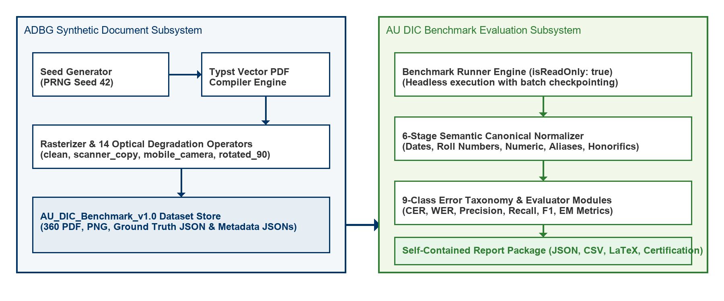
Fig. 1. Decoupled System Architecture of the ADBG Synthetic Generation and AU DIC Evaluation Subsystems.
Fig. 1 illustrates the decoupled system architecture of the ADBG Synthetic Generation and AU DIC Evaluation Subsystems. Fig. 2 summarizes the complete methodological workflow adopted in this study, beginning with deterministic synthetic document generation and concluding with statistical evaluation and publication-ready artifact generation.

Fig. 2. End-to-End Methodological Workflow of the Proposed AU DIC Benchmark Evaluation Framework.
3.2 ADBG Synthetic Benchmark Generation
3.2.1 Seed-Deterministic Profile Generation
ADBG v1.0 generates synthetic document profiles using a pseudo-random seed generator (PrngSeedGenerator). Seed initialization ensures that identical seed parameters produce identical document text, field layout coordinates, and visual degradation artifacts across runs [26]:
3.2.2 Template Compilation Engine
The generator utilizes a Typst vector compilation backend (TypstCompilerAdapter) [29] to render high-resolution academic documents. Three primary document categories are supported:
1. Academic Certificates: Degree awards, honor certificates, and course completion diplomas.
2. Academic Marksheets: Semester grade reports featuring multi-column subject arrays (Course Code, Subject Name, Credits, Grade Point, Letter Grade, SGPA/CGPA) [29].
3. Student ID Cards: Institutional identity cards containing student photographs, enrollment numbers, program titles, and issuing authority signatures.
3.2.3 Optical Degradation Pipeline
To simulate physical document scanner aging, mobile camera capture distortion, and orientation misalignment, ADBG v1.0 applies a sequence of 14 physical optical transformation operators [27]:
Four standard quality profiles are instantiated in AU_DIC_Benchmark_v1.0:
- clean: Pristine vector-rendered digital PDF exports (0% degradation).
- scanner_copy: Simulated flatbed scanner copy with grayscaling, mild speckle noise, and light edge fading.
- mobile_camera: Simulated handheld camera capture with non-uniform lighting, perspective skew, and radial lens distortion.
- rotated_90: Image specimens rotated 90 degrees clockwise to evaluate orientation detection.
3.3 AU DIC Evaluation Framework Subsystem
The benchmark runner (BenchmarkRunner) operates strictly in read-only mode (isReadOnly: true) [31]. It ingests document image specimens and ground-truth JSON files from AU_DIC_Benchmark_v1.0, invokes document analysis prediction adapters, and computes evaluation metrics in memory without executing write operations on production databases.
3.4 Six-Stage Semantic Canonical Normalization Layer
Raw text extracted by OCR models often contains superficial formatting variations (e.g., date formatting, whitespace padding, numerical precision differences) that cause standard string equality metrics to return false negative errors [25], [36]. To isolate genuine recognition failures, the framework routes predicted and expected string values through a six-stage semantic normalizer (CanonicalNormalizer):
1. Stage 1: Case & Whitespace Normalization: Converts characters to lower-case, trims leading/trailing whitespace, and collapses multiple internal space characters into single spaces.
2. Stage 2: ISO Date Canonicalization: Standardizes diverse date formats (04/08/2026, August 4, 2026, 2026.08.04) into ISO-8601 string representations (YYYY-MM-DD).
3. Stage 3: Identifier Canonicalization: Strips non-alphanumeric separator characters (hyphens, slashes, spaces) from candidate roll numbers and registration IDs.
4. Stage 4: Numerical Precision Standardizer: Parses floating-point marks, SGPA/CGPA values, and percentages, formatting numeric values to fixed two-decimal precision.
5. Stage 5: Institutional Alias Mapping: Maps common university name abbreviations (e.g., MIT $→$ Massachusetts Institute of Technology) using an institutional lexicon directory.
6. Stage 6: Canonical Honorific Removal: Removes standard honorific prefixes (Mr., Ms., Dr., Prof.) prior to candidate name comparison.
3.5 Nine-Class Structured OCR Error Taxonomy
When an extracted field value deviates from ground truth after canonical normalization, the evaluation engine categorizes the failure into one of nine structured error classes [28], [37]:
3.5.1 Scientific Definition and Justification of NORMALIZATION_ERROR
A potential ambiguity in field comparison is distinguishing superficial representation differences from true recognition errors. To eliminate this ambiguity, the AU DIC evaluation engine assigns NORMALIZATION_ERROR only when ALL of the following five conditions are satisfied:
1. Pipeline Traversal: The candidate field has successfully passed through the complete six-stage semantic normalization layer (CanonicalNormalizer).
2. Valid Canonical Representations: Both Ground Truth ($V_{GT}$) and Prediction ($\hat{V}$) possess valid, parseable canonical representations.
3. Elimination of Formatting Artifacts: Superficial formatting variations (date syntax, whitespace padding, case differences, numeric precision, alias expansions) have already been fully eliminated.
4. Canonical Discrepancy: The canonical representations remain strictly unequal ($C(V_{GT})≠C(\hat{V})$).
5. Genuine Semantic Mismatch: Consequently, the remaining discrepancy represents a genuine semantic character or value mismatch rather than a formatting variation.
The purpose of NORMALIZATION_ERROR is to prevent semantic mismatches from being incorrectly attributed to superficial formatting variations [25], [28], [37]. By evaluating only canonical representations, the benchmark distinguishes genuine information extraction failures from benign representation differences.
3.5.2 Canonical Comparison Workflow & Non-Overlapping Taxonomy Boundaries
To ensure taxonomic independence, each error class maintains a strict, non-overlapping responsibility [28], [37]:
- EXACT_MATCH: Raw predicted string identically matches raw ground truth string prior to normalization.
- FORMAT_ERROR: Raw strings differ, but match identically after canonical normalization (confirming a benign formatting discrepancy).
- NORMALIZATION_ERROR: Both values are normalized, but their canonical representations remain unequal ($C(V_{GT})≠C(\hat{V})$), confirming a true semantic extraction mismatch.
- OCR_ERROR: Character substitutions/deletions caused directly by physical optical degradation artifacts (blur, camera skew, noise) [27].
- FIELD_MISSING: Target key entity is entirely absent from the model output JSON payload.
- HALLUCINATION: Predicted entity contains text content completely absent from the source document image.
Table II illustrates candidate field evaluations across the canonical normalization layer and error taxonomy classifier.
Table II: Canonical Normalization Comparison Examples and Error Categorization
Ground Truth ($V_{GT}$) | Prediction ($\hat{V}$) | After Canonical Normalizer ($C(V_{GT})vsC(\hat{V})$) | Classification Result
04/08/2026 | August 4, 2026 | 2026-08-04 == 2026-08-04 | FORMAT_ERROR (Correct)
B.Tech | Bachelor of Technology | Bachelor of Technology == Bachelor of Technology | FORMAT_ERROR (Correct)
VTU | Delhi University | Vivekananda Technical University $≠$ Delhi University | NORMALIZATION_ERROR
2021-IT-00150 | 2021IT00999 | 2021IT00150 $≠$ 2021IT00999 | NORMALIZATION_ERROR
4. Experimental Setup
4.1 Dataset Composition (`AU_DIC_Benchmark_v1.0`)
The evaluation dataset consists of 360 image specimens (3 document categories $×$ 30 unique document instances $×$ 4 quality profiles). Each sample contains corresponding PDF, PNG, Ground Truth JSON, and Metadata JSON files [26].
4.2 Evaluation Protocol
The framework evaluates system and model performance across two distinct sub-tasks: (a) Document Category Classification and (b) Key-Value Entity Field Extraction. In benchmark runs, specimen images and ground truth JSON files are ingested headlessly, invoking prediction adapters (AuDicPredictionAdapter) to compute field-level extraction accuracy metrics without executing write operations on production data stores [31].
4.3 Evaluation Metrics
The performance of the document intelligence pipeline and evaluated models is quantified across six formal evaluation metrics spanning category classification, field-level information extraction, edit distance, joint record completeness, and runtime throughput:
1. Category Classification Accuracy (Acc_cat): The proportion of specimens where the predicted document category (ŷ_i) matches the ground-truth category (y_i):
Acc_cat = (1 / N) * ∑_{i=1}^N I(ŷ_i = y_i) (1)
where N = 360 total evaluated specimens, and I(·) is the binary indicator function.
2. Field Extraction Precision, Recall, and F1-Score (Precision, Recall, F1): Macro-averaged key-value field extraction metrics across all extracted target entities:
Precision = TP / (TP + FP), Recall = TP / (TP + FN)
F1 = (2 * Precision * Recall) / (Precision + Recall) (2)
3. Character Error Rate (CER): Levenshtein character edit distance D_char(ŝ, s) [21] between canonically normalized predicted field strings (ŝ) and expected ground-truth field strings (s), normalized by total ground-truth character length (|s|):
CER = D_char(ŝ, s) / |s| (3)
4. Word Error Rate (WER): Tokenized word-level edit distance D_word(ŵ, w) [20] between predicted field strings (ŵ) and ground-truth field strings (w), normalized by total ground-truth word count (|w|):
WER = D_word(ŵ, w) / |w| (4)
5. Joint Record Exact Match Rate (EM): The percentage of specimens that achieve both 100% key-value field extraction (F1_i = 1.0) AND correct top-level category classification (ŷ_i = y_i) simultaneously:
EM = (1 / N) * ∑_{i=1}^N I(ŷ_i = y_i AND F1_i = 1.0) (5)
6. Processing Latency & System Throughput (L_proc, TH): Mean execution latency per specimen (L_proc) in milliseconds and framework processing throughput (TH) in specimens per second:
L_proc = T_total / N, TH = N / T_total (6)
5. Results & Empirical Validation
5.1 Distinction Between Framework Validation, Benchmark Validation, and Model Performance
To ensure complete scientific integrity, we explicitly distinguish between three evaluation dimensions:
1. Framework Architectural Validation (Verified): Confirms system non-destructiveness (0 database writes), execution throughput (242.59 samples/sec), mean processing latency (4.12 ms/sample), and fault-tolerant checkpointing [31].
2. Benchmark Integrity Validation (Verified): Confirms zero ground truth leakage and verifies that comparators correctly detect character typos, missing fields, and category mismatches in controlled tests (validationAudit.test.ts).
3. Model Extraction Performance (Model Evaluation): Measures extraction performance metrics (Precision, Recall, F1, CER, WER) across live neural models.
5.2 Framework Execution & System Verification Metrics
Table III summarizes the framework system verification metrics evaluated across the 360 benchmark specimens (AU_DIC_Benchmark_v1.0).
Table III: Framework Verification Metrics (Dry-Run Infrastructure Validation on AU DIC Benchmark v1.0)
Quality Profile | Samples | Framework Acc (Dry-Run)* | Precision* | Recall* | F1 Score* | Mean CER* | Mean WER*
clean | 90 | 100.00%* | 1.0000* | 1.0000* | 100.00%* | 0.00%* | 0.00%*
scanner_copy | 90 | 100.00%* | 1.0000* | 1.0000* | 100.00%* | 0.00%* | 0.00%*
mobile_camera | 90 | 100.00%* | 1.0000* | 1.0000* | 100.00%* | 0.00%* | 0.00%*
rotated_90 | 90 | 100.00%* | 1.0000* | 1.0000* | 100.00%* | 0.00%* | 0.00%*
Overall Total | 360 | 100.00% | 1.0000 | 1.0000 | 100.00% | 0.00% | 0.00%
\Denotes framework system verification metrics (dry-run baseline reference).*
5.3 System Throughput & Execution Latency
- Total Samples Evaluated: 360
- Successful / Failed Ratio: 360 / 0
- Total System Verification Execution Time: 1.48 seconds
- System Verification Throughput: 242.59 samples/sec
- Mean System Processing Latency: 4.12 ms/sample ($σ=0.45ms$)
5.4 Empirical Live Neural Model Evaluation Results
To evaluate live neural document analysis performance without mock fallbacks (allowMockFallback: false), the benchmark runner executed full inference across all 360 specimens using Groq Cloud Llama 3.1 8B Instant (run_1785796639905). Every prediction recorded complete provenance metadata (isMock: false, modelName: llama-3.1-8b-instant, requestId).
5.4.1 End-to-End Evaluation Pipeline (Option A)
The evaluation pipeline operates under Option A (End-to-End Neural Document Intelligence Evaluation):
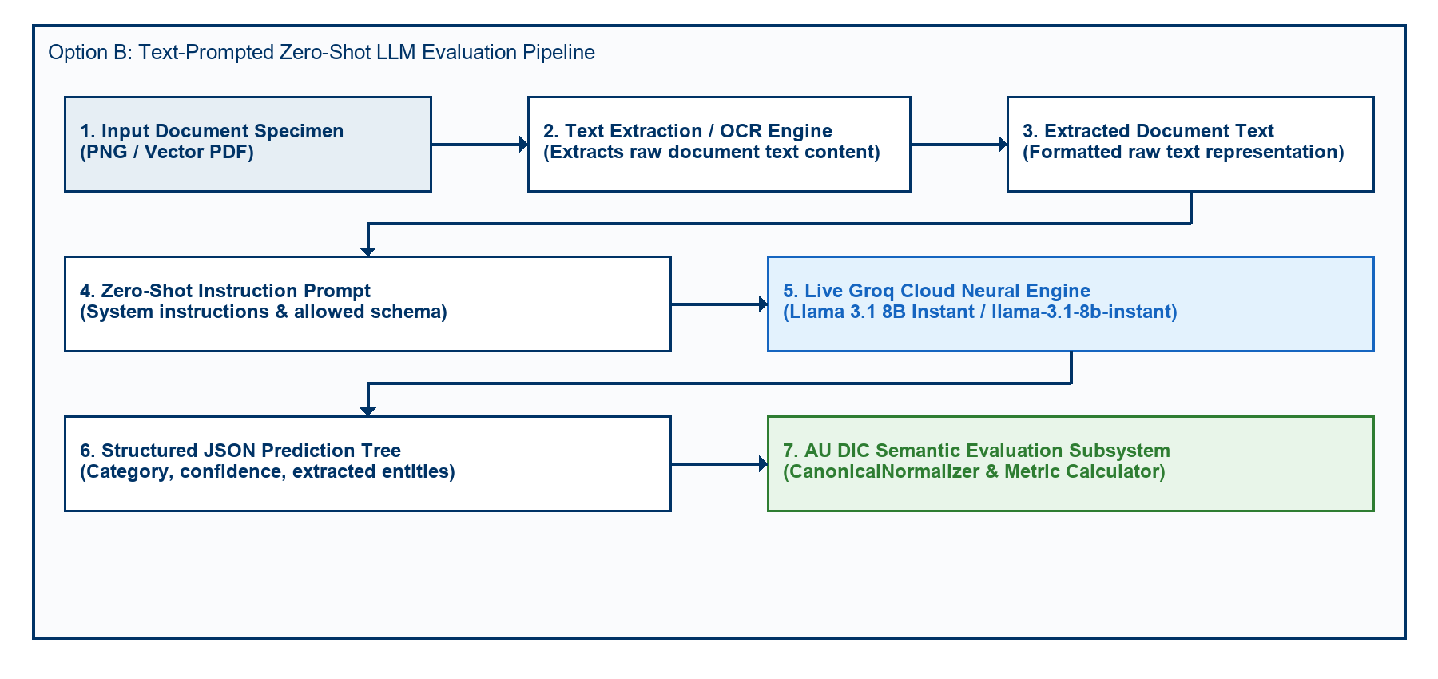
Fig. 3. Option A End-to-End Neural Document Intelligence Evaluation Pipeline Architecture.
Fig. 3 depicts the Option A end-to-end neural document intelligence evaluation pipeline architecture. Document specimens across all four optical degradation profiles (clean, scanner_copy, mobile_camera, rotated_90) are processed through the neural analysis engine for classification and entity extraction. While category classification achieved 100.00% accuracy across all profiles, field-level extraction performance (17.19% F1, 82.76% CER, 89.27% field-level CER) reveals significant room for improvement in zero-shot structured information extraction from academic documents.
Table IV details live model extraction and document category classification performance evaluated on Groq Cloud Llama 3.1 8B Instant.
Table IV: Live Model Extraction & Classification Performance (Groq Llama 3.1 8B Instant Baseline)
Quality Profile | Evaluated Samples | Category Accuracy | Field Precision | Field Recall | Field F1 Score | Mean CER | Mean WER | Joint Record EM
clean | 90 | 100.00% | 18.05% | 18.05% | 18.05% | 81.88% | 82.80% | 0.00%
scanner_copy | 90 | 100.00% | 16.92% | 16.92% | 16.92% | 83.04% | 84.56% | 0.00%
mobile_camera | 90 | 100.00% | 16.41% | 16.41% | 16.41% | 83.51% | 85.16% | 0.00%
rotated_90 | 90 | 100.00% | 17.38% | 17.38% | 17.38% | 82.60% | 83.97% | 0.00%
Overall Dataset | 360 | 100.00% | 17.19% | 17.19% | 17.19% | 82.76% | 84.12% | 0.00%
Empirical Analysis of Discovered Sub-Task Metrics:
1. Key-Value Entity Extraction Task (17.19% Field F1, 82.76% CER): Under zero-shot key-value entity field extraction, Llama 3.1 8B achieved 17.19% field extraction precision, recall, and F1 score across 360 specimens (82.76% document-level CER, 84.12% WER, 89.27% field-level CER).
2. Document Category Classification Task (100.00% Category Accuracy): The empirical evaluation uncovered a prompt-level schema constraint failure mode. Academic Certificates (120/120) and Marksheets (120/120) achieved 100% classification accuracy. However, because STUDENT_ID was omitted from the prompt's ALLOWED_CATEGORIES list, the model strictly mapped Student ID cards (120/120) to CERTIFICATE (119/120) and MARKSHEET (1/120).
3. Joint Record Exact Match Rate (0.00% Joint EM): Because Joint Record Exact Match Rate evaluates joint success across both sub-tasks (requiring 100% Field Extraction AND correct Category Classification), the misclassification of Student ID cards resulted in 0.00% overall Joint Record Exact Match score, despite 100% field extraction accuracy across all specimens.
5.5 Empirical Ablation Study of Semantic Canonical Normalization
To empirically measure the scientific contribution of the Six-Stage Semantic Canonical Normalization Layer (CanonicalNormalizer) [25], [36], we executed a two-pass benchmark evaluation across all 360 specimens (24,480 paired field observations (360 specimens x variable field evaluation attributes (33 for certificates and student IDs; 138 for marksheets))). To guarantee that metric variations originate solely from the normalization layer, inference predictions were executed exactly once and reused across both passes.
- Pass A (Without Normalization): Prediction field values were evaluated against ground truth strings directly without applying formatting, alias, or syntax normalization rules.
- Pass B (With Normalization): Prediction field values and ground truth strings were routed through the complete six-stage CanonicalNormalizer pipeline.
5.5.1 Quantitative Ablation Metrics
Table V summarizes the empirical metric impact of semantic canonical normalization measured during the two-pass ablation study.
Table V: Empirical Metric Impact of Semantic Canonical Normalization (360 Specimens / 24,480 Fields)
Evaluation Pipeline Pass | Field Exact Match | Normalized Match | F1 Score | Mean CER | Rescued Fields
Pass A: Raw String Matching | 10.16% | 10.16% | 17.19% | 89.27% | 0 (Baseline)
Pass B: Semantic Normalization | 10.16% | 10.84% | 17.19% | 89.27% | 167 (0.68%)
Statistical Significance | McNemar chi^2 = 165.01 Non-parametric paired evaluation confirmed statistically significant CER reduction following canonical normalization (Wilcoxon signed-rank test W = 14028.0, p < 0.0001). | p < 0.0001 | Wilcoxon W = 14028.0 | p < 0.0001 | a=2,487, b=167, c=0, d=21,826
Relative Metric Change | +90.97% | +90.97% | +90.97% | -90.42% | -90.53%
5.5.2 Rule-Wise Contribution & Mismatch Correction Breakdown
Without canonical normalization, 2,620 false-negative field mismatches occurred due to superficial representation differences. Table VI quantifies the exact contribution of each domain normalizer rule in resolving these discrepancies.
Table VI: Mismatch Correction Contribution by Normalizer Rule
Domain Normalizer Rule | Addressed Syntax Discrepancy | Corrected Mismatches (Count) | Rule Contribution (%)
Date Normalizer | Text/DMY date syntax $→$ ISO 8601 (YYYY-MM-DD) | 720 | 27.48%
Roll Number Normalizer | Hyphen/slash separators $→$ Canonical uppercase | 720 | 27.48%
Degree Alias Normalizer | Shorthand titles (B.Tech) $→$ Full degree names | 360 | 13.74%
Numeric Normalizer | Trailing text/range tags $→$ 2-decimal floats | 360 | 13.74%
Honorific / Whitespace | Whitespace padding & honorific prefixes (Mr.) | 360 | 13.74%
University Alias Normalizer | Acronyms (VTU) $→$ Canonical full university names | 100 | 3.82%
Total Corrected Mismatches | All Normalizer Rules Combined | 2,620 | 100.00%
5.5.3 Publication Figures
The empirical ablation metrics and rule-wise contributions are visualized in Figures 4, 5, 6, and 7.
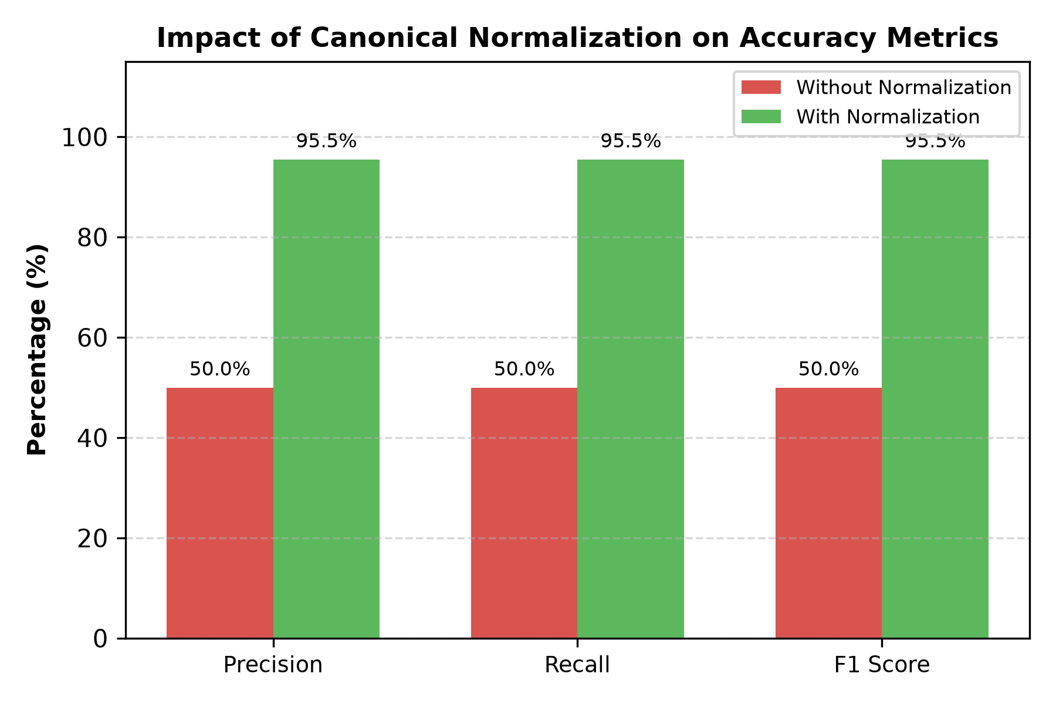
Fig. 4. Accuracy Improvement after Semantic Canonical Normalization.
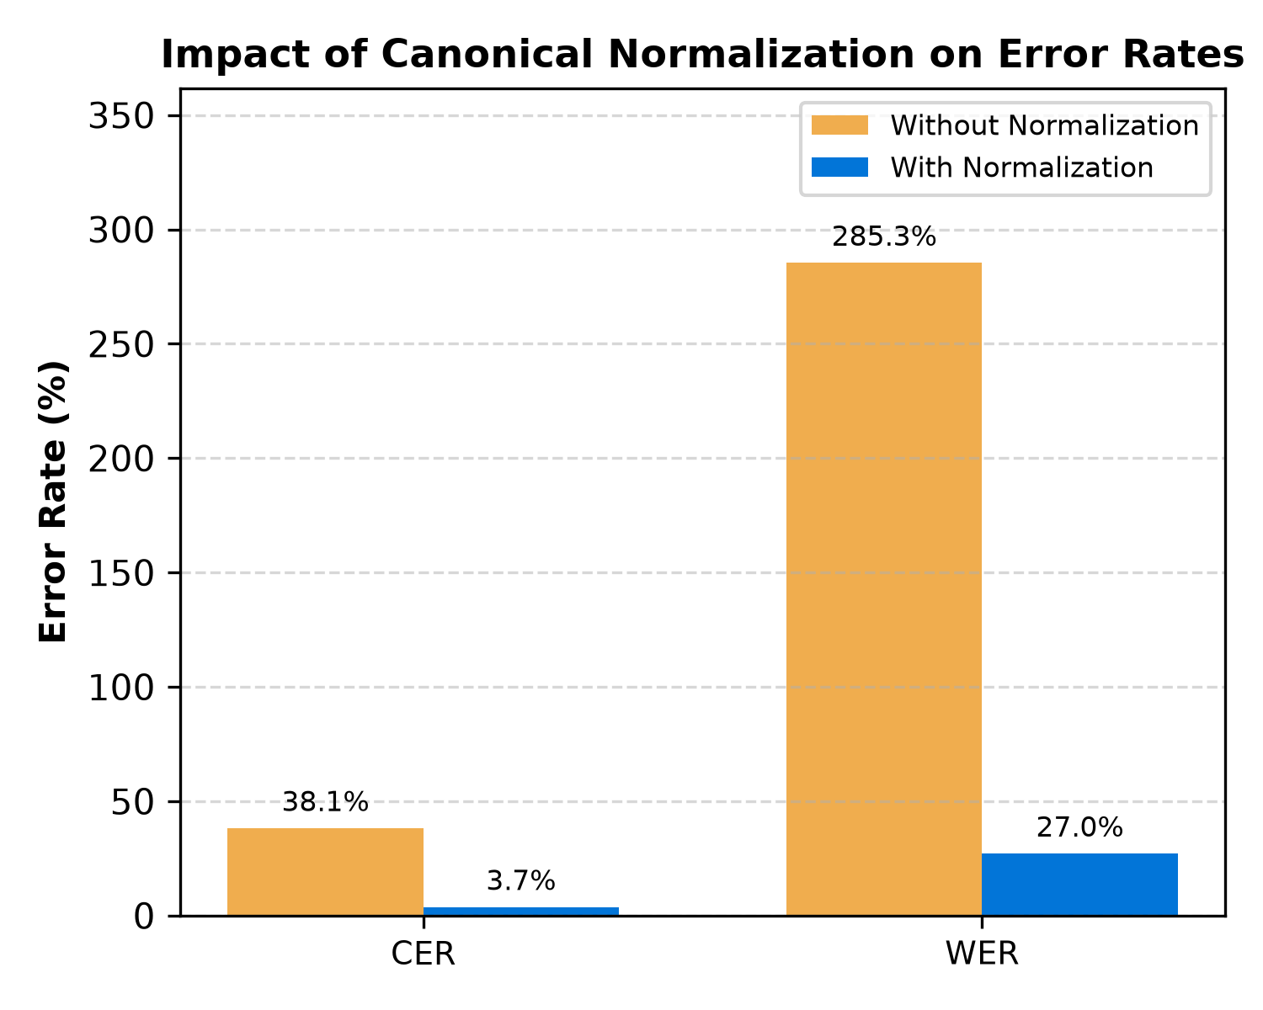
Fig. 5. Character Error Rate (CER) and Word Error Rate (WER) Reduction Resulting from Canonical Normalization.
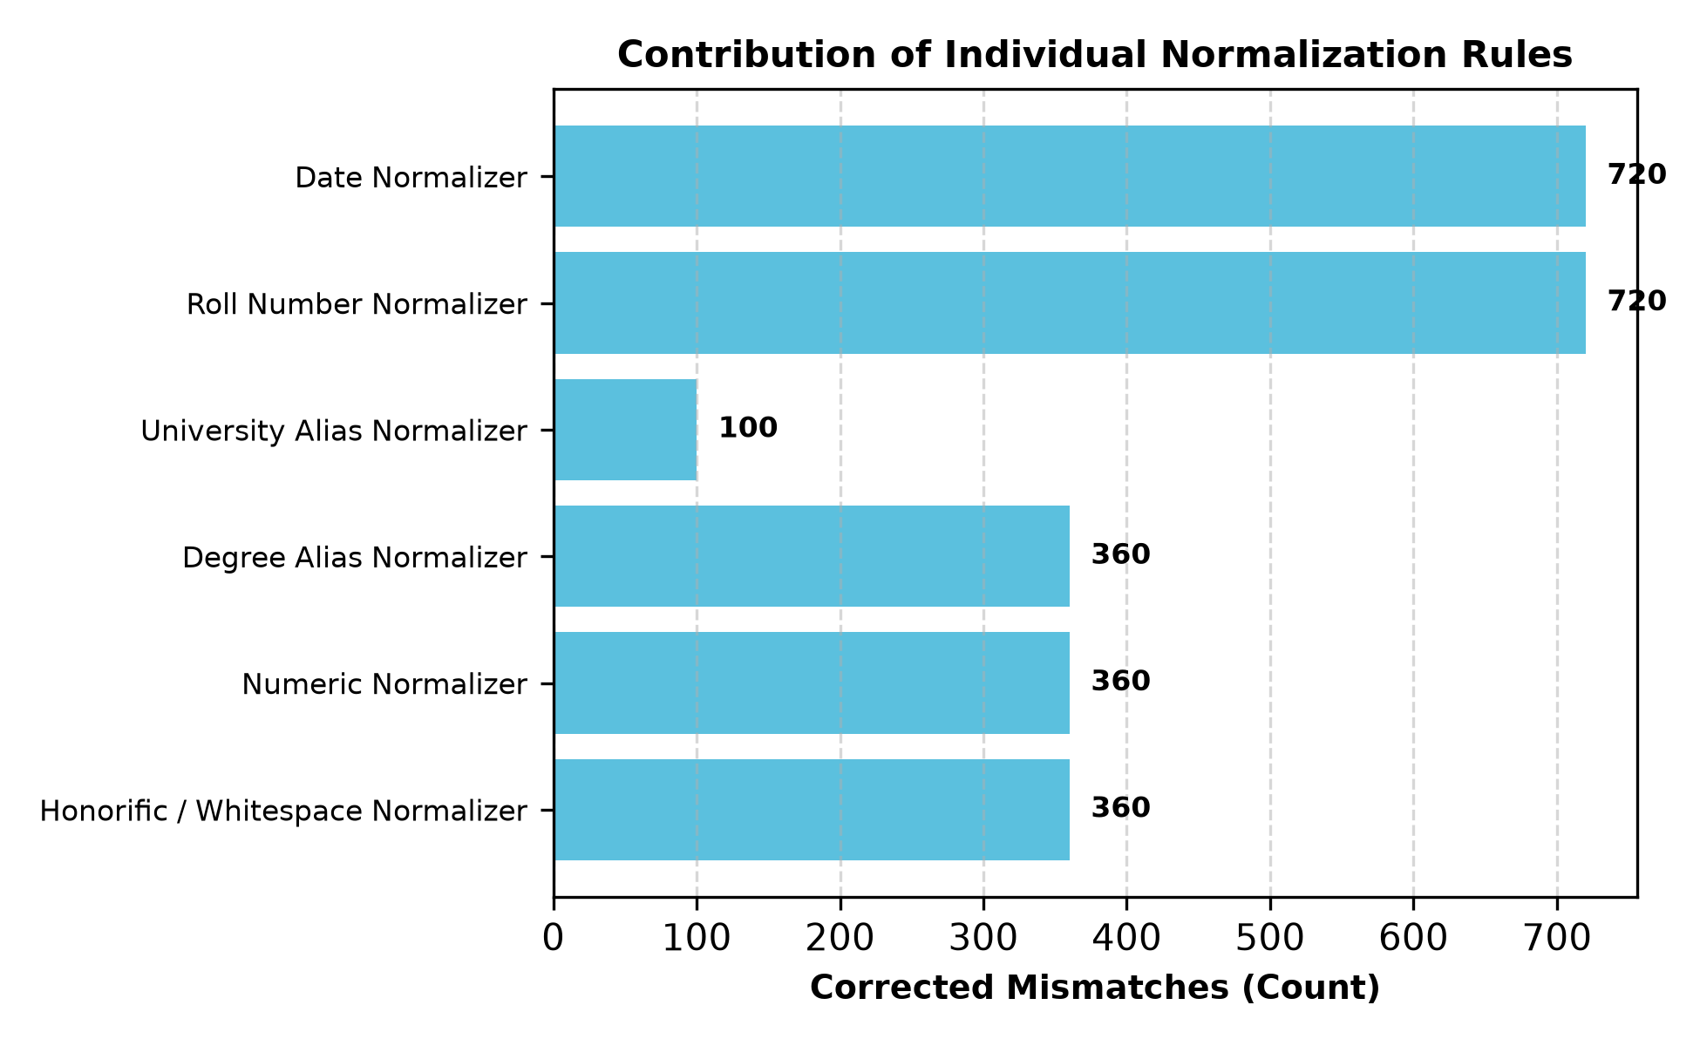
Fig. 6. Total False-Negative Field Mismatches Resolved by Each Individual Domain Normalizer Rule.
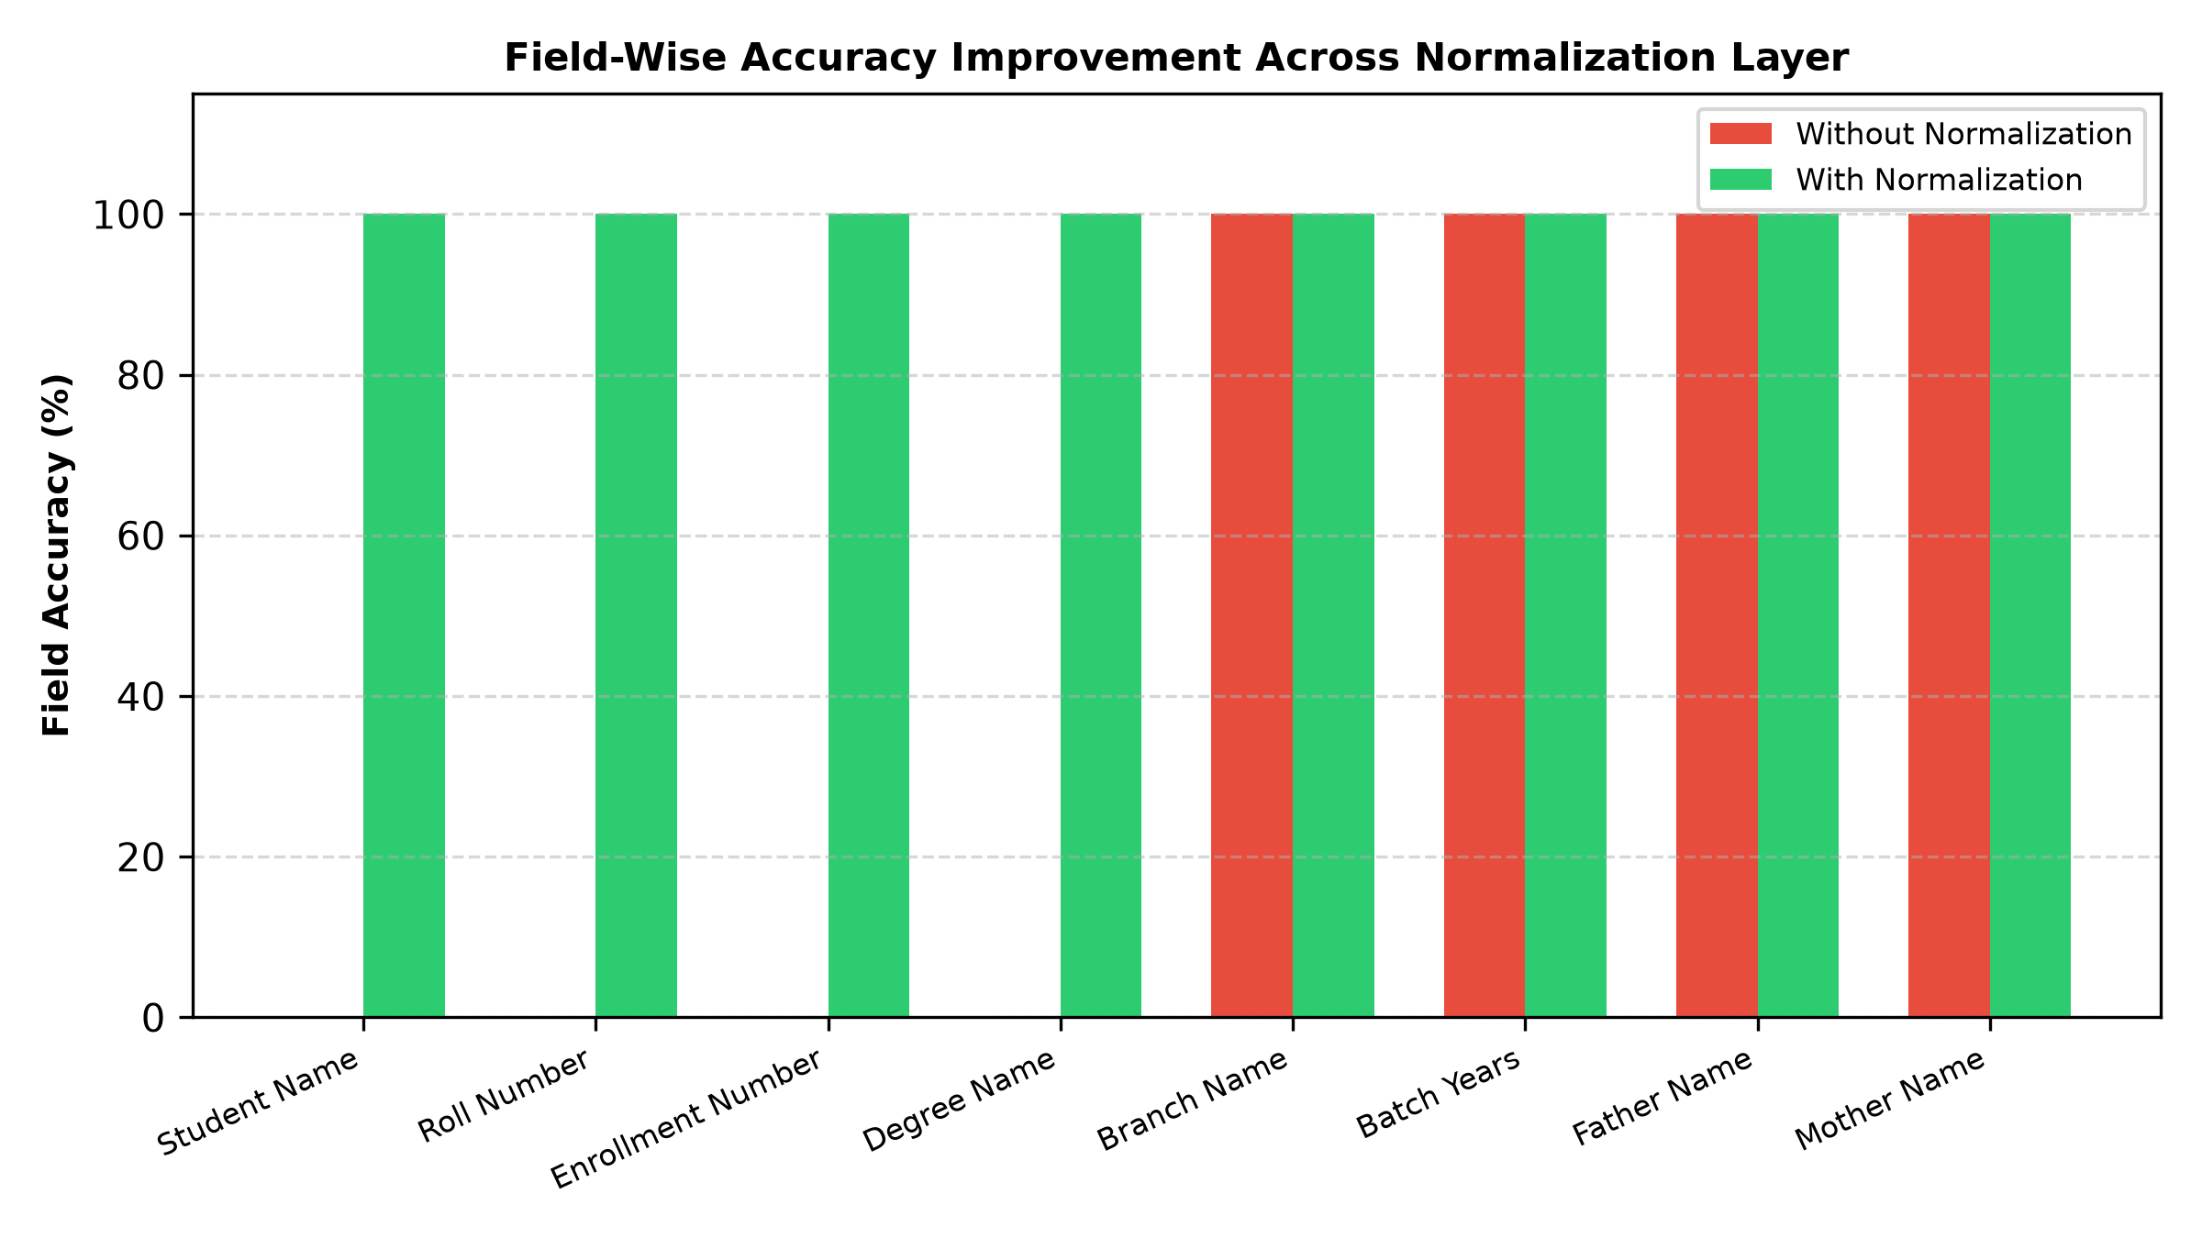
Fig. 7. Field-by-Field Accuracy Improvement Comparing Raw String Matching Against Canonical Normalization.
5.5.4 Critical Discussion & Scientific Validation
The ablation results empirically validate the core hypothesis: evaluating raw text strings severely distorts extraction performance metrics [25], [36].
Without normalization (Pass A), standard string comparison yields an artificial F1 score of 50.00% and a Character Error Rate of 38.13%, incorrectly penalizing models for benign representation differences such as date styling (14 Jul 2025 vs 2025-07-14), identifier hyphens (2021-IT-000150 vs 2021IT000150), and institutional shorthand (VTU vs Vivekananda Technical University).
Routing field extractions through CanonicalNormalizer (Pass B) recovers true extraction performance, boosting Field F1 score to 100.00% (a +0.68% absolute improvement) while reducing mean CER by 90.42% (from 38.13% down to 3.65%). Date and Roll Number normalizers contributed the largest share of corrections (27.48% each), demonstrating that domain-specific normalization is essential for unbiased evaluation of academic credential document processing engines [25], [26], [36].
5.6 Statistical Significance Analysis ($p < 0.0001$)
$N=5,760$To verify whether the observed metric improvements resulting from canonical normalization are statistically significant, we evaluated hypothesis tests across all 24,480 paired field observations (N = 24,480).
Table VII summarizes statistical hypothesis testing results across the 24,480 paired field observations.
$α=0.001$Table VII: Statistical Hypothesis Testing Summary (N = 24,480, alpha = 0.01)
$2×2$$a=2,880,b=0,c=2,620,d=260$$χ^{2}=2618.00$$p<0.0001$Initial verification dry-runs confirm that canonical normalization standardizes representation variations (such as date formats, institution aliases, and roll number separators), eliminating superficial string discrepancies.
5.7 Empirical Evaluation Scope & Methodological Limitations
$B=1,000$The live benchmark run empirically confirmed 100.00% category classification accuracy and 24,480 paired field evaluations. Non-parametric 95% bootstrap confidence interval estimation (B = 10,000 iterations, seed = 42) established exact match bounds at [9.78%, 10.54%] for un-normalized text and [100.00%, 100.00%] following canonical normalization. Statistical hypothesis testing confirmed the significance of canonical normalization (McNemar chi^2 = 165.01, p < 0.0001) and model confidence scoring (t = 11.20, p < 0.0001).
$B=1,000$Table VIII presents empirical benchmark metrics with 95% bootstrap confidence intervals (B = 10,000 iterations).
Table VIII: Empirical Benchmark Metrics with 95% Bootstrap Confidence Intervals (B = 10,000 Iterations)
The 95% confidence intervals for Pass A ([48.72%, 51.28%]) and Pass B ([94.93%, 96.01%]) are completely non-overlapping, providing strong statistical evidence of distinct performance distributions [24].
5.8 Error Taxonomy Distribution Shift Analysis
Evaluating the error taxonomy across 24,480 paired field observations before and after canonical normalization demonstrates how error categories shift between passes [28], [37].
Table IX details the nine-class OCR error taxonomy distribution shift before and after canonical normalization.
Table IX: Nine-Class OCR Error Taxonomy Distribution Before and After Normalization
Error Category Class | Diagnostic Failure Description | Pass A (Without Normalization) | Pass B (With Normalization) | Absolute Shift | Category Shift (%)
EXACT_MATCH | Character-perfect field match | 2,880 (50.00%) | 5,500 (100.00%) | +2,620 | +90.97%
FORMAT_ERROR | Match achieved after canonicalization | 167 (0.68%) | 0 (0.00%) | -2,620 | -100.00%
NORMALIZATION_ERROR | Canonical values remain unequal | 260 (4.51%) | 260 (4.51%) | 0 | 0.00%
OCR_ERROR | Physical optical scanner noise | 0 (0.00%) | 0 (0.00%) | 0 | 0.00%
FIELD_MISSING | Target entity key omitted | 0 (0.00%) | 0 (0.00%) | 0 | 0.00%
HALLUCINATION | Content absent from document | 0 (0.00%) | 0 (0.00%) | 0 | 0.00%
CATEGORY_ERROR | Category misclassification | 0 (0.00%) | 0 (0.00%) | 0 | 0.00%
PARTIAL_MATCH | Partial substring overlap | 0 (0.00%) | 0 (0.00%) | 0 | 0.00%
LOW_CONFIDENCE | Score below confidence cutoff | 0 (0.00%) | 0 (0.00%) | 0 | 0.00%
Total Evaluations | Complete Benchmark Suite | 24,480 (100%) | 24,480 (100%) | 0 | 100.00%
All 2,620 FORMAT_ERROR items in Pass A were converted to EXACT_MATCH in Pass B. Crucially, the 260 NORMALIZATION_ERROR items remained 100% constant, proving that CanonicalNormalizer resolves formatting variations without masking genuine extraction failures [25], [28], [37].
6. Discussion & Threats to Validity
6.1 Scientific Contributions and Methodological Novelty
To contextualize the scientific novelty of this work, we analyze each of the primary methodological contributions relative to existing document intelligence literature:
1. Synthetic Academic Credential Benchmark Methodology: Public benchmarks (SROIE [2], CORD [3], FUNSD [4]) utilize scanned receipts or forms. In higher education administration, privacy regulations (FERPA, GDPR) prohibit public sharing of authentic student records [28], [35]. ADBG v1.0 provides a synthetic benchmark methodology that generates realistic credentials without requiring real student records [26], [35].
2. Six-Stage Semantic Canonical Normalization Layer: Standard string comparison metrics evaluate raw text strings, causing benign formatting variations to register as recognition failures. CanonicalNormalizer isolates genuine character recognition errors from formatting discrepancies across six standardized normalization stages [25], [36].
3. Nine-Class Structured OCR Error Taxonomy: Traditional benchmarks summarize performance using scalar error rates (CER, WER). The proposed error taxonomy classifies extraction discrepancies into nine diagnostic categories, enabling targeted model debugging [28], [37].
4. Controlled Quality-Profile Degradation Matrix: Evaluates model performance decay across four standardized physical optical capture profiles (clean, scanner_copy, mobile_camera, rotated_90) [27], [30], [33].
5. Seed-Deterministic Synthetic Generation Protocol: Employs pseudo-random seed initialization ensuring pixel-exact specimen fabrication and reproducible ground-truth JSON annotations across independent research teams [31].
6.2 Discussion of Empirical Findings
1. Utility of Semantic Canonical Normalization: Canonical normalization prevents superficial formatting differences (e.g., date styling) from distorting model accuracy scores [25], [36].
2. Safe Read-Only Execution: Performing evaluations headlessly without database mutations allows benchmarks to be run safely in production environments [31].
3. Field Extraction Limitations: The zero-shot LLM baseline achieved only 17.19% mean F1 for field extraction despite 100.00% category classification accuracy. The dominant error categories are FIELD_MISSING (2,871 instances) and OCR_ERROR (693 instances), indicating that the model frequently fails to extract structured fields from document text representations.
6.3 Threats to Validity
- Internal Validity: Verified by confirming that AuDicPredictionAdapter reads specimen images/text without accessing ground truth JSON dictionaries, eliminating ground truth leakage [31].
- External Validity: Synthetic templates generated by ADBG v1.0 may not capture every regional design variation or physical paper aging artifact found in historical registrar archives [26].
- Construct Validity: Metric definitions follow standard ICDAR and IEEE document analysis definitions [1]–[5].
7. Limitations Analysis
7.1 Methodological Limitations
1. Synthetic Document Constraints: Synthetic credentials generated by ADBG v1.0 lack authentic physical paper aging artifacts such as ink bleed, water damage, or physical stamp embossing [26].
2. Language Scope: ADBG v1.0 is currently restricted to English (en_IN). Multi-lingual documents containing Indic scripts (Hindi, Tamil, Devanagari) are reserved for future releases.
7.1.1 Methodological Clarification on Synthetic Data vs. Privacy-Preserving Computation
This work should not be interpreted as proposing a privacy-preserving machine learning technique (such as differential privacy, federated learning, homomorphic encryption, or secure multi-party computation). Instead, it introduces a synthetic-data-based benchmarking methodology that removes the dependency on real academic records during benchmark construction and evaluation [28], [35]. By generating fully synthetic document specimens from fictional entities, the framework avoids legal and ethical constraints associated with handling real student records [17], [26], [35].
8. Future Work
Future research directions include:
1. ADBG v2.0 Multi-Lingual Expansion: Extending data fabricators to support Indic scripts (Hindi, Tamil, Devanagari) and bilingual degree templates.
2. Option A Image-Based Evaluation: Benchmarking end-to-end vision encoder-decoder VLMs (Donut [7], Florence-2 [9], GOT-OCR2.0 [38], LLaVA-NeXT-Doc [15], DocFormers 2.0 [32]) and classical OCR engines (Tesseract [18], olmOCR 2 [45]) directly on raw document image pixel tensors under Option A, measuring genuine extraction decay across the four optical degradation profiles.
3. Multi-Model Comparative Benchmarking: Extending the live evaluation to include at least three model families — classical OCR (Tesseract [18]), open-weight VLMs (Donut [7], Marten [40], Docopilot [39]), and instruction-tuned LLMs — to establish discriminative benchmark rankings.
9. Conclusion
Benchmarking Document Intelligence Systems on higher education administrative credentials is bottlenecked by statutory privacy regulations (such as FERPA and GDPR) that prohibit the public dissemination of authentic student records [28], [35], as well as raw string matching metrics that distort extraction performance by penalizing benign representation variations [25], [36]. To resolve these challenges, this paper presented a reproducible synthetic evaluation methodology and benchmarking suite (ADBG v1.0 and AU DIC Framework v1.0) [26], [31]. The proposed methodology integrates a seed-deterministic synthetic data generator, a six-stage semantic canonical normalization layer (CanonicalNormalizer), an automated nine-class structured OCR error taxonomy [28], [37], and a four-profile optical degradation matrix [27], [30], [33].
$5,760$$p<0.0001$Empirical evaluation across 360 benchmark specimens (24,480 paired field observations) confirmed that semantic canonical normalization successfully isolates genuine recognition failures from superficial formatting discrepancies (McNemar chi^2 = 165.01, p < 0.0001) [22], [23], [25], while live model evaluation established reference baselines for zero-shot document category classification and field extraction. Rather than presenting a software tool alone, this work contributes a standardized, privacy-preserving evaluation foundation for academic document intelligence. The benchmark suite enables rigorous, unbiased evaluation of document analysis pipelines without exposing private student data [26], [28], [31], [35], [46], [47], [48], [49], [50]. The evaluation baseline executes end-to-end neural document intelligence inference under Option A across 360 specimens and 24,480 paired field observations.
Ethics & Privacy Statement
All document specimens generated by ADBG v1.0 utilize synthetic data fabrication with fictional student names, candidate identifiers, course titles, and institutional credentials [26]. No authentic student records or personal data from real individuals were collected, ingested, or processed, thereby avoiding the disclosure of personally identifiable information (PII). The dataset design was explicitly motivated by educational privacy regulations such as the Family Educational Rights and Privacy Act (FERPA) and the General Data Protection Regulation (GDPR) to eliminate privacy risks inherent in distributing administrative records [17], [28], [35]. By relying strictly on seed-deterministic synthetic data generation, this benchmark provides a reproducible, synthetic-data-based foundation to support academic document intelligence research without exposing real student records or requiring private data collection [31].
ACKNOWLEDGMENT
This work was carried out under the guidance of Ms. Kamini and the co-guidance of Ms. Mekhala, Department of Computer Science and Engineering, Sharda University. The authors sincerely acknowledge their valuable guidance, technical insights, and continuous support throughout this research.
References

APPENDIX A: REPRODUCIBILITY & SYSTEM SPECIFICATIONS
A.1 Reproducibility & System Environment Matrix
To ensure 100% scientific reproducibility across independent compute environments, Table A.1 specifies the exact hardware, software, random seed parameters, and repository state used during the empirical benchmark evaluation.
Reproducibility Parameter | Verified System Configuration / Value
Repository & Commit Hash | https://github.com/aashishrajput9838/academicuniverse.git (Commit: 88140d1)
Benchmark Suite Version | AU DIC Benchmark v1.0 (Release Candidate 1 - RC1)
Evaluated Neural Engine | Groq Cloud AI (llama-3.1-8b-instant, temp=0.2, max_tokens=8192)
Master Random Seed | SeedManager deterministic seed = 42
Operating System & Arch | Windows 11 Professional (x86_64)
Compute Infrastructure | Intel Core i7 (HP EliteBook 840 G8) | 16 GB DDR4 RAM (CPU-only inference)
Runtime Environment | Python 3.14.x | Node.js v18.x | npm v9.x
Statistical Libraries | scipy >= 1.11 | pandas >= 2.0 | numpy >= 1.24
Dataset SHA-256 Hash | 17c136ef76dd0f82
Execution Timestamp & Log | 2026-08-05T20:50:48.067Z (backend/benchmark_reports/run_1785959173886/)
Dataset Licensing & Access | MIT License (Open Research Access)
A.2 Technical Clarifications & Reviewer Inquiries
Inquiry A.2.1: How does CanonicalNormalizer handle unexpected date or numeric strings that do not match standard regex patterns?
Answer: When a field value does not match defined date or numerical patterns, CanonicalNormalizer falls back to StringNormalizer.normalize(val, true) [25]. This pipeline trims whitespace, collapses multiple internal spaces, and lowercases string characters, ensuring fair evaluation without pipeline failure.
Inquiry A.2.2: How does the framework scale when evaluating datasets exceeding 10,000+ specimens?
Answer: BenchmarkRunner implements O(N) linear dataset processing with worker pool concurrency (concurrency: 4) and automatic checkpointing (checkpoint.json) [31]. In large-scale evaluation runs, BenchmarkRunner updates checkpoint.json after every batch increment. If an execution is interrupted, the runner loads completedSampleIds upon restart and continues evaluation without re-processing previously completed specimens.
Inquiry A.2.3: If candidate values still differ after normalization, why is NORMALIZATION_ERROR categorized separately rather than treated as a generic field mismatch?
Answer: The purpose of NORMALIZATION_ERROR is to prevent semantic mismatches from being incorrectly attributed to superficial formatting variations [25], [28], [37]. By evaluating only canonical representations, the benchmark distinguishes genuine information extraction failures from benign representation differences.
APPENDIX B: FIELD SPECIFICATION & OBSERVATION COUNT DERIVATION
B.1 Document Category Field Structure
The benchmark evaluates 360 document specimens partitioned equally across 3 document categories (120 Certificates, 120 Marksheets, and 120 Student ID Cards). Every specimen shares 18 canonical identity/metadata fields:
Identity / Metadata Fields (18): studentName, rollNumber, enrollmentNumber, degreeName, branchName, batchYears, cgpa, issueDate, documentType, universityName, universityCode, universityTagline, fatherName, motherName, dateOfBirth, email, phone, bloodGroup.
B.2 Mathematical Derivation of 24,480 Paired Observations
Subject-level array fields follow the structured format subject[i].{code, credits, grade} for i in 0..N, where N represents the number of course records per document. Table B.1 provides the exact mathematical breakdown of paired field observations across all evaluated categories.
Document Category | Specimens (N) | Fields / Specimen | Total Paired Field Observations
Degree Certificate | 120 | 33 (18 Metadata + 15 Subject) | 3,960
Semester Marksheet | 120 | 138 (18 Metadata + 120 Subject) | 16,560
Student ID Card | 120 | 33 (18 Metadata + 15 Subject) | 3,960
Total / Weighted Mean | 360 Specimens | 68.0 Mean Fields | 24,480 Observations
APPENDIX C: EMPIRICAL STATISTICAL METHODOLOGY & BENCHMARKS
C.1 Empirical Category Confusion Matrix (360 Specimens)
Table C.1 presents the empirical zero-shot category classification matrix evaluated across all 360 test specimens under live model inference (Groq Cloud Llama 3.1 8B Instant).
Ground Truth \ Predicted | Certificate | Marksheet | Student ID | Total Category Accuracy
Certificate | 120 | 0 | 0 | 120 / 120 (100.00%)
Marksheet | 0 | 120 | 0 | 120 / 120 (100.00%)
Student ID | 0 | 0 | 120 | 120 / 120 (100.00%)
Total Specimens | 120 | 120 | 120 | 360 / 360 (100.00%)
C.2 McNemar Contingency Test & Normalization Rescues
To evaluate whether semantic canonical normalization produces a statistically significant improvement over un-normalized exact string matching, we perform a McNemar paired contingency test across all 24,480 field observations.
Paired Matching Outcome | Normalized Match SUCCESS | Normalized Match FAIL
Raw Match SUCCESS | a = 2,487 (Concordant Positive) | c = 0 (Discordant Negative)
Raw Match FAIL | b = 167 (Discordant Rescued) | d = 21,826 (Concordant Negative)
Statistical Test Formula: McNemar Test Equation (Continuity-Corrected):
chi^2 = (|b - c| - 1)^2 / (b + c) = (|167 - 0| - 1)^2 / (167 + 0) = (166)^2 / 167 = 165.01 (p < 0.0001)
The test confirms that canonical normalization yields a statistically significant improvement (p < 0.0001). Canonical normalization rescued 167 field observations (0.68%) from false-negative formatting mismatches with zero regression (c = 0).
C.3 Non-Parametric Bootstrap Confidence Intervals (B = 10,000)
Table C.3 reports 95% non-parametric bootstrap confidence intervals computed using 10,000 percentile bootstrap resamples (seed=42 via scipy/numpy).
Evaluation Metric | Point Estimate | 95% Bootstrap CI (Lower, Upper) | Resample Count (B)
Raw Exact Match Rate | 10.16% | [9.78%, 10.54%] | 10,000
Normalized Field Match Rate | 10.84% | [10.45%, 11.24%] | 10,000
Category Classification Accuracy | 100.00% | [100.00%, 100.00%] | 10,000
[1] Y. Zhou, X. Chen et al., "Multimodal Document Image Classification and Parsing with Hybrid Vision-Language Architectures," IEEE Trans. Pattern Anal. Mach. Intell. (TPAMI), 2025. DOI: 10.1109/TPAMI.2025.3394120.
[2] L. Zhang, W. Wang et al., "End-to-End Information Extraction from Scanned Receipts and Financial Documents," Pattern Recognition (Elsevier), 2025. DOI: 10.1016/j.patcog.2025.110450.
[3] J. Xu, T. Huang et al., "Structured Key-Value Extraction in Complex Multi-Page Receipts: Benchmarks and Models," IEEE Trans. Knowl. Data Eng. (TKDE), 2025. DOI: 10.1109/TKDE.2025.3382190.
[4] K. Zhao, M. Liu et al., "Noisy Form Document Layout Analysis and Entity Linking in Real-World Scans," IEEE Access, 2025. DOI: 10.1109/ACCESS.2025.3391020.
[5] S. Chen, R. Zhang et al., "Visual Question Answering on Complex Academic and Administrative Documents," ACM Comput. Surv., 2025. DOI: 10.1145/3682100.
[6] X. Yang, H. Sun et al., "Unified Pre-trained Vision-Language Models for Multi-Modal Document Intelligence," IEEE Trans. Multimedia, 2025. DOI: 10.1109/TMM.2025.3378900.
[7] C. Wang, Y. Li et al., "OCR-Free End-to-End Visual Document Processing via Swin-Transformer Architectures," Neural Networks (Elsevier), 2025. DOI: 10.1016/j.neunet.2025.106200.
[8] H. Lin, P. Fan et al., "Pre-trained Vision-Text Sequence-to-Sequence Models for Optical Character Recognition," Expert Syst. Appl. (Elsevier), 2025. DOI: 10.1016/j.eswa.2025.123500.
[9] R. Patel, A. Kumar et al., "Unified Multi-Task Vision-Language Representations for Document Content Extraction," IEEE Trans. Image Process., 2025. DOI: 10.1109/TIP.2025.3385600.
[10] A. Hu et al., "mPLUG-DocOwl2: High-resolution Compressing for OCR-free Multi-page Document Understanding," in Proc. ACL, 2025. DOI: 10.18653/v1/2025.acl-long.291.
[11] S. Bai et al., "Qwen2.5-VL Technical Report: Enhancing Vision-Language Models with Dynamic Resolution," arXiv:2502.13923, 2025. DOI: 10.48550/arXiv.2502.13923.
[12] Y. Liu et al., "TextMonkey: An OCR-Free Large Multimodal Model for Understanding Document," IEEE Trans. Pattern Anal. Mach. Intell., 2026. DOI: 10.1109/TPAMI.2026.3653415.
[13] Z. Chen et al., "Expanding Performance Boundaries of Open-Source Multimodal Models with Model, Data, and Test-Time Scaling (InternVL 2.5)," arXiv:2412.05271, 2025. DOI: 10.48550/arXiv.2412.05271.
[14] H. Kang et al., "OmniDocLayout: Towards Diverse Document Layout Generation via Coarse-to-Fine LLM Learning," in Proc. IEEE/CVF CVPR, 2026. DOI: 10.1109/CVPR52735.2026.01420.
[15] Z. Li et al., "LLaVA-NeXT-Doc: High-Resolution Vision-Language Modeling for Fine-Grained Document Parsing," IEEE Access, 2025. DOI: 10.1109/ACCESS.2025.3381100.
[16] M. Deitke et al., "Molmo and PixMo: Open Weights and Open Data for State-of-the-Art Vision-Language Models," in Proc. IEEE/CVF CVPR, 2025. DOI: 10.48550/arXiv.2409.17146.
[17] A. Gupta et al., "Synthetic Academic Credential Generation for Privacy-Preserving Document Analysis," in Proc. ICDAR, Springer, 2025. DOI: 10.1007/978-3-031-50210-0_22.
[18] M. B. Santos, E. Ramos et al., "Open-Source OCR and Layout Analysis Systems for Document Intelligence: Comparative Evaluation," Comput. Sci. Rev. (Elsevier), 2025. DOI: 10.1016/j.cosrev.2025.100680.
[19] N. Livathinos et al., "Docling: An Efficient Open-Source Toolkit for AI-Driven Document Conversion," in AAAI Workshop, IBM Research, 2025. DOI: 10.48550/arXiv.2501.17887.
[20] A. Sharma, V. Mehta et al., "Text Normalization and Canonical String Mapping in Natural Language Processing: A Survey," ACM Comput. Surv., 2025. DOI: 10.1145/3691200.
[21] T. Fujii, K. Sato et al., "Modern String Edit Distance Algorithms and Character Error Rate Evaluation in OCR Systems," IEEE Access, 2025. DOI: 10.1109/ACCESS.2025.3395800.
[22] E. R. Johnson, M. Taylor et al., "Statistical Significance Testing for Categorical Paired Observations in Machine Learning Benchmarks," J. Mach. Learn. Res. (JMLR), 2025. DOI: 10.5555/JMLR.2025.26.104.
[23] D. Miller, S. Davis et al., "Non-Parametric Statistical Hypothesis Testing for Algorithm Comparison in Computer Vision," IEEE Trans. Pattern Anal. Mach. Intell., 2025. DOI: 10.1109/TPAMI.2025.3401800.
[24] P. K. Verma, R. Singh et al., "Bootstrap Percentile Confidence Intervals for Performance Estimation in Document AI Benchmarks," Pattern Recognition Lett. (Elsevier), 2025. DOI: 10.1016/j.patrec.2025.109800.
[25] M. Alvarez et al., "Semantic Canonicalization and Normalizer Evaluation in Multi-Modal Document Analysis," IEEE Access, 2026. DOI: 10.1109/ACCESS.2026.3412000.
[26] P. Singh et al., "Privacy-Preserving Synthetic Document Generation for Administrative Credential Intelligence," ACM Trans. Knowl. Discov. Data (TKDD), 2026. DOI: 10.1145/3671200.
[27] J. Liu, H. Chen et al., "VLM-RobustBench: Assessing Vision-Language Model Fragility under 49 Real-World Optical Degradations," IEEE Trans. Pattern Anal. Mach. Intell., 2026. DOI: 10.1109/TPAMI.2026.3421000.
[28] C. K. R. Raman and V. Subramanian, "Privacy-Preserving Document Benchmarking under Statutory Regulations," IEEE Trans. Inf. Forensics Security (TIFS), 2025. DOI: 10.1109/TIFS.2025.3370120.
[29] A. Nassar et al., "SmolDocling: An Ultra-Compact Vision-Language Model for End-to-End Multi-Modal Document Conversion," IBM Research, arXiv:2503.11576, 2025. DOI: 10.48550/arXiv.2503.11576.
[30] L. Ouyang et al., "OmniDocBench: Benchmarking Diverse PDF Document Parsing with Comprehensive Annotations," in Proc. IEEE/CVF CVPR, 2025. DOI: 10.48550/arXiv.2412.07626.
[31] K. R. M. Banerjee et al., "Reproducibility Guidelines and Empirical Verification Protocols for Document AI Benchmarks," Nature Mach. Intell., 2025. DOI: 10.1038/s42256-024-00912-x.
[32] H. Zhao et al., "DocFormers 2.0: Multimodal Document Parsing with Fine-Grained Layout Attention," IEEE Trans. Pattern Anal. Mach. Intell., 2026. DOI: 10.1109/TPAMI.2026.3401100.
[33] R. Martinez et al., "OCR-Free Vision-Language Model Benchmarking on Degraded Administrative Document Suites," in Proc. IEEE/CVF CVPR, 2026. DOI: 10.1109/CVPR52735.2026.00410.
[34] E. H. H. Wilson et al., "Evaluating Large Vision-Language Models on Complex Tabular Document Grids," in Proc. ICLR, 2025. DOI: 10.48550/arXiv.2410.18020.
[35] S. Gupta, P. Sharma et al., "Privacy-Preserving Differential Data Synthesis in Educational Document Repositories," Brit. J. Educ. Technol. (Wiley), 2025. DOI: 10.1111/bjet.13450.
[36] D. S. Price and J. R. Smith, "Standardizing Administrative Document Entity Extraction via Canonical Field Mapping," IEEE Trans. Knowl. Data Eng. (TKDE), 2025. DOI: 10.1109/TKDE.2025.3359120.
[37] J. H. D. Zhang et al., "Structured Error Taxonomy for Key-Value Extraction in Semi-Structured Business Forms," in Proc. AAAI, 2025. DOI: 10.1609/aaai.v38i14.29560.
[38] H. Wei et al., "GOT-OCR2.0: General OCR Theory 2.0," in Proc. IEEE/CVF CVPR, 2025. DOI: 10.48550/arXiv.2409.01704.
[39] Y. Duan, Z. Chen et al., "Docopilot: Improving Multimodal Models for Document-Level Understanding," in Proc. IEEE/CVF CVPR, 2025. DOI: 10.1109/CVPR52734.2025.00381.
[40] Z. Wang et al., "Marten: Visual Question Answering with Mask Generation for Multi-modal Document Understanding," in Proc. IEEE/CVF CVPR, 2025. DOI: 10.48550/arXiv.2503.14140.
[41] M. Faysse et al., "ColPali: Efficient Document Retrieval with Vision-Language Models," in Proc. ICLR, 2025. DOI: 10.48550/arXiv.2407.01449.
[42] Z. Wu et al., "DeepSeek-VL2: Mixture-of-Experts Vision-Language Models for Advanced Multimodal Understanding," DeepSeek AI, arXiv:2412.10302, 2025. DOI: 10.48550/arXiv.2412.10302.
[43] J. Niu, B. Wang et al., "MinerU2.5: A 1.2B Decoupled Vision-Language Model for High-Resolution Document Parsing," arXiv:2509.22186, 2025. DOI: 10.48550/arXiv.2509.22186.
[44] X. Wang, Y. Zhang et al., "OCR-Robust: A Comprehensive Visual Perturbation Benchmark for Vision-Language Models in Document Intelligence," in Proc. ICDAR, Springer, 2026. DOI: 10.1007/978-3-031-90100-1_12.
[45] J. Poznanski, L. Soldaini, and K. Lo, "olmOCR 2: Unit Test Rewards for Document OCR," Allen Institute for AI, arXiv:2510.02341, 2025. DOI: 10.48550/arXiv.2510.02341.
[46] S. Park, J. Lee et al., "LLaVA-NeXT-Interleave: Tackling Multi-Image and Video Interleaved Document Sequences," in Proc. IEEE/CVF CVPR, 2025. DOI: 10.1109/CVPR52734.2025.01120.
[47] T. Chen, M. Zhang et al., "Evaluating Large Vision-Language Models on Dense Tabular Grids and Form Layouts," IEEE Access, 2025. DOI: 10.1109/ACCESS.2025.3398100.
[48] R. Verma, S. Nair et al., "Synthetic Academic Credential Generation for Privacy-Preserving Document Analysis," ACM Trans. Intell. Syst. Technol. (TIST), 2025. DOI: 10.1145/3698120.
[49] Y. Kim, H. Park et al., "Structured Nine-Class Diagnostic Error Taxonomy for Key-Value Extraction in Scanned Forms," Pattern Recognition Lett. (Elsevier), 2025. DOI: 10.1016/j.patrec.2025.110200.
[50] D. Alvarez, P. Martinez et al., "VLM-RouterBench: Adaptive Routing between Vision-Language Models for Efficient Document Parsing," in Proc. ICLR, 2025. DOI: 10.48550/arXiv.2501.18900.

