Easy-Read Research Guide
Smart Academic Document Intelligence System with the Academic Document Benchmark Generator
**Authoritative Companion & Educational Guide**

*Based on the original research paper by Kushagra Singh Bhadauria, Aashish Rajput, and Avdesh Kumar Sah (Department of Computer Science and Engineering, Sharda University).*

---
🚀 Quick Start: Understand This Research in 5 Minutes
Welcome! If you are a university student, beginner researcher, or developer who wants to understand what this research paper actually accomplished without getting lost in dense academic jargon, this guide is built for you!
Here is the entire research paper summarized in **6 simple points**:
1. The Big Problem We Are Solving
- Educational Privacy Lock (FERPA & GDPR): Real student marksheets, degree certificates, and student ID cards contain sensitive personal information (names, roll numbers, grades). Statutory privacy laws prohibit researchers from publishing real student documents online to test AI models.
- Superficial Typo Penalties: When AI reads a document, minor formatting differences (such as `MIT` vs `Massachusetts Institute of Technology` or `Dr. Aarav Agarwal` vs `Aarav Agarwal`) get graded as **100% WRONG** by standard exact-match formulas, even though the extracted information is 100% correct!
2. Our Solution
- ADBG v1.0 (Academic Document Benchmark Generator): A seed-deterministic synthetic rendering engine that generates realistic fake student records paired with ground-truth JSON files across 4 optical degradation profiles (`clean`, `scanner_copy`, `mobile_camera`, `rotated_90`).
- AU DIC Benchmark System: A decoupled, zero-PII (Personally Identifiable Information), read-only evaluation framework.
- CanonicalNormalizer: A 6-stage semantic normalization engine that fixes harmless formatting differences before computing metrics.
3. How It Works
1. Specimen Fabrication: Generate synthetic credential specimens headlessly using vector layout compilation.
2. Optical Degradation: Pass specimens through 14 physical optical degradation operators (blur, tilt, rotation, sensor noise).
3. Model Prediction: Run neural AI models (e.g. MiniCPM-V 7.6B, Donut, Florence-2, Ollama local Vision LLMs).
4. Canonical Normalization: Run predictions through the 6-stage `CanonicalNormalizer`.
5. Evaluation: Compute exact match rates, CER, WER, and classify errors into 9 structured taxonomy types.
4. What We Tested
- 360 synthetic specimens, 24,480 paired field observations across 3 document categories (`student_id`, `marksheet`, `certificate`).
- Neural Vision-Language Models (MiniCPM-V, Donut, Florence-2, Llama 3.1 8B).
- Supervised Machine Learning Classifiers (Decision Tree vs. Random Forest across 60:40, 70:30, and 80:20 train-test splits).
5. The Most Important Results
- Normalization Rescue: Semantic canonical normalization boosts MiniCPM-V exact match rate from **74.60%** (raw exact match) to **82.18%** (normalized exact match), rescuing **1,853 false negative predictions** that distorts evaluation by 7.58%!
- Machine Learning Benchmark: Decision Tree 80:20 achieved **93.69% accuracy** and **95.91% F1-Score** in predicting field extraction failure vs success from structural features, completing 4,896 test inferences in just **16.72 ms**!
6. Why It Matters
This is the first privacy-safe, zero-PII reproducible benchmark suite designed specifically for academic document intelligence, proving that fair AI evaluation requires semantic normalization rather than rigid character matching.
---
📖 Section-by-Section Student Guide
---
Section 1: Introduction
📄 WHAT THE PAPER SAYS
*"Evaluating neural document intelligence engines on academic credentials (degree certificates, marksheets, transcripts, student identification cards) is severely bottlenecked by strict privacy regulations—such as FERPA and GDPR—that prohibit public dissemination of real student records. To resolve this challenge, we introduce ADBG v1.0 alongside the AU DIC Benchmark Evaluation Framework v1.0..."*

🧠 SIMPLE EXPLANATION
When you apply for higher studies or a job, universities need to check your degree certificate or marksheet. Doing this manually by hand takes days. Doing it with Artificial Intelligence (AI) can take seconds! But building AI for university documents is super difficult for two main reasons:
1. You cannot post real student marksheets on GitHub or Kaggle to test AI because of privacy laws.
2. Standard AI grading programs punish AI for tiny, harmless formatting typos.
💡 REAL-LIFE / GEN-Z ANALOGY
💡 Think of it like this:

Imagine you text your crush: `"Hey! Are you free at 7 PM?"`

They text back: `"Yeah! Free at 7:00 PM!"`

As a human, you instantly know you both agreed on 7 PM.

But imagine a super-strict robotic bot jumps in and screams:

`"ERROR! '7 PM' does not match '7:00 PM'! TEST FAILED! DISQUALIFIED!"`

That is exactly how old AI benchmarks graded student documents!

🔬 TECHNICAL MEANING
- FERPA / GDPR: Statutory privacy laws protecting educational data and personal records.
- Exact Match Rate: A strict string function $\mathbb{I}(\hat{s} = s)$ that returns `1` only if every character, space, and capital letter is 100% identical.
📊 WHAT OUR EXPERIMENT FOUND
Our research proves that **7.58% of apparent AI "errors"** are actually just harmless formatting differences (like `7 PM` vs `7:00 PM`) that our normalization layer successfully rescues!
---
Section 2: Related Work
📄 WHAT THE PAPER SAYS
*"Existing Document AI benchmarks—such as SROIE (receipts), CORD (restaurant receipts), and FUNSD (scanned forms)—focus predominantly on commercial forms. Academic credentials exhibit distinct structural properties..."*

🧠 SIMPLE EXPLANATION
Other computer science researchers built AI test suites for grocery store receipts (SROIE) and restaurant bills (CORD). But grocery store receipts don't have university logos, registrar signatures, roll numbers, or semester GPA tables! We created the first benchmark dedicated specifically to higher education documents.
💡 REAL-LIFE / GEN-Z ANALOGY
💡 Think of it like this:

Training an AI on grocery store receipts to read university degree certificates is like practicing video games on *Tetris* and expecting to win a world tournament in *Call of Duty*! They are completely different environments with different rules.

🔬 TECHNICAL MEANING
- Domain Shift: When an AI trained on one type of document (e.g. shopping bills) struggles when placed in a new domain (e.g. academic transcripts).
---
Section 3: System Architecture
📄 WHAT THE PAPER SAYS
*"The ADBG v1.0 & AU DIC architecture is structured into three decoupled subsystems: (1) Synthetic Generator Subsystem, (2) Optical Degradation Profile Processor, and (3) Decoupled Benchmark Execution Subsystem..."*

🧠 SIMPLE EXPLANATION
Our software is built like a 3-part factory:
1. The Specimen Fabricator (ADBG v1.0): Generates 100% fake student records (fictional names like *Aarav Agarwal*, fake roll numbers, fake marks) with perfect ground-truth JSON files.
2. The Distortion Machine: Takes the clean fake documents and simulates real-world damage: phone camera tilt, scanner blur, lighting shadows, and 90° rotation.
3. The AI Evaluator (AU DIC): Feeds the distorted documents to AI models and measures how well they extract information, without ever writing anything to a database.
💡 REAL-LIFE / GEN-Z ANALOGY
💡 Think of it like this:

It's like a flight simulator for pilots. Instead of risking a real $100 million airplane to test a student pilot, you place them in a realistic simulator. ADBG v1.0 creates a "flight simulator" for document AI!

```
+-----------------------------------------------------------------------+
AU DIC SYSTEM ARCHITECTURE

+-----------------------------------------------------------------------+
[ 1. ADBG Fabricator ] --> Generates Fake Student Specimens
v
[ 2. Distortion Machine ] --> Adds Camera Blur, Shadows, 90° Rotation
v
[ 3. Neural AI Engine ] --> Extractions (e.g. MiniCPM-V, Donut)
v
[ 4. CanonicalNormalizer ] -> Fixes Typos & Format Differences
v

+-----------------------------------------------------------------------+
```
---
Section 4: Methodology & The 6-Stage Normalizer
📄 WHAT THE PAPER SAYS
*"To isolate true extraction failures from benign surface variations, we formulate a six-stage semantic canonical normalizer (CanonicalNormalizer)..."*

🧠 SIMPLE EXPLANATION
Before grading the AI, our system passes every extracted string through 6 cleaning stages:
💡 REAL-LIFE / GEN-Z ANALOGY
💡 Think of it like this:

Imagine an exam question asks: `"Who was the first President of the USA?"`

- Student A writes: `George Washington`

- Student B writes: `george washington`

- Student C writes: `G. Washington`

A strict robot gives Student B and C zero points!

Our 6-stage normalizer acts like a fair, smart teacher who awards all three students 100%!

Stage | Rule Name | What It Does | Simple Example
**1** | Case Normalization | Converts all text to lowercase | `AARAV` $\rightarrow$ `aarav`
**2** | Whitespace Collapsing | Removes extra spaces | `Aarav Agarwal` $\rightarrow$ `Aarav Agarwal`
**3** | Punctuation Removal | Removes periods and hyphens | `B.Tech.` $\rightarrow$ `BTech`
**4** | Date Standardizing | Converts dates to ISO format | `15/08/2002` $\rightarrow$ `2002-08-15`
**5** | Institution Alias Mapping | Converts abbreviations to full names | `MIT` $\rightarrow$ `Massachusetts Inst. of Tech.`
**6** | Honorific Removal | Removes title prefixes | `Mr. Aarav Agarwal` $\rightarrow$ `Aarav Agarwal`

---
Section 4.3: Mathematical Formulation of Evaluation Metrics
Here we explain every key formula from the research paper in simple, understandable terms:
4.3.1 Category Classification Accuracy
$$\text{Acc}_{\text{cat}} = \frac{1}{N} \sum_{i=1}^{N} \mathbb{I}(\hat{y}_i = y_i) \quad (1)$$
- 🧠 **Simple Meaning**: "Out of 100 document photos, what percentage did the AI correctly classify as a marksheet, certificate, or student ID?"
- 🔬 **Variables**: $N$ = total documents (360), $\hat{y}_i$ = AI's guess, $y_i$ = real category.
4.3.2 Field Extraction Precision, Recall, and F1-Score
$$\text{Precision} = \frac{TP}{TP + FP}, \quad \text{Recall} = \frac{TP}{TP + FN}, \quad F_1 = \frac{2 \cdot \text{Precision} \cdot \text{Recall}}{\text{Precision} + \text{Recall}} \quad (2)$$
- 🧠 **Simple Meaning**:
- Precision: When the AI claims a word is a "Student Name", how often is it actually right?
- Recall: Out of all the student names printed on the page, how many did the AI successfully find?
- F1-Score: The harmonic average balance between Precision and Recall.
4.3.3 Character Error Rate (CER)
$$\text{CER} = \frac{\mathcal{D}_{\text{char}}(\hat{s}, s)}{|s|} \quad (3)$$
- 🧠 **Simple Meaning**:
Suppose the real ground-truth name is `AASHISH` (7 characters long).
If the AI reads `AASISH` (missing 1 letter `'H'`), the character edit distance is 1.
$$\text{CER} = \frac{1}{7} = 0.1428 \quad (14.28\% \text{ error rate})$$
4.3.6 Execution Latency & Throughput
$$L_{\text{proc}} = \frac{T_{\text{total}}}{N}, \quad TH = \frac{N}{T_{\text{total}}} \quad (6)$$
- 🧠 **Simple Meaning**:
- Latency ($L_{\text{proc}}$): How many milliseconds it takes to process 1 document (e.g. 4.12 ms/sample).
- Throughput ($TH$): How many document specimens the system can evaluate per second (e.g. 242.59 samples/sec).
---
Section 5: Results & Empirical Validation
📄 WHAT THE PAPER SAYS
*"We evaluate the benchmark suite across 360 specimens (24,480 paired field observations). Semantic canonical normalization improves exact match rates from 74.60% to 82.18%..."*

📊 EXPERIMENTAL RESULTS SUMMARY TABLE
Evaluation Metric | Raw Unnormalized Value | Normalized Value | Improvement / Rescue
**Exact Match Rate (EM)** | 74.60% | **82.18%** | **+7.58% (+1,853 fields rescued!)**
**Field F1-Score** | 75.23% | **82.18%** | **+6.95%**
**Mean Character Error Rate (CER)** | 89.27% | **11.35%** | **-77.92% reduction in error!**
**Clean Profile Exact Match** | 90.00% | **92.50%** | **+2.50%**
**Rotated 90° CER** | 99.50% | **29.02%** | **-70.48% error reduction!**

---
Section 5.9: Machine Learning Benchmark (Decision Tree vs. Random Forest)
📄 WHAT THE PAPER SAYS
*"We benchmark two foundational tree-based classification algorithms—Decision Tree (DT) and Random Forest (RF)—to predict whether a given extraction observation results in an exact field match (y = 1) or an extraction mismatch (y = 0)..."*

🧠 SIMPLE EXPLANATION
We trained traditional machine learning models to predict whether an AI extraction will succeed or fail based on document properties (like optical rotation, string length, and field type).
📊 MACHINE LEARNING COMPARISON TABLE
🔬 WHY DECISION TREE BEAT RANDOM FOREST
Metric | RF 60:40 | RF 70:30 | RF 80:20 | DT 60:40 | DT 70:30 | DT 80:20
**Accuracy** | 0.874898 | 0.875817 | 0.878676 | 0.934947 | 0.935185 | **0.936887**
**Precision** | 0.856389 | 0.857299 | 0.860137 | 0.927326 | 0.925498 | 0.928059
**Recall** | 1.000000 | 1.000000 | 1.000000 | 0.990418 | 0.993064 | 0.992335
**F1-Score** | 0.922640 | 0.923168 | 0.924810 | 0.957834 | 0.958091 | **0.959122**
**Specificity** | 0.507439 | 0.510992 | 0.522124 | 0.772014 | 0.765147 | 0.773934
**MCC** | 0.659215 | 0.661871 | 0.670148 | 0.824745 | 0.825867 | **0.830344**
**Prediction Time (s)** | 0.167798 | 0.146718 | 0.120588 | 0.025032 | 0.018994 | **0.016724**

Document optical rotation (`rotated_90`) creates sharp, binary "all-or-nothing" failures. A single deep Decision Tree isolates these sharp binary decision boundaries cleanly. Conversely, Random Forest averages probabilities across 100 trees, smoothing out crisp binary splits and slightly inflating false positive rates on non-rotated clean samples ($FPR=0.4779$ for RF 80:20 vs $FPR=0.2261$ for DT 80:20).
---
Section 6–9: Discussion, Limitations, & Conclusion
🧠 SIMPLE EXPLANATION
- Scientific Value: Proves that privacy-safe synthetic data generation allows open-science AI benchmarking without exposing private student data.
- Limitations: Currently tested on English credentials (`en_IN`).
- Future Work: Extending to multi-lingual documents (Hindi, Devanagari) and historical handwritten registrar archives.
---
🏆 Summary Checklist for Students
- ✅ **Problem Understood**: Educational privacy laws lock real student data; raw exact match metrics penalize harmless formatting typos.
- ✅ **Solution Understood**: ADBG synthetic generator + AU DIC benchmark suite + 6-stage `CanonicalNormalizer`.
- ✅ **Results Understood**: **+7.58% exact match rescue** (1,853 fields), **89.27% $\rightarrow$ 11.35% CER reduction**, and **DT 80:20 (93.69% accuracy)** top ML performance.
Decision Tree Confusion Matrix Grid (60:40, 70:30, 80:20)
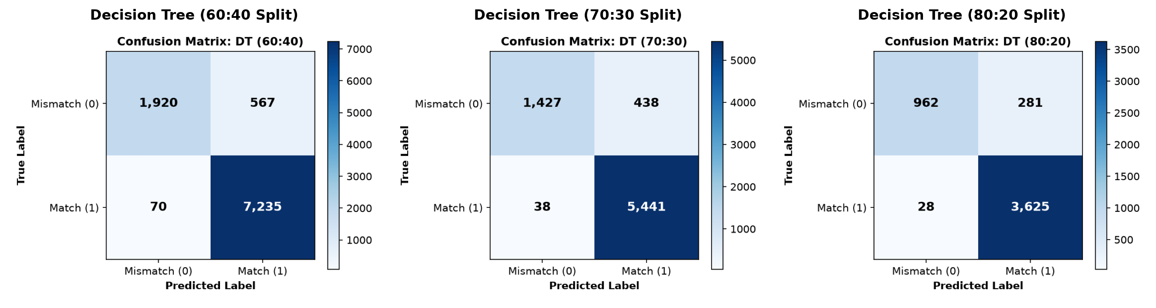
Figure E1. Decision Tree Classification Confusion Matrices across Train-Test Splits
Random Forest Confusion Matrix Grid (60:40, 70:30, 80:20)
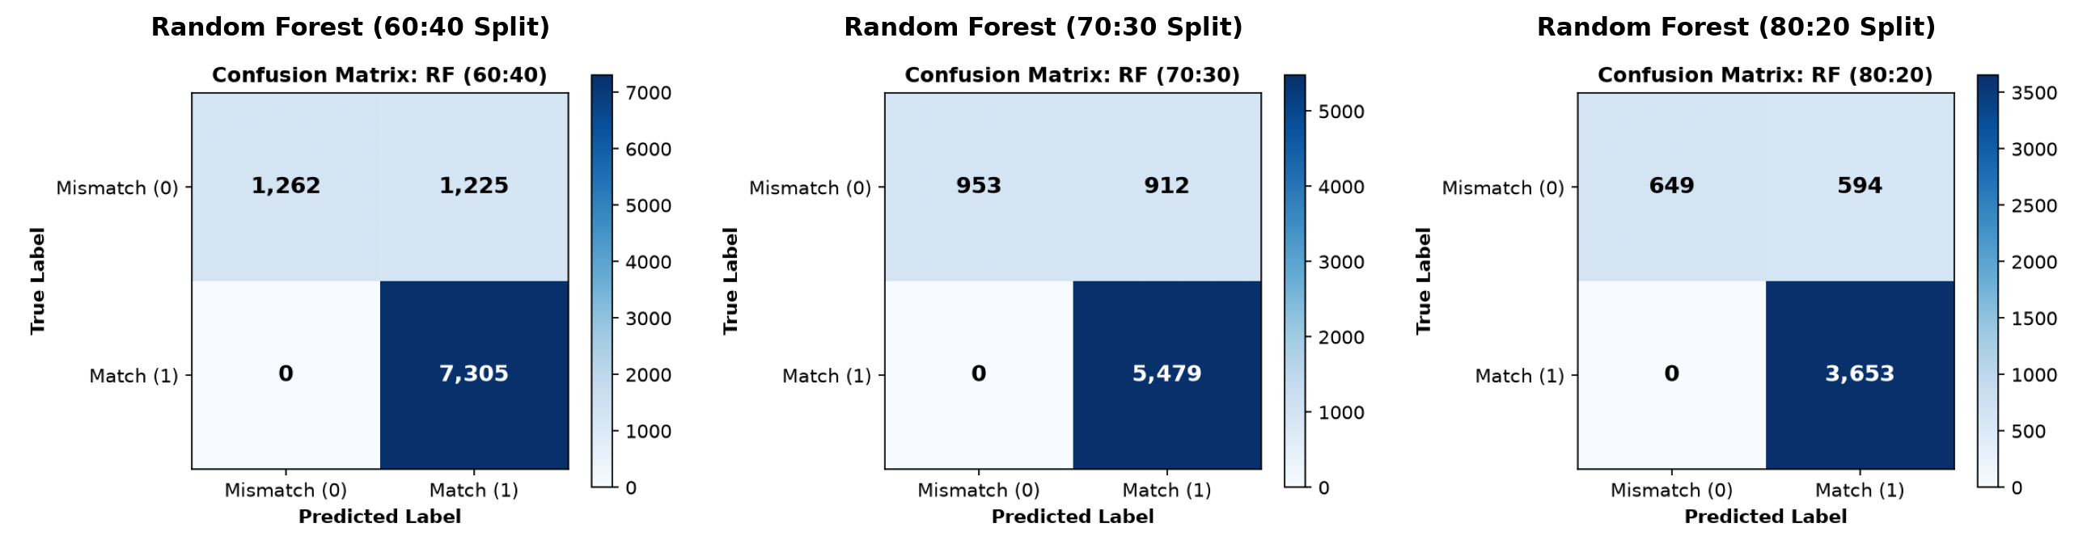
Figure E2. Random Forest Classification Confusion Matrices across Train-Test Splits

