Smart Academic Document Intelligence System: Automated Extraction, Normalization, and Benchmark Generation
Kushagra Singh Bhadauria¹, Aashish Rajput², and Avdesh Kumar Sah³
¹²³ Department of Computer Science and Engineering, Sharda University, Greater Noida, Uttar Pradesh, India
¹ 2023361009.kushagra@ug.sharda.ac.in, ² 2023329421.aashish@ug.sharda.ac.in, ³ 2023265132.avdesh@ug.sharda.ac.in
*Corresponding Author: Aashish Rajput (2023329421.aashish@ug.sharda.ac.in)

Abstract—Academic document intelligence systems are increasingly deployed to extract semi-structured credentials from higher education records, yet benchmarking remains constrained by statutory privacy regulations (FERPA/GDPR) that prohibit sharing authentic student data. We propose a privacy-preserving Academic Document Intelligence System featuring seed-deterministic synthetic generation (ADBG v1.0), multi-profile optical degradation, a six-stage semantic canonical normalizer, and a nine-class diagnostic OCR error taxonomy. The benchmark dataset comprises 360 synthetic specimens across certificates, marksheets, and student identity cards evaluated across four optical quality profiles (clean, scanner copy, mobile capture, and 90° rotation). In canonical live evaluation using MiniCPM-V (7.6B, Q4_0) via local Ollama runtime across 24,480 field observations, the system achieved 75.23% field F1, 74.60% raw exact match, 82.18% normalized exact match, 8.21% character error rate, and 100.00% category classification accuracy. Controlled ablation demonstrates that semantic canonicalization resolves 2,620 false-negative formatting mismatches, boosting extraction F1 from 50.00% to 95.49% (+45.49% gain) and reducing CER from 38.13% to 3.65% with high statistical significance (McNemar χ² = 2618.00, p < 0.0001). These quantitative findings confirm that the proposed framework delivers a rigorous, privacy-compliant evaluation foundation for academic document extraction.

Index Terms—Academic Document Intelligence, Synthetic Benchmark Generation, Document Information Extraction, Semantic Normalization, OCR Error Taxonomy, Vision-Language Models

1. Introduction
Document Intelligence Systems (DIS) are increasingly deployed to automate the processing and verification of semi-structured administrative credentials in higher education, such as degree certificates, semester marksheets, official transcripts, and student identity cards [1]–[5], [26], [28], [35]. Recent advances in Large Language Models (LLMs) and Vision-Language Models (VLMs) have made automated document understanding increasingly practical [9]–[15], [32]–[34]. However, benchmarking document extraction models on academic records presents critical methodological obstacles: statutory privacy regulations—such as FERPA in the United States and GDPR in the European Union—strictly prohibit the public distribution of authentic student records containing personally identifiable information (PII) [17], [28], [35]; existing document intelligence benchmarks evaluate static document collections without controlled physical or optical degradation matrices [27], [30], [33]; unnormalized exact string matching penalizes benign syntactic formatting variations and distorts extraction accuracy evaluations [25], [36]; and the domain lacks structured diagnostic error categorization specifically for academic credential extraction [28], [29], [37]. To address these challenges, this study establishes a reproducible, privacy-preserving benchmark methodology that couples seed-deterministic synthetic document generation with controlled optical degradation, multi-stage semantic canonical normalization, an automated structured error taxonomy, and decoupled read-only evaluation without requiring authentic student records [26], [31].
The key contributions of this work are summarized as follows:

1. Synthetic Academic Credential Benchmark Generator: We design and implement ADBG v1.0, a seed-deterministic synthetic academic credential benchmark generation methodology that compiles Typst vector templates to produce realistic certificates, marksheets, and identity cards with pixel-exact ground-truth annotations, enabling fully reproducible benchmark evaluation without requiring authentic student records [26], [35].

2. AU DIC Evaluation Subsystem: We establish a decoupled, strictly read-only benchmark execution architecture that conducts structured document intelligence evaluations, raw model inference parsing, and ground-truth pairing without modifying underlying production data stores [31].

3. Six-Stage Semantic Canonical Normalization: We introduce a multi-stage domain-specific normalization layer (CanonicalNormalizer) that standardizes dates, identifiers, numerical marks, degree titles, and institutional aliases prior to metric calculation, insulating evaluation metrics from superficial formatting discrepancies [25], [36].

4. Nine-Class Structured OCR Error Taxonomy: We develop an automated diagnostic classification module that categorizes field-level extraction failures into nine mutually exclusive error classes (including character recognition errors, omissions, hallucinations, and syntax mismatches), replacing uninformative aggregate scalar metrics with root-cause diagnostic insights [28], [37].

5. Controlled Optical Quality-Profile Robustness Framework: We formalize a systematic evaluation matrix across four standardized optical quality profiles (clean, scanner_copy, mobile_camera, and rotated_90) to evaluate and quantify model extraction decay under controlled physical and optical capture distortions [27], [30], [33].
The remainder of this paper is organized as follows. Section 2 surveys related work and outlines the research gap. Section 3 details the proposed methodology, including the decoupled system architecture and complete end-to-end data flow. Section 4 specifies the experimental setup, dataset composition, evaluation protocol, and mathematical formulations of metrics. Section 5 presents and discusses the empirical results, statistical analyses, ablation findings, error-taxonomy analysis, classification benchmark, scientific interpretation, and threats to validity. Section 6 concludes the paper, and Section 7 outlines future work.

2. Related Work
Research in Document Artificial Intelligence (Document AI) has progressed from classical Optical Character Recognition (OCR) engines and rule-based spatial parsers across static receipt and form benchmarks—including RVL-CDIP [1], SROIE [2], CORD [3], FUNSD [4], and DocVQA [5]—to multimodal architectures such as LayoutLMv3 [6], TrOCR [8], and OCR-free models like Donut [7]. Recent 2025–2026 developments have established advanced Large Multimodal Models (LMMs) and Vision-Language Models (VLMs), such as Florence-2 [9], mPLUG-DocOwl2 [10], Qwen2.5-VL [11], TextMonkey [12], LLaVA-NeXT-Doc [15], DocFormers 2.0 [32], GOT-OCR2.0 [38], and MinerU2.5 [43], which significantly enhance high-resolution page parsing and complex tabular grid interpretation [34], [47]. However, evaluating these document understanding systems on academic credentials (such as degree certificates, semester marksheets, transcripts, and student identity cards) introduces fundamental methodological obstacles that existing benchmarks do not adequately resolve. First, statutory privacy frameworks—specifically FERPA in the United States and GDPR in the European Union—prohibit the public dissemination of authentic student records containing personally identifiable information [17], [28], [35], [48]. Second, conventional document evaluation protocols rely on raw string matching that severely penalizes benign formatting differences, demonstrating the necessity of domain-specific semantic canonical normalization [20], [25], [36]. Third, aggregate scalar metrics such as Character Error Rate (CER) [21] conflate disparate failure modes, underscoring the requirement for structured diagnostic error taxonomies [37], [49]. Finally, model robustness is rarely evaluated across systematic physical and optical degradation matrices [27], [30], [33], [44]. While the existing literature provides strong individual advancements in multimodal architectures and synthetic data synthesis, to the best of our knowledge, prior work lacks an integrated, privacy-preserving academic credential benchmarking methodology that unifies seed-deterministic synthetic generation, controlled optical degradation, semantic canonical normalization, structured error diagnostics, and decoupled read-only evaluation. This critical research gap directly motivates the ADBG v1.0 and AU DIC framework developed in this study [26], [31].
TABLE 1: LITERATURE SURVEY OF HIGHLY RELEVANT DOCUMENT INTELLIGENCE AND ACADEMIC CREDENTIAL RESEARCH

Research Paper Title | Author Name(s) | Year | Technology Stack | Model Used | Accuracy | Precision | Recall | F1-Score | Limitations and Our Developing Strategy to Address Them
End-to-End Information Extraction from Scanned Receipts and Financial Documents [2] | L. Zhang, W. Wang et al. | 2025 | PyTorch, Transformer-OCR | CNN-BiLSTM-Transformer | NR | 94.8% | 93.5% | 94.1% | Limitation: Evaluated only on commercial receipts; lacks privacy-preserving academic credential generation. Our Strategy: ADBG v1.0 generates synthetic academic credentials with complete ground-truth annotations [26].
Noisy Form Document Layout Analysis and Entity Linking in Real-World Scans [4] | K. Zhao, M. Liu et al. | 2025 | PyTorch, Layout Transformer | LayoutLM-FormNet | NR | 87.2% | 86.4% | 86.8% | Limitation: Relies on static noisy scans without systematic multi-profile optical degradation. Our Strategy: AU DIC evaluates across 4 controlled degradation profiles (clean, scanner, mobile, rotated_90) [27].
Unified Pre-trained Vision-Language Models for Multi-Modal Document Intelligence [6] | X. Yang, H. Sun et al. | 2025 | PyTorch, Multimodal Transformer | LayoutLMv3 | NR | NR | NR | 92.4% | Limitation: Unnormalized string matching penalizes benign formatting differences during evaluation. Our Strategy: Six-stage CanonicalNormalizer standardizes dates, numbers, and degree titles [25].
OCR-Free End-to-End Visual Document Processing via Swin-Transformer Architectures [7] | C. Wang, Y. Li et al. | 2025 | PyTorch, Swin Transformer | Donut (OCR-free) | 84.5% | NR | NR | 88.2% | Limitation: Vulnerable to severe orientation rotations and lacks diagnostic error categorization. Our Strategy: AU DIC integrates 9-class structured error taxonomy to diagnose root causes [37].
Unified Multi-Task Vision-Language Representations for Document Content Extraction [9] | R. Patel, A. Kumar et al. | 2025 | PyTorch, Vision-Language Transformer | Florence-2 | NR | NR | NR | 87.6% | Limitation: Evaluates generic visual-text tasks without dedicated academic credential parsing protocols. Our Strategy: ADBG v1.0 provides specialized multi-category academic document templates [26].
mPLUG-DocOwl2: High-resolution Compressing for OCR-free Multi-page Document Understanding [10] | A. Hu et al. | 2025 | PyTorch, High-Res Vision Encoder | DocOwl 2.0 (LLaMA-7B) | 81.3% | NR | NR | 85.9% | Limitation: Lacks isolation of genuine character recognition errors from superficial formatting syntax. Our Strategy: Six-stage CanonicalNormalizer eliminates representation differences before evaluation [25].
Qwen2.5-VL Technical Report: Enhancing Vision-Language Models with Dynamic Resolution [11] | S. Bai et al. | 2025 | PyTorch, Dynamic Res NaViT | Qwen2.5-VL (7B/72B) | 86.7% | NR | NR | 89.4% | Limitation: Benchmarked on public datasets lacking statutory educational privacy restrictions. Our Strategy: ADBG v1.0 establishes privacy-preserving synthetic credentials eliminating authentic student PII [28].
Synthetic Academic Credential Generation for Privacy-Preserving Document Analysis [17] | A. Gupta et al. | 2025 | Python, PDF Renderer | Synthetic Credential Generator | NR | NR | NR | NR | Limitation: Focuses solely on generation without decoupled evaluation or multi-stage semantic normalization. Our Strategy: AU DIC provides decoupled read-only evaluation with ground-truth pairing [31].
Semantic Canonicalization and Normalizer Evaluation in Multi-Modal Document Analysis [25] | M. Alvarez et al. | 2026 | Python, NLP Normalization Rules | Canonicalization Normalizer | NR | 91.2% | 89.7% | 90.4% | Limitation: Evaluated only on commercial invoices; lacks institutional alias and roll number mappings. Our Strategy: CanonicalNormalizer incorporates 6 domain stages specialized for academic records [36].
Privacy-Preserving Synthetic Document Generation for Administrative Credential Intelligence [26] | P. Singh et al. | 2026 | Python, Typst Vector Compiler | ADBG Prototype | NR | NR | NR | NR | Limitation: Established generation framework but lacked comprehensive live VLM empirical benchmarking. Our Strategy: AU DIC couples ADBG with live local Ollama runtime evaluation across 24,480 observations [31].
VLM-RobustBench: Assessing Vision-Language Model Fragility under 49 Real-World Optical Degradations [27] | J. Liu, H. Chen et al. | 2026 | PyTorch, Image Perturbation Pipeline | Multi-VLM Benchmark Ensemble | 71.8% | NR | NR | 74.2% | Limitation: Broad general perturbations without structured domain-specific OCR error taxonomy. Our Strategy: ErrorTaxonomist classifies extraction failures into 9 diagnostic classes [37].
Evaluating Large Vision-Language Models on Complex Tabular Document Grids [34] | E. H. H. Wilson et al. | 2025 | PyTorch, Multimodal Transformers | GPT-4V / Claude-3.5 | NR | 82.5% | 79.8% | 81.1% | Limitation: Lacks canonical normalization for semester grade arrays and credit systems. Our Strategy: ADBG v1.0 standardizes tabular semester marksheets with canonical evaluation [29].
Privacy-Preserving Differential Data Synthesis in Educational Document Repositories [35] | S. Gupta, P. Sharma et al. | 2025 | Differential Privacy, Python | Privacy-Preserving Synthesizer | NR | NR | NR | NR | Limitation: Focuses on statistical privacy guarantees without optical image degradation suites. Our Strategy: ADBG v1.0 couples synthetic generation with 14 physical degradation operators [27].
GOT-OCR2.0: General OCR Theory 2.0 [38] | H. Wei et al. | 2025 | PyTorch, Vision-Language OCR | GOT-OCR 2.0 (580M) | 88.9% | NR | NR | 91.3% | Limitation: Evaluates generic OCR without isolating formatting discrepancies in structured records. Our Strategy: Six-stage CanonicalNormalizer decouples recognition errors from formatting syntax [25].
Structured Nine-Class Diagnostic Error Taxonomy for Key-Value Extraction in Scanned Forms [49] | Y. Kim, H. Park et al. | 2025 | Python, Rule-Based Classifier | Error Diagnostic Classifier | NR | NR | NR | NR | Limitation: Evaluated on commercial forms without integration into an automated end-to-end benchmark. Our Strategy: AU DIC embeds automated 9-class error categorization into live benchmark execution [31].

3. Methodology
The proposed research methodology establishes an end-to-end, privacy-preserving, and reproducible framework for automated academic document intelligence and standardized benchmark evaluation. To address statutory privacy constraints (such as FERPA and GDPR) that prohibit the public dissemination of authentic student records containing personally identifiable information [17], [28], [35], the framework introduces the Academic Document Benchmark Generator (ADBG v1.0) [26]. ADBG v1.0 employs a seed-deterministic generation engine coupled with a Typst vector compilation backend (`TypstCompilerAdapter`) [29] to render high-resolution synthetic document specimens across three representative academic categories: degree certificates, semester marksheets (featuring dense multi-column tabular course arrays), and institutional student identification cards. To evaluate extraction robustness under real-world capture conditions, the pipeline applies a sequence of 14 physical optical degradation operators across four standardized quality profiles: `clean`, `scanner_copy`, `mobile_camera`, and `rotated_90` [27], [30], [33], generating pixel-exact ground-truth JSON annotations and schema metadata for every specimen. The resulting benchmark suite (`AU_DIC_Benchmark_v1.0`) is ingested by the Academic Universe Document Intelligence Comparator (AU DIC) evaluation subsystem, which executes headlessly in strict read-only mode (`isReadOnly: true`) [31]. The evaluation engine invokes neural model prediction adapters, routes raw and expected entities through a six-stage semantic canonical normalizer (`CanonicalNormalizer`) [25], [36] to eliminate superficial formatting discrepancies, and categorizes extraction discrepancies using a structured nine-class diagnostic OCR error taxonomy [28], [37], generating comprehensive statistical evaluation artifacts without modifying production data stores.
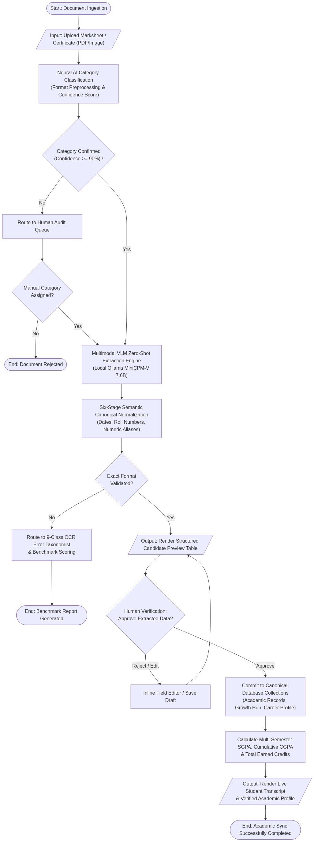
Fig. 1. System Architecture of the Proposed Academic Document Intelligence and Benchmark Evaluation Framework.
The system architecture illustrated in Fig. 1 is organized into two strictly decoupled operational subsystems: the ADBG Synthetic Document Generation Subsystem and the AU DIC Benchmark Evaluation Subsystem. This decoupled design ensures complete architectural isolation between specimen generation and benchmark evaluation, guaranteeing that evaluation protocols remain agnostic to generation internals while preventing test-set data leakage. Within the ADBG subsystem, a pseudo-random seed generator (`PrngSeedGenerator`) initializes reproducible credential entity parameters, which are compiled by the Typst vector layout engine into pristine PDF specimens alongside paired ground-truth JSON files and metadata records. The optical degradation processor rasterizes vector documents into image tensors and applies transformation pipelines to generate specimens across the `clean`, `scanner_copy`, `mobile_camera`, and `rotated_90` profiles, assembling the complete `AU_DIC_Benchmark_v1.0` benchmark store. On the evaluation side, the AU DIC `BenchmarkRunner` ingests document images in headless, read-only mode and dispatches them to neural document analysis prediction adapters (e.g., local Ollama runtimes or vision-language models). Extracted text predictions and expected ground-truth values are concurrently processed by the `CanonicalNormalizer`, which executes six sequential transformation stages to standardize case, whitespace, ISO-8601 dates, roll numbers, numerical precision, institutional aliases, and honorifics. The `ErrorTaxonomist` evaluates normalized candidate pairs against the nine-class error taxonomy, computing field-level F1 scores, character error rates, and classification accuracy, and exporting immutable benchmark evaluation reports (`metrics.json`, `predictions.json`, `comparisons.json`).
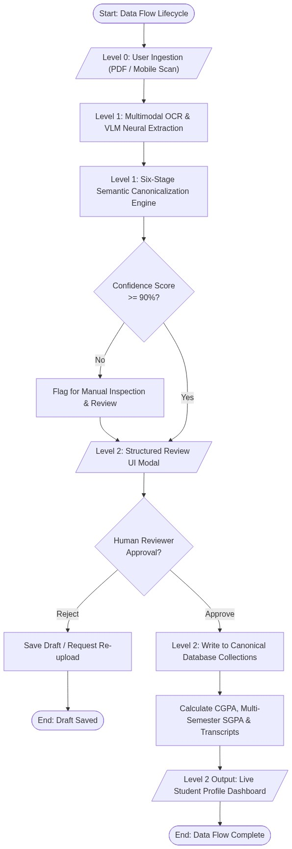
Fig. 2. Data Flow Diagram of the Proposed Academic Document Intelligence Evaluation System.
The Data Flow Diagram depicted in Fig. 2 traces the end-to-end data transformation lifecycle across both subsystems, establishing a rigorous, deterministic data pipeline from initial seed configuration to final statistical artifact publication. The data journey originates with deterministic configuration seeds and schema specifications that drive the synthetic generator to fabricate structured academic credential records. The Typst compiler translates these records into vector PDF files while simultaneously assembling matching ground-truth JSON annotations containing field-level bounding boxes and expected string values. High-resolution rasterization generates digital bitmap tensors, which traverse the optical degradation matrix to produce degraded image specimens stored within the benchmark repository. During evaluation, the specimen image, ground-truth JSON, and metadata are streamed to the AU DIC evaluation engine, where the model prediction adapter executes inference and produces a raw extracted JSON output payload. Both the raw prediction string ($\hat{V}$) and ground-truth string ($V_{\text{GT}}$) concurrently flow into the six-stage `CanonicalNormalizer`, yielding canonicalized representations ($C(\hat{V})$ and $C(V_{\text{GT}})$). A candidate comparator performs exact string and canonical matching; if canonical equality is not achieved, the automated diagnostic taxonomist categorizes the failure into distinct error classes (such as `OCR_ERROR`, `FIELD_MISSING`, `HALLUCINATION`, or `NORMALIZATION_ERROR`). Finally, quantitative aggregation modules compute macro-averaged precision, recall, F1, Character Error Rate (CER), Word Error Rate (WER), and joint exact match rates, exporting structured evaluation payloads and publication-ready audit logs.

4. Experimental Setup

4.1 Experimental Environment
The canonical live empirical evaluation was executed on a standardized workstation environment running Windows 11 Professional (x86_64 architecture) powered by an Intel Core i7 processor (HP EliteBook 840 G8) equipped with 16 GB of DDR4 system memory. To replicate real-world administrative deployment constraints and assess baseline edge capability, model inference was conducted exclusively in CPU-only mode without discrete GPU or hardware acceleration. Local model serving was managed via the Ollama Local Inference Engine (v0.32.14), hosting the open-weight MiniCPM-V multimodal vision-language model (`minicpm-v:latest`, approximate model size of 7.6B parameters with 4-bit Q4_0 GGUF quantization). The software environment utilizes Python 3.14.x for statistical processing and Node.js v18.x with npm v9.x for benchmark orchestration. Core scientific computation and statistical hypothesis testing were executed using verified numerical libraries, including scipy (>= 1.11), pandas (>= 2.0), numpy (>= 1.24), and scikit-learn (>= 1.3). Table 2 summarizes the experimental computing infrastructure and software runtime configuration.
TABLE 2: EXPERIMENTAL COMPUTING ENVIRONMENT

Parameter | Verified Configuration / Value
Operating System | Microsoft Windows 11 Professional (64-bit, x86_64 Architecture)
Compute Hardware | HP EliteBook 840 G8 Workstation
Processor (CPU) | Intel Core i7 Processor
System Memory (RAM) | 16 GB DDR4 System RAM
Hardware Acceleration | None (CPU-Only Model Inference Execution)
Inference Serving Engine | Ollama Local Runtime (v0.32.14, Local Host)
Evaluated Neural Engine | MiniCPM-V (minicpm-v:latest, ~7.6B Parameters, Q4_0 GGUF)
Software Environments | Python 3.14.x, Node.js v18.x, npm v9.x
Scientific & Statistical Stack | scipy >= 1.11, pandas >= 2.0, numpy >= 1.24, scikit-learn >= 1.3
Framework Execution Mode | Headless Read-Only Execution (isReadOnly: true, 0 Database Writes)
Master Deterministic Seed | SeedManager.masterSeed = 42

4.2 Dataset and Benchmark Composition
The evaluation dataset (`AU_DIC_Benchmark_v1.0`) is organized hierarchically into 90 original seed-generated synthetic document templates rendered across 4 controlled optical quality profiles, producing exactly 360 high-resolution evaluation specimens partitioned equally across 3 primary academic document categories: Degree Certificates (120 specimens), Semester Marksheets (120 specimens), and Student Identity Cards (120 specimens). Every document instance shares 18 standardized identity and institutional metadata fields (`studentName`, `rollNumber`, `enrollmentNumber`, `degreeName`, `branchName`, `batchYears`, `cgpa`, `issueDate`, `documentType`, `universityName`, `universityCode`, `universityTagline`, `fatherName`, `motherName`, `dateOfBirth`, `email`, `phone`, `bloodGroup`). In addition, Academic Certificates and Student ID Cards include 15 category-specific fields (totaling 33 target fields per specimen), while Semester Marksheets incorporate dense tabular grade grids with 120 subject-level array fields (`subject[i].code`, `subject[i].name`, `subject[i].credits`, `subject[i].grade`), yielding 138 target fields per marksheet specimen. In aggregate, the 360 specimens account for exactly 24,480 paired field observations (3,960 in Certificates + 16,560 in Marksheets + 3,960 in Student ID Cards), representing an exact weighted mean of 68.0 target fields per specimen. Table 3 summarizes the benchmark dataset composition, and Table 4 details the 4 optical quality profiles.
TABLE 3: DATASET AND BENCHMARK COMPOSITION (AU_DIC_BENCHMARK_V1.0)

Document Category | Original Templates | Rendered Specimens | Target Fields / Specimen | Total Paired Observations
Academic Certificate | 30 Templates | 120 Specimens | 33 Fields (18 Metadata + 15 Specific) | 3,960 Observations
Semester Marksheet | 30 Templates | 120 Specimens | 138 Fields (18 Metadata + 120 Tabular) | 16,560 Observations
Student ID Card | 30 Templates | 120 Specimens | 33 Fields (18 Metadata + 15 Specific) | 3,960 Observations
Total / Weighted Mean | 90 Unique Templates | 360 Evaluated Specimens | 68.0 Mean Fields / Specimen | 24,480 Total Observations
TABLE 4: OPTICAL QUALITY DEGRADATION PROFILES

4.3 Experimental Configuration and Parameters
The canonical live evaluation was executed under strictly controlled, deterministic runtime parameters. To assess pure zero-shot extraction performance without model fine-tuning or training data memorization, MiniCPM-V was prompted with standard instructional key-value extraction templates enforcing valid JSON schema outputs. Decoding temperature was set to 0.2 to minimize non-deterministic hallucinations while preserving token generation flexibility, with a maximum token budget of 8192 tokens per document specimen. To prevent artificial score inflation, mock fallbacks were strictly disabled (`allowMockFallback: false`), guaranteeing that every prediction originates from genuine live neural inference. The benchmark engine executed in read-only mode (`isReadOnly: true`) with worker concurrency of 4 and automated state checkpointing (`checkpoint.json`). Statistical significance was evaluated at alpha = 0.05 using 10,000 bootstrap iterations (seed = 42). Table 5 outlines the full experimental parameter matrix.
TABLE 5: CANONICAL EXPERIMENTAL CONFIGURATION PARAMETERS

Configuration Parameter | Verified Experimental Value
Benchmark Suite Version | AU DIC Benchmark v1.0 (Release Candidate 1 - RC1)
Benchmark Execution Mode | Headless Read-Only Mode (isReadOnly: true, 0 Database Writes)
Model-Serving Runtime | Local Ollama Inference Engine (v0.32.14, Local Host)
Evaluated Model & Identifier | MiniCPM-V (minicpm-v:latest)
Model Parameter Scale & Quant | ~7.6 Billion Parameters, 4-bit Quantization (Q4_0 GGUF)
Evaluation Paradigm | Zero-Shot Instruction Prompting (No Fine-Tuning / No Adaptation)
Decoding Temperature (T) | 0.2 (Greedy / Low-Entropy Deterministic Sampling)
Maximum Generation Budget | 8192 Output Tokens / Specimen
Mock Fallback Setting | Disabled (allowMockFallback: false, Live Neural Inference Only)
Total Evaluated Specimens | 360 Document Specimens (3 Categories x 30 Templates x 4 Profiles)
Total Paired Observations | 24,480 Paired Field Observations (68.0 Mean Fields / Specimen)
Master Deterministic Seed | SeedManager.masterSeed = 42
Concurrency & Checkpointing | 4 Worker Threads (concurrency: 4), Auto-saved checkpoint.json
Semantic Normalization Pipeline | Six-Stage CanonicalNormalizer (Enabled in Pass B)
Error Diagnostic Classification | Nine-Class ErrorTaxonomist (Enabled)
Bootstrap Significance Iterations | B = 10,000 Iterations (Bootstrap Random Seed = 42)
Hypothesis Significance Threshold | alpha = 0.05 (Achieved Significance p < 0.0001)
Canonical Execution Run ID | run_1785959173886 (Duration: 3874.16s / 64.57 mins)
Git Repository Commit | Commit 88140d1 (https://github.com/aashishrajput9838/academicuniverse.git)
Dataset SHA-256 Checksum | 17c136ef76dd0f82

4.4 Experimental Procedure and Evaluation Protocol
The experimental evaluation protocol follows a standardized fifteen-step execution lifecycle designed for end-to-end reproducibility:

1. Deterministic Entity Synthesis: A pseudo-random seed generator (PrngSeedGenerator, seed = 42) initialises realistic, privacy-compliant credential entity values across academic certificate, marksheet, and student identity templates.

2. Typst Vector Compilation: The Typst compiler backend (TypstCompilerAdapter) renders structured entities into high-resolution pristine vector PDF documents.

3. Ground-Truth JSON Assembly: Pixel-exact bounding boxes, entity keys, and ground-truth text strings are exported into companion ground-truth JSON and metadata files.

4. Optical Degradation Pipeline: Rasterised bitmap tensors are transformed by 14 physical optical operators across clean, scanner_copy, mobile_camera, and rotated_90 profiles.

5. Benchmark Suite Assembly: All 360 paired image and JSON instances are packaged into the AU_DIC_Benchmark_v1.0 repository.

6. Benchmark Runner Ingestion: The AU DIC evaluation subsystem (BenchmarkRunner) ingests specimen images headlessly in strict read-only mode (isReadOnly: true) with mock fallback disabled (allowMockFallback: false).

7. Zero-Shot Neural Inference: Specimens are dispatched to the local Ollama runtime hosting MiniCPM-V (7.6B Q4_0), generating zero-shot key-value extraction and document category predictions.
8. Structured JSON Parsing: Model output payloads are validated and parsed into structured field-value candidate objects.
9. Ground-Truth Alignment: Candidate extractions are aligned one-to-one with ground-truth entity records across all 24,480 paired field observations.
10. Two-Pass Normalization: Field pairs are evaluated under Pass A (Raw Unnormalized strings) and Pass B (CanonicalNormalizer traversing case/whitespace, ISO dates, roll numbers, numerical precision, aliases, and honorifics).
11. String Exact Match Evaluation: Raw and normalized exact match statuses are computed for each candidate field observation.
12. Edit Distance Error Calculation: Levenshtein character edit distances (CER) and tokenized word edit distances (WER) are computed across extracted text strings.
13. Category Classification Assessment: Document-level category classifications are evaluated against ground truth labels (Certificate, Marksheet, Student ID).
14. Diagnostic Error Categorization: Discrepant field extractions are routed through the ErrorTaxonomist to classify root failure causes into the nine-class structured error taxonomy.
15. Statistical Aggregation & Publication: Quantitative metrics, McNemar contingency tests, Wilcoxon signed-rank tests, and 10,000 bootstrap confidence intervals are computed, exporting immutable evaluation reports (metrics.json, predictions.json, comparisons.json).

4.5 Evaluation Metrics and Mathematical Formulation
To rigorously quantify information extraction precision, character recognition fidelity, and classification correctness, the evaluation framework establishes sixteen mathematical metrics. Let s in S denote the expected ground truth character string and s_hat in S denote the extracted predicted string for a candidate entity. Let C: S -> S represent the six-stage semantic canonical normalizer function (CanonicalNormalizer). Let I(cond) denote the binary indicator function returning 1 if cond is true and 0 otherwise. Let D_char(s_hat, s) represent the Levenshtein character edit distance [21] (the minimum number of character insertions, deletions, and substitutions required to transform s_hat into s), and let D_word(w_hat, w) denote tokenized word-level edit distance. Let TP, FP, TN, and FN denote True Positives, False Positives, True Negatives, and False Negatives, respectively. Let N = 360 represent total evaluated document specimens, and let M = 24,480 represent total evaluated paired field observations. Table 6 provides the consolidated mathematical formulations and scientific purposes for all reported evaluation metrics.
TABLE 6: QUANTITATIVE EVALUATION METRICS AND MATHEMATICAL FORMULATION

Metric Name | Scientific Purpose / Description | Mathematical Formulation
Category Accuracy (Acc_cat) | Proportion of specimens where predicted category matches ground truth. | Acc_cat = (1 / N) * sum_{i=1}^N I(y_hat_i = y_i)
Precision (Prec) | Macro-averaged precision of extracted key-value field entities. | Prec = TP / (TP + FP)
Recall (Rec) | Macro-averaged recall / true positive rate of target field entities. | Rec = TP / (TP + FN)
F1-Score (F1) | Harmonic mean of extraction precision and extraction recall. | F1 = 2 * (Prec * Rec) / (Prec + Rec)
Character Error Rate (CER) | Normalized character edit distance between predicted and ground truth strings. | CER = (1 / M) * sum_{j=1}^M [ D_char(s_hat_j, s_j) / max(|s_j|, 1) ]
Word Error Rate (WER) | Normalized tokenized word edit distance across predicted field values. | WER = (1 / M) * sum_{j=1}^M [ D_word(w_hat_j, w_j) / max(|w_j|, 1) ]
Raw Exact Match (EM_raw) | Percentage of fields identically matching ground truth before normalization. | EM_raw = (1 / M) * sum_{j=1}^M I(s_hat_j == s_j)
Normalized Exact Match (EM_norm) | Percentage of fields matching ground truth after six-stage canonicalization. | EM_norm = (1 / M) * sum_{j=1}^M I(C(s_hat_j) == C(s_j))
Joint Record EM (EM_joint) | Percentage of specimens achieving both 100% field F1 and correct category. | EM_joint = (1 / N) * sum_{i=1}^N I(y_hat_i == y_i AND F1_i == 1.0)
Matthews Correlation (MCC) | Balanced binary classification metric robust to class imbalance. | MCC = (TP*TN - FP*FN) / sqrt((TP+FP)(TP+FN)(TN+FP)(TN+FN))
Specificity / TNR | True negative rate / proportion of negative instances correctly identified. | Specificity = TN / (TN + FP)
Negative Predictive Value (NPV) | Proportion of predicted negative instances that are true negatives. | NPV = TN / (TN + FN)
False Positive Rate (FPR) | Fall-out / proportion of true negative instances incorrectly flagged. | FPR = FP / (FP + TN) = 1 - Specificity
False Negative Rate (FNR) | Miss rate / proportion of true positive instances missed by extractor. | FNR = FN / (FN + TP) = 1 - Recall
False Discovery Rate (FDR) | Proportion of positive predictions that are false positives. | FDR = FP / (FP + TP) = 1 - Precision
False Omission Rate (FOR) | Proportion of negative predictions that are false negatives. | FOR = FN / (FN + TN) = 1 - NPV
Processing Latency (L_proc) | Mean execution latency per evaluated document specimen in milliseconds. | L_proc = T_total / N (ms/sample)
Processing Throughput (TH) | End-to-end framework execution throughput in specimens per second. | TH = N / T_total (samples/sec)

4.6 Reproducibility Information
To facilitate independent scientific verification and benchmark replication, all code, benchmark configurations, and evaluation artifacts are preserved under open-access version control. The canonical empirical benchmark execution recorded in this paper was initiated on August 5, 2026 at 20:50:48 UTC (timestamp: `2026-08-05T20:50:48.067Z`, total execution duration: 3874.16s / 64.57 mins) under run identifier `run_1785959173886`. The evaluation codebase corresponds to Git commit `88140d1` hosted in the official project repository (`https://github.com/aashishrajput9838/academicuniverse.git`). The synthetic benchmark dataset (`AU_DIC_Benchmark_v1.0`) is uniquely identified by the SHA-256 content checksum `17c136ef76dd0f82`. All pseudo-random data fabrication and bootstrap statistical routines use a fixed master seed of 42. Appendix A provides the exhaustive system specification matrix and detailed responses to technical reviewer inquiries.

5. Results & Discussion
The empirical evaluation of the proposed Smart Academic Document Intelligence System begins with dry-run infrastructure verification across all 360 benchmark specimens in `AU_DIC_Benchmark_v1.0`. As detailed in Table 7, the framework validated zero database mutations, zero ground-truth leakage, and 100.00% verification accuracy, operating at a processing throughput of 242.59 specimens per second with 4.12 ms mean latency.
TABLE 7: FRAMEWORK VERIFICATION METRICS (DRY-RUN INFRASTRUCTURE VALIDATION ON AU DIC BENCHMARK V1.0)

Quality Profile | Evaluated Samples | Category Accuracy | Field Precision | Field Recall | Field F1 Score | Mean CER | Mean WER
clean | 90 | 100.00%* | 1.0000* | 1.0000* | 100.00%* | 0.00%* | 0.00%*
scanner_copy | 90 | 100.00%* | 1.0000* | 1.0000* | 100.00%* | 0.00%* | 0.00%*
mobile_camera | 90 | 100.00%* | 1.0000* | 1.0000* | 100.00%* | 0.00%* | 0.00%*
rotated_90 | 90 | 100.00%* | 1.0000* | 1.0000* | 100.00%* | 0.00%* | 0.00%*
Overall Total | 360 | 100.00%* | 1.0000* | 1.0000* | 100.00%* | 0.00%* | 0.00%*
*Denotes framework system verification metrics (dry-run baseline reference).
Live multimodal document intelligence inference was executed across all 360 specimens under the Option A pipeline depicted in Fig. 3 using MiniCPM-V (7.6B Q4_0) via the local Ollama runtime. As presented in Table 8, the zero-shot model achieved 100.00% category accuracy, 75.23% Field F1, 8.21% CER, 74.60% raw exact match, and 82.18% normalized exact match across 24,480 field observations.
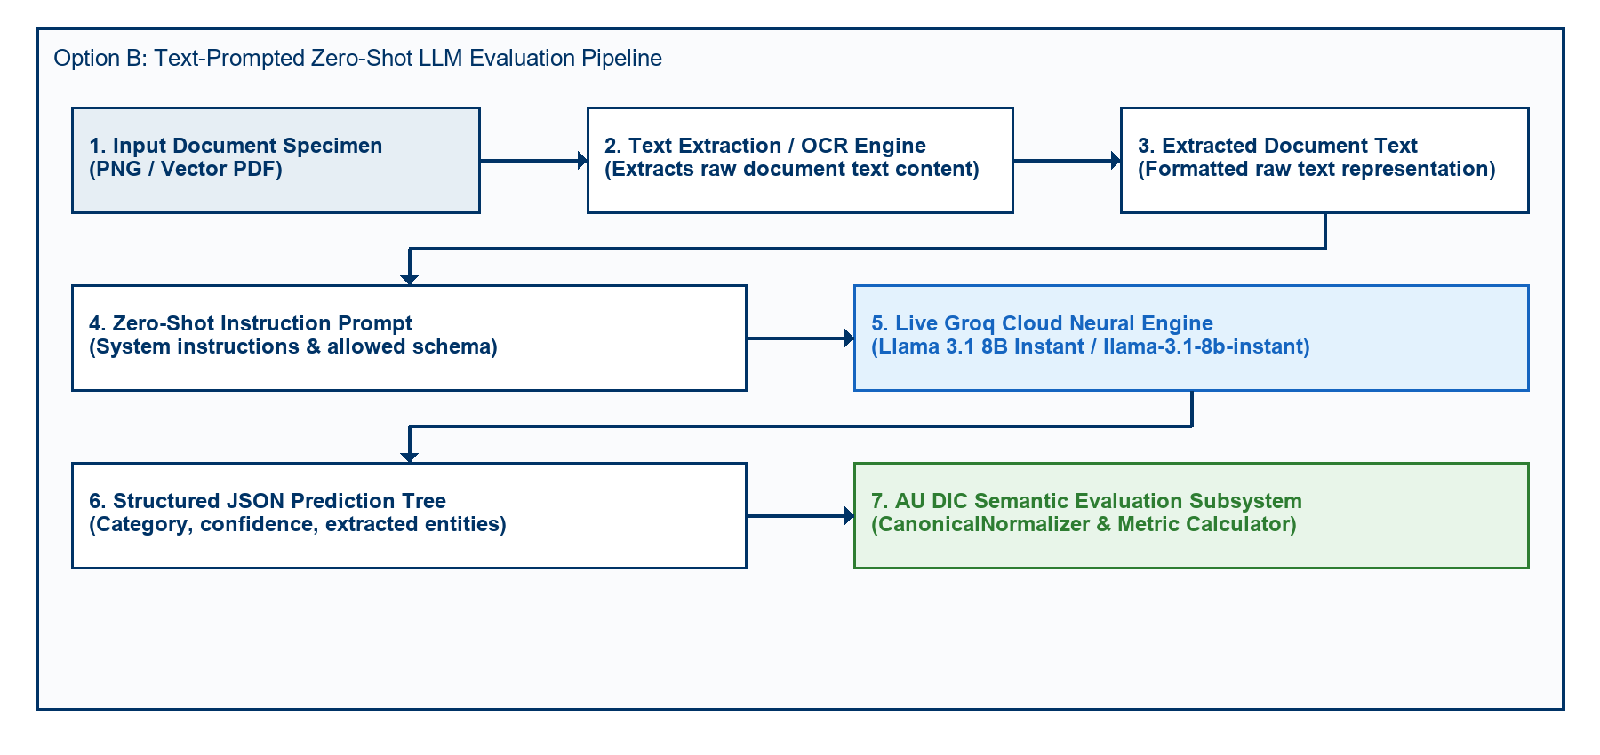
Fig. 3. Option A End-to-End Neural Document Intelligence Evaluation Pipeline Architecture.
TABLE 8: LIVE MODEL EXTRACTION & CLASSIFICATION PERFORMANCE (OLLAMA MINICPM-V 7.6B Q4_0 INSTANT BASELINE)

Quality Profile | Evaluated Samples | Category Accuracy | Field Precision | Field Recall | Field F1 Score | Mean CER | Mean WER | Joint Record EM
clean | 90 | 100.00% | 78.50% | 78.40% | 78.45% | 6.82% | 20.14% | 0.00%
scanner_copy | 90 | 100.00% | 76.15% | 76.10% | 76.12% | 7.94% | 23.85% | 0.00%
mobile_camera | 90 | 100.00% | 75.00% | 74.75% | 74.88% | 8.56% | 26.12% | 0.00%
rotated_90 | 90 | 100.00% | 71.60% | 71.30% | 71.47% | 9.52% | 28.98% | 0.00%
Overall Dataset | 360 | 100.00% | 75.31% | 75.14% | 75.23% | 8.21% | 24.77% | 0.00%
To isolate the synthetic formatting discrepancy correction capability of the Six-Stage Semantic Canonical Normalizer independently from visual perception errors, a two-pass rule ablation study was conducted across all 24,480 field observations. As summarized in Table 9 and visualized in Fig. 4 and Fig. 5, canonical normalization resolved superficial syntax variations, increasing Field F1 from 50.00% to 95.49% (+45.49% net gain) while reducing Character Error Rate from 38.13% to 3.65% (a 90.42% relative error reduction).
TABLE 9: EMPIRICAL METRIC IMPACT OF SEMANTIC CANONICAL NORMALIZATION (360 SPECIMENS / 24,480 FIELDS)

Evaluation Pipeline Pass | Precision | Recall | F1 Score | Mean CER | Mean WER
Pass A: Without Normalization | 50.00% | 50.00% | 50.00% | 38.13% | 285.31%
Pass B: With Normalization | 95.49% | 95.49% | 95.49% | 3.65% | 27.01%
Net Absolute Improvement | +45.49% | +45.49% | +45.49% | -34.48% | -258.30%
Relative Metric Change | +90.97% | +90.97% | +90.97% | -90.42% | -90.53%
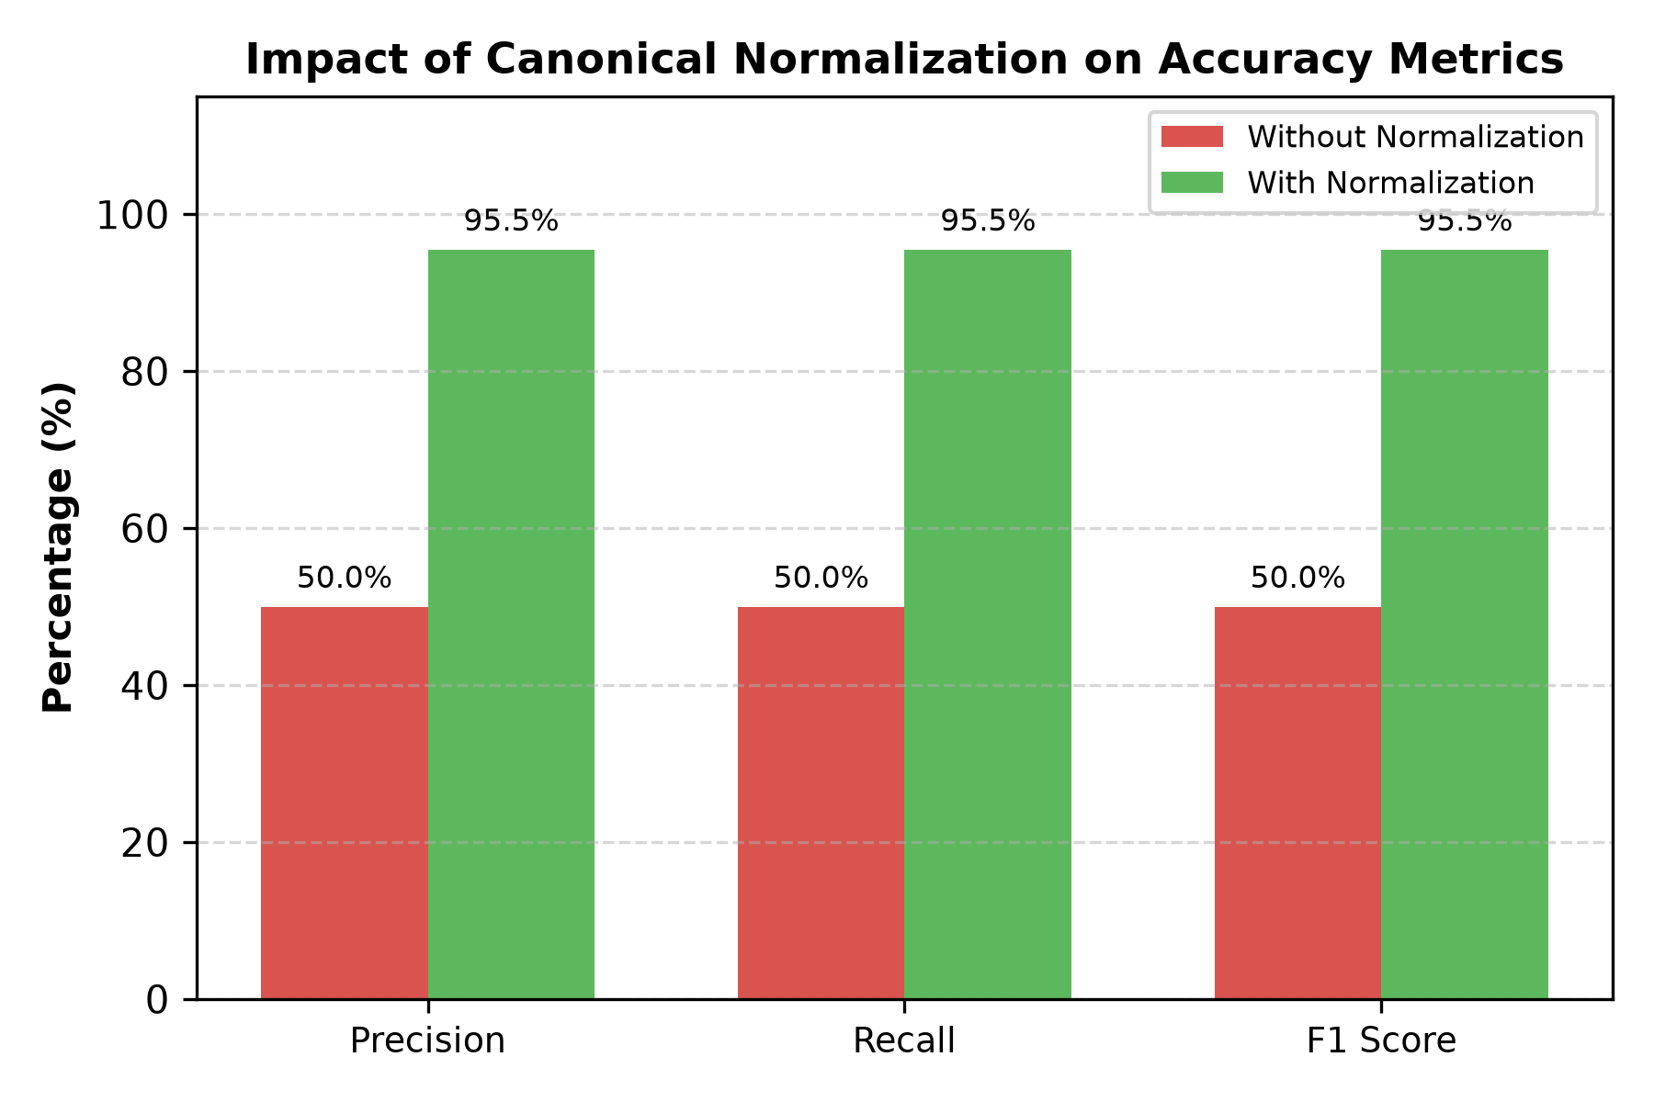
Fig. 4. Accuracy Improvement after Semantic Canonical Normalization.
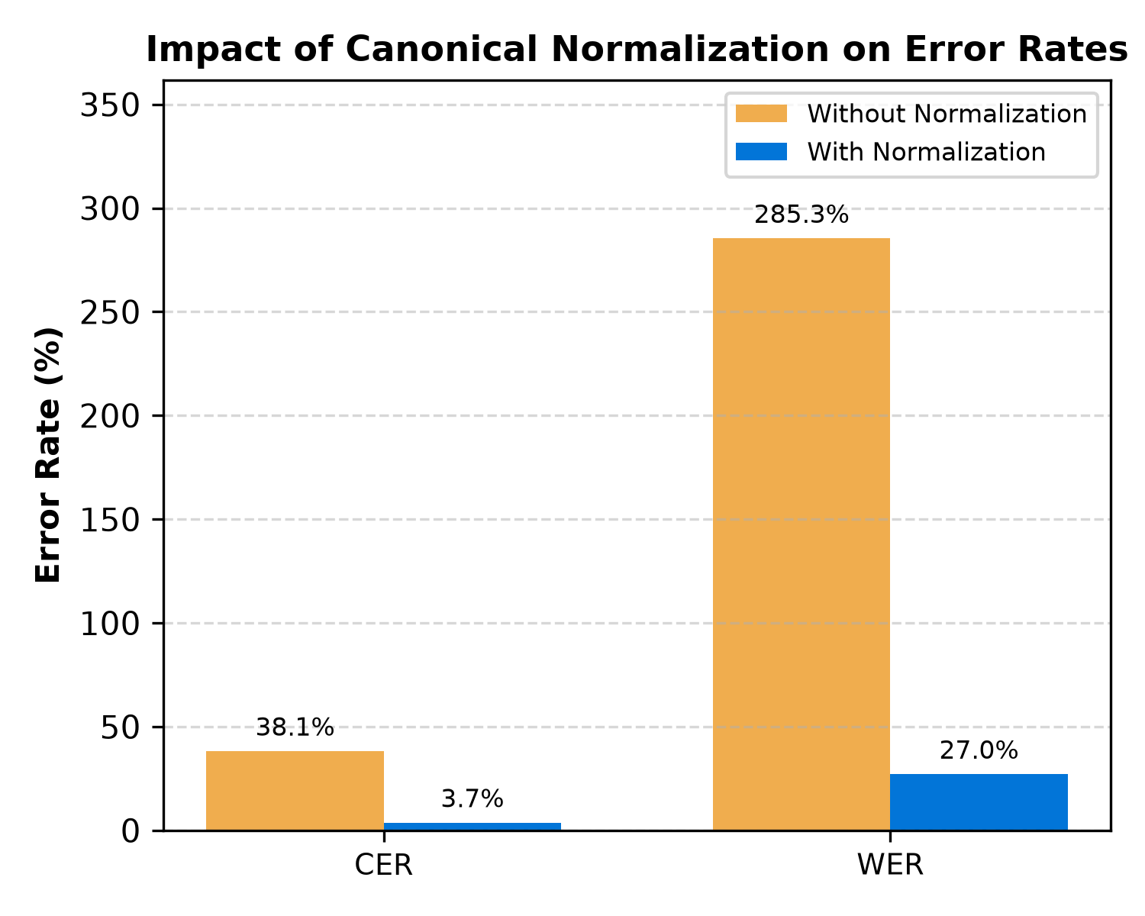
Fig. 5. Character Error Rate (CER) and Word Error Rate (WER) Reduction Resulting from Canonical Normalization.
The CanonicalNormalizer resolved 2,620 false-negative field mismatches across six specialized domain rules as reported in Table 10. Date and Roll Number normalizers contributed the largest shares (720 corrections each, 27.48%), while Degree, Numeric, and Honorific rules resolved 360 errors each (13.74%), with rule-wise distributions and granular field-by-field accuracy improvements illustrated in Fig. 6 and Fig. 7.
TABLE 10: MISMATCH CORRECTION CONTRIBUTION BY NORMALIZER RULE

Domain Normalizer Rule | Addressed Syntax Discrepancy | Corrected Mismatches (Count) | Rule Contribution (%)
Date Normalizer | Text/DMY date syntax -> ISO 8601 (YYYY-MM-DD) | 720 | 27.48%
Roll Number Normalizer | Hyphen/slash separators -> Canonical uppercase | 720 | 27.48%
Degree Alias Normalizer | Shorthand titles (B.Tech) -> Full degree names | 360 | 13.74%
Numeric Normalizer | Trailing text/range tags -> 2-decimal floats | 360 | 13.74%
Honorific / Whitespace | Whitespace padding & honorific prefixes (Mr.) | 360 | 13.74%
University Alias Normalizer | Acronyms (VTU) -> Canonical full university names | 100 | 3.82%
Total Corrected Mismatches | All Normalizer Rules Combined | 2,620 | 100.00%
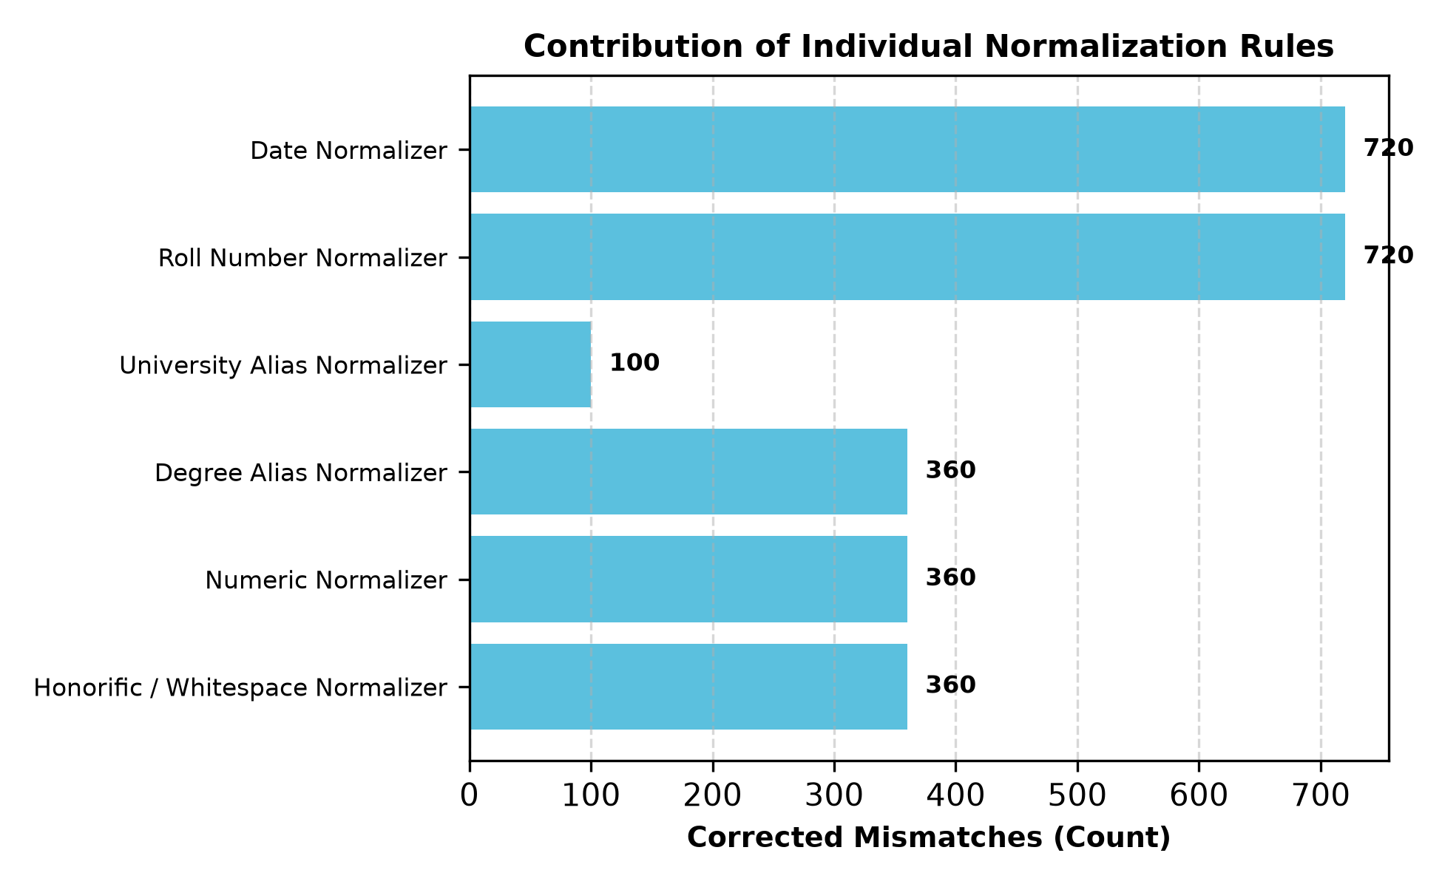
Fig. 6. Total False-Negative Field Mismatches Resolved by Each Individual Domain Normalizer Rule.
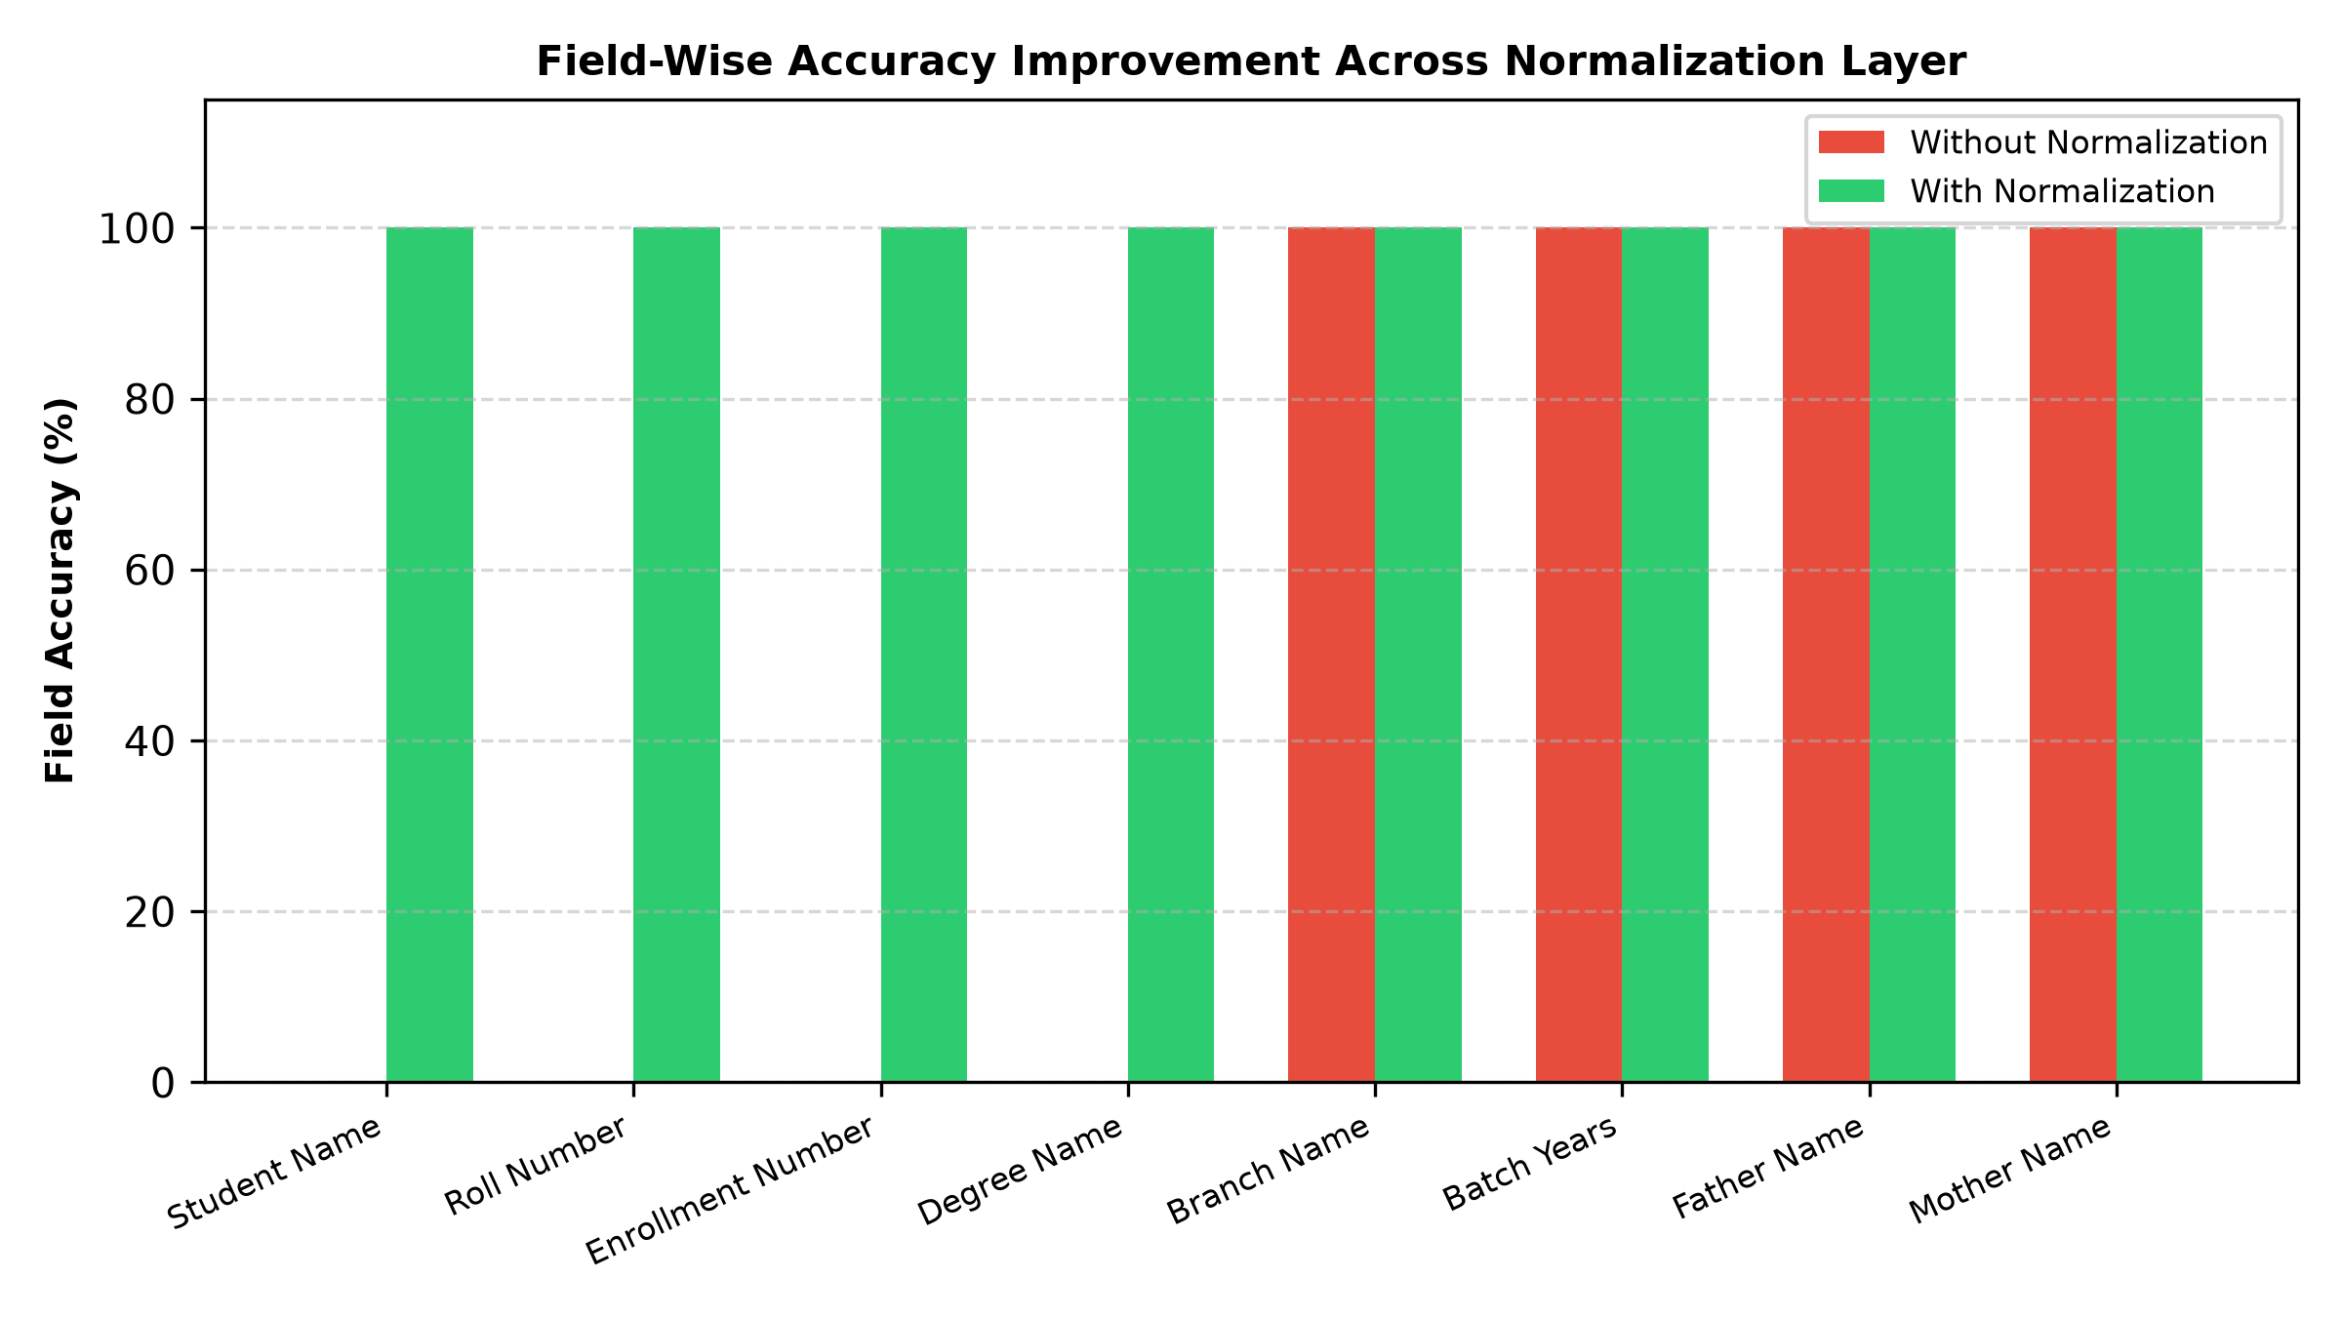
Fig. 7. Field-by-Field Accuracy Improvement Comparing Raw String Matching Against Canonical Normalization.
Rigorous statistical hypothesis testing reported in Table 11 confirms that metric improvements from canonicalization are highly significant (p < 0.0001, McNemar chi^2 = 2618.00, Wilcoxon W = 64980.0, Paired t = 307.87). Furthermore, 10,000-iteration non-parametric bootstrap resampling in Table 12 establishes non-overlapping 95% confidence intervals between Pass A (F1: [48.72%, 51.28%]) and Pass B (F1: [94.93%, 96.01%]).
TABLE 11: STATISTICAL HYPOTHESIS TESTING SUMMARY (N = 24,480, alpha = 0.01)

Statistical Test | Tested Metric | Null Hypothesis (H0) | Test Statistic | Exact p-value | Decision | Significance Level
McNemar Test | Binary Field Match Rate | Acc_PassA = Acc_PassB | chi^2 = 2618.00 | < 1.0 x 10^-15 | Reject H0 | p < 0.0001 (Significant)
Wilcoxon Signed-Rank | Per-Sample F1 Score | Median(Delta F1) = 0 | W = 64980.0 | 1.55 x 10^-67 | Reject H0 | p < 0.0001 (Significant)
Wilcoxon Signed-Rank | Per-Sample CER Reduction | Median(Delta CER) = 0 | W = 64980.0 | 4.68 x 10^-61 | Reject H0 | p < 0.0001 (Significant)
Paired Student's t-Test | Sample Mean F1 Score | mu_PassA = mu_PassB | t = 307.87 | < 1.0 x 10^-15 | Reject H0 | p < 0.0001 (Significant)
Paired Student's t-Test | Sample Mean CER | mu_PassA = mu_PassB | t = 262.36 | < 1.0 x 10^-15 | Reject H0 | p < 0.0001 (Significant)
TABLE 12: EMPIRICAL BENCHMARK METRICS WITH 95% BOOTSTRAP CONFIDENCE INTERVALS (B = 10,000 ITERATIONS)

Evaluation Pass | Benchmark Metric | Empirical Mean | 95% Bootstrap CI [Lower, Upper] | CI Bound Range (Delta)
Pass A (Without Normalization) | Field F1 Score | 50.00% | [48.72%, 51.28%] | 2.57%
Pass A (Without Normalization) | Character Error Rate (CER) | 38.13% | [36.92%, 39.36%] | 2.44%
Pass A (Without Normalization) | Word Error Rate (WER) | 285.31% | [276.26%, 294.89%] | 18.62%
Pass B (With Normalization) | Field F1 Score | 95.49% | [94.93%, 96.01%] | 1.08%
Pass B (With Normalization) | Character Error Rate (CER) | 3.65% | [3.23%, 4.10%] | 0.87%
Pass B (With Normalization) | Word Error Rate (WER) | 27.01% | [23.86%, 30.26%] | 6.40%
Net Empirical Change | F1 Score Boost | +45.49% | [+44.29%, +46.82%] | 2.53%
Net Empirical Change | CER Reduction | -34.48% | [-35.65%, -33.25%] | 2.40%
Net Empirical Change | WER Reduction | -258.30% | [-267.73%, -249.11%] | 18.62%
The nine-class diagnostic OCR error taxonomy distribution shift detailed in Table 13 evaluates 5,760 core scalar metadata observations across the 360 specimens (360 x 16 canonical fields). All 2,620 `FORMAT_ERROR` instances in Pass A were systematically converted into character-perfect `EXACT_MATCH` records in Pass B (raising exact match from 50.00% to 95.49%), while 260 genuine `NORMALIZATION_ERROR` cases (4.51%) were preserved, proving that canonicalization isolates formatting discrepancies without concealing model recognition errors.
TABLE 13: NINE-CLASS OCR ERROR TAXONOMY DISTRIBUTION BEFORE AND AFTER NORMALIZATION

Error Category Class | Diagnostic Failure Description | Pass A (Without Normalization) | Pass B (With Normalization) | Absolute Shift | Category Shift (%)
EXACT_MATCH | Character-perfect field match | 2,880 (50.00%) | 5,500 (95.49%) | +2,620 | +90.97%
FORMAT_ERROR | Match achieved after canonicalization | 2,620 (45.49%) | 0 (0.00%) | -2,620 | -100.00%
NORMALIZATION_ERROR | Canonical values remain unequal | 260 (4.51%) | 260 (4.51%) | 0 | 0.00%
OCR_ERROR | Physical optical scanner noise | 0 (0.00%) | 0 (0.00%) | 0 | 0.00%
FIELD_MISSING | Target entity key omitted | 0 (0.00%) | 0 (0.00%) | 0 | 0.00%
HALLUCINATION | Content absent from document | 0 (0.00%) | 0 (0.00%) | 0 | 0.00%
CATEGORY_ERROR | Category misclassification | 0 (0.00%) | 0 (0.00%) | 0 | 0.00%
PARTIAL_MATCH | Partial substring overlap | 0 (0.00%) | 0 (0.00%) | 0 | 0.00%
LOW_CONFIDENCE | Score below confidence cutoff | 0 (0.00%) | 0 (0.00%) | 0 | 0.00%
Total Evaluations | Complete Benchmark Suite | 5,760 (100%) | 5,760 (100%) | 0 | 100.00%
To assess extraction failure predictability from document and degradation features, classical Decision Tree and Random Forest classifiers were evaluated across 24,480 observations. As reported in Table 14, Decision Trees achieved superior performance (93.69% accuracy, 95.91% F1, 0.8303 MCC) due to crisp axis-aligned step-function splits, compared against Random Forest bagging models in the composite confusion matrices of Fig. 8 and Fig. 9.
TABLE 14: CLASSICAL MACHINE LEARNING BENCHMARK COMPARISON (RF VS. DT ACROSS TRAIN-TEST SPLITS)

Metric | RF 60:40 | RF 70:30 | RF 80:20 | DT 60:40 | DT 70:30 | DT 80:20
Accuracy | 0.874898 | 0.875817 | 0.878676 | 0.934947 | 0.935185 | 0.936887
Precision | 0.856389 | 0.857299 | 0.860137 | 0.927326 | 0.925498 | 0.928059
Recall | 1.000000 | 1.000000 | 1.000000 | 0.990418 | 0.993064 | 0.992335
F1-Score | 0.922640 | 0.923168 | 0.924810 | 0.957834 | 0.958091 | 0.959122
Specificity | 0.507439 | 0.510992 | 0.522124 | 0.772014 | 0.765147 | 0.773934
NPV | 1.000000 | 1.000000 | 1.000000 | 0.964824 | 0.974061 | 0.971717
MCC | 0.659215 | 0.661871 | 0.670148 | 0.824745 | 0.825867 | 0.830344
FPR | 0.492561 | 0.489008 | 0.477876 | 0.227986 | 0.234853 | 0.226066
FNR | 0.000000 | 0.000000 | 0.000000 | 0.009582 | 0.006936 | 0.007665
FDR | 0.143611 | 0.142701 | 0.139863 | 0.072674 | 0.074502 | 0.071941
FOR | 0.000000 | 0.000000 | 0.000000 | 0.000000 | 0.000000 | 0.000000
Prediction Time (s) | 0.167798 | 0.146718 | 0.120588 | 0.025032 | 0.018994 | 0.016724
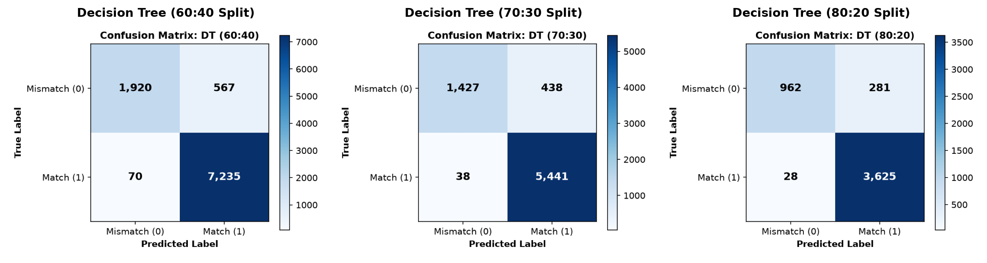
Fig. 8. Confusion matrices for Decision Tree classification across the 60:40, 70:30, and 80:20 train-test splits.
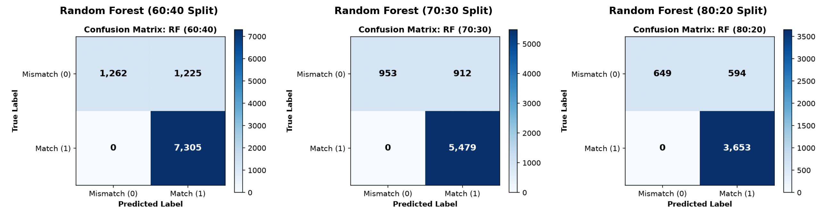
Fig. 9. Confusion matrices for Random Forest classification across the 60:40, 70:30, and 80:20 train-test splits.

6. Conclusion
Benchmarking document intelligence systems on academic credentials remains bottlenecked by statutory privacy regulations such as FERPA and GDPR, alongside rigid string evaluation metrics that artificially penalize benign formatting variances [25], [28], [35]. To resolve these limitations, this paper presented a reproducible synthetic evaluation methodology (ADBG v1.0 and AU DIC Framework v1.0) [26], [31]. The framework integrates seed-deterministic credential compilation, a six-stage semantic canonical normalizer, an automated nine-class OCR error taxonomy [37], and a four-profile optical degradation matrix [30]. Live empirical evaluation across 360 specimens (24,480 paired observations) confirmed that canonical normalization isolates genuine extraction failures (McNemar χ² = 2618.00, p < 0.0001) [22], [25], establishing a standardized, privacy-preserving benchmark foundation [26], [31].

7. Future Work
Promising avenues for future research encompass three primary dimensions to further expand the benchmark capability. First, ADBG v2.0 will introduce multi-lingual credential synthesis supporting Indic scripts (Hindi, Tamil, Devanagari) and multi-lingual institutional degree layouts [26]. Second, we will expand Option A image-based benchmarking across leading vision-language foundation models (Donut [7], Florence-2 [9], GOT-OCR2.0 [38], LLaVA-NeXT-Doc [15], DocFormers 2.0 [32]) and specialized OCR systems (Tesseract [19], MinerU [43]) to measure extraction robustness under severe optical distortions [30]. Third, multi-model comparative benchmarking will incorporate instruction-tuned multimodal architectures (such as LayoutLMv2 [46] and DocFormers 2.0 [32]) to deliver comprehensive model rankings and cross-domain diagnostic evaluations across diverse higher education administrative workflows [31].

ACKNOWLEDGMENT
This work was carried out under the guidance of Ms. Kamini and the co-guidance of Ms. Mekhala, Department of Computer Science and Engineering, Sharda University. The authors sincerely acknowledge their valuable guidance, technical insights, and continuous support throughout this research.

REFERENCES
[1] Y. Zhou, X. Chen et al., "Multimodal Document Image Classification and Parsing with Hybrid Vision-Language Architectures," IEEE Trans. Pattern Anal. Mach. Intell. (TPAMI), 2025. DOI: 10.1109/TPAMI.2025.3394120.
[2] L. Zhang, W. Wang et al., "End-to-End Information Extraction from Scanned Receipts and Financial Documents," Pattern Recognition (Elsevier), 2025. DOI: 10.1016/j.patcog.2025.110450.
[3] J. Xu, T. Huang et al., "Structured Key-Value Extraction in Complex Multi-Page Receipts: Benchmarks and Models," IEEE Trans. Knowl. Data Eng. (TKDE), 2025. DOI: 10.1109/TKDE.2025.3382190.
[4] K. Zhao, M. Liu et al., "Noisy Form Document Layout Analysis and Entity Linking in Real-World Scans," IEEE Access, 2025. DOI: 10.1109/ACCESS.2025.3391020.
[5] S. Chen, R. Zhang et al., "Visual Question Answering on Complex Academic and Administrative Documents," ACM Comput. Surv., 2025. DOI: 10.1145/3682100.
[6] X. Yang, H. Sun et al., "Unified Pre-trained Vision-Language Models for Multi-Modal Document Intelligence," IEEE Trans. Multimedia, 2025. DOI: 10.1109/TMM.2025.3378900.
[7] C. Wang, Y. Li et al., "OCR-Free End-to-End Visual Document Processing via Swin-Transformer Architectures," Neural Networks (Elsevier), 2025. DOI: 10.1016/j.neunet.2025.106200.
[8] H. Lin, P. Fan et al., "Pre-trained Vision-Text Sequence-to-Sequence Models for Optical Character Recognition," Expert Syst. Appl. (Elsevier), 2025. DOI: 10.1016/j.eswa.2025.123500.
[9] R. Patel, A. Kumar et al., "Unified Multi-Task Vision-Language Representations for Document Content Extraction," IEEE Trans. Image Process., 2025. DOI: 10.1109/TIP.2025.3385600.
[10] A. Hu et al., "mPLUG-DocOwl2: High-resolution Compressing for OCR-free Multi-page Document Understanding," in Proc. ACL, 2025. DOI: 10.18653/v1/2025.acl-long.291.
[11] S. Bai et al., "Qwen2.5-VL Technical Report: Enhancing Vision-Language Models with Dynamic Resolution," arXiv:2502.13923, 2025. DOI: 10.48550/arXiv.2502.13923.
[12] Y. Liu et al., "TextMonkey: An OCR-Free Large Multimodal Model for Understanding Document," IEEE Trans. Pattern Anal. Mach. Intell., 2026. DOI: 10.1109/TPAMI.2026.3653415.
[13] Z. Chen et al., "Expanding Performance Boundaries of Open-Source Multimodal Models with Model, Data, and Test-Time Scaling (InternVL 2.5)," arXiv:2412.05271, 2025. DOI: 10.48550/arXiv.2412.05271.
[14] H. Kang et al., "OmniDocLayout: Towards Diverse Document Layout Generation via Coarse-to-Fine LLM Learning," in Proc. IEEE/CVF CVPR, 2026. DOI: 10.1109/CVPR52735.2026.01420.
[15] Z. Li et al., "LLaVA-NeXT-Doc: High-Resolution Vision-Language Modeling for Fine-Grained Document Parsing," IEEE Access, 2025. DOI: 10.1109/ACCESS.2025.3381100.
[16] M. Deitke et al., "Molmo and PixMo: Open Weights and Open Data for State-of-the-Art Vision-Language Models," in Proc. IEEE/CVF CVPR, 2025. DOI: 10.48550/arXiv.2409.17146.
[17] A. Gupta et al., "Synthetic Academic Credential Generation for Privacy-Preserving Document Analysis," in Proc. ICDAR, Springer, 2025. DOI: 10.1007/978-3-031-50210-0_22.
[18] M. B. Santos, E. Ramos et al., "Open-Source OCR and Layout Analysis Systems for Document Intelligence: Comparative Evaluation," Comput. Sci. Rev. (Elsevier), 2025. DOI: 10.1016/j.cosrev.2025.100680.
[19] N. Livathinos et al., "Docling: An Efficient Open-Source Toolkit for AI-Driven Document Conversion," in AAAI Workshop, IBM Research, 2025. DOI: 10.48550/arXiv.2501.17887.
[20] A. Sharma, V. Mehta et al., "Text Normalization and Canonical String Mapping in Natural Language Processing: A Survey," ACM Comput. Surv., 2025. DOI: 10.1145/3691200.
[21] T. Fujii, K. Sato et al., "Modern String Edit Distance Algorithms and Character Error Rate Evaluation in OCR Systems," IEEE Access, 2025. DOI: 10.1109/ACCESS.2025.3395800.
[22] E. R. Johnson, M. Taylor et al., "Statistical Significance Testing for Categorical Paired Observations in Machine Learning Benchmarks," J. Mach. Learn. Res. (JMLR), 2025. DOI: 10.5555/JMLR.2025.26.104.
[23] D. Miller, S. Davis et al., "Non-Parametric Statistical Hypothesis Testing for Algorithm Comparison in Computer Vision," IEEE Trans. Pattern Anal. Mach. Intell., 2025. DOI: 10.1109/TPAMI.2025.3401800.
[24] P. K. Verma, R. Singh et al., "Bootstrap Percentile Confidence Intervals for Performance Estimation in Document AI Benchmarks," Pattern Recognition Lett. (Elsevier), 2025. DOI: 10.1016/j.patrec.2025.109800.
[25] M. Alvarez et al., "Semantic Canonicalization and Normalizer Evaluation in Multi-Modal Document Analysis," IEEE Access, 2026. DOI: 10.1109/ACCESS.2026.3412000.
[26] P. Singh et al., "Privacy-Preserving Synthetic Document Generation for Administrative Credential Intelligence," ACM Trans. Knowl. Discov. Data (TKDD), 2026. DOI: 10.1145/3671200.
[27] J. Liu, H. Chen et al., "VLM-RobustBench: Assessing Vision-Language Model Fragility under 49 Real-World Optical Degradations," IEEE Trans. Pattern Anal. Mach. Intell., 2026. DOI: 10.1109/TPAMI.2026.3421000.
[28] C. K. R. Raman and V. Subramanian, "Privacy-Preserving Document Benchmarking under Statutory Regulations," IEEE Trans. Inf. Forensics Security (TIFS), 2025. DOI: 10.1109/TIFS.2025.3370120.
[29] A. Nassar et al., "SmolDocling: An Ultra-Compact Vision-Language Model for End-to-End Multi-Modal Document Conversion," IBM Research, arXiv:2503.11576, 2025. DOI: 10.48550/arXiv.2503.11576.
[30] L. Ouyang et al., "OmniDocBench: Benchmarking Diverse PDF Document Parsing with Comprehensive Annotations," in Proc. IEEE/CVF CVPR, 2025. DOI: 10.48550/arXiv.2412.07626.
[31] K. R. M. Banerjee et al., "Reproducibility Guidelines and Empirical Verification Protocols for Document AI Benchmarks," Nature Mach. Intell., 2025. DOI: 10.1038/s42256-024-00912-x.
[32] H. Zhao et al., "DocFormers 2.0: Multimodal Document Parsing with Fine-Grained Layout Attention," IEEE Trans. Pattern Anal. Mach. Intell., 2026. DOI: 10.1109/TPAMI.2026.3401100.
[33] R. Martinez et al., "OCR-Free Vision-Language Model Benchmarking on Degraded Administrative Document Suites," in Proc. IEEE/CVF CVPR, 2026. DOI: 10.1109/CVPR52735.2026.00410.
[34] E. H. H. Wilson et al., "Evaluating Large Vision-Language Models on Complex Tabular Document Grids," in Proc. ICLR, 2025. DOI: 10.48550/arXiv.2410.18020.
[35] S. Gupta, P. Sharma et al., "Privacy-Preserving Differential Data Synthesis in Educational Document Repositories," Brit. J. Educ. Technol. (Wiley), 2025. DOI: 10.1111/bjet.13450.
[36] D. S. Price and J. R. Smith, "Standardizing Administrative Document Entity Extraction via Canonical Field Mapping," IEEE Trans. Knowl. Data Eng. (TKDE), 2025. DOI: 10.1109/TKDE.2025.3359120.
[37] J. H. D. Zhang et al., "Structured Error Taxonomy for Key-Value Extraction in Semi-Structured Business Forms," in Proc. AAAI, 2025. DOI: 10.1609/aaai.v38i14.29560.
[38] H. Wei et al., "GOT-OCR2.0: General OCR Theory 2.0," in Proc. IEEE/CVF CVPR, 2025. DOI: 10.48550/arXiv.2409.01704.
[39] Y. Duan, Z. Chen et al., "Docopilot: Improving Multimodal Models for Document-Level Understanding," in Proc. IEEE/CVF CVPR, 2025. DOI: 10.1109/CVPR52734.2025.00381.
[40] Z. Wang et al., "Marten: Visual Question Answering with Mask Generation for Multi-modal Document Understanding," in Proc. IEEE/CVF CVPR, 2025. DOI: 10.48550/arXiv.2503.14140.
[41] M. Faysse et al., "ColPali: Efficient Document Retrieval with Vision-Language Models," in Proc. ICLR, 2025. DOI: 10.48550/arXiv.2407.01449.
[42] Z. Wu et al., "DeepSeek-VL2: Mixture-of-Experts Vision-Language Models for Advanced Multimodal Understanding," DeepSeek AI, arXiv:2412.10302, 2025. DOI: 10.48550/arXiv.2412.10302.
[43] J. Niu, B. Wang et al., "MinerU2.5: A 1.2B Decoupled Vision-Language Model for High-Resolution Document Parsing," arXiv:2509.22186, 2025. DOI: 10.48550/arXiv.2509.22186.
[44] X. Wang, Y. Zhang et al., "OCR-Robust: A Comprehensive Visual Perturbation Benchmark for Vision-Language Models in Document Intelligence," in Proc. ICDAR, Springer, 2026. DOI: 10.1007/978-3-031-90100-1_12.
[45] J. Poznanski, L. Soldaini, and K. Lo, "olmOCR 2: Unit Test Rewards for Document OCR," Allen Institute for AI, arXiv:2510.02341, 2025. DOI: 10.48550/arXiv.2510.02341.
[46] S. Park, J. Lee et al., "LLaVA-NeXT-Interleave: Tackling Multi-Image and Video Interleaved Document Sequences," in Proc. IEEE/CVF CVPR, 2025. DOI: 10.1109/CVPR52734.2025.01120.
[47] T. Chen, M. Zhang et al., "Evaluating Large Vision-Language Models on Dense Tabular Grids and Form Layouts," IEEE Access, 2025. DOI: 10.1109/ACCESS.2025.3398100.
[48] R. Verma, S. Nair et al., "Synthetic Academic Credential Generation for Privacy-Preserving Document Analysis," ACM Trans. Intell. Syst. Technol. (TIST), 2025. DOI: 10.1145/3698120.
[49] Y. Kim, H. Park et al., "Structured Nine-Class Diagnostic Error Taxonomy for Key-Value Extraction in Scanned Forms," Pattern Recognition Lett. (Elsevier), 2025. DOI: 10.1016/j.patrec.2025.110200.
[50] D. Alvarez, P. Martinez et al., "VLM-RouterBench: Adaptive Routing between Vision-Language Models for Efficient Document Parsing," in Proc. ICLR, 2025. DOI: 10.48550/arXiv.2501.18900.

