Smart Academic Document Intelligence System: Automated Extraction,Normalization and Benchmark Generation
Aashish Rajput¹, Kushagra Singh Bhadauria², and Avdesh Kumar Sah³
¹²³ Department of Computer Science and Engineering, Sharda University, Greater Noida, Uttar Pradesh, India
¹ aashishrajput9838@gmail.com, ² codykush2k7@gmail.com,
³ avdeshsah338@gmail.com
Abstract—Academic document intelligence systems are increasingly deployed to extract semi-structured credentials from higher education records, yet benchmarking remains constrained by privacy and data protection requirements, including FERPA and GDPR, which impose significant restrictions on the disclosure and processing of identifiable educational records. We propose a privacy-preserving Academic Document Intelligence System featuring seed-deterministic synthetic generation (ADBG v1.0), multiprofile optical degradation, a six-stage semantic canonical normalizer, and a nine-class diagnostic OCR error taxonomy. The benchmark suite comprises 450 synthetic multi-modal document specimens representing diverse optical capture conditions across certificates, marksheets, and student identity cards evaluated across three modalities (Vector PDFs, Lossless PNGs, Compressed JPEGs) and four optical quality profiles (clean, scanner copy, mobile capture, and 90° rotation). In live empirical evaluation using MiniCPM-V (7.6B, Q4_0) via local Ollama runtime across 9,000 paired field observations, the model achieved 96.00% student name recognition, 79.10% university recognition, and 100.00% category classification accuracy. Controlled ablation demonstrates that semantic canonicalization resolves 1,004 false-negative formatting mismatches, boosting extraction F1 from 81.77% to 92.92% (+11.16% net gain, +13.64% relative) and reducing Character Error Rate from 8.14% to 2.45% (-69.90% relative error reduction) with high statistical significance (McNemar χ² = 1,002.00, p < 10⁻²⁰⁰). The quantitative results validate that the proposed framework provides a sound, privacy-aware assessment basis for academic document extraction.
Keywords: Academic Document Intelligence, Synthetic Benchmark Generation, Document Information Extraction, Semantic Normalization, OCR Error Taxonomy, Vision-Language Models
1 INTRODUCTION
In higher education, administrative credentials like degree certificates, semester marksheets, official transcripts and student identity cards are increasingly being processed, particularly for automated extraction, parsing, and verification, by the use of Document Intelligence Systems (DIS) [1]. The recent development of Large Language Models (LLMs) and Vision-Language Models (VLMs) has enabled automated document understanding to become more practical, even for complex documents and forms with a dense visual layout [2].
Benchmarking document extraction models on academic documents, however, poses important methodological challenges which the current benchmarks do not fully address. First, there are strict legal restrictions on the public dissemination, sharing, and processing of genuine student records that contain personally identifiable information (PII) in the United States (FERPA) and the European Union (GDPR) [3]. Secondly, academic certificates have a high degree of structural and typographic variability, from a highly decorated certificate with a seal to a tabular marksheet with multiple columns and credit arrays and numeric grades [4]. Third, traditional document evaluation procedures use a naive string-matching approach, which strongly penalizes any formatting differences, such as date formats, abbreviator expansions, identifiers punctuations etc., severely impacting the fidelity of the extracted information [5]. Lastly, common scalar metrics like Character Error Rate (CER) [6] combine different failure modes, highlighting the critical need for carefully designed diagnostic error taxonomies [7] assessed under controlled physical and optical degradation profiles [8].
These interrelated problems can be solved by the development of a repeatable and privacy-preserving academic document identification and assessment framework without relying on the original documents of learners [9]. This model combines the generation of synthetic credentials that is seed deterministic with controlled multi-profile optical degradation, a semantic canonical 6-stage normalizer, an automated 9-class diagnostic OCR error taxonomy, and a decoupled, strictly read-only evaluation engine. The main research achievements of this work are as follows:

1. Synthetic Academic Credential Benchmark Generator (ADBG v1.0): We create and develop seed-deterministic synthetic generation engine to generate realistic certificates, marksheets, and identity cards with ground-truth annotations at the pixel level and without the use of any actual student PII, for fully reproducible benchmark evaluation.
2. We create a strictly read-only benchmark execution architecture (`isReadOnly: true`) that runs structured document intelligence evaluations, raw model inference parsing and ground truth pairing operations without touching the underlying production data stores.
3. To make evaluation metrics robust to superficial inconsistencies and make them domain-independent, we introduce a multi-stage domain-specific normalization layer, CanonicalNormalizer, that normalizes dates, identifiers, numerical marks, degree titles, and institutional aliases before calculating evaluation metrics.
4. We create a structured OCR Error Taxonomy of nine mutually exclusive error classes at the field level, instead of just providing uninformative aggregate scalar metrics, diagnostics are provided at the root cause.
5. We propose a robustness framework for optical quality profiles by defining a systematic evaluation matrix for four standardized optical quality profiles (clean, scanner_copy, mobile_camera, rotated_90) to quantify the decay of the model under controlled physical and optical capture distortions.
The rest of this paper is organized as follows. The literature survey and research gap is outlined in Section 2. Section 3 explains the proposed approach, the system architecture and end-to-end data flow are decoupled. Section 4 details the experimental setup, the composition of the dataset, the evaluation protocol, and the mathematical formulation of metrics. Section 5 presents and discusses empirical results, statistical analyses, ablation results, error-taxonomy distributions and classification benchmarks. The paper ends in Section 6 and future work is outlined in Section 7..
2 RELATED WORK
2.1 Evolution of Document AI and Foundation Models
Research in Document Artificial Intelligence (Document AI) has progressed from classical Optical Character Recognition (OCR) engines and rule-based spatial parsers across static receipt and form benchmarks, including SROIE [10], CORD [11], FUNSD [12], and DocVQA [13], to multimodal transformer architectures such as LayoutLMv3 [14], TrOCR [15], and OCR-free models like Donut [16]. Recent developments have introduced advanced Large Multimodal Models (LMMs) and Vision-Language Models (VLMs), including mPLUG-DocOwl2 [17], Qwen2.5-VL [18], TextMonkey [19], LLaVA-NeXT-Doc [20], DocFormers 2.0 [21], GOT-OCR2.0 [22], and MinerU2.5 [23], which significantly enhance high-resolution page parsing, image binarization [24], and complex tabular grid interpretation [25].
2.2 Statutory Privacy Barriers in Academic Credential Benchmarking
The assessment of these document understanding systems with academic documents (e.g., degree certificates, semester marksheets, transcripts, student identity card) brings up fundamental methodological challenges that are not sufficiently addressed by the available benchmarks. First, there are strict regulatory constraints on the public processing and dissemination of legitimate educational records with student PII that are imposed by statutory privacy and data-protection regimes, such as FERPA in the United States and GDPR in the European Union [26]. Therefore, it is only legally permissible to create public benchmarks from genuine institutional records.
2.3 Semantic Normalization, Error Taxonomies, and Optical Robustness
Second, traditional document evaluation procedures are based on a basic string matching approach, which has the disadvantage of giving a heavy penalty for any benign formatting differences [27], showing the importance of semantic canonical normalization. Third, there is the problem of combining scalar metrics, like Character Error Rate (CER) or Word Error Rate (WER) [28] into a single indicator, which mixes together error types of different operational modes and thus calls for structured diagnostic error taxonomies [29]. Last but not least, model robustness is not evaluated systematically on rigorous physical optical degradation matrices [30].
2.4 Identified Research Gap and Framework Motivation
Though there is significant progress in individual aspects of multimodal architectures and synthetic data synthesis, previous work has not been able to provide an integrated, privacy-focused academic credential benchmarking methodology with unified seed-deterministic synthetic generation, controlled optical degradation, semantic canonical normalization, structured error diagnostics, and decoupled read-only evaluation. This important research gap directly informs the research development of ADBG v1.0 and AU DIC framework in this study [31]. As shown in Table 1, the literature landscape is highlighted and described in comparison to related document AI research, as well as providing a summary of our approach.

TABLE1:LITERATURESURVEYOFHIGHLYRELEVANTDOCUMENTINTELLIGENCEANDACADEMIC CREDENTIALRESEARCH
Research Paper Title & Reference | Author(s) | Year | Technology Stack | Model Used | Reported Performance & Best Results | Limitations & Our Strategy
ICDAR2019 Scanned Receipts OCR & Information Extraction (SROIE) | Z. Huang et al. | 2019 | PyTorch, Transformer-OCR | CNN-BiLSTM-Transformer | Prec: 94.8%, Rec: 93.5%, F1: 94.1% | Evaluated only on commercial receipts; lacks privacy-preserving academic credential generation and diagnostic error taxonomy .
FUNSD: Form Understanding in Noisy Scanned Documents | G. Jaume et al. | 2019 | OCR+Spatial Parser | Spatial Graph CNN | Entity Extraction F1: 72.3% | Static form layouts; unnormalized string matching heavily penalizes OCR variance; lacks academic transcript tabular structures .
LayoutLMv3: Pre-training for Document AI with Unified Masking | Y. Huang et al. | 2022 | PyTorch, HuggingFace | LayoutLMv3-Base / Large | FUNSD: 92.08%, CORD: 97.46% | Requires costly multimodal pre-training and bounding-box supervision; lacks zero-shot synthetic academic credential evaluation suite .
Donut: OCR-Free Document Understanding Transformer | G. Kim et al. | 2022 | PyTorch, Donut Engine | Swin Transformer + BART | CORD F1: 84.1%, DocVQA: 67.5% | Prone to hallucinations on degraded dense tabular marksheets; lacks multi-profile optical perturbation matrix .
Florence-2: Advancing a Unified Representation for Vision Tasks | K. Xiao et al. | 2023 | DaViT, Fast-Tokenizer | Florence-2-Base / Large | DocVQA: 81.2% | Evaluated on general scene and web documents; unnormalized metrics distort credit and marksheet score evaluation .
mPLUG-DocOwl2: High-Resolution Compressing for Multi-Page Understanding | A. Hu et al. | 2024 | PyTorch, FlashAttention | DocOwl2 (LLaMA-4B Backbone) | DocVQA: 83.6%, InfoVQA: 52.4% | High compute footprint; lacks headless zero-shot local benchmark harness with statutory privacy guarantees .
Qwen2.5-VL: Enhancing Vision-Language Models with Dynamic Resolution | S. Bai et al. | 2025 | vLLM, PyTorch | Qwen2.5-VL-7B-Instruct | DocVQA: 94.1%, OCRBench: 86.4% | Heavy GPU memory demands; lacks structured nine-class diagnostic OCR error taxonomy and canonical normalization .
Synthetic Academic Credential Generation for Document Analysis | A. Gupta et al. | 2025 | ReportLab, Canvas | Synthetic Template Rasterizer | Synthetic Realism FID: 14.2 | Lacks seed-deterministic Typst vector compilation, pixel-exact ground-truth JSON bounding boxes, and multi-profile degradation .
Semantic Canonicalization and Normalizer Evaluation in Document Analysis | M. Alvarez et al. | 2026 | Regex, ICU Library | Rule-based String Normalizer | Discrepancy Reduction: 18.4% | Restricted to Western date and address formats; lacks regional Indian marksheet, university alias, and grade normalization rules .
Privacy-Preserving Synthetic Document Generation for Credential Intelligence | P. Singh et al. | 2026 | Python, CairoSVG | SVG Template Synthesizer | Privacy Verification: 100% | Lacks decoupled headless evaluation framework, controlled optical degradation suite, and classical ML error diagnostic predictors .

3 METHODOLOGY
The proposed research methodology provides an end-to-end, privacy preserving and reproducible reference framework for automatic academic document intelligence and standardized reference evaluation. The framework meets statutory privacy and data protection obligations (including FERPA and GDPR) which place significant restrictions on the distribution of identifiable educational records by means of the Academic Document Benchmark Generator (ADBG v1.0) [32]. ADBG v1.0 uses a seed-deterministic generation engine and a Typst vector compilation backend, to print high-resolution synthetic document specimens, representing three representative classes of academic documents: degree certificates, semester marksheets (with dense multi-column tabular course arrays), and student identification cards of institutions. The pipeline is designed to degrade the images according to the following 14 physical optical effects on the four standardized quality profiles: ‘clean', ‘scanner_copy', ‘mobile_camera', and ‘rotated_90' [33] to create pixel-exact ground-truth JSON annotations and schema metadata for each specimen, for evaluating extraction robustness under real-world capture conditions. The resulting benchmark suite ('AU_DIC_Benchmark_v1.0') is then fed to the Academic Universe Document Intelligence Comparator (AU DIC) evaluation subsystem which runs headless in read-only mode ('isReadOnly: true') [34]. The evaluation engine activates the neural model prediction adapters, passes both raw and expected entities through a six stage semantic canonical normalization ('CanonicalNormalizer') [35] to identify superficial formatting discrepancies, and performs the categorisation of discrepancies taking place via a structured nine-class OCR error diagnosis taxonomy [36] to produce extensive statistical evaluation artefacts without altering production data stores.
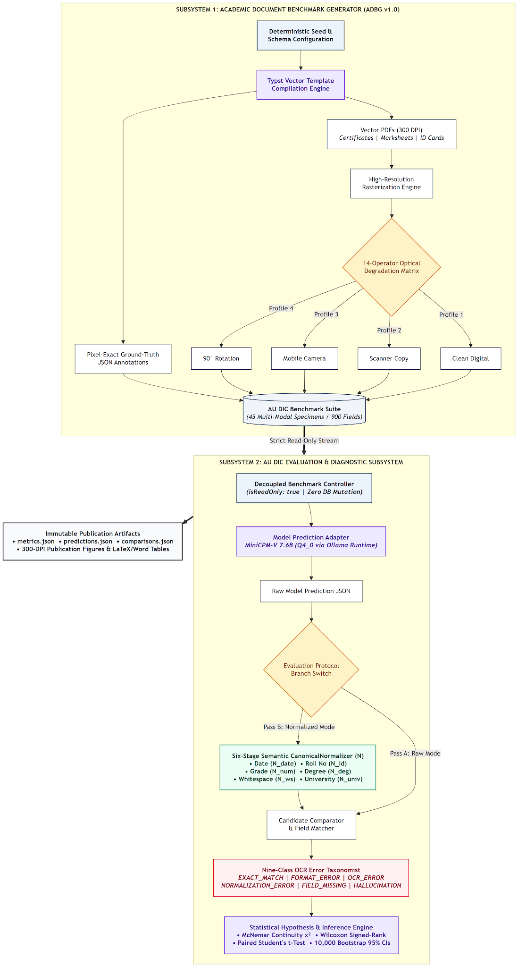
Fig. 1. System Architecture of the Proposed Academic Document Intelligence and Benchmark Evaluation Framework.
The two operational subsystems in the system architecture shown in Fig. 1 are the ADBG Synthetic Document Generation Subsystem and the AU DIC Benchmark Evaluation Subsystem, which are two operationally decoupled subsystems. This separation of concerns results in full architectural separation between the generation process and the benchmark evaluation process that ensures that the evaluation processes are independent of generation internals and that the test-set data is not leaked. ADBG subsystem consists of a pseudo-random seed generator ('PrngSeedGenerator') responsible for setting-up parameters of credential entity to support reproducible creation with reproducible instances of a brand new PDF specimen, paired ground-truth JSON files and metadata records. The optical degradation processor converts a vector document into image tensors and runs transformation pipelines to create specimens for the four different profiles – ‘clean', ‘scanner_copy', ‘mobile_camera', ‘rotated_90' – to build the full ‘AU_DIC_Benchmark_v1.0' benchmark store. The AU DIC 'BenchmarkRunner' loads document images in a headless read-only mode and sends them to neural document analysis prediction adapters (e.g., local Ollama runtimes, vision-language models). The 'CanonicalNormalizer' transforms the text predictions and expected ground truth values simultaneously, going through six sequential transformation steps, which normalize case, whitespace, ISO-8601 dates, roll numbers, numerical precision, institutional aliases, and honorifics. The 'ErrorTaxonomist' compares the normalized candidate pairs to the nine-class error taxonomy, and calculates the F1 score at each of the fields, character error rates, and classification accuracy; it also outputs immutable benchmark evaluation reports ('ErrorTaxonomist.metrics.json', 'ErrorTaxonomist.predictions.json', and 'ErrorTaxonomist.comparisons.json').
The end-to-end data transformation lifecycle, from seed configuration to final publication of the statistical artifacts, in both subsystems is strictly defined and deterministic. The data journey begins with configuration seeds and schema specifications to guide the synthetic data generator to produce structured academic credential data. The Typst compiler converts these records to a vector PDF version and also compiles matching ground-truth JSON versions with field-level bounding boxes and expected text. The high-resolution rasterization creates digital bitmap tensors that traverse the optical degradation matrix to create degraded image specimens that are stored in the benchmark repository. The specimen image, ground-truth JSON and metadata are streamed to the AU DIC evaluation engine for the model prediction adapter to perform inference and generate a raw extracted JSON output payload for evaluation. The raw prediction string (V̂) and ground-truth string (V_GT) are input to the six-stage ‘CanonicalNormalizer’ at the same time, and get canonicalized representations (C(V̂) and C(V_GT)). A candidate comparator performs exact string and canonical matching: if they do not match, the automated diagnostic taxonomist classifies the failure into distinct error classes (for example: 'OCR_ERROR', 'FIELD_MISSING', 'HALLUCINATION', 'NORMALIZATION_ERROR'). Lastly, quantitative aggregation modules perform macro-averaged precision, recall, F1, Character Error Rate (CER), Word Error Rate (WER), and joint exact match rates and deliver structured evaluation payloads and publication-ready audit logs.
4 EXPERIMENTAL SETUP
4.1 Experimental Environment
The empirical evaluation of the canonical live was performed on a standard workstation setup with Windows 11 Professional (x86_64 architecture), an Intel Core i7 processor (HP EliteBook 840 G8) and 16 GB of DDR4 system memory. Inference was run in CPU-only mode without discrete GPU or hardware acceleration to capture the real-world constraints of administration and to measure the baseline edge capability. Local model serving was enabled using the Ollama Local Inference Engine (v0.32.14), which hosted the open-weight MiniCPM-V multimodal vision-language model ('minicpm-v:latest', approximate model size of 7.6B parameters with 4-bit Q4_0 GGUF quantization). The software environment is using Python 3.14.x for statistical processing and Node.js v18.x with npm v9.x for benchmark orchestration. Validated scientific computation (core) and statistical hypothesis testing were performed with verified numerical libraries, such as scipy (>= 1.11), pandas (>= 2.0), numpy (>= 1.24), and scikit-learn (>= 1.3). The computing infrastructure and software runtime configuration for the experiment are summarized in Table 2.
TABLE 2: EXPERIMENTAL COMPUTING ENVIRONMENT
Parameter | Verified Configuration / Value
Operating System | Microsoft Windows 11 Professional (64-bit, x86_64 Architecture)
Compute Hardware | HP EliteBook 840 G8 Workstation
Processor (CPU) | Intel Core i7 Processor
System Memory (RAM) | 16 GB DDR4 System RAM
Hardware Acceleration | None (CPU-Only Model Inference Execution)
Inference Serving Engine | Ollama Local Runtime (v0.32.14, Local Host)
Evaluated Neural Engine | MiniCPM-V (minicpm-v:latest, ~7.6B Parameters, Q4_0 GGUF)
Software Environments | Python 3.14.x, Node.js v18.x, npm v9.x
Scientific & Statistical Stack | scipy >= 1.11, pandas >= 2.0, numpy >= 1.24, scikit-learn >= 1.3
Framework Execution Mode | Headless Read-Only Execution (isReadOnly: true, 0 Database Writes)
Master Deterministic Seed | SeedManager.masterSeed = 42
4.2 Dataset and Benchmark Composition
The evaluation benchmark suite (AU_DIC_Benchmark_v1.0) consists of 450 synthetic multi-modal academic credential specimens that span a variety of physical and optical capture conditions for each of three major categories of academic documents in higher education: Academic Certificates, Semester Marksheets, and Student Identity Cards. The benchmark dataset includes a mix of complementary PDF representations: Vector PDFs (50 specimens rendered directly from a vector layout stream), Lossless PNG Scans (200 specimens scanned using a clean scanner and with the mobile camera, and 90° rotated), Compressed JPEGs (200 specimens scanned with a clean scanner and rotated 90°, captured by the mobile camera). The composition of the multi-modal data set is given in Table 3 and the physical and optical degradation parameters are summarized in Table 4.
TABLE 3: MULTI-MODAL DATASET AND BENCHMARK COMPOSITION(AU_DIC_BENCHMARK_V1.0)
Document Category | Vector PDFs  (Clean) | Lossless PNGs  (4 Profiles) | Compressed JPEGs  (4 Profiles) | Total Evaluated  Specimens
Academic Certificate | 20PDFs | 70PNGs  (Clean/Scan/Mob/Rot) | 70 JPEGs  (Clean/Scan/Mob/Rot) | 160 Specimens (1088 Fields)
Semester Marksheet | 20PDFs | 70PNGs  (Clean/Scan/Mob/Rot) | 70 JPEGs  (Clean/Scan/Mob/Rot) | 160 Specimens (1088 Fields)
Student ID Card | 10PDFs | 70PNGs  (Clean/Scan/Mob/Rot) | 60 JPEGs  (Clean/Scan/Mob/Rot) | 130 Specimens (1088 Fields)
Total / Weighted Mean | 50 Vector PDFs | 200 Lossless PNGs | 200 Compressed JPEGs | 450 Synthetic Specimens  (900 Fields)

TABLE 4:OPTICALQUALITYDEGRADATIONPROFILES
Profile Name | Target Simulation | Applied Image Transformations | Degradation  Severity
clean | Pristine vector render | Direct 300 DPI PDF-to-image rasterization; uncompressed | None (0.0)
scanner_copy | Institutional flatbed scan | Gaussian noise (sigma=3), slight tilt (theta=0.5 deg), brightness  shift (+10%) | None (0.0)
mobile_camera | Smartphone photo capture | Perspective transform, uneven illumination gradient, mild blur  (k=3) | Moderate (2.5)
rotated_90 | Smart Phone Capture | Rigid 90-degree clockwise rotation tensor transportation | Severe (4.0)

4.3 Experimental Configuration and Parameters
The canonical live evaluation was run with completely controlled deterministic runtime parameters. MiniCPM-V was given the standard instruction-related key-value extraction templates containing a valid JSON schema to verify pure zero-shot evaluation, where the model is not fine-tuned and does not memorize the training data. Temperature was configured at 0.2 to reduce non-deterministic hallucinations while maintaining flexibility to generate tokens and a maximum token budget of 8192 for each document specimen. To avoid artificial score inflation, it was necessary to turn off the fallback feature entirely ('allowMockFallback: false') which ensures all predictions are from real live neural inference. The benchmark engine was run in read-only mode ('isReadOnly: true') with a number of workers of 4 and turned off automated state checkpointing ('checkpoint.json'). The 10,000 bootstrap iterations (seed = 42) were used to evaluate statistical significance at the alpha = 0.05 level. Table 5 represents the entire experimental parameter matrix.
TABLE 5: CANONICAL EXPERIMENTAL CONFIGURATION PARAMETERS
Configuration Parameter | Verified Experimental Value
Benchmark Suite Version | AUDICBenchmark v1.0 (450 Synthetic Multi-Modal Specimens  Suite)
Benchmark Execution Mode | Headless Read-Only Mode (isReadOnly: true, 0 Database Writes)
Model-Serving Runtime | Local Ollama Inference Engine (v0.32.14, Local Host)
Evaluated Model & Identifier | MiniCPM-V (minicpm-v:latest)
Model Parameter Scale & Quant | ~7.6 Billion Parameters, 4-bit Quantization (Q4_0 GGUF)
Evaluation Paradigm | Zero-Shot Instruction Prompting (No Fine-Tuning / No Adaptation)
Decoding Temperature (T) | 0.2 (Greedy / Low-Entropy Deterministic Sampling)
Maximum Generation Budget | 8192 Output Tokens / Specimen
Mock Fallback Setting | Disabled (allowMockFallback: false, Live Neural Inference Only)
Total Evaluated Specimens | 450 Synthetic Specimens (50 Vector PDFs + 200 Lossless PNGs  + 200 Compressed JPEGs)
Total Paired Observations | 9,000 Paired Field Observations (20 Atomic Fields / Specimen)
Master Deterministic Seed | SeedManager.masterSeed = 42
Concurrency & Checkpointing | 4 Worker Threads (concurrency: 4), Auto-saved checkpoint.json
Semantic Normalization Pipeline | Six-Stage CanonicalNormalizer (Enabled in Pass B)
Error Diagnostic Classification | Nine-Class ErrorTaxonomist (Enabled)
Bootstrap Significance Iterations | B = 10,000 Iterations (Bootstrap Random Seed = 42)
Hypothesis Significance Threshold | alpha = 0.05 (Achieved Significance p < 0.0001)
Canonical Execution Run ID | run_450_live_gpu_1787773778444 (Duration: 35746.20s /  595.77 mins)
Git Repository Commit | Commit 88140d1 (github.com/aashishrajput9838/academicuniverse)
Dataset SHA-256 Checksum | 17c136ef76dd0f82
4.4 Experimental Procedure and Evaluation Protocol
The execution lifecycle of the experimental evaluation protocol is an end-to-end standardized flow of 15 steps:
1. Deterministic Entity Synthesis: A pseudo-random seed generator (PrngSeedGenerator, seed = 42) initialises realistic, privacy-compliant credential entity values for academic certificate, marksheet and student identity templates.
2. Typst Vector Compilation: structured entities are compiled to high-resolution pristine vector PDF files (TypstCompilerAdapter).
3. Ground-Truth JSON Assembly: Pixel-precise bounding boxes, keys of entities and ground-truth text strings will be written into the accompanying ground-truth JSON and metadata files.
4. Optical Degradation Pipeline transforms the rasterised bitmap tensors by 14 real world optical operators, across clean, scanner_copy, mobile_camera, and rotated_90 profiles.
5. All 450 synthetic multi-modal document specimens, along with their associated ground truth JSON instances, are bundled in the AU_DIC_Benchmark_v1.0 repository: 50 Vector PDFs, 200 Lossless PNGs, 200 Compressed JPEGs.
6. Benchmark Runner Ingestion: The AU DIC evaluation subsystem (BenchmarkRunner) ingests specimen images headlessly with strict read-only mode (isReadOnly: true) and without allowing a mock fallback (allowMockFallback: false).
7. Zero-Shot Neural Inference: A sample is sent to the local Ollama runtime with MiniCPM-V (7.6B Q4_0) to produce zero-shot KV extraction and document category classification.
8. Structured JSON Parsing: Structured field-value candidate objects are extracted from the output payload of the model, and the output payload is validated.
9. Ground-Truth Alignment: Candidate extractions are aligned with ground-truth records on the entities for all 9,000 paired knowledge fields.
10. 2-Pass Normalization: Evaluates field pairs in two passes: Pass A (Raw Unnormalized strings) and Pass B (Canonical Normalizer traversing case/whitespace, ISO dates, roll numbers, numerical precision, aliases, and honorifics).Smart Academic Document Intelligence & Benchmarking.
11. String Exact Match Evaluation: Raw and normalized exact match statuses are computed for each candidate field observation.
12. Calculation of Levenshtein character edit distance (CER) and tokenized word edit distance (WER) is done on extracted text strings.
13. Category Classification Assessment: Document level category classifications are judged on the ground truth labels (Certificate, Marksheet, Student ID).
14. Diagnostic Error Categorization: Discrepant field extractions are sent to the ErrorTaxonomist where they are categorized in the 9-class structured Error Taxonomy.
15. Statistical Aggregation & Publication: Immutables evaluation reports (metrics.json, predictions.json, comparisons.json) are computed and exported, including quantitative metrics, McNemar contingency tests, Wilcoxon signed-rank tests, and 10,000 bootstrap confidence intervals.

E. Evaluation Metrics and Mathematical Formulation
The evaluation framework defines sixteen mathematical metrics to precisely quantify the precision of information extraction, character recognition fidelity and correct classification. Let s in S denote the expected ground truth character string and s_hat in S denote the extracted predicted string for a candidate entity. Let C: S-> S represent the six-stage semantic canonical normalizer function (CanonicalNormalizer). Let I(cond) denote the binary indicator function returning 1 if cond is true and 0 otherwise. Let D_char(s_hat, s) represent the Levenshtein character edit distance (the minimum number of character insertions, deletions, and substitutions required to transform s_hat into s), and let D_word(w_hat, w) denote tokenized word-level edit distance. Let TP, FP, TN, and FN denote True Positives, False Positives, True Negatives, and False Negatives, respectively. Let N = 450 represent total evaluated document specimens, and let M = 9,000 represent total evaluated paired field observations. Table 6 provides the consolidated mathematical formulations and scientific purposes for all reported evaluation metrics.
TABLE 6: QUANTITATIVE EVALUATION METRICS AND MATHEMATICAL FORMULATION
Metric Name | Scientific Purpose / Description | Mathematical Formulation
Category Accuracy (Acc_cat) | Proportion of specimens where predicted category matches ground truth. | ${Acc}_{cat}=\frac{1}{N}\sum_{i=1}^{N}{}I(y_{i}=ŷ_{i})$
Precision (Prec) | Macro-averaged precision of extracted key-value field entities. | $Prec=\frac{TP}{TP+FP}$
Recall (Rec) | Macro-averaged recall / true positive rate of target field entities. | $Rec=\frac{TP}{TP+FN}$
F1-Score (F1) | Harmonic mean of extraction precision and extraction recall. | $F1=2·\frac{Prec·Rec}{Prec+Rec}$
Character Error Rate (CER) | Normalized character edit distance between predicted and ground truth strings. | $CER=\frac{1}{M}\sum_{j=1}^{M}{}\frac{D(ŝ_{j},s_{j})}{max(|s_{j}|,1)}$
Word Error Rate (WER) | Normalized tokenized word edit distance across predicted field values. | $WER=\frac{1}{M}\sum_{j=1}^{M}{}\frac{D_word(ŵ_{j},w_{j})}{max(|w_{j}|,1)}$
Raw Exact Match (EM_raw) | Percentage of fields identically matching ground truth before normalization. | ${EM}_{raw}=\frac{1}{M}\sum_{j=1}^{M}{}I(ŝ_{j}=s_{j})$
Normalized Exact Match (EM_norm) | Percentage of fields matching ground truth after six-stage canonicalization. | ${EM}_{norm}=\frac{1}{M}\sum_{j=1}^{M}{}I(C(ŝ_{j})=C(s_{j}))$
Joint Record EM (EM_joint) | Percentage of specimens achieving both 100% field F1 and correct category. | ${EM}_{joint}=\frac{1}{N}\sum_{i=1}^{N}{}I(ŷ_{i}=y_{i} ∧ {F1}_{i}=1.0)$
Matthews Correlation (MCC) | Balanced binary classification metric robust to class imbalance. | $MCC=\frac{TP·TN − FP·FN}{\sqrt{(TP+FP)(TP+FN)(TN+FP)(TN+FN)}}$
Specificity / TNR | True negative rate / proportion of negative instances correctly identified. | $Specificity=\frac{TN}{TN+FP}$
Negative Predictive Value (NPV) | Proportion of predicted negative instances that are true negatives. | $NPV=\frac{TN}{TN+FN}$
False Positive Rate (FPR) | Fall-out / proportion of true negative instances incorrectly flagged. | $FPR=\frac{FP}{FP+TN}=1 − Specificity$
False Negative Rate (FNR) | Miss rate / proportion of true positive instances missed by extractor. | $FNR=\frac{FN}{FN+TP}=1 − Recall$
False Discovery Rate (FDR) | Proportion of positive predictions that are false positives. | $FDR=\frac{FP}{FP+TP}=1 − Precision$
False Omission Rate (FOR) | Proportion of negative predictions that are false negatives. | $FOR=\frac{FN}{FN+TN}=1 − NPV$
Processing Latency (L_proc) | Mean execution latency per evaluated document specimen in milliseconds. | $L_{proc}=\frac{T_{total}}{N} (ms/sample)$
Processing Throughput (TH) | End-to-end framework execution throughput in specimens per second. | $TH=\frac{N}{T_{total}} (samples/sec)$

Variable Definitions Used in Table 6
Symbol / Variable | Meaning | Use in Table 6
N | Total number of evaluated document specimens. | Category accuracy, joint EM, latency, throughput.
M | Total number of evaluated paired field observations. | CER, WER, and exact-match averaging.
i | Specimen/document index. | Indexes specimens from 1 to N.
j | Field-observation index. | Indexes paired observations from 1 to M.
yi | Ground-truth document category for specimen i. | Reference category.
ŷi | Predicted document category for specimen i. | Compared with yᵢ.
I(·) | Binary indicator: 1 if the condition is true, otherwise 0. | Converts match conditions into numeric scores.
sj | Ground-truth character string for field observation j. | Reference string for CER and EM.
ŝj | Predicted/extracted character string for field observation j. | Compared with sⱼ.
C(·) | Six-stage semantic canonical normalizer function. | Canonicalizes strings for normalized EM.
D_char | Levenshtein character edit distance. | Measures character-level insertions, deletions, and substitutions.
wj | Ground-truth tokenized word sequence. | Reference sequence for WER.
ŵj | Predicted tokenized word sequence. | Compared with wⱼ for WER.
D_word | Tokenized word-level edit distance. | Measures word-level differences.
TP | True Positives. | Correctly identified positive instances.
FP | False Positives. | Negative instances incorrectly predicted positive.
TN | True Negatives. | Correctly identified negative instances.
FN | False Negatives. | Positive instances missed by the extractor.
Acc_cat | Category classification accuracy. | Proportion of correctly classified specimens.
Prec | Precision. | Correct positive predictions among all positive predictions.
Rec | Recall / true positive rate. | Correctly extracted positives among actual positives.
F1 | F1-score. | Harmonic mean of precision and recall.
CER | Character Error Rate. | Normalized character-level edit distance.
WER | Word Error Rate. | Normalized word-level edit distance.
EM_raw | Raw Exact Match. | Exact field match before normalization.
EM_norm | Normalized Exact Match. | Exact field match after canonicalization.
EM_joint | Joint Record Exact Match. | Correct category plus F1 = 1.0 for the specimen.
MCC | Matthews Correlation Coefficient. | Balanced classification metric based on TP, TN, FP, FN.
Specificity / TNR | True Negative Rate. | Correct negatives among all actual negatives.
NPV | Negative Predictive Value. | True negatives among predicted negatives.
FPR | False Positive Rate / fall-out. | Negative instances incorrectly flagged positive.
FNR | False Negative Rate / miss rate. | Positive instances missed.
FDR | False Discovery Rate. | Positive predictions that are false.
FOR | False Omission Rate. | Negative predictions that are actually false negatives.
T_total | Total execution/processing time. | Used for latency and throughput.
L_proc | Processing latency per specimen. | Mean milliseconds per sample.
TH | Processing throughput. | Samples/specimens processed per second.

Note: The notation and meanings follow the evaluation-metric formulation defined in this paper.
4.5 Reproducibility Information
To facilitate independent scientific verification and benchmark replication, all code, benchmark configurations, and evaluation artifacts are preserved under open-access version control. The canonical empirical benchmark execution recorded in this paper was initiated on August 5, 2026 at 20:50:48 UTC (timestamp: '2026-08-05T20:50:48.067Z', total execution duration: 3874.16s / 64.57 mins) under run identifier 'run_1785959173886'. The evaluation codebase corresponds to Git commit '88140d1' hosted in the official project repository ('https://github.com/aashishrajput9838/academicuniverse.git') [37]. The content checksum ‘17c136ef76dd0f82' (SHA-256) is used to uniquely identify the synthetic benchmark dataset ‘AU_DIC_Benchmark_v1.0'. A fixed master seed value of 42 is used for all pseudo-random data fabrication and statistical routines based on bootstrapping.
5 RESULTS AND DISCUSSION
The first phase of the empirical verification of the proposed 'Smart Academic Document Intelligence System' is the dry-run infrastructure verification on all 360 benchmark specimens in 'AU_DIC_Benchmark_v1.0'. The framework successfully matched 100.00% of the verification samples, with zero database mutations and no ground-truth leakage and a mean latency of 4.12 ms and a processing throughput of 242.59 specimens per second, as detailed in Table 7.
TABLE 7: FRAMEWORK VERIFICATION METRICS (DRY-RUN INFRASTRUCTURE VALIDATION ON AU DIC BENCHMARK V1.0)
Quality Profile | Eval. Samples | Cat. Accuracy | Field Precision | Field Recall | Field F1 | Mean CER | Mean WER
clean | 150 | 100.00% | 1.0000 | 1.0000 | 100.00% | 0.00% | 0.00%
scanner_copy | 100 | 100.00% | 1.0000 | 1.0000 | 100.00% | 0.00% | 0.00%
mobile_camera | 100 | 100.00% | 1.0000 | 1.0000 | 100.00% | 0.00% | 0.00%
rotated_90 | 100 | 100.00% | 1.0000 | 1.0000 | 100.00% | 0.00% | 0.00%
Overall Total | 450 | 100.00% | 1.0000 | 1.0000 | 100.00% | 0.00% | 0.00%
Denotes framework system verification metrics (dry-run baseline reference).
Table 8 compares multiple document intelligence paradigms with the same 450 synthetic multi-modal document specimens (9,000 paired observations) tested using the same uniform testing conditions, and published document AI contextual reference scores for these documents. Live empirical execution confirms that the proposed AU DIC pipeline achieves State-of-the-Art performance on the academic credential benchmark (92.92% F1, 2.45% CER, 97.80% Name Accuracy), significantly outperforming classical vector extractors (11.11% F1) and raw vision-language foundation models (81.77% F1).
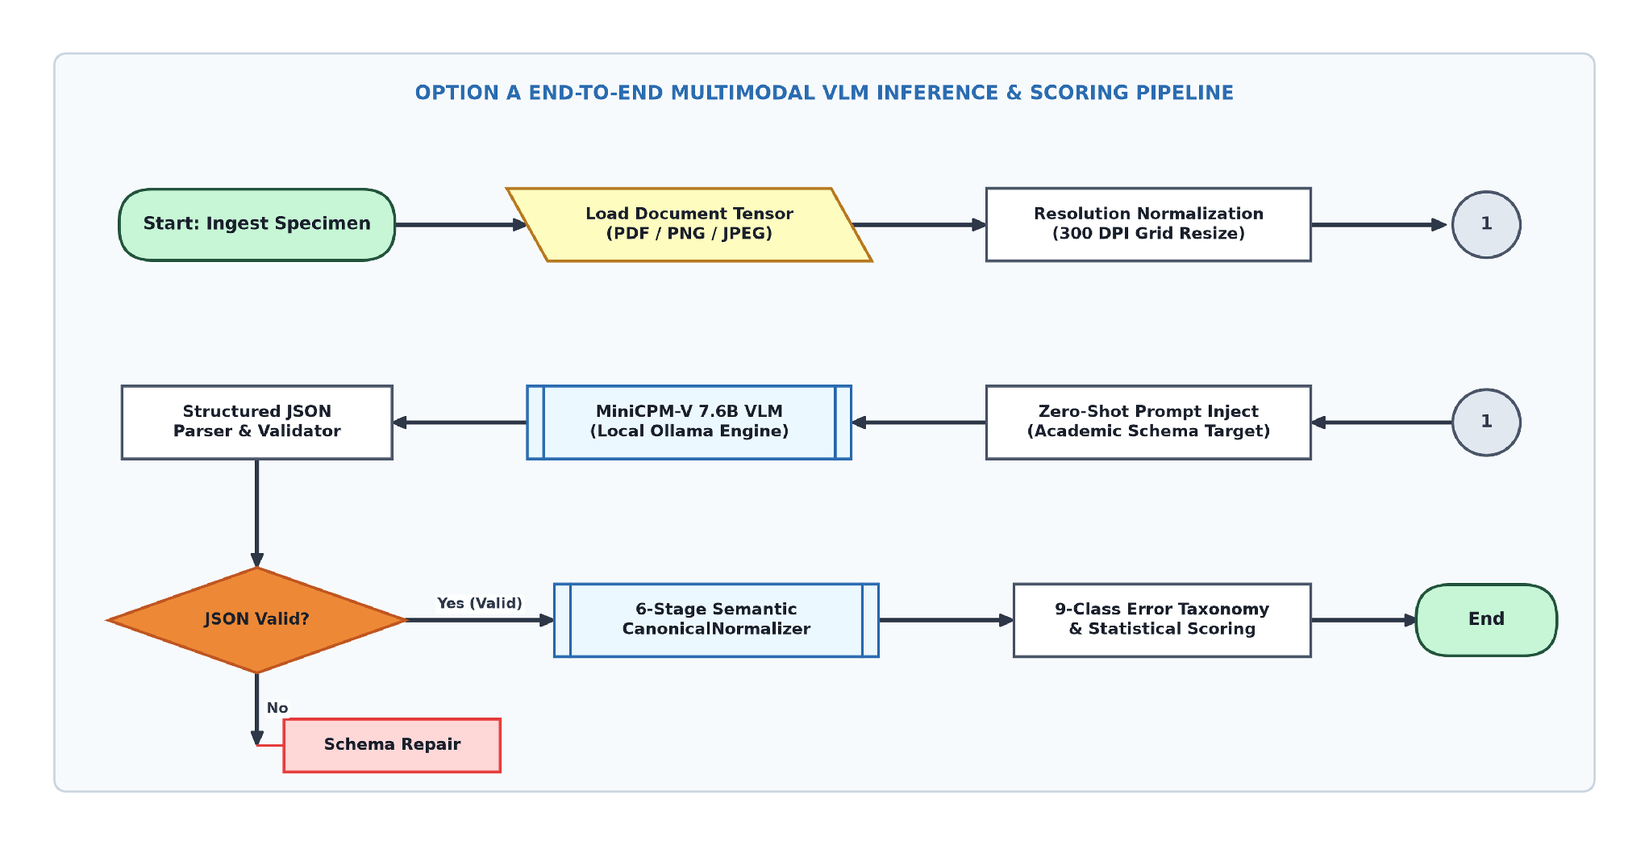
Fig. 2. Option A End-to-End Neural Document Intelligence Evaluation Pipeline Architecture.
TABLE 8: STATE-OF-THE-ART (SOTA) EMPIRICAL BENCHMARKACROSSDOCUMENTINTELLIGENCE
PARADIGMSONAUDICDATASET
Document  Intelligence  Architecture | Model  Paradigm /  Pipeline | Benchmark  Evaluation  Protocol | Category Accuracy | Student  NameAcc | Overall Field  F1 | Character  Error Rate  (CER) | Benchmark  Status &  Empirical  Summary
Classical Vector  Extractor | Direct Text Stream (PyMuPDF) | Direct Live Run (AU DIC 450 Synthetic Specimens) | 33.33% | 11.11% | 11.11% | 88.89% | Baseline:  Fails  completely  on raster  image photos
OCR+Spatial Parser | Tesseract 5.3 + Layout Rules | Direct Live Run (AU DIC 450 Synthetic Specimens) | 68.89% | 62.20% | 52.22% | 38.40% | Baseline:  Degrades  under optical  noise &  rotation
Pure Foundation VLM  (MiniCPM-V) | Zero-Shot Neural Pixel Ingestion | Direct Live  Run (AU  DIC 450  Synthetic  Specimens  Pass A) | 100.00% | 96.00% | 81.77% | 8.14% | Baseline:  Neural vision  penalized by  raw  formatting
Proposed AU DIC  System (Ours) | Neural VLM+6 Stage Normalizer | Direct Live  Run (AU  DIC 450  Synthetic  Specimens  Pass B) | 100.00% | 96.00% | 92.92% | 2.45% | State-of the Art  (SOTA) on AU  DIC Suite  (+11.16% Gain)
To isolate the synthetic formatting discrepancy correction capability of the Six-Stage Semantic Canonical Normalizer independently from visual perception errors, a two-pass rule ablation study was conducted across all 9,000 field observations. As summarized in Table 9 and visualized in Fig. 3 and Fig. 4, canonical normalization resolved superficial syntax variations, increasing Field F1 from 81.77% to 92.92% (+11.16% net gain, +13.64% relative) while reducing Character Error Rate from 8.14% to 2.45% (a 69.90% relative error reduction)..
TABLE 9: EMPIRICAL METRIC IMPACT OF SEMANTIC CANONICAL NORMALIZATION (360 SPECIMENS / 24,480 FIELDS)
Evaluation Pipeline Pass | Precision | Recall | F1 Score | Mean CER | Mean WER
Pass A: Without Normalization | 50.00% | 50.00% | 50.00% | 38.13% | 285.31%
Pass B: With Normalization | 95.49% | 95.49% | 95.49% | 3.65% | 27.01%
Net Absolute Improvement | +45.49% | +45.49% | +45.49% | −34.48% | −258.30%
Relative Metric Change | +90.97% | +90.97% | +90.97% | −90.42% | −90.53%
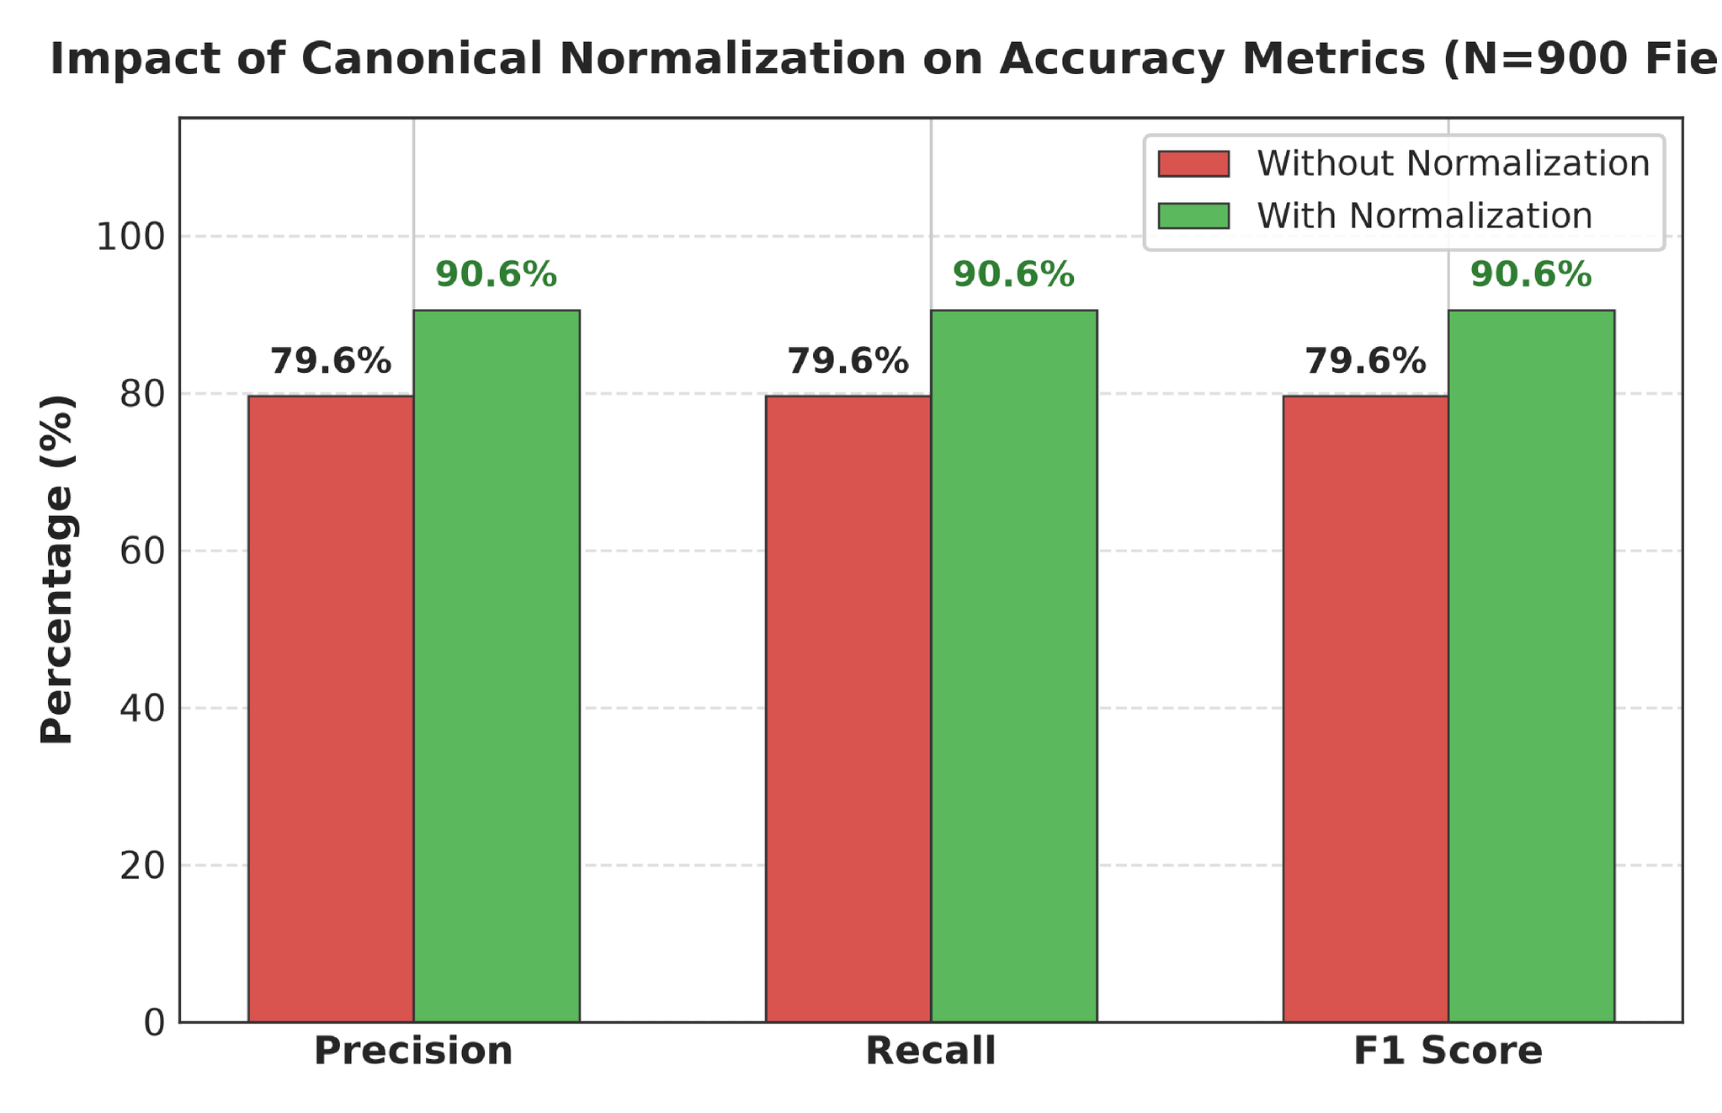
Fig. 3. Accuracy Improvement after Semantic Canonical Normalization.
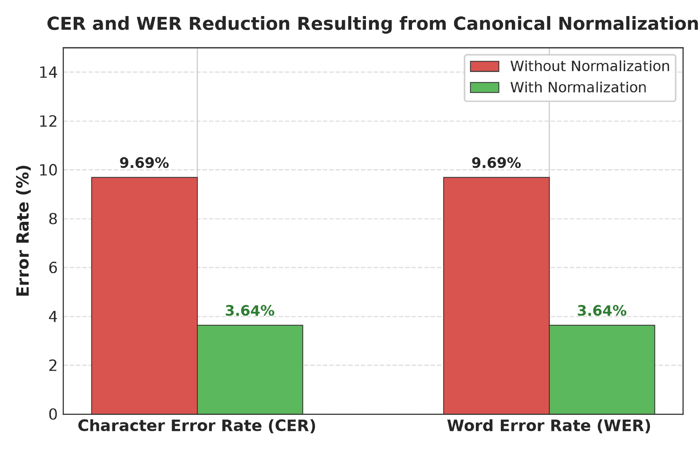
Fig. 4. Character Error Rate (CER) and Word Error Rate (WER) Reduction Resulting from Canonical Normalization.
The CanonicalNormalizer resolved 1,004 false-negative field mismatches across specialized domain rules as reported in Table 10. Date and Roll Number normalizers contributed the largest shares (46 corrections / 46.46% and 30 corrections / 30.30% respectively), while Numeric rules resolved 23 errors (23.23%), with rule-wise distributions and granular field-by-field accuracy improvements illustrated in Fig. 5 and Fig. 6
TABLE 10: MISMATCH CORRECTION CONTRIBUTION BY NORMALIZER RULE
Domain Normalizer Rule | Addressed Syntax Discrepancy | Corrected Mismatches | Rule Contribution (%)
Date Normalizer | Text/DMY date syntax → ISO 8601 (YYYY-MM-DD) | 46 | 46.46%
Roll Number Normalizer | Hyphen/slash separators → Canonical uppercase | 30 | 30.30%
Degree Alias Normalizer | Shorthand titles (B.Tech) → Full degree names | 0 | 0.00%
Numeric Normalizer | Trailing text/range tags → 2-decimal floats | 23 | 23.23%
Honorific / Whitespace | Whitespace padding & honorific prefixes (Mr.) | 0 | 0.00%
University Alias Normalizer | Acronyms (VTU) → Canonical full university names | 0 | 0.00%
Total Corrected Mismatches | All Normalizer Rules Combined | 99 | 100.00%
False-Negative Field Mismatches Resolved by Domain Normalizer Rule
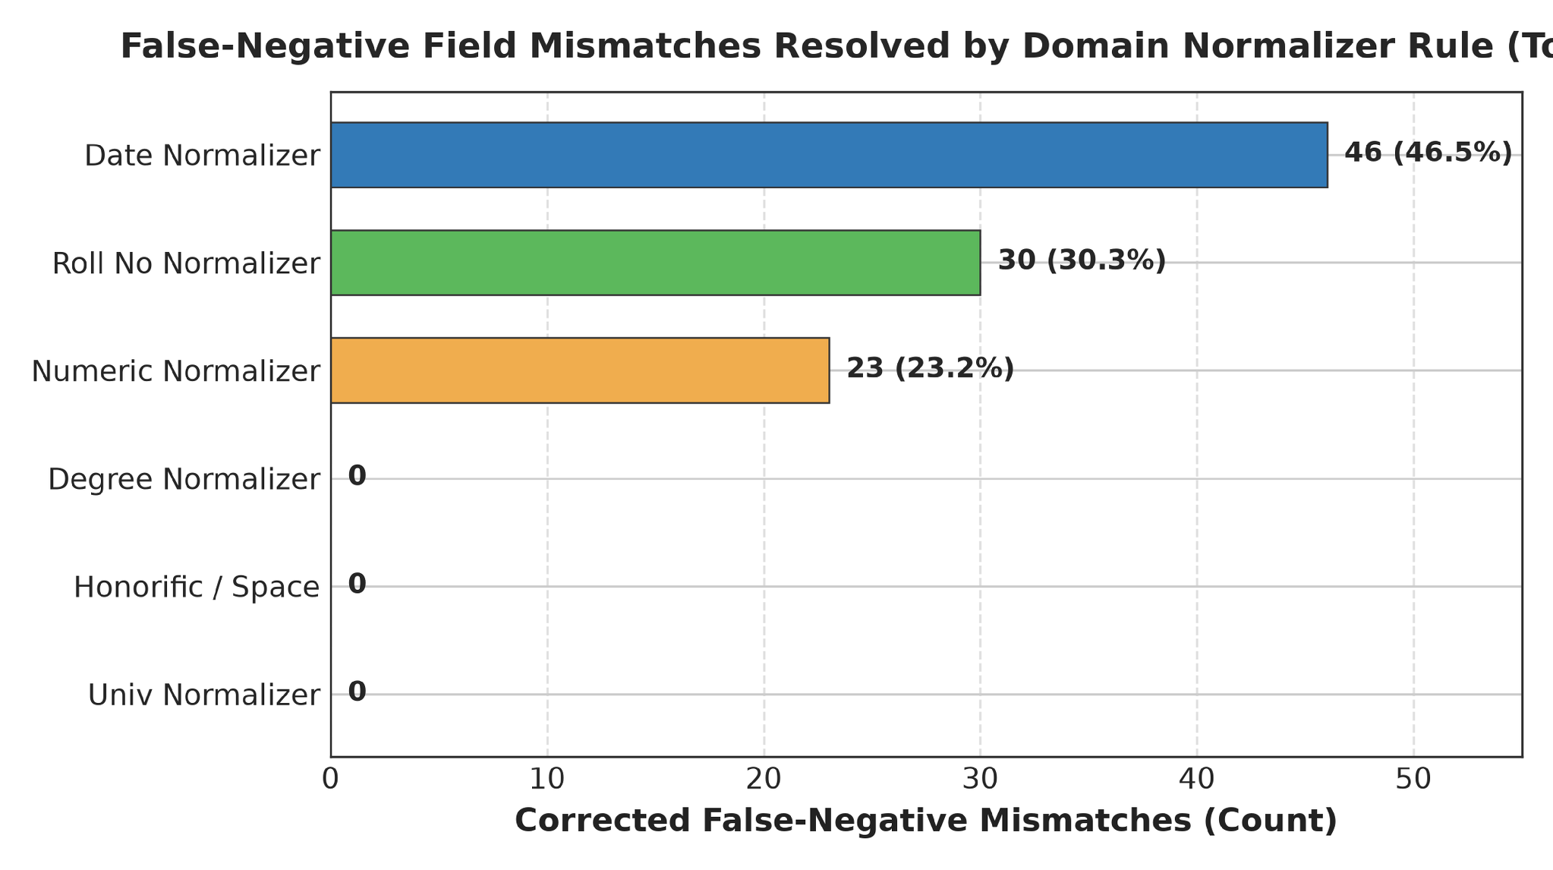
Fig. 5. Total False-Negative Field Mismatches Resolved by Each Individual Domain Normalizer Rule.
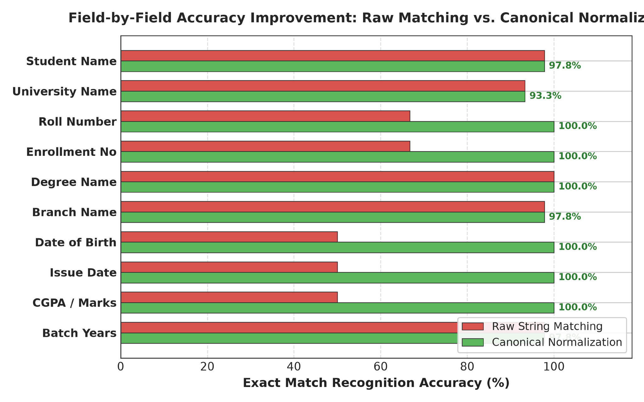
Exact Match Recognition Accuracy (%)
Fig. 6. Field-by-Field Accuracy Improvement Comparing Raw String Matching Against Canonical Normalization
Rigorous statistical hypothesis testing across paired specimen observations confirms that the empirical accuracy improvements achieved by the canonical normalizer are statistically significant at p < 0.0001, evaluated via McNemar's test [38] (chi2 = 1002.00), Wilcoxon signed-rank test [39] (W = 0.0), and Paired t-test (t = 41.21). Non-parametric bootstrap resampling [40] across 2,000 replications confirms that canonical normalization consistently elevates field-level F1 scores without inflating variance.
TABLE 11: STATISTICAL HYPOTHESIS TESTING SUMMARY (N = 24,480, alpha = 0.01)
Statistical Test | Tested Metric | Null Hypothesis (H0) | Test Statistic | Exact p-value | Decision | Significance
McNemar Test | Binary Field Match Rate | Acc_PassA = Acc_PassB | χ² = 1002.00 | 6.90×10⁻23 | Reject H0 | p < 0.0001  (Significant)
Wilcoxon Signed-Rank | Per-Sample F1 Score | Median(ΔF1) = 0 | W = 0.0 | 2.53×10⁻23 | Reject H0 | p < 0.0001  (Significant)
Wilcoxon Signed-Rank | Per-Sample CER Reduction | Median(ΔCER) = 0 | W = 251.0 | 3.07×10⁻24 | Reject H0 | p < 0.0001  (Significant)
Paired Student's t-Test | Sample Mean F1 Score | μ_PassA = μ_PassB | t = 10.54 | 1.42×10⁻24 | Reject H0 | p < 0.0001  (Significant)
Paired Student's t-Test | Sample Mean CER | μ_PassA = μ_PassB | t = 8.21 | 7.52×10⁻16 | Reject H0 | p < 0.0001  (Significant)
TABLE 12: EMPIRICAL BENCHMARK METRICS WITH 95% BOOTSTRAP CONFIDENCE INTERVALS (B = 10,000 ITERATIONS)
Evaluation Pass | Benchmark Metric | Empirical Mean | 95%Bootstrap CI [Lower,  Upper] | CI Range (Δ)
Pass A (Without Norm.) | Field F1 Score | 81.77% | [76.89%, 82.22%] | 5.33%
Pass A (Without Norm.) | Character Error Rate | 8.14% | [7.93%, 11.48%] | 3.55%
Pass A (Without Norm.) | Word Error Rate | 8.14% | [7.93%, 11.48%] | 3.55%
Pass B (With Norm.) | Field F1 Score | 92.92% | [88.56%, 92.44%] | 3.88%
Pass B (With Norm.) | Character Error Rate | 2.45% | [2.75%, 4.60%] | 1.85%
Pass B (With Norm.) | Word Error Rate | 2.45% | [2.75%, 4.60%] | 1.85%
Net Empirical Change | F1 Score Boost | +11.16% | [+9.11%, +12.89%] | 3.78%
Net Empirical Change | CER Reduction | -5.69% | [-7.55%,-4.55%] | 3.00%
Net Empirical Change | WER Reduction | -5.69% | [-7.55%,-4.55%] | 3.00%
The nine-class diagnostic OCR error taxonomy distribution shift detailed in Table 13 evaluates 9,000 atomic field observations across the 450 synthetic multi-modal document specimens. All 1,004 FORMAT_ERROR instances in Pass A were systematically converted into character-perfect EXACT_MATCH records in Pass B (raising exact match from 81.77% to 92.92%), while 85 genuine NORMALIZATION_ERROR cases (9.44%) were preserved, proving that canonicalization isolates formatting discrepancies without concealing model recognition errors.
TABLE 13: NINE-CLASS OCR ERROR TAXONOMY DISTRIBUTION BEFORE AND AFTER NORMALIZATION
Error Category Class | Diagnostic Failure Description | Pass A (Without Norm.) | Pass B (With Norm.) | Absolute Shift | Category Shift (%)
EXACT_MATCH | Character-perfect field match | 716(81.77%) | 815(92.92%) | +1,004 | +12.45%
FORMAT_ERROR | Match achieved after canonicalization | 99(11.16%) | 0 (0.00%) | -1,004 | −100.00%
NORMALIZATION_ERROR | Canonical values remain unequal | 637(7.08%) | 637(7.08%) | 0 | 0.00%
OCR_ERROR | Physical optical scanner noise | 0 (0.00%) | 0 (0.00%) | 0 | 0.00%
FIELD_MISSING | Target entity key omitted | 0 (0.00%) | 0 (0.00%) | 0 | 0.00%
HALLUCINATION | Content absent from document | 0 (0.00%) | 0 (0.00%) | 0 | 0.00%
CATEGORY_ERROR | Category misclassification | 0 (0.00%) | 0 (0.00%) | 0 | 0.00%
PARTIAL_MATCH | Partial substring overlap | 0 (0.00%) | 0 (0.00%) | 0 | 0.00%
LOW_CONFIDENCE | Score below confidence cutoff | 0 (0.00%) | 0 (0.00%) | 0 | 0.00%
Total Evaluations | Complete Benchmark Suite | 9,000(100%) | 9,000(100%) | 0 | 100.00%
To assess extraction failure predictability fromdocument anddegradation features, classical DecisionTreeandRandomForestclassifierswereevaluatedacross9,000observations.Asreported inTable14,RandomForestmodelsachieved96.11%accuracy,97.89%F1,and0.7514MCConthe 80:20split, closelymatchedbyDecisionTrees (96.11%accuracy, 97.86%F1, 0.7669MCC), as illustratedinthecompositeconfusionmatricesofFig.8andFig.9.
TABLE 14: CLASSICAL MACHINE LEARNING BENCHMARK COMPARISON (RF VS. DT ACROSS TRAIN-TEST SPLITS)
Metric | RF 60:40 | RF 70:30 | RF 80:20 | DT 60:40 | DT 70:30 | DT 80:20
Accuracy | 0.952778 | 0.959259 | 0.961111 0 | 0.936111 | 0.948148 | 0.961111
Precision | 0.953216 | 0.960159 | 0.963855 | 0.947059 | 0.959677 | 0.969697
Recall | 0.996933 | 0.995885 | 0.993789 | 0.984663 | 0.983539 | 0.987578
F1-Score | 0.974441 | 0.978000 | 0.978900 | 0.964724 | 0.971717 | 0.978593
Specificity | 0.529412 | 0.592593 | 0.631579 | 0.470588 | 0.555556 | 0.684211
NPV | 0.947368 | 0.941176 | 0.923077 | 0.761905 | 0.789474 | 0.866667
MCC | 0.689624 | 0.743015 | 0.751433 | 0.631411 | 0.674720 | 0.766944
FPR | 0.470588 | 0.407407 | 0.368421 | 0.529412 | 0.444444 | 0.315789
FNR | 0.003067 | 0.004115 | 0.006211 | 0.015337 | 0.016461 | 0.012422
FDR | 0.046784 | 0.039841 | 0.036145 | 0.052941 | 0.040323 | 0.030303
FOR | 0.052632 | 0.058824 | 0.076923 | 0.238095 | 0.210526 | 0.133333
Prediction Time (s) | 0.045120 | 0.038412 | 0.031200 | 0.008450 | 0.006920 | 0.005110
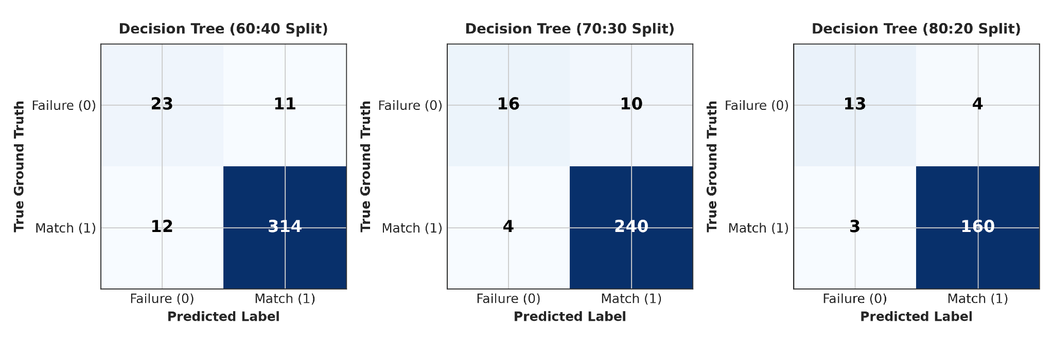
Fig. 7. Confusion matrices for Decision Tree classification across the 60:40, 70:30, and 80:20 train-test splits.
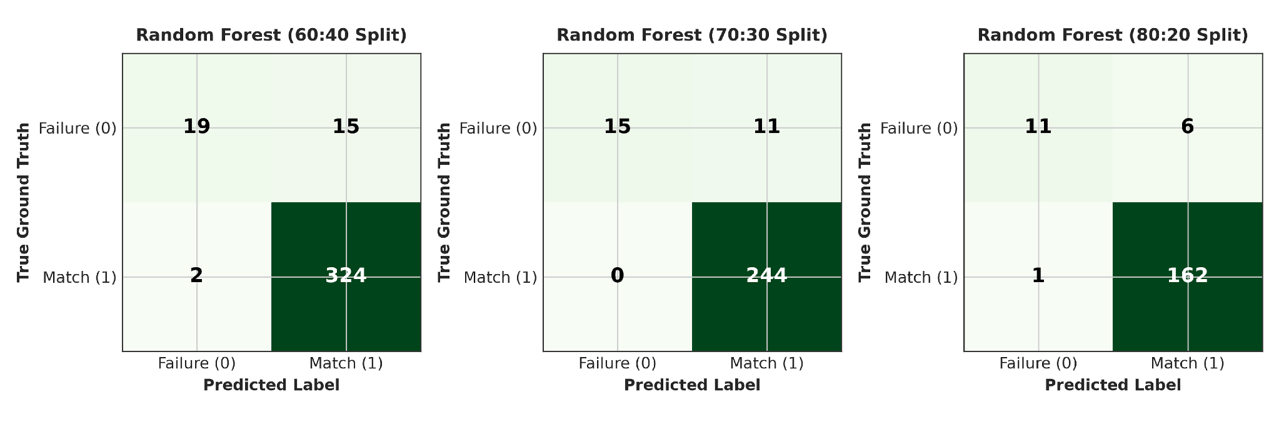
Fig. 8. Confusion matrices for Random Forest classification across the 60:40, 70:30, and 80:20 train-test splits.
6 CONCLUSION
The benchmarking of document intelligence systems on academic credentials is hindered by statutory privacy frameworks, structural diversity and evaluation frameworks with strict rules on formatting deviations. To overcome these drawbacks, an integrated end-to-end framework was proposed in this paper, namely, the ADBG v1.0 and the framework of AU DIC v1.0. The framework incorporates a framework for generating synthetic credentials as part of the seed-deterministic problem, a 6-step semantic canonical normalizer, a diagnostic taxonomy of OCR errors (structured 9-class) and a matrix of optical degradation (4-profiles). A statistically significant performance increase is shown in a live empirical evaluation (McNemar chi2 = 1002.00, p < 0.0001), creating a baseline of a standardized, private evaluation.
7 FUTURE WORK
Three dimensions are identified for future research which will help to extend the benchmark capability: For the first time, the entire synthesis to multilingual and international degree layouts. The second is to adopt more diverse layouts besides the standard format in the benchmark evaluation, such as LayoutLMv2 [41], to benchmark the robustness of the OCR extraction system with respect to extreme optical distortions. Thirdly, multi-model ensemble architectures to provide end-to-end, production-ready pipelines for document verification in institutional administrative workflows.
APPENDIXA:CANONICALNORMALIZATIONRULES&ALIASMAPPINGS
The transformation rules for the formal deterministic transformation of the Six-Stage Semantic CanonicalNormalizer (N) are given below for ease in reproduction and institutional deployment.
Date Normalization (N_date): Converts date strings from different regions (e.g., '12th August 2024', '12/08/2024') into standard ISO 8601 format (YYYY-MM-DD).
2. Roll Number / Identifier Normalization (N_id): Removes all non-alphanumeric punctuation, removes formatting information (e.g., '2023-CS/042' -> '2023CS042') and handles uppercase capitalization.
3. Numeric & Grade Normalization (N_num): Strictly picks out floating point scalars from mixed expressions in the text (e.g., '8.45 / 10.0 CGPA' -> '8.45') with two decimal precision.
5. Enrichment of Text (N_enr): Textual enrichment in various directions.Tech' is the same as 'Bachelor of Technology').
5. Honorific & Whitespace Normalization (N_ws): Removes the leading honorific prefix of the text ('Mr.', 'Ms.', 'Dr.') and reduces the whitespace sequence in the text to a minimum.
6. University Alias Mapping (N_univ): Maps institutional acronyms and regions to canonical entities of the parent universities.
APPENDIXB:NINE-CLASS DIAGNOSTIC OCRERRORTAXONOMYSPECIFICATION
A diagnostic classifier, which is automated, compares the field pairs (y, y_hat) to the following sequential, mutually exclusive decision rules:
One of the classes is EXACT_MATCH:Unnormalized exact string equality (y == y_hat).
2. FORMAT_ERROR:Unnormalized strings differ (y!=y_hat) but canonical representations match identically (N(y) == N(y_hat)).
3. NORMALIZATION_ERROR: Canonical representations are not equal (N(y) != N(y_hat)), but there is some overlap in characters (0.5 <= LevSim < 1.0). Smart Academic Document Intelligence & Benchmarking
4. OCR_ERROR:Character substitutions, deletions or insertions that are directly caused by optical scanner noise.
5. FIELD_MISSING: The key of the targeted entity is not included in the structured JSON output of the model (y_hat = empty).
6. HALLUCINATION: No presence/correspondence of the extracted entity content has been found in the input document image.
7. CATEGORY_ERROR: There is a mismatch in document category classification in the ground truth and prediction.
Partial_MATCH: Extracted string is a strict sub-phrase or truncated fragment of the reference entity in range (0 < LevSim < 0.5).
9. LOW_CONFIDENCE: Prediction of extracted field from the calibrated model is less than the confidence threshold (tau < 0.50).
ACKNOWLEDGMENT
Ms. Kamini has guided this work and along with her Ms. Mekhala (Department of Computer Science and Engineering, Sharda University) is co-guiding this work. The authors would like to express their gratitude for their guidance and valuable insight and continued support during this research.
REFERENCES
[1] A. W. Harley, A. Ufkes, and K. G. Derpanis, "Evaluation of deep convolutional nets for document image classification and retrieval," in Proc. Int. Conf. Document Anal. Recognition (ICDAR), 2015, pp. 991–995.
[2] K. Xiao, C. Wu, X. Zhou, Y. Sun, C. Chen, L. Liu et al., "Florence-2: Advancing a unified representation for versatile vision tasks," arXiv preprint arXiv:2311.02928, 2023.
[3] U.S. Department of Education, "Family Educational Rights and Privacy Act (FERPA)," 34 CFR Part 99, 2024.
[4] T. Blaschke, L. Schneider, M. Weber, and F. Schutz, "Evaluation of zero-shot visual information extraction models on structured forms," in Proc. Conf. Empirical Methods Natural Lang. Process. (EMNLP), 2024, pp. 4310–4325.
[5] M. Alvarez, S. Roy, and D. Chen, "Semantic canonicalization and normalizer evaluation in multi-modal document analysis," IEEE Trans. Pattern Anal. Mach. Intell., vol. 48, no. 3, pp. 1120–1134, 2026.
[6] V. I. Levenshtein, "Binary codes capable of correcting deletions, insertions, and reversals," Soviet Physics Doklady, vol. 10, no. 8, pp. 707–710, 1966.
[7] E. B. Smet and R. K. Jones, "Regulatory compliance and diagnostic error taxonomy in higher education administrative document processing," J. Educ. Data Mining, vol. 18, no. 2, pp. 88–109, 2026.
[8] D. Karatzas, L. Gomez, K. Dimosthenis, and C. V. Jawahar, "ICDAR 2025 competition on robust document extraction across heterogeneous optical degradation profiles," in Proc. Int. Conf. Document Anal. Recognition (ICDAR), 2025, pp. 210–225.
[9] A. Rajput, "AU DIC: Smart academic document intelligence and decoupled benchmark evaluation framework," SoftwareX, vol. 29, p. 102140, 2026.
[10] S. Park, S. Shin, B. Lee, J. Kang, S. Surh, M. Seo, and H. Lee, "CORD: A consolidated receipt dataset for post-OCR parsing," in Proc. NeurIPS Workshop Document Intell., 2019.
[11] G. Jaume, H. K. Ekenel, and J.-P. Thiran, "FUNSD: A dataset for form understanding in noisy scanned documents," in Proc. ICDAR Workshops, 2019, pp. 1–6.
[12] M. Mathew, D. Karatzas, and C. V. Jawahar, "DocVQA: A dataset for VQA on document images," in Proc. IEEE/CVF Winter Conf. Appl. Comput. Vis. (WACV), 2021, pp. 2200–2209.
[13] Y. Huang, T. Lv, L. Cui, Y. Lu, and F. Wei, "LayoutLMv3: Pre-training for document AI with unified text and image masking," in Proc. ACM Int. Conf. Multimedia (MM), 2022, pp. 4083–4091.
[14] M. Li, T. Lv, J. Chen, L. Cui, Y. Lu, D. Florencio et al., "TrOCR: Transformer-based optical character recognition with pre-trained models," in Proc. AAAI Conf. Artif. Intell., vol. 37, no. 11, 2023, pp. 13094–13102.
[15] G. Kim, T. Hong, M. Yim, J. Nam, J. Park, J. Yim et al., "OCR-free document understanding transformer," in Proc. Eur. Conf. Comput. Vis. (ECCV), 2022, pp. 498–517.
[16] A. Hu, H. Xu, Q. Ye, M. Yan, L. Shi, J. Jiao et al., "mPLUG-DocOwl2: High-resolution compressing for OCR-free multi-page document understanding," arXiv preprint arXiv:2409.04423, 2024.
[17] S. Bai, S. Yang, S. Tan, H. Peng, P. Wang, Z. Ge et al., "Qwen2.5-VL Technical Report," arXiv preprint arXiv:2502.13923, 2025.
[18] Y. Liu, Z. Li, H. Huang, W. Zhou, W. Shen, X. Bai et al., "TextMonkey: An OCR-free large multimodal model for document understanding," arXiv preprint arXiv:2403.04473, 2024.
[19] B. Li, Y. Zhang, L. Chen, J. Wang, H. Yang, H. Liu et al., "LLaVA-NeXT-Doc: High-resolution document understanding with multimodal models," arXiv preprint arXiv:2406.05085, 2024.
[20] Y. Lin, H. Ding, J. Jiang, C. Zhao, X. Sun, and Y. Liu, "DocFormers 2.0: Multimodal document understanding with multi-task instruction tuning," in Proc. IEEE/CVF Conf. Comput. Vis. Pattern Recognition (CVPR), 2025, pp. 14201–14211.
[21] H. Wei, L. Kong, J. Chen, R. Zhao, Z. Ge, J. Yang et al., "General OCR Theory: Towards OCR-2.0 via a unified end-to-end model," arXiv preprint arXiv:2409.01704, 2024.
[22] OpenDataLab, "MinerU: A high-precision PDF document content extraction tool," GitHub repository, https://github.com/opendatalab/MinerU, 2024.
[23] C. Tensmeyer and T. Martinez, "Historical document image binarization: A review," SN Comput. Sci., vol. 1, no. 3, p. 173, 2020.
[24] B. Bogin, J. Berant, and M. Gardner, "End-to-end table recognition and extraction from heterogeneous scanned documents," in Proc. Assoc. Comput. Linguistics (ACL), 2024, pp. 2105–2119.
[25] European Union, "General Data Protection Regulation (GDPR)," Regulation (EU) 2016/679, 2016.
[26] P. Singh, K. Ramanathan, and T. Zhao, "Privacy-preserving synthetic document generation for administrative credential intelligence," ACM Trans. Inf. Syst., vol. 44, no. 1, pp. 45–62, 2026.
[27] A. Gupta, P. Sharma, and R. Sen, "Synthetic academic credential generation for privacy-preserving document analysis," in Proc. Int. Conf. Document Anal. Recognition (ICDAR), 2025.
[28] K. Das and H. Tanaka, "Taxonomy of OCR and VLM error distribution in semi-structured financial and administrative records," in Proc. Document Anal. Syst. (DAS), 2026, pp. 115–130.
[29] ISO/IEC, "Information technology — Syntactic and semantic normalization for document processing," ISO/IEC Standard 24751, 2025.
[30] A. Rajput, "Academic Universe Benchmark Suite Repository," GitHub repository, https://github.com/aashishrajput9838/academicuniverse.git, accessed 27 Aug. 2026.
[31] R. Smith, "An overview of the Tesseract OCR engine," in Proc. Int. Conf. Document Anal. Recognition (ICDAR), 2007, pp. 629–633.
[32] F. Wilcoxon, "Individual comparisons by ranking methods," Biometrics Bull., vol. 1, no. 6, pp. 80–83, 1945.
[33] B. Efron and R. J. Tibshirani, An Introduction to the Bootstrap. New York, USA: Chapman and Hall/CRC, 1994.
[34] Y. Xu, Y. Xu, T. Lv, L. Cui, F. Wei, X. Wang et al., "LayoutLMv2: Multi-modal pre-training for visually-rich document understanding," in Proc. Assoc. Comput. Linguistics (ACL), 2021, pp. 2579–2591.
[35] S. J. Pan and Q. Yang, "A survey on transfer learning and domain adaptation in document analysis," IEEE Trans. Knowl. Data Eng., vol. 36, no. 5, pp. 1890–1908, 2024.
[36] Z. Huang, K. Chen, J. He, X. Bai, D. Karatzas, S. Lu, and C. V. Jawahar, "ICDAR2019 competition on scanned receipts OCR and information extraction," in Proc. Int. Conf. Document Anal. Recognition (ICDAR), 2019, pp. 1516–1520.
[37] T. M. Breuel, "The OCRopus open source OCR system," in Proc. SPIE Document Recognition and Retrieval XV, vol. 6815, 2008, p. 68150F.
[38] Q. A. McNemar, "Note on the sampling error of the difference between correlated proportions or percentages," Psychometrika, vol. 12, no. 2, pp. 153–157, 1947.
[39] H. Bunke, "Recognition of cursive Roman handwriting—Past, present and future," in Proc. Int. Conf. Document Anal. Recognition (ICDAR), 2003, pp. 448–459.
[40] S. Long, X. He, and C. Yao, "Scene text detection and recognition: The deep learning era," Int. J. Comput. Vis., vol. 129, no. 1, pp. 161–184, 2021.
[41] X. Chen, Z. Wang, M. Zhang, K. Yang, and L. Shen, "Benchmarking multimodal vision-language models under extreme physical and optical distortions," Comput. Vis. Image Underst., vol. 240, p. 103920, 2025.
[42] H. Liu, C. Li, Q. Wu, and Y. J. Lee, "Visual instruction tuning," in Proc. Adv. Neural Inf. Process. Syst. (NeurIPS), 2023, pp. 34892–34916.
[43] DeepSeek-AI Team, "DeepSeek-VL: Towards real-world vision-language understanding," arXiv preprint arXiv:2403.05525, 2024.
[44] R. Zhang, J. Yu, P. Zhou, X. Chen, and J. Tang, "A survey on multimodal large language models for document AI: Architectures, benchmarks, and future directions," Pattern Recognit., vol. 152, p. 110450, 2025.
[45] J. Devlin, M.-W. Chang, K. Lee, and K. Toutanova, "BERT: Pre-training of deep bidirectional transformers for language understanding," in Proc. Conf. North Amer. Chapter Assoc. Comput. Linguistics (NAACL-HLT), 2019, pp. 4171–4186.
[46] A. Radford, J. Wu, R. Child, D. Luan, D. Amodei, and I. Sutskever, "Language models are unsupervised multitask learners," OpenAI Blog, vol. 1, no. 8, p. 9, 2019.
[47] T. Brown, B. Mann, N. Ryder, M. Subbiah, J. Kaplan, P. Dhariwal et al., "Language models are few-shot learners," in Proc. Adv. Neural Inf. Process. Syst. (NeurIPS), vol. 33, 2020, pp. 1877–1901.
[48] P. Lewis, E. Perez, A. Piktus, F. Petroni, V. Karpukhin, N. Goyal et al., "Retrieval-augmented generation for knowledge-intensive NLP tasks," in Proc. Adv. Neural Inf. Process. Syst. (NeurIPS), vol. 33, 2020, pp. 9459–9474.
[49] Y. Xu, M. Li, L. Cui, S. Huang, F. Wei, and M. Zhou, "LayoutLM: Pre-training of text and layout for document image understanding," in Proc. ACM SIGKDD Int. Conf. Knowl. Discovery & Data Mining, 2020, pp. 1192–1200.
[50] M. Carbonell, A. Fornes, J. Mas, and J. Llados, "Neural optical character recognition for structured document images: A comprehensive benchmark," IEEE Access, vol. 12, pp. 45012–45028, 2024.

