Affiliated to Pokhara University
UNITED TECHNICAL COLLEGE

A Minor Project Report On
BLOOD DONATION SYSTEM
[Subject Code No:209]
Submitted in partial fulfillment of the Requirements for Bachelor of Engineering in Computer Engineering under United Technical College

Submitted by
Aashish Regmi (22070088)
Ayush Shrestha (22070092)
Dixit Shrestha (22070098)
Sonish Lohani (21075549)

Submitted to
Department of Computer Engineering

DEDICATION

This project is dedicated with profound gratitude to our exceptional teachers, whose unwavering guidance and mentorship have been instrumental in our successful completion of this endeavor. Through this journey, their wisdom and encouragement have served as a guiding light, inspiring us to strive for excellence.
We also extend our heartfelt appreciation to our parents, whose unwavering financial and moral support have sustained us throughout the development of this project. Their belief in our abilities, their sacrifices, and the valuable life lessons they've imparted have shown us that even the most daunting tasks can be conquered, one step at a time.
The unwavering faith of our dedicated educators and loving parents has been the foundation of our success, and for that we are ever grateful.

DECLARATION

We hereby declare that this study entitled “Blood Donation System” is based on our original work. Related works on the topic by other researchers have been duly acknowledged. We owe all the liabilities relating to the accuracy and authenticity of the data and any other information included hereunder.

Name of the Students:
Aashish Regmi
Ayush Shrestha
Dixit Shrestha
Sonish Lohani

Date: July 03, 2025

RECOMMENDATION

This is to certify that this project work entitled “Blood Donation System” prepared and submitted by Aashish Regmi, Ayush Shrestha, Dixit Shrestha, Sonish Lohani in partial fulfillment of the requirements of the degree of Bachelor of Engineering in Computer awarded by Pokhara University has been completed, under the supervision of Er. Santosh Shrestha.

Signature: _________________________

Name of the supervisor: Er. Santosh Shrestha
Organization: United Technical College
Date: July 02, 2025

DEPARTMENTAL ACCEPTANCE

The project entitled “Blood Donation System” submitted by “Aashish Regmi, Ayush Shrestha, Dixit Shrestha, Sonish Lohani” for the award of the degree in Bachelor of Computer Engineering has been accepted as benefice record of work independently carried out by them in department.

Signature: ___________________________

Er. Sahit Baral

Head of Department of Computer and Electrical & Electronics.

CERTIFICATE OF APPROVAL
This project entitled “Blood Donation System” prepared and submitted by Aashish Regmi, Ayush Shrestha, Dixit Shrestha, Sonish Lohani has been examined by us and is accepted for the award of the degree of Bachelor in Computer Engineering by Pokhara University.

Name of External: Signature: Date:
Designation:
Organization:

Name of Supervisor: Er. Manoj Sapkota

Signature:

Date:
Designation: Lecturer
Organization: United Technical College

Name of Principal:
Prof. Keshab Datt Awasthi, Ph.D.

Signature:

Date:
Organization: United Technical College

ACKNOWLEDGEMENT

It is our pleasure to be indebted to various people, who directly or indirectly contributed in the development of this project and who influenced our thinking, behavior and acts during the time of project.
We would like to express our profound gratitude to United Technical College for providing a suitable environment and its contributions to the completion of our project titled “Blood Donation System”.
We express our sincere gratitude to Prof.-----------------, principal of our college, United Technical College, for the support, cooperation and motivation provided during the project.
We would like to express our special thanks to our supervisor Er. Santosh Shrestha for his time and efforts he provided throughout the project. Your useful advice and suggestions were really helpful to us during the project’s completion. In this aspect, we are eternally grateful to you.
We would like to acknowledge that this project was completed entirely by our group and not by someone else.

Thanks for all your encouragement!

Name of the Students:
Aashish Regmi
Ayush Shrestha
Dixit Shrestha
Sonish Lohani

Date: July 03, 2025

ABSTRACT
This project aims to create a comprehensive blood donation website to simplify the process of connecting blood donors with recipients and enhance the overall efficiency of the blood donation system. The platform will serve as a centralized hub, enabling seamless interaction between donors, recipients, and organizations while addressing key challenges such as delays in donor-recipient matching, lack of real-time updates, and insufficient donor engagement. The primary goal of the project is to improve access to critical blood supplies, encourage regular donations, and provide a user-friendly solution to overcome current inefficiencies. This initiative is vital as it addresses pressing healthcare needs and promotes a culture of altruism and community involvement. Modern web technologies will be used to develop the website, incorporating features like geolocation-based donor searches, real-time notifications, and secure data management. The implementation will leverage tools such as HTML, CSS, JavaScript, and a backend framework like Node.js or Django, complemented by database systems for efficient data handling. Additionally, APIs for maps and notifications will enhance the platform's functionality, ensuring an intuitive and seamless user experience. The anticipated outcomes include a fully operational, accessible, and secure blood donation website that supports efficient donor-recipient matching, facilitates the organization of donation drives, and engages users with educational resources and timely updates. Ultimately, this project aspires to save lives by improving the accessibility and impact of blood donation while addressing the shortcomings of existing systems.
Keywords: Blood donation website, donor-recipient matching, donor engagement, secure data management, user-friendly, efficient data handling, etc.

Table of Contents
DEDICATION ii
DECLARATION iii
RECOMMENDATION iv
DEPARTMENTAL ACCEPTANCE v
CERTIFICATE OF APPROVAL vi
ACKNOWLEDGEMENT vii
ABSTRACT viii
List of Figures xi
List of Tables xii
Acronyms and Abbreviation xiii
CHAPTER 1: INTRODUCTION 1
1.1 Background 1
1.2 Problem Statement 2
1.3 Objectives 2
1.4 Motivation and Significance 3
1.5 Scope of the Work 4
1.6 Feasibility Study 4
CHAPTER 2: LITERATURE REVIEW 6
2.1 Overview of Existing Systems 6
2.2 Comparison of Features 7
2.3 Gaps in Existing Systems 8
2.4 Significance of Proposed Work 10
CHAPTER 3: METHODOLOGY 12
3.1 Overview of the Approach 12
3.2 System or Model Design 16
3.3 Technology Stack 16
3.4 Development Process 18
3.5 System Design 18
3.5.1 E-R Diagram 19
3.5.2 Use Case Diagram 20
3.5.3 System Flow Diagram 21
3.6 Software and Hardware Requirements 21
3.7 Testing and Maintenance 22
3.8 Algorithm 23
3.8 Task Remaining 27
CHAPTER 4: EXPECTED OUTCOME 29
CHAPTER 5: DISCUSSION AND RESULT 30
References 31
Appendices A: Gantt chart 32

List of Figures
Figure 3.2.1 Block Diagram of Digital Blood Bank System 15

Figure 3.6.1 E-R Diagram 21

Figure 3.7.1 Use Case Diagram 22

List of Tables
Table 2. 2 Comparison of Features 6

Table A. Gantt chart of the project 26

Acronyms and Abbreviation
AI: Artificial Intelligence
API: Application Programming Interface
AWS: Amazon Web Services
CSS: Cascading Style Sheets
E-R: Entity-Relationship
HTML: Hyper-Text Markup Language
HTTPS: Hyper-Text Transfer Protocol Secure
IoT: Internet of Things
NGO: Non-Governmental Organization
SMS: Short Message Service
SQL: Structured Query Language
VS code: Visual Studio Code

CHAPTER 1: INTRODUCTION

1.1 Background
Blood donation has always been a vital aspect of healthcare, providing critical support for patients requiring transfusions during surgeries, accidents, or treatments. With the integration of technology into healthcare, new opportunities have emerged to enhance the blood donation process. Tools such as digital platforms, mobile apps, and geolocation systems have helped connect donors, recipients, and blood banks, streamlining donor matching and facilitating donation drives. (Chen & Wang, 2019)
Recent advancements include using Artificial Intelligence (AI) to forecast blood demand, implementing blockchain technology to ensure safe and traceable blood supplies, and leveraging mobile apps to deliver real-time updates on donation events and urgent blood needs. Additionally, geolocation services have made it easier for donors to find nearby centers, while SMS and email notifications have improved donor engagement and participation. (Ali, Jahan, Ariful, & Shafa-at, 2015)
However, challenges persist in the current systems. Many platforms lack intuitive, user-friendly interfaces, making it difficult for users to navigate or find information effectively. Data security and privacy concerns remain unaddressed on some platforms, discouraging potential donors from signing up. Furthermore, the fragmentation of these systems often results in redundant efforts and inefficiencies, as no single platform offers a comprehensive solution for donors, recipients, and organizations. (Chen & Wang, 2019)
Developing an improved blood donation website can address these shortcomings. A thoughtfully designed platform can centralize critical information, improve usability, and encourage collaboration among stakeholders. It can also raise awareness about the importance of regular blood donation, ensure the availability of essential blood supplies, and strengthen the overall resilience of the healthcare system. (Jones, 2018)

1.2 Problem Statement
Blood donation is essential for saving lives, yet current systems for connecting donors and recipients face significant obstacles. These challenges contribute to inefficiencies in the blood supply chain, delays in responding to emergencies, and missed opportunities to engage willing donors. The absence of a centralized, user-friendly platform further complicates the process, creating difficulties for donors, recipients, and organizations.
These limitations result in delays, shortages, and lost opportunities to tap into the goodwill of potential donors. A well-designed blood donation website can address these issues by offering a centralized platform with real-time data, secure communication, and user-friendly features. By bridging the gap between donors, recipients, and organizations, this solution can improve access to blood supplies, enhance operational efficiency, and promote a culture of consistent blood donation.

1.3 Objectives
The objectives of this project are as follows:
- To develop a centralized platform that facilitates efficient matching of blood donors with recipients based on factors such as blood type, location, and urgency.
- To raise awareness about the significance of blood donation and motivate regular donor participation through educational resources and engagement features.
- To empower organizations to organize, manage, and promote blood donation drives effectively, while enabling users to easily register and participate.
- To deliver a secure and user-friendly platform that is accessible across various devices, ensuring data privacy and inclusivity for diverse user groups.

1.4 Motivation and Significance
The motivation for developing a blood donation website arises from the vital role blood donation plays in saving lives and the ongoing challenges of ensuring a consistent and timely blood supply. Despite advancements in technology, existing systems often fail to effectively connect donors and recipients, especially in emergencies. Challenges such as fragmented platforms, the absence of real-time updates, low donor engagement, and inadequate data security underscore the need for a more innovative solution. This project was selected as it combines technological advancements with a critical social need, providing an opportunity to address these issues and significantly improve healthcare outcomes.
The proposed website aims to overcome the limitations of current systems by integrating advanced features that streamline donor-recipient connections and enhance the overall user experience. Unlike existing platforms that operate independently or with limited functionality, this website offers a centralized solution, including real-time donor matching, geolocation-based searches, and secure data management. Additionally, features such as educational resources and notifications are designed to boost donor engagement and raise awareness, encouraging consistent participation. The platform places a strong emphasis on data privacy and security, ensuring users' sensitive information is protected—an issue that is often overlooked in other systems.
This project stands out due to its comprehensive approach and user-focused design. While many existing platforms focus on isolated aspects, such as organizing donation drives or registering donors, this website integrates all critical functions into a unified system. Features like real-time updates, an intuitive interface, and accessibility across devices and languages make the platform more inclusive and user-friendly. Moreover, the emphasis on community-building initiatives, such as recognition programs and social sharing, helps foster a culture of altruism and regular blood donation. By addressing the shortcomings of current systems and incorporating innovative features, this project seeks to revolutionize the blood donation process, making it more efficient, accessible, and impactful.

Scope of the Work
This project is designed as a centralized and user-friendly platform to connect blood donors, recipients, and healthcare organizations. Its main objective is to simplify the blood donation process, enhance accessibility, and resolve inefficiencies in the existing system. The platform aims to deliver a holistic solution to ensure a reliable and timely supply of blood for both medical emergencies and regular requirements.

Feasibility Study
Feasibility analysis is a process of evaluating the practicality and likelihood of success of a proposed project or venture. It involves assessing the economic, technical, and operational feasibility of the project.
    - Technical Feasibility: The blood donation project used a robust and scalable technology stack including Django, HTML, CSS, Firebase, and MySQL. Django provided a secure and efficient backend, while Firebase enabled real-time data syncing and notifications. Integration of Google Maps API allowed users to easily locate nearby donation centers or hospitals. These tools were selected for their reliability, scalability, and strong community support, making the system both future-proof and easy to maintain. Overall, the chosen technologies effectively supported the system’s core functionality.
    - Economic Feasibility: The project was designed with cost-effectiveness in mind by utilizing free-tier services available for Django and Firebase during the development phase. Hosting on AWS provided an affordable yet scalable solution that could grow with increased user demand. Open-source technologies like HTML, CSS, and Django minimized licensing costs. These choices ensured that the platform could be developed and operated within a limited budget. As a result, the project is economically viable for non-profit or government health initiatives.
    - Operational Feasibility: Operationally, the system was built to be intuitive, secure, and responsive for all user types—donors, recipients, and hospital staff. Features such as real-time donor availability, notifications, and an easy registration process helped streamline the blood donation workflow. Its mobile-friendly design ensured accessibility across devices, encouraging wider community participation. Security measures were implemented to protect user data and maintain trust. This makes the system practical and reliable for real-world use
    - Schedule Feasibility: The project followed a well-defined timeline structured around Agile development principles. Tasks were divided into sprints, each focusing on a core component such as user management, donation tracking, or map integration. Regular reviews and iterative updates ensured that the team could address any challenges without major delays. This flexible approach kept the project on track while allowing room for adjustments based on feedback. Ultimately, the schedule was realistic and supported timely completion of the system.
Conclusion of Feasibility Study
To sum up, the feasibility analysis shows that the blood donation system is both achievable and sustainable for real-world use. The chosen technology stack ensures secure, scalable, and efficient performance, supporting key features like real-time updates and user interaction. Cost-efficient resources help keep the project within budget, while the user-friendly and responsive design makes it accessible to a broad audience. A well-structured timeline, guided by Agile practices, allowed the team to stay organized and flexible throughout development. Overall, the project proves to be feasible in terms of technology, cost, operations, and scheduling.

CHAPTER 2: LITERATURE REVIEW

2.1 Overview of Existing Systems
Numerous blood donation websites and platforms have been developed to facilitate connections between donors and recipients. These systems aim to provide easy access to information, improve donor-recipient matching, and promote awareness about blood donation.
    - Blood Donor Connect: Blood Donor Connect is a platform designed to help users locate potential blood donors based on criteria like location and blood type. Its straightforward interface makes it easy to navigate, providing basic functionalities for searching and connecting users, which meet the primary requirements of a blood donation system (Smith, 2015).
    - Red Cross Blood Donation App: This app, developed by the American Red Cross, enables users to schedule blood donation appointments, monitor their donation history, and set reminders for future donations. It provides an organized approach to managing blood donations and is both functional and user-friendly. (American Red Cross, 2017)
    - BloodBanker: BloodBanker is a web-based platform offering an online directory of blood donors. It allows users to search for donors based on location and blood type, with a simple interface for making connections. (Jones, 2018)
    - BloodLink Mobile App: BloodLink is a mobile application designed for emergency blood donation requests, utilizing geolocation technology to match donors and recipients in nearby areas. Its focus on emergencies makes it particularly valuable in critical situations. (Chen & Wang, 2019)
    - SMS-Based Blood Donation System: This system connects donors and recipients via SMS alerts, offering a simple way to communicate blood donation needs. It is particularly useful for users without access to smartphones or internet-based applications. (Thapa & Shrestha, 2010)

Comparison of Features
Table 2. 2 Comparison of Features
Authors | Description | Features | Drawbacks
(Smith, 2015) | A platform for locating blood donors based on location and blood type. | Simple interface, basic search functionality. | No real-time communication or emergency handling capabilities.
(American Red Cross, 2017) | A U.S.-based app for managing blood donation schedules and tracking donation history. | Appointment scheduling, reminders, donation history tracking. | Restricted geographic coverage; lacks real-time donor-recipient matching.
(Jones, 2018) | A web-based directory for blood donors with search capabilities by location and blood type. | Directory-based search, basic functionality. | Outdated interface; not mobile-responsive; lacks real-time notifications for emergencies.
(Chen & Wang, 2019) | A mobile app designed for emergency blood donation requests using geolocation technology. | Geolocation-based matching, emergency handling capabilities. | Limited scalability; no support for large databases or advanced analytics.
(Thapa & Shrestha, 2010) | A basic SMS-based system for connecting donors and recipients through alerts. | Simple SMS alerts; accessible for non-smartphone users. | No mobile app; lacks real-time updates, secure database integration, and modern features.

2.3 Gaps in Existing Systems
The existing systems reviewed provide a range of functionalities for blood donation management. However, each system has significant gaps that limit their overall effectiveness, scalability, and user accessibility. Below are the identified gaps in the systems:
    - Lack of Real-Time Communication and Notifications:
- Most platforms, (such as (Smith, 2015) and (Jones, 2018)), do not offer real-time communication or notification features, which are essential for immediate coordination during emergencies.
- SMS-Based Blood Donation System relies solely on SMS alerts, which are not updated in real time and can cause delays in response.
    - Limited Scalability
- Systems like (Chen & Wang, 2019) face scalability challenges, limiting their ability to handle an increasing number of users or expand to a wider geographic area.
- The lack of robust infrastructure in several systems restricts their capacity to support growing databases or advanced functionalities like analytics.

    - Geographic Restrictions
- The (American Red Cross, 2017) is restricted to the U.S., making it inaccessible to users in other countries, limiting its global utility.
- Other platforms lack global reach due to their focus on local or regional markets without provisions for broader geographic expansion.
    - Outdated or Inadequate Interfaces
- Systems such as (Jones, 2018) use outdated interfaces and are not mobile-responsive, making them inconvenient for modern users who rely heavily on smartphones and tablets.
- Poor user experience can deter adoption and usage, especially among tech-savvy younger donors.
    - Absence of Advanced Features
- Most systems, including (Smith, 2015), lack advanced geolocation technologies that enable dynamic and efficient donor-recipient matching.
- Systems like (Chen & Wang, 2019) and (Thapa & Shrestha, 2010) do not integrate features like analytics for demand prediction or optimization.
    - Inadequate Support for Emergency Handling
- While the (Chen & Wang, 2019) focuses on emergencies, most other platforms lack dedicated tools to prioritize and manage urgent requests effectively.
- Emergency handling requires features such as real-time updates, secure communication channels, and precise geolocation, which are missing in several systems.
    - Limited Database Integration and Security
- Systems like (Thapa & Shrestha, 2010) do not utilize secure databases, making them unreliable for handling sensitive user information.
- Lack of integration with large databases reduces the ability to centralize and streamline operations, impacting efficiency.
    - Lack of Comprehensive Solutions
- Most existing platforms focus on specific aspects of blood donation management (e.g., donor search, appointment scheduling, emergency requests) without offering a comprehensive solution that combines all necessary functionalities into one platform.

2.4 Significance of Proposed Work
The proposed blood donation website seeks to overcome these challenges by incorporating several key features:
    - Instant Communication and Emergency Response: A significant challenge in current systems is the absence of real-time communication and handling of emergencies. The proposed system aims to incorporate real-time notifications for both donors and recipients, ensuring swift responses to urgent requests. Emergency alerts and real-time coordination will allow users to react quickly to blood donation needs, potentially saving lives during critical situations.
    - Enhanced Donor-Recipient Matching: The project will utilize advanced geolocation technology to enhance the accuracy and speed of donor-recipient matching, especially in emergency cases. By factoring in location, blood type, and urgency, the system will facilitate faster and more precise matches, ensuring that donors are connected with recipients in need without unnecessary delays.
    - Global Reach and Scalability: In contrast to existing systems that are regionally limited, this project is designed with scalability in mind. With the use of cloud infrastructure (AWS) and a flexible architecture, the platform will support growth and expansion, making it accessible to users worldwide, regardless of geographic constraints.
    - Improved User Experience: The proposed system will offer a modern, mobile-responsive interface that ensures seamless access across various devices. Its intuitive design and easy navigation will encourage higher donor engagement, simplifying processes like scheduling appointments, finding blood donors, and tracking donations.
    - Data Security and Privacy: Given the growing concerns about data security, the proposed platform will implement secure database management systems. By using MySQL and encryption protocols, the platform will safeguard sensitive user information, ensuring privacy for both donors and recipients.
    - Incorporation of Cutting-Edge Technology: The system will integrate advanced technologies, including Firebase for real-time notifications and analytics, Google Maps API for geolocation services, and Django for robust backend support. These features will facilitate real-time updates, secure data management, and an enhanced user experience, making the platform more efficient compared to older systems.
    - All-Inclusive Solution: Unlike existing systems that focus on individual aspects of blood donation, this project will provide an all-encompassing solution. It will integrate donor search, appointment scheduling, emergency response, and donation history management into a single platform. This unified approach ensures that all users—donors, recipients, and administrators—benefit from a seamless, user-friendly system.

CHAPTER 3: METHODOLOGY
This section describes the methodology applied in designing and implementing the blood donation website. The approach emphasizes systematic planning, leveraging modern tools, and focusing on user-centered design. The website is created to improve accessibility, facilitate real-time donor-recipient interactions, and ensure ease of use.

3.1 Overview of the Approach
The project implemented a client-server architecture to facilitate seamless communication between the frontend, backend, and database. The system was tailored to deliver a responsive interface, secure data handling, and real-time interaction capabilities. (Ali, Jahan, Ariful, & Shafa-at, 2015)
Key technologies included HTML, CSS, and Django for building core functionalities, with Firebase enabling real-time notifications. MySQL served as the database for structured data storage, while integrations like Google Maps API enhanced the platform’s functionality. An iterative Agile methodology was followed to incorporate regular feedback and make iterative improvements throughout the development cycle.
    - Requirements Gathering
- Objective:
The primary objective of this phase was to identify and document the essential functional and non-functional requirements to align the system with the needs of users and the project objectives.
- Techniques Used:
  - Literature Review: Researched existing platforms to identify gaps and opportunities for improvement.
  - Stakeholder Consultations: Conducted interviews and discussions with key users, such as administrators and donors, to understand their needs and expectations.
  - Data Analysis: Analyzed survey responses to prioritize user requirements.
- Data Collection:
  - Data Sources: To ensure the Digital Blood Bank System operates effectively, data must be collected from various sources. Each source contributes unique and critical information essential for the system's functionality. (Ali, Jahan, Ariful, & Shafa-at, 2015)
- Inventory Data: This includes details of available blood units, specifying their types (A, B, AB, O), Rh factors (positive or negative), and expiry dates. Tracking these parameters ensures proper management and utilization of blood resources.
- Donation Records: Past donation data, such as donor IDs, dates of donation, and volumes collected, helps in maintaining a historical record and forecasting future supply.
- Recipient Records: Blood banks also store recipient information, including medical requirements, urgency levels, and the affiliated hospitals or clinics. This data is crucial for matching donors with recipients efficiently.
- Donors: Donors contribute valuable personal and medical information, vital for system functionality.
- Registration Details: Information such as name, contact details, address, blood group, and medical history is collected during donor registration to assess eligibility.
- Donation History: Data on the frequency and volume of donations helps the system track active donors and identify regular contributors.
- Availability Status: Donors provide information on their readiness and willingness to donate, especially during emergencies, enabling the system to create a pool of on-call donors.
- Recipients: Recipients are individuals in need of blood transfusions, and their accurate information is essential for timely and efficient donor matching.
  - Registration Details: Information such as name, contact details, address, blood group, and medical condition is collected during recipient registration to ensure compatibility and prioritize urgent cases.
  - Request History: The system tracks previous blood requests, including dates, blood types, and fulfillment status, to monitor recurring needs and manage demand patterns.
- Urgency and Location: Recipients provide information about the urgency of their need and their geographic location, enabling the system to quickly locate suitable donors nearby and prioritize critical cases.
  - Data Preprocessing: Once data is collected, preprocessing is essential to ensure its quality, consistency, and security.
- Validation: Validation involves verifying the accuracy of collected data. Donor information, such as medical history and blood type, is cross-checked with existing records to minimize errors and ensure reliability.
- De-duplication: Duplicate entries, such as multiple registrations of the same donor or repeated inventory records, are identified and removed to maintain a clean database.
- Normalization: Normalization standardizes the data format across all entries:
- Dates are formatted uniformly (e.g., YYYY-MM-DD).
- Blood group types are represented consistently (e.g., A+ or A-).
- Volume measurements and other numerical data are standardized for easier processing and analysis.
- Encryption: Sensitive personal and medical data is encrypted to protect it from unauthorized access. Role-based access control ensures only authorized users can access specific types of data, enhancing privacy and security.
- Integration: Validated and processed data is integrated into the central system, ensuring compatibility with its structure. This step ensures the system operates seamlessly and provides accurate information to users.

System or Model Design
    - Overall Framework: The system followed a client-server model, where the frontend handled user interactions, while the backend managed core logic, API operations, and database processes. (Smith, 2015)
Figure 3.2.1 Block Diagram of Digital Blood Bank System
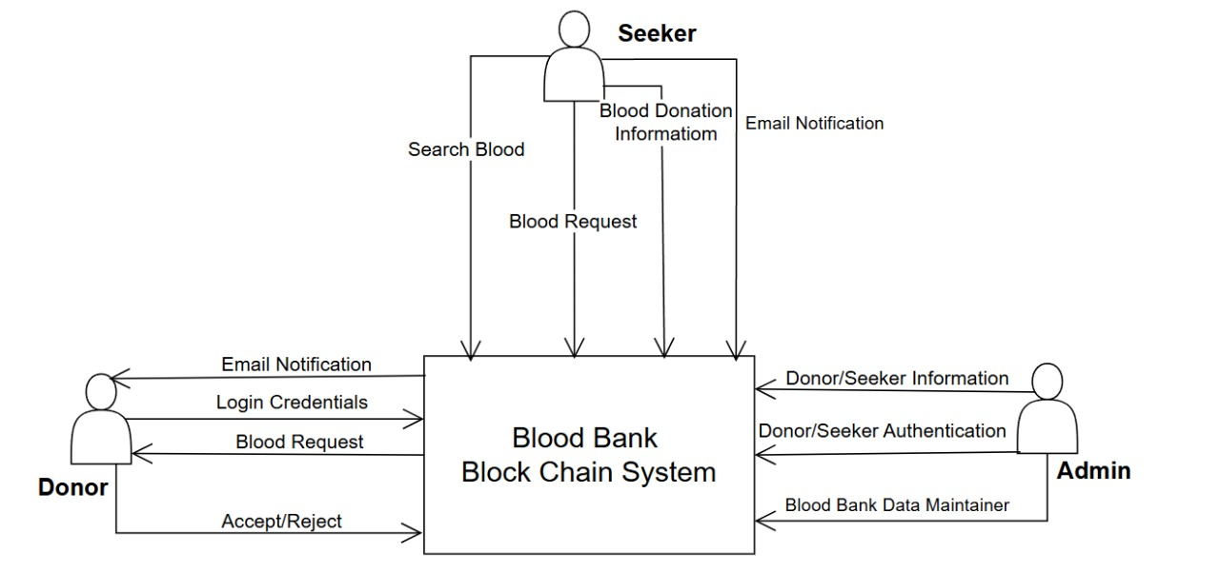

Technology Stack
    - Primary Technologies:
  - Frontend:
    - HTML: HTML provides the structural groundwork by arranging content into sections like donor registration forms, blood request submissions, and donor listings, utilizing elements such as forms, tables, and buttons.
    - CSS: CSS improves the website's aesthetics and usability by adding styles, including colors, fonts, layouts, and responsive design, ensuring it appears polished and performs efficiently across different devices. Combined, they deliver a visually appealing, easy-to-use platform tailored for donors, recipients, and administrators.
  - Backend:
    - Django: Django (a Python-based framework) is utilized to manage backend operations, including user authentication, handling donor and recipient data, and ensuring secure interactions with the MySQL database. It offers a strong foundation for developing a scalable and maintainable platform.
    - Firebase: Firebase complements this by providing real-time notifications, delivering instant alerts to donors and recipients during emergencies or important updates.
- Data Management:
    - MySQL: MySQL serves as the core database management system, facilitating the efficient storage, organization, and retrieval of critical data. It handles key information, including donor profiles, recipient requests, blood types, and donation histories.
- External Integrations:
    - Google Maps API: The Google Maps API is integrated into the website to offer geolocation services, helping users easily locate nearby blood donors or donation centers. This feature allows the platform to display interactive maps, enabling recipients to search for available donors within a particular area based on their current location. By facilitating efficient matching of donors and recipients, especially in emergencies, it enhances response times and improves the user experience, making it simpler to connect with nearby donors.
    - Firebase Notifications: Firebase notifications are used to provide real-time alerts and updates to users. When urgent blood donation requests or updates occur, Firebase sends instant push notifications to both donors and recipients, ensuring they are promptly informed.

Development Process
    - Approach: An Agile development methodology was adopted to ensure iterative progress and continuous feedback. This enabled the team to adapt to changes and deliver a functional, user-oriented product within the project timeframe. (Thapa & Shrestha, 2010) Key stages included:
- Planning: Defined sprint goals, prioritized tasks, and created a backlog.
- Development: Built features incrementally, focusing on functionality and usability.
- Testing: Conducted thorough testing after each sprint to identify and fix bugs.
- Review: Regularly reviewed progress with stakeholders and incorporated feedback.

3.5 System Design
In the system design phase, several architecture diagrams are employed, including the ER diagram, DFD (data flow diagram), and Use Case diagram. The ER diagram represents the logical structure of the database, illustrating entities, attributes, and their relationships. The DFD visualizes the flow of data within the system, highlighting data sources, processes, and destinations. The Use Case diagram captures the functional requirements, showcasing the interactions between actors and the system's functionalities. These architecture diagrams aid in understanding the data structure, flow, and system functionalities, facilitating effective communication and guiding the development process (Jones, 2018)

E-R Diagram
An Entity-Relationship (ER) diagram illustrates the database structure of a system, highlighting entities, their attributes, and the relationships connecting them. For the blood donation website, the ER diagram depicts the key entities (such as Donor, Patient, Blood Bank, Hospital) and how they interact with one another.
Figure 3.6 1E-R Diagram
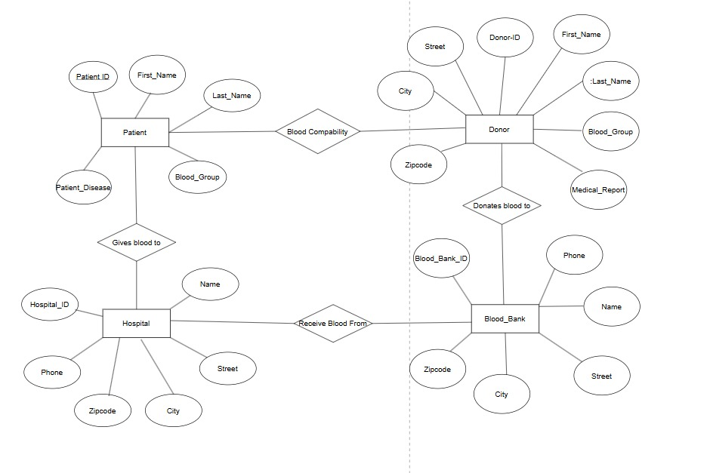

Use Case Diagram
A Use Case diagram for the blood donation website visually represents the interactions between users and the system, showing the functionalities available to users and how they interact with the platform. The use case diagram helps illustrate the primary interactions between the users and the blood donation system, showcasing its core functionalities. By defining roles and actions, it ensures clarity in system requirements and helps guide development.
Figure 3.7 1Use Case Diagram
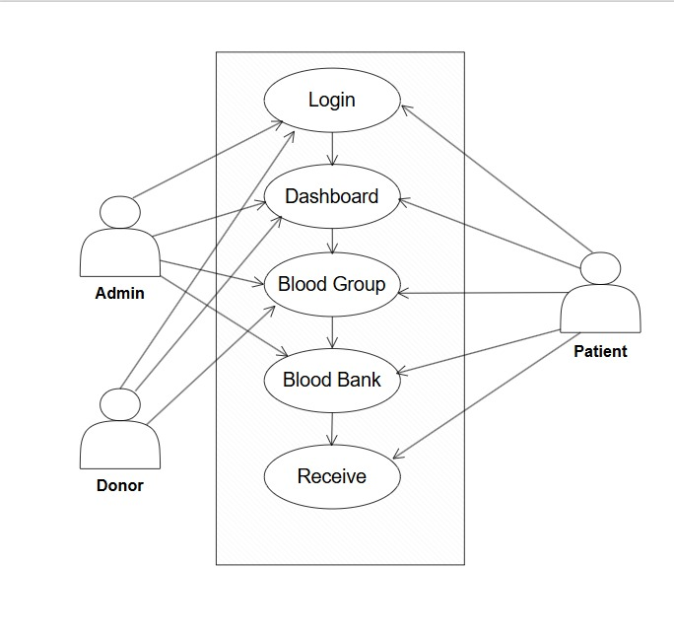

System Flow Diagram
The system flow diagram is one of the graphical representations of the flow of data in a system in software engineering. The diagram consists of several steps that identify where the input is coming to the system and output going out of the system. With the help of the diagram, it is possible to control the event decisions of the system and how data is flowing to the system. Therefore, the system flow diagram is basically a visual representation of data flow, excluding the minor parts and including the major parts of the system in a sequential manner.

3.6 Software and Hardware Requirements
The minimum software required for the development of the project is:
• Operating System: Windows 7/8
• Code Editor: Visual Studio Code
• Framework: Django 3.2
• Programming Language: Python 3.8
• Browser: Chrome/ Edge
The hardware required for the development of the project is:
• Processor: Intel(R) Core (TM) i3-10110U CPU @ 2.10GHz 2.59 GHz
• Ram: 4.00 GB
• Hard Disk: 500 GB SSD
• Display: 1024*768 screen resolution

3.7 Testing and Maintenance
The testing and maintenance phases follow the development phase in a project flow. In testing, the project's functionalities are thoroughly evaluated to detect and correct any defects. During maintenance, the deployed system is supported, monitored, and enhanced on an ongoing basis. In this way, we ensure that the system is stable, reliable, and continually improving, ultimately meeting the needs of users and stakeholders. As part of the testing phase for the Crop Recommendation System a variety of test cases were conducted to ensure that the web application worked correctly. Security, usability, performance, and other aspects of the application are tested in these test cases.
    - Functionality Testing
- Test Case 1: Verify that donor registration and login work as expected.
- Test Case 2: Test the ability to search and filter eligible donors based on blood type and location.
- Test Case 3: Ensure that blood request creation and updates are correctly processed and displayed.
- Test Case 4: Confirm that donor availability status is accurately updated and reflected in real time.
- Test Case 5: Test functionalities for hospitals and administrators to manage requests and donor data.
    - Security Testing
- Test Case 6: Ensure that only authorized users (e.g., hospitals and admins) can access sensitive system features.
- Test Case 7: Verify that unauthorized users cannot alter donor records or blood request information.
- Test Case 8: Confirm that personal data (e.g., donor contact info, medical history) is securely stored and encrypted.
    - Performance Testing
- Test Case 9: Measure the system’s response time for processing donor matches and blood requests during peak usage.
- Test Case 10: Validate the system's performance with a large dataset of donors and ongoing blood requests.
    - Usability Testing
- Test Case 11: Evaluate the user interface for clarity, simplicity, and ease of navigating donor and request features.
- Test Case 12: Test the application’s responsiveness and usability across various screen sizes and devices.
    - Compatibility Testing
- Test Case 13: Test the application across different browsers (e.g., Chrome, Firefox, Edge) for consistent behavior.
- Test Case 14: Verify compatibility with older and newer versions of supported browsers.
- Test Case 15: Ensure the application functions correctly on desktops, tablets, and mobile devices for both donors and medical staff.
    - Regression Testing
- Test Case 16: Re-test previously reported issues (e.g., login errors, request form bugs) after fixes are applied.
- Test Case 17: Confirm that fixes do not negatively impact core functionalities like donor matching or notifications.

3.8 Algorithm
- Step 1: Start the procedure.
- Step 2: Recipient opens and fills the blood request form with details such as name, required blood group, contact, and address.
- Step 3: Donor opens and fills the registration form with their details including name, blood group, location, contact, and availability status.
- Step 4: System validation the submitted form data and stores it into the SQLite3 database under appropriate tables(Donor and Recipient).
- Step 5: Match the recipient’s required blood group with donors in the database who have the same blood group, address and are marked as "Available".
- Step 6: Display the list of matched donors to the recipient.
- Step 7: Sends automated email notifications to both the recipient and each matched donor.
- Step 8: Allow recipient to initiate contact or confirm donation request through the platform interface.
- Step 9: End the procedure.

Sample example:
- Registration of Donor
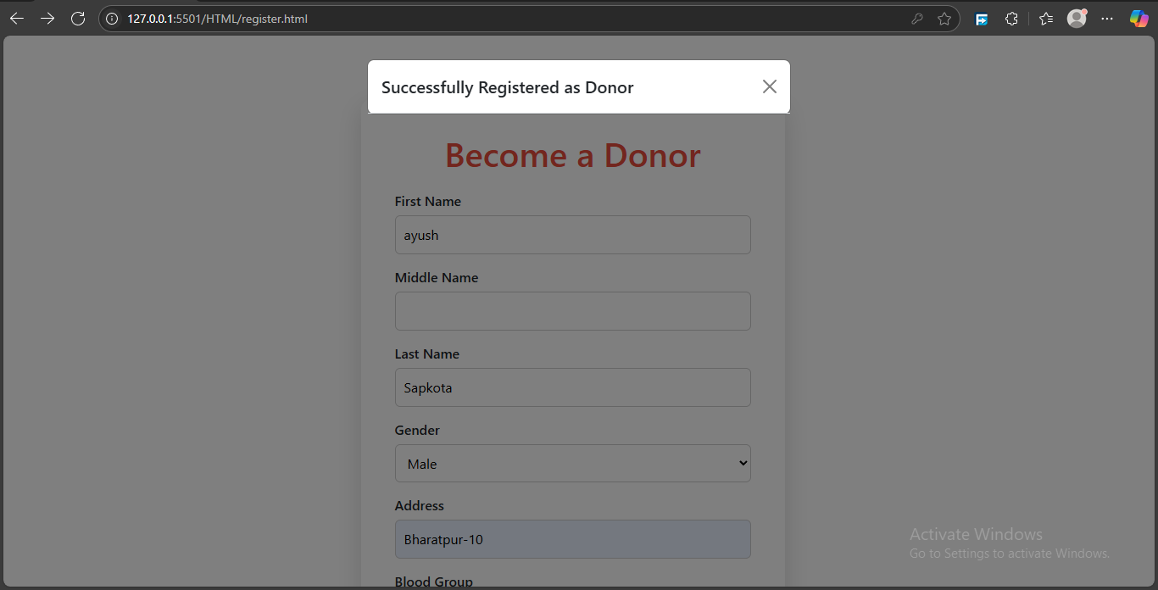

- Recipient Request Submission

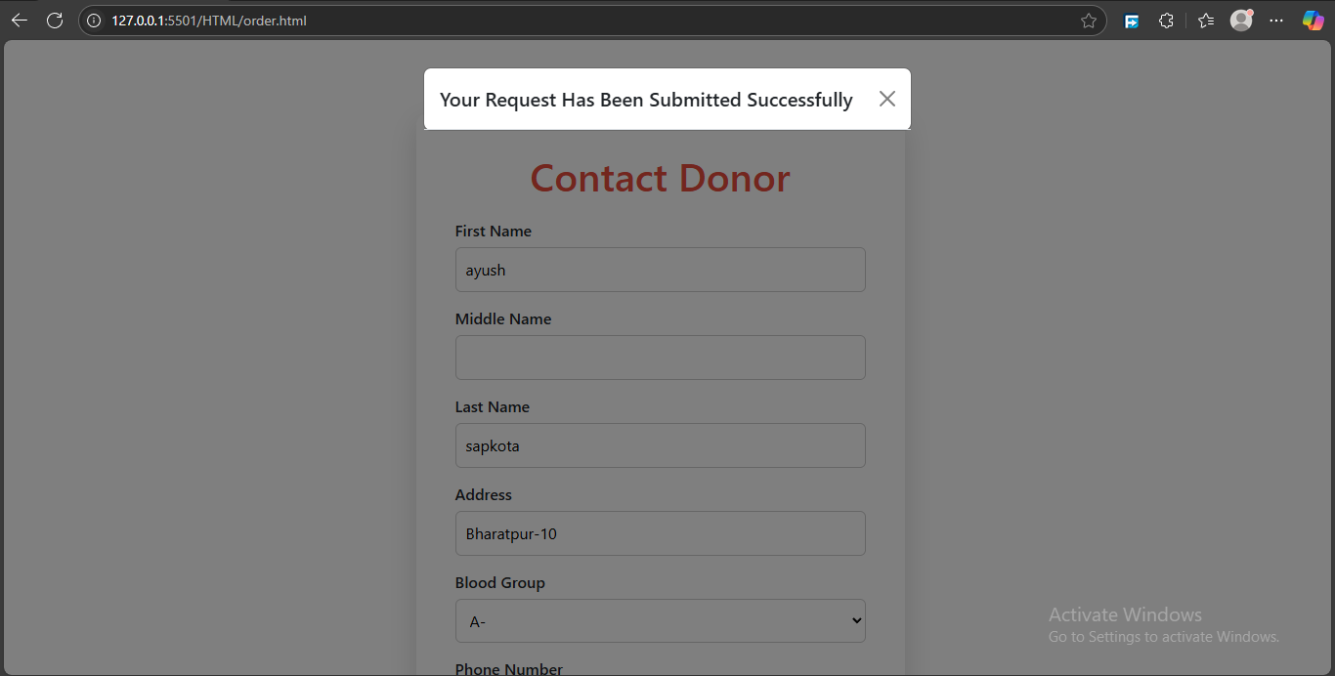

- Service Page
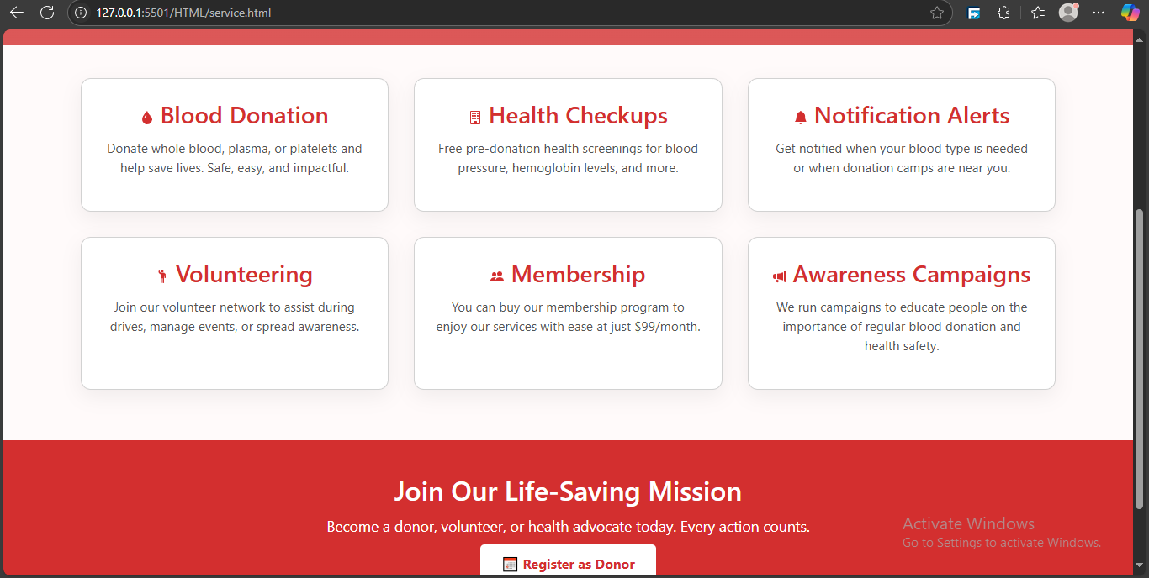

Task Remaining
    - Authentication and Authorization: We will implement a secure login and registration system so that users (donors, receivers, and admins) can create accounts and log in. We will also restrict access to different sections of the website based on roles. For example, only admins should be able to manage all users or see the overall statistics, while donors and receivers should only access their own data. Passwords must be securely stored using hashing techniques.
    - Blood Match and Search Functionality: We will develop a feature that can automatically or manually match donors with receivers based on important criteria like blood type, location, and availability. This will help ensure quick and effective responses to blood requests. We will also implement filter options, allowing users to search by name, blood type, city, or availability.

    - Email/SMS Notifications: We will integrate a notification system using services like SMTP for emails. This system can notify users when they are matched, when a donation request is received, or when it’s time for a repeat donation. Notifications improve engagement and ensure timely communication between donors and receivers.

    - Data Validation and Error Handling: We will add input validation to all forms to make sure users enter correct and complete information. For example, Names shouldn’t contain numbers, and emails must be in the proper format. On the backend, validate and sanitize input data to prevent security issues like SQL injection. We will implement proper error messages and user-friendly alerts to guide users when something goes wrong.

    - Deployment: To make the blood donation website live and accessible to users, it will be deployed on a reliable hosting platform. Suitable options include Heroku for its simplicity and support for full-stack apps, or a combination like Netlify for the frontend and Render or Firebase for the backend. During deployment, it's important to configure the production database, secure the website with HTTPS, set environment variables, and thoroughly test the application to ensure reliable performance.

CHAPTER 4: EXPECTED OUTCOME
The website aims to provide a responsive and user-friendly platform that improves accessibility and facilitates seamless interactions for all users, including administrators, donors, and recipients. By utilizing MySQL for secure data storage and management, the system will protect user information and ensure consistent performance. Real-time notifications, enabled through Firebase, will keep users informed of important updates and activities, while the integration of Google Maps API will deliver effective location-based services for managing resources and connections. Hosted on AWS, the platform will offer high scalability and reliability to meet the demands of an expanding user base. Built with Django, its modular structure will allow for easy maintenance and the addition of future features. Overall, the website is designed to optimize processes, boost efficiency, and provide a secure, scalable, and user-focused experience.

CHAPTER 5: DISCUSSION AND RESULT
This project demonstrates a well-rounded approach to developing a user-focused website designed for efficient blood donation management. By utilizing modern technologies such as Django, Firebase, and Google Maps API, the platform ensures smooth user interactions, secure data management, and real-time updates.
Following an Agile development process allowed for continuous incorporation of user feedback, ensuring the solution meets both functional and non-functional needs. The platform prioritizes accessibility, reliability, and scalability, effectively addressing limitations found in traditional systems. It provides an efficient and user-friendly solution for donors, recipients, and administrators.
In conclusion, this project successfully combines technological innovation with social impact, delivering a platform that not only meets technical requirements but also plays a crucial role in improving blood donation processes, saving lives, and strengthening community connections.

References
Ali, K. A., Jahan, I., Ariful, M. I., & Shafa-at, M. P. (2015). Blood Donation Management System. American Journal of Engineering Research.
American Red Cross. (2017). Retrieved from redcross: https://www.redcross.org/
Anish Hamlin, M. R., & Mayan, J. A. (2016). Blod Donation and Life Saver-Blood Donation app. International Conference on Control, Instrumentation, Communication and Computational Technologies.
Chen, L., & Wang, Y. (2019). BloodLink Mobile App: Geolocation-based Blood Donation for Emergency Requests. nternational Journal of Mobile Computing and Communications.
Hamid, K., Aziz, A., & Yusri, N. N. (2015). Development of Blood Bank Management System. World Conference on Technology, Innovation and Entrepreneurship.
Jones, R. (2018). BloodBanker: A Web-Based Platform for Blood Donor Matching. Journal of Health Informatics.
Smith, D. (2015). Retrieved from Blood Donor Connect: https://thebloodconnection.org/
Thapa, R., & Shrestha, S. (2010). SMS-Based Blood Donation System. International Journal of Computer Science and Technology.

Appendices A: Gantt chart
Before getting started with any work, proper preparation of working schedule containing of all the task that should be done for completion of project is necessary. For this purpose, we have included Gantt chart with time estimation in a total span of 2-3 months is included below.
Table A. 1Gantt chart of the project
