Affiliated to Pokhara University
UNITED TECHNICAL COLLEGE

A Minor Project Report On
BLOOD DONATION SYSTEM
[Subject Code No:209]
Submitted in partial fulfillment of the Requirements for Bachelor of Engineering in Computer Engineering under United Technical College

Submitted by
Aashish Regmi (22070088)
Ayush Shrestha (22070092)
Dixit Shrestha (22070098)
Sonish Lohani (21075549)

Submitted to
Department of Computer Engineering

DEDICATION

This project is dedicated with profound gratitude to our exceptional teachers, whose unwavering guidance and mentorship have been instrumental in our successful completion of this endeavor. Through this journey, their wisdom and encouragement have served as a guiding light, inspiring us to strive for excellence.
We also extend our heartfelt appreciation to our parents, whose unwavering financial and moral support have sustained us throughout the development of this project. Their belief in our abilities, their sacrifices, and the valuable life lessons they've imparted have shown us that even the most daunting tasks can be conquered, one step at a time.
The unwavering faith of our dedicated educators and loving parents has been the foundation of our success, and for that we are ever grateful.

DECLARATION

We hereby declare that this study entitled “Blood Donation System” is based on our original work. Related works on the topic by other researchers have been duly acknowledged. We owe all the liabilities relating to the accuracy and authenticity of the data and any other information included here under.

Name of the Students:
Aashish Regmi
Ayush Shrestha
Dixit Shrestha
Sonish Lohani

Date: July 03, 2025

RECOMMENDATION

This is to certify that this project work entitled “Blood Donation System” prepared and submitted by Aashish Regmi, Ayush Shrestha, Dixit Shrestha, Sonish Lohani in partial fulfillment of the requirements of the degree of Bachelor of Engineering in Computer awarded by Pokhara University has been completed, under the supervision of Er. Santosh Shrestha.

Signature: _________________________

Name of the supervisor: Er. Santosh Shrestha
Organization: United Technical College
Date: July 02, 2025

DEPARTMENTAL ACCEPTANCE

The project entitled “Blood Donation System” submitted by “Aashish Regmi, Ayush Shrestha, Dixit Shrestha, Sonish Lohani” for the award of the degree in Bachelor of Computer Engineering has been accepted as benefice record of work independently carried out by them in department.

Signature: ___________________________

Er. Sahit Baral

Head of Department of Computer and Electrical & Electronics.

CERTIFICATE OF APPROVAL
This project entitled “Blood Donation System” prepared and submitted by Aashish Regmi, Ayush Shrestha, Dixit Shrestha, Sonish Lohani has been examined by us and is accepted for the award of the degree of Bachelor in Computer Engineering by Pokhara University.

Name of External: | Signature: | Date:
Designation:
Organization:
Name of Supervisor: Er. Santosh Shrestha | Signature: | Date:
Designation: Lecturer
Organization: United Technical College
Name of Principal:  Prof., Ph.D. | Signature: | Date:
Organization: United Technical College

ACKNOWLEDGEMENT

It is our pleasure to be indebted to various people, who directly or indirectly contributed in the development of this project and who influenced our thinking, behavior and acts during the time of project.
We would like to express our profound gratitude to United Technical College for providing a suitable environment and its contributions to the completion of our project titled “Blood Donation System”.
We express our sincere gratitude to Prof.-----------------, principal of our college, United Technical College, for the support, cooperation and motivation provided during the project.
We would like to express our special thanks to our supervisor Er. Santosh Shrestha for his time and efforts he provided throughout the project. Your useful advice and suggestions were really helpful to us during the project’s completion. In this aspect, we are eternally grateful to you.
We would like to acknowledge that this project was completed entirely by our group and not by someone else.

Thanks for all your encouragement!

Name of the Students:
Aashish Regmi
Ayush Shrestha
Dixit Shrestha
Sonish Lohani

Date: July 03, 2025

ABSTRACT
This project aims to create a comprehensive blood donation website to simplify the process of connecting blood donors with recipients and enhance the overall efficiency of the blood donation system. The platform will serve as a centralized hub, enabling seamless interaction between donors, recipients, and organizations while addressing key challenges such as delays in donor-recipient matching, lack of real-time updates, and insufficient donor engagement. The primary goal of the project is to improve access to critical blood supplies, encourage regular donations, and provide a user-friendly solution to overcome current inefficiencies. This initiative is vital as it addresses pressing healthcare needs and promotes a culture of altruism and community involvement. Modern web technologies will be used to develop the website, incorporating features like geolocation-based donor searches, real-time notifications, and secure data management. The implementation will leverage tools such as HTML, CSS, JavaScript, and a backend framework like Node.js or Django, complemented by database systems for efficient data handling. Additionally, APIs for maps and notifications will enhance the platform's functionality, ensuring an intuitive and seamless user experience. The anticipated outcomes include a fully operational, accessible, and secure blood donation website that supports efficient donor-recipient matching, facilitates the organization of donation drives, and engages users with educational resources and timely updates. Ultimately, this project aspires to save lives by improving the accessibility and impact of blood donation while addressing the shortcomings of existing systems.
Keywords: Blood donation website, donor-recipient matching, donor engagement, secure data management, user-friendly, efficient data handling, etc.

Table of Contents
DEDICATION ii
DECLARATION iii
RECOMMENDATION iv
DEPARTMENTAL ACCEPTANCE v
CERTIFICATE OF APPROVAL vi
ACKNOWLEDGEMENT vii
ABSTRACT viii
List of Figures xiii
List of Tables xiv
Acronyms and Abbreviation xv
CHAPTER 1: INTRODUCTION 1
1.1 Background 1
1.2 Problem Statement 2
1.3 Objectives 2
1.4 Motivation and Significance 3
1.5 Scope of the Work 4
1.6 Feasibility Study 4
CHAPTER 2: LITERATURE REVIEW 7
2.1 Overview of Existing Systems 7
2.2 Comparison of Features 8
2.3 Gaps in Existing Systems 9
2.4 Significance of Proposed Work 11
CHAPTER 3: METHODOLOGY 13
3.1 Overview of the Approach 13
3.2 System or Model Design 17
3.3 Technology Stack 17
3.4 Software Development Model 19
3.5 System Design 21
3.5.1 E-R Diagram 23
3.5.2 Use Case Diagram 24
3.5.3 System Flow Diagram 25
3.6 Software and Hardware Requirements 26
3.7 Testing and Maintenance 26
CHAPTER 4: DISCUSSION AND RESULT 28
4.2 Output 28
4.3 Web Development 29
4.3.1 Frontend 29
4.3.2 Backend 32
The backend of the Blood Donation System handles user authentication, form submissions, data storage, and matching logic. It stores and manages donor and recipient data securely in a database, encrypts sensitive information like contact details, and processes blood requests by matching them with suitable donors based on blood group and location. It also ensures real-time updates and smooth communication between the frontend and server. The backend is designed to be secure, scalable, and efficient. 32
4.4 Database 32
The database in the Blood Donation System is designed to store and manage all essential data efficiently and securely. It contains separate tables for users, donors, and blood requests. The donor table stores fields like first name, middle name, last name, gender, blood group, email, password, contact number, address, and donor card. The recipient table includes similar fields such as name, gender, blood group, contact number, address, blood report, and email. A request-matching mechanism is implemented to fetch and display only those donors whose blood group and location match the recipient's request. Sensitive information is encrypted, and the database is optimized for fast access, accuracy, and real-time updates. Relationships between tables ensure data integrity and smooth backend operations. 32
CHAPTER 5 : CONCLUSION AND FUTURE ENHANCEMENT 33
5.1 Conclusion 33
The Blood Donation System successfully streamlines the process of connecting blood donors with recipients in need. By integrating user-friendly frontend features with a secure and efficient backend, the system ensures quick registration, accurate donor matching, and real-time response. It helps save lives by reducing delays in finding suitable blood donors, especially in emergency situations. Overall, the system provides a reliable, accessible, and scalable solution to support blood donation efforts and improve healthcare response. 33
5.2 Future Enhancement 33
REFERENCES 35
APPENDICES 36

List of Figures
Figure 3.2.1 Block Diagram of Digital Blood Bank System 15

Figure 3.6.1 E-R Diagram 21

Figure 3.7.1 Use Case Diagram 22

List of Tables
Table 2. 2 Comparison of Features 6

Table A. Gantt chart of the project 26

Acronyms and Abbreviation
AI: Artificial Intelligence
API: Application Programming Interface
AWS: Amazon Web Services
CSS: Cascading Style Sheets
E-R: Entity-Relationship
HTML: Hyper-Text Markup Language
HTTPS: Hyper-Text Transfer Protocol Secure
IoT: Internet of Things
NGO: Non-Governmental Organization
SMS: Short Message Service
SQL: Structured Query Language
VS code: Visual Studio Code

CHAPTER 1: INTRODUCTION

1.1 Background
Blood donation has always been a vital aspect of healthcare, providing critical support for patients requiring transfusions during surgeries, accidents, or treatments. With the integration of technology into healthcare, new opportunities have emerged to enhance the blood donation process. Tools such as digital platforms, mobile apps, and geolocation systems have helped connect donors, recipients, and blood banks, streamlining donor matching and facilitating donation drives. (Chen & Wang, 2019)
Recent advancements include using Artificial Intelligence (AI) to forecast blood demand, implementing blockchain technology to ensure safe and traceable blood supplies, and leveraging mobile apps to deliver real-time updates on donation events and urgent blood needs. Additionally, geolocation services have made it easier for donors to find nearby centers, while SMS and email notifications have improved donor engagement and participation. (Ali, Jahan, Ariful, & Shafa-at, 2015)
However, challenges persist in the current systems. Many platforms lack intuitive, user-friendly interfaces, making it difficult for users to navigate or find information effectively. Data security and privacy concerns remain unaddressed on some platforms, discouraging potential donors from signing up. Furthermore, the fragmentation of these systems often results in redundant efforts and inefficiencies, as no single platform offers a comprehensive solution for donors, recipients, and organizations. (Chen & Wang, 2019)
Developing an improved blood donation website can address these shortcomings. A thoughtfully designed platform can centralize critical information, improve usability, and encourage collaboration among stakeholders. It can also raise awareness about the importance of regular blood donation, ensure the availability of essential blood supplies, and strengthen the overall resilience of the healthcare system. (Jones, 2018)

1.2 Problem Statement
Blood donation is essential for saving lives, yet current systems for connecting donors and recipients face significant obstacles. These challenges contribute to inefficiencies in the blood supply chain, delays in responding to emergencies, and missed opportunities to engage willing donors. The absence of a centralized, user-friendly platform further complicates the process, creating difficulties for donors, recipients, and organizations.
These limitations result in delays, shortages, and lost opportunities to tap into the goodwill of potential donors. A well-designed blood donation website can address these issues by offering a centralized platform with real-time data, secure communication, and user-friendly features. By bridging the gap between donors, recipients, and organizations, this solution can improve access to blood supplies, enhance operational efficiency, and promote a culture of consistent blood donation.

1.3 Objectives
The objectives of this project are as follows:
- To develop a centralized platform that facilitates efficient matching of blood donors with recipients based on factors such as blood type, location, and urgency.
- To raise awareness about the significance of blood donation and motivate regular donor participation through educational resources and engagement features.
- To empower organizations to organize, manage, and promote blood donation drives effectively, while enabling users to easily register and participate.
- To deliver a secure and user-friendly platform that is accessible across various devices, ensuring data privacy and inclusivity for diverse user groups.

1.4 Motivation and Significance
The motivation for developing a blood donation website arises from the vital role blood donation plays in saving lives and the ongoing challenges of ensuring a consistent and timely blood supply. Despite advancements in technology, existing systems often fail to effectively connect donors and recipients, especially in emergencies. Challenges such as fragmented platforms, the absence of real-time updates, low donor engagement, and inadequate data security underscore the need for a more innovative solution. This project was selected as it combines technological advancements with a critical social need, providing an opportunity to address these issues and significantly improve healthcare outcomes.
The proposed website aims to overcome the limitations of current systems by integrating advanced features that streamline donor-recipient connections and enhance the overall user experience. Unlike existing platforms that operate independently or with limited functionality, this website offers a centralized solution, including real-time donor matching, geolocation-based searches, and secure data management. Additionally, features such as educational resources and notifications are designed to boost donor engagement and raise awareness, encouraging consistent participation. The platform places a strong emphasis on data privacy and security, ensuring users' sensitive information is protected—an issue that is often overlooked in other systems.
This project stands out due to its comprehensive approach and user-focused design. While many existing platforms focus on isolated aspects, such as organizing donation drives or registering donors, this website integrates all critical functions into a unified system. Features like real-time updates, an intuitive interface, and accessibility across devices and languages make the platform more inclusive and user-friendly. Moreover, the emphasis on community-building initiatives, such as recognition programs and social sharing, helps foster a culture of altruism and regular blood donation. By addressing the shortcomings of current systems and incorporating innovative features, this project seeks to revolutionize the blood donation process, making it more efficient, accessible, and impactful.

Scope of the Work
This project is designed as a centralized and user-friendly platform to connect blood donors, recipients, and healthcare organizations. Its main objective is to simplify the blood donation process, enhance accessibility, and resolve inefficiencies in the existing system. The platform aims to deliver a holistic solution to ensure a reliable and timely supply of blood for both medical emergencies and regular requirements.

Feasibility Study
Feasibility analysis is a process of evaluating the practicality and likelihood of success of a proposed project or venture. It involves assessing the economic, technical, and operational feasibility of the project.
    - Technical Feasibility: The blood donation project used a robust and scalable technology stack including Django, HTML, CSS, Firebase, and MySQL. Django provided a secure and efficient backend, while Firebase enabled real-time data syncing and notifications. Integration of Google Maps API allowed users to easily locate nearby donation centers or hospitals. These tools were selected for their reliability, scalability, and strong community support, making the system both future-proof and easy to maintain. Overall, the chosen technologies effectively supported the system’s core functionality.
    - Economic Feasibility: The project was designed with cost-effectiveness in mind by utilizing free-tier services available for Django and Firebase during the development phase. Hosting on AWS provided an affordable yet scalable solution that could grow with increased user demand. Open-source technologies like HTML, CSS, and Django minimized licensing costs. These choices ensured that the platform could be developed and operated within a limited budget. As a result, the project is economically viable for non-profit or government health initiatives.
    - Operational Feasibility: Operationally, the system was built to be intuitive, secure, and responsive for all user types—donors, recipients, and hospital staff. Features such as real-time donor availability, notifications, and an easy registration process helped streamline the blood donation workflow. Its mobile-friendly design ensured accessibility across devices, encouraging wider community participation. Security measures were implemented to protect user data and maintain trust. This makes the system practical and reliable for real-world use
    - Schedule Feasibility: The project followed a well-defined timeline structured around Agile development principles. Tasks were divided into sprints, each focusing on a core component such as user management, donation tracking, or map integration. Regular reviews and iterative updates ensured that the team could address any challenges without major delays. This flexible approach kept the project on track while allowing room for adjustments based on feedback. Ultimately, the schedule was realistic and supported timely completion of the system.
Conclusion of Feasibility Study
To sum up, the feasibility analysis shows that the blood donation system is both achievable and sustainable for real-world use. The chosen technology stack ensures secure, scalable, and efficient performance, supporting key features like real-time updates and user interaction. Cost-efficient resources help keep the project within budget, while the user-friendly and responsive design makes it accessible to a broad audience. A well-structured timeline, guided by Agile practices, allowed the team to stay organized and flexible throughout development. Overall, the project proves to be feasible in terms of technology, cost, operations, and scheduling.

CHAPTER 2: LITERATURE REVIEW

2.1 Overview of Existing Systems
Numerous blood donation websites and platforms have been developed to facilitate connections between donors and recipients. These systems aim to provide easy access to information, improve donor-recipient matching, and promote awareness about blood donation.
    - Blood Donor Connect: Blood Donor Connect is a platform designed to help users locate potential blood donors based on criteria like location and blood type. Its straightforward interface makes it easy to navigate, providing basic functionalities for searching and connecting users, which meet the primary requirements of a blood donation system (Smith, 2015).
    - Red Cross Blood Donation App: This app, developed by the American Red Cross, enables users to schedule blood donation appointments, monitor their donation history, and set reminders for future donations. It provides an organized approach to managing blood donations and is both functional and user-friendly. (American Red Cross, 2017)
    - BloodBanker: BloodBanker is a web-based platform offering an online directory of blood donors. It allows users to search for donors based on location and blood type, with a simple interface for making connections. (Jones, 2018)
    - BloodLink Mobile App: BloodLink is a mobile application designed for emergency blood donation requests, utilizing geolocation technology to match donors and recipients in nearby areas. Its focus on emergencies makes it particularly valuable in critical situations. (Chen & Wang, 2019)
    - SMS-Based Blood Donation System: This system connects donors and recipients via SMS alerts, offering a simple way to communicate blood donation needs. It is particularly useful for users without access to smartphones or internet-based applications. (Thapa & Shrestha, 2010)

Comparison of Features
Table 2. 2 Comparison of Features
Authors | Description | Features | Drawbacks
(Smith, 2015) | A platform for locating blood donors based on location and blood type. | Simple interface, basic search functionality. | No real-time communication or emergency handling capabilities.
(American Red Cross, 2017) | A U.S.-based app for managing blood donation schedules and tracking donation history. | Appointment scheduling, reminders, donation history tracking. | Restricted geographic coverage; lacks real-time donor-recipient matching.
(Jones, 2018) | A web-based directory for blood donors with search capabilities by location and blood type. | Directory-based search, basic functionality. | Outdated interface; not mobile-responsive; lacks real-time notifications for emergencies.
(Chen & Wang, 2019) | A mobile app designed for emergency blood donation requests using geolocation technology. | Geolocation-based matching, emergency handling capabilities. | Limited scalability; no support for large databases or advanced analytics.
(Thapa & Shrestha, 2010) | A basic SMS-based system for connecting donors and recipients through alerts. | Simple SMS alerts; accessible for non-smartphone users. | No mobile app; lacks real-time updates, secure database integration, and modern features.

2.3 Gaps in Existing Systems
The existing systems reviewed provide a range of functionalities for blood donation management. However, each system has significant gaps that limit their overall effectiveness, scalability, and user accessibility. Below are the identified gaps in the systems:
    - Lack of Real-Time Communication and Notifications:
- Most platforms, (such as (Smith, 2015) and (Jones, 2018)), do not offer real-time communication or notification features, which are essential for immediate coordination during emergencies.
- SMS-Based Blood Donation System relies solely on SMS alerts, which are not updated in real time and can cause delays in response.
    - Limited Scalability
- Systems like (Chen & Wang, 2019) face scalability challenges, limiting their ability to handle an increasing number of users or expand to a wider geographic area.
- The lack of robust infrastructure in several systems restricts their capacity to support growing databases or advanced functionalities like analytics.

    - Geographic Restrictions
- The (American Red Cross, 2017) is restricted to the U.S., making it inaccessible to users in other countries, limiting its global utility.
- Other platforms lack global reach due to their focus on local or regional markets without provisions for broader geographic expansion.
    - Outdated or Inadequate Interfaces
- Systems such as (Jones, 2018) use outdated interfaces and are not mobile-responsive, making them inconvenient for modern users who rely heavily on smartphones and tablets.
- Poor user experience can deter adoption and usage, especially among tech-savvy younger donors.
    - Absence of Advanced Features
- Most systems, including (Smith, 2015), lack advanced geolocation technologies that enable dynamic and efficient donor-recipient matching.
- Systems like (Chen & Wang, 2019) and (Thapa & Shrestha, 2010) do not integrate features like analytics for demand prediction or optimization.
    - Inadequate Support for Emergency Handling
- While the (Chen & Wang, 2019) focuses on emergencies, most other platforms lack dedicated tools to prioritize and manage urgent requests effectively.
- Emergency handling requires features such as real-time updates, secure communication channels, and precise geolocation, which are missing in several systems.
    - Limited Database Integration and Security
- Systems like (Thapa & Shrestha, 2010) do not utilize secure databases, making them unreliable for handling sensitive user information.
- Lack of integration with large databases reduces the ability to centralize and streamline operations, impacting efficiency.
    - Lack of Comprehensive Solutions
- Most existing platforms focus on specific aspects of blood donation management (e.g., donor search, appointment scheduling, emergency requests) without offering a comprehensive solution that combines all necessary functionalities into one platform.

2.4 Significance of Proposed Work
The proposed blood donation website seeks to overcome these challenges by incorporating several key features:
    - Instant Communication and Emergency Response: A significant challenge in current systems is the absence of real-time communication and handling of emergencies. The proposed system aims to incorporate real-time notifications for both donors and recipients, ensuring swift responses to urgent requests. Emergency alerts and real-time coordination will allow users to react quickly to blood donation needs, potentially saving lives during critical situations.
    - Enhanced Donor-Recipient Matching: The project will utilize advanced geolocation technology to enhance the accuracy and speed of donor-recipient matching, especially in emergency cases. By factoring in location, blood type, and urgency, the system will facilitate faster and more precise matches, ensuring that donors are connected with recipients in need without unnecessary delays.
    - Global Reach and Scalability: In contrast to existing systems that are regionally limited, this project is designed with scalability in mind. With the use of cloud infrastructure (AWS) and a flexible architecture, the platform will support growth and expansion, making it accessible to users worldwide, regardless of geographic constraints.
    - Improved User Experience: The proposed system will offer a modern, mobile-responsive interface that ensures seamless access across various devices. Its intuitive design and easy navigation will encourage higher donor engagement, simplifying processes like scheduling appointments, finding blood donors, and tracking donations.
    - Data Security and Privacy: Given the growing concerns about data security, the proposed platform will implement secure database management systems. By using MySQL and encryption protocols, the platform will safeguard sensitive user information, ensuring privacy for both donors and recipients.
    - Incorporation of Cutting-Edge Technology: The system will integrate advanced technologies, including Firebase for real-time notifications and analytics, Google Maps API for geolocation services, and Django for robust backend support. These features will facilitate real-time updates, secure data management, and an enhanced user experience, making the platform more efficient compared to older systems.
    - All-Inclusive Solution: Unlike existing systems that focus on individual aspects of blood donation, this project will provide an all-encompassing solution. It will integrate donor search, appointment scheduling, emergency response, and donation history management into a single platform. This unified approach ensures that all users—donors, recipients, and administrators—benefit from a seamless, user-friendly system.

CHAPTER 3: METHODOLOGY
This section describes the methodology applied in designing and implementing the blood donation website. The approach emphasizes systematic planning, leveraging modern tools, and focusing on user-centered design. The website is created to improve accessibility, facilitate real-time donor-recipient interactions, and ensure ease of use.

3.1 Overview of the Approach
The project implemented a client-server architecture to facilitate seamless communication between the frontend, backend, and database. The system was tailored to deliver a responsive interface, secure data handling, and real-time interaction capabilities. (Ali, Jahan, Ariful, & Shafa-at, 2015)
Key technologies included HTML, CSS, and Django for building core functionalities, with Firebase enabling real-time notifications. MySQL served as the database for structured data storage, while integrations like Google Maps API enhanced the platform’s functionality. An iterative Agile methodology was followed to incorporate regular feedback and make iterative improvements throughout the development cycle.
    - Requirements Gathering
- Objective:
The primary objective of this phase was to identify and document the essential functional and non-functional requirements to align the system with the needs of users and the project objectives.
- Techniques Used:
  - Literature Review: Researched existing platforms to identify gaps and opportunities for improvement.
  - Stakeholder Consultations: Conducted interviews and discussions with key users, such as administrators and donors, to understand their needs and expectations.
  - Data Analysis: Analyzed survey responses to prioritize user requirements.
- Data Collection:
  - Data Sources: To ensure the Digital Blood Bank System operates effectively, data must be collected from various sources. Each source contributes unique and critical information essential for the system's functionality. (Ali, Jahan, Ariful, & Shafa-at, 2015)
- Inventory Data: This includes details of available blood units, specifying their types (A, B, AB, O), Rh factors (positive or negative), and expiry dates. Tracking these parameters ensures proper management and utilization of blood resources.
- Donation Records: Past donation data, such as donor IDs, dates of donation, and volumes collected, helps in maintaining a historical record and forecasting future supply.
- Recipient Records: Blood banks also store recipient information, including medical requirements, urgency levels, and the affiliated hospitals or clinics. This data is crucial for matching donors with recipients efficiently.
- Donors: Donors contribute valuable personal and medical information, vital for system functionality.
- Registration Details: Information such as name, contact details, address, blood group, and medical history is collected during donor registration to assess eligibility.
- Donation History: Data on the frequency and volume of donations helps the system track active donors and identify regular contributors.
- Availability Status: Donors provide information on their readiness and willingness to donate, especially during emergencies, enabling the system to create a pool of on-call donors.
- Recipients: Recipients are individuals in need of blood transfusions, and their accurate information is essential for timely and efficient donor matching.
  - Registration Details: Information such as name, contact details, address, blood group, and medical condition is collected during recipient registration to ensure compatibility and prioritize urgent cases.
  - Request History: The system tracks previous blood requests, including dates, blood types, and fulfillment status, to monitor recurring needs and manage demand patterns.
- Urgency and Location: Recipients provide information about the urgency of their need and their geographic location, enabling the system to quickly locate suitable donors nearby and prioritize critical cases.
  - Data Preprocessing: Once data is collected, preprocessing is essential to ensure its quality, consistency, and security.
- Validation: Validation involves verifying the accuracy of collected data. Donor information, such as medical history and blood type, is cross-checked with existing records to minimize errors and ensure reliability.
- De-duplication: Duplicate entries, such as multiple registrations of the same donor or repeated inventory records, are identified and removed to maintain a clean database.
- Normalization: Normalization standardizes the data format across all entries:
- Dates are formatted uniformly (e.g., YYYY-MM-DD).
- Blood group types are represented consistently (e.g., A+ or A-).
- Volume measurements and other numerical data are standardized for easier processing and analysis.
- Encryption: Sensitive personal and medical data is encrypted to protect it from unauthorized access. Role-based access control ensures only authorized users can access specific types of data, enhancing privacy and security.
- Integration: Validated and processed data is integrated into the central system, ensuring compatibility with its structure. This step ensures the system operates seamlessly and provides accurate information to users.

System or Model Design
    - Overall Framework: The system followed a client-server model, where the frontend handled user interactions, while the backend managed core logic, API operations, and database processes. (Smith, 2015)
Figure 3.2.1 Block Diagram of Digital Blood Bank System
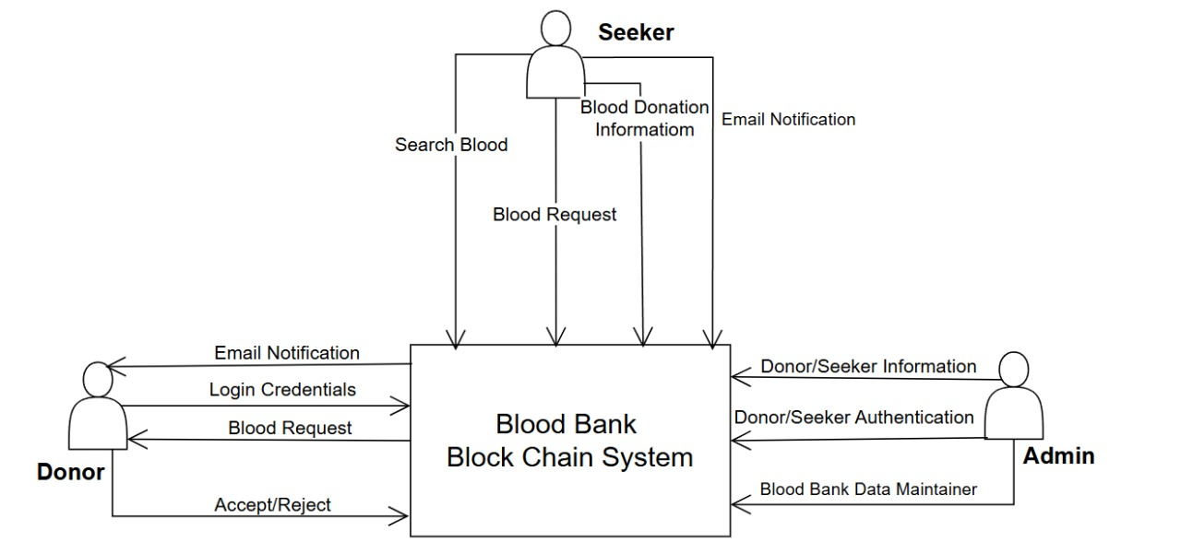

Technology Stack
    - Primary Technologies:
  - Frontend:
    - HTML: HTML provides the structural groundwork by arranging content into sections like donor registration forms, blood request submissions, and donor listings, utilizing elements such as forms, tables, and buttons.
    - CSS: CSS improves the website's aesthetics and usability by adding styles, including colors, fonts, layouts, and responsive design, ensuring it appears polished and performs efficiently across different devices. Combined, they deliver a visually appealing, easy-to-use platform tailored for donors, recipients, and administrators.
  - Backend:
    - Django: Django (a Python-based framework) is utilized to manage backend operations, including user authentication, handling donor and recipient data, and ensuring secure interactions with the MySQL database. It offers a strong foundation for developing a scalable and maintainable platform.
    - Firebase: Firebase complements this by providing real-time notifications, delivering instant alerts to donors and recipients during emergencies or important updates.
- Data Management:
    - MySQL: MySQL serves as the core database management system, facilitating the efficient storage, organization, and retrieval of critical data. It handles key information, including donor profiles, recipient requests, blood types, and donation histories.
- External Integrations:
    - Google Maps API: The Google Maps API is integrated into the website to offer geolocation services, helping users easily locate nearby blood donors or donation centers. This feature allows the platform to display interactive maps, enabling recipients to search for available donors within a particular area based on their current location. By facilitating efficient matching of donors and recipients, especially in emergencies, it enhances response times and improves the user experience, making it simpler to connect with nearby donors.
    - Firebase Notifications: Firebase notifications are used to provide real-time alerts and updates to users. When urgent blood donation requests or updates occur, Firebase sends instant push notifications to both donors and recipients, ensuring they are promptly informed.

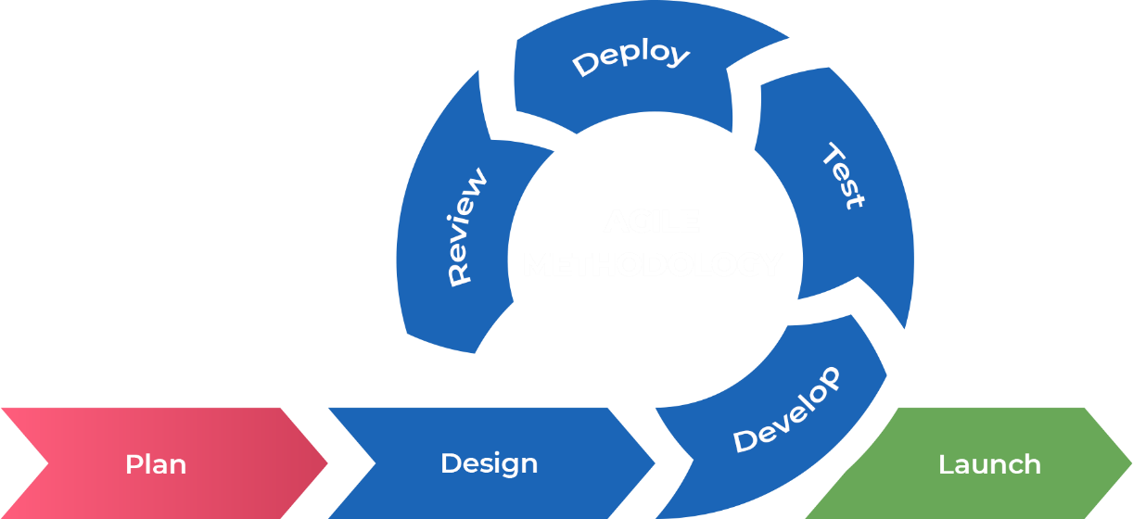
3.4 Software Development Model

Figure 3.4: Agile Development Model

The Agile methodology was adopted for the development of the Blood Donation System to promote flexibility, iterative progress, and close collaboration with stakeholders. Agile’s sprint-based approach enabled the development team to respond to dynamic requirements, ensure timely feature releases, and maintain alignment with user needs throughout the development lifecycle. By breaking down the project into smaller, manageable sprints, the team could implement and refine features such as donor-recipient matching, notification services, and user dashboards incrementally. Agile also emphasized collaboration, regular testing, and continuous feedback, which were critical in ensuring a reliable and user-focused system (Shore & Waden, 2021).
- Plan: In the initial planning phase, the development team gathered core system requirements from stakeholders including blood banks, hospitals, and potential users. High-priority functionalities—such as donor registration, blood request submission, automatic email and SMS notifications, and geolocation-based donor matching—were identified and distributed across development sprints. The planning ensured that essential components were delivered early, while less critical features could be added in future iterations (Shore & Waden, 2021).
- Design: The system design followed an iterative model, starting with a high-level architecture comprising a web-based frontend, an SQLite database, and backend logic developed using Python. The initial design emphasized modularity to support future scalability. Components such as user authentication, request handling, and notification services were mapped out in detail. The system interface was also designed to be responsive and user-friendly to accommodate users with varying technical backgrounds, including support for basic mobile access and simplified navigation (Shore & Waden, 2021).
- Develop: Development progressed in iterative sprints, each focused on delivering specific components like the donor registration form, blood request module, and the email/SMS notification engine. Integration of the OpenCV library for optional image verification and the inclusion of geolocation features further enhanced the system. Developers utilized version control and continuous integration tools to streamline coding, merging, and deployment. Collaboration between frontend and backend developers ensured cohesive and functional system behavior throughout (Shore & Waden, 2021).
- Test: Testing was integrated into every sprint to ensure quality and reliability. Unit testing validated individual modules like form validation, data retrieval, and notification sending. Integration testing was conducted to confirm smooth communication between components such as the donor-matching logic and the email/SMS service. End-to-end testing validated the complete workflow—from user login to successful donor-recipient match—ensuring usability, correctness, and robustness across devices and use cases (Shore & Waden, 2021).
- Deploy: At the conclusion of each sprint, the system was deployed to a testing or staging environment. Each deployment included the latest feature updates, bug fixes, and enhancements. Deployment was supported by scripts and automation tools to minimize manual errors. This phased deployment approach allowed real-time testing by users and facilitated continuous delivery without compromising ongoing functionality (Shore & Waden, 2021).
- Review: Post-deployment reviews were conducted after each sprint. Feedback was gathered from end-users, including hospital staff and registered donors, to identify usability issues and functional gaps. Suggestions such as improving search filters, optimizing location-based matching, and enhancing email templates were incorporated into subsequent sprints. This continuous feedback loop allowed the system to evolve based on real-world usage and stakeholder expectations (Shore & Waden, 2021).
- Launch: Upon the successful integration of all core features—including donor registration, blood request handling, geolocation-based donor matching, automated notifications, and donation history tracking—the system was launched for production use. Final testing and system monitoring ensured smooth operation and stability. Post-launch support included monitoring email delivery success, user login patterns, and matching efficiency, followed by routine updates to refine the platform (Shore & Waden, 2021).
Agile was chosen for the Blood Donation System due to its adaptability and iterative nature, which were essential in meeting the technical and humanitarian needs of the project. The Agile model enabled timely delivery of critical features like donor matching and real-time notifications, while also allowing continuous refinement based on stakeholder feedback. Its emphasis on user collaboration, continuous testing, and modular development ensured that the final system was secure, responsive, and user-centered—ultimately supporting more efficient and timely blood donation coordination in both routine and emergency scenarios.

3.5 System Design
In the system design phase, several architecture diagrams are employed, including the ER diagram, System Flow Diagram and Use Case diagram. The ER diagram represents the logical structure of the database, illustrating entities, attributes, and their relationships. A System Flow Diagram is a visual representation that shows how data moves through a system and how different components or processes interact with each other. The Use Case diagram captures the functional requirements, showcasing the interactions between actors and the system's functionalities. These architecture diagrams aid in understanding the data structure, flow, and system functionalities, facilitating effective communication and guiding the development process (Jones, 2018).

E-R Diagram
An Entity-Relationship (ER) diagram illustrates the database structure of a system, highlighting entities, their attributes, and the relationships connecting them. For the blood donation website, the ER diagram depicts the key entities (such as Donor, Patient, Blood Bank, Hospital) and how they interact with one another.
Figure 3.6 1E-R Diagram
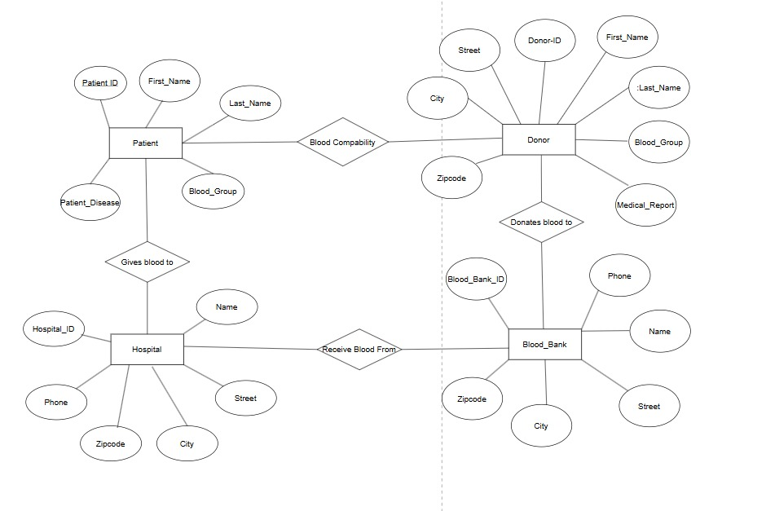

Use Case Diagram
A Use Case diagram for the blood donation website visually represents the interactions between users and the system, showing the functionalities available to users and how they interact with the platform. The use case diagram helps illustrate the primary interactions between the users and the blood donation system, showcasing its core functionalities. By defining roles and actions, it ensures clarity in system requirements and helps guide development.
Figure 3.7 1Use Case Diagram
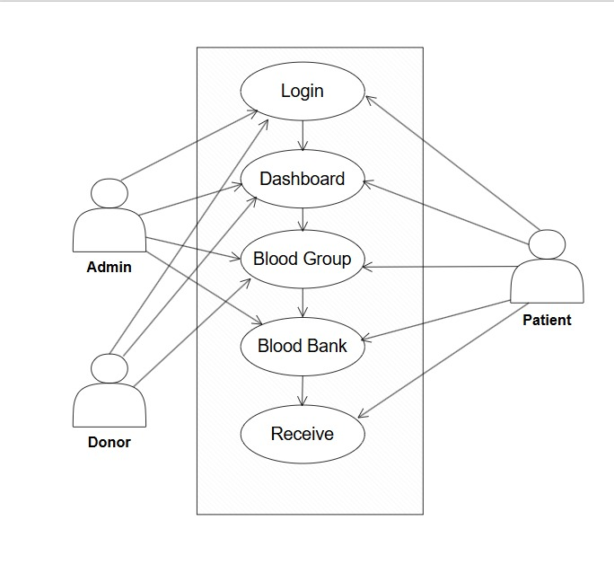

System Flow Diagram
The system flow diagram is one of the graphical representations of the flow of data in a system in software engineering. The diagram consists of several steps that identify where the input is coming to the system and output going out of the system. With the help of the diagram, it is possible to control the event decisions of the system and how data is flowing to the system.

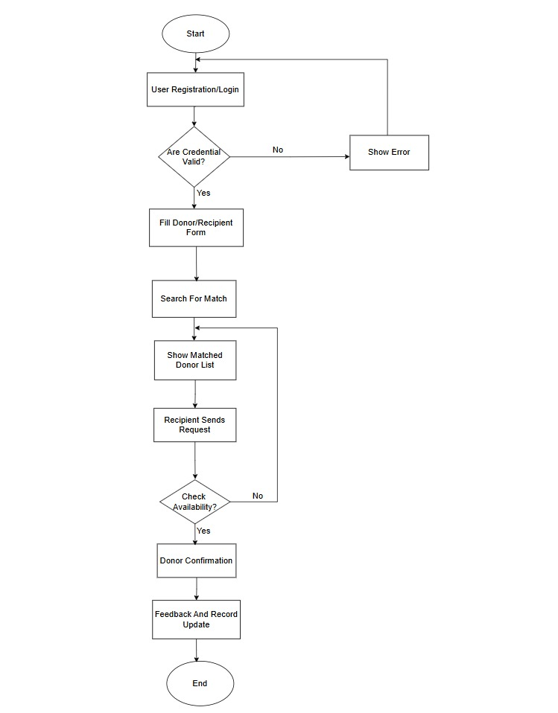

3.6 Software and Hardware Requirements
The minimum software required for the development of the project is:
• Operating System: Windows 7/8
• Code Editor: Visual Studio Code
• Framework: Django 3.2
• Programming Language: Python 3.8
• Browser: Chrome/ Edge
The hardware required for the development of the project is:
• Processor: Intel(R) Core (TM) i3-10110U CPU @ 2.10GHz 2.59 GHz
• Ram: 4.00 GB
• Hard Disk: 500 GB SSD
• Display: 1024*768 screen resolution

3.7 Testing and Maintenance
The testing and maintenance phases follow the development phase in a project flow. In testing, the project's functionalities are thoroughly evaluated to detect and correct any defects. During maintenance, the deployed system is supported, monitored, and enhanced on an ongoing basis. In this way, we ensure that the system is stable, reliable, and continually improving, ultimately meeting the needs of users and stakeholders. As part of the testing phase for the Crop Recommendation System a variety of test cases were conducted to ensure that the web application worked correctly. Security, usability, performance, and other aspects of the application are tested in these test cases.

    - Functionality Testing
- Test Case 1: Verify that donor registration and login work as expected.
- Test Case 2: Test the ability to search and filter eligible donors based on blood type and location.
- Test Case 3: Ensure that blood request creation and updates are correctly processed and displayed.
- Test Case 4: Confirm that donor availability status is accurately updated and reflected in real time.
    - Security Testing
- Test Case 5: Ensure that only authorized users (e.g., admins) can access sensitive system features.
- Test Case 6: Verify that unauthorized users cannot alter donor records or blood request information.
    - Usability Testing
- Test Case 7: Evaluate the user interface for clarity, simplicity, and ease of navigating donor and request features.
- Test Case 8: Test the application’s responsiveness and usability across various screen sizes and devices.
    - Compatibility Testing
- Test Case 9: Test the application across different browsers (e.g., Chrome, Firefox, Edge) for consistent behavior.
    - Regression Testing
- Test Case 10: Re-test previously reported issues (e.g., login errors, request form bugs) after fixes are applied.
- Test Case 11: Confirm that fixes do not negatively impact core functionalities like donor matching or notifications.

CHAPTER 4: DISCUSSION AND RESULT
4.1 Discussion
The findings highlight that the proposed system provides a more comprehensive and technologically advanced solution than the systems currently in use. Unlike apps such as the Red Cross Blood Donation App or BloodLink, which focus primarily on scheduling or geolocation services, the proposed system unifies multiple critical features—such as automated notifications, and real-time data handling—into a single platform. This approach simplifies user interaction while significantly improving coordination in emergency and non-emergency scenarios. Additionally, by replacing SMS-based communication with email alerts, the system modernizes user engagement while still maintaining accessibility. The removal of redundant processes further streamlines the workflow, making the system more practical for real-world application. Overall, the discussion underscores the system’s potential to fill existing gaps and offer a more secure, timely, and integrated solution for blood donation management.

4.2 Output
The Blood Donation System is a web-based platform that connects blood donors with recipients in need. Users can sign up and log in to the system, and those who require blood can fill out a request form directly on the website. This request is matched with suitable registered donors based on blood type and location. To become a donor, users must also fill out a donor registration form containing personal and medical details. All registered donors are displayed in a searchable and filterable donor list within the system. Hospitals or users can then send requests to eligible donors through the platform. The system ensures real-time request processing, accurate donor availability tracking, and a user-friendly experience across all devices. Overall, the application improves the efficiency, reliability, and speed of the blood donation process, making it easier for patients to connect with potential donors without delay.

4.3 Web Development

4.3.1 Frontend

The frontend of the Blood Donation System is clean, responsive, and easy to use. It includes features like user login/signup, donor registration form, blood request form, and a searchable donor list. The interface works smoothly on all devices and helps users navigate the system quickly and efficiently.
- Service page
Our Blood Donation System offers essential services to make blood donation easier and faster. Users can register and log in, submit blood requests by providing their details, and view matched donors based on location and blood group. Donors can also register themselves to help others in need. The system ensures quick matching, smooth communication, and real-time updates — all through a clean and responsive interface.
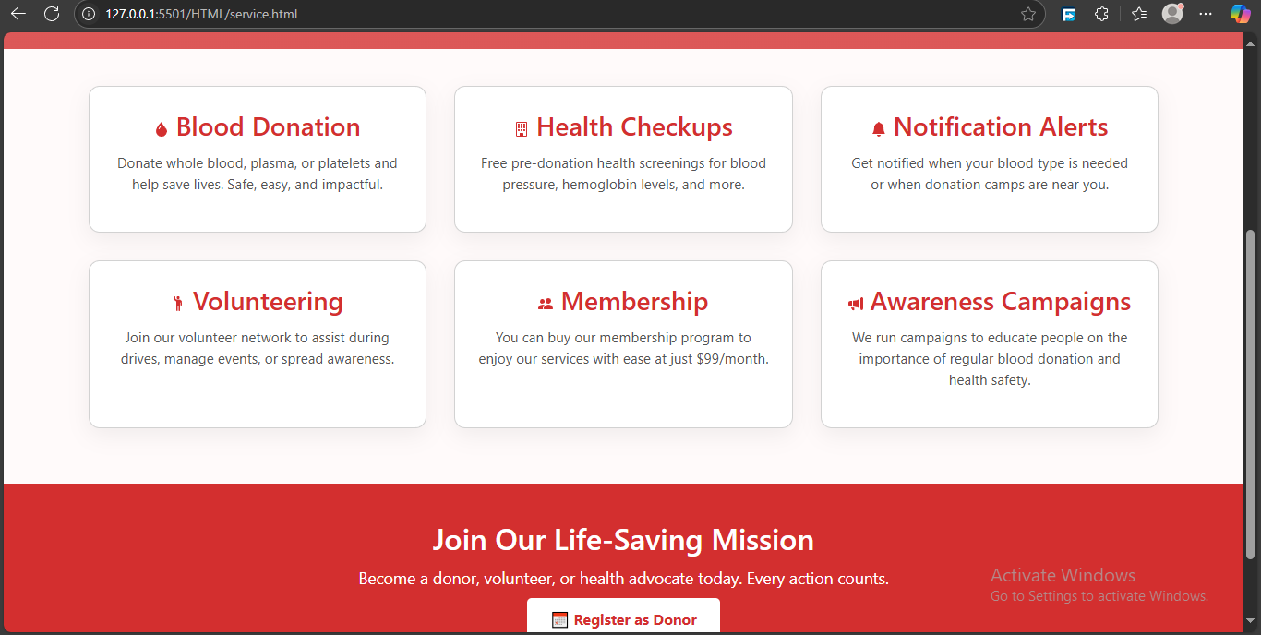
- Donor form
The Donor Form allows users to register as blood donors by providing important details such as first name, middle name, last name, gender, blood group, email address, password, contact number, address/location, and donor card. This information is securely stored and used to match the donor with nearby recipients in need. The form is simple, mobile-friendly, and designed for quick, hassle-free registration.

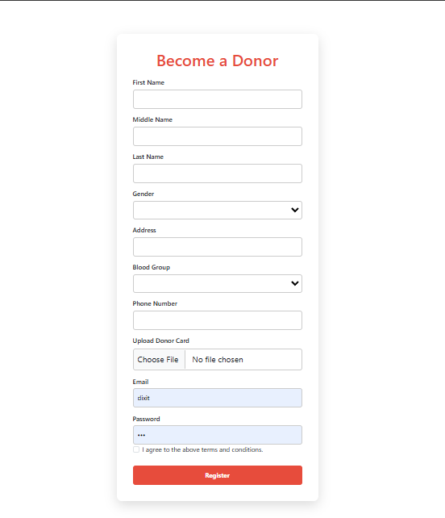
- Receipent form
The Recipient Form is used by users who need blood. It collects key information such as the first name, middle name, last name, address gender, blood group, contact number, blood report and email address. Based on this input, the system automatically finds and displays a list of matching nearby donors. The form is simple, quick to fill out, and helps ensure that patients get timely support.
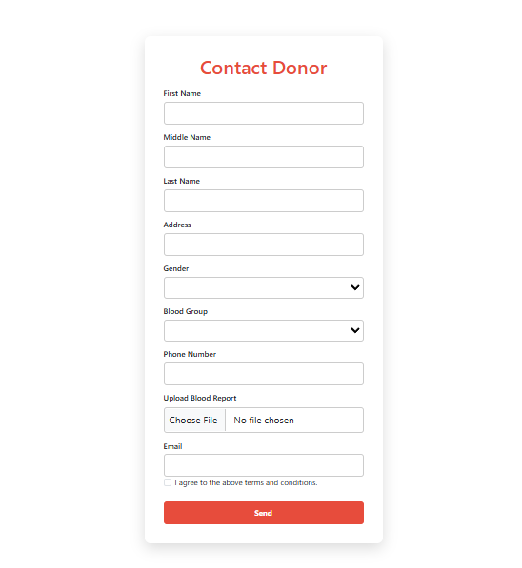

- Donor list
The Donor List displays only those donors who match the recipient’s blood group and location after a request is submitted. It includes key details like donor name, contact info, gender and email address. This helps recipients quickly identify and reach out to the right donors without browsing through unrelated data. The list is clear, real-time, and easy to read on any device.

4.3.2 Backend

The backend of the Blood Donation System handles user authentication, form submissions, data storage, and matching logic. It stores and manages donor and recipient data securely in a database, encrypts sensitive information like contact details, and processes blood requests by matching them with suitable donors based on blood group and location. It also ensures real-time updates and smooth communication between the frontend and server. The backend is designed to be secure, scalable, and efficient.

4.4 Database

The database in the Blood Donation System is designed to store and manage all essential data efficiently and securely. It contains separate tables for users, donors, and blood requests. The donor table stores fields like first name, middle name, last name, gender, blood group, email, password, contact number, address, and donor card. The recipient table includes similar fields such as name, gender, blood group, contact number, address, blood report, and email. A request-matching mechanism is implemented to fetch and display only those donors whose blood group and location match the recipient's request. Sensitive information is encrypted, and the database is optimized for fast access, accuracy, and real-time updates. Relationships between tables ensure data integrity and smooth backend operations.

CHAPTER 5 : CONCLUSION AND FUTURE ENHANCEMENT

5.1 Conclusion

The Blood Donation System successfully streamlines the process of connecting blood donors with recipients in need. By integrating user-friendly frontend features with a secure and efficient backend, the system ensures quick registration, accurate donor matching, and real-time response. It helps save lives by reducing delays in finding suitable blood donors, especially in emergency situations. Overall, the system provides a reliable, accessible, and scalable solution to support blood donation efforts and improve healthcare response.

5.2 Future Enhancement
To make the Blood Donation System more powerful and impactful, the following features can be added in the future:
- SMS and Email Notifications: The system sends timely SMS and email alerts to donors and recipients to inform them of new blood requests, confirmation of matches, and updates on donation status, ensuring fast and reliable communication.
- Donation History Tracking: A built-in feature tracks and stores past donation records for both donors and hospitals, allowing users to view their donation history and helping hospitals maintain organized medical records for future reference.
- Geo-location Integration: By using map-based services, the system locates and suggests the nearest available blood banks or donors, helping users respond quickly during emergencies and making the donation process more efficient.
- Admin Dashboard with Analytics: The admin panel provides a comprehensive overview of system activity, including donation trends, user engagement, and request statuses, enabling administrators to manage operations and make data-driven decisions effectively.

REFERENCES
Ali, K. A., Jahan, I., Ariful, M. I., & Shafa-at, M. P. (2015). Blood Donation Management System. American Journal of Engineering Research.
American Red Cross. (2017). Retrieved from redcross: https://www.redcross.org/
Anish Hamlin, M. R., & Mayan, J. A. (2016). Blod Donation and Life Saver-Blood Donation app. International Conference on Control, Instrumentation, Communication and Computational Technologies.
Chen, L., & Wang, Y. (2019). BloodLink Mobile App: Geolocation-based Blood Donation for Emergency Requests. nternational Journal of Mobile Computing and Communications.
Hamid, K., Aziz, A., & Yusri, N. N. (2015). Development of Blood Bank Management System. World Conference on Technology, Innovation and Entrepreneurship.
Jones, R. (2018). BloodBanker: A Web-Based Platform for Blood Donor Matching. Journal of Health Informatics.
Shore, J., & Waden, S. (2021). The Art of Agile Development. O'Reilly Media, Inc.
Smith, D. (2015). Retrieved from Blood Donor Connect: https://thebloodconnection.org/
Thapa, R., & Shrestha, S. (2010). SMS-Based Blood Donation System. International Journal of Computer Science and Technology.

APPENDICES

