Affiliated to Pokhara University
UNITED TECHNICAL COLLEGE

Mid Project Report
on
BLOOD DONATION SYSTEM
[Code No:…….]
(For partial fulfillment of Sixth Semester in Computer Engineering)

Submitted by
Aashish Regmi (22070088)
Ayush Shrestha (22070092)
Dixit Shrestha (22070098)
Sonish Lohani (21075549)

Submitted to
Department of Computer Engineering

ABSTRACT
This project aims to create a comprehensive blood donation website to simplify the process of connecting blood donors with recipients and enhance the overall efficiency of the blood donation system. The platform will serve as a centralized hub, enabling seamless interaction between donors, recipients, and organizations while addressing key challenges such as delays in donor-recipient matching, lack of real-time updates, and insufficient donor engagement. The primary goal of the project is to improve access to critical blood supplies, encourage regular donations, and provide a user-friendly solution to overcome current inefficiencies. This initiative is vital as it addresses pressing healthcare needs and promotes a culture of altruism and community involvement. Modern web technologies will be used to develop the website, incorporating features like geolocation-based donor searches, real-time notifications, and secure data management. The implementation will leverage tools such as HTML, CSS, JavaScript, and a backend framework like Node.js or Django, complemented by database systems for efficient data handling. Additionally, APIs for maps and notifications will enhance the platform's functionality, ensuring an intuitive and seamless user experience. The anticipated outcomes include a fully operational, accessible, and secure blood donation website that supports efficient donor-recipient matching, facilitates the organization of donation drives, and engages users with educational resources and timely updates. Ultimately, this project aspires to save lives by improving the accessibility and impact of blood donation while addressing the shortcomings of existing systems.
Keywords: Blood donation website, donor-recipient matching, donor engagement, secure data management, user-friendly, efficient data handling.

Table of Contents
ABSTRACT ii
List of Figures iv
List of Tables v
Acronyms and Abbreviation vi
CHAPTER 1: INTRODUCTION 1
1.1 Background 1
1.2 Problem Statement 2
1.3 Objectives 2
1.4 Motivation and Significance 3
1.5 Scope of the Work 4
CHAPTER 2: LITERATURE REVIEW 5
2.1 Overview of Existing Systems 5
2.2 Comparison of Features 6
2.3 Gaps in Existing Systems 7
2.4 Significance of Proposed Work 9
CHAPTER 3: METHODOLOGY 11
3.1 Overview of the Approach 11
3.2 System or Model Design 14
3.3 Technology Stack 15
3.4 Development Process 16
3.5 Task Completed 17
3.6 Task Remaining 18
3.5 E-R Diagram 20
3.6 Use Case Diagram 21
CHAPTER 4: EXPECTED OUTCOME 22
CHAPTER 5: DISCUSSION AND RESULT 23
References 24
Appendices A: Gantt chart 25

List of Figures
Figure 3.2.1 Block Diagram of Digital Blood Bank System .15

Figure 3.7 E-R Diagram……. ………………………………………………………..20

Figure 3.7 Use Case Diagram 21

List of Tables
Table 2. 2 Comparison of Features 6

Table A. Gantt chart of the project 25

Acronyms and Abbreviation
AI: Artificial Intelligence
API: Application Programming Interface
AWS: Amazon Web Services
CSS: Cascading Style Sheets
E-R: Entity-Relationship
HTML: Hyper-Text Markup Language
HTTPS: Hyper-Text Transfer Protocol Sercure
IoT: Internet of Things
NGO: Non-Governmental Organization
SMS: Short Message Service
SQL: Structured Query Language

CHAPTER 1: INTRODUCTION

1.1 Background
Blood donation has always been a vital aspect of healthcare, providing critical support for patients requiring transfusions during surgeries, accidents, or treatments. With the integration of technology into healthcare, new opportunities have emerged to enhance the blood donation process. Tools such as digital platforms, mobile apps, and geolocation systems have helped connect donors, recipients, and blood banks, streamlining donor matching and facilitating donation drives. (Chen & Wang, 2019)
Recent advancements include using Artificial Intelligence (AI) to forecast blood demand, implementing blockchain technology to ensure safe and traceable blood supplies, and leveraging mobile apps to deliver real-time updates on donation events and urgent blood needs. Additionally, geolocation services have made it easier for donors to find nearby centers, while SMS and email notifications have improved donor engagement and participation. (Jones, 2018)
However, challenges persist in the current systems. Many platforms lack intuitive, user-friendly interfaces, making it difficult for users to navigate or find information effectively. Data security and privacy concerns remain unaddressed on some platforms, discouraging potential donors from signing up. Furthermore, the fragmentation of these systems often results in redundant efforts and inefficiencies, as no single platform offers a comprehensive solution for donors, recipients, and organizations. (American Red Cross, 2017)
Developing an improved blood donation website can address these shortcomings. A thoughtfully designed platform can centralize critical information, improve usability, and encourage collaboration among stakeholders. It can also raise awareness about the importance of regular blood donation, ensure the availability of essential blood supplies, and strengthen the overall resilience of the healthcare system. (Jones, 2018)

1.2 Problem Statement
Blood donation is essential for saving lives, yet current systems for connecting donors and recipients face significant obstacles. These challenges contribute to inefficiencies in the blood supply chain, delays in responding to emergencies, and missed opportunities to engage willing donors. The absence of a centralized, user-friendly platform further complicates the process, creating difficulties for donors, recipients, and organizations.
These limitations result in delays, shortages, and lost opportunities to tap into the goodwill of potential donors. A well-designed blood donation website can address these issues by offering a centralized platform with real-time data, secure communication, and user-friendly features. By bridging the gap between donors, recipients, and organizations, this solution can improve access to blood supplies, enhance operational efficiency, and promote a culture of consistent blood donation.

1.3 Objectives
The objectives of this project are as follows:
- To develop a centralized platform that facilitates efficient matching of blood donors with recipients based on factors such as blood type, location, and urgency.
- To raise awareness about the significance of blood donation and motivate regular donor participation through educational resources and engagement features.
- To empower organizations to organize, manage, and promote blood donation drives effectively, while enabling users to easily register and participate.
- To deliver a secure and user-friendly platform that is accessible across various devices, ensuring data privacy and inclusivity for diverse user groups.

1.4 Motivation and Significance
The motivation for developing a blood donation website arises from the vital role blood donation plays in saving lives and the ongoing challenges of ensuring a consistent and timely blood supply. Despite advancements in technology, existing systems often fail to effectively connect donors and recipients, especially in emergencies. Challenges such as fragmented platforms, the absence of real-time updates, low donor engagement, and inadequate data security underscore the need for a more innovative solution. This project was selected as it combines technological advancements with a critical social need, providing an opportunity to address these issues and significantly improve healthcare outcomes.
The proposed website aims to overcome the limitations of current systems by integrating advanced features that streamline donor-recipient connections and enhance the overall user experience. Unlike existing platforms that operate independently or with limited functionality, this website offers a centralized solution, including real-time donor matching, geolocation-based searches, and secure data management. Additionally, features such as educational resources and notifications are designed to boost donor engagement and raise awareness, encouraging consistent participation. The platform places a strong emphasis on data privacy and security, ensuring users' sensitive information is protected—an issue that is often overlooked in other systems.
This project stands out due to its comprehensive approach and user-focused design. While many existing platforms focus on isolated aspects, such as organizing donation drives or registering donors, this website integrates all critical functions into a unified system. Features like real-time updates, an intuitive interface, and accessibility across devices and languages make the platform more inclusive and user-friendly. Moreover, the emphasis on community-building initiatives, such as recognition programs and social sharing, helps foster a culture of altruism and regular blood donation. By addressing the shortcomings of current systems and incorporating innovative features, this project seeks to revolutionize the blood donation process, making it more efficient, accessible, and impactful.

Scope of the Work
This project is designed as a centralized and user-friendly platform to connect blood donors, recipients, and healthcare organizations. Its main objective is to simplify the blood donation process, enhance accessibility, and resolve inefficiencies in the existing system. The platform aims to deliver a holistic solution to ensure a reliable and timely supply of blood for both medical emergencies and regular requirements.

CHAPTER 2: LITERATURE REVIEW

2.1 Overview of Existing Systems
Numerous blood donation websites and platforms have been developed to facilitate connections between donors and recipients. These systems aim to provide easy access to information, improve donor-recipient matching, and promote awareness about blood donation.
    - Blood Donor Connect: Blood Donor Connect is a platform designed to help users locate potential blood donors based on criteria like location and blood type. Its straightforward interface makes it easy to navigate, providing basic functionalities for searching and connecting users, which meet the primary requirements of a blood donation system (Smith, 2015).
    - Red Cross Blood Donation App: This app, developed by the American Red Cross, enables users to schedule blood donation appointments, monitor their donation history, and set reminders for future donations. It provides an organized approach to managing blood donations and is both functional and user-friendly. (American Red Cross, 2017)
    - BloodBanker: BloodBanker is a web-based platform offering an online directory of blood donors. It allows users to search for donors based on location and blood type, with a simple interface for making connections. (Jones, 2018)
    - BloodLink Mobile App: BloodLink is a mobile application designed for emergency blood donation requests, utilizing geolocation technology to match donors and recipients in nearby areas. Its focus on emergencies makes it particularly valuable in critical situations. (Chen & Wang, 2019)
    - SMS-Based Blood Donation System: This system connects donors and recipients via SMS alerts, offering a simple way to communicate blood donation needs. It is particularly useful for users without access to smartphones or internet-based applications. (Thapa & Shrestha, 2010)

Comparison of Features
Table 2. 2 Comparison of Features
Authors | Description | Features | Drawbacks
(Smith, 2015) | A platform for locating blood donors based on location and blood type. | Simple interface, basic search functionality. | No real-time communication or emergency handling capabilities.
(American Red Cross, 2017) | A U.S.-based app for managing blood donation schedules and tracking donation history. | Appointment scheduling, reminders, donation history tracking. | Restricted geographic coverage; lacks real-time donor-recipient matching.
(Jones, 2018) | A web-based directory for blood donors with search capabilities by location and blood type. | Directory-based search, basic functionality. | Outdated interface; not mobile-responsive; lacks real-time notifications for emergencies.
(Chen & Wang, 2019) | A mobile app designed for emergency blood donation requests using geolocation technology. | Geolocation-based matching, emergency handling capabilities. | Limited scalability; no support for large databases or advanced analytics.
(Thapa & Shrestha, 2010) | A basic SMS-based system for connecting donors and recipients through alerts. | Simple SMS alerts; accessible for non-smartphone users. | No mobile app; lacks real-time updates, secure database integration, and modern features.

2.3 Gaps in Existing Systems
The existing systems reviewed provide a range of functionalities for blood donation management. However, each system has significant gaps that limit their overall effectiveness, scalability, and user accessibility. Below are the identified gaps in the systems:
    - Lack of Real-Time Communication and Notifications:
- Most platforms, (such as (Smith, 2015) and (Jones, 2018)), do not offer real-time communication or notification features, which are essential for immediate coordination during emergencies.
- SMS-Based Blood Donation System relies solely on SMS alerts, which are not updated in real time and can cause delays in response.
    - Limited Scalability
- Systems like (Chen & Wang, 2019) face scalability challenges, limiting their ability to handle an increasing number of users or expand to a wider geographic area.
- The lack of robust infrastructure in several systems restricts their capacity to support growing databases or advanced functionalities like analytics.

    - Geographic Restrictions
- The (American Red Cross, 2017) is restricted to the U.S., making it inaccessible to users in other countries, limiting its global utility.
- Other platforms lack global reach due to their focus on local or regional markets without provisions for broader geographic expansion.
    - Outdated or Inadequate Interfaces
- Systems such as (Jones, 2018) use outdated interfaces and are not mobile-responsive, making them inconvenient for modern users who rely heavily on smartphones and tablets.
- Poor user experience can deter adoption and usage, especially among tech-savvy younger donors.
    - Absence of Advanced Features
- Most systems, including (Smith, 2015), lack advanced geolocation technologies that enable dynamic and efficient donor-recipient matching.
- Systems like (Chen & Wang, 2019) and (Thapa & Shrestha, 2010) do not integrate features like analytics for demand prediction or optimization.
    - Inadequate Support for Emergency Handling
- While the (Chen & Wang, 2019) focuses on emergencies, most other platforms lack dedicated tools to prioritize and manage urgent requests effectively.
- Emergency handling requires features such as real-time updates, secure communication channels, and precise geolocation, which are missing in several systems.
    - Limited Database Integration and Security
- Systems like (Thapa & Shrestha, 2010) do not utilize secure databases, making them unreliable for handling sensitive user information.
- Lack of integration with large databases reduces the ability to centralize and streamline operations, impacting efficiency.
    - Lack of Comprehensive Solutions
- Most existing platforms focus on specific aspects of blood donation management (e.g., donor search, appointment scheduling, emergency requests) without offering a comprehensive solution that combines all necessary functionalities into one platform.

2.4 Significance of Proposed Work
The proposed blood donation website seeks to overcome these challenges by incorporating several key features:
    - Instant Communication and Emergency Response: A significant challenge in current systems is the absence of real-time communication and handling of emergencies. The proposed system aims to incorporate real-time notifications for both donors and recipients, ensuring swift responses to urgent requests. Emergency alerts and real-time coordination will allow users to react quickly to blood donation needs, potentially saving lives during critical situations.
    - Enhanced Donor-Recipient Matching: The project will utilize advanced geolocation technology to enhance the accuracy and speed of donor-recipient matching, especially in emergency cases. By factoring in location, blood type, and urgency, the system will facilitate faster and more precise matches, ensuring that donors are connected with recipients in need without unnecessary delays.
    - Global Reach and Scalability: In contrast to existing systems that are regionally limited, this project is designed with scalability in mind. With the use of cloud infrastructure (AWS) and a flexible architecture, the platform will support growth and expansion, making it accessible to users worldwide, regardless of geographic constraints.
    - Improved User Experience: The proposed system will offer a modern, mobile-responsive interface that ensures seamless access across various devices. Its intuitive design and easy navigation will encourage higher donor engagement, simplifying processes like scheduling appointments, finding blood donors, and tracking donations.
    - Data Security and Privacy: Given the growing concerns about data security, the proposed platform will implement secure database management systems. By using MySQL and encryption protocols, the platform will safeguard sensitive user information, ensuring privacy for both donors and recipients.
    - Incorporation of Cutting-Edge Technology: The system will integrate advanced technologies, including Firebase for real-time notifications and analytics, Google Maps API for geolocation services, and Django for robust backend support. These features will facilitate real-time updates, secure data management, and an enhanced user experience, making the platform more efficient compared to older systems.
    - All-Inclusive Solution: Unlike existing systems that focus on individual aspects of blood donation, this project will provide an all-encompassing solution. It will integrate donor search, appointment scheduling, emergency response, and donation history management into a single platform. This unified approach ensures that all users—donors, recipients, and administrators—benefit from a seamless, user-friendly system.

CHAPTER 3: METHODOLOGY
This section describes the methodology applied in designing and implementing the blood donation website. The approach emphasizes systematic planning, leveraging modern tools, and focusing on user-centered design. The website is created to improve accessibility, facilitate real-time donor-recipient interactions, and ensure ease of use.

Overview of the Approach
The project implemented a client-server architecture to facilitate seamless communication between the frontend, backend, and database. The system was tailored to deliver a responsive interface, secure data handling, and real-time interaction capabilities.
Key technologies included HTML, CSS, and Django for building core functionalities, with Firebase enabling real-time notifications. MySQL served as the database for structured data storage, while integrations like Google Maps API enhanced the platform’s functionality. An iterative Agile methodology was followed to incorporate regular feedback and make iterative improvements throughout the development cycle.
    - Requirements Gathering
- Objective:
The primary objective of this phase was to identify and document the essential functional and non-functional requirements to align the system with the needs of users and the project objectives.
- Techniques Used:
  - Literature Review: Researched existing platforms to identify gaps and opportunities for improvement.
  - Stakeholder Consultations: Conducted interviews and discussions with key users, such as administrators and donors, to understand their needs and expectations.
  - Data Analysis: Analyzed survey responses to prioritize user requirements.
- Data Collection:
  - Data Sources: To ensure the Digital Blood Bank System operates effectively, data must be collected from various sources. Each source contributes unique and critical information essential for the system's functionality.
- Inventory Data: This includes details of available blood units, specifying their types (A, B, AB, O), Rh factors (positive or negative), and expiry dates. Tracking these parameters ensures proper management and utilization of blood resources.
- Donation Records: Past donation data, such as donor IDs, dates of donation, and volumes collected, helps in maintaining a historical record and forecasting future supply.
- Recipient Records: Blood banks also store recipient information, including medical requirements, urgency levels, and the affiliated hospitals or clinics. This data is crucial for matching donors with recipients efficiently.
- Donors: Donors contribute valuable personal and medical information, vital for system functionality.
- Registration Details: Information such as name, contact details, address, blood group, and medical history is collected during donor registration to assess eligibility.
- Donation History: Data on the frequency and volume of donations helps the system track active donors and identify regular contributors.
- Availability Status: Donors provide information on their readiness and willingness to donate, especially during emergencies, enabling the system to create a pool of on-call donors.
- Recipients: Recipients are individuals in need of blood transfusions, and their accurate information is essential for timely and efficient donor matching.
- Registration Details: Information such as name, contact details, address, blood group, and medical condition is collected during recipient registration to ensure compatibility and prioritize urgent cases.
- Request History: The system tracks previous blood requests, including dates, blood types, and fulfillment status, to monitor recurring needs and manage demand patterns.
- Urgency and Location: Recipients provide information about the urgency of their need and their geographic location, enabling the system to quickly locate suitable donors nearby and prioritize critical cases.
  - Data Preprocessing: Once data is collected, preprocessing is essential to ensure its quality, consistency, and security.
- Validation: Validation involves verifying the accuracy of collected data. Donor information, such as medical history and blood type, is cross-checked with existing records to minimize errors and ensure reliability.
- De-duplication: Duplicate entries, such as multiple registrations of the same donor or repeated inventory records, are identified and removed to maintain a clean database.

- Normalization: Normalization standardizes the data format across all entries:
- Dates are formatted uniformly (e.g., YYYY-MM-DD).
- Blood group types are represented consistently (e.g., A+ or A-).
- Volume measurements and other numerical data are standardized for easier processing and analysis.
- Encryption: Sensitive personal and medical data is encrypted to protect it from unauthorized access. Role-based access control ensures only authorized users can access specific types of data, enhancing privacy and security.
- Integration: Validated and processed data is integrated into the central system, ensuring compatibility with its structure. This step ensures the system operates seamlessly and provides accurate information to users.

System or Model Design
    - Overall Framework: The system followed a client-server model, where the frontend handled user interactions, while the backend managed core logic, API operations, and database processes.
Figure 3.2. 1 Block Diagram of Digital Blood Bank System
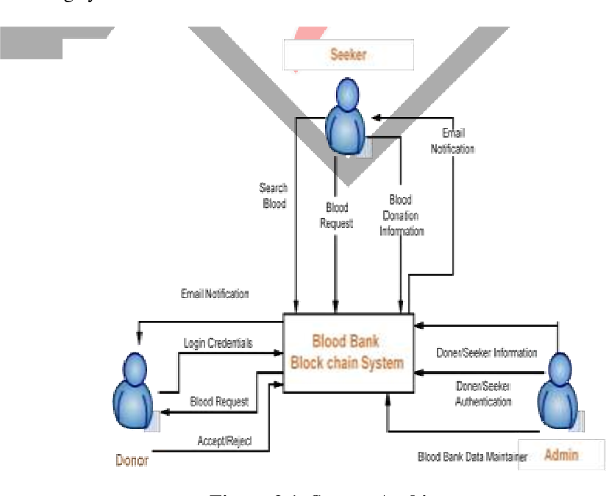

Technology Stack
    - Primary Technologies:
  - Frontend:
    - HTML provides the structural groundwork by arranging content into sections like donor registration forms, blood request submissions, and donor listings, utilizing elements such as forms, tables, and buttons.
    - CSS improves the website's aesthetics and usability by adding styles, including colors, fonts, layouts, and responsive design, ensuring it appears polished and performs efficiently across different devices. Combined, they deliver a visually appealing, easy-to-use platform tailored for donors, recipients, and administrators.
  - Backend:
    - Django, a Python-based framework, is utilized to manage backend operations, including user authentication, handling donor and recipient data, and ensuring secure interactions with the MySQL database. It offers a strong foundation for developing a scalable and maintainable platform.
    - Firebase complements this by providing real-time notifications, delivering instant alerts to donors and recipients during emergencies or important updates.
- Data Management:
    - MySQL serves as the core database management system, facilitating the efficient storage, organization, and retrieval of critical data. It handles key information, including donor profiles, recipient requests, blood types, and donation histories.
- External Integrations:
    - Google Maps API: The Google Maps API is integrated into the website to offer geolocation services, helping users easily locate nearby blood donors or donation centers. This feature allows the platform to display interactive maps, enabling recipients to search for available donors within a particular area based on their current location. By facilitating efficient matching of donors and recipients, especially in emergencies, it enhances response times and improves the user experience, making it simpler to connect with nearby donors.
    - Firebase Notifications: Firebase notifications are used to provide real-time alerts and updates to users. When urgent blood donation requests or updates occur, Firebase sends instant push notifications to both donors and recipients, ensuring they are promptly informed.

Development Process
    - Approach: An Agile development methodology was adopted to ensure iterative progress and continuous feedback. This enabled the team to adapt to changes and deliver a functional, user-oriented product within the project timeframe. Key stages included:
- Planning: Defined sprint goals, prioritized tasks, and created a backlog.
- Development: Built features incrementally, focusing on functionality and usability.
- Testing: Conducted thorough testing after each sprint to identify and fix bugs.
- Review: Regularly reviewed progress with stakeholders and incorporated feedback.

Task Completed
    - Frontend:
The user interface (UI) for the blood donation website, focusing on creating an intuitive, user-friendly, and visually appealing experience has been designed, which includes key features such as donor registration forms, a searchable donor database, blood request submission pages, and informative sections about donation eligibility and procedures. The website ensures consistency in layout, color scheme, typography, and navigation across all pages to enhance usability and accessibility. The frontend was developed using modern web technologies (e.g., HTML, CSS), with responsiveness across various devices to ensure seamless interaction for all users. This completed UI lays the foundation for integrating backend functionality and user interaction flows.
    - Backend:
The CRUD (Create, Read, Update, Delete) operations was implemented efficiently to manage donor and receiver information. These operations enable the system to add, view, update, and delete records as needed, ensuring that all data remains current and accurate. This functionality supports smooth interaction for both users and administrators, making the platform responsive and user-friendly.
To support these operations, structured databases was created for both donors and receivers. Each database contains key information such as Name, Blood type, Contact details, and Address. The database was built with scalability and data integrity in mind, ensuring reliable performance and easy future expansion. This setup forms the core of the system’s ability to manage and match blood donation records effectively.
Sample example:
- Registration of Donor
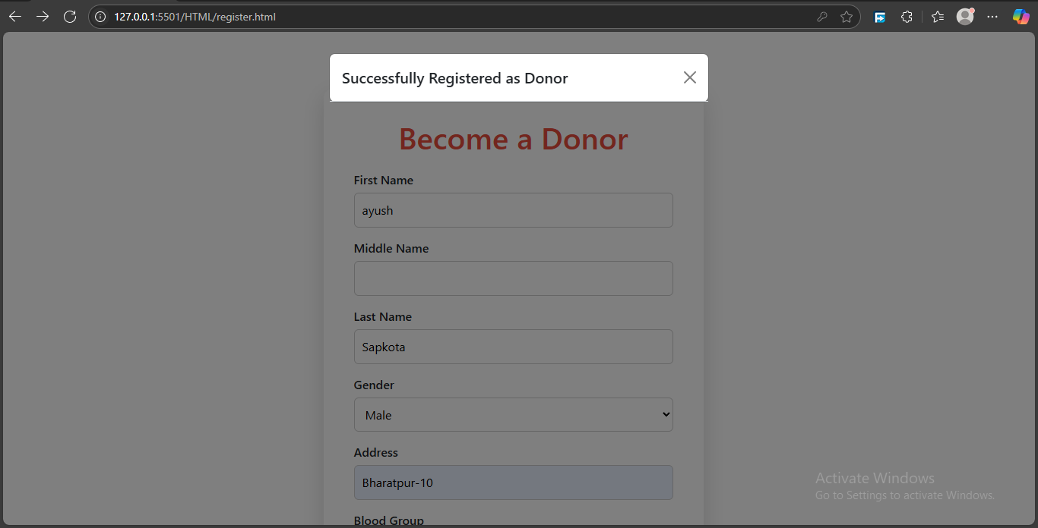
Sample example:
- Recipient Request Submission

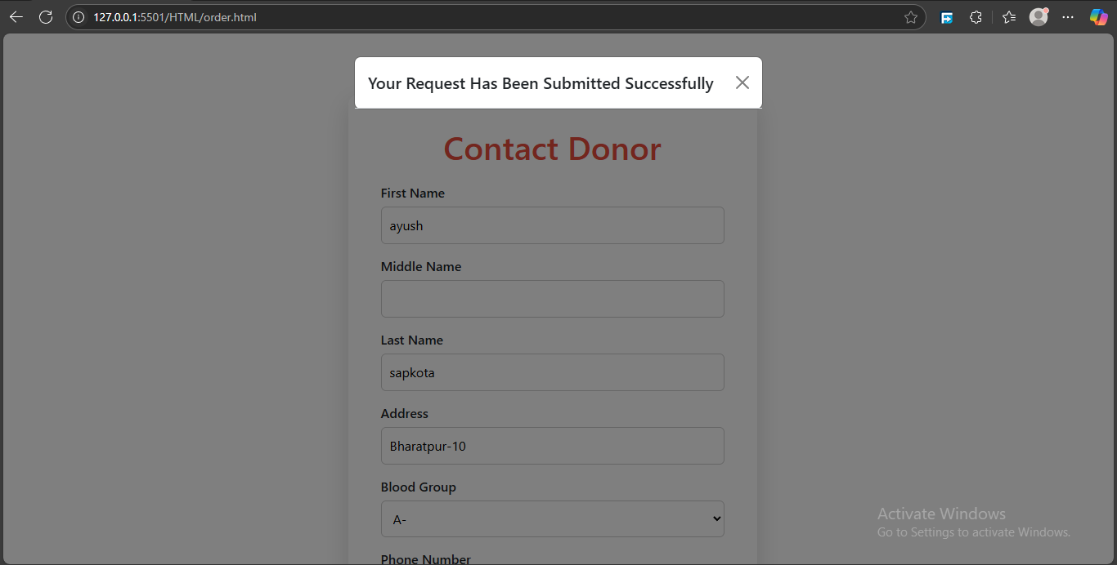

Task Remaining
    - Authentication and Authorization: We will implement a secure login and registration system so that users (donors, receivers, and admins) can create accounts and log in. We will also restrict access to different sections of the website based on roles. For example, only admins should be able to manage all users or see the overall statistics, while donors and receivers should only access their own data. Passwords must be securely stored using hashing techniques.
    - Blood Match and Search Functionality: We will develop a feature that can automatically or manually match donors with receivers based on important criteria like blood type, location, and availability. This will help ensure quick and effective responses to blood requests. We will also implement filter options, allowing users to search by name, blood type, city, or availability.

    - Email/SMS Notifications: We will integrate a notification system using services like SMTP for emails. This system can notify users when they are matched, when a donation request is received, or when it’s time for a repeat donation. Notifications improve engagement and ensure timely communication between donors and receivers.

    - Data Validation and Error Handling: We will add input validation to all forms to make sure users enter correct and complete information. For example, Names shouldn’t contain numbers, and emails must be in the proper format. On the backend, validate and sanitize input data to prevent security issues like SQL injection. We will implement proper error messages and user-friendly alerts to guide users when something goes wrong.

    - Deployment: To make the blood donation website live and accessible to users, it will be deployed on a reliable hosting platform. Suitable options include Heroku for its simplicity and support for full-stack apps, or a combination like Netlify for the frontend and Render or Firebase for the backend. During deployment, it's important to configure the production database, secure the website with HTTPS, set environment variables, and thoroughly test the application to ensure reliable performance.

E-R Diagram
An Entity-Relationship (ER) diagram illustrates the database structure of a system, highlighting entities, their attributes, and the relationships connecting them. For the blood donation website, the ER diagram depicts the key entities (such as Donor, Patient, Blood Bank, Hospital) and how they interact with one another.
Figure 3.7 E-R Diagram
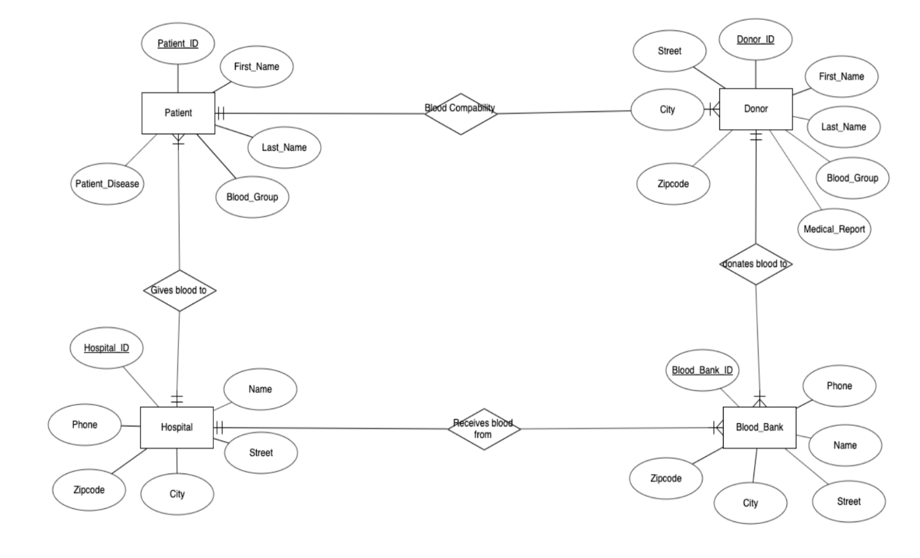

Use Case Diagram
A use case diagram for the blood donation website visually represents the interactions between users and the system, showing the functionalities available to users and how they interact with the platform. The use case diagram helps illustrate the primary interactions between the users and the blood donation system, showcasing its core functionalities. By defining roles and actions, it ensures clarity in system requirements and helps guide development.
Figure 3.8 Use Case Diagram

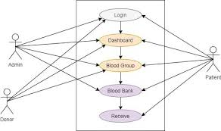

CHAPTER 4: EXPECTED OUTCOME
The website aims to provide a responsive and user-friendly platform that improves accessibility and facilitates seamless interactions for all users, including administrators, donors, and recipients. By utilizing MySQL for secure data storage and management, the system will protect user information and ensure consistent performance. Real-time notifications, enabled through Firebase, will keep users informed of important updates and activities, while the integration of Google Maps API will deliver effective location-based services for managing resources and connections. Built with Django, its modular structure will allow for easy maintenance and the addition of future features. Overall, the website is designed to optimize processes, boost efficiency, and provide a secure, scalable, and user-focused experience.

CHAPTER 5: DISCUSSION AND RESULT
This project demonstrates a well-rounded approach to developing a user-focused website designed for efficient blood donation management. By utilizing modern technologies such as Django, Firebase, and Google Maps API, the platform ensures smooth user interactions, secure data management, and real-time updates.
Following an Agile development process allowed for continuous incorporation of user feedback, ensuring the solution meets both functional and non-functional needs. The platform prioritizes accessibility, reliability, and scalability, effectively addressing limitations found in traditional systems. It provides an efficient and user-friendly solution for donors, recipients, and administrators.
In conclusion, this project successfully combines technological innovation with social impact, delivering a platform that not only meets technical requirements but also plays a crucial role in improving blood donation processes, saving lives, and strengthening community connections.

References
American Red Cross. (2017). Retrieved from redcross: https://www.redcross.org/
Chen, L., & Wang, Y. (2019). BloodLink Mobile App: Geolocation-based Blood Donation for Emergency Requests. nternational Journal of Mobile Computing and Communications.
Jones, R. (2018). BloodBanker: A Web-Based Platform for Blood Donor Matching. Journal of Health Informatics.
Smith, D. (2015). Retrieved from Blood Donor Connect: https://thebloodconnection.org/
Thapa, R., & Shrestha, S. (2010). SMS-Based Blood Donation System. International Journal of Computer Science and Technology.

Appendices A: Gantt chart
Before getting started with any work, proper preparation of working schedule containing of all the task that should be done for completion of project is necessary. For this purpose, we have included Gantt chart with time estimation in a total span of 2-3 months is included below.
Table A. Gantt chart of the project
