**OUTPUT**

**login.spec.cy.js (success)**

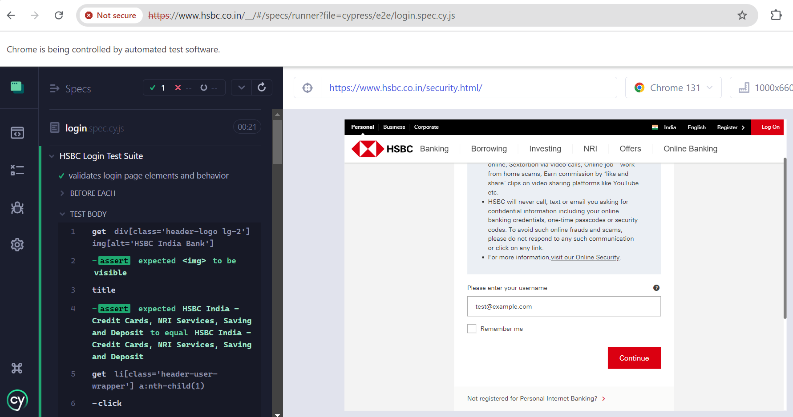

**atm-search.spec.cy.js (with failure)**

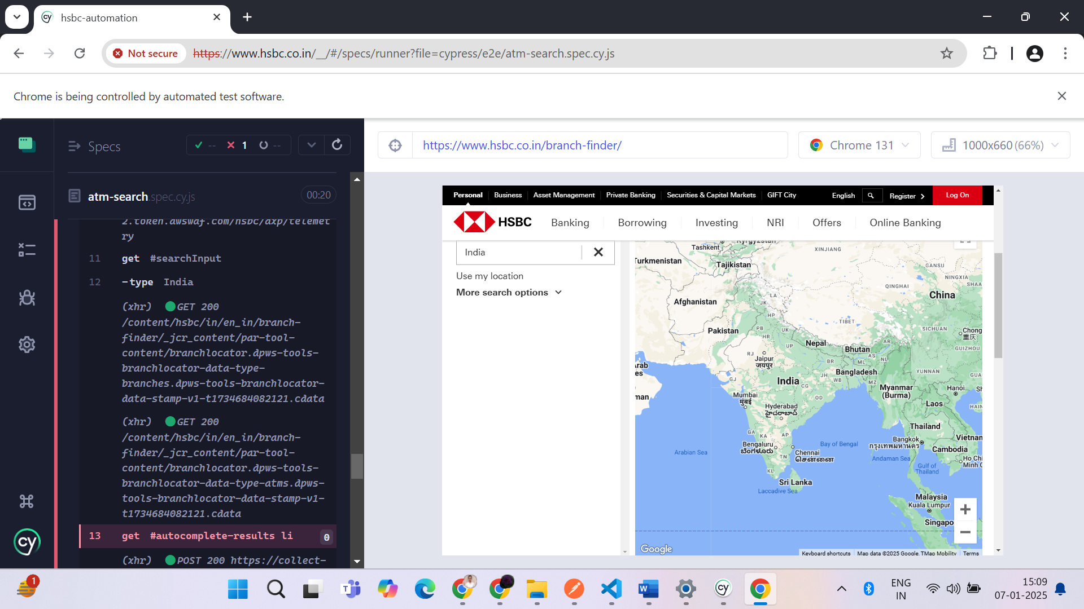

**credit-card.spec.cy.js**

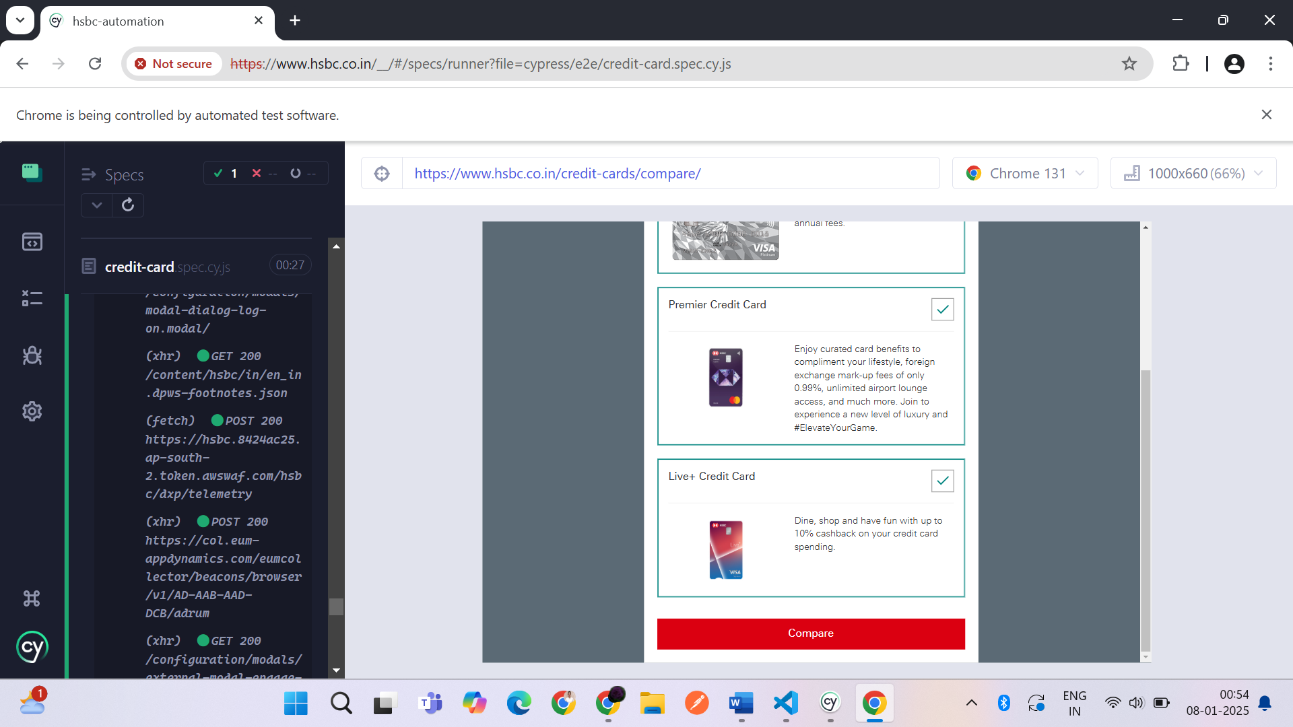

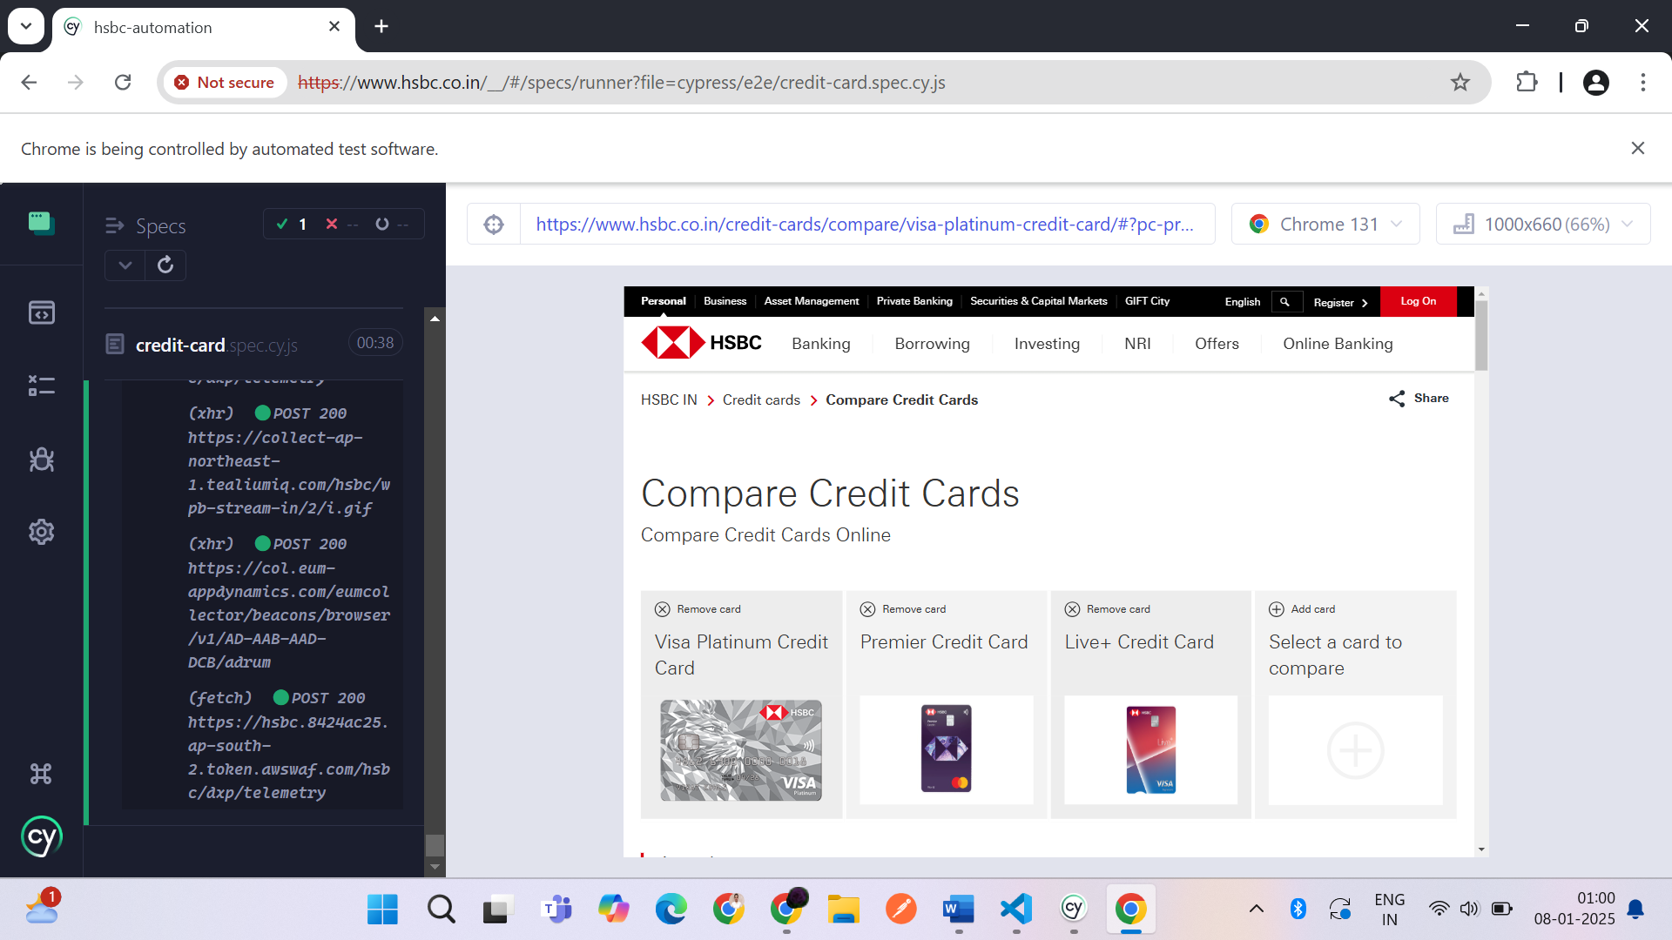

**PAGE OBJECT MODEL**

**cypress\e2e\login.spec.cy.js :** for Login test case code

**cypress\e2e\atm-search.spec.cy.js :** for Atm search test case code

**cypress\e2e\credit-card.spec.cy.js :** for Credit Card test case code

**cypress\support\commands.js :** methodto open common url across all test case

**cypress\fixtures\example.json :** to derive test data & element locators

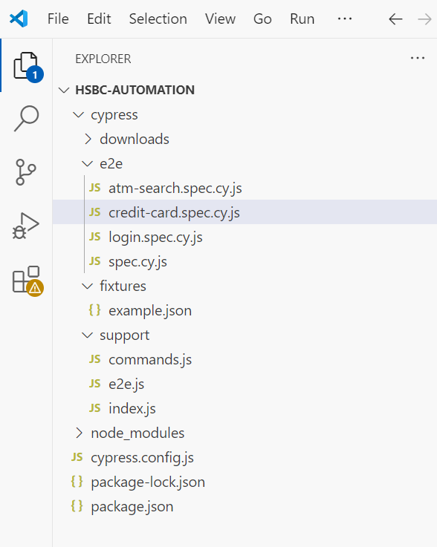

**SOURCE CODE SCREENSHOTS**

**cypress > support > commands.js**

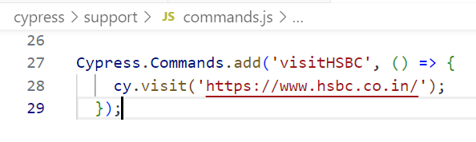

**cypress > fixtures > example.json**

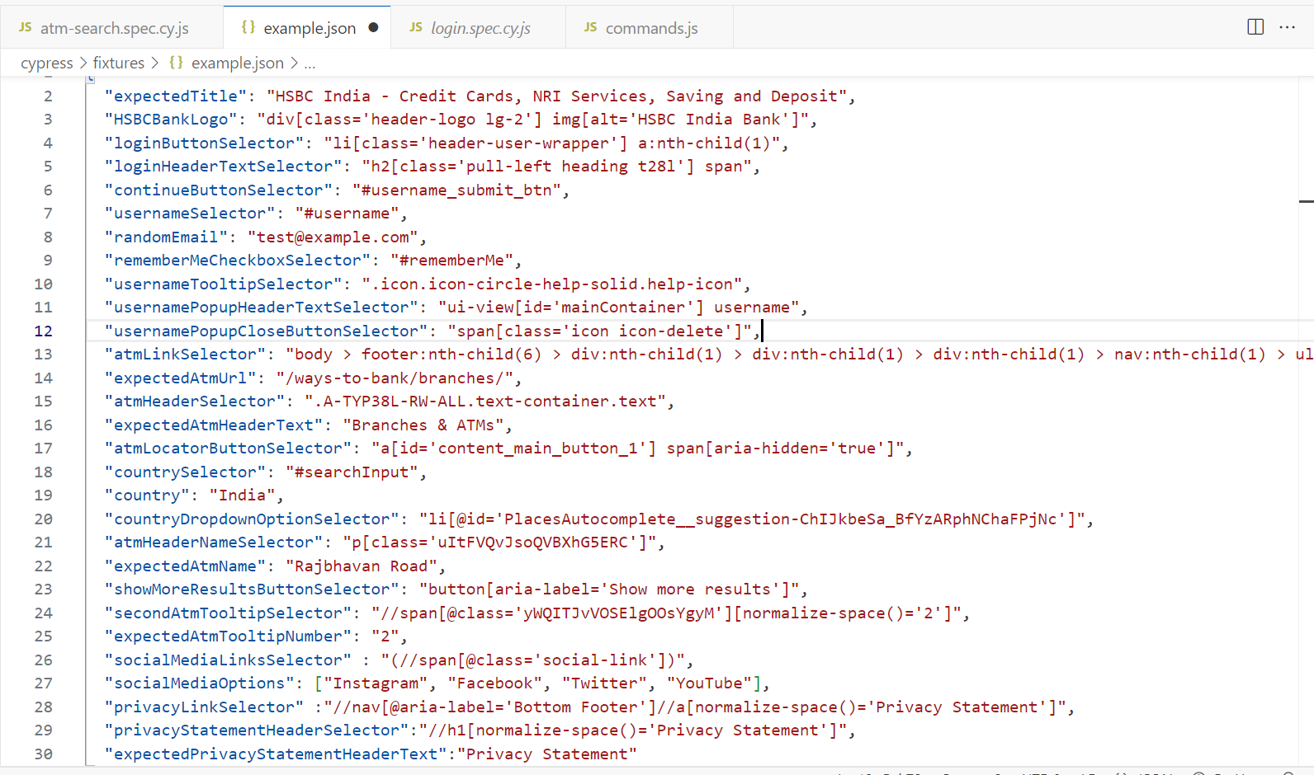

**\cypress\e2e\login.spec.cy.js**

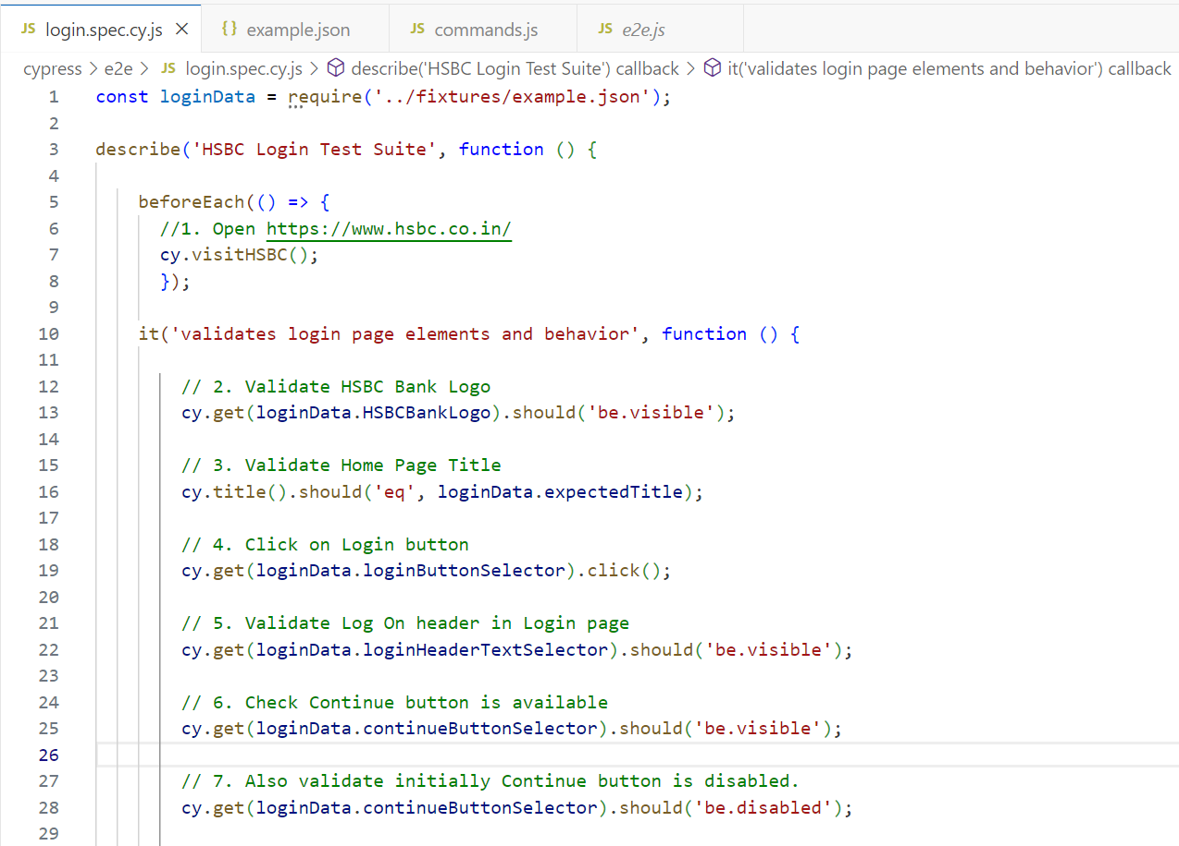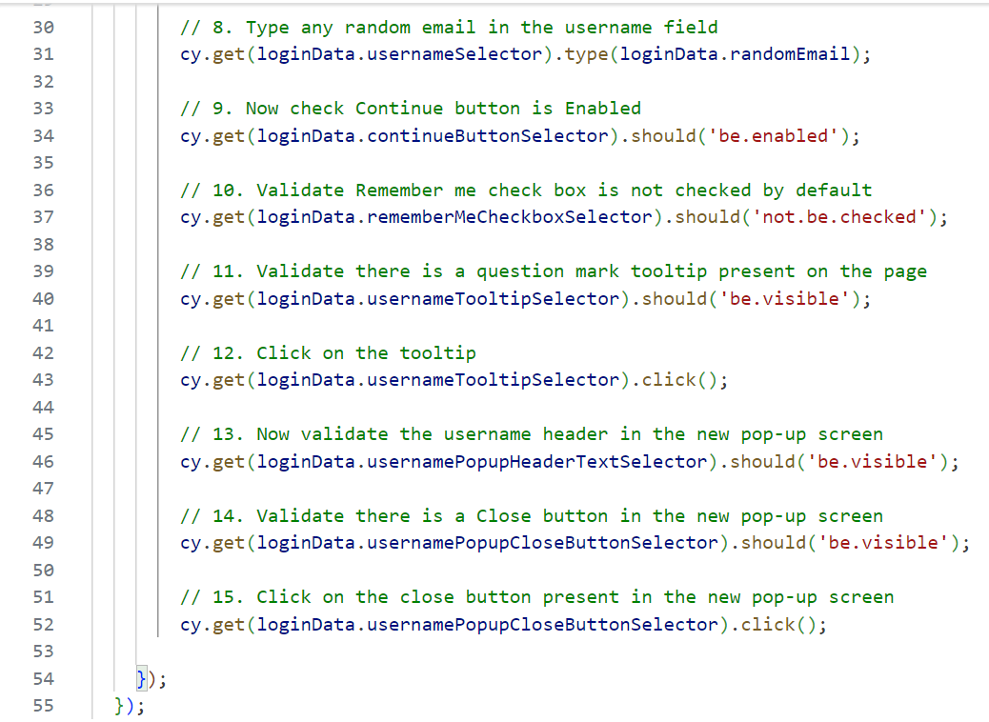

**cypress\e2e\ atm-search.spec.cy.js**

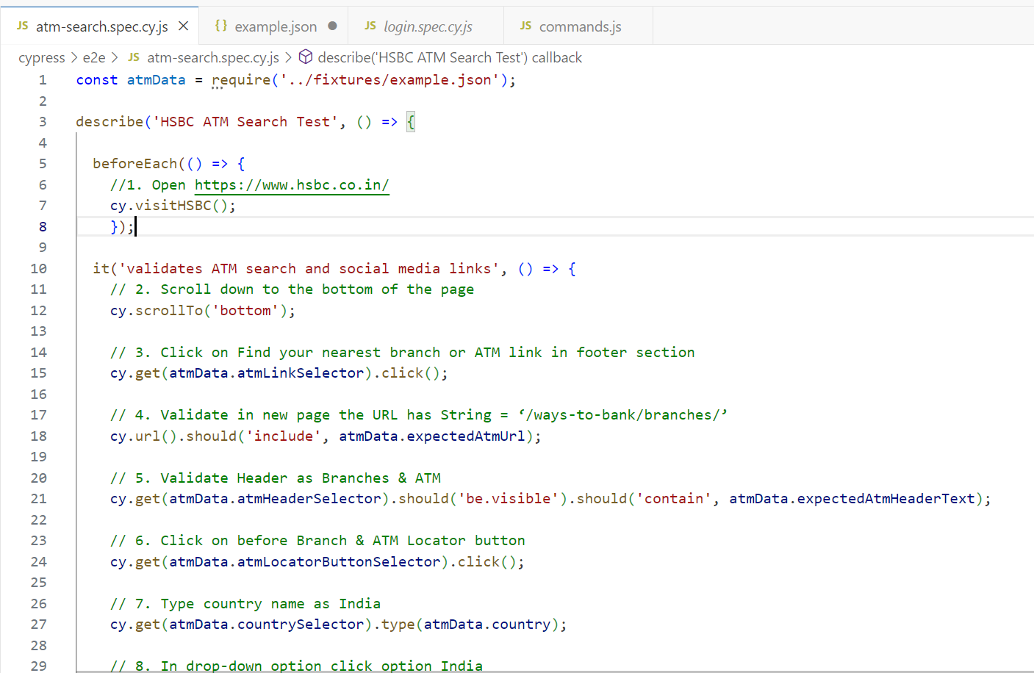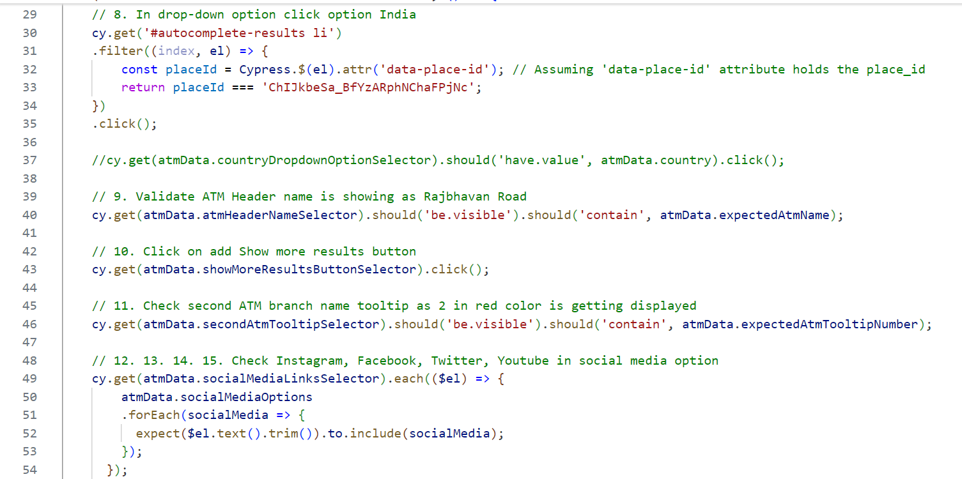 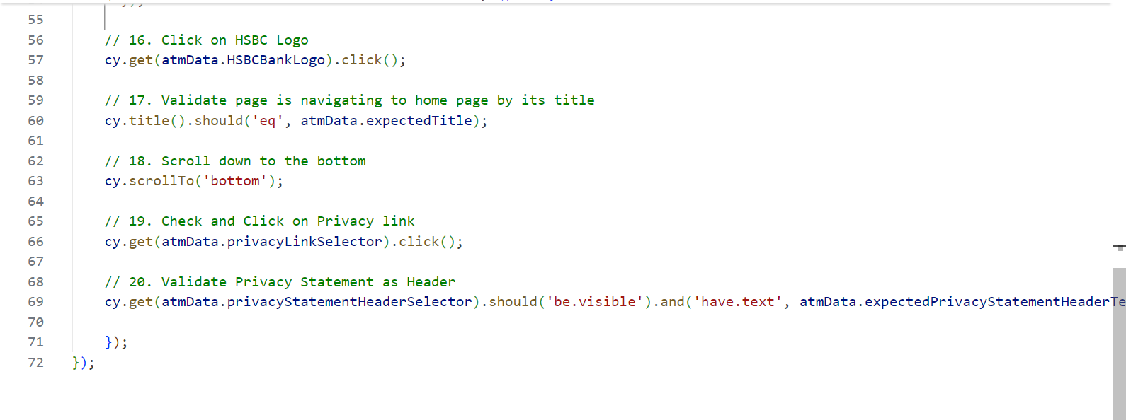

**\cypress\e2e\credit-card.spec.cy.js**

