Student name: ___________________________________

Student ID: _______________________

Score: ______ /75 (Please do not fill this field)

|  |
| --- |
| **Note:**  You are allowed to use class materials and all online materials. |

**Project: Github Git Project**

**Time: 5 hours**

**Description:**

Visit <https://try.github.io> and follow the steps and provide commands and screenshots to pass each strep.

**Step 1: Initializing**

Command: git init

Screenshot: 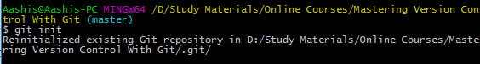

**Step 2: Checking the status**

Command: git status

Screenshot: 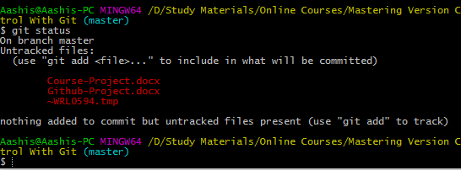

**Step 3: Adding & commiting**

Command: git add

git commit

Screenshot: 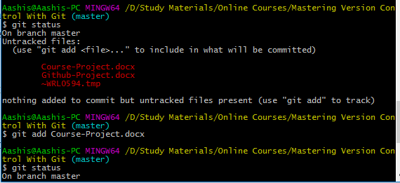

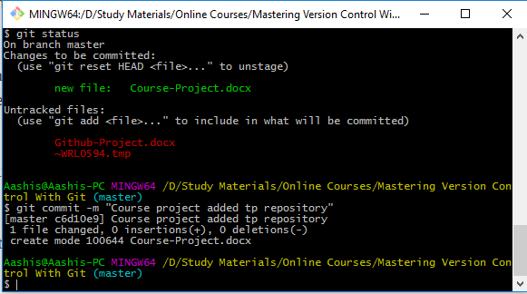

**Step 4: Adding changes**

Command: git add . or git add <filename>

Screenshot: 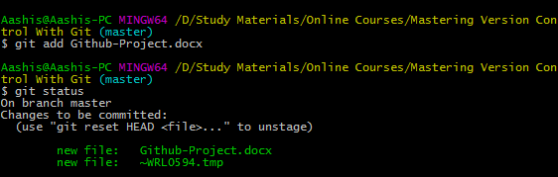

**Step 5: Checking for changes**

Command: git status

Screenshot: 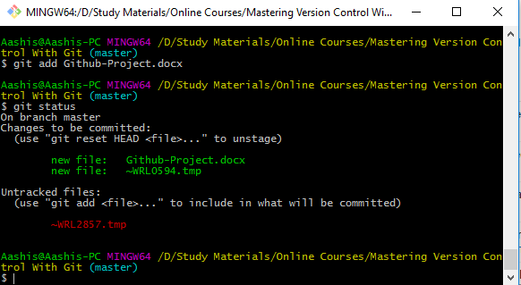

**Step 6: Committing**

Command: git commit –m <”Message”>

Screenshot: 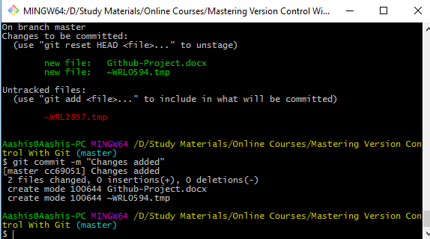

**Step 7: Adding All Changes**

Command: git add .

Screenshot: 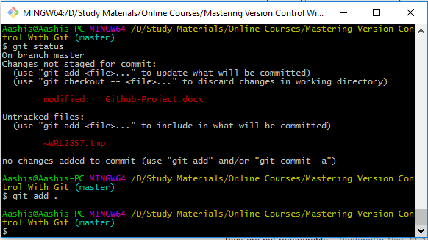

**Step 8: Committing All Changes**

Command: git commit –am <“Commit message”>

Screenshot: 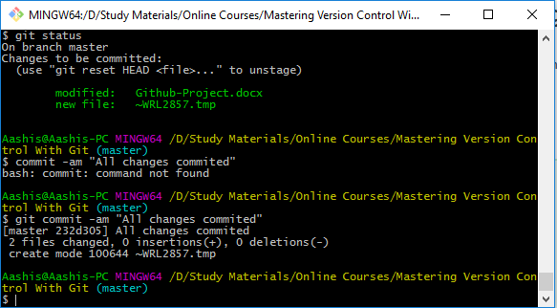

**Step 9: History**

Command: git log

Screenshot: 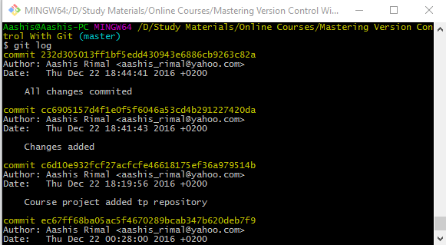

**Step 10: Remote Repositories**

Command: git remote add <name> <url>

Screenshot: 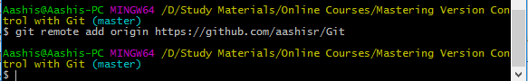

**Step 11: Pushing Remotely**

Command: git push <remote> <branch>

(I had to use the force update since there was some error with the normal push. This might be because I already have a commit in my repo which I do not have locally.)

Screenshot: 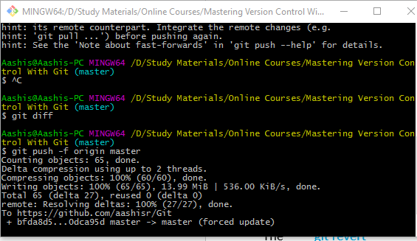

**Step 12: Pulling Remotely**

Command: git pull <remote><branch>

Screenshot: 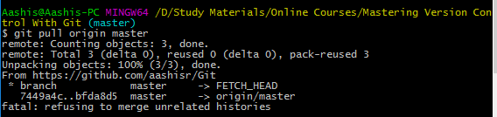

**Step 13: Differences**

Command:

Screenshot:

**Step 14: Staged Differences**

Command:

Screenshot:

**Step 15: Staged Differences (cont'd)**

Command:

Screenshot:

**Step 16: Resetting the Stage**

Command:

Screenshot:

**Step 17: Undo**

Command:

Screenshot:

**Step 18: Branching Out**

Command:

Screenshot:

**Step 19: Switching Branches**

Command:

Screenshot:

**Step 20: Removing All The Things**

Command:

Screenshot:

**Step 21: Committing Branch Changes**

Command:

Screenshot:

**Step 22: Switching Back to master**

Command:

Screenshot:

**Step 23: Preparing to Merge**

Command:

Screenshot:

**Step 24: Keeping Things Clean**

Command:

Screenshot:

**Step 25: The Final Push**

Command:

Screenshot:

**You need to return this document for your final assessment.**

**Good luck!** ☺ **Farhad Eftekhari**

Copyright © 2016 by Farhad Eftekhari

All rights reserved. No part of this publication may be reproduced, distributed, or transmitted in any form or by any means, including photocopying, recording, or other electronic or mechanical methods, without the prior written permission of the publisher, except in the case of brief quotations embodied in critical reviews and certain other noncommercial uses permitted by copyright law. For permission requests, write to the publisher, addressed “Attention: Permissions Coordinator,” at the address below.

Helsinki Metropolia UAS  
Bulevardi 31  
00079 Heksinki, Finland  
www.techclass.co

  