Tribhuvan University
Institute of Science and technology



project Proposal
on
“Futsal Booking and Management System”

A project proposal submitted for the partial fulfillment of the requirements for the degree of
Bachelor of Science in Computer Science and Information Technology (B.Sc. CSIT)

Submitted by:
Aashish Rijal (79010939)
Kedar Dhungana (79010957)
Dipesh Devkota (79010952)

Submitted to:
Asian School of Management and Technology
Gongabu, Kathmandu

Under the Supervision of
Mr. Surya Bam
February 15, 2026
TABLE OF CONTENTS
1. Introduction.................................................................................................. 3
2. Problem Statement...................................................................................... 4
3. Objectives.................................................................................................... 4
4. Methodology............................................................................................... 5
4.1 Requirement Identification........................................................... 6
4.1.1 Literature Review………………………………………… 6
4.1.2 Requirement Analysis …………………………………… 7
4.2 Feasibility Study ........................................................…………. 10
1.1.1 Technical Feasibility......................................................... 10
1.1.2 Operational Feasibility...................................................... 10
1.1.3 Economic Feasibility.......................................................... 10
1.1.4 Schedule Feasibility............................................................ 11
4.3 High-Level Design of System......................................................... 12
4.3.0 Flow chart.......................................................................... 12
4.3.1 Proposed System Methodology.......................................... 12
4.4 Core Algorithms Description................................................. 13
5. Expected Outcome............................................................................... 15
6. References..............................................................................................16

1. Introduction

Online booking platforms have become an essential part of modern service industries, enabling users to reserve services efficiently while helping businesses manage operations digitally. Sports facility booking systems, in particular, allow players to check availability, reserve time slots, manage schedules, and communicate with facility owners through a centralized platform. Internationally, many sports centers use automated booking systems to reduce manual errors, improve customer experience, and optimize resource utilization.
In Nepal, the number of futsal centers has increased rapidly in recent years due to growing interest in indoor football and recreational sports. However, many futsal facilities still rely on manual booking methods such as phone calls, social media messages, or handwritten registers. These approaches often result in double bookings, scheduling conflicts, poor record management, and inefficient communication between players and futsal operators. The lack of a unified digital system also makes it difficult for customers to compare locations, prices, and user reviews before making a booking decision.[1]
To address these challenges, the proposed project Online Futsal Booking and Management System developed as a multi-tenant SaaS platform where multiple futsal businesses can operate independently within a shared infrastructure while maintaining secure data separation. The system provides a centralized web-based platform where users can search futsal centers, view available time slots, make bookings, and manage reservations, while futsal owners can manage schedules, pricing, subscriptions, and customer interactions through a dedicated dashboard. The platform is designed to be scalable, secure, mobile-responsive, and API-driven to support modern deployment needs.
In addition to core booking and management features, the system integrates machine learning and data-driven components to enhance decision support and user experience. User reviews are analyzed using natural language processing techniques such as sentiment analysis and TF-IDF–based text processing for automatic review summarization. A location-based recommendation mechanism suggests nearby futsal courts based on proximity and user preference patterns. Furthermore, Logistic Regression is applied as a supervised classification method to support prediction tasks such as review sentiment categorization and user behavior likelihood estimation. By combining SaaS architecture with intelligent analytics features, AllFutsal aims to provide an efficient, reliable, and smart digital solution for futsal facility management in Nepal.[2]
2. Problem Statement
In recent years, the demand for futsal facilities in urban areas has grown rapidly, yet many futsal centers still rely on outdated and manual management systems. Bookings are often handled through phone calls, paper regist
ers, or messaging apps, which leads to frequent issues such as double bookings, inaccurate record-keeping, poor coordination, and the absence of real-time availability updates. Additionally, there is no centralized platform where players can easily discover and compare multiple futsal courts, making the process of finding suitable venues time-consuming and inefficient. These limitations reduce both customer satisfaction and operational efficiency.
Furthermore, existing systems lack advanced features that could significantly improve business performance and user engagement. Most futsal centers do not provide proper rating and review mechanisms, detailed booking and revenue reports, or automated customer support. Owners have limited access to business intelligence insights, such as usage trends and revenue analysis, which restricts informed decision-making. Modern technologies like AI-powered sentiment Analysis, review summaries, are also largely absent. Therefore, there is a clear need for a centralized, secure, and intelligent online futsal booking and management system. The proposed AllFutsal platform aims to address these challenges through a scalable multi-tenant SaaS architecture that enhances booking efficiency, management capabilities, and overall user experience.
3. Objectives
The main objectives of the proposed project include:
- To develop a centralized online platform for futsal discovery and real-time court booking, ensuring convenience and accessibility for users.
- To implement a multi-tenant SaaS architecture that allows multiple futsal facilities to operate independently within a single scalable and secure system.
- To enable community features including verified ratings, reviews, and a discussion forum to enhance user interaction and trust.
- To integrate AI and ML technologies such as review summarization and sentiment analysis of user reviews for smarter decision-making.
4. Methodology
For our project, we have selected the Agile development model as it supports iterative development, continuous feedback, and flexible requirement handling. The Agile model allows the system to be developed in small incremental stages known as iterations or sprints. Each sprint delivers a working version of the system with improved features and refinements. This approach is suitable for our project because requirements such as booking flow, recommendation features, analytics, and user interface improvements can evolve based on testing results and supervisor feedback.
For the AllFutsal system, the development process will begin with requirement gathering and feature prioritization, followed by sprint planning. Core modules such as user registration, futsal listing, booking management, and admin dashboard will be developed in early sprints. Advanced modules such as review analysis, recommendation engine, and machine learning components will be implemented in later sprints. Each sprint will include coding, integration, and testing activities to ensure that every increment is functional and stable.

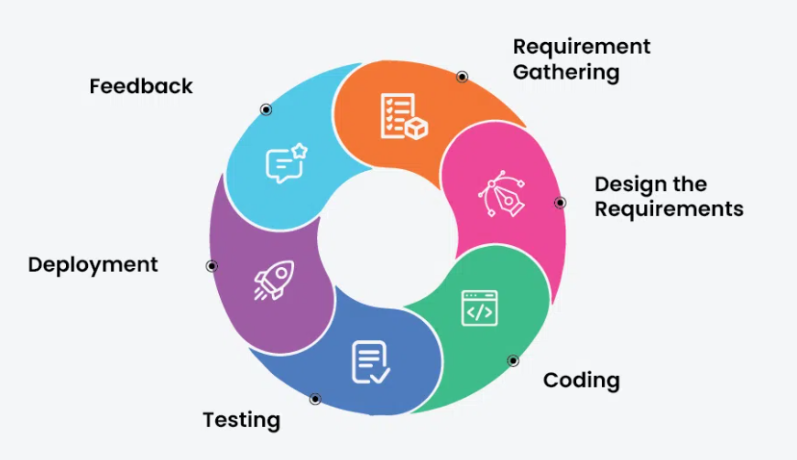
Fig: Agile Methodology [3]

4.1 Requirement Identification

4.1.1 Literature Review
The development of the AllFutsal system is based on prior research in three main areas: digital sports facility management, multi-tenant SaaS architecture, and machine learning techniques for user engagement and decision support.
Recent academic research shows a growing shift from manual futsal court booking toward web- based digital systems. Many futsal centers still use manual booking methods such as log books and phone reservations, which increase the risk of data loss and make schedule management difficult. A study by Suhaimi and Sahid developed a futsal court booking system to replace manual records with a database-driven platform. Their system improved booking visibility, scheduling clarity, and electronic data management through a structured booking interface built using the prototyping model [1].
Similarly, Fauzi et al. presented a web-based futsal field rental information system aimed at improving business opportunities and operational efficiency in the sports rental sector. Their research highlights that website-based booking platforms help replace hand-written and manual rental processes while increasing accessibility and customer reach [4].
Industry analysis also supports the effectiveness of specialized sports booking software, reporting measurable reductions in scheduling conflicts and improved operational transparency when centralized booking systems are used [5]. In addition, mobile-first and Progressive Web Application approaches are recommended for booking platforms because they provide responsive, app-like user experience across devices without the high cost of native mobile app development.[6]
Modern system design literature further recommends multi-tenant SaaS architecture for shared booking platforms serving multiple independent facility owners with proper data isolation. Machine learning techniques such as sentiment analysis and text feature extraction (e.g., TF-IDF) are increasingly applied to process user reviews automatically [1][4], while location-based recommendation methods are used to rank nearby services based on user proximity and preference patterns [9].
Machine learning techniques are increasingly applied to process user reviews and support decision-making. Recent studies utilize Logistic Regression as a robust supervised learning algorithm for human sentiment analysis across various domains, often using it to classify user feedback into binary outcomes (e.g., positive or negative sentiment) based on feature extraction [6][9]. This is often paired with techniques such as Term Frequency-Inverse Document Frequency (TF-IDF) to extract text features and rank nearby services based on user proximity and preference patterns [2][9].
These studies and industry practices collectively demonstrate the effectiveness of digital, database- driven, and intelligent booking systems, while also showing that integrated, multi-tenant, ML- enhanced futsal management platforms remain limited which motivates the development of the futsal system.

4.1.2 Requirement Analysis:
In requirement analysis, the primary goal is to identify and define both the functional and non-functional requirements of the system. Functional requirements for a futsal management & Booking system include features like user operation, search and filter, booking, Rating & Review, Suboptimal. Non-functional requirements focus on Multi-tenant data isolation, Mobile responsiveness, API-based design, system performance, ensuring that the system can handle a growing number of users and transactions. This analysis helps ensure that the system meets the needs of the futsal and its customers while maintaining efficiency and effectiveness.

Functional Requirements:
Functional requirements define what the system should do and how it should behave under specific conditions. For the system, the core functional requirements include:
User:
- Create and manage user profile
- Search futsal centers by location,price and available time slots
- View futsal details, facilities, pricing and reviews
- Book available futsal courts online.
- Cancel or reschedule bookings based on rules.
- Submit ratings and reviews after playing.
- Receive booking confirmation and notifications.
- View booking history.
- Get recommended futsal centers based on location and preferences.
Futsal Owner:
- Register and manage futsal center profile.
- Add and manage grounds/courts.
- Set available time slots and pricing.
- Approve or manage booking requests.
- View booking schedules and customer details.
- Manage offers and subscription plans.
- View analytics dashboard for bookings and revenue.
- Respond to customer reviews and queries.
Admin:
- Manage all futsal tenants.
- Manage user accounts and permissions.
- Monitor system usage and reports.
- Manage subscription plans and packages.
- Handle complaints and system-level moderation.
Use Case: 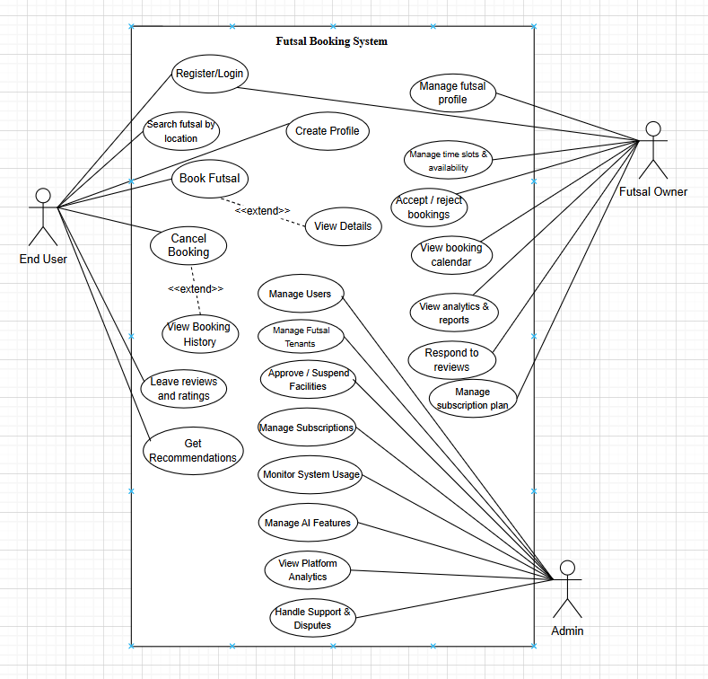 ` Fig: Use case diagram for Futsal Booking System

Non-Functional Requirements:
Non-functional requirements define how the system performs rather than what it does. These ensure following things:
- Performance
- Scalability
- Usability
- Security
- Reliability
- Availability

4.2 Feasibility Study

4.2.1 Technical Feasibility
The AllFutsal system is technically feasible because it is based on widely used and well-supported technologies for modern web and data-driven applications. The platform can be developed using React for the frontend and Node.js with Express.js and MySQL for the backend, which are proven for building scalable, secure, and multi-tenant SaaS systems. Redis can be integrated for caching, session handling, and fast real-time slot availability checks to improve performance, while Docker can be used to containerize services for consistent development, testing, and deployment across environments. Required features such as JWT authentication, Google OAuth, OTP verification, Email notifications, and cloud file storage are supported through reliable third-party APIs, making integration practical. The machine learning components, including review sentiment analysis, review summarization can be implemented using Python ML/NLP libraries with datasets from Kaggle and real user reviews. Since all required frameworks, tools, and infrastructure are readily available and compatible with the team’s technical skills, the project is technically achievable within the given resources.

4.2.2 Operational Feasibility
The system is designed to mimic existing manual workflows but digitize them, reducing the learning curve for futsal owners. Since most owners and players already use smartphones, the operational adoption barrier is low. The system automates tedious tasks (recording bookings, calculating totals), thereby streamlining operations rather than complicating them.

4.2.3 Economic Feasibility
As a SaaS product, the development cost involves primarily developer time and hosting fees (cloud servers like AWS or affordable VPS). The revenue model (subscription-based for tenants) ensures sustainability. For this academic project, open-source tools and free-tier hosting services will be used, making the development cost negligible.

4.2.4 Schedule Feasibility

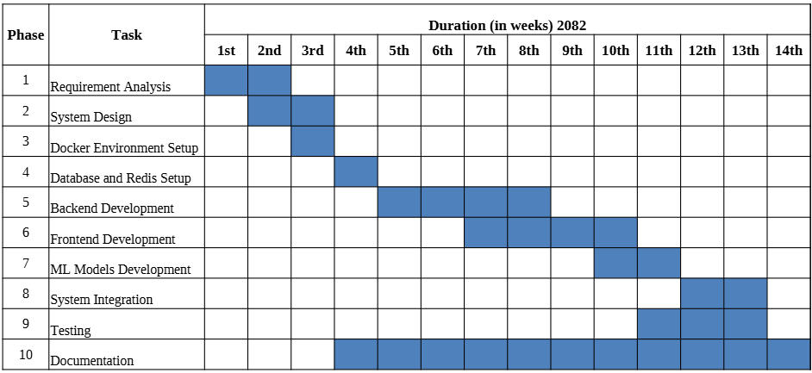
Fig : Gantt chart

4.3 High Level Design of System
A High-Level Design (HLD) system means a big-picture plan of how a system will work. It shows the main parts of the system and how they will connect to each other. This design phase focuses on the overall structure, modules, data flow, and communication between components, rather than the specific code or functions.

4.3.0 Flow Chart of the System
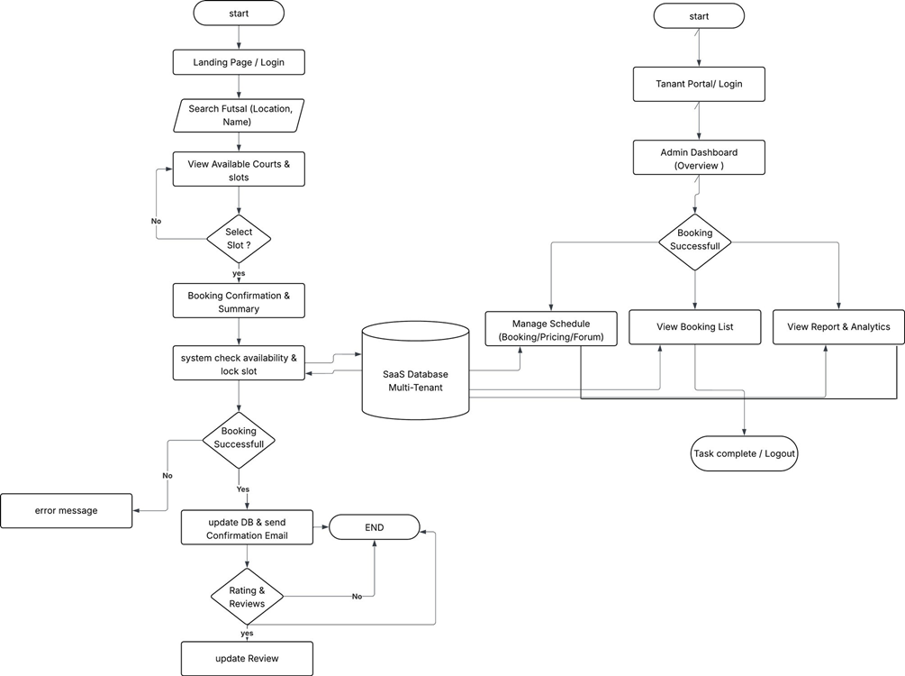
Fig: Flow Chart of System

4.4 Core Algorithms Description
The AllFutsal system uses several core algorithms to ensure correct booking, smart recommendations, sentimental analysis of reviews and summarization. The main algorithms are described below.

Slot Conflict Prevention Algorithm (Time Slot Validation)
To prevent double booking of futsal courts, the system uses a Slot Conflict Prevention algorithm that validates time-slot availability before confirming a reservation. This ensures that no two bookings are assigned to the same court at overlapping time intervals.
Logical Flow:
The algorithm checks existing bookings for the selected court and date.
For a new booking request with start time Sₙ and end time Eₙ, the system verifies overlap with existing slots (Sᵢ, Eᵢ).
→ If overlap exists → Booking is rejected.
→ If no overlap → Booking is confirmed and slot is locked.
Mathematical Logic:
Two slots overlap if:
(Sₙ < Eᵢ) AND (Eₙ > Sᵢ)
Booking is allowed only if:
∀ i : NOT[(Sₙ < Eᵢ) AND (Eₙ > Sᵢ)]
This guarantees that only one active booking exists per court per time range.

Location Distance Algorithm (Nearest Futsal Suggestion)
To recommend nearby futsal centers, the system calculates the geographical distance between the user’s location and each futsal center using coordinate-based distance computation. This supports proximity-based search and ranking.
Logical Flow:
The algorithm reads user latitude and longitude.
It compares them with futsal center coordinates.
Distances are calculated and sorted ascending.
Nearest futsal centers are recommended first.
Mathematical Representation (Haversine Formula):
d = 2r × arcsin( √( sin²(Δφ/2) + cos(φ₁) × cos(φ₂) × sin²(Δλ/2) ) )
Where:
d = distance between two points
r = Earth radius (6371 km)
φ = latitude, λ = longitude (in radians)
Δφ = φ₂ − φ₁
Δλ = λ₂ − λ₁

TF–IDF Algorithm (Review Feature Extraction & Summarization)
The system uses TF-IDF (Term Frequency – Inverse Document Frequency) to identify important words in user reviews and support automatic review summarization and feature extraction.
Logical Flow:
Text reviews are collected and preprocessed.
Stop words are removed and tokens are generated.
TF and IDF values are calculated.
Each review is converted into a TF-IDF feature vector.
These vectors are then used as input to the Logistic Regression classifier.
Mathematical Representation:
TF(t,d) = (Number of times term t appears in document d) / (Total terms in d)
IDF(t) = log ( N / df(t) )
TF-IDF(t,d) = TF(t,d) × IDF(t)
Where:
t=term
d=document(review)
N=total number of reviews
df(t) = number of reviews containing term t
Logistic Regression Algorithm (Sentiment Classification)
Logistic Regression is used as a supervised machine learning algorithm to classify review sentiment (positive or negative). It predicts the probability that a review belongs to a particular sentiment class based on extracted text features.
Logical Flow:
TF-IDF feature vectors are generated from reviews.
These features are passed into the logistic regression model.
The model computes probability scores.
A threshold (usually 0.5) is used to assign class labels.
→ Probability ≥ threshold → Positive sentiment
→ Probability < threshold → Negative sentiment
Mathematical Representation:
p = 1 / (1 + e^(−z))
Where:
z = w₀ + w₁x₁ + w₂x₂ + … + wₙxₙ
Decision rule:
Class = 1 if p ≥ 0.5
Class = 0 if p < 0.5
This method is efficient, interpretable, and suitable for text-based sentiment classification in the AllFutsal review analysis module.

5. Expected Outcome
Upon completion, the futsal management and booking project will provide a fully functional Software as a Service (SaaS) platform capable of hosting multiple independent futsal businesses while ensuring complete data isolation. The system will feature an intelligent booking engine that prevents scheduling conflicts, manages peak hours efficiently, and handles cancellations automatically. Futsal owners will have access to analytical dashboards that provide insights into peak usage times, revenue trends, and customer engagement, supporting data-driven decision-making. From the user’s perspective, the platform will offer an AI-enhanced experience, including a recommendation system that suggests futsal courts based on user location, as well as a review summarization feature that condenses user feedback into meaningful insights. Additionally, the project will deliver comprehensive code documentation and a detailed final report describing the system architecture, implemented algorithms, and overall methodology, ensuring the solution is well-documented and maintainable.
6. References
[1] A. N. S. Suhaimi and M. Z. Sahid, “A Development of Futsal Court Booking System,” Applied Information Technology and Computer Science (AITCS), vol. 4, no. 1, pp. 967–980, 2023. doi:10.30880/aitcs.2023.04.01.055.
[2] Coursera, “What is TF-IDF (Term Frequency–Inverse Document Frequency)?,” Coursera Articles. [Online]. Available: https://www.coursera.org/articles/what-is-tfidf
[3] Agile SDLC (Software Development Life Cycle), GeeksforGeeks. [Online]. Available:https://www.geeksforgeeks.org/software-engineering/agile-sdlc-software-development-life-cycle/. [Accessed: 12- Feb- 2026].
[4] A. Fauzi et al., “Explore Business Opportunities in the Sport Industry in Bekasi: Web-Based Futsal Field Rent Information System,” Indonesian Journal of Economics and Strategic Management (IJESM), vol. 1, no. 2, Jul. 2023.
[5] SportsKey, “Sports Facility Booking Software Trends and Conflict Reduction Statistics,” 2026.[Online]. Available: https://www.sportskey.com
[6] Universiti Teknologi MARA (UiTM), “Progressive Web Applications for Mobile-First Systems,” 2024.
[7] S. Nagar, P. Bhanodia, K. K. Sethi and N. P. S. Rathore, "Logistic Regression Based Approach for Human Sentiment Analysis Across Domains," 2024 International Conference on Advances in Computing Research on Science Engineering and Technology (ACROSET), Indore, India, 2024, pp. 1-11, doi: 10.1109/ACROSET62108.2024.10743868.
[8] IBM, “What is multi-tenant architecture?,” IBM Think Topics. [Online]. Available: https://www.ibm.com/think/topics/multi-tenant

